SO235 first weekly report 23.-27.07.2014 from Port Louis / Mauritius to Malé / Maldives
Here is the first weekly report of our SO235 SONNE-OASIS ("Organic very short-lived substances and their air-sea exchange from the Indian Ocean to the stratosphere") expedition, funded by the BMBF (project 03G0235A). The aim of our research is to investigate the biogeochemical cycling and exchange of gases between the atmosphere and ocean, as well as the transport of ocean derived trace gases from the Indian Ocean up to the stratosphere during southwest monsoon.
On the morning of 23/07/14 our SO235 team was finally on board, consisting of chemical oceanographers, atmospheric chemists, meteorologists, physical oceanographers and biologists: 23 scientists from Germany, Norway, Taiwan, Spain, and an observer from Mauritius. The only missing item was a major airfreight shipment of spare parts for the ship. At around 15:00 local time (LT) we left the harbor of Port Louis, after a 6 h delay of departure. At 26 °C and even moderate SE winds, we set out north-eastwards towards the equator (Figure 1). From 16.00 LT we started with the continuous underway measurements in air and water - our OASIS SONNE research journey had begun. With more than 50 measurement instruments, we investigate the sources/sinks and air-sea exchange of volatile ozone-and climate-relevant substances from the subtropical and tropical Indian Ocean to low and high atmospheric layers during the southwest monsoon. Simultaneous underway measurements of chemical, biological and physical parameters, a drifter for tracking surface water masses, ocean depth profiles, weather balloons equipped with radio and ozone sondes are performed on board.

The first day concluded with a small reception at the bowling alley to get to know the SO235 team and exchange ideas. In addition to the daily measurement program, every morning we have group leader meetings, afternoon lectures to present the work onboard, and in the evening the daily blog is written (www.oceanblogs.org/sonne-oasis).
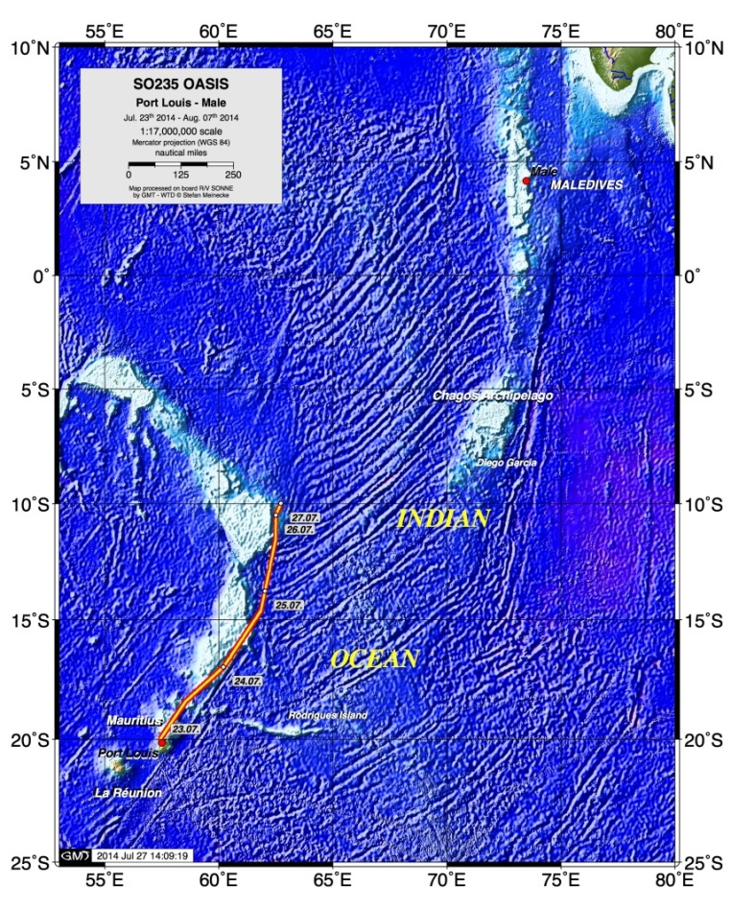
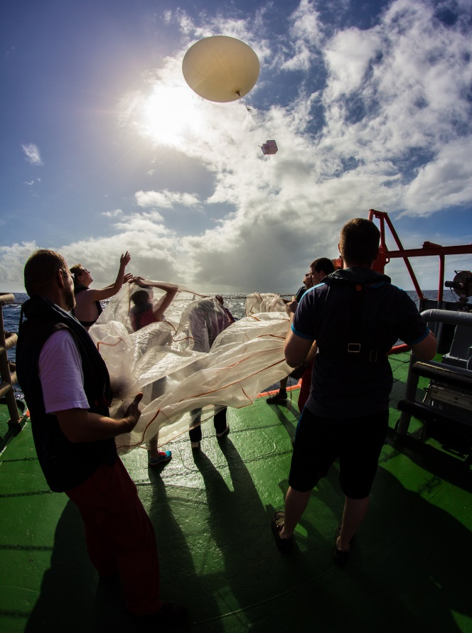

Figure: SO235 cruise track (Stefan Meinecke); Ozone sonde launch (Matthias Krüger).
Due to increased chlorophyll content and increased halocarbon and DMS concentrations in the water, we planned a 26 hour station near the bank of Saya de Malha at 10° S and 62° E, from 26.07. 10:00 LT to 12:00 LT 27.07.14 under stormy conditions with high waves. We conducted thirteen station events, including five depth profiles accompanied by radiation measurements, an ozonesonde release, and six-hourly radiosondes to detect a diurnal signal at the station. After a day of steaming and continuous underway measurements, we came to the second long station where we deployed the drifter for the first time on SO235 on 28/07/2014 in the late afternoon, in a region with a slightly elevated oceanic production. At 5° 55'S and 64° 36'E we enter another daily cycle of biological, chemical and physical parameters in the marine boundary layer and in the surface water. Strong winds continue, but fortunately the swell has subsided, and now everyone on board is feeling well.
That is the first news of OASIS-SONNE cruise, see you in a week again.
Your SO235 cruise leader Kirstin Krueger (UiO, Oslo, Norway)

