Supplemental material for manuscript:
Long-term acoustic monitoring at North Sea well site 22/4b

Sean M. Wiggins^{a,*}, Ira Leifer^{b,c}, Peter Linke^{d} and John A. Hildebrandª

ªScripps Institution of Oceanography, 9500 Gilman Drive, La Jolla, California 92093-0205, USA

^{b}Bubbleology Research International, Solvang, California 93463-2613, USA

^{c}Marine Science Institute, University of California, Santa Barbara, California 93106-1080, USA

^{d}Helmholtz Centre for Ocean Research Kiel (GEOMAR), Wischhofstr. 1-3, 24148 Kiel, Germany

*Corresponding author electronic mail and phone number: swiggins@ucsd.edu
1-858-822-2744

SM.1 Seismic air guns
Used for seismic exploration, air gun shots were present in the recording nearly continuously from June to October, with the last shots recorded in mid-November. Seismic air guns are low frequency, impulsive sources, but often in shallow water wave guides, such as the North Sea, the signal can travel long distances becoming dispersed as it separates into multiple modes with different frequencies arriving at different times (e.g. Wiggins et al., 2004) (Figure S1). In this data set, most of the energy from air guns arrives below 100-200 Hz, but closer sources can extend up to 500 Hz and above. Because of the constant presence of air gun sounds, most of the seep acoustic analysis was focused above 500 Hz.
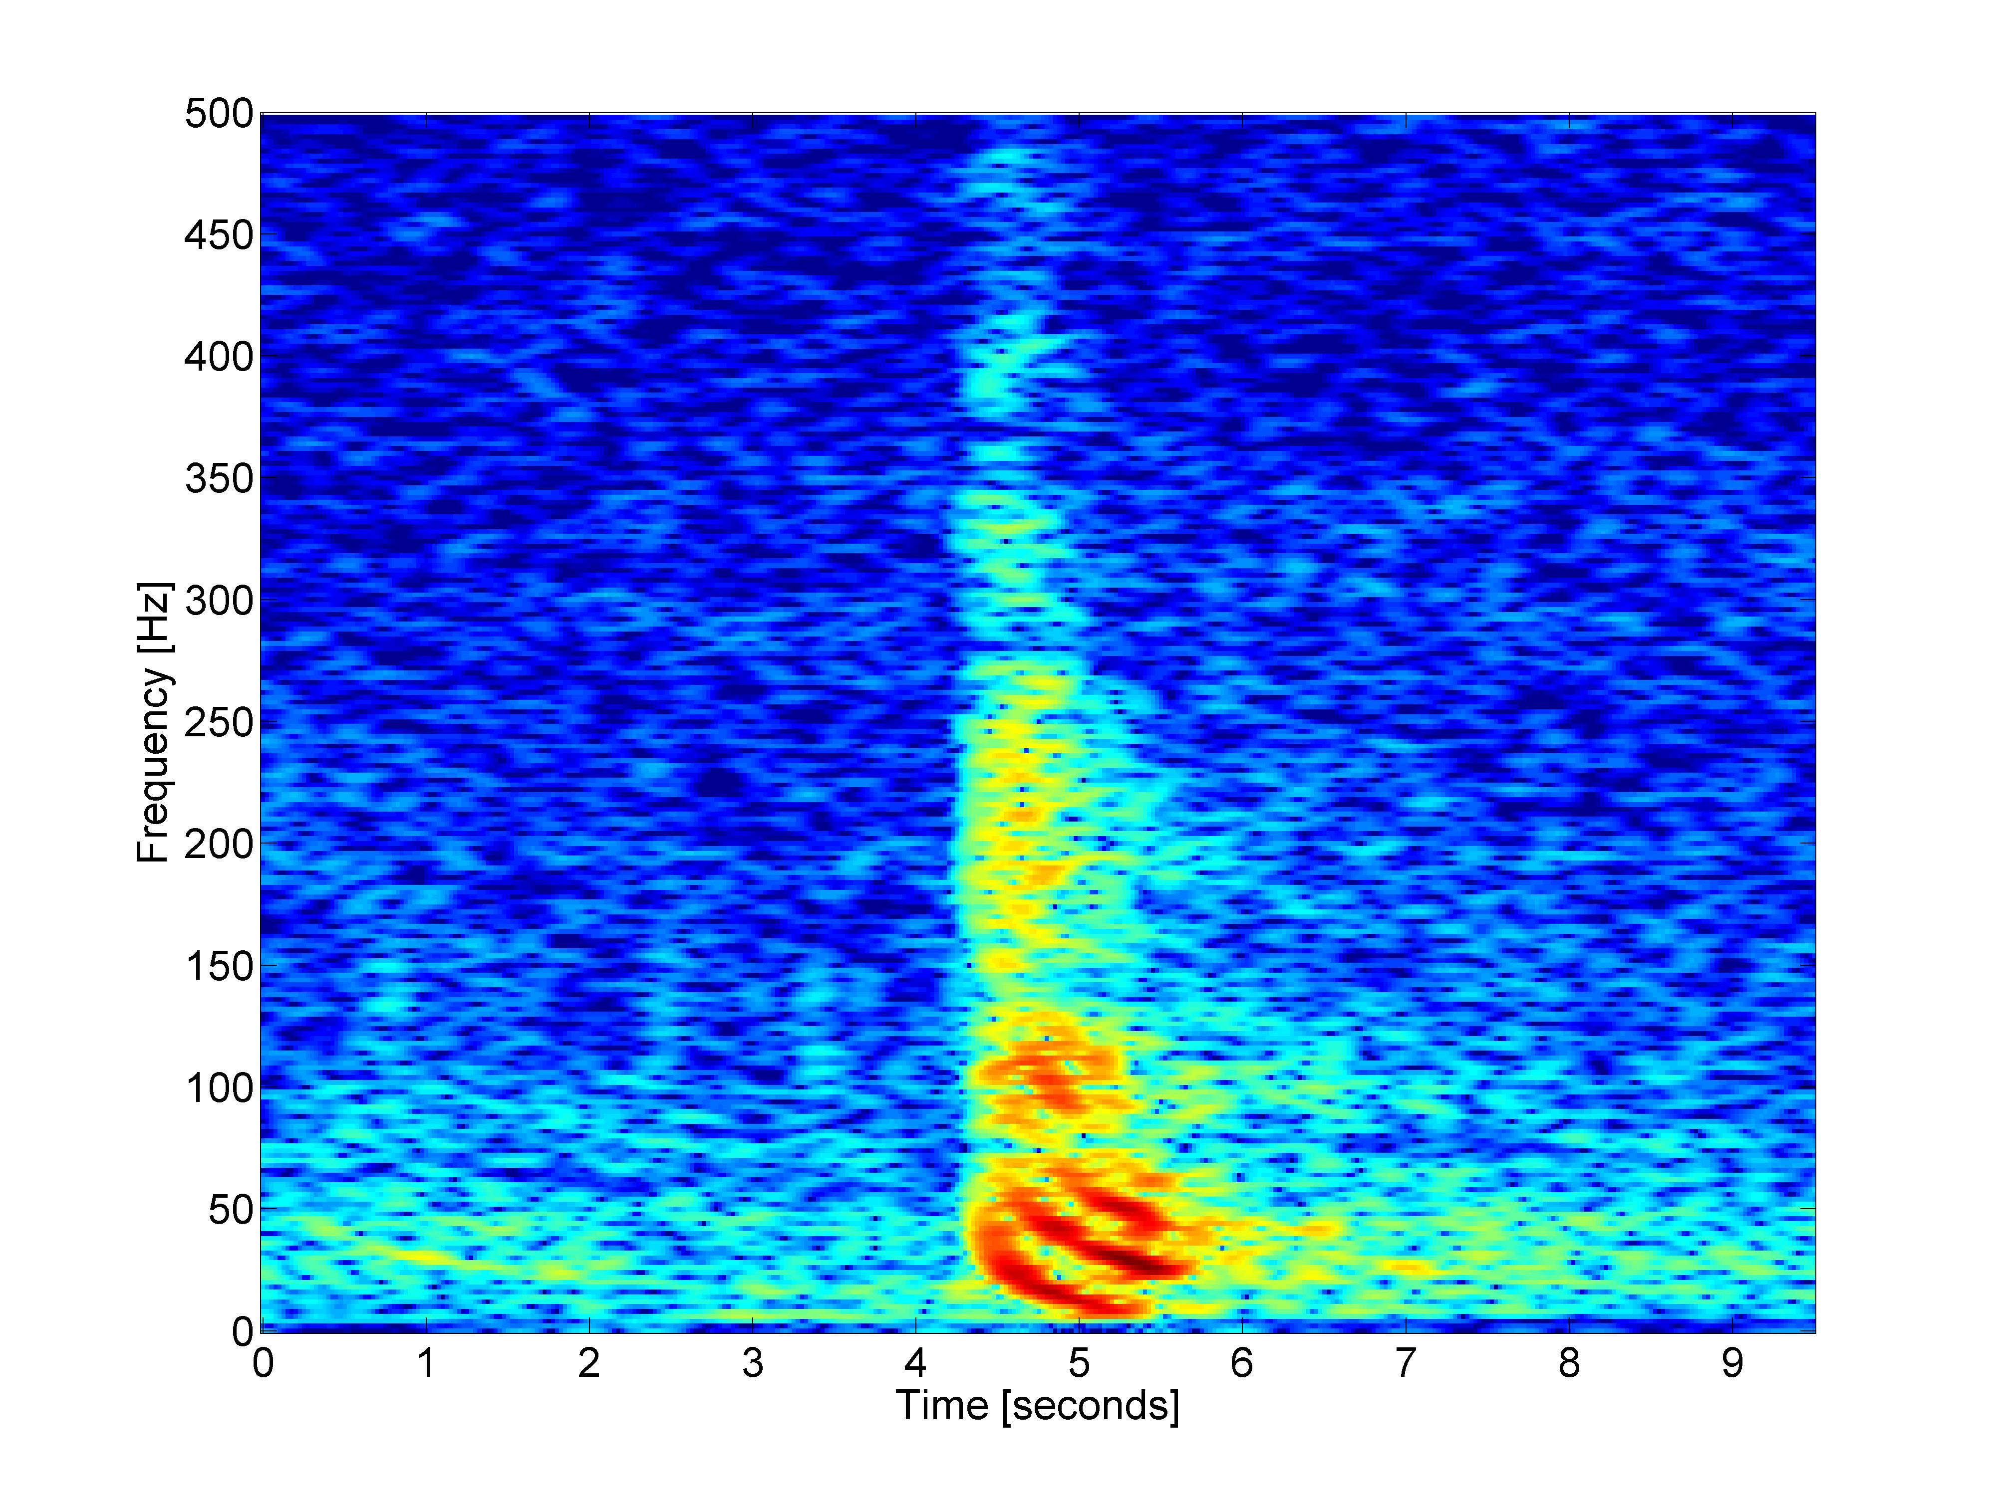
Figure S1. Example spectrogram of a recorded seismic exploration air gun shot from 24 August 2011 shows the arrival of dispersed modes as downsweeps below ~ 125 Hz, although energy extends up to 500 Hz. Air guns were present almost continuously throughout the first data set. Spectrogram was made from full band data (200 kHz sample rate, 100,000 samples, 95% overlap, Hanning window, warm colors represent higher intensity).

SM.2 Long-term Variations
Long-term spectral averages (LTSAs) provide insight to sound pressure spectral energy variations over long periods. An LTSA of a mid-frequency band (500 – 2500 Hz) shows periods of increased and decreased activity over the first 88 days of recording (Figure S2A). For example, on 27 June 2011, there was a sharp decrease in acoustic energy for about one day; this event will be discussed in more detail below (section SM.4). Increased energy events occurred around 24 July and 28 August, both with durations lasting a few days. There was a down-step in acoustic energy around 10 August and various short-term (~ one day or less) oscillations in energy throughout the deployment, especially during the end of this recording in the beginning of September.

Daily-mean acoustic anomalies were calculated over the 1-3 kHz band and show the same low energy event on 27 June, the high energy events on 24 July and 28 August, and the down-step event on 10 August as the LTSA (Figure S2A). An overall downward trend in acoustic energy is apparent in both the LTSA and acoustic anomaly plot, but short duration oscillations are more easily observed in the LTSA plot.

Daily-mean wind speeds for Dyce Airport, Aberdeen, Scotland (57.2° N, 2.2° W) show some of the same events as the LTSA and acoustic anomalies; for example, the two high energy events around 24 July and 28 August, in addition to the event around 9 August (Figure S2B). Even though these wind measurements were about 240 km WSW from the HARP location, the correlation with the high energy events is strong suggesting these acoustic events are related to local weather. Conversely, the low energy event on 27 June was not observed in the wind data, supporting the possibility that this event was related solely to a decrease in activity of the seep system acoustic emissions and potentially flux.
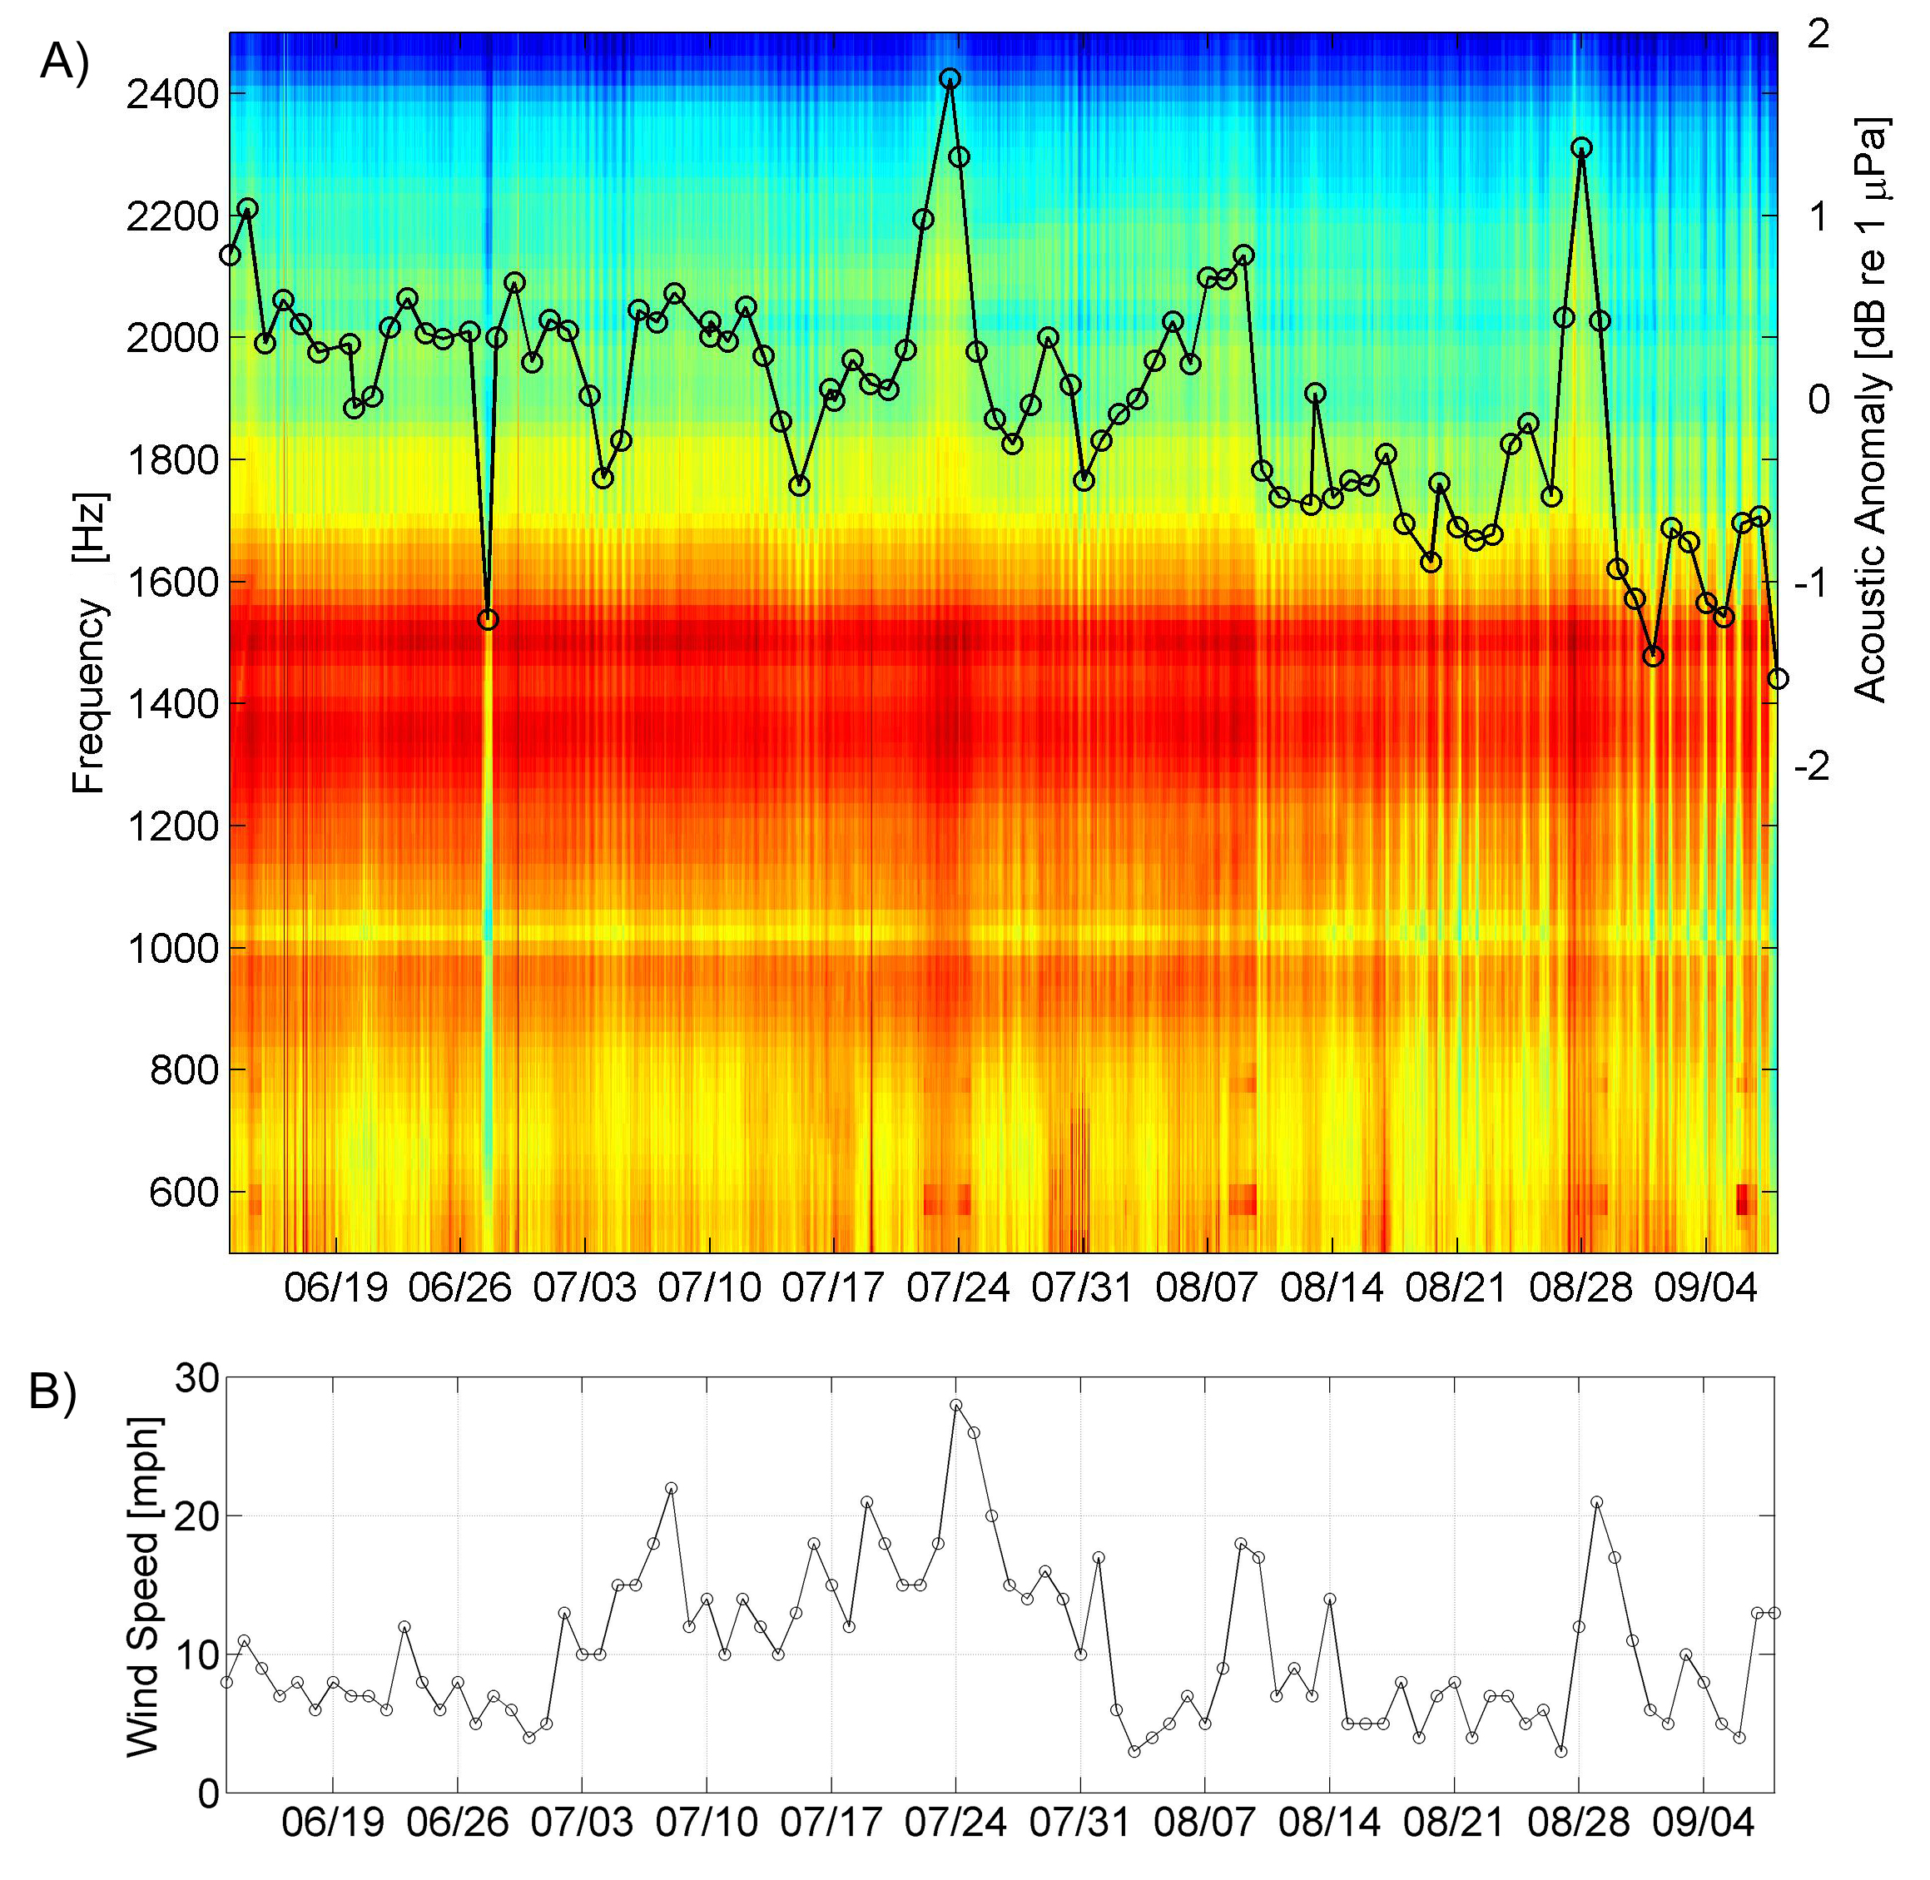
Figure S2. A) Long-Term Spectral Average (LTSA) of 88-day first deployment with acoustic anomaly. For the LTSA, warm colors represent higher intensity sound than cool colors and 5s spectral averages were averaged again to 1 h with 25 Hz frequency bins. Acoustic anomalies (black circles) are averaged from 1-3 kHz over 1d with axis on right. B) Daily-mean wind speeds from Dyce Airport, Aberdeen, Scotland at 57.2° N, 2.2° W ~ 8 km inland from the coast and ~240 km WSW of the HARP site. Wind data obtained from Aaron Howard - Bubbleology Research International.

SM.3 Daily Fluctuations
Computing a spectrogram of the hourly-mean acoustic anomalies provides a measure of the periodicity of events on the daily and sub-daily time scales. An hourly-mean acoustic anomaly spectrogram for the first deployment shows likely tidal related events (two cycles per day) for about one week in duration every other week (Figure S3). Also, a strong diel pattern from near the end of the full deployment LTSA (Figure S2) is apparent near the end of the spectrogram (1 cycle/day) and periodicity of about 6 h (four cycles per day) also is present.

During the beginning of July, the semi-diurnal pattern observed in the acoustic anomaly spectrogram also is apparent in the LTSA and hourly-average acoustic anomaly and appears to be tidally driven (Figure S4). Peaks and troughs in the acoustic anomaly are well correlated with concurrent tide measurements from Lerwick, Shetland Islands, United Kingdom such that at high tide the acoustic anomaly is also high, showing that pressurizing the seep system through tides appears to increase seep acoustic levels and perhaps increased emissions.

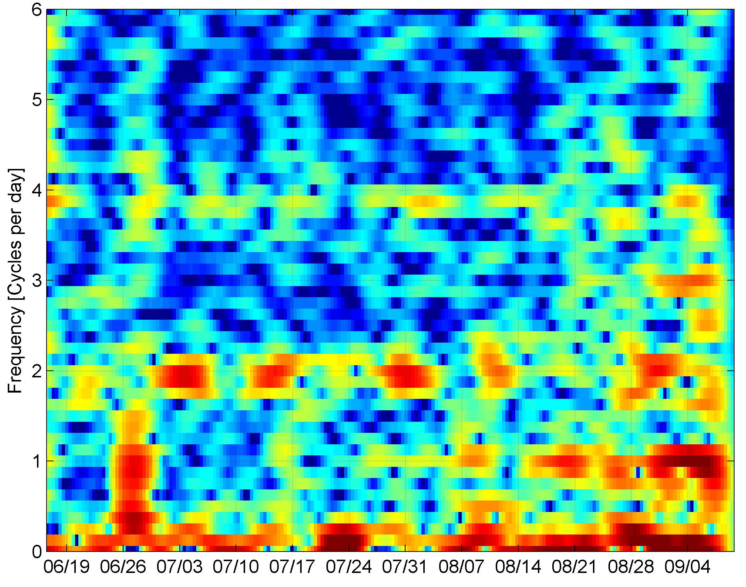
Figure S3. Spectrogram of hourly-mean acoustic anomalies for the first deployment. The events around two cycles per day are likely tidal related. Spectrogram window length is 8 days (192 samples) with 95% overlap using a Hanning window.

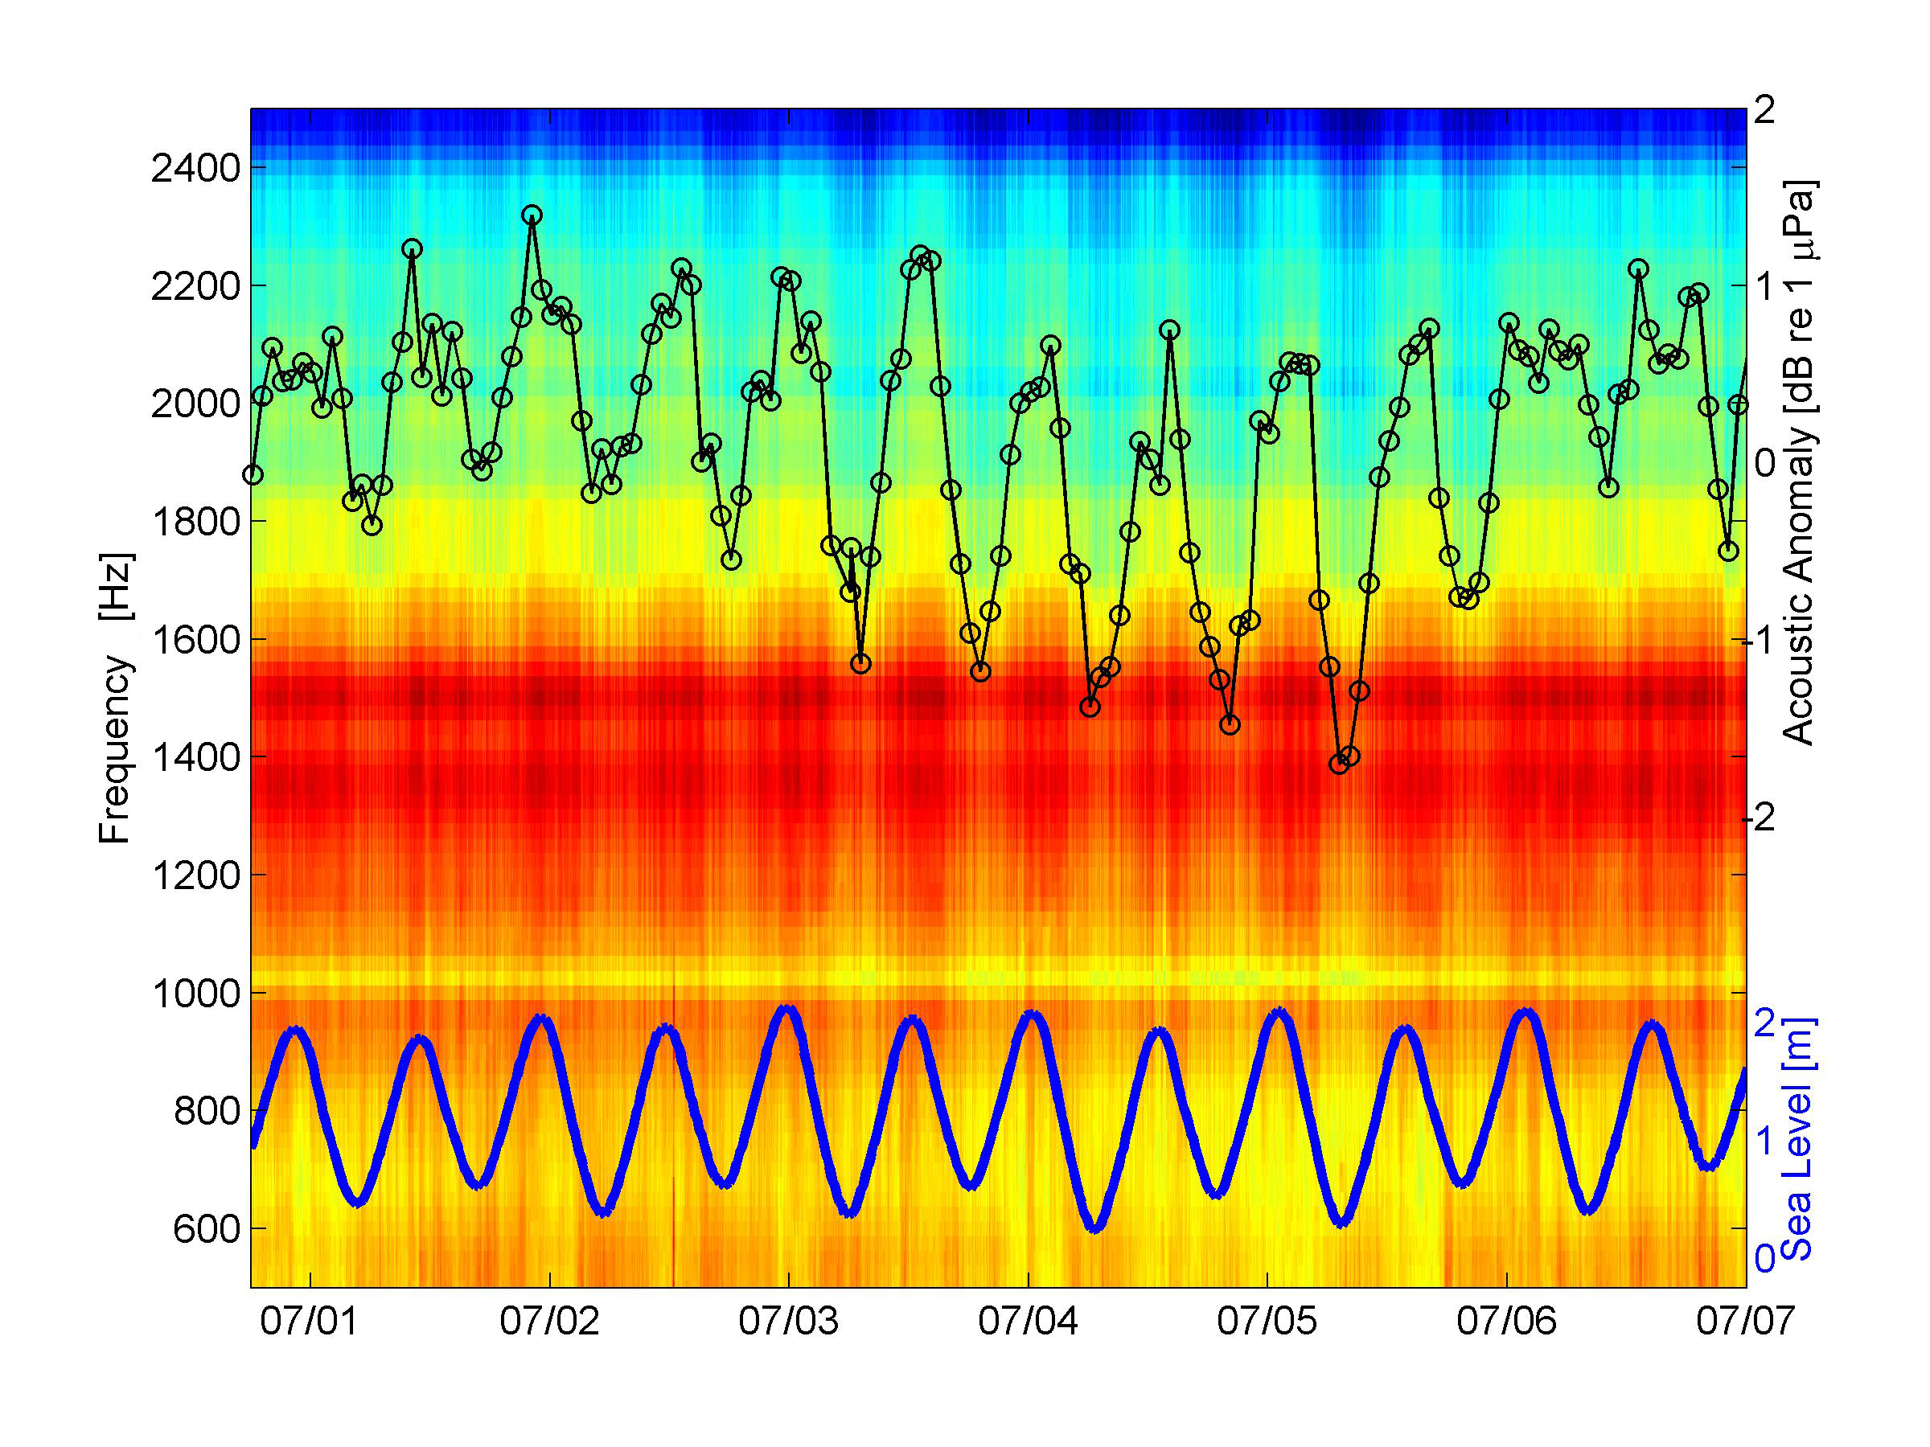
Figure S4. LTSA and hourly-averaged acoustic anomaly (black circles) for approximately six days of the first deployment. LTSA frequency axis is on left and hourly-mean acoustic anomaly axis is on the right. Sea level (blue line) data from Lerwick, Shetland Islands, United Kingdom were provided by the British Oceanographic Data Centre.

SM.4 Event 27 June 2011
The decrease in sound levels on 27 June 2011 (Figures S2A) is shown in finer detail with an LTSA and 15-minute mean acoustic anomalies over a 24 h period (Figure S5). The acoustic levels are slightly raised (0.5-1.0 dB acoustic anomaly) for approximately the first 5 h and then there is a sharp decrease which rebounds a few times over the next 6 h but slowly decreases until a short duration pulse is recorded just after 11 h from the beginning of the period. Three more pulses occur during low sound levels (down to ~ -4 dB) over the next 7 h after which the spectra returns to the slightly raised levels observed prior to this event. Closer evaluation of the pulses shows that they are one to two hours apart and only a few minutes in duration (Figure S6).

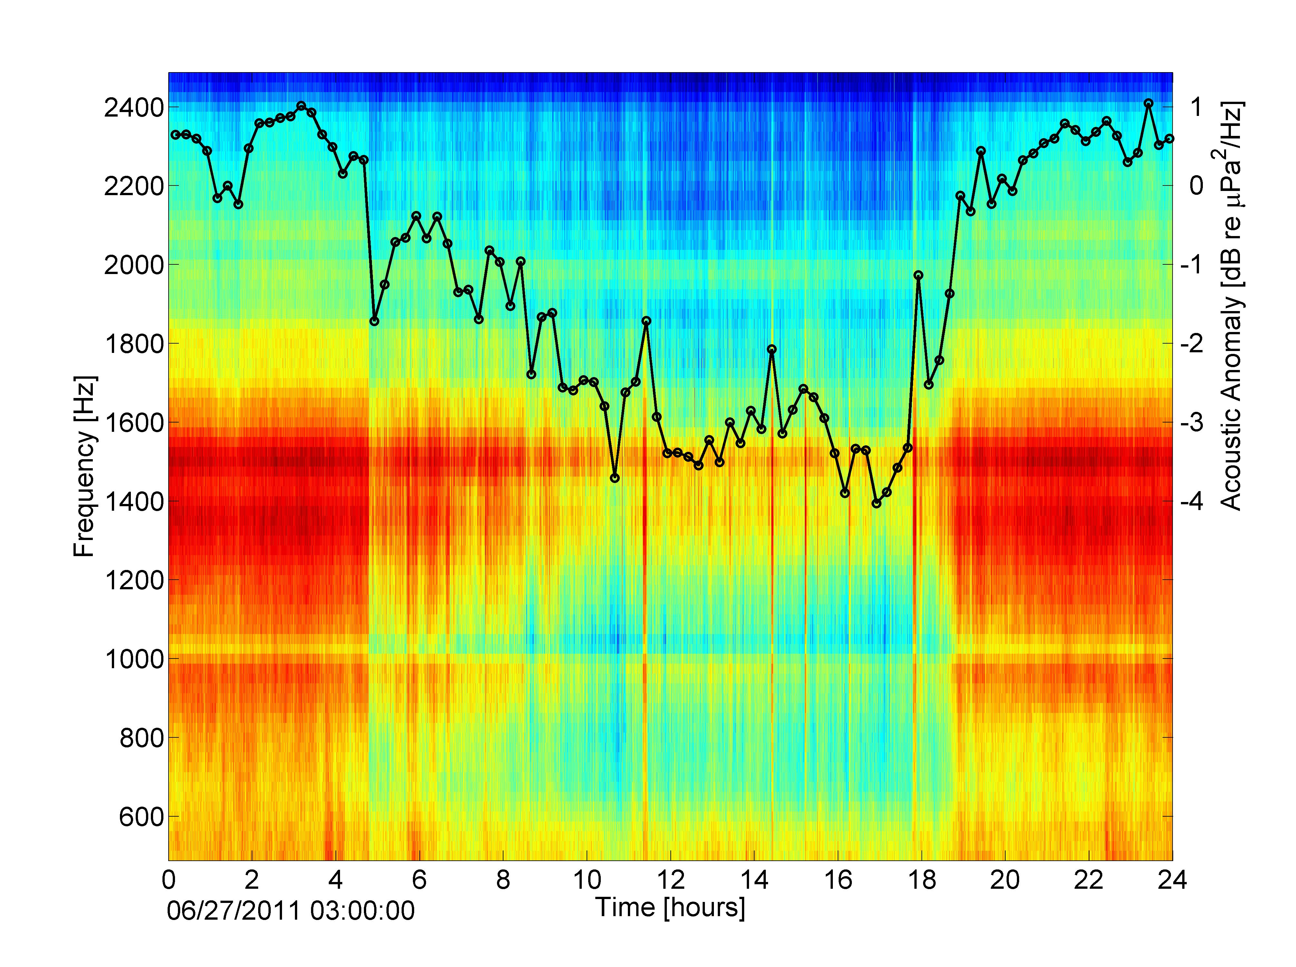

Figure S5. LTSA and 15-minute mean acoustic anomaly for 24 h starting at 03:00:00 on 27 June 2011. Left vertical axis is for the LTSA and the right vertical axis if for the acoustic anomaly.

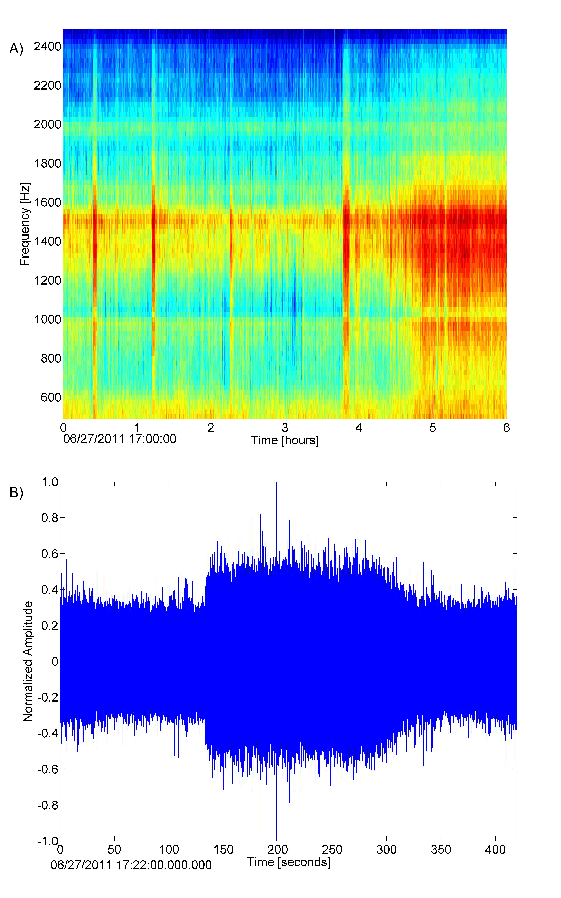

Figure S6. Increased sound level pulses during 27 June 2011 low sound level event. A) 6-hr LTSA, shows interval between pulses is ~1-2 h and B) 7-minute time series, shows the pulse events are a few minutes in duration.

SM.5 Marine Mammal Sounds
HARPs were primarily designed to record sounds from marine mammals, such as whales and dolphins. While the focus of this project was not marine mammal recordings, two distinct types of sounds, likely from porpoises and dolphins, were recorded and noted while analyzing the acoustic data (Figures S7 & S8). Because the deployment site is at a relatively shallow depth, sounds from sperm whales or beaked whales are not expect in the recording as these animals are deep diving species. Baleen whales, such as fin whales (Balaenoptera physalus), may occur near the deployment site, but the presence of persistent airguns and ship sounds in the same frequency band as these animals’ sounds precluded detecting any fin whale calls. Additional effort, perhaps with various filtering schemes, is needed to confirm or rule out the presence of fin whale calls in this data set.

The dolphin encounters observed at this site last only a few minutes likely because the shallow water depth and soft sediment reduces the detection range of high-frequency echolocation clicks as potentially does the acoustic shadowing caused by the crater walls with the location of the HARP near the bottom of the crater. The dolphin echolocation clicks show a spectral peak structure similar to Pacific white-sided (Lagenorhynchus obliquidens) and Risso’s (Grampus griseus) dolphin offshore of southern California (Soldevilla et al., 2008). This structure is presumed to be caused by the shape of the animal’s head and reflections within the head. Dolphins that are known to occur in the North Sea and ones with head morphology similar to those two Pacific species are Atlantic white-sided (Lagenorhynchus acutus) and white-beaked (Lagenorhynchus albirostris) dolphins. The spectral peaks for the North Sea dolphins are around 27.5, 35, and 42 kHz, potentially with another peak near 50 kHz (Figure S7).

The porpoise encounters are also short in duration, but consist of higher frequencies than the dolphins, extending from 75 kHz up to the Nyquist frequency (one-half the sample rate or 100 kHz) of the HARP (Figure S8). It is likely that some or most of the energy from these clicks is from frequencies above the Nyquist frequency and the signals have been aliased around to lower frequencies, as porpoises typically exhibit clicks with frequencies above 100 kHz (e.g., Mohl and Andersen, 1973). We assume these recordings are of harbor porpoise (Phocoena phocoena) since they are the only known species to inhabit the North Sea which produce clicks at these high frequencies. The amplitude time series of the clicks show ramping up and down of click received levels as is often observed with narrow-beam echolocation clicks when the beams are swept by a hydrophone as an animal turns its head or body.

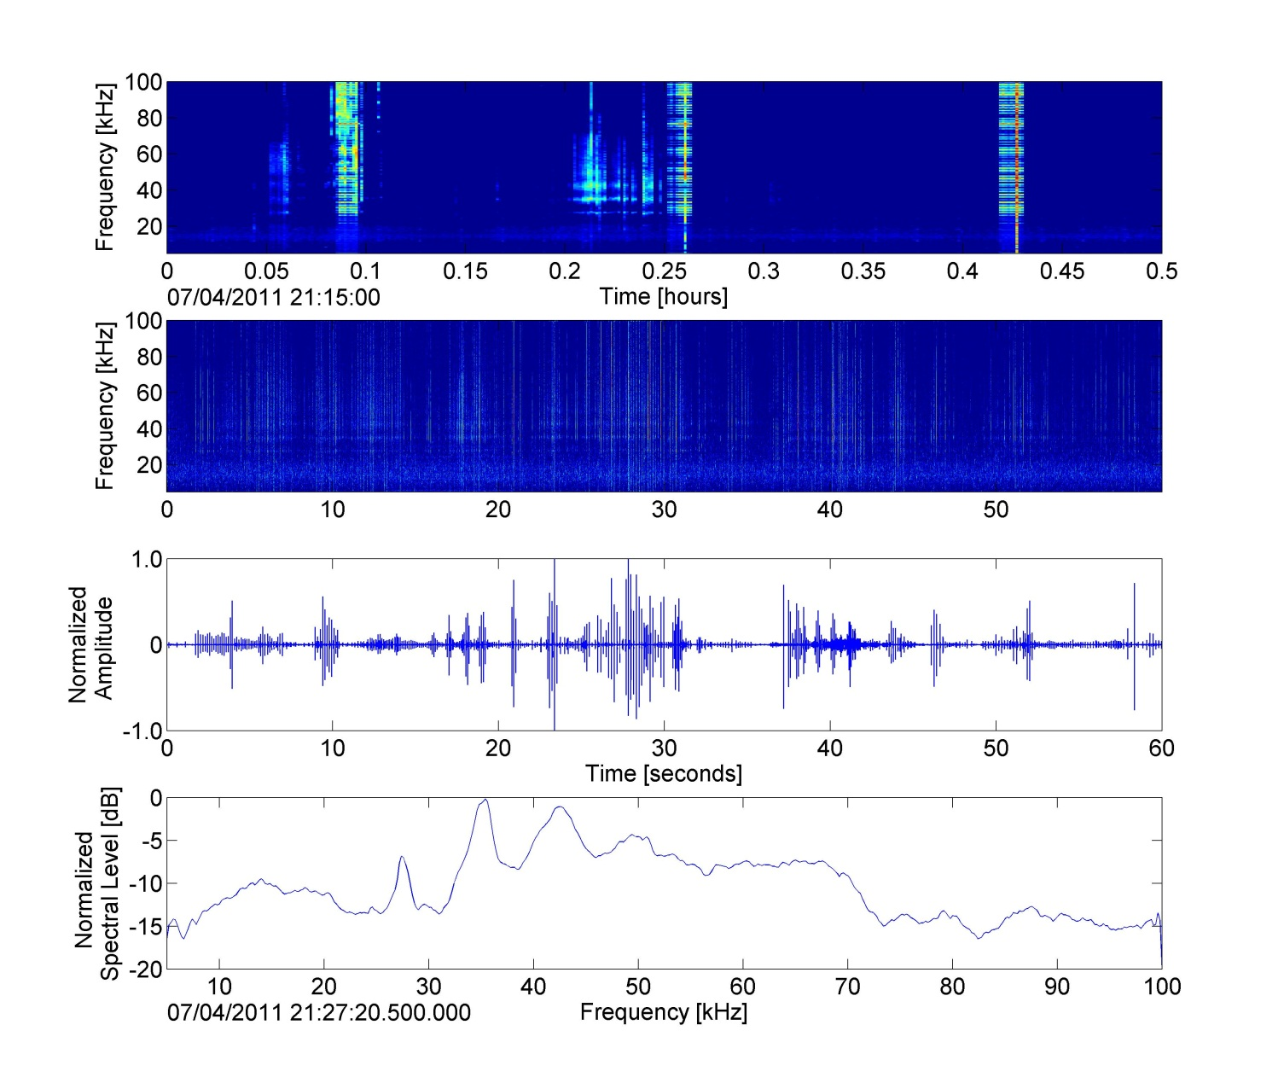
Figure S7. Dolphin echolocation clicks from the North Sea on 4 July 2011. Top panel LTSA shows two short bouts of dolphin clicking starting at 0.05 h and 0.2 h. The broadband pulses every 10 minutes (i.e., before 0.1 h, after 0.25 h and after 0.4 h) are from active sonar aboard the Benthic Lander. Middle two panels are dolphin clicks spectrogram and time series, respectively. The bottom panel is spectrum level over the 60s window. All spectral panels clearly show a spectral peak structure associated with these echolocation clicks, potentially providing species identification.

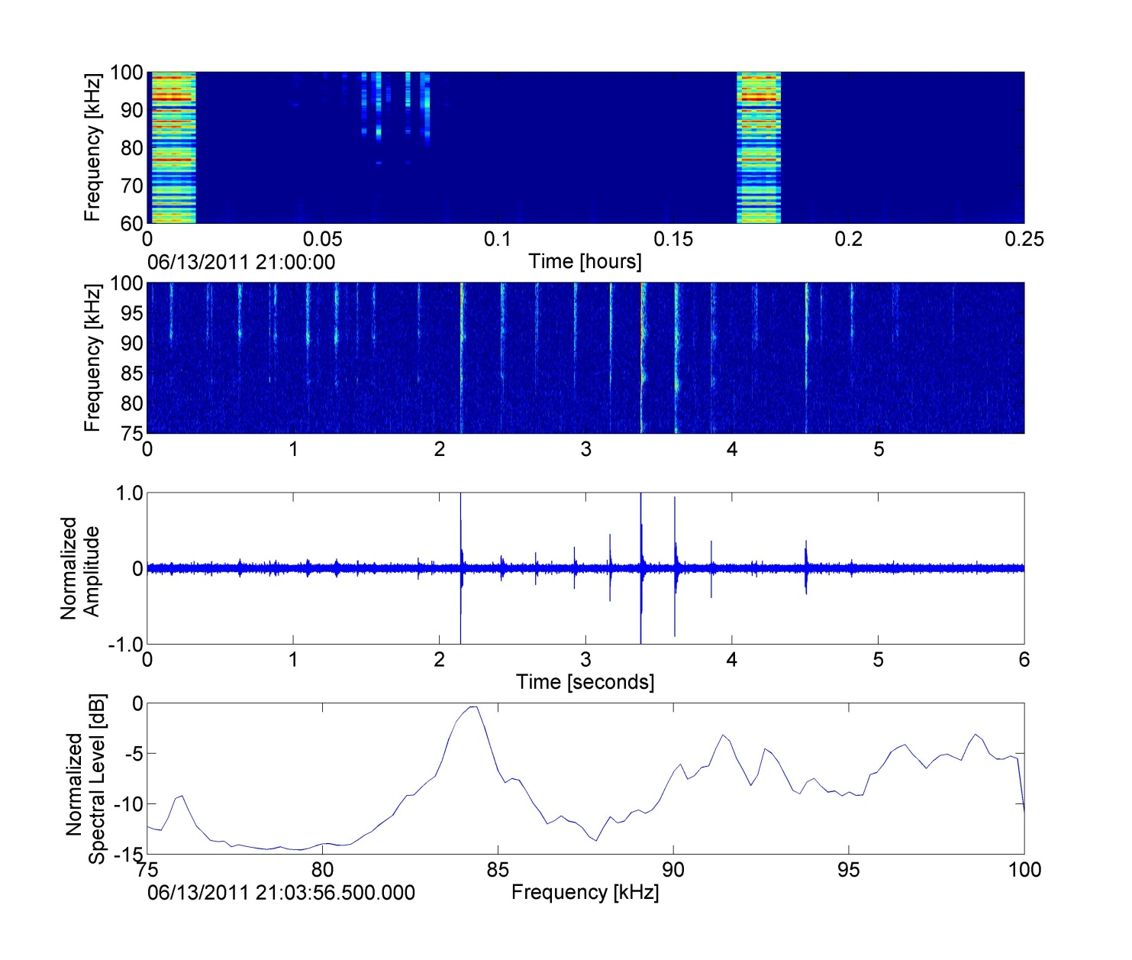
Figure S8. Porpoise echolocation clicks from the North Sea on 13 June 2011. The top panel LTSA shows porpoise clicks above 80 kHz starting around 0.06 h. Broadband pulses every 10 minutes are from sonar pings aboard Benthic Lander. Middle two panels are porpoise clicks spectrogram and time series, respectively. The bottom panel is normalized spectrum levels over the 6 s window showing distinct peaks. These clicks are likely produced at frequency above the 100 kHz Nyquist frequency of the HARP and are aliased around to lower frequencies.

References
Mohl, B., Andersen, S., 1973. Echolocation: high-frequency component in the click of the Harbour Porpoise (Phocoena ph. L.). The Journal of the Acoustical Society of America 54(5), 1368-1372.

Soldevilla, M. S., Henderson, E. E., Campbell, G. S., Wiggins, S. M., Hildebrand, J. A., Roch, M. A., 2008. Classification of Risso's and Pacific white-sided dolphins using spectral properties of echolocation clicks. Journal of the Acoustical Society of America 124(1), 609-624.

Wiggins, S. M., McDonald, M. A., Munger, L. M., Moore, S. E., Hildebrand, J. A., 2004. Waveguide propagation allows range estimates for North Pacific right whales in the Bering Sea. Canadian Acoustics 32(2), 146-154.

