GEOMAR
Helmholtz-Zentrum für Date: 14.07.2014
Ozeanforschung Kiel

Cruise Report

Compiled by: Dipl. Biol. Burkhard von Dewitz

R.V. ALKOR Cruise No.: AL 457

Dates of Cruise: 16.05. – 30.05.2014

Areas of Research: Physical, chemical, biological and fishery oceanography

Port Calls: Gdynia, Poland, 22.05. – 24.05.2014

Institute: GEOMAR, FB3 (Marine Ecology, Evolutionary Ecology of Marine Fishes)

Chief Scientist: Dipl. Biol. Burkhard von Dewitz

Number of Scientists: 12

Projects: BONUS BIO-C3

Cruise Report

This cruise report consists of 14 pages including the cover page:

1. Scientific crew…………………………………………………………………. 2
2. Research program…………………………………………………………........ 3
3. Narrative of cruise with technical details……………………………………… 5
Table1. Overview of gear deployment…………………………………………… 7
4. Detailed cruise timeline………………………………………………………... 8
5. Scientific report and first results……………………………………………….. 9
6. Scientific equipment …………………………..…………………………..….. 12
7. Acknowledgements……………………………………………………………. 12
8. Appendix E1: Station list…………………………………………………….... 12

1. Scientific crew

Name | Function | Institute | Leg
Burkhard von Dewitz | Chief scientist | GEOMAR Kiel | Entire cruise
Svend Mees | Scientist | GEOMAR Kiel | Entire cruise
Florian Webers | Master student | GEOMAR Kiel | Entire cruise
Sophia Wagner | Master student | MPI Plön | Entire cruise
Christian Pawlitzki | Bachelor student | CAU Biology Kiel | Entire cruise
Carola Wagner | Bachelor student | GEOMAR Kiel | Entire cruise
Julia Hoffmann | Scientist | Department of Economics, CAU Kiel | Entire cruise
Jonas Müller | Bachelor student | GEOMAR Kiel | Entire cruise
Nils Kreuter | Bachelor student | GEOMAR Kiel | Entire cruise
Philipp Weßel | Bachelor student | Department of Economics, CAU Kiel | Entire cruise
Alondra Radriguez Buelna | Bachelor student | DTU Aqua, Kopenhagen | Entire cruise
Maria Krüger-Johnson | Scientist | DTU Aqua, Kopenhagen | From Gdynia to Kiel
Julie Nielsen | Bachelor student | DTU Aqua, Kopenhagen | From Kiel to Gdynia
Total | 12

Chief scientist:

Dipl. Biol. Burkhard von Dewitz, GEOMAR Helmholtz Centre for Ocean Research
Düsternbrooker Weg 20, 24105 Kiel
Phone: 0431 600 4539
Fax: 0431 600 4553
E-Mail: bdewitz@geomar.de
2. Research program

This multidisciplinary cruise extended a long-term data series on (eco-)system composition and functioning of the Baltic Sea, with a focus on the deeper basins, collected since 1986 by the GEOMAR Helmholtz Centre for Ocean Research and its predecessors IFM-GEOMAR Kiel and IFM Kiel. The key characteristic of this series is the integration of oceanographic and biological information to enhance understanding of environmental and (fish) population fluctuations, and evolutionary processes in this system, in the context of climate change and anthropogenic stressors. The resulting datasets and samples are essential for a number of ongoing projects, including the large-scale international project BONUS BIO-C3 coordinated by GEOMAR. The spatial focus lies on the Bornholm Basin (the most important spawning area of Baltic cod), but also includes the Western Baltic Sea, Arkona and Gotland Basin and Gdansk Deep (Figure 1), thus covering ICES subdivisions 22, 24, 25, 26 and 28 (Figure 2).

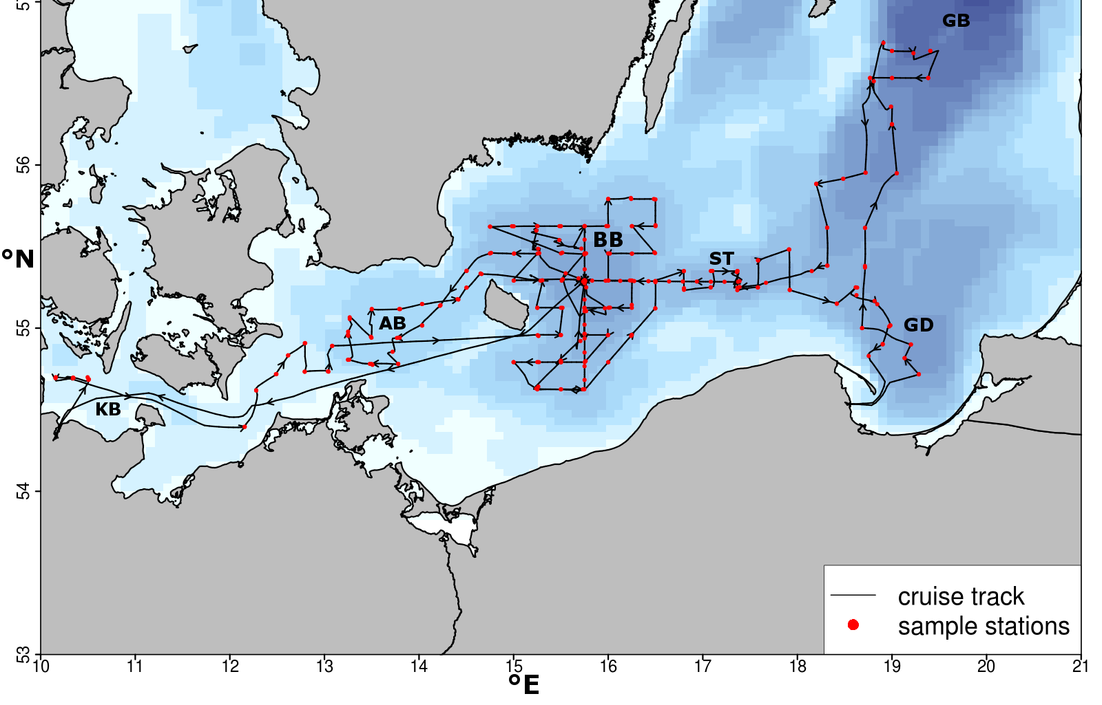
Figure 1 Cruise track of AL 457. KB = Kiel Bight, AB= Arkona Basin, BB = Bornholm Basin, ST = Stolpe Trench, GD = Gdansk Deep, GB = Gotland Basin

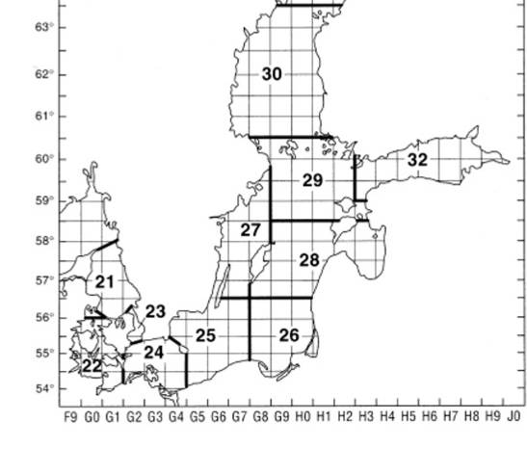
Figure 2 ICES subdivisions in the Baltic Sea area. Source: ICES
Specific investigations included a detailed hydrographic survey (oxygen, salinity, temperature, light intensity) (Figure 3), plankton surveys (zoo- and ichthyplankton, with the goal to determine the composition, abundance, vertical and horizontal distribution, and nutritional status of species, and to address questions regarding plankton phenology) (Figure 4a), and pelagic fishery hauls (Figure 4b). The latter served to determine size distributions, maturity status, and length – weight relationships of the three dominant fish species in the pelagic system of the Baltic, cod (Gadus morhua), herring (Clupea harengus) and sprat (Sprattus sprattus), as well as the benthic flatfish flounder (Plathichthys flesus). Secondly, various different samples were obtained for more detailed analyses, including gonad samples of cod, stomachs of cod, herring and sprat for dietary analyses, otoliths of cod for aging, and tissue samples of cod, flounder, whiting, plaice and others for genetic analyses. In addition, along the cruise track, hydroacoustic (echosounder) data were collected continuously for later analysis of fish abundance and distribution.
While these analyses and samples mainly stood in the context of the continuation of the long-term data series, cod and plankton samples were also taken for new research lines, e.g., by DTU Aqua in Silkeborg, Denmark, and the IOW in Warnemünde, Germany, in the context of the project BIO-C3. In addition, cruise AL 457 included a new work line on board. In cooperation with DTU Aqua tissue samples of cod liver and gonads were sampled in histo formalin for later histology and lipid content analysis to determine maturity and fecundity in comparison to lipid composition and overall condition. Additionally the cruise was utilized to perform further test deployments of the improved illuminated high resolution towed camera system already tested on last year cruises. At the moment under development by Henk-Jan Hoving (GEOMAR) it will be utilized for the Future Ocean research project ‚In situ observations of Cape Verdean pelagic fauna in a changing ocean’.

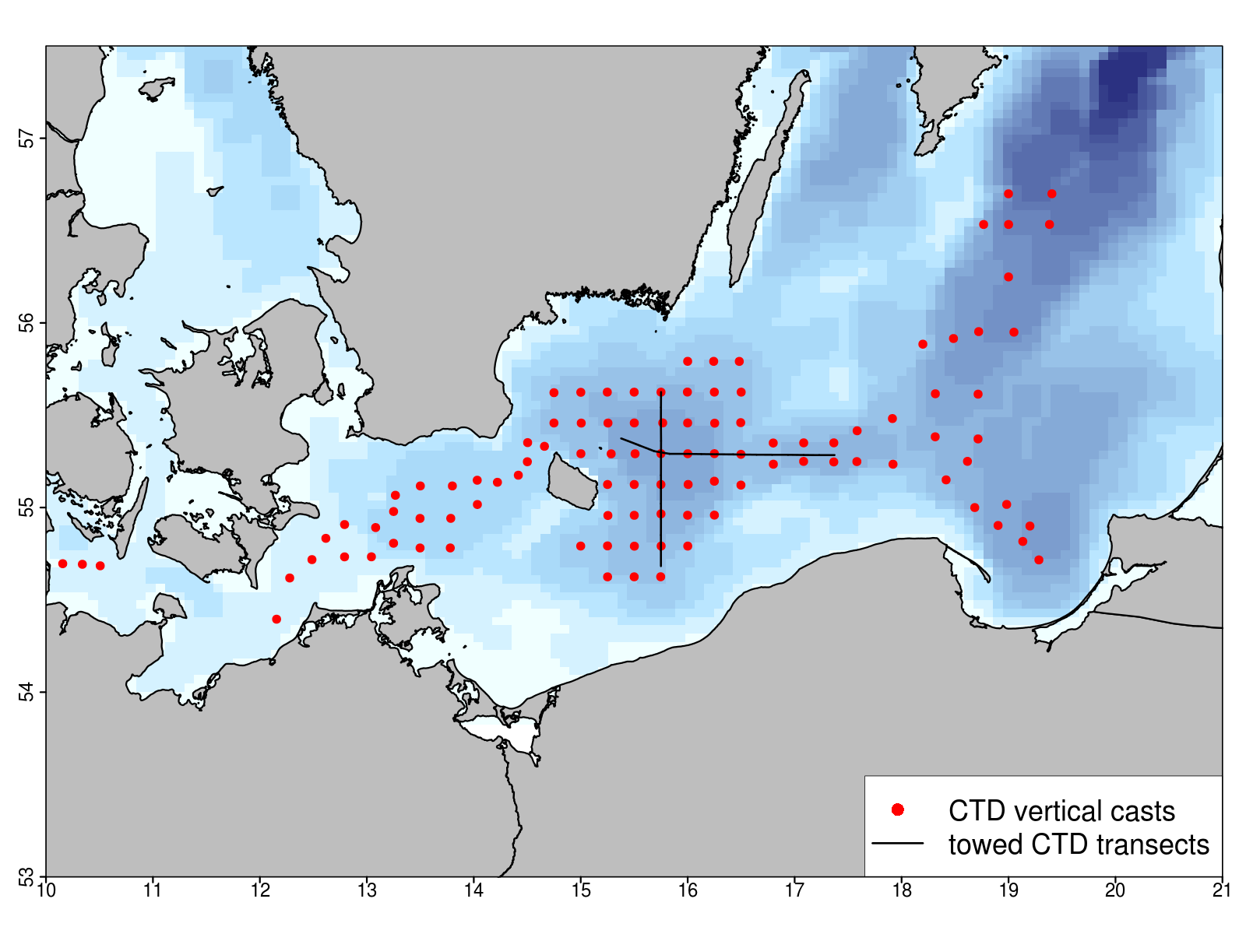
Figure 3 Stations where vertical CTD profiles were obtained on AL457.
3. Narrative of cruise with technical details

Cruise AL 457 successfully accomplished the ambitious work program that had been planned, exept a few plankton stations and one day of fishing in the Arkona Basin. Wind conditions prohibited working in the area during the second and beginning of the third day. Stations in the Bornholm Basin were proponed to avoid the conditions and to limit time loss.
On May 16 2015 7:30 (all times board time) remaining scientific gear was loaded on RV ALKOR and first preparations of gear and laboratories started. As all preparations showed sufficient progress to ensure operational capability on arrival at the first station, RV ALKOR departed from GEOMAR pier at 9:00 heading to the first research area in the Kiel Bight.
Over the duration of the cruise, hydroacoustic data obtained with four different echosounder frequencies (38, 70, 120 and 200 kHz) were continuously recorded. In addition, work for the cod maturity fecundity and lipid composition project (see 4.i) took place in parallel to the standard program throughout the duration of the cruise whenever suitable samples were available.
In the Kiel Bight (SD22) the first working area of the cruise 3 Stations were covered during the first day (May 16) with Bongo, CTD and towed Multinet MIDI casts. Additionally one fishery haul with a pelagic trawl were performed in the Kiel Bight. All 3 Stations were placed in the deeper ditch in the central Bight running from Maasholm eastward to the Fehmarn Belt. This area is frequently used as fishing ground from surrounding ports and is therefore suitable for sampling of fishery related projects.
The next Day May 17 2015 0:00 station work continued in the Arkona Basin (SD 24). 8 Stations of the previously set Station grid in this Area were covered with CTD and Bongo net hauls (Figure 3,4a) starting in the east with station H31. Wind speeds increased steadily during the night and reached 6 to 7 beaufort in the morning as fishing in the Arkona Basin was planned. In a joint decision between chief scientist and captain fishing was canceled for the day and an alternative plan was prepared. Station work was continued on the leeward side of the Island of Bornholm. From 15:00 to May 18 2:10 during a period of intense wind speeds 9 stations of the Bornholm station grid were covered with CTD and Bongo hauls and continued with 5 stations in the north west corner of the Arkona Basin (Figure 3,4). On May 18 8:45 fishing was continued with 4 hauls in the Arkona Basin area with some additional CTD and Bongo stations in between hauls (Figure 3,4). The fishery stations were chosen to obtain a suitable sample size of Cod individuals in this area and therefore were oriented on the current commercial fishery activities in the area and the previously recorded echosounder information. Station work in the Arkona Basin was continued during the night working our way towards the Bornholm Basin area (10 stations covered). In total due to the weather conditions only 6 plankton stations could not be covered and 4 planned fishery hauls were canceled.
Following the completed station work in the Arkona Basin the main working Area in the Bornholm Basin (SD 25) and also half of the Stolpe Trench was covered in 51 Stations with CTD and Bongo net hauls (Figure 3,4a) from May 19 2015 7:25 until May 21 2015 22:58. During this Period 3 stations in the Central Part of the Basin were also used for pelagic fish trawls and one for a test deployment of the towed pelagic camera system. In Addition the central deep station BB23 in Bornholm Basin was intensively sampled, including CTD casts, zoo- and phytoplankton sampling with Bongo, Apstein and WP-2 nets, oxygen measurements of water samples obtained with the rosette water sampler using the Winkler method, and micro-/nanoplankton samples taken from the same water samples.
The cruise then continued with plankton stations covered with CTD and IKS-80 casts in the eastern part of the Stolpe Trench and the north eastern part of the Gdansk Deep (both SD26) until May 22 6:18.Plankton stations were followed by a day of mixed plankton sampling and fishing efforts in the Gdansk Deep. 4 fishery hauls, 3 CTD and 3 IKS-80 hauls were performed before the first leg was completed with a scheduled visit to Gdynia, Poland, (May 22 17:00 – May 24 15:00) to debark one scientist and embark the replacement on May 24 2015.

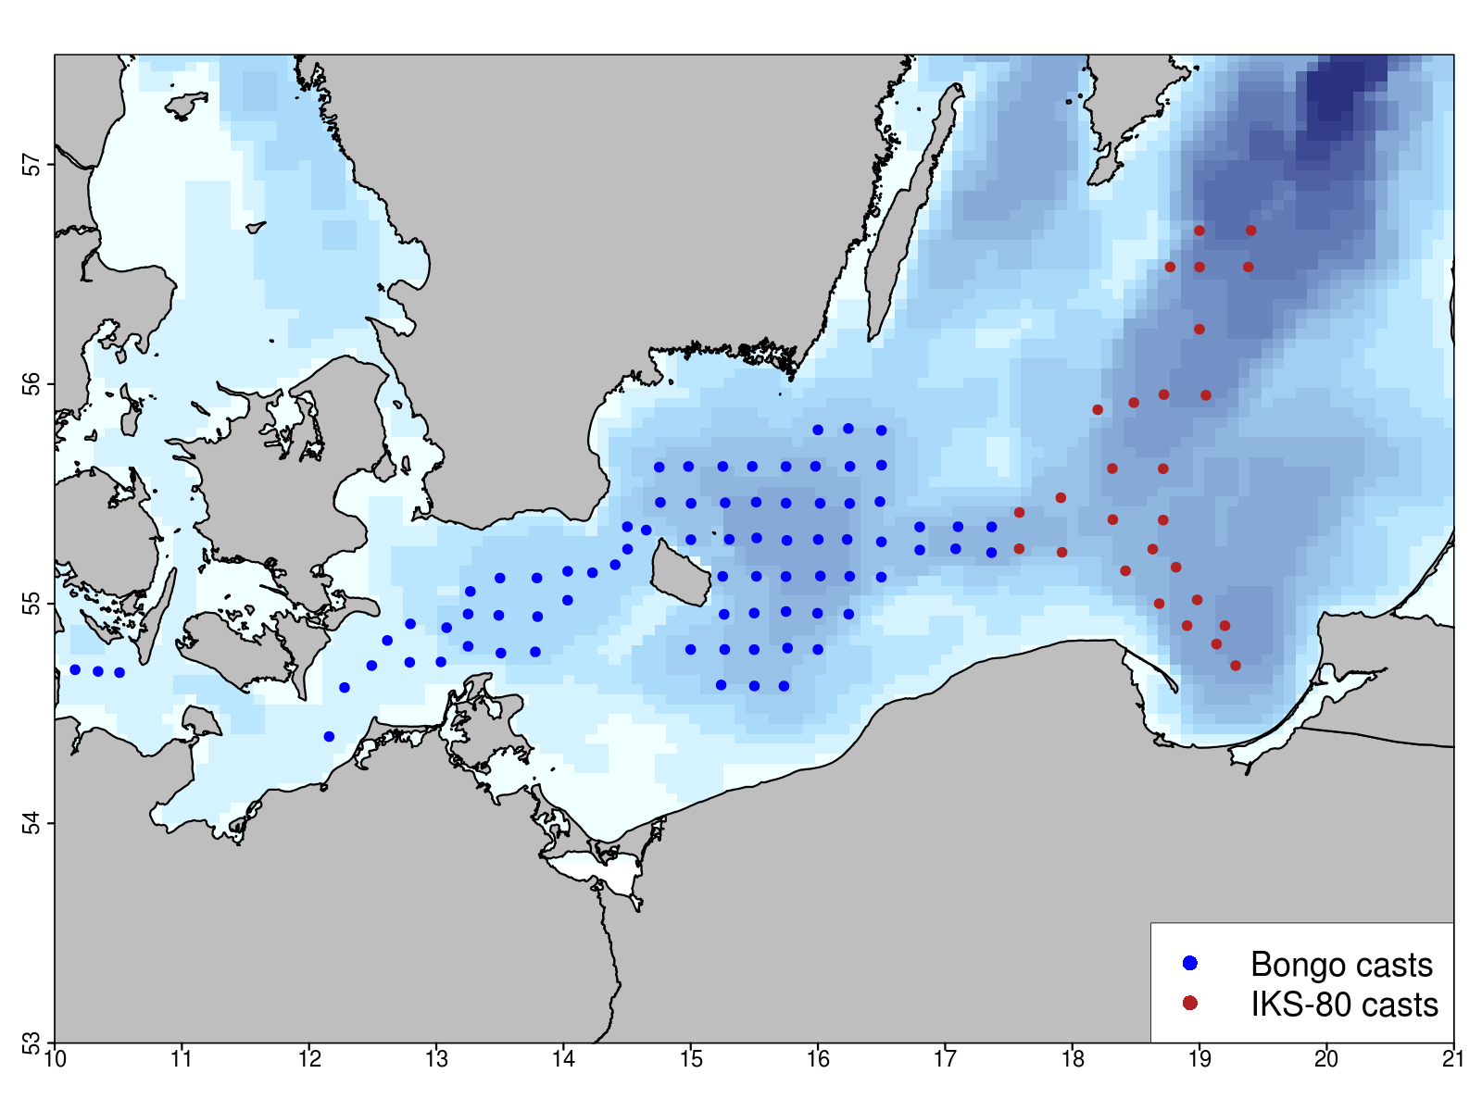
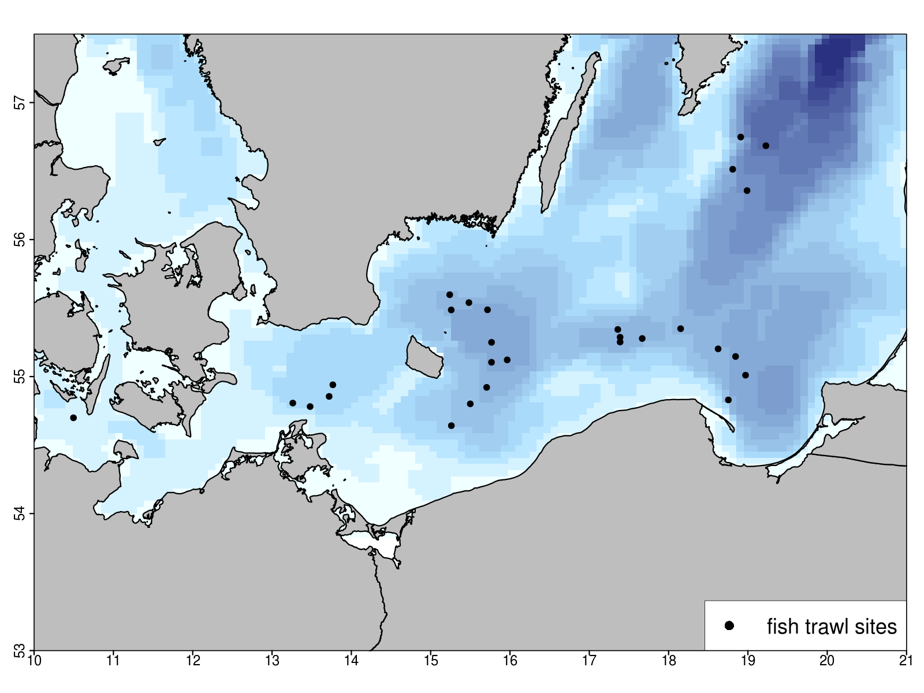
Figure 4 Stations covered during cruise AL 457. a.) Plankton sampling with Bongo (blue circles) and IKS-80 (red circles) net casts. b.) Fishery stations covered with pelagic trawls.

On the second leg of the cruise station work was resumed first in the Gdansk Deep (May 24 17:35) and continued towards north to the southern Gotland Basin performing CTD and IKS-80 net casts on 8 Stations. In the southern Gotland Basin (SD 28) 4 fishery hauls were performed before station work continued towards the south west with destination Stolpe Trench. On arrival at the Stolpe Trench May 26. 08:54 5 fishery hauls were performed in the eastern Part of the trench (Figure 4).
During the night from May 26 to May 27 the first towed CTD transect was performed reaching from the eastern part of the Stolp Trench to the north western part of the Bornholm Basin (Figure 3, horizontal black line). On May 27 between 8:45 and 16:00 4 stations in the northern part of the Bornholm Basin were used for fishery sampling (Figure 4) before the second towed transect was covered during the following night oriented from north to south starting at station BB06 and ending at station BB45 (Figure 3 vertical black line). Fishing efforts were completed after that with another 3 fishing hauls in the south eastern part of the basin from 8:08 till 14:00 on May 28 2015.
To add a second time point to the first intensive sampling of the central Bornholm Basin on May 19, same sampling efforts including CTD casts, zoo- and phytoplankton sampling with Apstein and WP-2 nets were repeated from 16:22 to 19:11 on May 28 at the same station BB23 in the center of the Basin.
Last sampling efforts from May 29 2015 00:05 to 21:25 were dedicated to the intensive vertically and temporally resolved sampling of plankton communities by four towed Multinet MAXI and four vertical Multinet MIDI hauls over a 22 hour period, covering the water depth in 5 m and 10 m depth layers, respectively, at the previous mentioned station BB23.
Following the completion of the research program on May 29 at 22:00, RV ALKOR steamed for Kiel harbor and reached port on May 30 at 17:00. After unloading, the cruise ended at 19:00. Compared to the initial program, the only changes lay in the mentioned canceling of one fishing day and 6 plankton stations in the Arkona Basin. Catches of the 4 performed fishery hauls in the area however provided comparable sample sizes to previous years and the canceled plankton station are located at the shallow outer most parts of the Basin. In regard to the scientific targets of this cruise these changes are therefore minor.
Additional detail on the cruise timeline and track (Figure 1), the station list (Appendix E1) and an overview of gear deployments (Table 1) are provided below.

Table 1 Overview of gear deployment. Mesh sizes are given in brackets.
Gear | Deployments (n)
ADM-CTD vertical | 104
ADM-CTD towed | 2
Hydroacoustic transect  (continuous along cruise track) | 1
Watersampler + CTD | 1
Bongo, Babybongo (150μ, 335μ, 500μ) | 78
IKS-80 (500μ) | 27
WP-2 (100μ) | 7
Apstein (55μ) | 7
Multinet MAXI horizontal (335μ) | 8
Multinet MIDI horizontal (335μ) | 5
Multinet MIDI vertical (50μ) | 8
pelagic trawl (Jungfischtrawl) | 28

4. Detailed cruise timeline (all times board time):

Saturday 16/05/2015 Loading equipment, Leaving GEOMAR Westshore pier, steaming to Kiel Bight. 1140 start of station work in Kiel Bight. CTD, Bongo, MIDI multinet towed, pelagic fishery.

Sunday 17/05/2015 Station work in the Arkona Basin. CTD, Bongo. Fishing canceled. Continued station work Bornholm Basin and Arkona Basin, CTD, Bongo.

Monday 18/05/2015 Station work Arkona Basin CTD, Bongo, pelagic fishery.

Tuesday 19/05/2015 1030, first detailed plankton sampling with additional Apstein, WP-2, and rosette water sampler hauls. Upon completion, continuation of station work CTD, Bongo including pelagic fisheries in Bornholm Basin until Thursday 21/05/2015 1500.

Thursday 21/05/2015 Station work Stolpe Trench and Gdansk Deep. CTD IKS-80, pelagic fisheries until Friday 22/05/2015 1349. Steaming to Gdynia harbor.

Friday 22/05/2015 1700 arriving at port of Gdynia, Poland

Sunday 24/05/2015 Debarking of one scientist, embarking of one scientist

Sunday 24/05/2015 1500 departure from Gdynia heading to first station on Gdansk Deep.

Sunday 24/05/2015 1735 Start of station work CTD, IKS-80 area Gdansk Deep until Monday 25/05/2015 0043. Heading to Gotland Basin.

Monday 25/05/2015 0204 Start of station work in Gotland Basin. CTD, IKS-80, pelagic fisheries.

Tuesday 26/05/2015 0627 End of station work Gotland Basin heading to Stolpe Trench.

Tuesday 26/05/2015 0749 Station work CTD, IKS-80, pelagic fisheries in the area Stolpe Trench. Overnight towed CTD transect to Bornholm Basin

Wednesday 27/05/2015 0845 pelagic fisheries in the northern Bornholm Basin. Overnight towed CTD transect from north to south.

Thursday 28/05/2015 0808 pelagic fisheries in the southern Bornholm Basin.

Thursday 28/05/2015 1622 - 1911 station BB23, intensive sampling: CTD, water sampler, Apstein, WP-2.

Friday 29/05/2015 0005 Start of intensive 24h sampling with towed multinet MAXI, vertical multinet MIDI. 2125 steaming for Kiel harbor.

Saturday 30/05/2015 1700 Arrival Kiel East shore pier, unloading; 17:45 relocation to GEOMAR west shore berth. 19:00 unloading completed; end of cruise.

5. Scientific report and first results

Ichthyo– and zooplankton sampling

Bongo- and Babybongo hauls covered Kiel Bight (3 hauls), Arkona Basin (24 hauls), and Bornholm Basin including the western part of the Stolpe Trench (51 hauls) (Figure 4a). Larvae of cod (Gadus morhua) (n = 9 in total), sprat (Sprattus sprattus) (n = ~585), flounder (Plathichthys flesus) (n = 153) and other species (n = 40) were picked from the 500 μm bongo-samples and conserved at -80 °C for subsequent RNA/DNA analysis. All Bongo samples were also checked for the presence of gelatinous zooplankton. The jellyfish species Aurelia aurita, Cyanea capillata and the invasive combjelly Mnemiopsis leidyi were present regularly, whereas no larvae of Mnemiopsis leidyi were found. In light of the last year absents of Mnemiopsis the quite high number of individuals found in the samples (n = 69) hinds on a second invasion of the combjelly possibly connected with the major Baltic inflow event in January 2015. Following these initial on board steps, all Bongo samples were conserved in formol, and will be used for the determination of species composition and abundance of (ichthyo-)plankton.
Stations in the eastern part of Stolpe trench and the Gdansk Deep and Southern Gotland Basin were covered with IKS-80 instead of Bongo hauls (Figure 4a) to ensure compatibility of data with a long-term IKS-80 sampling series maintained by the Latvian Fish Resources Agency (LATFRA; Andrei Makarcuks).
Repeated Multinet MAXI (335μ, towed, sampling of the water column in 5 m layers) and MIDI (50μ, vertical, sampling of the water column in 10 m layers) (HYDROBIOS, Kiel) casts were done over a 24 hour period on May 29 on the central deep Bornholm Basin station BB23 to reveal the vertical distribution of ichthy- and zooplankton. In addition, WP-2 (100 μm) and Apstein (55 μm) nets and the rosette water sampler were deployed to obtain additional samples, including nano/micro phytoplankton samples in the context of plankton phenology work within the BONUS BIO-C3 project (Dr. Jörg Dutz, IOW).

Fishery

Pelagic fishery was conducted in the Kiel Bight (1 hauls), Arkona Basin (4 hauls), Bornholm Basin (10 hauls), Stolpe Trench (4 hauls), Gotland Basin (4 hauls) and Gdansk Deep (4 hauls) (Figure 4b). In parallel to the fishery hauls, hydroacoustic measurements of fish distribution patterns were recorded continuously. Catches were dominated by sprat (Sprattus sprattus) followed by cod (Gadus morhua) (n = 1892), herring (Clupea hargenus) (n=1321), whiting (Merlangius merlangus) (n = 79) and flatfishes. The latter were comprised mainly of flounder (Platichthys flesus) (n = 26), but also, plaice (Pleuronectes platessa) (n = 7), american plaice (Hippoglossoides platessoides) (n = 2) and in western parts common dab (Limanda limanda) (n = 183). Eight fourbeard rocklings (Enchelyopus cimbrius), 48 three-spined sticklebacks (Gasterosteus aculeatus), nine atlantic horse mackerel (Trachurus trachurus), one pouting (Trisopterus luscus) and one european smelt (Osmerus eperlanus) completed the catches. Regarding cod, it was noticeable that higher catches were usually accomplished when the net was trawled on to the bottom, indicating a near benthic distribution and oxygen levels sufficiently high for cod in the bottom layers.
For each haul and the entire catch, catch weight and length frequencies of all species (illustrated in Figure 5 for cod) were taken. Stomach samples were taken from sprat (10 per 1 cm length class) and herring (10 per 2 cm length class). For cod, single fish data (length, weight, sex and maturity stage) and samples (otoliths, fin clips for genetic analysis, stomachs and gonads) were obtained for 1200 individuals (see Figure 6 for illustration), whereas only length and weight were measured for the remaining individuals.

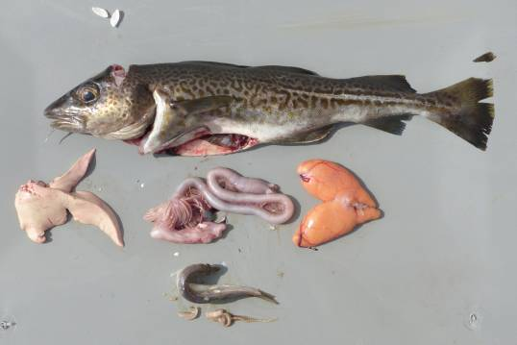
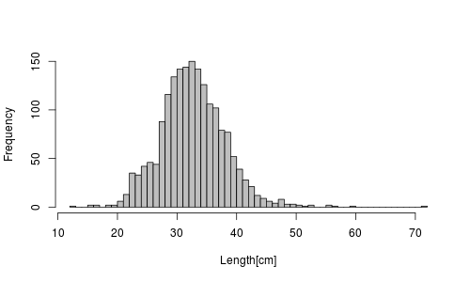

Figure 5 Relative length frequency distribution of individual sampled cod during AL 457 (n = 1892).
Figure 6 Samples (otoliths, fin clips, stomach contents, gonads) and measures (total length, weight, gutted weight, liver and gonad weight) taken from 1200 out of 1892 cod individual during the cruise (illustrated here for a 38 cm female, maturity stage IV, with full stomach, from Bornholm Basin). Photo: Nickel

Hydrography

CTD profiles from 104 stations were obtained with the ADM-CTD and the HYDROBIOS water sampler with attached CTD (Figure 3). In the Bornholm Basin additional two transects were covered with a towed ADM-CTD for a higher resolution cross section of the hydrographic situation in the basin after the Major Baltic Inflow Event in January 2015. Conditions varied depending on the basin and location of the Baltic sampled, and will be analyzed in depth in context of the long-term data series on hydrographic conditions. In general, High salinities and high oxygen content was measured in all areas west of the Gdansk Deep .Stations in the Bornholm Basin were characterized by a permanent halocline starting in ca. 45 m depth, with sharply increasing salinity and decreasing oxygen levels below 50 to 60 m. However, oxygen conditions below the halocline varied around 5 ml/l and rarely decreased below 4.5 ml/l, which shows the major changes induced by the Major Baltic Inflow Event over the winter/early spring 2014/2015. The relatively good oxygen situation also explained the distribution of cod adults near the bottom, indicated by increased catches with increasing proximity of the trawl to the bottom during AL 457.

Figure 7 CTD profile of station BB23 in the central Bornholm Basin in April 2015. Temperature red line, salinity blue line and oxygen green line.
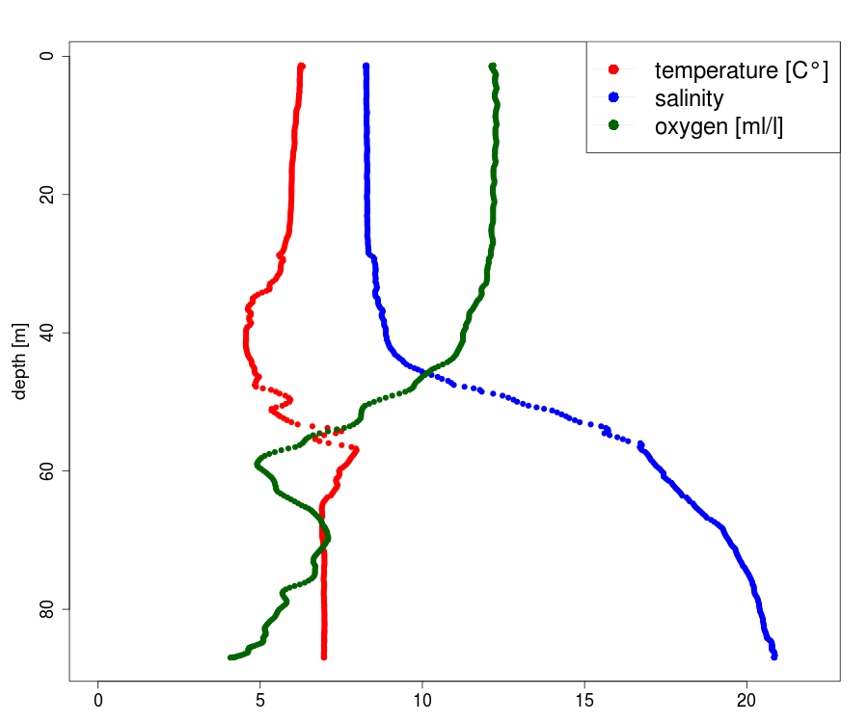
Hydrographic conditions east of the transition zone between Bornholm Basin and Gdansk Deep showed less to no impact of the Major Baltic Inflow Event. Indicating that water exchange of fresh oxygen rich water further to the east was either not yet completed or the water mass introduced did not have a sufficient magnitude to spill over to the Gdansk Deep and Gotland Basin.

Special projects

The additional line of work carried out in parallel to the above cruise program as “special project” successfully completed the planned sampling. Short summary of this project and the work realized on board is given below.

(i) Impact of changes in the Baltic Sea food web structure and potential limitation of certain EFA on Baltic cod reproduction (Jonna Tomkiewicz, Maria Krüger-Johnsen and Fritz Köster, DTU Aqua)

Lipid storage and fatty acid dynamics are particularly important aspects of fish physiology and population dynamics because they have a large influence on growth, reproduction and survival. Lipids are obtained directly from the diet or synthesised de novo by the fish, however some fatty acids considered essential (EFA) must be obtained through the diet. The liver plays a critical role in various aspects of lipid metabolism such as the uptake, oxidation and conversion of fatty acids and the supply of long chain polyunsaturated fatty acids (PUFA) to other tissues. Fish store reserve lipid in the liver or muscle and during maturation dietary nutrients. These lipid reserves are mobilized and used in ovaries for egg development and in testes for sperm development with differing PUFA requirements among sexes.
Changes in the food web structure of the central Baltic Sea and the potential limitation of certain EFA in the ecosystem may significantly impact cod growth, nutritional condition and reproduction. Analyses of lipid content and FA profiles of body, liver and gonads from fish under natural or controlled feeding conditions can yield valuable information, which may elucidate their nutritional status and sex specific FA requirements during reproduction. In total, 1200 cod were maturity staged and measured. Form these fish, 289 female and male cod of different length and weight were sampled for histological analysis of reproductive state and fatty acid analyses of liver and gonads. Gonad samples were stored in histoformalin, while liver and gonads were frozen at -80ºC for later lipid and fatty acid analyses in the lab. This sampling is part of one year sampling program under the EU BONUS BIO-C3 project.

6. Scientific equipment: instruments and gear

Hydrography:
- ADM-CTD with additional O2 sensor
- Hydrobios Water Sampler with CTD and O2 sensor

Zooplankton:
- Baby Bongo-Net (150 μm)
- Bongo-Net (335 μm)
- Bongo Net (500 μm)
- WP2 (100 μm)
- Apstein net (55 μm)
- towed pelagic camera device

Ichthyoplankton:
- Bongo-Net (335 μm and 500 μm)
- Hydrobios Multinet MAXI (335 μm horizontal tows)
- Hydrobios Multinet MIDI (300 μm horizontal tows and 50 μm vertical hauls)
- IKS-80 (500 μm)

Fish:
- Jungfisch Trawl (pelagic trawls) (0.5 cm)

Hydroacoustic:
- 38, 70, 120 and 200 kHz-echosounder EK60

7. Acknowledgements

Thanks to Captain Lass and the entire crew of RV ALKOR for their outstanding support during the cruise, and to Rudi Lüthje and Svend Mees for their support in preparing the cruise!

8. Appendix E1: Station list of AL 457

Supplied with the report in electronic form as Excel table, “Appendix E1 – AL457_station_list.xlsx

