**Appendix 1**

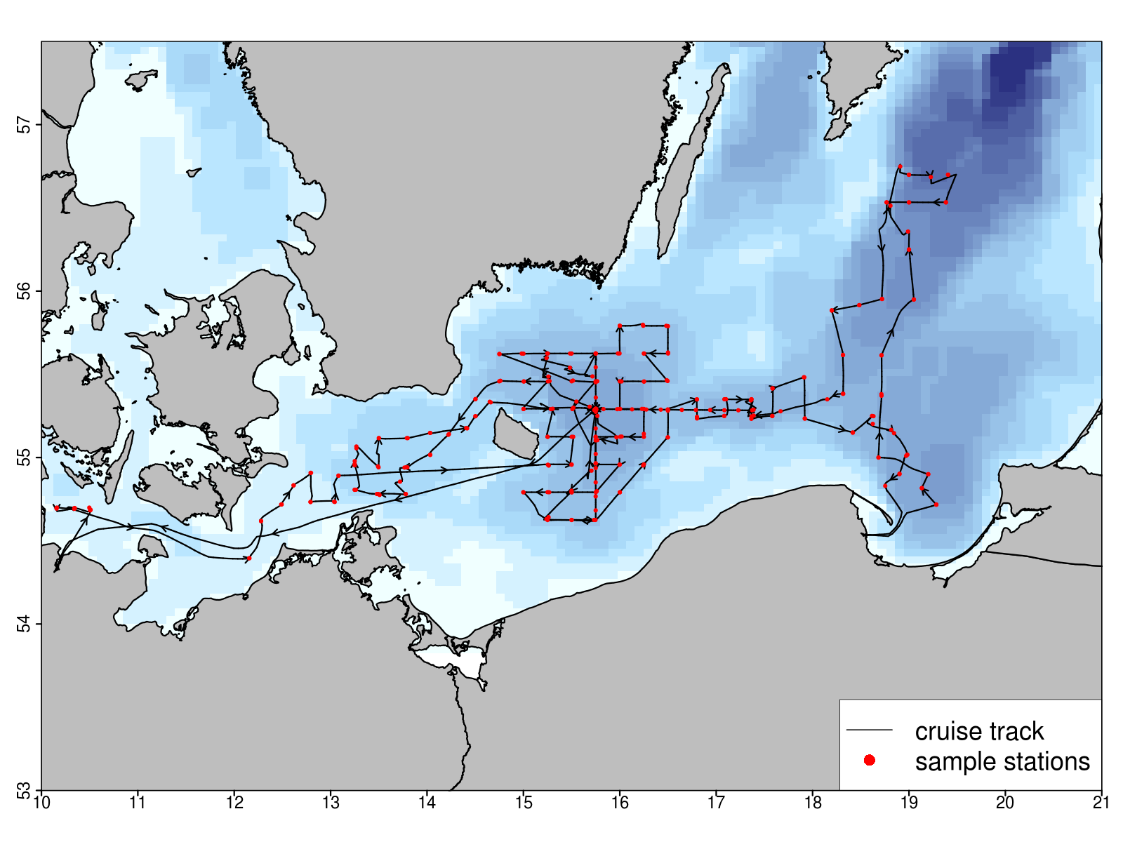Cruise track and all stations of AL457, May 16-31 2015 (for detailed info, see https://portal.geomar.de/metadata/leg/show/329874 ).