

GEOPHYSICAL RESEARCH LETTERS

Supporting Information for

**Temporal nutrient dynamics in the Mediterranean Sea**

**in response to anthropogenic inputs**

Ji-Young Moon1,

Kitack Lee1*,

Toste Tanhua2,

Nurit Kress3,

Il-Nam Kim4

1School of Environmental Sciences and Engineering, POSTECH, Pohang, 790−784, Korea.

2Marine Biogeochemie, GEOMAR Helmholtz Centre for Ocean Research, Kiel, Germany

3Israel Oceanographic & Limnological Res, National Institute of Oceanography, Haifa, Israel

4Department of Marine Science, Incheon National University, Incheon. 22012, Korea.

*Correspondence to: Kitack Lee ([ktl@postech.ac.kr](mailto:ktl@postech.ac.kr))

**Contents of this file**

Text S1

Figures S1 to S4

Tables S1 to S2

***Text S1. Data analysis***

In the Western and Eastern MED, the concentrations of N, P, and N* were transformed into the 5-year moving mean values, such that long-term trends in these parameters could easily be discerned, while reducing their short-term variations (< 1 year) (Figure 1).

We grouped the N, P, and N* data into 12 boxed regions (3 boxes in the western basin and 9 boxes in the eastern basin), each 3° latitude × 4° longitude; this size was optimal for providing an appropriate number of data points for assessment of the trends in N, P, and N*. The significance of the temporal trend found within each box was evaluated using the Student’s *t* and Mann-Kendall tests (*p* = 0.05) [*Mann*, 1945; *Kendall*, 1990]. In particular, the Mann-Kendall test is most suitable for analysis of non-periodically collected data, and is less sensitive to outliers. As a result, this method has commonly been used for analysis of climatological and hydrological datasets [*Wernand* et al*.*, 2013; *Roxy* et al*.*, 2015]. Linear regression analysis (*p* = 0.05) was used to determine the rate of change in N and P. All statistical analyses stated above were performed in the MATLAB R2015a.

**Table S1. Literature values of N2 fixation rates reported for the MED Sea.**

|  |  |  |  |
| --- | --- | --- | --- |
| Sampling site | Sampling period | N2 fixation rate ($nmol N∙l^{-1}∙D^{-1}$) | Reference |
| Western Mediterranean |  |  |  |
| DYFAMED station | 03/2003–10/2004 | 2–17 | a |
| DYFAMED station | 01/2004–10/2004 | 2–7.5 | b |
| Northwestern Mediterranean | 09/2004–10/2004 | 1 | c |
| BOUM stations | 06/2008–07/2008 | 0.43 $±$ 0.33 | d |
| BOUM station | 06/2008–07/2008 | 0.1 | e |
| Eastern Mediterranean |  |  |  |
| Off-shelf Israeli stations | 01/2006–11/2007 | ~0.13 | g |
| Off-shelf Israeli stations | 06/2006–05/2007 | 0.4–4.5 | h |
| BOUM stations | 06/2008–07/2008 | 0.63 $±$ 0.45 | d |
| The Shikmona Eddy | 09/2008 | ~0.03 | g |
| The Shikmona Eddy | 07/2009 | ~0.15 | g |
| BOUM station (in the Ionican Sea) | 06/2008–07/2008 | 0.08 | e |
| BOUM stations (in the Levantine Sea) | 06/2008–07/2008 | 0.09 | e |
| Entire Mediterranean |  |  |  |
| TRANSMED stations | 05/2007-07/2007 | 0.052 $±$ 0.031 | i |
| M84/3 stations | 04/2011 | 0.1-2.35 | j |

(a) *Garcia et al.*, 2006. (b) *Sandroni et al.*, 2007. (c) *Marty et al.*, 2008. (d) *Bonnet et al.*, 2011. (e) *Ridame et al.*, 2011. (f) *Yogev et al.*, 2011. (g) *Zeev et al.*, 2008. The N2 fixation rate is derived for $>1μm$ size fraction. (h) *Ibello et al.*, 2010. (i) *Rahav et al.*, 2013.

**Table S2. The rate of increase in the N inventory in the Mediterranean (MED) intermediate layer (200**–**600 m) compared with the magnitude of atmospheric and riverine nitrogen inputs.**

|  |  |  |  |
| --- | --- | --- | --- |
| Sources | Period | N input (Tg N yr–1) | 15-year input (Tg N) |
| Atmosphere | 1965–1980 | 0.84 | 12.63 |
| River | 0.53 | 7.93 |
| Total anthropogenic | 1.37 | 20.56 |
| Inventory | Period | N increase (Tg N yr–1) | 15-year increase (Tg N) |
| MED Sea (200–600 m) | 1985–2000a | 1.27b ± 0.10c | 19.0 ± 1.54 |

a For comparison, the MED Sea intermediate water mass in 1985–2000 was assumed to be ventilated in the period of 1965–1980.

b Estimated by multiplying the rate of N increase per unit volume of seawater and the total volume of the intermediate water layer influenced by anthropogenic nutrient inputs.

c The error was based on the 95% confidence interval of a linear regression used to estimate the rate of N increase.

**Figure S1. The spatiotemporal distribution of data points used in our analysis.** The color gradient of the points indicates the time that measurements were made.

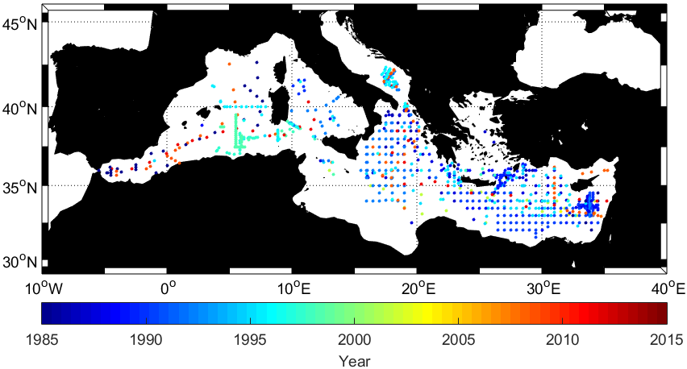**Figure S2. Comparison of the dataset prior to and following correction.** The plots of P ($μ$ mol kg–1) versus N ($μ$ mol kg–1) data prior to correction for (a) the western Mediterranean (MED) Sea and (b) the eastern MED Sea, and the plots of these nutrients for the two basins following correction (c and d, respectively). Note that different numerical scales were used for each plot.

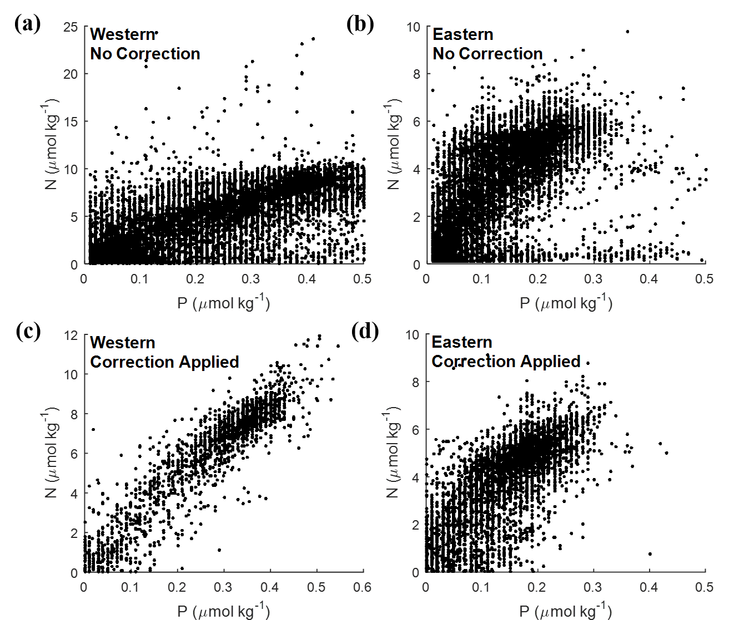

**Figure S3. Atmospheric NOx emission and riverine nitrogen and phosphorus inputs.** Red lines represent the temporal trend of NOx emission. Blue and green lines indicate the riverine inputs of nitrogen and phosphorus, respectively.

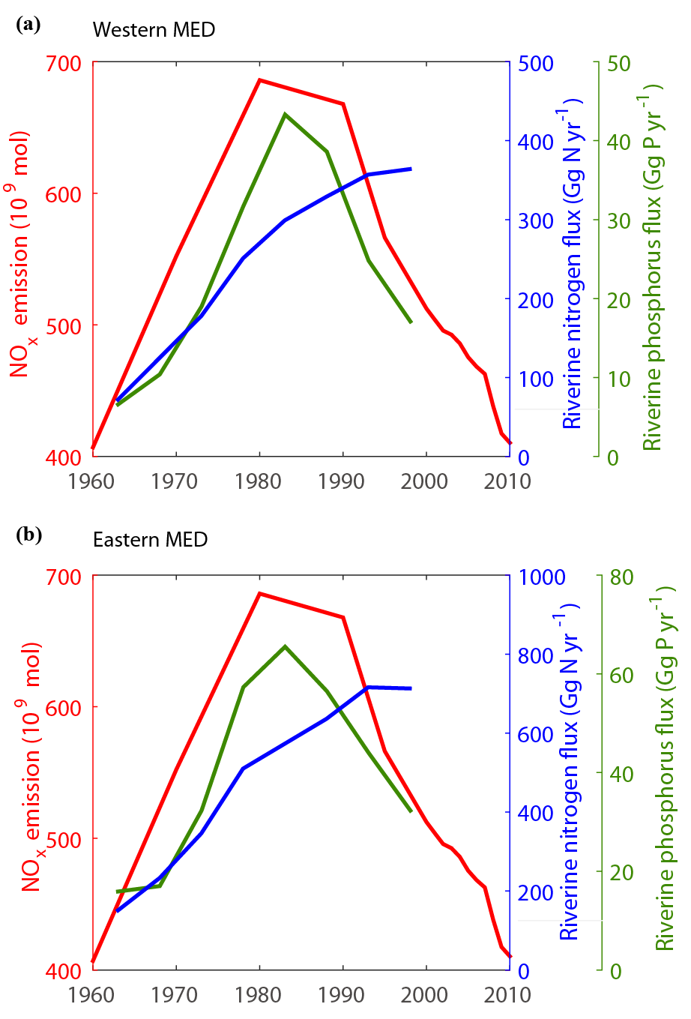

**Figure S4. Historical values of N2 fixation in the MED Sea in chronological order.** The red and blue markers refer to measurements in the western and the eastern MED Sea, respectively. The two black markers indicate measurement for the entire MED Sea.



**References**

Bonnet, S., O. Grosso, and T. Moutin (2011), Planktonic dinitrogen fixation along a longitudinal

gradient across the Mediterranean Sea during the stratified period (BOUM cruise), *Biogeosciences*, *8*(8), 2257–2267.

Garcia, N., P. Raimbault, E. Gouze, and V. Sandroni (2006), Nitrogen fixation and primary

production in Western Mediterranean, *C. R. Biol.*, *329*(9), 742–750.

Ibello, V., C. Cantoni, S. Cozzi, and G. Civitarese (2010), First basin-wide experimental results

on N2 fixation in the open Mediterranean Sea, *Geophys. Res. Lett*., *37*, L03608, doi:[10.1029/2009GL041635](http://dx.doi.org/10.1029/2009GL041635).

Kendall, M. G., and J. D. Gibbons (1990), Rank Correlation Methods, 5th ed., 260 pp., Oxford

Univ. Press, New York.

Mann, H. B. (1945), Nonparametric tests against trend, *Econometrica*, *13*, 245–259.

Marty, J.-C., N. Garcia, and P. Raimbault (2008), Phytoplankton dynamics and primary

production under late summer conditions in the NW Mediterranean Sea, *Deep Sea Res., Part I*, *55*(9), 1131–1149.

Rahav, E., B. Herut, A. Levi, M. R. Mulholland, and I. Berman-Frank (2013), Springtime

contribution of dinitrogen fixation to primary production across the Mediterranean Sea, *Ocean Sci*., *9*(3), 489–498.

Ridame, C., M. Le Moal, C. Guieu, E. Ternon, I. C. Biegala, S. L'Helguen, and M. Pujo-Pay

(2011), Nutrient control of N2 fixation in the oligotrophic Mediterranean Sea and the impact of Saharan dust events, Biogeosciences, 8, 2773–2783, doi:10.5194/bg-8-2773-2011.

Roxy, M. K., K. Ritika, P. Terray, R. Murtugudde, K. Ashok, and B. N. Goswami (2015),

Drying of Indian subcontinent by rapid Indian Ocean warming and a weakening land-sea thermal gradient, *Nat. Commun*., *6*, 7423.

Sandroni, V., P. Raimbault, C. Migon, N. Garcia, and E. Gouze (2007), Dry atmospheric

deposition and diazotrophy as sources of new nitrogen to northwestern Mediterranean oligotrophic surface waters, *Deep Sea Res., Part I*, *54*(11), 1859–1870.

Wernand, M. R., H. J. van der Woerd, and W. W. C. Gieskes (2013), Trends in Ocean Colour

and Chlorophyll Concentration from 1889 to 2000, Worldwide, *PLoS ONE*, *8*(6), e63766.

Yogev, T., E. Rahav, E. Bar‐Zeev, D. Man‐Aharonovich, N. Stambler, N. Kress, O. Béjà, M. R.

Mulholland, B. Herut, and I. Berman‐Frank (2011), Is dinitrogen fixation significant in the Levantine Basin, East Mediterranean Sea?, *Environ. Microbiol.*, *13*(4), 854–871.

Zeev, E. B., T. Yogev, D. Man-Aharonovich, N. Kress, B. Herut, O. Béja, and I. Berman-Frank

(2008), Seasonal dynamics of the endosymbiotic, nitrogen-fixing cyanobacterium Richelia intracellularis in the eastern Mediterranean Sea, *ISME J.,* *2*(9), 911–923.