#### Supplemental Information

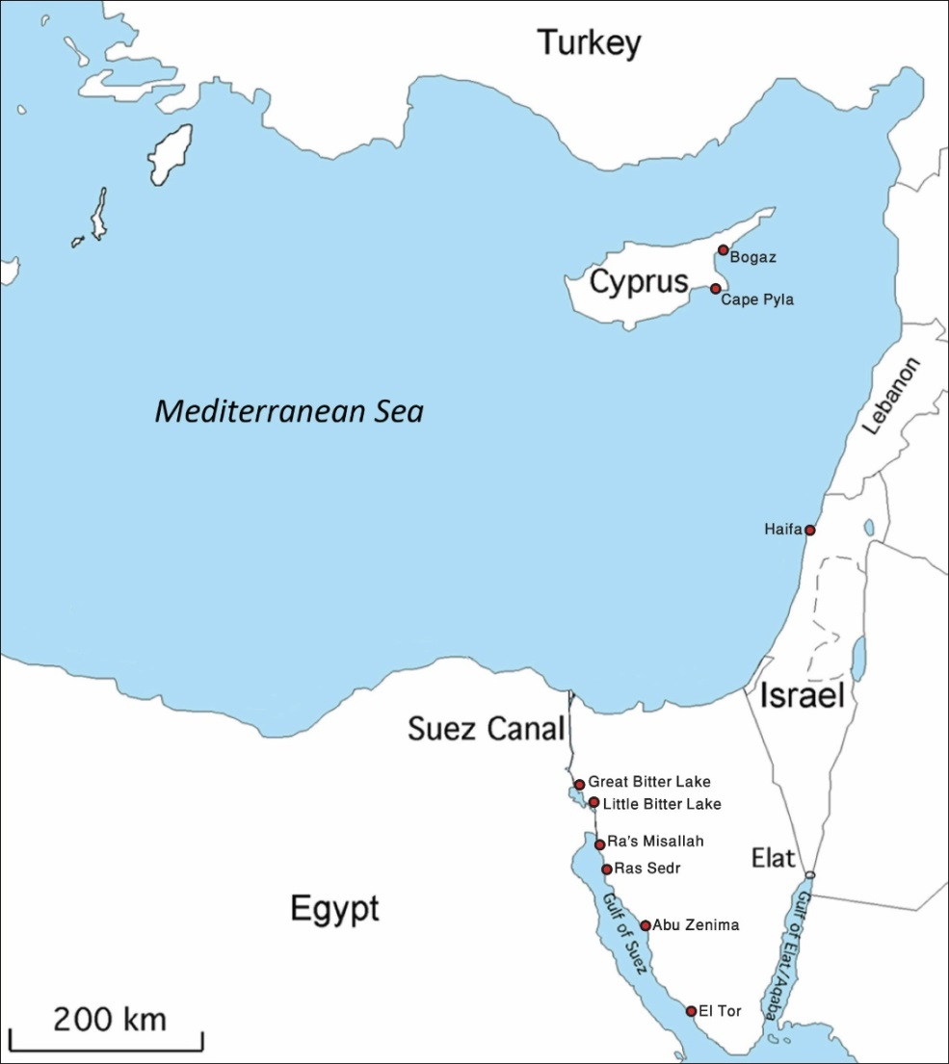

**Figure S1.** Rabbitfish collection sites. Live fish used in this study were collected in Haifa (August 2015 – July 2016). Historical data of fish from the Gulf of Suez, Egypt, and Cyprus were obtained from the Hebrew University Zoological Museum, Jerusalem. The dates of collection in chronological order are: Abu-Zenima (1967), Cape Pyla (1969), Ra's Misallah (1970), Ras Sedr (1970), Bogaz (1970), El-Tor (1972), Little Bitter Lake (1972), Great Bitter Lake (1975).

**Table S1:** Presence of live foraminifera, invertebrates, and algae in fecal pellets of rabbitfish collected off the coast of Haifa Bay. The geographic origin of the foraminiferal species is given and the observed motility is indicated. The taxa are ordered alphabetically.

|  |  |  |  |  |  |  |  |
| --- | --- | --- | --- | --- | --- | --- | --- |
| **Taxa** | **Geographic origin** | | | ***Siganus rivulatus*** | | ***Siganus luridus*** | |
| **Indo-Pacific** | **Atlantic** | | **Present** | **Motile** | **Present** | **Motile** |
| **Foraminifera** | | | | | | | |
| 1. *Adelosina pulchella* |  | • | |  |  | • |  |
| 1. *Ammonia parkinsoniana* |  | • | |  |  | • |  |
| 1. *Amphistegina lobifera* | • |  | | • | • | • | • |
| 1. *Coscinospira hemprichii* | • |  | | • |  |  |  |
| 1. *Cycloforina* cf. *C. contorta* | • | • | | • |  |  |  |
| 1. *Cycloforina quinquecarinata* | • |  | | • |  |  |  |
| 1. *Epistomaroides punctulata* | • |  | | • |  |  |  |
| 1. [*Eponides repandus*](http://www.marinespecies.org/aphia.php?p=taxdetails&id=113356) | • | • | | • | • |  |  |
| 1. *Hauerina diversa* | • |  | | • | • | • | • |
| 1. *Heterostegina depressa* | • |  | | • |  |  |  |
| 1. *Lachlanella* sp. | unknown | | | • | • | • | • |
| 1. *Miliolinella subrotunda* | • | • | | • | • | • | • |
| 1. *Neoconorbina* sp. | unknown | | | • |  | • |  |
| 1. *Pararotalia calcariformata* | • | |  | • | • | • | • |
| 1. *Peneroplis* cf. *P*. *pertusus* | unknown | | | • | • |  |  |
| 1. *Peneroplis pertusus* | • | • | | • | • | • | • |
| 1. *Peneroplis planatus* | • | • | | • | • | • | • |
| 1. *Pseudohauerinella dissidens* | • |  | | • |  | • |  |
| 1. *Pseudotriloculina laevigata* |  | • | | • | • |  |  |
| 1. *Pseudomassilina* sp. | unknown | | | • |  |  |  |
| 1. *Sigmoihaurenia bradyi* | • | • | | • | • |  |  |
| 1. *Spiroloculina* sp. | unknown | | | • |  | • |  |
| 1. *Spirophthalmidium* sp. | unknown | | | • |  |  |  |
| 1. *Sorites orbiculus* [1] | • | • | | • | • | • | • |
| 1. *Textularia agglutinans* [2] | • | • | | • |  | • |  |
| 1. *Triloculina marioni* |  | • | |  |  | • |  |
| 1. *Quinqueloculina berthelotiana* | • | • | | • |  | • |  |
| 1. *Quinqueloculina multimarginata* | • |  | | • |  | • |  |
| 1. *Quinqueloculina ungeriana* | • | • | | • |  | • |  |
| **Other Fauna and Flora** | | | | | | | |
| 1. Amphipoda (Gammaridea) | unknown | | | • | • | • | • |
| 1. Annelida (Polychaeta) | • | • | • | • |
| 1. Anthozoa (Hexacorallia) | • |  |  |  |
| 1. Chlorophyta (green algae) | • |  | • |  |
| 1. Copepoda | • | • | • | • |
| 1. Mollusca | • | • | • | • |
| 1. Ophiurida |  |  | • | • |
| 1. Ostracoda | • | • | • | • |
| 1. Phaeophyta (brown algae) | • |  | • |  |
| 1. Rhodophyta (red algae) | • |  | • |  |

**Table S2:** List of foraminifera species found in gastrointestinal tracts of rabbitfish collected in Gulf of Suez, 1967-1975. Collection sites are detailed in figure S2. Selected specimens are displayed in plates 1 and 2 (figures S2 and S3, correspondingly).

|  |  |  |
| --- | --- | --- |
| **Taxa** | **Geographic origin** | |
| **Indo-Pacific** | **Atlantic** |
| 1. *Adelosina carinatastriata* | • | • |
| 1. *Affinetrina planciana* | • | • |
| 1. *Ammonia convexa* | • |  |
| 1. *Amphistegina lobifera* | • |  |
| 1. *Buccella* sp. | unknown | |
| 1. *Challengerella bradyi* | • |  |
| 1. *Cribroelphidium* sp. | unknown | |
| 1. *Cycloforina quinquecarinata* | • | • |
| 1. *Cymbaloporetta* sp. | • | • |
| 1. *Elphidium advenum* | • | • |
| 1. *Elphidium advenum* subsp*. limbatum* | • | ? |
| 1. *Elphidium fichtellianum* | • | • |
| 1. *Elphidium striatopunctatum* | • | • |
| 1. *Eponides repandus* | • | • |
| 1. *Hauerina diversa* | • |  |
| 1. *Haynesina* sp. | unknown | |
| 1. *Miliolinella* sp. | unknown | |
| 1. *Neorotalia* *calcar* | • |  |
| 1. *Pararotalia* sp. | unknown | |
| 1. *Peneroplis pertusus* | • | • |
| 1. *Pseudomassillina* sp. | unknown | |
| 1. *Pseudoschlumbergerina ovata* | • |  |
| 1. *Pseudotriloculina* sp. | unknown | |
| 1. *Rosalina globularis* | • | • |
| 1. *Sigmoihauerina bradyi* | • | • |
| 1. *Sorites orbiculus* | • | • |
| 1. *Spiroloculina communis* | • | • |
| 1. *Spiroloculina* sp. | unknown | |
| 1. *Textularia agglutinans* | • | • |
| 1. *Tretomphalus bulloides* | • | • |
| 1. *Triloculina trigonula* | • | • |
| 1. *Triloculina terquemiana* | • | • |
| 1. *Quinqueloculina patagonica* | • | ? |
| 1. *Quinqueloculina* spp. | unknown | |

**Table S3:** First recorded sightings and corresponding references of *Siganus luridus* and *Amphistegina lobifera* at locations marked in figure 2.

|  |  |  |  |  |
| --- | --- | --- | --- | --- |
| Location | *Siganus luridus* | | *Amphistegina lobifera* | |
| First record year | Reference | First record year | Reference |
| Haifa, Israel | 1955 | [3] | 1959 | [4] |
| El-Kauf, Libya | 1968 | [5] | 1979 | [6] |
| Gulf of Tunis | 1971 | [7] | 1981 | [6] |
| Crete | 2002 | [9] | 2006 | [10] |
| Malta | 2002 | [11] | 2006 | [12] |
| Sicily | 2004 | [13] | 2014 | [14] |
| Marseille, France | 2008 | [15] |  |  |
| Albania | 2010 | [16] | 2015 | [17] |
| Trieste, Italy | 2010 | [18] |  |  |

#### Supplemental Information References

[1] Merkado, G., Holzmann, M., Apothéloz-Perret-Gentil, L., Pawlowski, J., Abdu, U., Almogi-Labin, A., Hyams-Kaphzan, O., Bakhrat, A. & Abramovich, S. 2013. Molecular evidence for Lessepsian invasion of Soritids (larger symbiont bearing benthic foraminifera). PloS one **8**: e77725.

[2] Merkado, G., Titelboim, D., Hyams-Kaphzan, O., Holzmann, M., Pawlowski, J., Almogi-Labin, A., Abdu, U., Herut, B. & Abramovich, S. 2015 Molecular Phylogeny and Ecology of *Textularia agglutinans* d’Orbigny from the Mediterranean Coast of Israel: A Case of a Successful New Incumbent. PloS one **10**: e0142263.

[3] Lundberg, B., G. Payiatas, and M. Argyrou. 1999. Notes on the diet of the Lessepsian migrant herbivorous fishes, *Siganus luridus* and *S. rivulatus*, in Cyprus. Israel Journal of Zoology **45:** 127-134.

[4] Reiss, Z. 1961. Recent foraminifera from the Mediterranean and the Red Sea coasts of Israel. Bulletin of the Geological Survey of lsrael **32:** 27-28.

[5] Stirn, J. 1970. Some note on western trends of Lessepsian migration. Journées Ichthyologiques **30:** 187-190.

[6] Blanc-Vernet, L., P. Clairefond, and P. Orsolini. 1979. Les foraminiferes, p. 171-209. Annales de l’Universite de Provence.

[7] Ktari-Chakroun, F., and M. Bouhlal. 1971. Record of *Siganus luridus* (Rüppel) in the Gulf of Tunisia. Bulletin de l'Institut national scientifique et technique d'océanographie et de pêche de Salammbô **2:** 49-52.

[8] Burollet, P. 1981. The Pelagian Sea east of Tunisia: bioclastic deposition under temperate climate. Marine Geology **44:** 157-170.

[9] Peristeraki, P., G. Lazarakis, C. Skarvelis, M. Georgiadis, and G. Tserpes. 2006. Additional records on the occurrence of alien fish species in the eastern Mediterranean Sea. Mediterranean Marine Science **7:** 61-66.

[10] Koukousioura, O., M. Dimiza, and M. Triantaphyllou. 2010. Alien foraminifers from Greek coastal areas (Aegean Sea, eastern Mediterranean). Mediterranean Marine Science **11:** 155-172.

[11] Schembri, P. J., A. Deidun, and M. A. Falzon. 2012. One Siganus or two? On the occurrence of *Siganus luridus* and *Siganus rivulatus* in the Maltese Islands. Marine Biodiversity Records **5:**  e71.

[12] Yokes, M., E. Meri̇c, N. Avsar, G. Boxshall, F. Boero, and S. Olenin. 2007. On the presence of alien foraminifera *Amphistegina lobifera* Larsen on the coasts of the Maltese Islands. Aquatic Invasions **2:** 439-441.

[13] Azzurro, E., and F. Andaloro. 2004. A new settled population of the lessepsian migrant *Siganus luridus* (Pisces: Siganidae) in Linosa Island—Sicily Strait. Journal of the Marine Biological Association of the UK **84:** 819-821.

[14] Caruso, A., and C. Cosentino. 2014. The first colonization of the Genus *Amphistegina* and other exotic benthic foraminifera of the Pelagian Islands and south-eastern Sicily (central Mediterranean Sea). Marine Micropaleontology **111:** 38-52.

[15] Daniel, B., S. Piro, E. Charbonnel, P. Francour, and Y. Letourneur. 2009. Lessepsian rabbitfish *Siganus luridus* reached the French Mediterranean coasts. Cybium **33:** 163-164.

[16] Katsanevakis, S. and others 2011. Twelve years after the first report of the crab *Percnon gibbesi* (H. Milne Edwards, 1853) in the Mediterranean: current distribution and invasion rates. Journal of Biological Research-Thessaloniki **16:** 224-236.

[17] Langer, M. R., and G. H. Mouanga. 2016. Invasion of amphisteginid foraminifera in the Adriatic Sea. Biological invasions **18:** 1335-1349.

[18] Poloniato, D., S. Ciriaco, R. Odorico, J. Dulčić, and L. Lipej. 2010. First record of the dusky spinefoot *Siganus luridus* (Ruppell, 1828) in the Adriatic Sea. Annales for Istrian and Mediterranean Studies, Series historia naturalis **20:** 161-166.