**RV POSEIDON cruise 518/1**

**25 September – 11 October 2017 (Bremerhaven – Bremerhaven)**

**2nd Weekly Report**

Due to the unfortunate weather conditions in the working area out in the open North Sea, we had to stay in the Moray Firth for 6 days. We efficiently used this time to process the data collected so far, prepare maps for the final station work or text and graphs for the cruise report. Some of the spare time on board was also utilized to catch a few mackerel from the Moray Firth, which were smoked for a very excellent dinner meal on Thursday.

On Friday, 6th, we returned to the working area and continued our hydroacoustic survey of abandoned wells in the UK sector, this time focusing on targets farther east of the Goldeneye platform. By Saturday evening it was then time to head south towards our final station at the Figge Maar blowout crater in the German Bight. Here, weather and wave conditions were favourable for a second dive with ROV PHOCA to sample the emitted gas and repeat the hydroacoustic mapping of the gas flares. This morning we stopped our station work after a last video-CTD cast at the Figge Maar and return to Bremerhaven port, where we will swap berths with the participants of leg 2 on Wednesday, 11 October.

Despite the difficult weather conditions that caused a loss of 6 full working days, each scientist managed to get a useful data set to accomplish the project tasks of STEMM-CCS and prepare for the upcoming cruises in 2018 and 2019.

On behalf of all participants I am sending the best wishes.

Matthias Haeckel, chief scientist

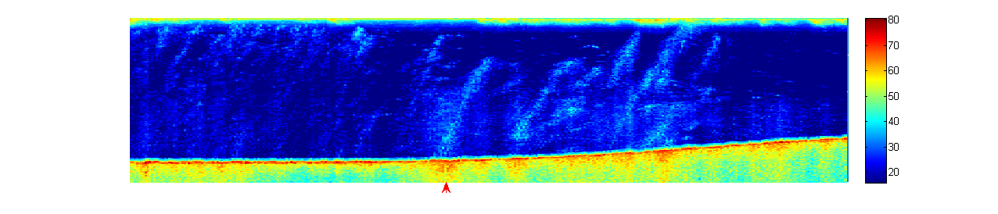

Figure: Example of hydroacoustic data at the Figge Maar in the German Bight showing multiple gas flares (light blue to white colours) in the water column (dark blue background colour) rising from the seabed (red to green colours at the bottom) to the sea surface. Water depths at Figge Maar are 30-45 m.