Institut für Hydrobiologie und Fischereiwissenschaft
Olbersweg 24
22767 Hamburg

Cruise Report

R.V. ALKOR Cruise No.: AL497

Compiled by: Jens-Peter Herrmann

Dates of Cruise: 15.07. – 29.07.2017

Areas of Research: Physical, chemical, biological and fishery oceanography

Port Calls: none

Institute: Institut für Hydrobiologie und Fischereiwissenschaft – Department fishery science

Chief Scientist: Jens-Peter Herrmann

Number of Scientists: 10 (plus 1 observer)

Projects: EU BONUS BIO-C3

Cruise Report

This cruise report consists of 10 pages including the cover page:

1. Scientific crew………………………………………………………………………... 2
2. Research program………………………………………………………….............…. 3
3. Narrative of cruise with technical details……………………………………………. 5
4. Scientific report and first results……………………………………………………… 6
4.1 Ichthyo- and zooplankton sampling……………………………………………… 6
4.2 Fishery…………………………….……………………………………………… 8
4.3 Hydrography ……………………...……………………………………………… 9
5. Scientific equipment …………………………..…………………………..…..………10
6. Acknowledgements………………………………………………………………….. . 11
7. Appendix E1: PDF File“Appendix_E1_AL497_station_list.pdf”.................................11

1. Scientific crew

Name | Function | Institute | Leg
Jens-Peter Herrmann | Chief scientist | UHH-IHF | Entire cruise
Margarethe Nowicki | PhD student | UHH | Entire cruise
Kristin Hänselmann | PhD student | UHH | Entire cruise
Richard Klinger | MSc student | UHH | Entire cruise
Kevin Haase | MSc student | UHH | Entire cruise
Mona Norbisrath | MSc student | UHH | Entire cruise
Tim Heimann | BSc student | UHH | Entire cruise
Isabel Salome Keller | PhD student | GEOMAR | Entire cruise
Julie Josias Nielsen | Technical assistent | DTU-Aqua | Entire cruise
Carla Tatiana Franco Cordón | MSc student | DTU-Aqua | Entire cruise
Marcin Jakub Zakrzewski | Observer | OIRM Gdynia, Polen | Entire cruise
Total per leg | 11/12

Chief scientist:

Jens-Peter Herrmann, University of Hamburg
Institut für Hydrobiologie und Fischereiwissenschaft
Olbersweg 24, 22767 Hamburg
Phone: 040 42838 6607
Fax: 040 42838 6618
E-Mail: jpherrmann@uni-hamburg.de

2. Research program

This multidisciplinary cruise extended a long-term data series on (eco-)system composition and functioning of the Baltic Sea, with a focus on the deeper basins, collected since 1986 by the GEOMAR Helmholtz Centre for Ocean Research and its predecessors IFM-GEOMAR Kiel and IFM Kiel. Since 2004 the August cruise of the time series is performed by the IHF of University of Hamburg. The key characteristic of this series is the integration of oceanographic and biological information to enhance understanding of environmental and (fish) population fluctuations, and evolutionary processes in this system, in the context of climate change and anthropogenic stressors. The resulting datasets and samples are essential for a number of ongoing projects, including the large-scale international project BONUS BIO-C3 coordinated by GEOMAR. The spatial focus lies on the Bornholm Basin (the most important spawning area of Baltic cod), but also includes the Western Baltic Sea, Arkona and Gotland Basin and Gdansk Deep (Figure 1), thus covering ICES subdivisions 22, 24, 25, 26 and 28 (Figure 2).
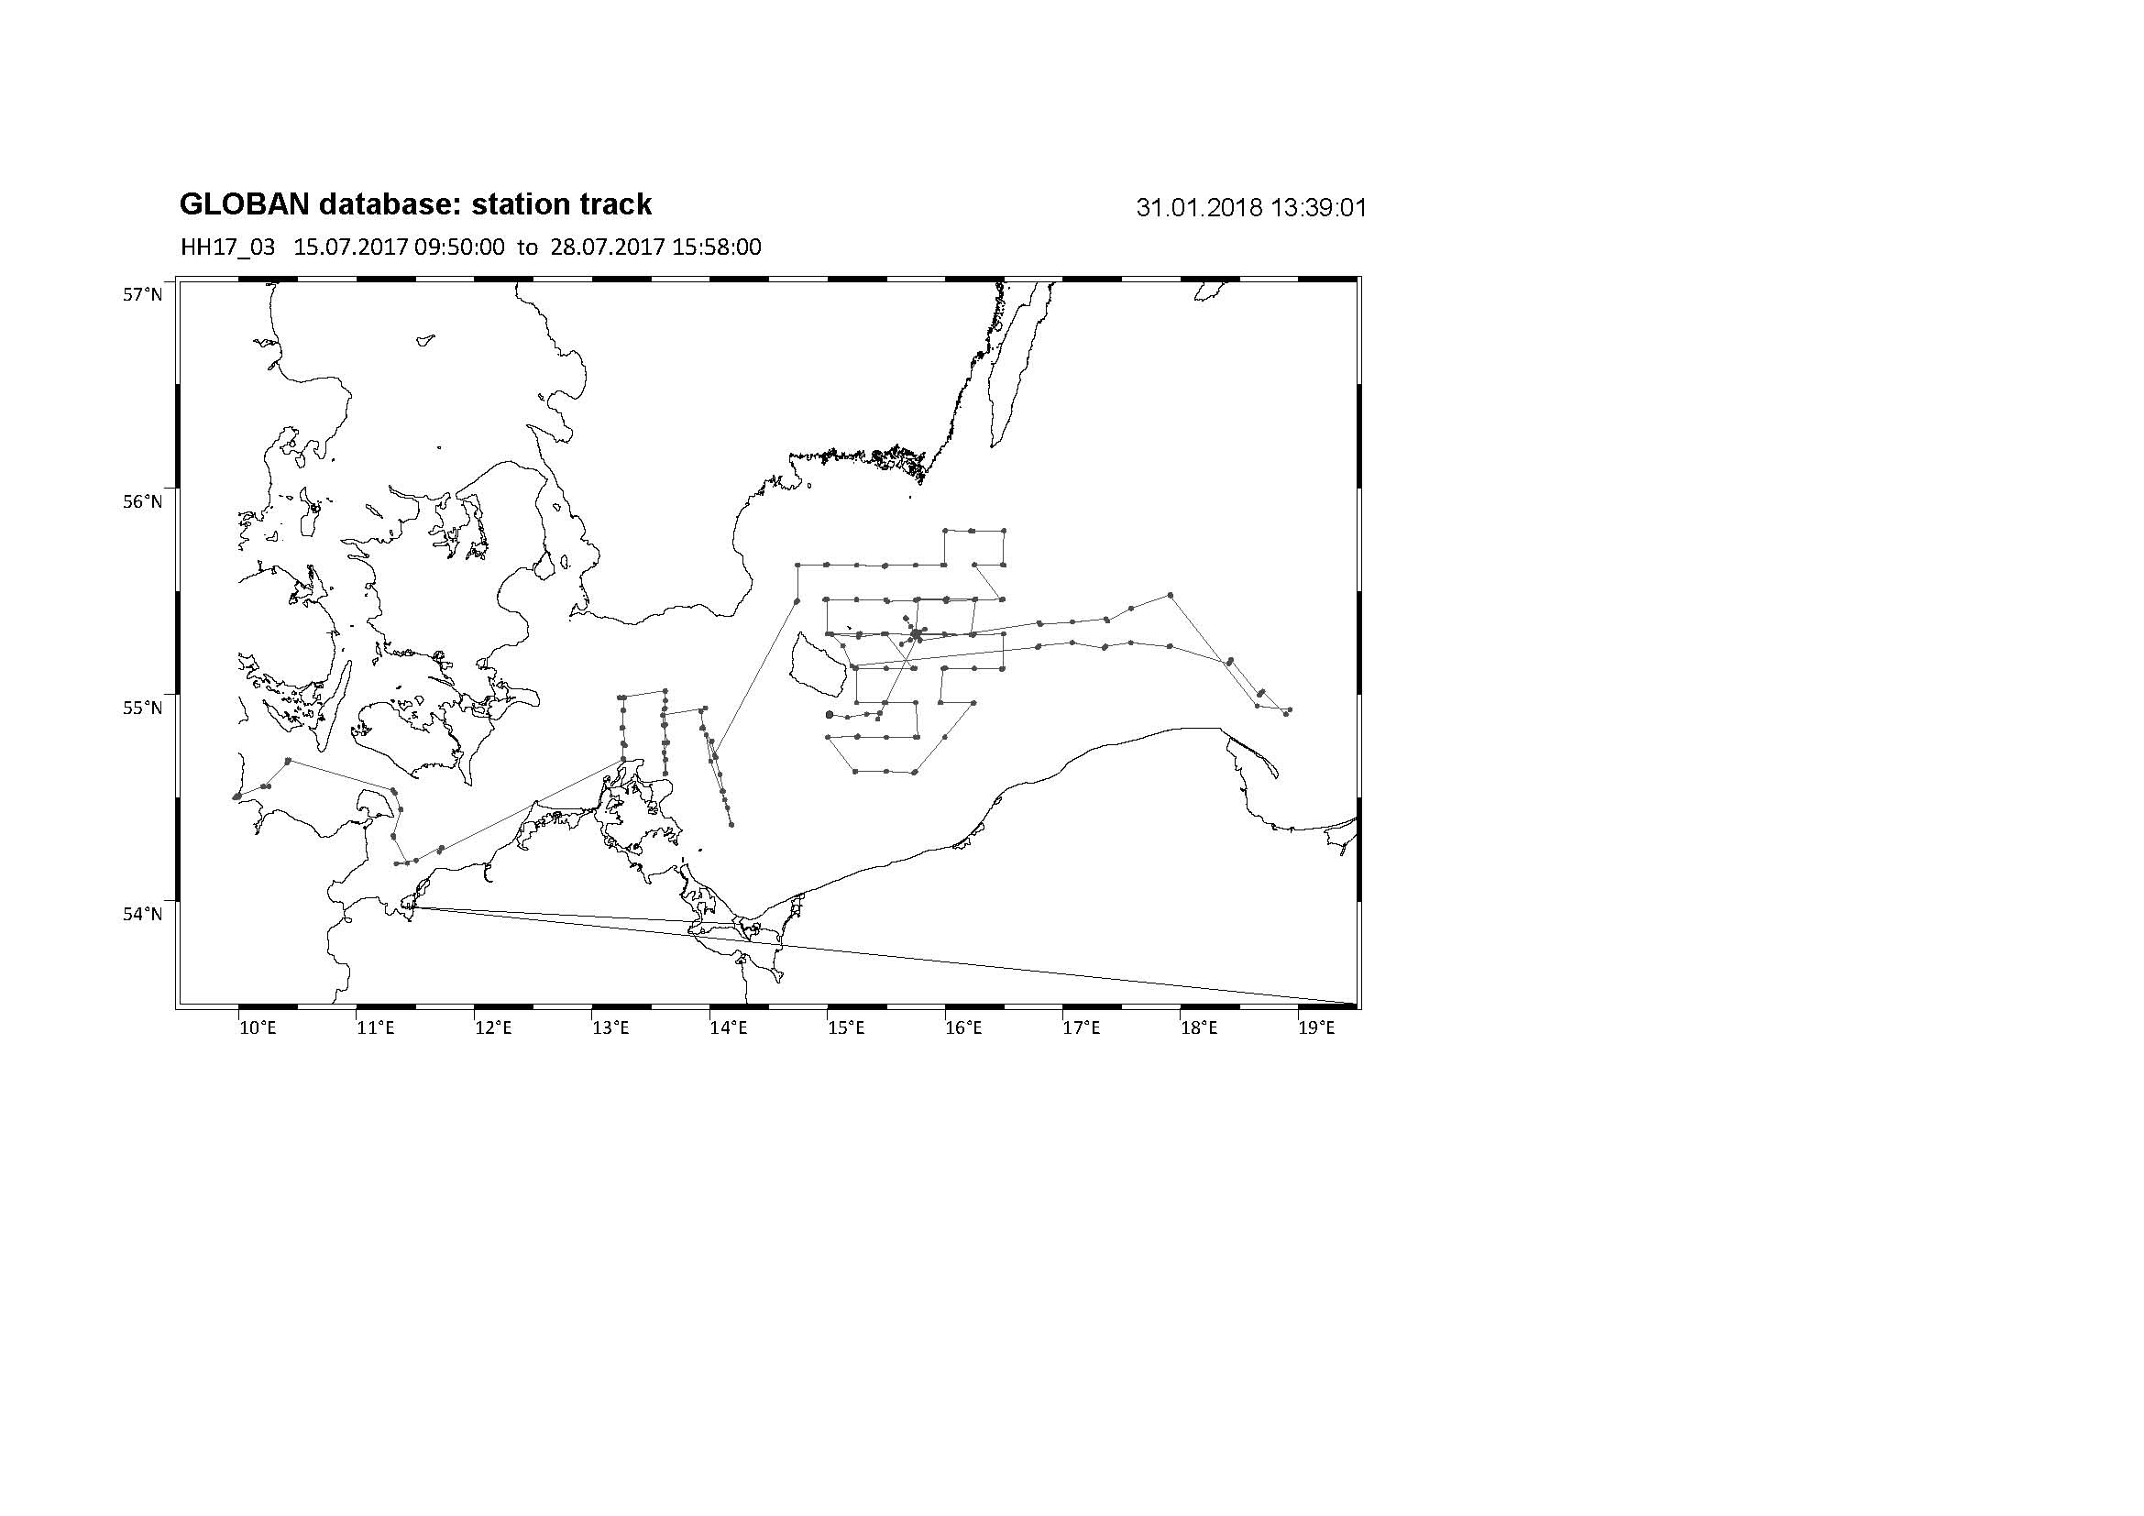

Figure 1 Cruise track of AL497. All realized sample stations are depicted by black dots.

Specific investigations included a detailed hydrographic survey (oxygen, salinity, temperature, light intensity, fluorescence), plankton surveys (zoo- and ichthyoplankton, with the goal to determine the composition, abundance, vertical and horizontal distribution, and nutritional status of species, and to address questions regarding plankton phenology) and
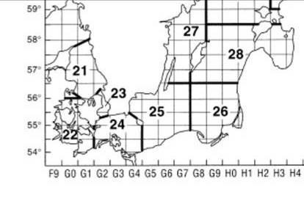
Figure 2 ICES subdivisions in the Baltic Sea area (Source: ICES). ICES SD22 corresponds to Kiel Bight = KB, SD24 to Arkona Basin = AB, SD25 to Bornholm Basin = BB and Stolpe Trench = SR, SD26 to Gdansk Deep = GD and Southern Gotland Basin (GB).

pelagic fishery hauls (Figure 3). The latter served to determine size distributions, maturity status, and length – weight relationships of the three dominant fish species in the pelagic system of the Baltic, cod (Gadus morhua), herring (Clupea harengus) and sprat (Sprattus sprattus), as well as the flatfish flounder (Plathichthys flesus). Secondly, various different samples were obtained for more detailed analyses, including gonad samples of cod, stomachs of cod, herring and sprat stomachs and whole samples for dietary analyses, otoliths of cod and whiting for aging, and tissue samples of cod, whiting for genetic analysis and stable isotope analysis. In addition, along the cruise track, hydroacoustic (echosounder) data were collected continuously for later analysis of fish abundance and distribution.
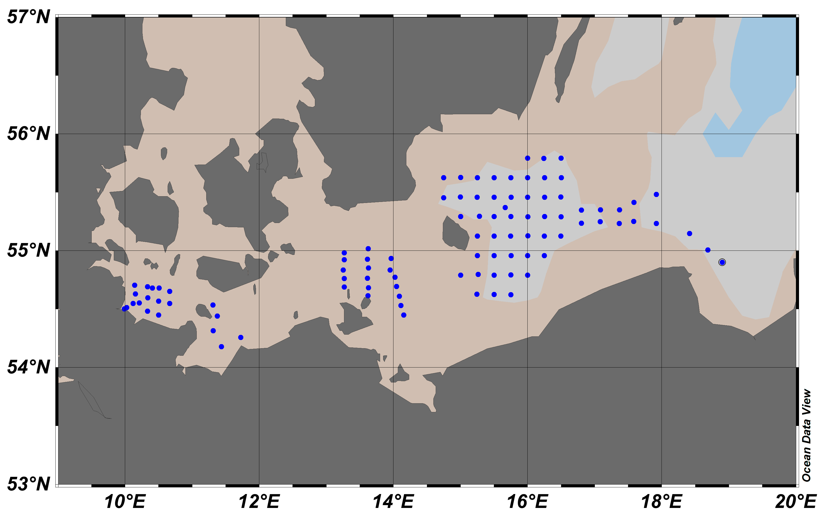
Figure 3 Sampling stations for hydrographic measurements, Plankton samplings and fish trawls covered by AL497.

3. Narrative of cruise with technical details

RV ALKOR departed from GEOMAR pier on Juli 15 2017 at 08:00 am (all times board time) and headed to the first research area in the Kiel Bight (SD22). Over the course of the cruise, pelagic fishery hauls, zooplankton hauls with Bongo/WP2/Apstein nets, Multinet MIDI/MAXI, water sampler, Video-Plankton-Recorder and CTD hauls were then carried out following a large-scale spatial sampling design covering Kiel Bight (SD22) on Juli 15, Mecklenburg Bight (SD22) on Juli 16, Arkona Basin (SD24) on on Juli 17-19, Bornholm Basin (SD25) on on Juli 20-24 and 27-28, Stolpe Trench (SD25) on July 24 and 25, and Gdansk Deep (SD26) on July 26 (Figure 3). In addition, hydroacoustic data obtained with four different echosounder frequencies (38, 70, 120 and 200 kHz) were continuously recorded.
In addition on July 22 repeated vertical tows with Apstein and WP2 net were conducted near the station BB23 in the Bornholm Basin to get Plankton samples in order to address questions regarding plankton phenology.
Also in addition to the program above, the central deep station BB23 in Bornholm Basin was intensively sampled on July 27 07:28 – July 28 03:07 with a detailed vertically and temporally resolved sampling of plankton communities by two towed Multinet MAXI, four vertical Multinet MIDI hauls and a two hours tow of the Video Plankton Rekorder over a 24 hour period, covering the water column in 5 m depth layers and undulating tows, respectively.

Additional detail on gear deployments (Table 1), the station list (Appendix E1), and an overview of first scientific results are provided below.

Table 1 Overview of gear deployment. Mesh sizes are given in brackets.

Gear |  | Total
ADM-CTD vertical |  | 86
Watersampler + CTD |  | 1
Hydroacoustic transect (continuous) |  | 1
Bongo, Babybongo (150μ, 335μ, 500μ) |  | 86
Multinet MAXI horizontal (335μ) |  | 8
Multinet MIDI vertical (50μ) |  | 12
Multinet MIDI horizontal (150μ) |  | 1
Apstein (55μ) plankton hauls |  | 3
WP-2 (100μ) |  | 3
Video-Plankton-Recorder |  | 4
Pelagic fishery trawl |  | 43
3 meter Beam trawl |  | 18
Total |  | 264

4. Scientific report and first results

Cruise AL497 accomplished all objectives of the original work program, and thus extended the integrative Baltic long-term data series that directly contributed to the BONUS BIO-C3 project. Specific work lines are described in the following.

4.1 Ichthyo– and zooplankton sampling

Bongo- and Babybongo hauls covered Kiel Bight (4 hauls), Mecklenburg Bight (5 hauls), Arkona Basin (19 hauls), and Bornholm Basin including the Stolpe Trench (58 hauls) (Figure 3, Table 1). Larvae of cod (Gadus morhua; n = 53 in total) were picked from the 500 μm bongo-samples and conserved at -80 °C for subsequent RNA/DNA and genetic analyses. The spatial distribution of the cod larvae is presented in Figure 4. Highest density was found in the central deep part of the basin. All of the 500 μm Bongo samples were also checked for the presence of gelatinous zooplankton. The jellyfish species Aurelia aurita, Cyanea capillata, Obelia spp. and the invasive combjelly Mnemiopsis leidyi were present regularly. Following these initial on board steps, all Bongo samples were conserved in formol, and will be used for the determination of species composition and abundance of zooplankton and ichthyoplankton.
Repeated Multinet MAXI (335μ, towed, sampling of the water column in 5 m layers) and MIDI (50μ, vertical, sampling of the water column in 10 m layers) casts were done over a 24 hour period on April 25-26 on the central deep Bornholm Basin station BB23 to reveal the vertical distribution of ichthyo- and zooplankton. In addition, WP-2 (100 μm) and Apstein (55 μm) nets and the rosette water sampler were deployed to obtain additional samples, including nano/micro phytoplankton samples in the context of plankton phenology work within the BONUS BIO-C3 project (Dr. Jörg Dutz, IOW) and the determination of vertical oxygen profiles using Winkler titration.
Bornholm
Basin
Grid
Stations
1
2
3
4
5
6
7
8
9
10
11
12
13
14
15
16
17
18
19
20
21
22
23
24
25
29
30
31
32
33
34
35
41
42
55
°
00
´
56
°
00
´
N
15
°
00
´
16
°
00
´
17
°
00
´
20 m
80 m
60 m
55
°
30'
54
°
30'
E
20 m
40 m
40 m
60 m
80 m
40 m
40
39
36
28
26
27
37
7
38
43
44
45
46
48
47
49
55
53
54
52
50
50
51
Figure 4 Sampling stations for hydrographic measurements and Bongo Plankton samplings in the Bornholm Basin covered by AL497 (black dots). Station number is given by small black notations. Number of cod larvae picked from the 500µm Bongo nets is presented by bold red numbers.
1
4
3
1
2
1
0
2
0
0
0
3
1
5
5
3
0
0
1
0
1
2
0
4
2
0
0
2
0
2
3
0
2
1
0
2
0
0
0
0
0
0
0
0
0

4.2 Fishery

Pelagic fishery was conducted in the Kiel Bight (5 hauls), Mecklenburg Bight (5 hauls), Arkona Basin (14 hauls), Bornholm Basin (16 hauls) and Gdansk Deep (3 hauls). In parallel to the fishery hauls, hydroacoustic measurements of fish distribution patterns were recorded continuously. The overall catch composition is shown in Table 2.

Table 2 Fish catch composition AL497. For cod, the number of individuals for which single fish measurement and samples were taken was 659, for whiting 188.

Latin name | Common name | n | mass (kg)
Sprattus sprattus | sprat | 274661 | 3094,4
Clupea harengus | herring | 21784 | 676,3
Gadus morhua | cod | 1952 | 494,1
Merlangius merlangus | whiting | 1284 | 165,8
Limanda limanda | common dab | 855 | 91,3
Hyperoplus lanceolatus | sand eel | 4526 | 62,9
Pleuronectes platessa | plaice | 52 | 12,9
Platichthys flesus | flounder | 57 | 11,0
Ammodytes marinus | sand eel | 356 | 6,3
Scomber scombrus | Atlantic mackerel | 7 | 1,5
Cyclopterus lumpus | Lump fish | 5 | 1,3
Hyperoplus immaculatus | Sand eel | 59 | 0,9
Scophthalmus maximus | turbot | 3 | 0,8
Melanogrammus aeglefinus | haddok | 2 | 0,6
Myoxocephalus scorpius | sea skulpin | 3 | 0,5
Hippoglossoides platessoides | American plaice | 3 | 0,1
Salmo trutta | Sea trout | 1 | 0,1
Gobius niger | black goby | 2 | 0,0
Rhinonemus cimbrius | four bearded rockling | 1 | 0,0
Agonus cataphractus | armed bullhead | 1 | 0,0
Gasterosteus aculeatus | three-spined stickleback | 2 | 0,0
 | Total | 305616 | 4620,9

For each haul and the entire catch, catch weight and length frequencies of all species (illustrated in Figure 5.2 for cod) were taken. Stomach samples were taken from sprat (30 per 1 cm length class) and herring (30 per 2 cm length class). For cod, single fish data (length, weight, liver weight, sex and maturity stage) and samples (otoliths, fin clips for genetic analysis, stomachs and gonads) were obtained for 841 individuals (see Figure 5.1) for illustration), whereas length and weight were measured for the remaining 949 individuals (juveniles are not included). All length and weight data together suggests that the caught individuals are representing foremost the lower third of the possible size spectrum for cod in the Baltic Sea. All whiting data presented are caught in the western Baltic part (SD 22 to 24).

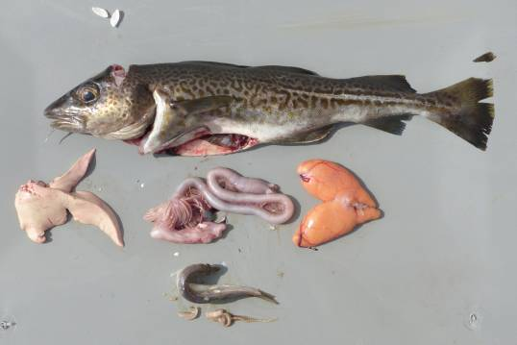
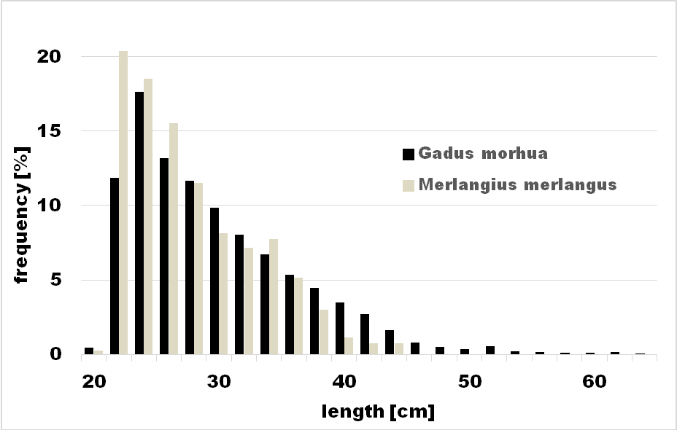

Figure 5.1 Relative length frequency distribution of individual sampled cod (n = 949) and whiting (n = 799) during AL497.
Figure 5.2 Samples (otoliths, fin clips, stomach contents, gonads) and measures (total length, weight, gutted weight, liver and gonad weight) taken from 841 out of 949 cod individuals and from 313 out of 799 whiting individuals during the cruise (illustrated here for a 38 cm cod female, maturity stage IV, with full stomach, from Bornholm Basin). Photo: Nickel

4.3 Hydrography

CTD profiles from 86 stations were obtained with the ADM-CTD and the HYDROBIOS water sampler with attached CTD. Conditions varied depending on the basin and location of the Baltic sampled, and will be analyzed in depth in context of our long-term data series on hydrographic conditions.

Oxygen concentrations at the bottom in the Bornholm Basin were found to be somewhat reduced to the concentration measured in summer 2016. This year, 2017, (< 2 ml/l) hypoxic to anoxic (0 ml/l) conditions prevailed at the bottom of stations with water depths >75m (see Figure 6). We assume that the Major Baltic Inflow event in winter of 2014/15 and the smaller inflow in winter 2015/16 increased the salinity and oxygen conditions below the halocline in the Bornholm Basin substantially, but that oxygen is declining after the absence of an inflow in winter 2016/2017. This underscores that isolated Major Baltic Inflow event like the one observed for the winter 2014/15 will not change the course of spreading hypoxia and anoxia in the Baltic Sea, i.e., only an overall shift back to more regular inflows would be able to do so. Moreover, other factors like eutrophication are contributing to the spread of anoxic areas.

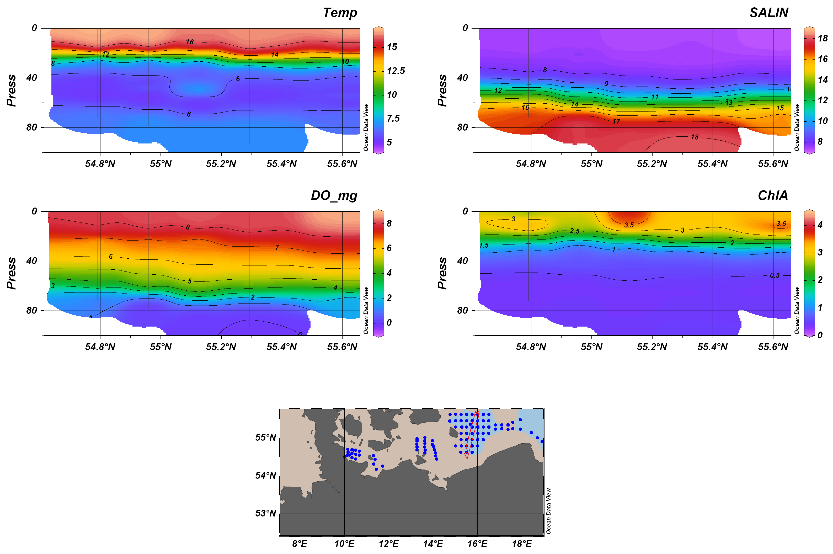
Figure 6 Hydrographic iso-plots along a transect from south to north across the central Bornholm Basin observed on cruise AL497 in July 2017.

5. Scientific equipment: instruments and gear

Hydrography:
- ADM-CTD with additional O2 and fluorescence (Chl. A) sensor
- Hydrobios Water Sampler with CTD and O2 sensor

Zooplankton:
- Baby Bongo-Net (150 μm)
- Bongo net (335 μm)
- Bongo net (500 μm)
- WP-2 net(100 μm)
- Apstein net (55 μm)

Ichthyoplankton:
- Bongo net (335 μm and 500 μm)
- Hydrobios Multinet MAXI (335 μm horizontal hauls)
- Hydrobios Multinet MIDI (50 μm vertical hauls)
- Hydrobios Multinet MIDI with CTD (150 μm horizontal hauls)

Fish:
- Jungfisch Trawl (pelagic trawl net; 5 mm mesh size in codend)
- 3 meter Beamtrawl (bottom trawl net; 4 mm mesh size in codend)

Hydroacoustics:
- 38, 70, 120 and 200 kHz-echosounder EK60
6. Acknowledgements

Thanks to Captain Jan Lass and the entire crew of RV ALKOR for their outstanding support throughout the cruise! I also want to thank my colleagues Richard Klinger, Margarethe Nowicki and Kristin Hänselmann for the great collaboration on cruise preparations and follow-up work for the Baltic integrative long-term data series cruises in 2017 as well as past years, and to Svend Mees ( GEOMAR) for his support in all technical equipment for the cruise. Finally, thank you to the scientific personal and student assistants on AL497 for their enthusiasm and motivation.
This cruise contributed to the EU BONUS BIO-C3 project and was supported by BONUS (Art 185), funded jointly by the EU and the German BMBF under grant No. 03F0682C.

7. Appendix E1: Station list of AL497

Supplied with the report in electronic form as PDF table, File“Appendix_E1_AL497_station_list.pdf”

