|  |  |  |  |  |  |  |  |  |  |  |  |  |
| --- | --- | --- | --- | --- | --- | --- | --- | --- | --- | --- | --- | --- |
| **CRUISE SUMMARY REPORT** | | | | | | | | | | | | FOR COLLATIMG CENTRE USE **Centre: DOD** **Ref. No.:**  Is data exchange  restricted Yes In part No |
| enter the unique number, name or acronym assigned to the cruise (or cruise leg, if appropriate).  **SHIP** enter the full name and international radio call sign of the ship from which the data were collected, and indicate the type of ship, for  example, research ship; ship of opportunity, naval survey vessel; etc.  **Name:** **FS ALKOR** **Call Sign:** **DBND**  **Type of ship:** **Research** | | | | | | | | | | | | |
| **CRUISE NO. / NAME** AL 507 | | | | | | | | | | | | |
| **CRUISE PERIOD** start **15**/**04**/**2018** to **29/04/2018** end  **(set sail) day/ month/ year day/ month/ year (return to port)**  **PORT OF DEPARTURE** (enter name and country) **Kiel, Germany**  **PORT OF RETURN** (enter name and country) **Kiel, Germany** | | | | | | | | | | | | |
| **RESPONSIBLE LABORATORY** enter name and address of the laboratory responsible for coodinating the scientific planning of  the cruise  **Name:** **GEOMAR Helmholtz Zentrum für Ozeanforschung Kiel**  **Address:** **Wischhofstraße 1-3, 24148 Kiel**  **Country:** **Germany** | | | | | | | | | | | | |
| **CHIEF SCIENTIST(S)** enter name and laboratory of the person(s) in charge of the scientific work (chief of mission) during the cruise.  **Dr. Jan Dierking, GEOMAR Helmholtz-Zentrum für Ozeanforschung Kiel, Düsternbrooker Weg 20, 24105 Kiel** | | | | | | | | | | | | |
| **OBJECTIVES AND BRIEF NARRATIVE OF CRUISE** enter sufficient information about the purpose and nature of the cruise so  as to provide the context in which the report data were collected.  **Physical, chemical, biological research and fishery oceanography**  **This multidisciplinary cruise extended a long-term data series on (eco-)system composition and functioning of the Baltic Sea, with a focus on the deeper basins. The series has been collected in similar form since 1986. A key characteristic of the cruise is the integration of oceanographic and biological information to enhance understanding of environmental and (fish) population fluctuations, and evolutionary processes in this system. The resulting datasets and samples feed into the EU projects BONUS BLUEWEBS and Horizon 2020 GoJelly, and the US NSF project "Evolutionary Responses to Global Change in Salinity and Temperature". The spatial focus lay on the Bornholm Basin as most important spawning area of Baltic cod, but also included the Western Baltic Sea, Arkona and Gotland Basin, Gdansk Deep, and Stolpe Trench.**  **Specific investigations included a detailed hydrological survey (oxygen, salinity, temperature) of the Bornholm Basin, plankton surveys (zoo- and ichthyplankton, with the goal to determine the composition and the abundance and vertical and horizontal distribution of species, and to take samples for later measurements of nutritional condition), and pelagic fishery hauls for clupeid and gadoid fish. The latter served to determine stock structure, gonadal maturation, stomach contents, and egg production of sprat and cod, and to sample tissue and otolith samples for individual-level genetic and ecological analyses of cod. The abundance and distribution of fishes in the cruise area was also assessed with hydroacoustic methods.**  **Additional cruise components were: (i) cod gonad sampling for fecundity studies and liver sampling for parasite studies. (ii) vertically resolved phytoplankton and zooplankton sampling for studies of plankton phenology. (iii) in-depth sampling of planktonic food webs for dietary tracer work. (iv) copepode Eurytemora affinis sampling along the salinity gradient of the Baltic Sea for the study of local adapations.** | | | | | | | | | | | | |
| **PROJECT** (IF APPLICABLE) if the cruise is designated as part of a larger scale cooperative project (or expedition), then enter the name of the project, and of organisation responsible for co-ordinating the project.  **Project name:** **EU HORIZON 2020 GoJelly, EU BONUS BLUEWEBS**  **Coordinating body:** **GEOMAR Helmholtz-Zentrum für Ozeanforschung Kiel** | | | | | | | | | | | | |
|  | | | | | | | | | | | | |
| **PRINCIPAL INVESTIGATORS:** Enter the name and address of the Principal Investigators responsible for the data collected on the cruise and who may be contacted for further information about the data. (The letter assigned below against each Principal Investigator is used on pages 2 and 3, under the column heading ‘PI‘, to identify the data sets for which he/she is responsible)   1. **Dr. Jan Dierking, fishery data: jdierking@geomar.de** 2. **Dr. Catriona Clemmesen, ichthyoplankton data: cclemmesen@geomar.de** 3. **Dr. Matthias Schaber, hydroacoustic data: matthias.schaber@thuenen.de** 4. **Burkhard v. Dewitz, hydrographic data: bdewitz@geomar.de** 5. **Dr. Jan Dierking, food web sampling and copepode sampling: jdierking@geomar.de** | | | | | | | | | | | | |
| MOORINGS, BOTTOM MOUNTED GEAR AND DRIFTING SYSTEMS This section should be used for reporting moorings, bottom mounted gear and drifting systems (both surface and deep) deployed and/or recovered during the cruise. Separate entries should be made for each location (only deployment positions need be given for drifting systems). This section  may also be used to report data collected at fixed locations which are returned to routinely in order to construct ‘long time series‘. | | | | | | | | | | | | |
| PI  See top of page. | | APPROXIMATE POSITION | | | | | | | | DATA TYPE  enter code(s) from list on cover page. | | DESCRIPTION |
| LATITUDE | | | | | LONGITUDE | | | Identify, as appropriate, the nature of the instrumentation the parameters (to be) measured, the number of instruments and their depths, whether deployed and/or recovered, dates of deployments and/or recovery, and any identifiers given to the site. |
| deg | | min | N/S | | deg | min | E/W |
|  | |  | |  |  | |  |  |  |  | |  |
|  | |  | |  |  | |  |  |  |  | |  |
|  | |  | |  |  | |  |  |  |  | |  |
|  | |  | |  |  | |  |  |  |  | |  |
|  | |  | |  |  | |  |  |  |  | |  |
|  | |  | |  |  | |  |  |  |  | |  |
|  | |  | |  |  | |  |  |  |  | |  |
|  | |  | |  |  | |  |  |  |  | |  |
|  | |  | |  |  | |  |  |  |  | |  |
|  | |  | |  |  | |  |  |  |  | |  |
|  | |  | |  |  | |  |  |  |  | |  |
|  | |  | |  |  | |  |  |  |  | |  |
|  | |  | |  |  | |  |  |  |  | |  |
|  | |  | |  |  | |  |  |  |  | |  |
|  | |  | |  |  | |  |  |  |  | |  |
|  | |  | |  |  | |  |  |  |  | |  |
|  | |  | |  |  | |  |  |  |  | |  |
|  | |  | |  |  | |  |  |  |  | |  |
|  | |  | |  |  | |  |  |  |  | |  |
|  | |  | |  |  | |  |  |  |  | |  |
|  | |  | |  |  | |  |  |  |  | |  |
|  | |  | |  |  | |  |  |  |  | |  |
|  | |  | |  |  | |  |  |  |  | |  |
|  | |  | |  |  | |  |  |  |  | |  |
|  | |  | |  |  | |  |  |  |  | |  |
|  | |  | |  |  | |  |  |  |  | |  |
|  | |  | |  |  | |  |  |  |  | |  |
|  | |  | |  |  | |  |  |  |  | |  |
|  | |  | |  |  | |  |  |  |  | | Please continue on separate sheet if necessary |
|  | | | | | | | | | | | | |
|  |  | |  |  |  | |  | |  |  |  | |
| SUMMARY OF MEASUREMENTS AND SAMPLES TAKEN Except for the data already described on page 2 under ‘Moorings, Bottom Mounted Gear and Drifting Systems‘, this section should include a summary of all data collected on the cruise, whether they be measurements (e.g. temperature, salinity values) or samples (e.g. cores, net hauls).  Separate entries should be made for each distinct and coherent set of measurements or samples. Different modes of data collection (e.g. vertical profiles as opposed to underway measurements) should be clearly distinguished, as should measurements/sampling techniques that imply distinctly different accuracy’s or spatial/temporal resolutions. Thus, for example, separate entries would be created for i) BT drops, ii) water bottle stations, iii) CTD casts, iv) towed CTD, v) towed undulating CTD profiler, vi) surface water intake measurements, etc.  Each data set entry should start on a new line – it’s description may extend over several lines if necessary.  NO, UNITS : for each data set, enter the estimated amount of data collected expressed in terms of the number of ‘stations‘; miles‘ of track; ’days‘ of  recording; ‘cores‘ taken; net ‘hauls‘; balloon ‘ascents‘; or whatever unit is most appropriate to the data. The amount should be entered  under ‘NO‘ and the counting unit should be identified in plain text under ‘UNITS‘. | | | | | | | | | | | | |
| PI  see page  2 | | NO  see  above | | UNITS  see  above | | DATA TYPE  Enter code(s) from list on cover page | | | DESCRIPTION | | | |
| Identify, as appropriate, the nature of the data and of the instrumentation/sampling gear and list the parameters measured. Include any supplementary information that may be appropriate, e. g. vertical or horizontal profiles, depth horizons, continuous recording or discrete samples, etc. For samples taken for later analysis on shore, an indication should be given of the type of analysis planned, i.e. the purpose for which the samples were taken. | | | |
|
| **D** | | **94** | | **station** | | **H10** | | | **Vertical CTD profiles on station grid** | | | |
| **C** | | **1** | | **transect** | | **B28** | | | **hydroacoustic data (continuous along cruise track)** | | | |
| **B** | | **8** | | **hauls** | | **B09, B13** | | | **Ichthyo- and zooplankton distribution (multinet MAXI 335 µm towed)** | | | |
| **B** | | **8** | | **hauls** | | **B09, B13** | | | **Ichthyo- and zooplankton distribution (multinet MIDI 50 µm vertical)** | | | |
| **E** | | **7** | | **hauls** | | **B09** | | | **Integrated vertical zooplankton hauls (WP2 100 µm)** | | | |
| **E** | | **16** | | **hauls** | | **B09** | | | **Integrated vertical zooplankton hauls (WP2 200 µm)** | | | |
| **E** | | **6** | | **hauls** | | **B09** | | | **Integrated vertical zooplankton hauls (Apstein net 55µm)** | | | |
| **B** | | **24** | | **hauls** | | **B09, B13** | | | **Horizontally and vertically integrated ichtyoplankton hauls (IKS80 500 µm)** | | | |
| **B** | | **74** | | **hauls** | | **B13** | | | **Horizontally and vertically integrated ichthyoplankton hauls (Bongo nets 150, 335, 500 µm)** | | | |
| **A** | | **30** | | **hauls** | | **B14** | | | **Pelagic fishery (pelagic trawl)** | | | |
| **C, E** | | **8** | | **hauls** | | **H09. B08** | | | **Water samples for oxygen calibration, phytoplankton, food web sampling (Rosette sampler)** | | | |
|  | |  | |  | |  | | |  | | | |
|  | |  | |  | |  | | |  | | | |
|  | |  | |  | |  | | |  | | | |
|  | |  | |  | |  | | |  | | | |
|  | |  | |  | |  | | |  | | | |
|  | |  | |  | |  | | |  | | | |
|  | |  | |  | |  | | |  | | | |
|  | |  | |  | |  | | |  | | | |
|  | |  | |  | |  | | |  | | | |
|  | |  | |  | |  | | |  | | | |
|  | |  | |  | |  | | |  | | | |
|  | |  | |  | |  | | |  | | | |
|  | |  | |  | |  | | |  | | | |
|  | |  | |  | |  | | |  | | | |
|  | |  | |  | |  | | |  | | | |
|  | |  | |  | |  | | |  | | | |
|  | |  | |  | |  | | |  | | | |
|  | |  | |  | |  | | |  | | | |
|  | |  | |  | |  | | |  | | | |
|  | |  | |  | |  | | |  | | | |
|  | |  | |  | |  | | |  | | | |
|  | |  | |  | |  | | |  | | | |
|  | |  | |  | |  | | |  | | | |
|  | |  | |  | |  | | |  | | | |
|  | |  | |  | |  | | | Please continue on separate sheet if necessary | | | |

|  |  |  |
| --- | --- | --- |
| TRACK CHART: You are strongly encouraged to submit, with the completedreport, an annotated track chart illustrating the route followed andthe points where measurements were taken. | Insert a tick() in **this box if a track**  **chart is supplied** |  |
| **GENERAL OCEAN AREA(S):** Enter the names of the oceans and/or seas in which data were collected during the cruise – please use commonly recognised names (see, for example, International Hydrographic Bureau Special Publication No. 23, ‘Limits of Oceans and Seas‘).  **Baltic Sea** | | |
| **SPECIFIC AREAS:** If the cruise activities were concentrated in a specific area(s) of an ocean or sea, then enter a description of the area(s). Such descriptions may include references to local geographic areas, to sea floor features, or to geographic coordinates. Please insert here the number of each square in which data were collected from the below given chart **Area 215, specifically Kiel Bight, Arkona Basin, Bornholm Basin, Stolpe Trench, Gdansk Deep, Gotland Basin.** | | |

###### THANK YOU FOR YOUR COOPERATION

Please send your completed report without delay to the collating centre indicated on the cover page

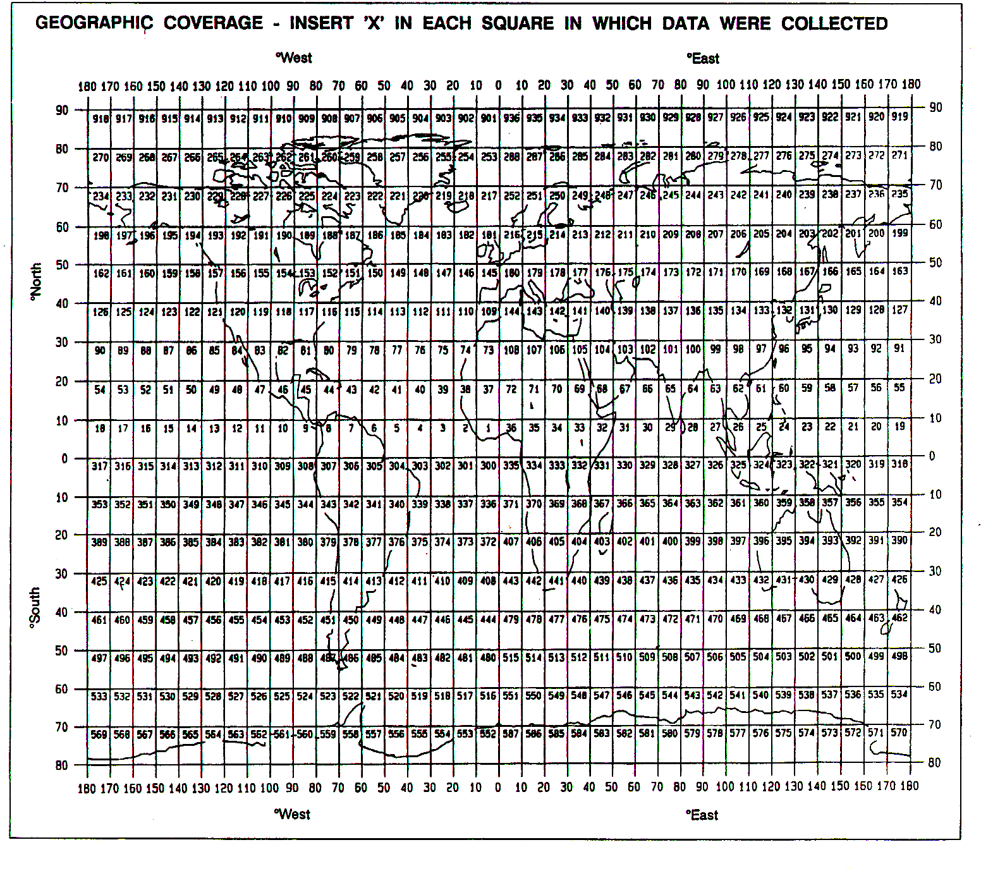

**see above**