**H2S events in the Peruvian oxygen minimum zone facilitate enhanced dissolved Fe concentrations**

Christian Schlosser1*, Peter Streu1, Martin Frank1, Gaute Lavik2, Peter L. Croot1,3, Marcus Dengler1 and Eric P. Achterberg1

1Marine Biogeochemie, Helmholtz-Zentrum für Ozeanforschung, GEOMAR, Kiel, Germany

2Max-Plank-Institut für Mikrobiologie, 28359 Bremen, Germany

3iCRAG (Irish Centre for Research in Applied Geoscience), Earth and Ocean Sciences, NUI Galway, Galway, Ireland

S1 – Applied concentrations and stability coefficient of model parameters for Visual MINTEQ 3.1

|  |  |  |
| --- | --- | --- |
| components | concentrations | |
|  |  | |
| Na1+ | 481 mM | |
| K1+ | 10 mM | |
| Mg2+ | 54 mM | |
| Ca2+ | 11 mM | |
| Sr2+ | 90 µM | |
| Cl-1 | 650 mM | |
| Br-1 | 870 µM | |
| CO3-2 | 2 mM | |
| B(III) | 430 µM | |
| F-1 | 70 µM | |
| H2S (variable) | 0.001 – 100 mM | |
| Fe(II) | 0.2 µM | |
| pH | 7.651 | |
|  |  | |
| included species | | |
| mackinawite | | log Ksp = -3.62 |
| FeSaqu | | log K = 5.623 |
|  | |  |

Supplementary Figures

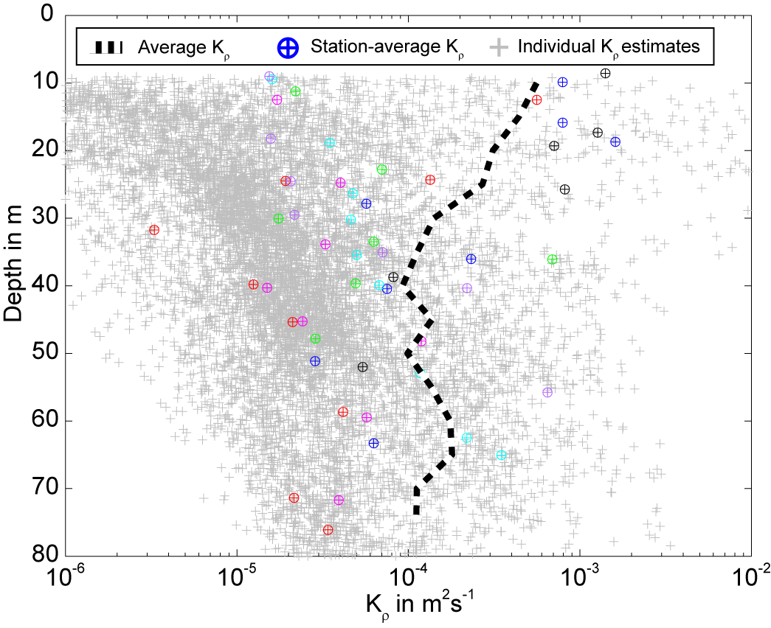

Figure S1: Shows vertical diffusivity (Kρ) versus depth. Kρ was estimated from 102 microstructure deployments at stations with water depth between 80 and 100 m as described in Schaftstall et al. 4. The data was collected during FS Metor cruise M92-2 in January 2012 (for more detail please read Sommer et al. 5). Cruise M92-2 took place in the same OMZ region than Meteor cruise M77-3. The dashed black line indicates the average Kρ at depth. The vertical diffusive DFe flux was calculated using an average value of Kρ = 3.1 x 10-4 m2 s-1, derived from Kρ values between mid-depth waters (40m) and the surface (10m).

References

1 Feely, R. A., Sabine, C. L., Hernandez-Ayon, J. M., Ianson, D. & Hales, B. Evidence for upwelling of corrosive “acidified” water onto the continental shelf. *Science* **320**, 1490-1492 (2008).

2 Gustafsson, J. P. *Visual MINTEQ ver. 3.1*, <<https://vminteq.lwr.kth.se>> (2014).

3 Rickard, D. & Luther III, G. W. Chemistry of Iron sulfids. *Chem. Rev.* **107**, 514-562 (2007).

4 Schafstall, J., Dengler, M., Brandt, P. & Bange, H. Tidal-induced mixing and diapycnal nutrient fluxes in the Mauritanian upwelling region. *J. Geophys. Res.: Oceans* **115**, 1-19 (2010).

5 Sommer, S., Dengler, M. & Treude, T. Benthic element cycling, fluxes and transport of solutes across the benthic boundary layer in the Peruvian oxygen minimum zone, (SFB754) – Cruise No. M92 – January 05 – February 03, 2013 – Callao (Peru) – Callao (Peru), Meteor-Berichte, M92, DFG-Senatskommission für Ozeanographie, 55 p. (2014).