APPENDIX
Supplementary Tables
Table A1. Summary of petrographic observations of chimney samples from the Tinakula deposit (see Anderson, 2018, for detailed petrographic reports)

Table A1. Continued

Table A2. Average trace-element concentrations measured by EMPA for sulfide minerals from the Tinakula deposit (full data in Anderson, 2018)

Table A3. Estimations of percent illite in mixed-layer illite/smectite clays using peak positions of glycol-saturated preparations, following Moore and Reynolds (1997).

Location |  | 001/002 | 002/003
Drill Hole | Sample | d(Å) | d(Å) | Δd(Å) | % Illite | R
Site A (North)
TKAD001 | MA13-088 | 9.306 | 5.310 | 3.996 | 62 | 1
 | MA13-089 | 9.231 | 5.264 | 3.967 | 61 | 1
 | MA13-090 | 9.173 | 5.158 | 4.015 | 63 | 1
 | P005 | 9.306 | 5.188 | 4.118 | 68 | 1
 | MA13-091 | 9.512 | 5.125 | 4.387 | 80 | 1
 | MA13-092 | 9.391 | 4.873 | 4.518 | 85 | 1
TKAD015 | MA13-050 | 9.565 | 4.912 | 4.653 | 91 | 3
 | MA13-051 | 9.530 | 5.092 | 4.438 | 82 | 1
 | MA13-052 | 9.391 | 5.085 | 4.306 | 76 | 1
 | MA13-053 | 9.374 | 5.092 | 4.282 | 75 | 1
TKAD027 | MA13-057 | 9.494 | 5.090 | 4.404 | 80 | 1
 | MA13-058 | 9.399 | 5.120 | 4.279 | 75 | 1
TKAD028 | MA13-099 | 9.272 | 5.270 | 4.002 | 63 | 1
Site B
TKAD016 | MA13-035 | 9.331 | 5.188 | 4.143 | 69 | 1
TKAD025 | MA13-039 | 9.408 | 5.085 | 4.323 | 77 | 1
TKAD026 | MA13-068 | 9.149 | 5.194 | 3.955 | 60 | 1
 | MA13-069 | 9.281 | 5.178 | 4.103 | 67 | 1
Site D
TKAD017 | MA13-020 | 9.628 | 5.102 | 4.526 | 86 | 1
TKAD030 | MA13-006 | 9.434 | 5.125 | 4.309 | 76 | 1
TKAD018 | MA13-014 | 9.391 | 5.170 | 4.221 | 72 | 1
 | MA13-015 | 9.231 | 5.140 | 4.091 | 66 | 1
 | MA13-016 | 9.422 | 5.112 | 4.310 | 76 | 1
TKAD031 | MA13-044 | 9.323 | 5.178 | 4.145 | 69 | 1
 | MA13-045 | 9.289 | 5.122 | 4.167 | 70 | 1
Site E (South)
TKAD005 | P020 | 8.904 | 4.698 | 4.206 | 72 | 1
TKAD003 | P012 | 9.374 | 5.125 | 4.249 | 73 | 1
 | P013 | 9.382 | 5.115 | 4.267 | 74 | 1
 | P014 | 9.391 | 5.117 | 4.274 | 75 | 1
Site F (West)
TKAD007 | P022 | 9.314 | 5.135 | 4.179 | 70 | 1
 | P023 | 9.709 | 5.060 | 4.649 | 91 | 3
R = Reichweite

Table A4. Fluid inclusion (FI) characteristics, homogenization temperatures (T_{h}), entrapment temperatures (T_{e}), and salinities (wt.% NaCl_{equivalent}) from drill hole TKAD001
Table A5. Results of S-isotope measurements of sulfide and sulfate minerals at the Tinakula deposit

Table A6. Water:rock (w/r) ratios calculated from mass changes in Mg and K in altered rocks for each mineral assemblage

Supplementary Figures
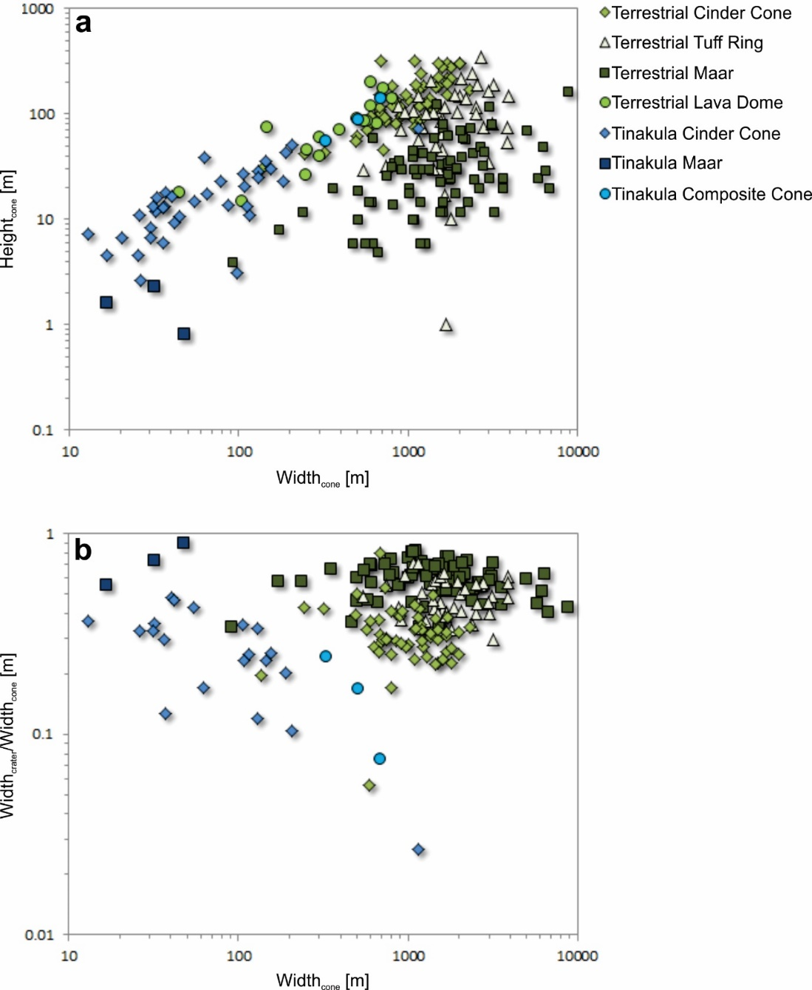
Fig. A1. Aspect ratios of volcanic edifices in terrestrial environments (green: Pike, 1978) and at the submarine Tinakula deposit (blue; this study), with logarithmic scales: (a) cone width vs. cone height; (b) cone width vs. crater/cone width. Parameters are tabulated in Anderson (2018). The composite cones are 55–140 m high with basal diameters of 327–691 m and low aspect ratios compared to cinder cones (H/W_{cone,avg} = 0.18). These volcanoes have relatively small craters (52–86 m in diameter and 11–26 m deep) relative to the basal diameter of the cone (W_{crater}/W_{cone,avg} = 0.16). The cinder cones vary in size, with heights of just 3 m up to 73 m, and basal diameters of 13–1158 m (H/W_{cone,avg} = 0.27). These are both uncratered (n = 16) and cratered (n = 20), with crater diameters of 5–35 m and crater depths of 1–13 m (W_{crater}/W_{cone,avg} = 0.27). The submarine equivalent of volcanic “maars” have the lowest aspect ratios (H/W_{cone,avg} = 0.06), with heights of only 1–2 m and basal diameters of 17–32 m. They also have the largest crater widths relative to their basal diameters (W_{crater}/W_{cone,avg} = 0.73), with crater diameters of 9–43 m. The defining feature of the “maars” is a crater floor that is at the same elevation, or even below, the surrounding seafloor depth, with crater depths of 2–4 m. This highlights the morphological similarity of volcanic cones at Tinakula with subaerial volcanoes, with smaller cone widths for all volcanic edifice types at Tinakula.
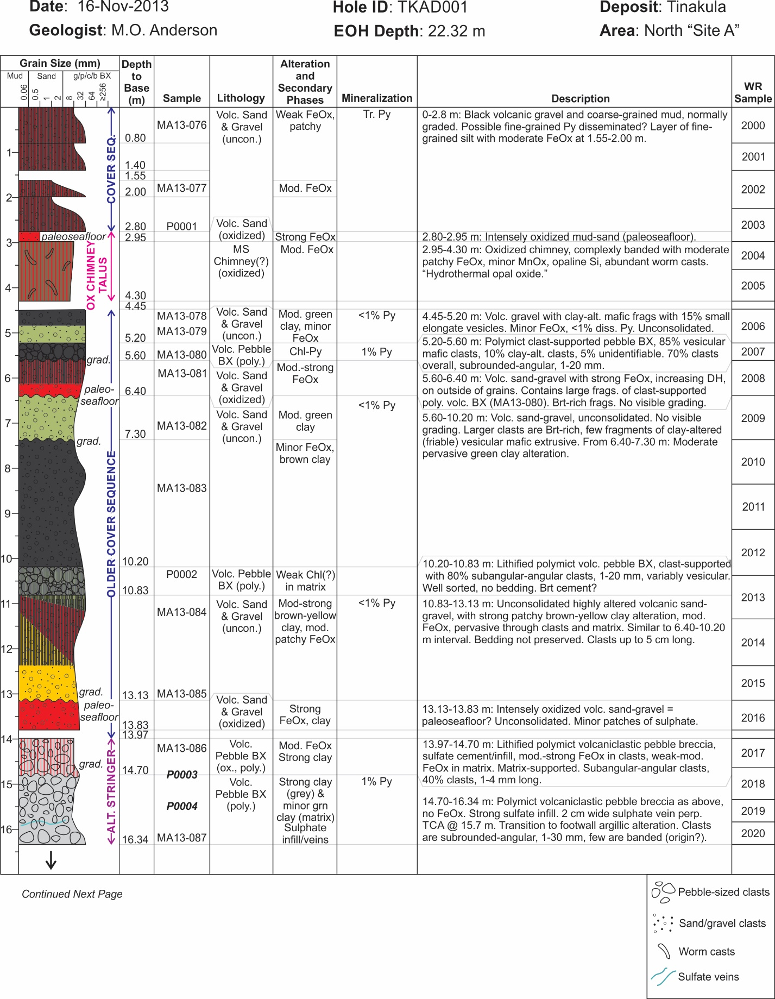
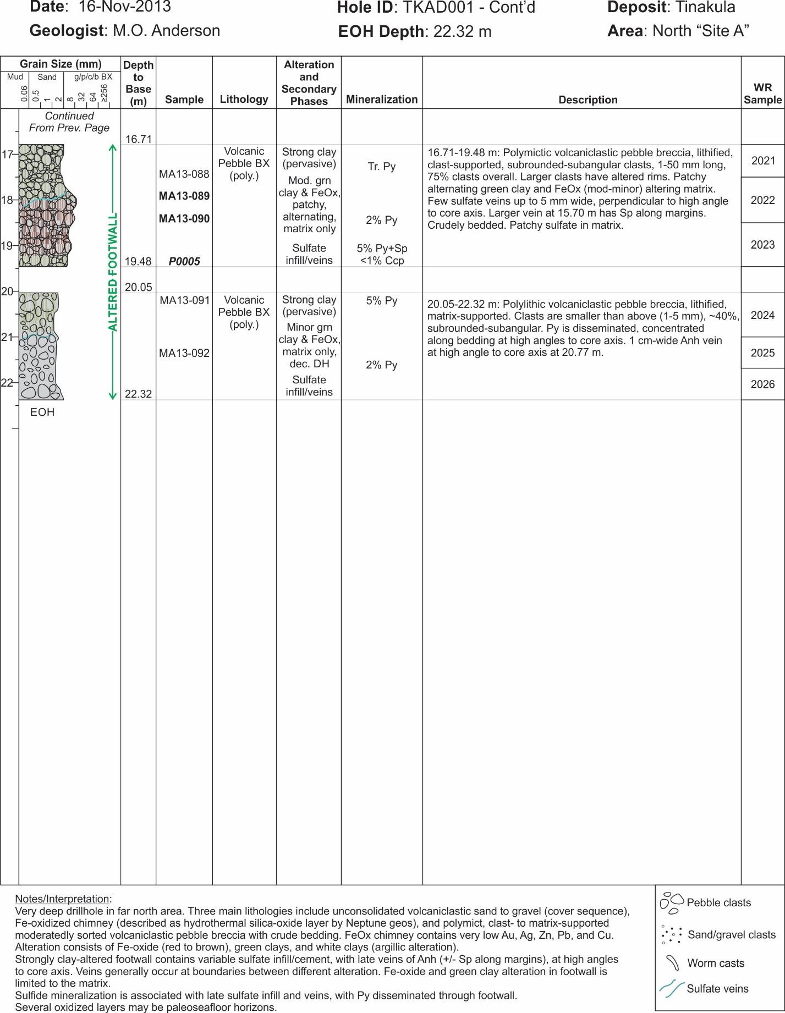

Fig. A2. Graphical drillcore summary log of TKAD001 from Site A (location shown on Fig. 2).

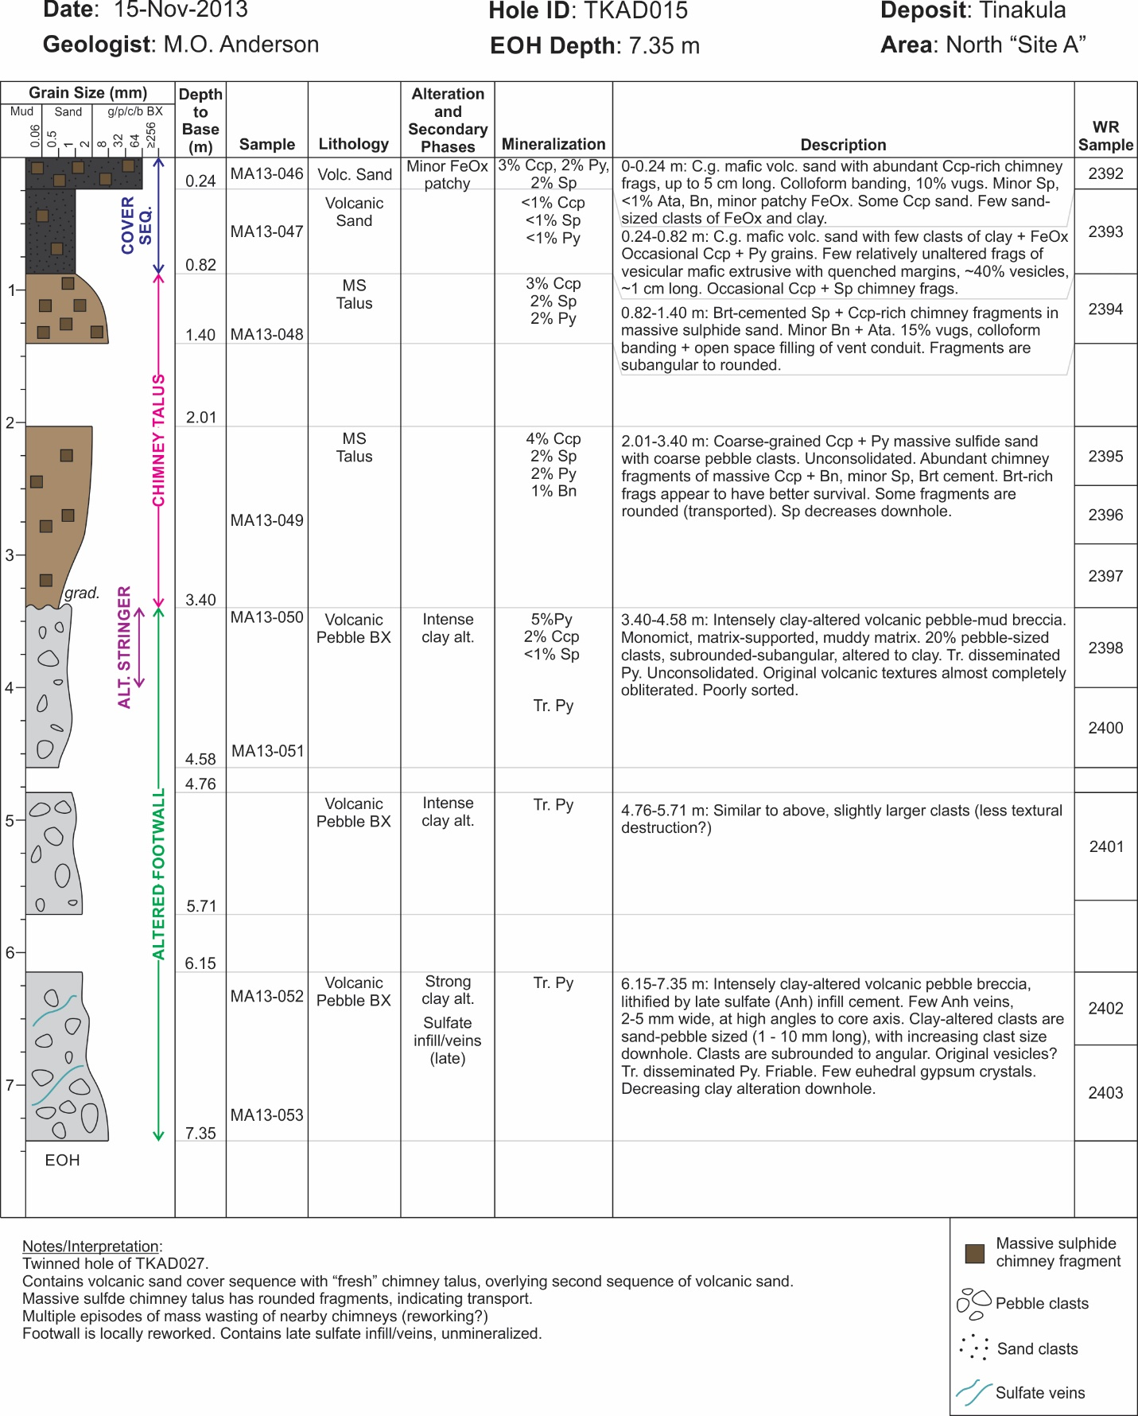
Fig. A3. Graphical drillcore summary log of TKAD015 from Site A (location shown on Fig. 2).

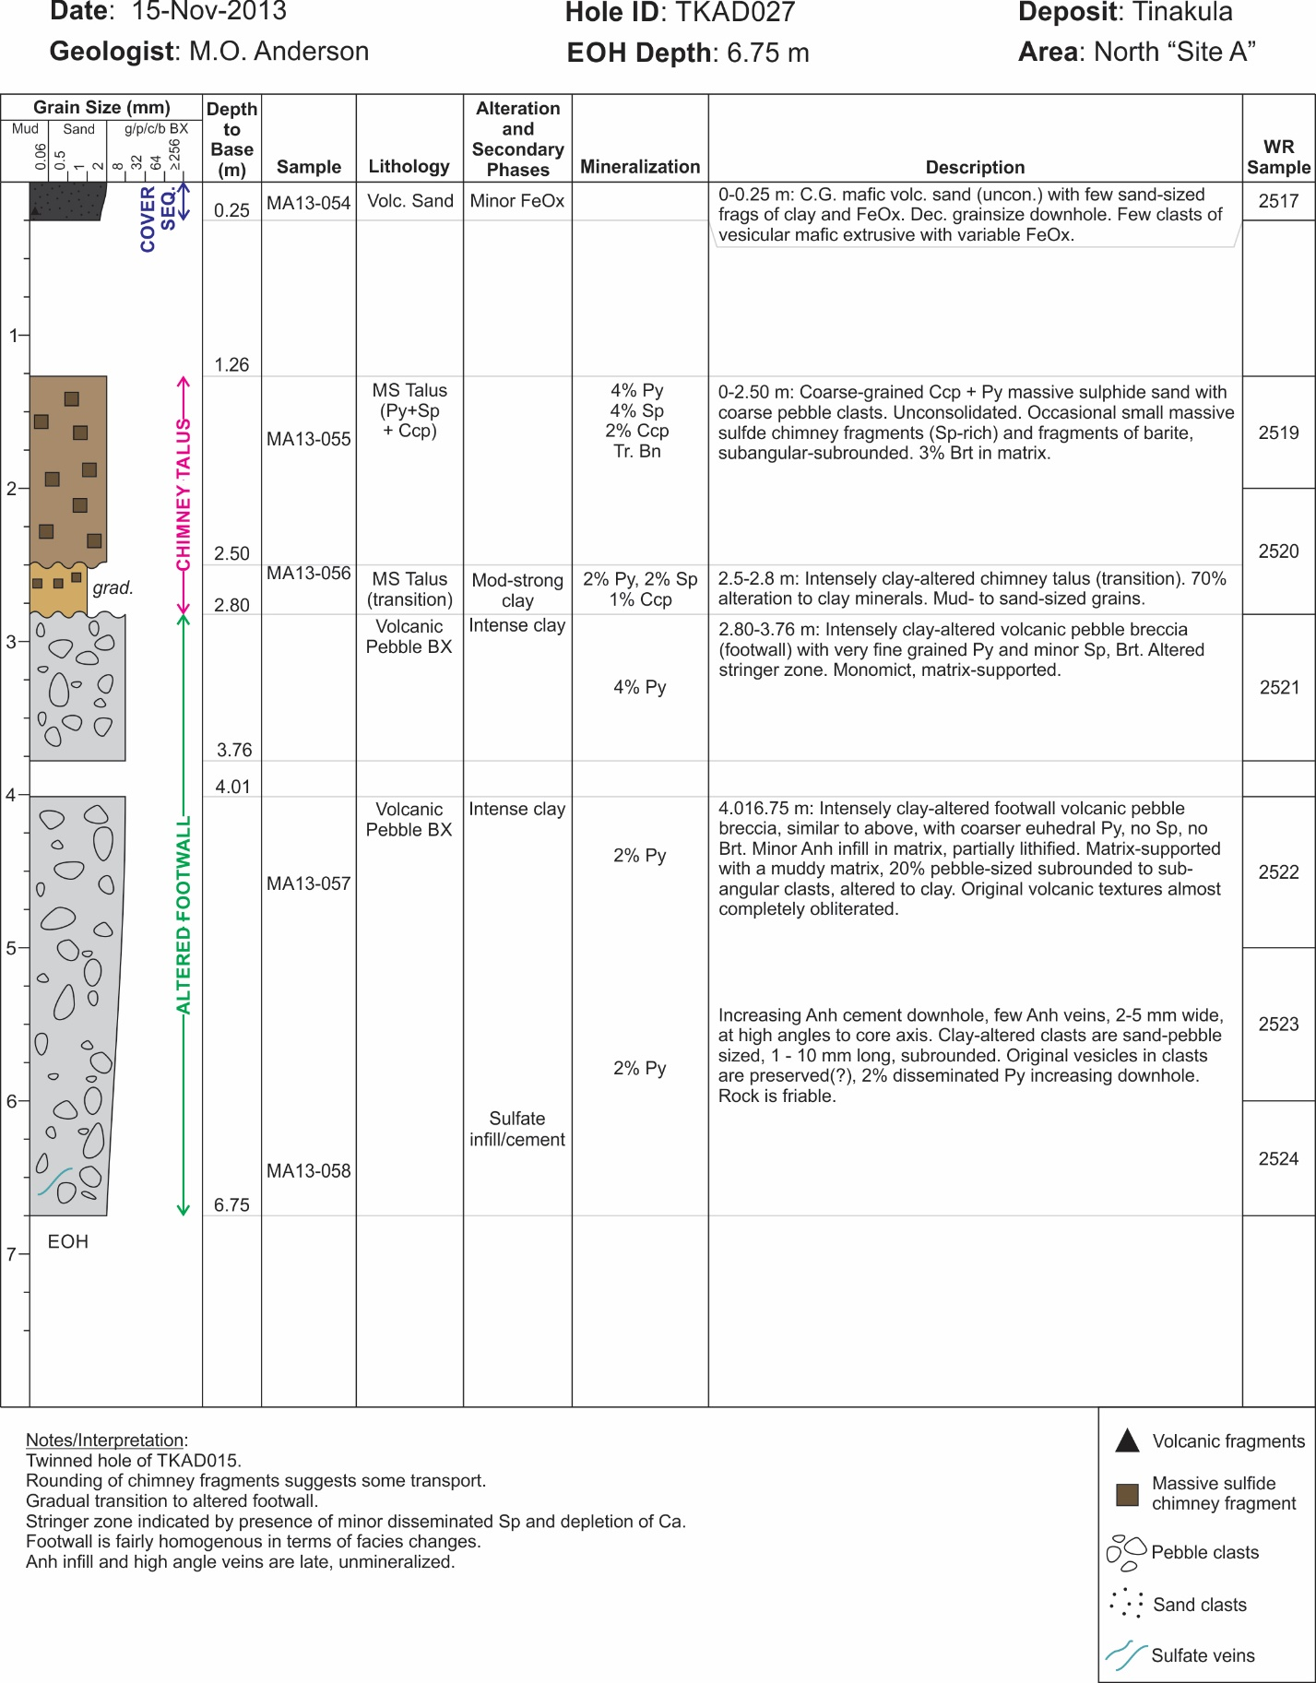

Fig. A4. Graphical drillcore summary log of TKAD027 from Site A (location shown on Fig. 2).

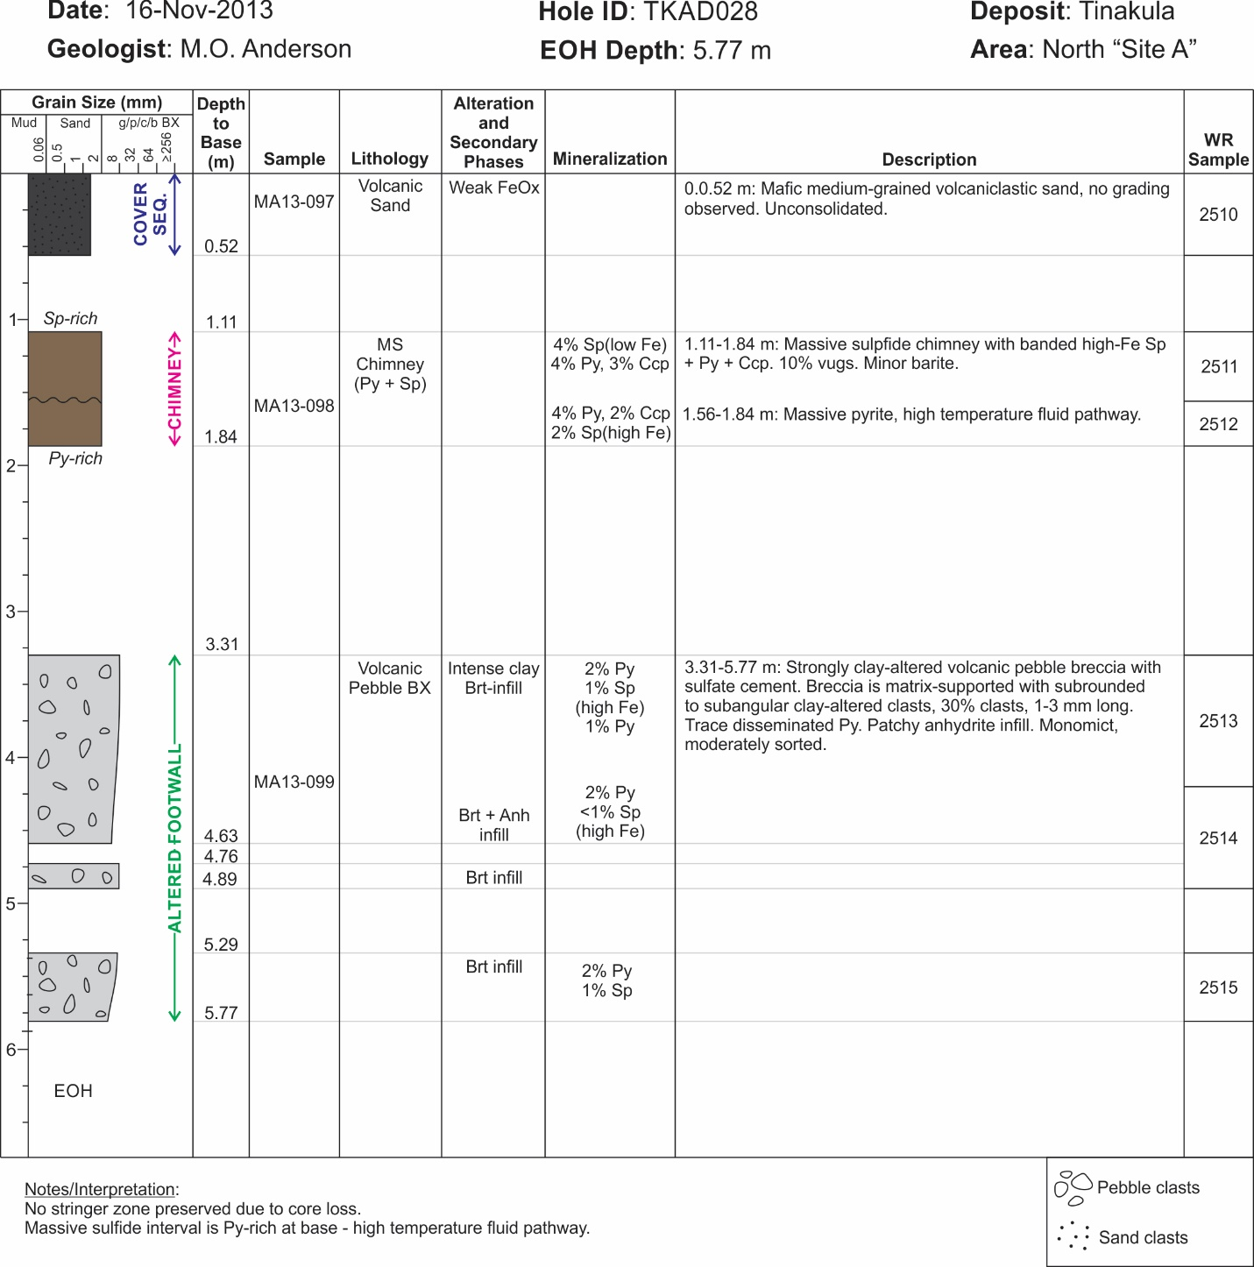

Fig. A5. Graphical drillcore summary log of TKAD028 from Site A (location shown on Fig. 2).

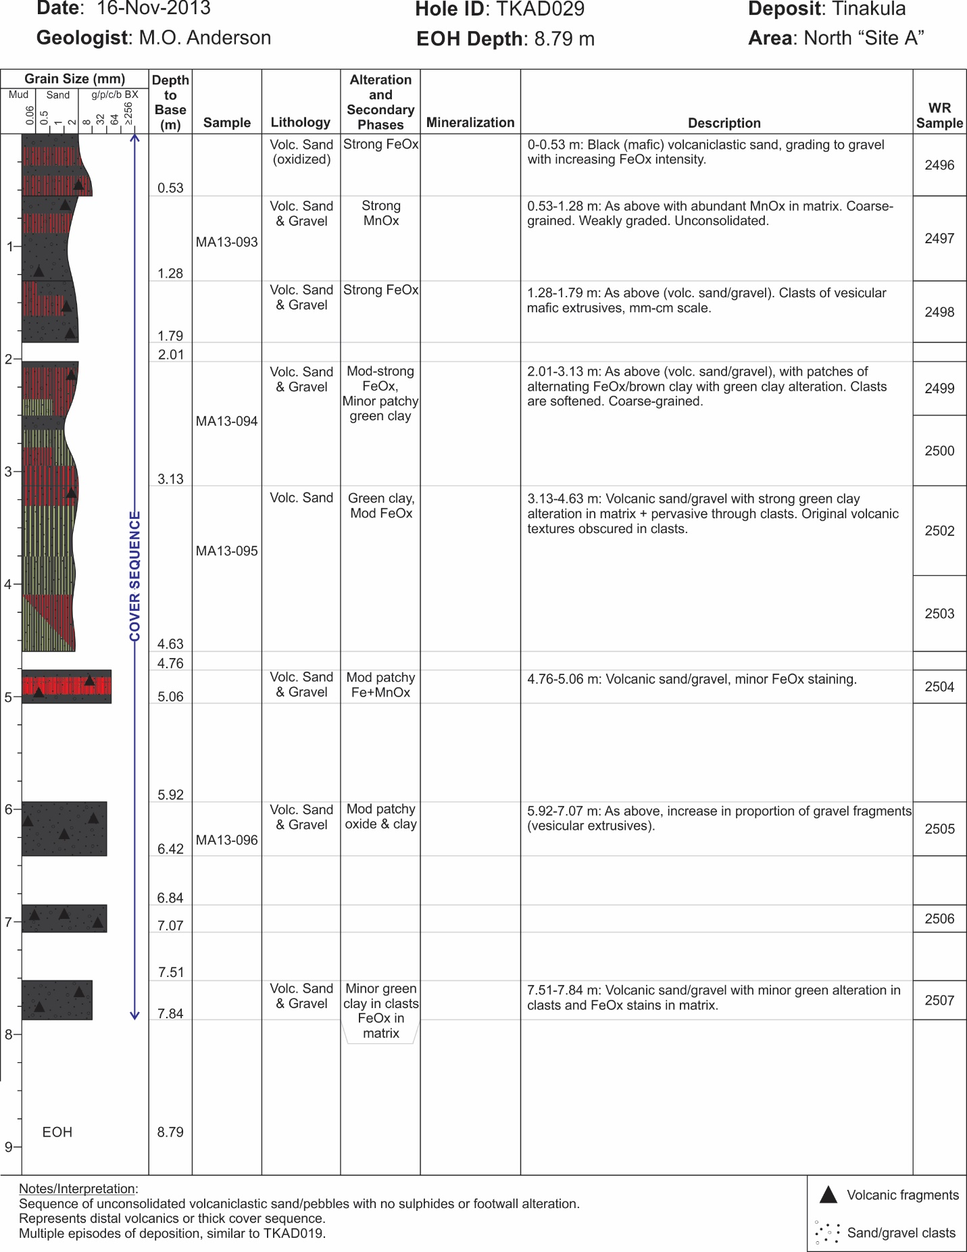

Fig. A6. Graphical drillcore summary log of TKAD029 from Site A (location shown on Fig. 2).

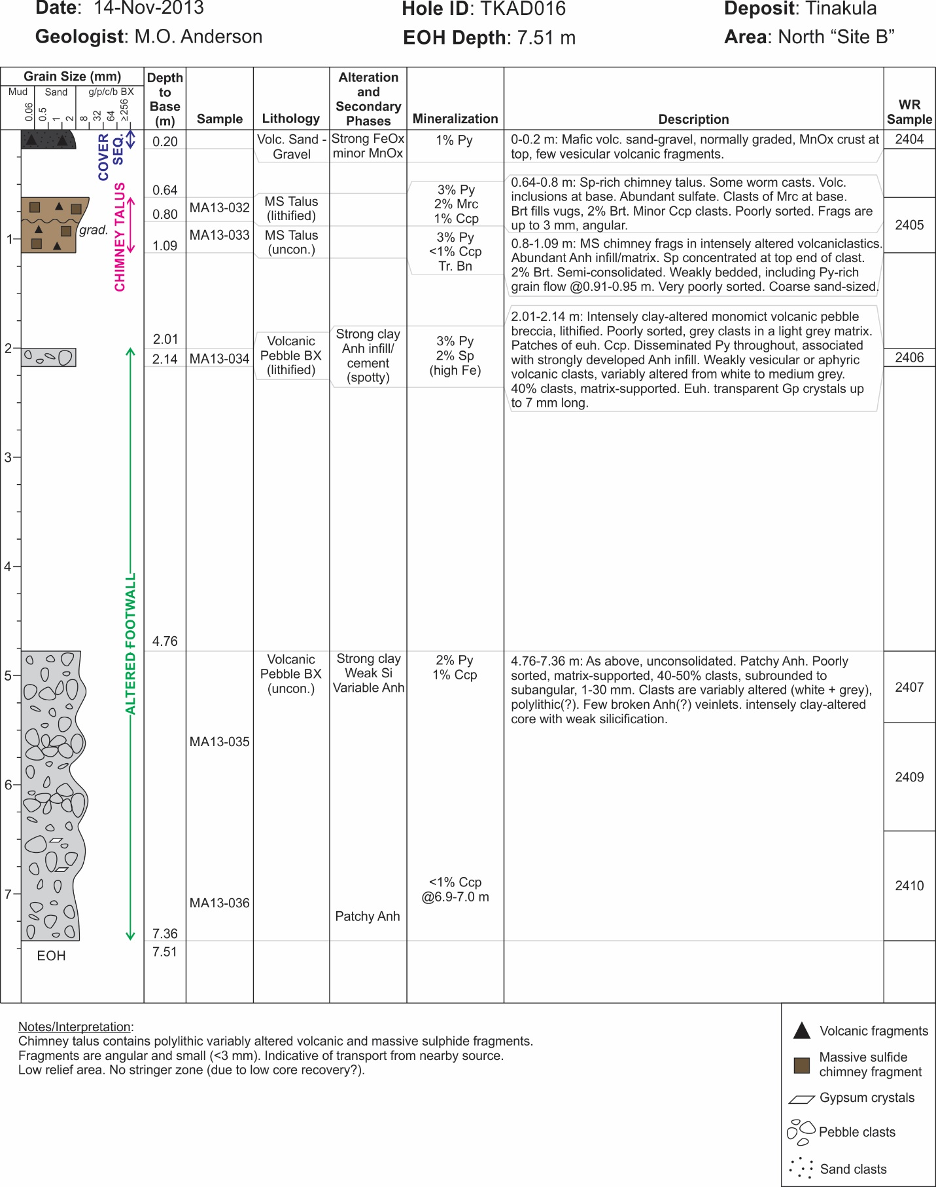

Fig. A7. Graphical drillcore summary log of TKAD016 from Site B (location shown on Fig. 2).
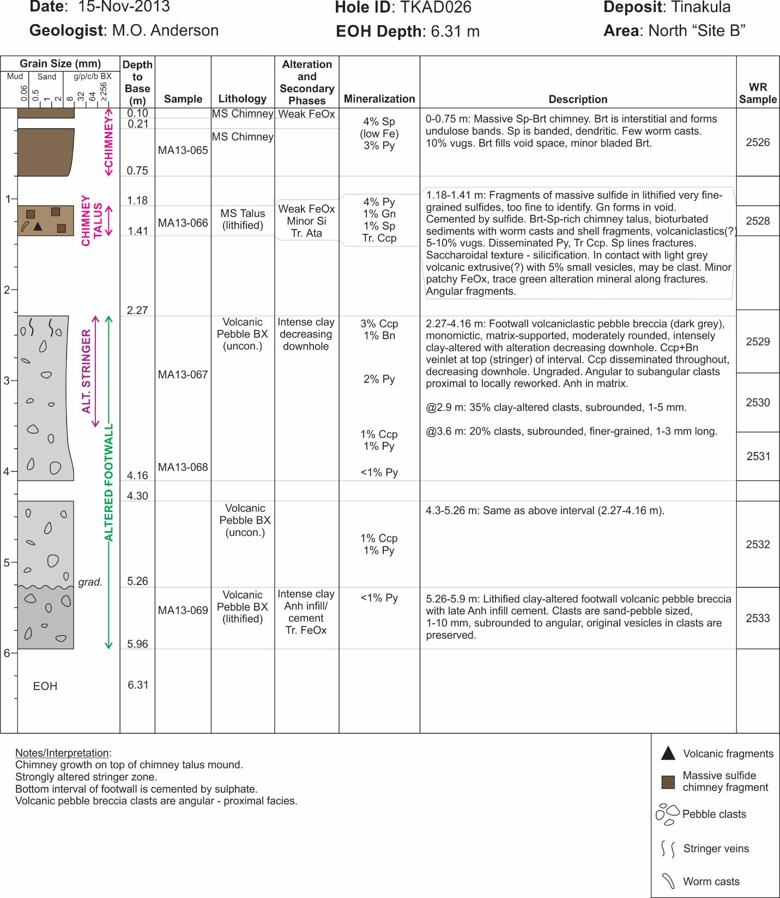

Fig. A8. Graphical drillcore summary log of TKAD026 from Site B (location shown on Fig. 2).

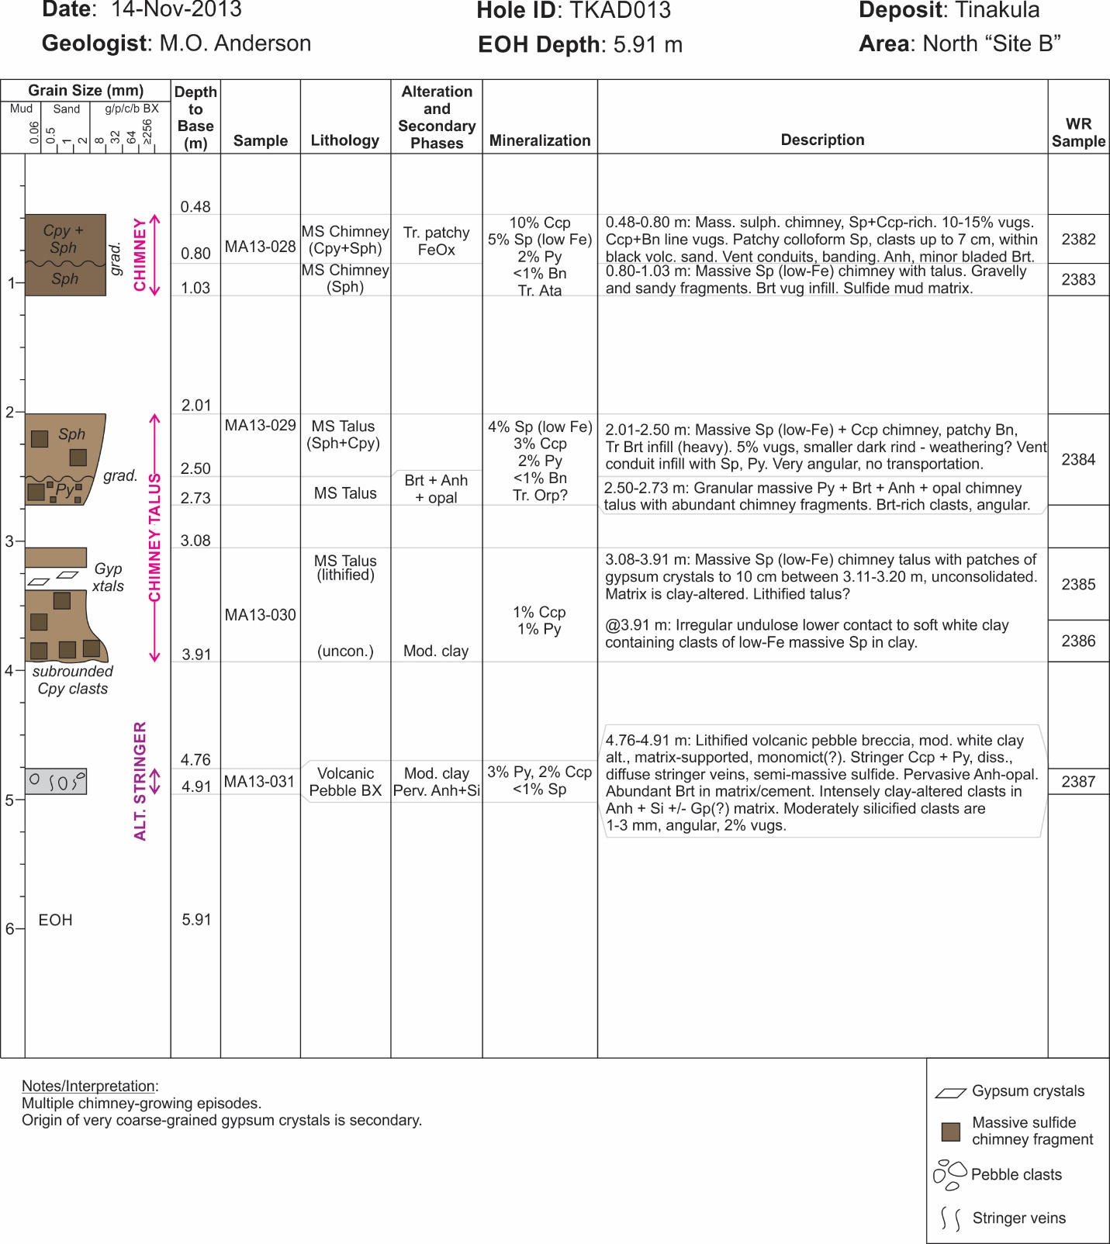
Fig. A9. Graphical drillcore summary log of TKAD013 from Site B (location shown on Fig. 2).

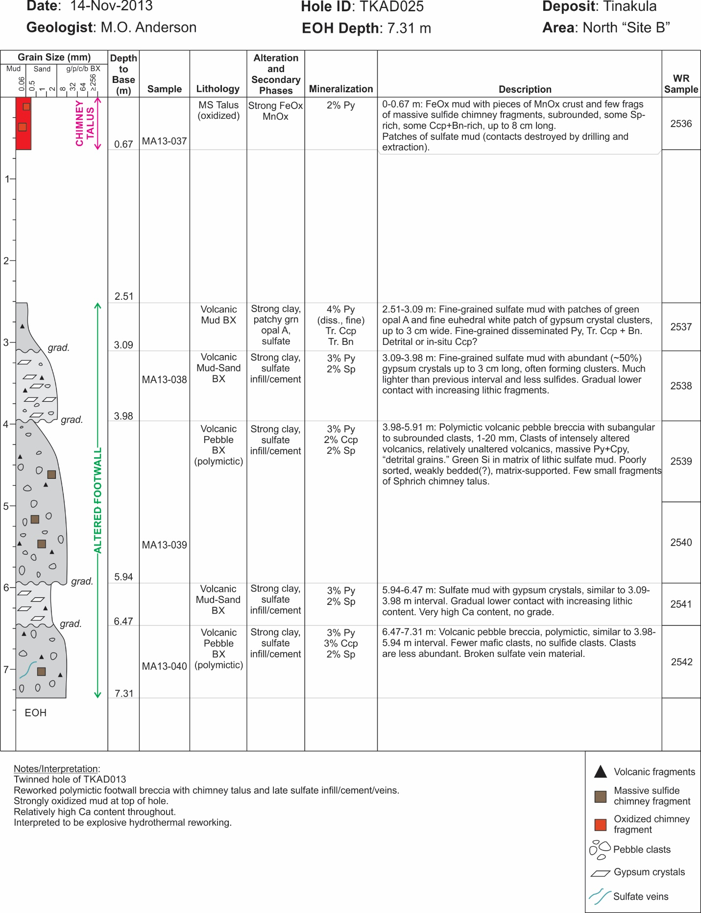

Fig. A10. Graphical drillcore summary log of TKAD025 from Site B (location shown on Fig. 2).

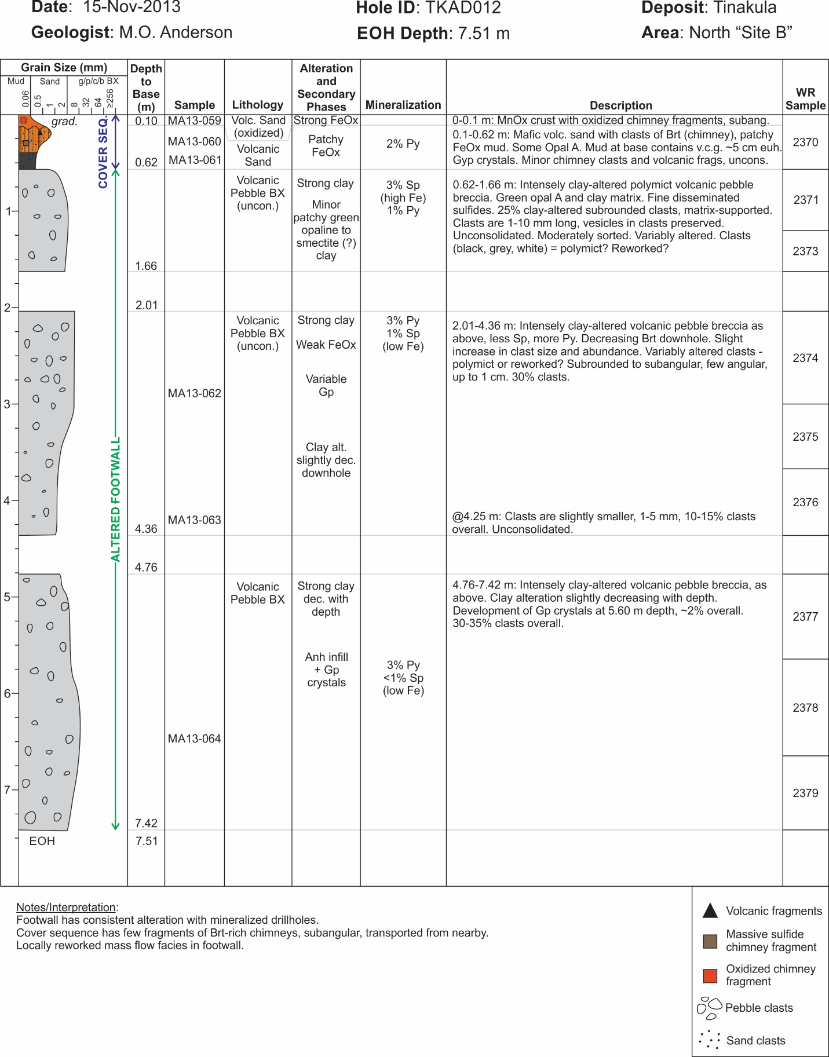
Fig. A11. Graphical drillcore summary log of TKAD012 from Site B (location shown on Fig. 2).

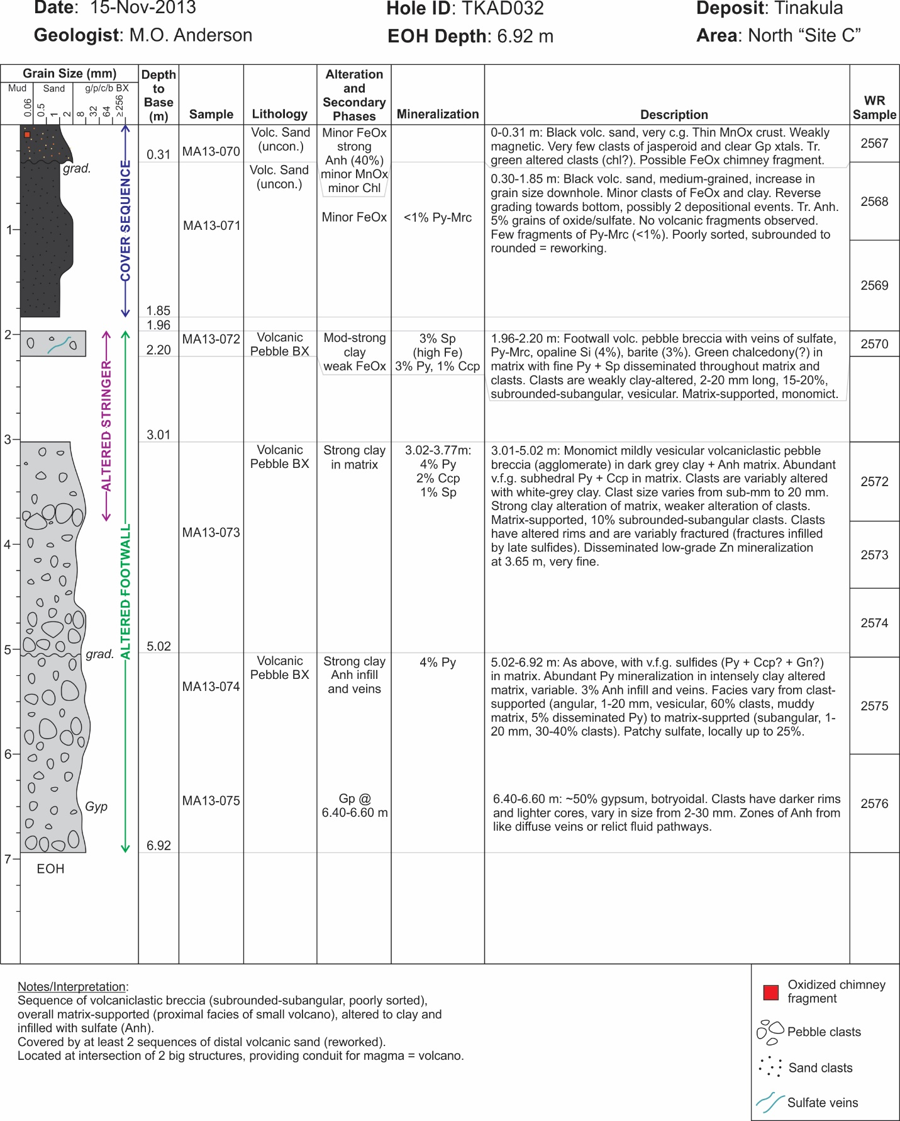

Fig. A12. Graphical drillcore summary log of TKAD032 from Site C (location shown on Fig. 2).

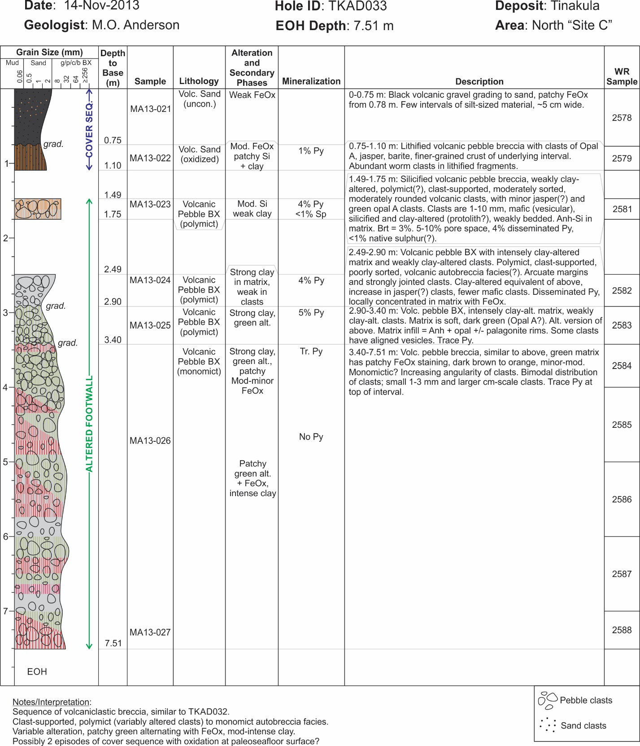

Fig. A13. Graphical drillcore summary log of TKAD033 from Site C (location shown on Fig. 2).

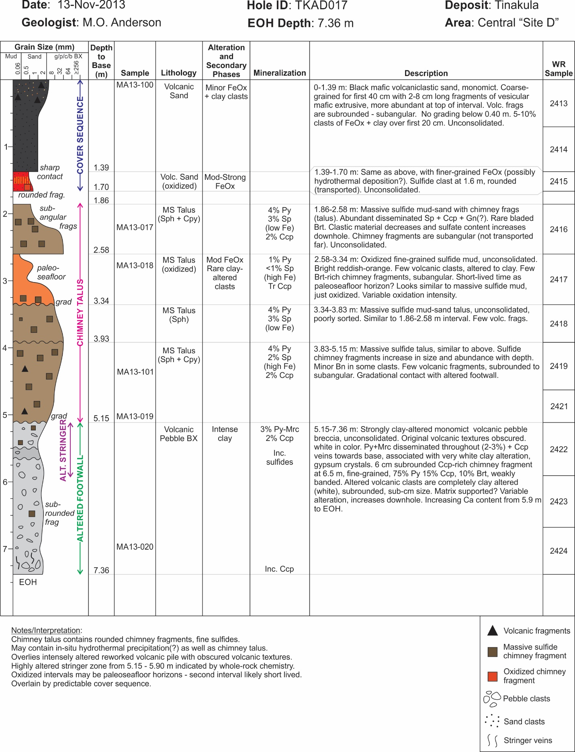

Fig. A14. Graphical drillcore summary log of TKAD017 from Site D (location shown on Fig. 2).
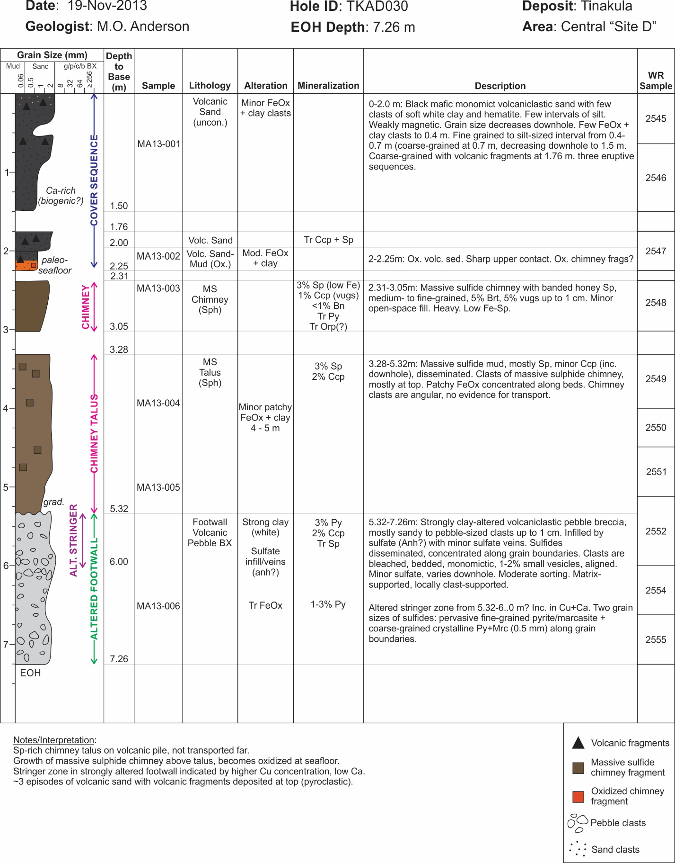

Fig. A15. Graphical drillcore summary log of TKAD030 from Site D (location shown on Fig. 2).
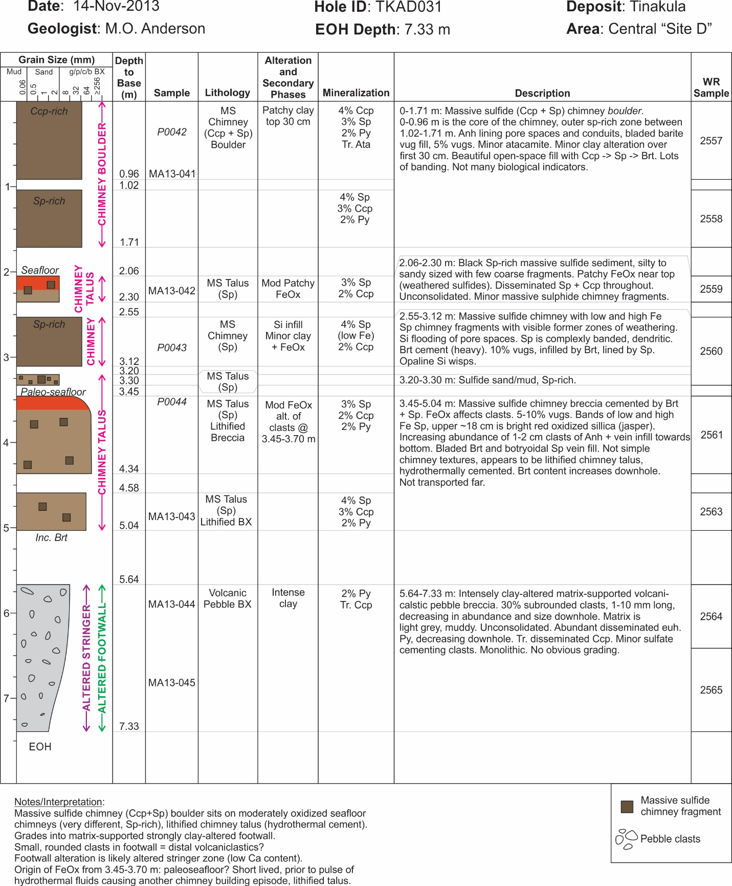

Fig. A16. Graphical drillcore summary log of TKAD031 from Site D (location shown on Fig. 2).

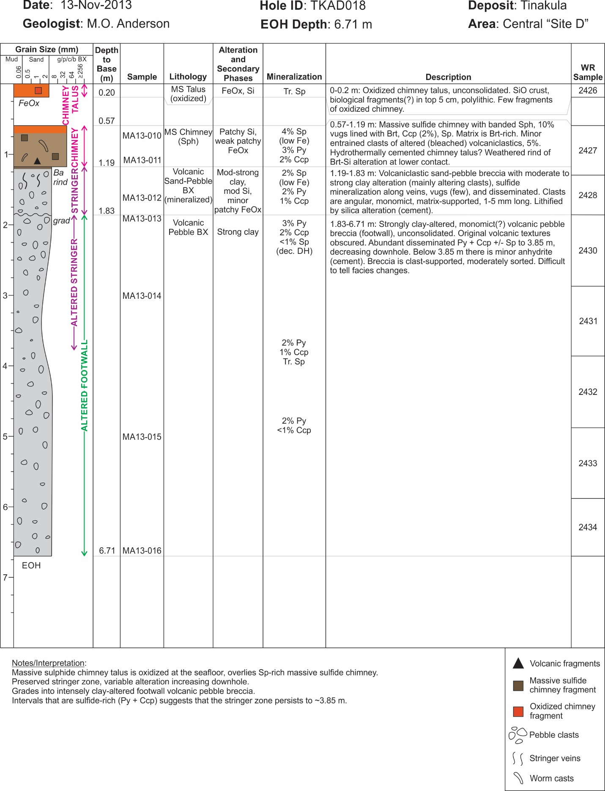

Fig. A17. Graphical drillcore summary log of TKAD018 from Site D (location shown on Fig. 2).

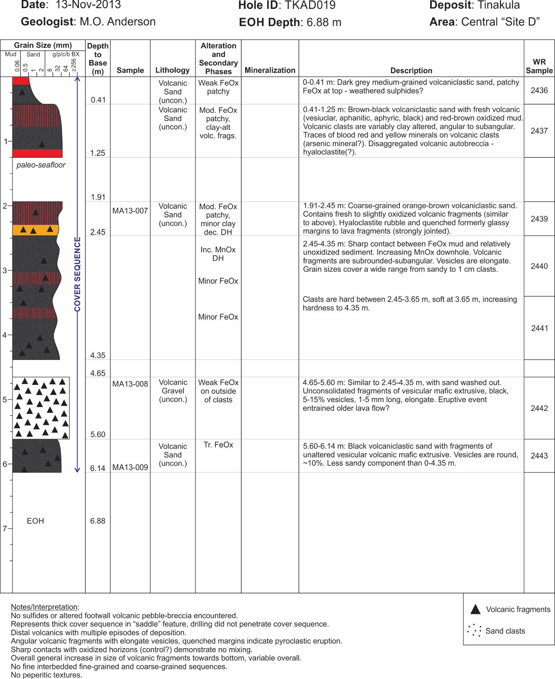

Fig. A18. Graphical drillcore summary log of TKAD019 from Site D (location shown on Fig. 2).

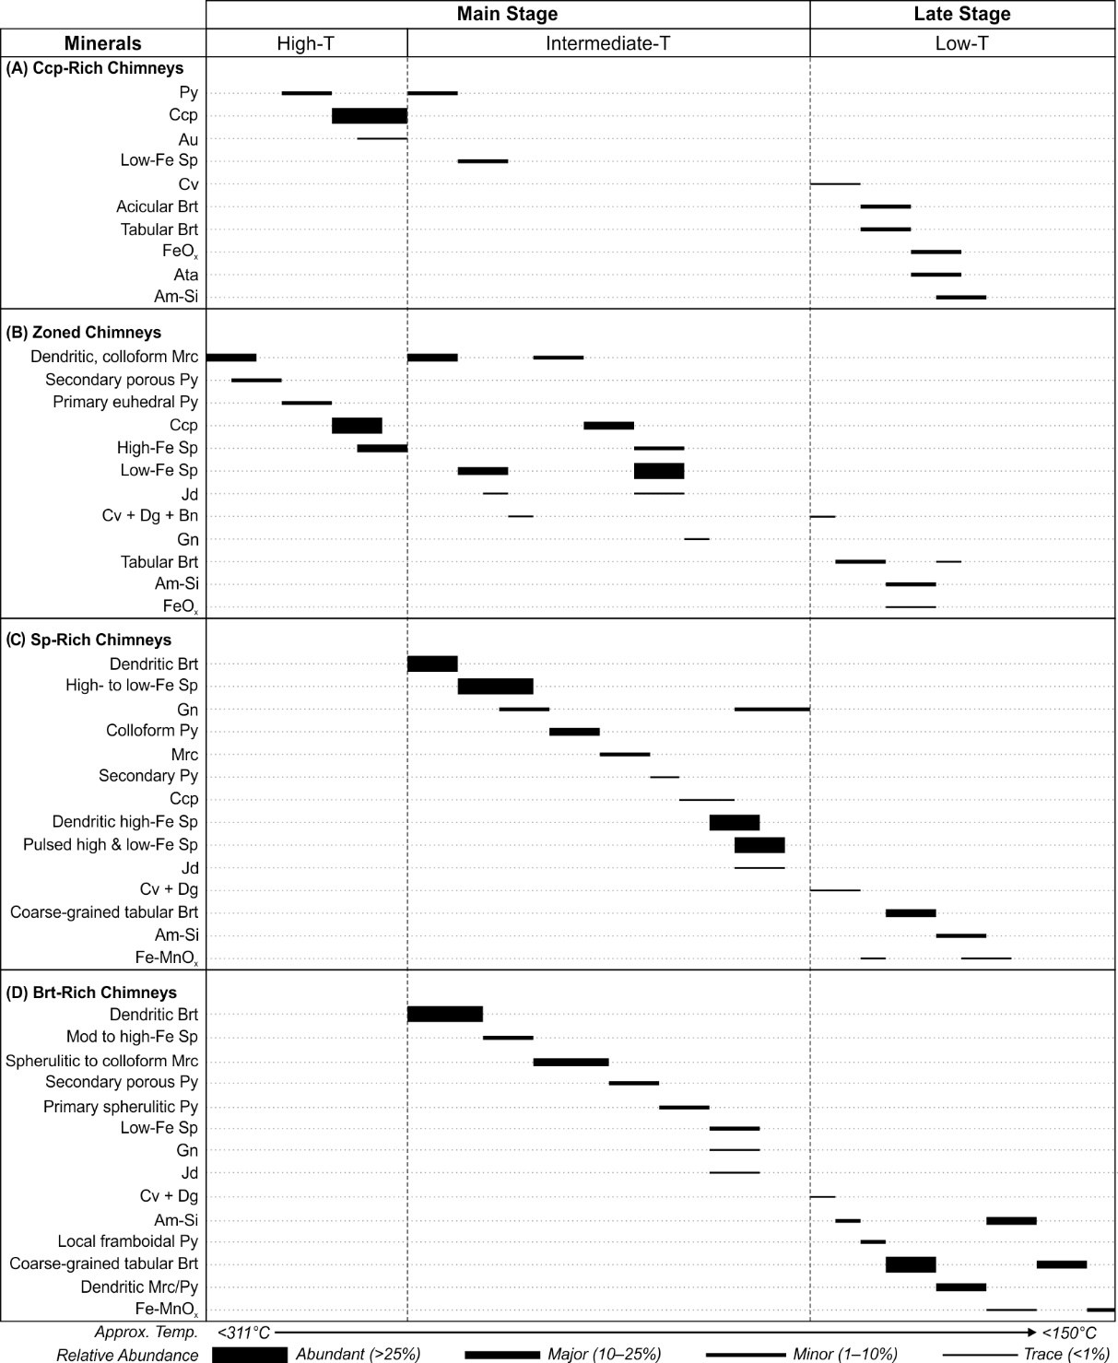
Fig. A19. General paragenesis of chimney types at the Tinakula deposit: (a) chalcopyrite-rich chimneys; (b) zoned chimneys; (c) sphalerite-rich chimneys; (d) barite-rich chimneys. Note that these generalized mineralization sequences are locally repeated within individual chimneys. Am-Si = amorphous silica; Ata = atacamite; Au = gold; Bn = bornite; Brt = barite; Dg = digenite; Ccp = chalcopyrite; Cv = covellite; Fe-MnOx = iron-manganese oxyhydroxide; Gn = galena; Jd = jordanite; Mrc = marcasite; Py = pyrite; Sp = sphalerite.

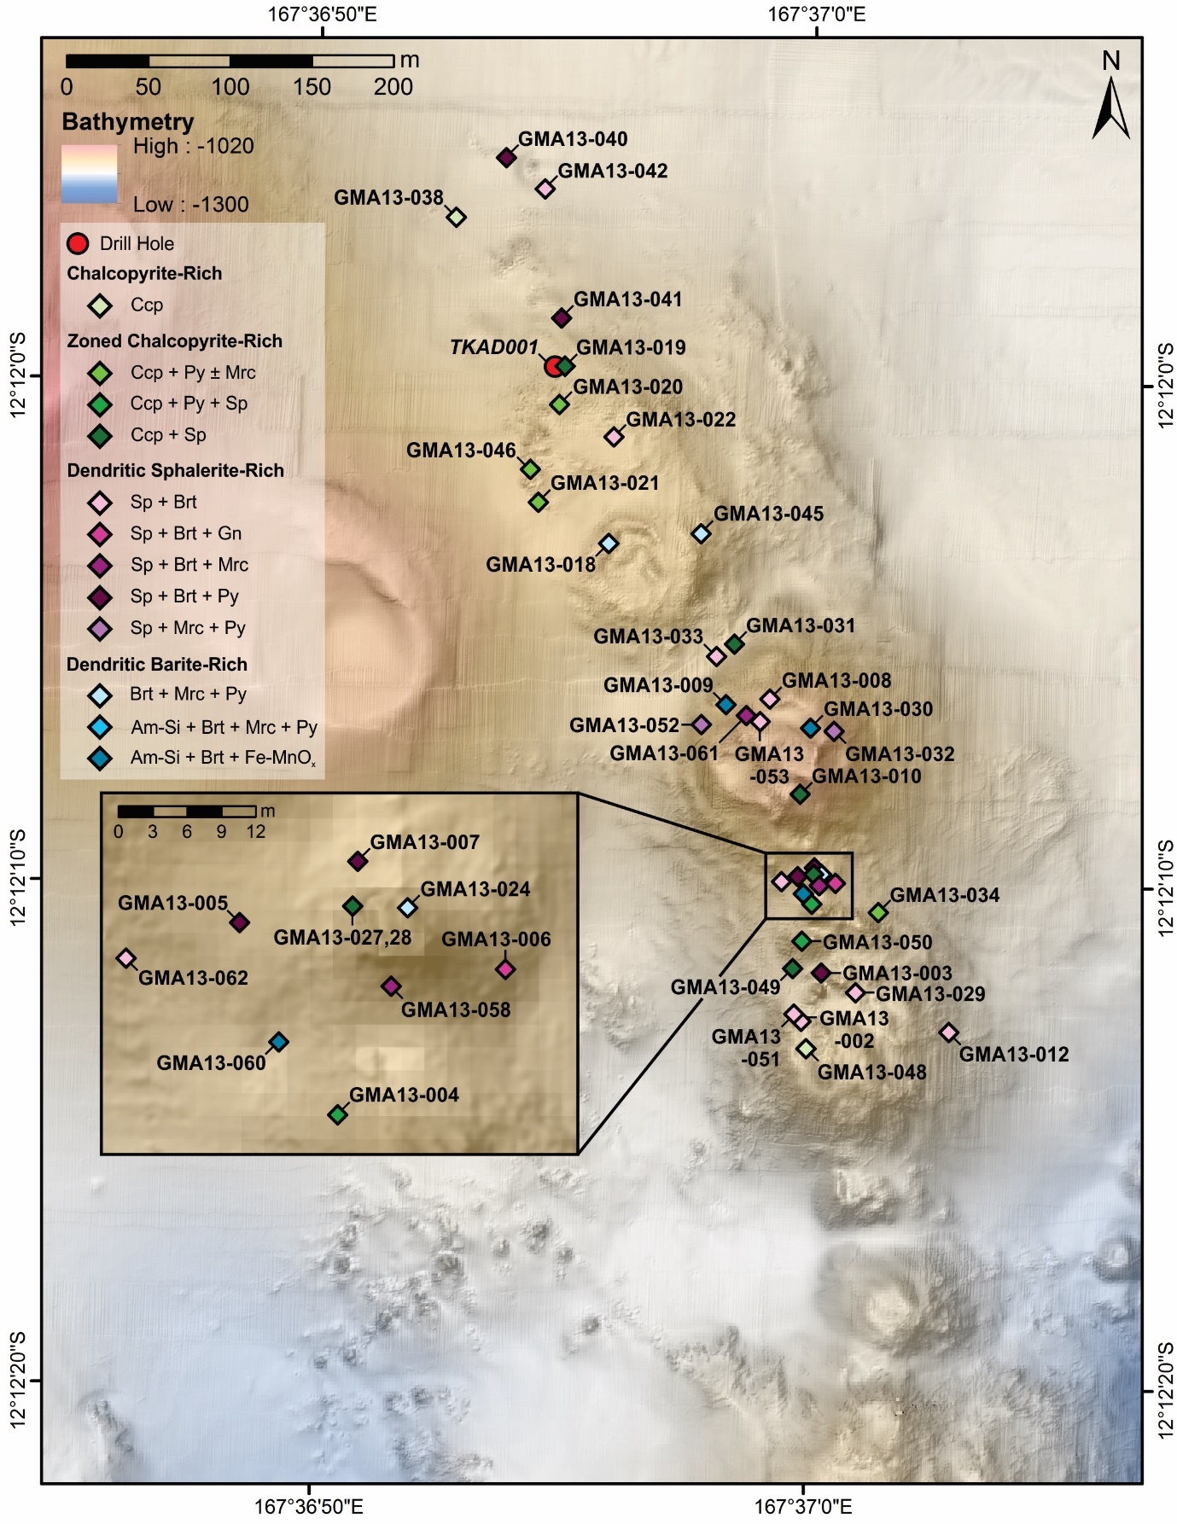
Fig. A20. Map of the distribution of sulfide-sulfate chimney types in the Tinakula area overlain on RESON SeaBat 7125-ROV2 multibeam bathymetry. See text for chimney classification. Am-Si = amorphous silica; Brt = barite; Ccp = chalcopyrite; Mrc = marcasite; Py = pyrite; Sp = sphalerite.

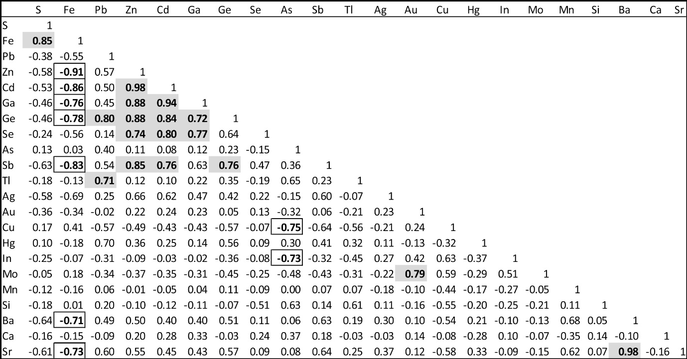
Fig. A21. Correlation matrix (Pearson) for high-temperature chimneys (chalcopyrite-rich and zoned chalcopyrite-rich chimney types) from the Tinakula deposit. Correlation coefficients indicating strong positive correlations are bold and shaded, and strong negative correlations are bold and outlined (minimum 99% confidence interval; n = 13).

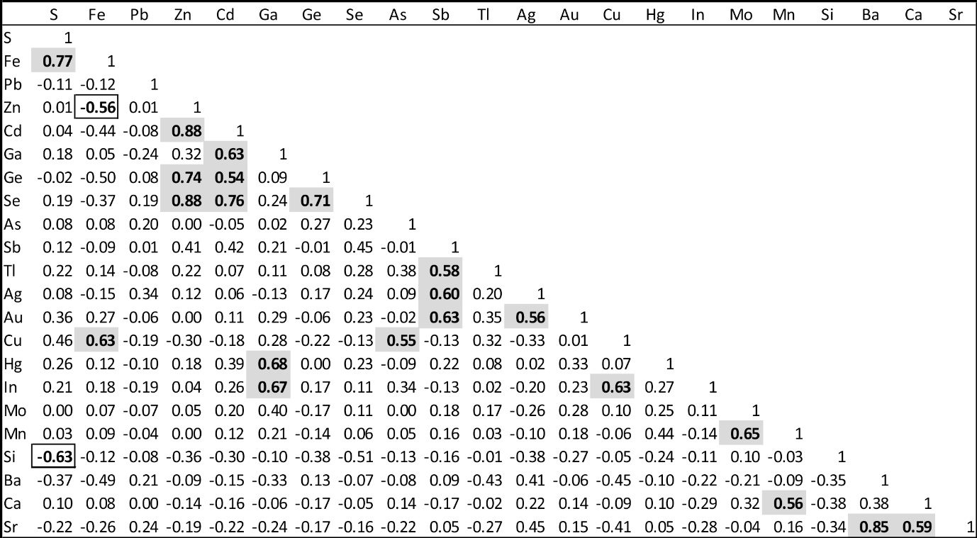

Fig. A22. Correlation matrix (Pearson) for low-temperature chimneys (dendritic sphalerite-rich and barite-rich chimney types) from the Tinakula deposit. Correlation coefficients indicating strong positive correlations are bold and shaded, and strong negative correlations are bold and outlined (minimum 99% confidence interval; n = 23).

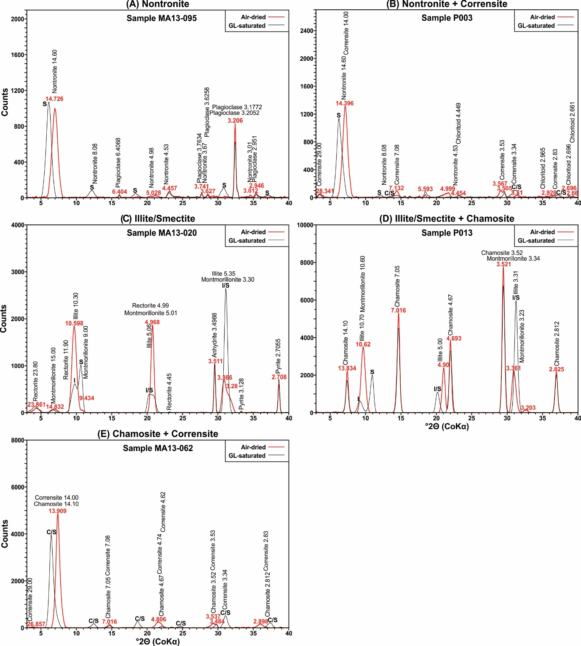
Fig. A23. Examples of XRD spectra (background-corrected) of air-dried (red) and glycol-saturated (black) samples showing main alteration assemblages from Tinakula deposit: (a) nontronite + plagioclase, (b) nontronite + corrensite, (c) illite/smectite + pyrite, (d) illite/smectite + chamosite, and (e) chamosite + corrensite.

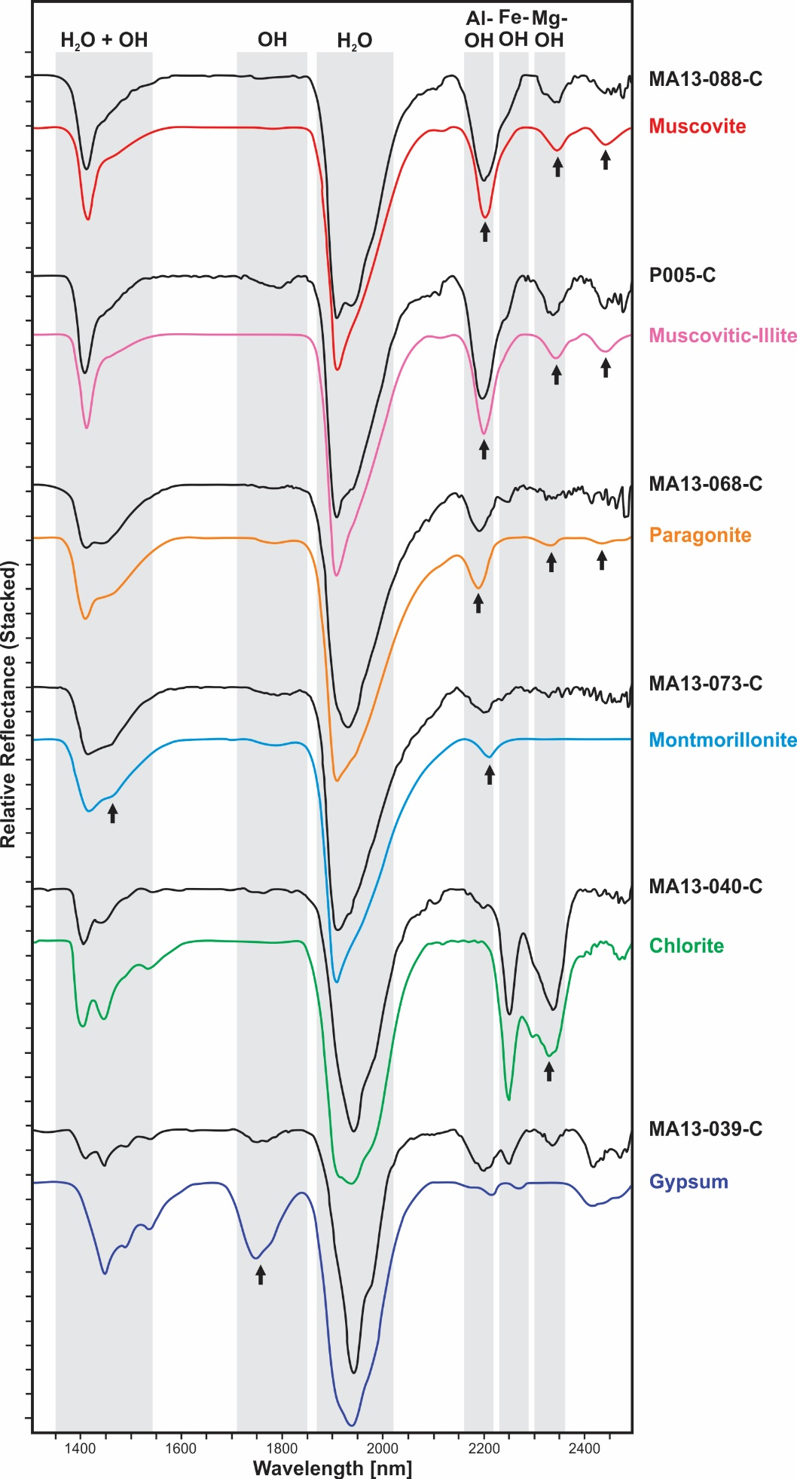
Fig. A24. Main minerals identified by SWIR spectroscopy, with reference spectra (colored lines) and examples of samples from intensely altered footwall from Tinakula deposit (Hull Quotient normalized). Diagnostic absorption features are shown by black arrows.

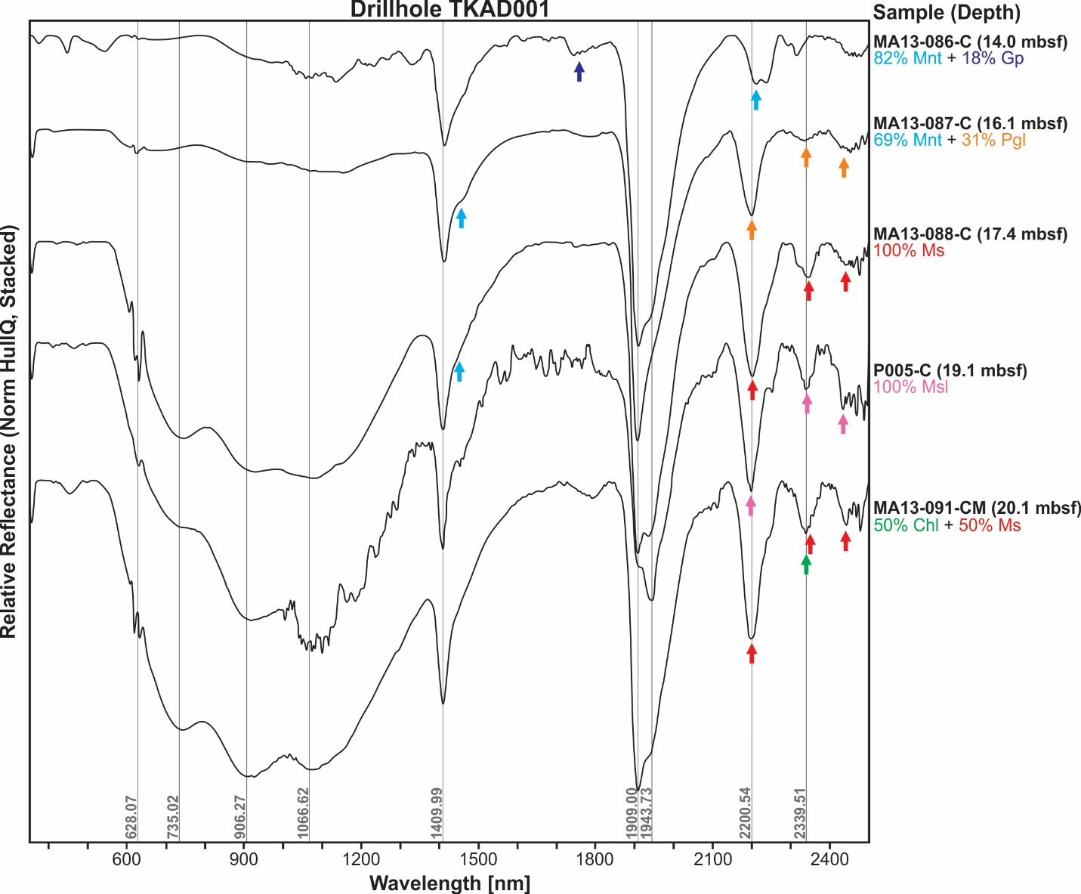
Fig. A25. Stacked SWIR spectra for samples from drill hole TKAD001 showing changes in mineralogy with depth (Hull Quotient normalized). Diagnostic absorption features are shown by colored arrows. Mnt = montmorillonite; Gp = gypsum; Pgl = paragonitic-illite; Ms = muscovite; Msl = muscovitic-illite; Chl = chlorite.

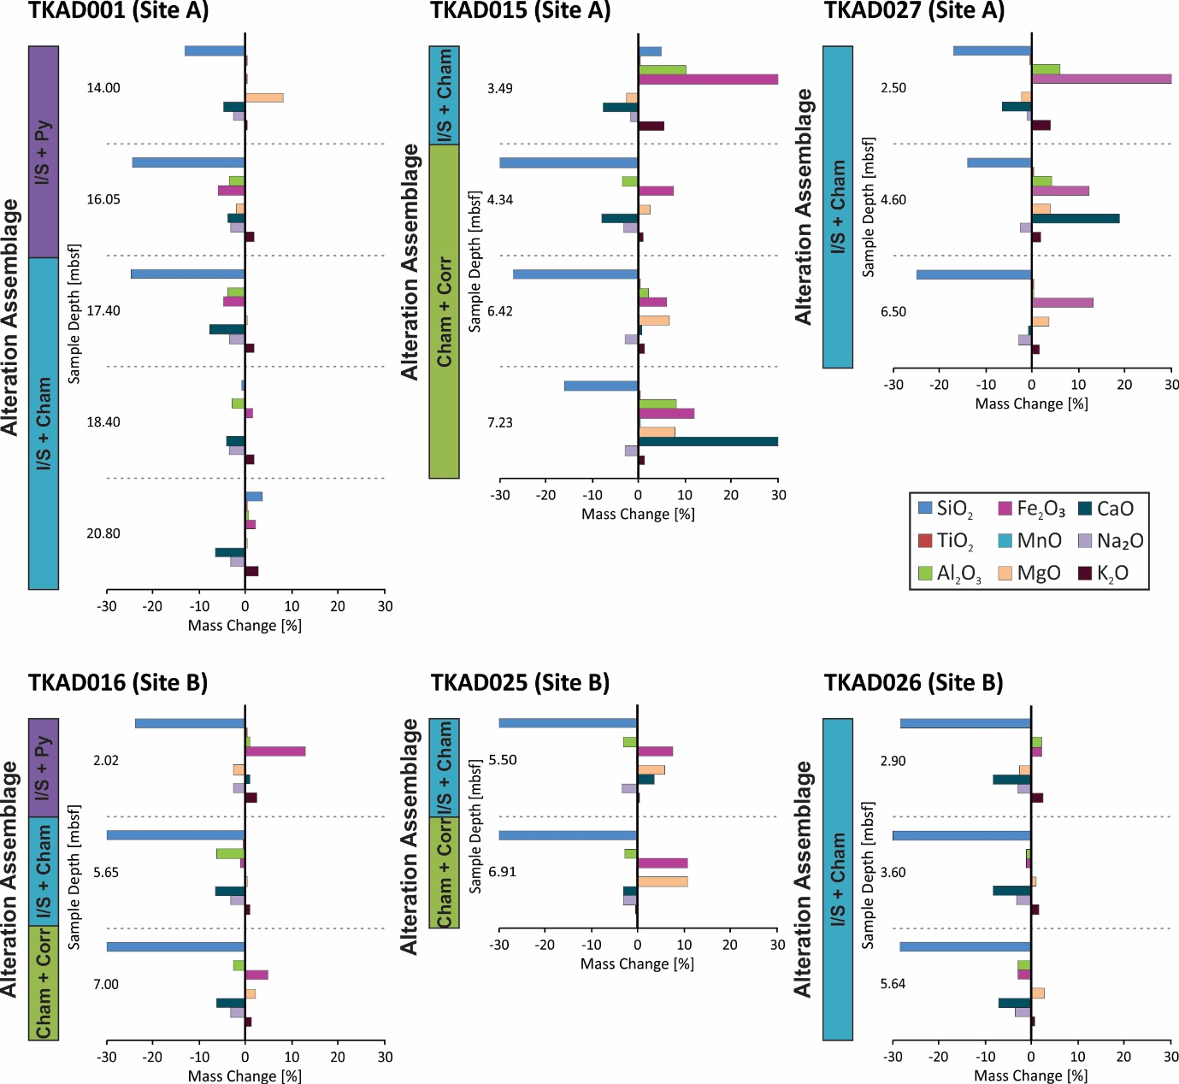
Fig. A26. Mass changes in drill holes associated with changes in alteration mineral assemblages (%Δ). Cham = chamosite; Corr = corrensite; I/S = illite/smectite; Py = pyrite.

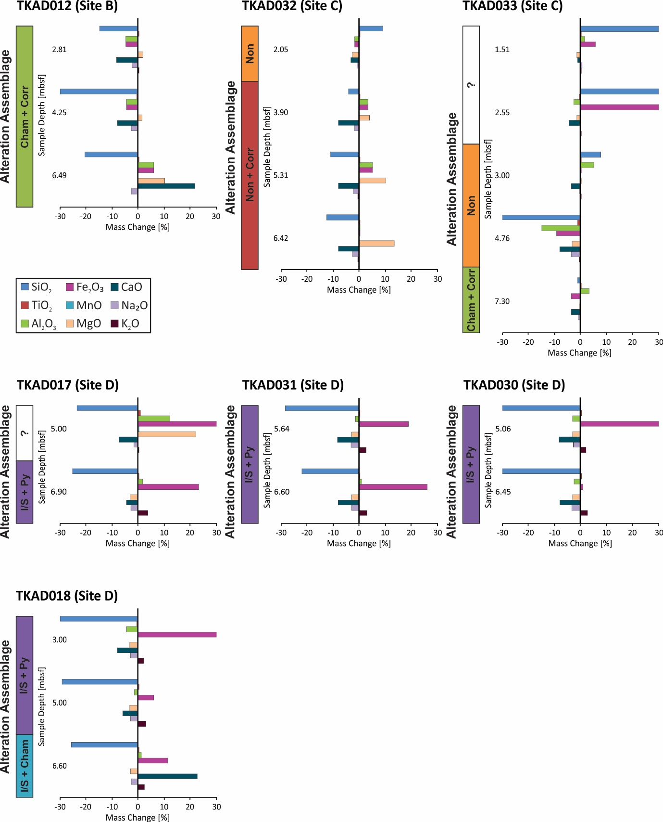

Fig. A27. Mass changes in drill holes associated with changes in alteration mineral assemblages (%Δ). Cham = chamosite; Corr = corrensite; I/S = illite/smectite; Non = nontronite; Py = pyrite.

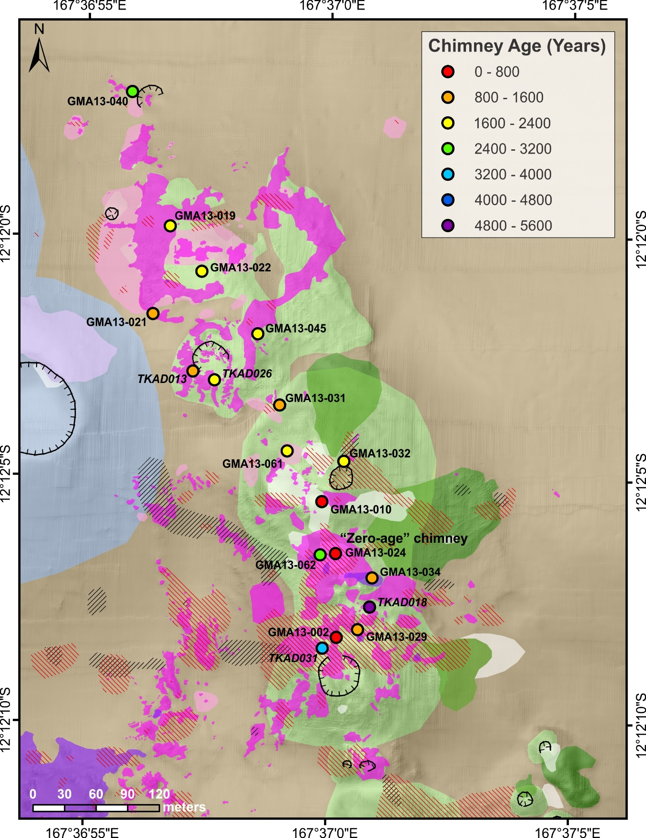
Fig. A28. Ages measured by ²²⁶Ra dating of hydrothermal barite at the Tinakula deposit, overlain on a close-up of the geology map from Fig. 2. Grab samples are labelled; drill holes are in italics. Data are in Table 7.

