**POS538**

Weekly report No. 1

7.10.2019 - 13.10.2019

Our scientific equipment arrived in Cartagena on the 4th of October and was brought on board and safely stowed. At 8:30 on the 7th, we departed Cartagena Harbour and began our six-day transit to our working area in the Aegean Sea. The aim of our expedition is to improve the understanding of the submarine volcano Kolumbo using active source seismic surveying. The volcanic cone developed as a result of continuous submarine eruptions in the year 1650 and formed a small island, which was then destroyed by a strong explosive eruption. The eruption formed a 2500 m wide and 500 m deep crater and triggered a tsunami that effected the coast of Santorini.

The genesis of tsunamis as a result of underwater eruptions is a poorly understood phenomenon that we aim to investigate during this expedition to Kolumbo volcano. To achieve this goal, we are deploying the P-Cable system to record a 3D seismic dataset of the volcano. In addition, we are deploying six ocean bottom seismometers. An additional goal of this cruise is to acquire 2D seismic profiles within, and outside of, the Santorini caldera, and south of the island of Amorgos. This work will directly support preparations for a drilling proposal to the International Ocean Discovery Program to investigate the volcanic and tectonic evolution of the Hellenic Arc.

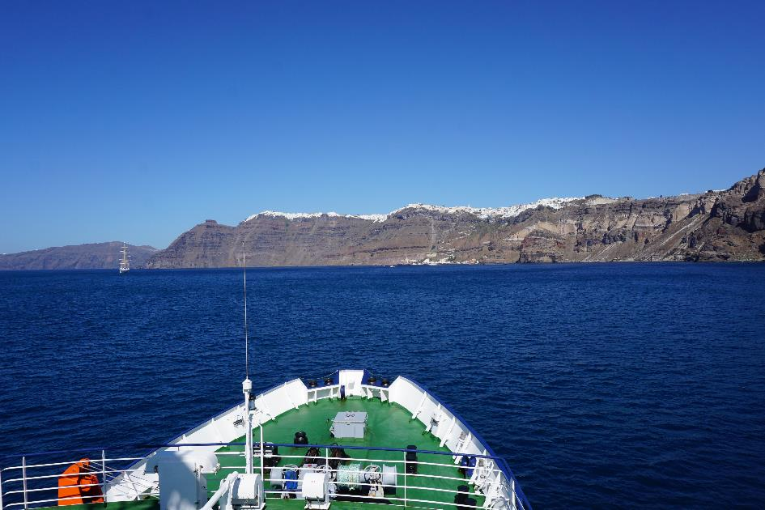

*Figure 1: The Poseidon in the Santorini Caldera*

Our science party comprises a total of 10 participants from Geomar Helmholtz Centre for Ocean Research Kiel, the University of Hamburg, the University of Bologna and the National and Kapodistrian University of Athens. We reached our working area at 11:00 a.m. on the 13th and started our scientific programme with releaser testing for the six ocean bottom seismometers. We then picked up our last cruise participant from within the Santorini Caldera and began the 2D seismic surveying at 2 p.m. Everybody on board is in good spirits, enjoying a very good working atmosphere and looking forward to new insights into the local geology.

On behalf of the science team,

Jens Karstens