Physical properties and core-log seismic integration from drilling at the Danube Deep-Sea Fan, Black Sea

M. Riedel¹, T. Freudenthal², M. Bergenthal², M. Haeckel¹, K. Wallmann¹, E. Spangenberg³, J. Bialas¹, G. Bohrmann²

1 GEOMAR Helmholtz Centre for Ocean Research Kiel, Wischhofstrasse 1 – 3, 24148 Kiel, Germany
2 MARUM, Center for Marine Environmental Sciences, University of Bremen, Leobener Str. 8, 28359 Bremen, Germany
3 Helmholtz-Centre Potsdam - GFZ German Research Centre for Geosciences, Telegrafenberg, 14473 Potsdam, Germany

Abstract
Drilling, coring, and geophysical logging were performed with the MARUM-MeBo200 seafloor drilling rig to investigate gas hydrate occurrences of the Danube deep sea fan, off Romania, Black Sea. Three sites within a channel-levee complex were investigated. Geophysical log data of P-wave velocity, electrical resistivity, and spectral gamma ray are combined with core-derived physical properties of porosity, magnetic susceptibility, and bulk density. Core- and log physical property data are used to define a time-depth conversion by synthetic seismogram modeling, which is then used to interpret the seismic data. Individual polarity reversed reflectors within the stratigraphic column drilled are linked to reduction in P-wave velocity and bulk density. Those reflectors (and associated reflection packages) are accompanied by distinct and systematic changes in sediment porosity, magnetic susceptibility, and electrical resistivity. Overall, the sediments at drill site GeoB22605 (MeBo-17) represent the younger (upper) levee sequence of the channel, that has been eroded at drill site GeoB22603 (MeBo-16). Splicing seismic data across the channel from the East (MeBo-16) to the West (MeBo-17) demonstrates the continuation of reflectors underneath the channel. The upper ~50 meter below seafloor (mbsf) at site MeBo-16 do not stratigraphically belong to the same sequence of the (deeper) levee-deposits. Above the marked erosional unconformity, sediments at Site MeBo-16 are likely derived by a mixture of repeated slump-events (identified as seismically transparent units) interbedded with hemi-pelagic sedimentation. Similarly, sediments within the upper ~20 mbsf at Site MeBo-17 are not stratigraphically the same levee-deposits, but are derived by a mixture of slump-events (also seen in the marked seafloor amphitheatre architecture of a large failure complex extending further upslope) and hemi-pelagic sedimentation. All observations combined show that the seismically observed stratigraphic pattern represents a reflectivity sequence mostly driven by variations in density (porosity) and correspondingly by changes in P-wave velocity and electrical resistivity. Observations from the geophysical log- and core, as well as geochemical data, show no evidence for the presence of any significant gas hydrates within the drilled/cored sequences.

1 Introduction
In 1974 gas hydrates were found for the first time in the Black Sea (Yefremova and Zhizchenko, 1974). Since then a number of research projects studied the occurrence and distribution of gas hydrates in the abyssal plain and along the continental margins of the Black Sea. Numerous active gas expulsion sites and indicators for gas and gas hydrate distribution were found (e.g. Naudts et al., 2006; Popescu et al., 2006, 2007; Starostenko et al., 2010; Vassilev and Dimitrov, 2002; Bialas et al., 2014; Ker et al., 2015). According to current temperature and salinity conditions in the Black Sea (MSM34, Bialas et al., 2014) gas hydrate is stable in water depths greater than ~670 m. Depending on the depth of the seafloor, gas hydrate is expected to be stable within the upper 200 m to 300 m below the seafloor (Bialas et al., 2014). This defines upper and lower limits of the distribution of the bottom-simulating reflector (BSR), as mapped by Popescu et al. (2006). Popescu et al. (2006) also reported multiple BSRs across the Danube Delta deep-sea fan and suggested that they remain from former stable climate conditions with lower temperatures between glacial and interglacial episodes. An alternative explanation was provided by Baristeas (2006) arguing that deep cutting faults may provide migration pathways for deeper-rooted gases of Oligocene age and that the multiple BSRs are from higher (than pure methane) hydrocarbons. Using multichannel seismic (MCS) data from expedition MSM34 (Bialas et al., 2014), Zander et al. (2017) showed that temperature and water level fluctuations together with variations in salinity during glacial and inter-glacial periods can create the multiple BSRs.
As part of the SUGAR-III project, drilling with the MARUM-MeBo200 (MeBo200) seafloor drilling rig (Freudenthal and Wefer, 2013) was performed in November and December 2017 within the Romanian sector of the Black Sea Danube deep-sea fan (Figure 1) to study the occurrence of gas hydrates and the nature of the sediments (Bohrmann et al., 2018). The only earlier scientific deep drilling in the Black Sea was performed during Deep Sea Drilling Project (DSDP) expedition 42B (Ross et al., 1978) that established some of the governing frame work of sedimentology, pore-fluid chemistry, and physical properties of the Black Sea sediments. Additional deep piston coring and geotechnical probing up to ~24 meter below seafloor (mbsf) had been performed in the study area during the GHASS project in 2015 (Ker et al., 2015).
Drill site locations for the MeBo200 rig were chosen based on the available grid of regional 2D seismic data and one P-cable 3D data set acquired during expedition MSM34 (Bialas et al., 2014). With a maximum anticipated drill depth of ~150 mbsf, the targets for drilling and coring were set to intersect the upper stratigraphic units representative for the region of the S2 channel and levee complex as well as trying to drill to the depth of the BSR. Four drill sites were visited (Figure 2) with the first drilling performed at Site GeoB22603 (MeBo-16) on the eastern side of the S2 channel. Drilling reached 147 meter below seafloor (mbsf) but no borehole logging was performed. The second site GeoB22605 (MeBo-17) was on the western side of the channel within the region of a known older slump-complex. This site was twinned with a second borehole (Site GeoB22620, MeBo-19) ~40 m SW of the first drill hole. Drilling and coring within the channel itself was difficult and an alternate Site in greater water depth along the S3 channel was visited (Site GeoB2209, MeBo-18), but only three cores were recovered and the site was abandoned for technical difficulties (Bohrmann et al., 2018). From cores recovered at Site MeBo-16, -17, and -19, physical properties were determined with the aim to establish a detailed tie to the seismic data and to establish required physical properties as ground-truth for other geophysical remote sensing data available, in particular a set of ocean bottom seismometer (OBS) recordings with derived P- and S-wave velocity structures (Hilbert, 2019), and controlled-source electromagnetic (CSEM) data revealing electrical resistivity structures (Schwalenberg, 2014). From the P-wave velocity and electrical resistivity data, estimates of gas hydrate pore-filling contents are made (see Dannowski et al., this issue; Schwalenberg et al., this issue; Duan et al., this issue) using the derived physical properties shown in this study.

- Data and Methods
2.1 Seismic and sub bottom profiler data
Several types of seismic and acoustic data are available for this study. During expedition MSM34 a set of regional MCS lines were acquired across the Danube deep-sea fan (Bialas et al., 2014). Processing of the MCS data included geometry definition, sorting, and velocity analyses with normal move-out correction for an initial stack. Time and depth migration were performed using the MCS-derived velocities. A 3D seismic data volume covering an area of 3.3 × 8.7 km² was acquired with the P-Cable system during expedition MSM34 (Hillman et al., 2018) around the MeBo-17 and MeBo-19 drill sites. The 2D regional lines and the P-Cable data were acquired with a Generator Injector (GI) airgun (105 + 105 in³ volume) covering a frequency range up to 150 Hz, with maximum energy at ~80 Hz (equivalent to an average vertical resolution (defined as 1/4 of the dominant wavelength) of 5 m at an acoustic velocity of 1600 m/s). We have created a splice through the drill sites using the available P-cable 3D as well as 2D data (Figure 3) highlighting the continuous levee-stratigraphy and BSR in the region.
Coincident with these regional lines, high-resolution sub bottom profiler data (PARASOUND) were acquired during MSM34. Additional PARASOUND data were acquired during expedition M142, specifically across the drill sites. PARASOUND data offer a penetration depth of up to 120 mbsf and a vertical resolution of ~0.5 m (1/4 wavelength of the dominant frequency of 1.5 kHz at a velocity of 1600 m/s) as data is used with the trace envelope (instantaneous amplitude) only. Examples of the PARASOUND data across the drill sites are given in Figure 4.

2.2 Borehole logging data
Borehole logging was performed at Sites MeBo-17 and MeBo-19, located ~40 m south of MeBo-17 (Table 1). Logging was performed with slim hole memory probes developed by ANTARES Datensysteme GmbH. The probes were deployed in the logging while tripping mode with the logging string being inserted into the drill string and the sensors located below the drill bit. The measurement is conducted as uplog while the drill string is pulled back to the seafloor out of the borehole. The trip out speed was about 1 cm/s and the logging frequency was 0.5 Hz. At Site MeBo-17, the spectral gamma ray (SGR) probe was used together with the acoustic tool (to determine P-wave velocity). At Site MeBo-19, the SGR tool and the dual induction (DI) probe measuring electrical resistivity were used together. P-wave velocity was determined from the acoustic wave form data by a semblance algorithm. The highest semblance (best correlation) is then an indicator for the in situ P-wave velocity. This algorithm was compared to that of a first-arrival technique and deemed superior to first-arrival picking as it results in more robust results as problems with cycle-skipping and outliers are avoided. Electrical resistivity is measured in two modes with the DI logging tool, yielding a medium and a deep penetration resistivity value. The SGR tool yields total counts of natural gamma radiation, as well as spectral components of Uranium (U), Potassium (K) and Thorium (Th).

Table 1. Overview of bore hole sites, water depth, depth of seismically inferred BSR, and logging measurements performed during expedition M142 (n.a.: not applicable; SGR: spectral Gamma Ray).

Site | Latitude  (N) | Longitude  (E) | Water depth (m) | BSR depth  (mbsf) | Probe | Logged interval  (mbsf)
GeoB22605-1  MeBo-17 | 43°56.902 | 30°47.013 | 765 | 144 | SGR | 140.9 – 5.0
 |  |  |  |  | Acoustic | 142.8 – 6.9
GeoB22620-1  MeBo-19 | 43°56.901 | 30°47.014 | 780 | 144 | SGR | 127.0 – 4.5
 |  |  |  |  | Dual Induction | 128.8 – 6.3
GeoB22603-1  MeBo-16 | 43°55.95 | 30°49.75 | 860 | 203 | n.a. | n.a.
GeoB2209-1  MeBo-18 | 43°52.83 | 30°52.67 | 1400 | n.a. | n.a. | n.a.

2.3 Physical property data
2.3.1 Porosity and contact resistivity
Porosity was determined following the procedures set out by Blum (1997) developed for the Ocean Drilling Program (ODP), typically referred to as moisture and density (MAD) analyses. The moisture content and mineral grain density are sediment properties determined through mass and volume determinations. Core specimens of 2-6 cm³ were manually extracted from the working-half split core shortly after the core was split during the M142 expedition, placed in plastic vials, sealed, and kept at 4°C cold storage until further processing. The mass of the plastic vials was determined prior to sampling. Moisture content is then calculated by measuring the specimen’s mass before and after removal of pore fluid through freeze drying. After drying, the sample is placed inside a pycnometer to measure its volume. A more detailed description of the calculations including all equations can be found in Blum (1997).
Electrical resistivity was measured on the surface of the split cores-halves (MeBo- and gravity cores) using a Wenner-style four-pin electrode probe. The outer two pins are the current-electrodes and the inner two pins are the potential-electrodes. The probe is mounted onto a frame and placed onto the core liner. To take a measurement, the four pins are pushed manually onto the sediment surface (with 1-2 mm penetration) and the resistance value is taken from the digital display of the instrument-unit. The resistance (R in Ω) is converted to the resistivity (ρ in Ωm) using a correlation function obtained from measurements on the same split core-linier filled with different electrolyte solutions of known resistivity (Figure A.1, ρ is ranging from 0.1 – 18 Ωm). The function with a correlation coefficient of 0.99993 is given by:
ρ = A × R ² + B × R, (1)
with the two coefficients being by A = 8.1479 × 10⁻⁶ m Ω⁻¹, and B = 0.0599 m.
Measurement interval varied based on core quality (avoiding obvious disturbed zones) and if possible was as close as 5 cm. Resistivity was measured after pore-water samples were extracted, thus there is no coincident value of core-resistivity, porosity and pore-water salinity. After resistivity was measured on the core surface, additional sediment samples were taken at the same point for porosity determination (approximately one sample per ~1.2 m long core section). Core-temperature was measured for each core-segment by inserting a thermometer into the center of the sediment half-core while resistivity is being measured (Figure A.2).
2.3.2 Correction of core-resistivity values
The electrical resistivity measured on the recovered cores is strongly affected by the environmental conditions during the time of measurement, mostly pore-water salinity and temperature of the core. Additionally, contamination of the cores by drilling fluid of bottom-water salinity ~22 (all salinity values given in this study are reported as dimensionless number of the practical salinity unit, PSU) did occur pervasively, but with variable amounts between individual core segments. Pore-water geochemical analyses yielded correction factors at selected intervals using pore-fluid sulfate concentrations as indicator for the degree of contamination (Bohrmann et al., 2018). Here, we use the measured temperatures of the split cores, sediment porosity values, and pore-water salinity values corrected for drilling fluid infiltration, as well as the general Archie relationship (Archie, 1942) to back-calculate the in situ electrical resistivity for the cores.
First, a matching value of porosity was defined for the measurement location of core-resistivity. Similarly, matching core-temperature and pore-water salinity values were defined at the same depth locations. The assumed in situ pore-water resistivity was calculated for a matching value in temperature and corrected pore-fluid salinity (based on sulfate-correction method) using the thermodynamic equations of seawater (Intergovernmental Oceanographic Commission, 2010). Together with the assumption of no gas hydrate present in the core (all gas hydrate if occurring in situ, was fully dissociated by the time of measurement of electrical resistivity in the laboratory), the values of core resistivity were adjusted using the corrected pore-water based salinities to represent in situ conditions. Two approaches in the final calculation of the resistivity data adjustment were made: (i) using a smoothed (polynomial best-fit) pore-fluid salinity-depth profile, and (ii) a salinity-depth profile based on a point-by-point piece-wise linear interpolation of the salinity values. A fifth-order polynomial (R²=0.9441) to estimate salinity (S) as function of depth (d in mbsf) was defined as:
S = 20.6 – 5.122×10⁻⁹ × d⁵ + 2.323·10⁻⁶ × d⁴ – 4.05×10⁻⁴ × d³ + 0.03353 × d² – 1.292
× d
Alternatively, the uncorrected electrical resistivity values from the cores can be used to define the degree of pore-water infiltration by calculating the salinity of the pore-water needed to yield the measured resistivity values at the given temperature conditions and porosity of the sediment. This helps to augment information on the core-contamination which typically only comes from the correction of pore-fluid chlorinity (and salinity) using sulfate concentrations. Sulfate concentration in the pore fluid should theoretically be zero throughout the cored section below ~4 mbsf (the approximate depth of the sulfate-methane reaction zone in this study region, Bohrmann et al., 2018).
2.3.3 Multi-sensor core logging
Since no multi-sensor core logger (MSCL) was available at sea, the archive halves of the cores for Sites MeBo-16 and MeBo-17 were logged at the laboratory of MARUM, University of Bremen, after the cruise. Measurements were made at different times in 2018 (April, June, and November) and the core material has suffered in quality during storage since acquisition in November 2017, mostly by moisture loss and compaction or consolidation of the material. We acquired Gamma-ray-density and magnetic susceptibility of the core with a point sensor at 1-cm intervals. The Gamma-ray-density tool of the MSCL was calibrated daily prior to all measurements. Physical properties obtained by the sensors are also corrected for core-thickness variations that may occur from storage-related compaction or uneven core-splitting. Gamma-ray-density and magnetic susceptibility values were manually corrected to remove artificially low values from incomplete fill of the core liners at top and bottom of the liners, obvious cracks, or missing material throughout the sections. The measurements of gamma-ray-density were then compared to expected bulk density values based on the porosity obtained from the same core. Several sections were identified with consistently higher values, most likely from a higher degree of drying of the material. Several sections of the core from Site MeBo-17 were also identified with lower values than those expected from porosity, probably due to effects of air-filled cracks in the core. All these sections were corrected by shifting the gamma-ray-density values to match on average the expected bulk density from porosity measurements (see Tables A.1 and A.2 for all sections identified and values of shift applied). These corrected density values were then used in the calculation of synthetic seismograms (see section 2.4) for core-log seismic integration and regional interpretation.

2.4 Synthetic seismogram and Time-Depth conversion
Synthetic seismogram generation was conducted with the GeoSyn application of the IHSTM Kingdom® software. The input parameters are an extracted wavelet from the regional 2D seismic (airgun) lines crossing the drill sites, as well as the acoustic log and density values at Site MeBo-17. Core-based density and an assumed constant velocity were used at Site MeBo-16. Bulk density values obtained from the cores at both drill sites were re-sampled (at 1 cm resolution to match the acoustics log) through interpolation to obtain a continuous log for the synthetics calculation. Average velocities at both drill sites were obtained from the MCS data for an initial time-depth (TD) conversion, which was then refined by tying individual reflector packages to the log- and core-derived physical property data.

3 Results
3.1 Porosity - resistivity relationship
An often-used technique to estimate gas hydrate concentrations from electrical resistivity data is based on the Archie relationship (Archie, 1942). The cross-plot of the formation factor (FF), defined as electrical resistivity of the core divided by pore water resistivity, and porosity (Φ) (also referred to as Picket-plot, Figure 5) is used to define the two empirical Archie parameters ‘a’ and ‘m’ by defining a best-fit function through the data set using this relationship:
FF = a × Φ^{-m}.
As the data set available from expedition M142 is poorly constrained due to only 165 data points with few data points at higher porosities > 0.5, it may be inappropriate to simply define a least-square fit to the data as some data points could potentially dominate the trend. We therefore implemented a bootstrap algorithm to estimate the most likely set of empirical parameters. Using a random number generator in Matlab, a subset of values for a Picket plot is selected and a least-square best fit is returned for both Archie parameters. Repeating this process many times results in the two histograms shown in Figure 6a, and Figure 6b. As a measure of the goodness in the fit, the R²-value is tracked for each of the solutions (Figure 6c, d). The cross-plot of the Archie parameters shows a non-linear distribution (Figure 6e) and the histograms of the parameters show bimodal distributions. The most likely solution (the values with the highest number of occurrence) was defined from the peak of the histograms. The difference to a simple best-fit analysis is relatively small (Figure 5). However, we recommend using the parameters defined from the bootstrap algorithm as they are statistically more robust (a=1.045, m=1.875).

3.2 Analysis of contamination of core with drilling fluid
Core resistivity measured at sea is strongly affected by the unknown contamination with drilling fluid, which in this case is bottom water at the drill sites with an average salinity of ~22. Infiltration of drilling fluid into the cored sediment is a result of probably two processes: (i) infiltration directly at the drill bit during the coring process, and (ii) due to degassing and pervasive cracking of the recovered cores (especially upon recovery of the tool to the surface), sea water can infiltrate into the sediment.
Correcting the resistivity data requires knowledge of the contaminated pore-fluid salinity which was obtained from the analysis of pore water (Bohrmann et al., 2018). This also incorporates the temperature of the sediment measured (once per core section, Figure A.1) and resistivity determined with the Archie constants derived from the well-log data of Site MeBo-19 (Figure 5). Figure 7 shows the measured sediment resistivity values in comparison to the estimated in situ values. Alternatively, the set of resistivity values measured on the core can be used to indirectly determine the degree of core-contamination with drilling fluid (Figure 8). Cores from Sites MeBo-16 and MeBo-17 show on average a degree of contamination of ~16%, whereas cores from MeBo-19 only show a contamination of ~8%. Individual samples, however, can be contaminated by up to 60%.

3.3 Correlation of physical properties at the drill sites
Sediment physical properties were determined from discrete samples and by using a MSCL as well as in situ using the MeBo200 logging tools. The discrete samples were also used to scale where required the MSCL-based measurements of bulk density due to the significant time gap between core recovery and final measurement (6 – 9 months). Figure 9 summarizes all measurements for Site MeBo-16, which includes bulk density, grain density, porosity, electrical resistivity, and magnetic susceptibility. Bulk density increases rapidly within the upper 10 mbsf and remains fairly constant at values between 1.8 and 2.0 g/cm³ below. A significant reduction of bulk density is seen within a short, ~4 m thick interval at 42-46 mbsf and at 106 – 122 mbsf. Those reductions in density correlate to increases in porosity. Porosity is for most part of the drilled interval below 0.55. Sediment electrical resistivity (corrected for in situ values based on the Archie relationship) shows little variation overall. In the interval up to 64 mbsf, resistivity is around 11 – 15 Ωm and in the interval up to 106 mbsf almost constant at ~12 Ωm. The reduction in resistivity to values of 8 – 9 Ωm below 106 mbsf is directly correlated to the change in porosity. Some minor variation in grain density occurs, but values remain on average between 2.6 g/cm³ and 2.7 g/cm³. Magnetic susceptibility shows several short intervals of elevated values (>100 ×10⁻⁶) in the upper 46 mbsf. Below that depth, only minor variations in susceptibility occur and below a depth of 106 mbsf, the lowest values of magnetic susceptibility overall are observed.
Sediment physical properties for Sites MeBo-17 and MeBo-19 are combined in Figure 10 and logging data for P-wave velocity, natural gamma radiation, and electrical resistivity are added for completeness. Bulk density is similarly to Site MeBo-16, increasing rapidly within the upper 10 mbsf (correlated to a reduction in porosity). Two subtle changes in the bulk density record occur at a depth of ~56 – 60 mbsf (increase by 0.2 g/cm³) and at ~100 mbsf (step-like reduction by 0.2 g/cm³). Grain density shows no significant variation and remains nearly constant at a value of 2.7 g/cm³ through the entire cored interval. Magnetic susceptibility shows similar spikes within the upper 42 mbsf as seen at Site MeBo-16. Below this depth, magnetic susceptibility varies only by small amounts (20 – 35 ×10⁻⁶) but shows a significant step to lower values (15 – 25 ×10⁻⁶) below 100 mbsf. Logging data of electrical resistivity (MeBo-19) show a characteristic gradual increase in the upper 20 mbsf, mimicking the decrease in pore water salinity and porosity. Logging- and sediment-derived resistivity below 20 mbsf show little variation but distinct layering (or intervals). In the interval from 58 – 100 mbsf, resistivity is elevated up to 14 Ωm with one short segment showing values as high as 25 Ωm. In the depth below 100 mbsf, log-resistivity is around 10 Ωm. The intervals between 30 and 40 mbsf, as well as 58 and 100 mbsf also show elevated and highly variable P-wave velocity. Above and below this interval, values do not vary significantly. Natural gamma ray radiation measured at Sites MeBo-17 and MeBo-19 are very similar and show two distinct short intervals of sharply reduced gamma counts (26 – 30 mbsf, 39 – 41 mbsf) that also correlate to sediments with a high amount of sand layers (Bohrmann et al., 2018).

3.4 Core-log-seismic integration
At drill site MeBo16, core-derived density is the main available data set for generating a synthetic seismogram and tie reflections seen in seismic data to the vertical profiles of all other physical properties. In order to generate a synthetic seismogram, we used the core-derived bulk density re-sampled at a 1cm interval and interpolated any data gaps. Together with an assumed constant velocity of 1600 m/s a vertical profile of reflection coefficients is calculated and convolved with a wavelet extracted from the seismic data crossing the drill site (Line 897-3 from expedition MSM34, Bialas et al., 2014). Two prominent, regionally continuous reflections seen in the seismic data below 1.3 s two-way time (TWT) are tied to the synthetics together with two shallower reflections near 1.25 s TWT (Figure 11). The stretch of the data then defines a final time-depth function for this drill site (Table 2).
At the MeBo-17 drill site, we are able to incorporate the log-defined P-wave velocity with the core-derived bulk density for generating a synthetic seismogram (Figure 12). The reflection coefficients are convolved with a wavelet extracted from seismic line 897-15 of expedition MSM34 (Bialas et al., 2014). Two regionally continuous reflections at 1.12 and 1.17 s TWT, respectively, and one shallower event at 1.08 s TWT are tied to the synthetics. The stretch applied to match these events then defines the final time-depth function for MeBo-17 (Table 2).

Table 2. Time-Depth conversion tables after core-log-seismic ties applied
Site | Depth (mbsf) | Two-way time (s)
MeBo-16  GeoB22603  Relative for  MCS Line 897-003 | 0 | 1.188
 | 25 | 1.221
 | 50 | 1.256
 | 75 | 1.2904
 | 100 | 1.325
 | 125 | 1.336
 | 150 | 1.394
MeBo-17 / -19  GeoB22605  Relative to P-Cable 3D data | 0 | 1.044
 | 25 | 1.077
 | 50 | 1.108
 | 75 | 1.140
 | 100 | 1.171
 | 125 | 1.202
 | 140 | 1.221

4 Discussion and Interpretation
4.1 Seismo-acoustic stratigraphy
The wealth of 2D and 3D seismic data available around the drill sites allows detailed stratigraphic interpretation of the sedimentary environment. The seismo-acoustic character of the sediments around the drill sites are defined into two main stratigraphic units. Both units were further split into sub-units, respectively, as outlined in more detail below. Mass-transport deposits (MTDs) are identified from their mostly low and chaotic internal acoustic reflectivity.
Seismo-stratigraphic Unit A can be seen almost everywhere in the study region and shows large reflection amplitudes in the MCS data. The thickness of this unit varies and can be up to 60 m in some places. Often, this unit, which is mostly comprised of seafloor-parallel layers, is interrupted by thin intervals of low reflection amplitude, interpreted as mass-transport deposits (MTDs). The underlying seismo-stratigraphic Unit B is overall well stratified but reflection amplitude is more uniform across the entire unit and overall much reduced compared to Unit A. This unit B is interpreted as older channel levee deposits.
Drilling intersected both units at Sites MeBo-16 and MeBo-17/19 and physical property measurements reveal only subtle differences overall and seismic reflectivity appears mostly driven by changes in sediment bulk density (and correlated variations in P-wave velocity and porosity). Using the character of the physical property record and visual core description allows further refinement of the seismo-stratigraphic units. Figures 13 and 14 show seismic and PARASOUND records across the drill sites with logs of sediment physical properties overlain as well as interpretation of the seismo-stratigraphic units.
The seismo-acoustic Unit A (0 – 46 mbsf at MeBo-16; 0 – 42 mbsf at Site MeBo-17/-19) is characterized by strong seismic reflectivity in MCS data (Figure 3) and is a mix of intervals of stratified sediments interchanged with smaller bodies of mass transport deposits as revealed by the PARASOUND records (Figure 4). Unit A was subdivided into an upper (sub-Unit A1) and a lower interval (sub-Unit A2) based on the seismic character of the PARASOUND data and sediment characteristics.
Sub-Unit A1 is characterized by high reflection amplitude in MCS data and the PARASOUND data show a mix of small-scale mass transport deposits interbedded with packages of layered sediments. Sub-Unit A1 is comprised of light-grey clay-dominated sediments, showing layering of varying thickness and occasional occurrence of shell fragments. There is no distinct occurrence of sand within Unit A1. The transition between sub-Unit A1 and A2 at MeBo-17 is within core 7, section 3 at a depth of ~ 20 mbsf (first occurrence of sand). The two sub-units A1 and A2 are separated at Site MeBo-16 by a MTD. Porosity decreases from 0.8 at shallow depths rapidly to almost uniform values around 0.55 within the lower interval of sub-Unit A1. Similarly, bulk density increases from values around 1.4 g cm⁻³ to ~ 1.8 g cm⁻³. Sediments in Unit A show intervals of elevated magnetic susceptibility with values of up to 450×10⁻⁶, which are not correlated to the occurrence of MTDs.
Sub-Unit A2 is a stratified unit with sediments being grey to light-grey silty clay with abundant sandy layers (in thickness up to 4 cm). The seismic reflectivity of sub-Unit A2 is overall lower than that of sub-Unit A1. The PARASOUND data further reveal apparent small-scale deformation patterns, mostly the result of uneven settlement of the sediments in sub-Unit A2 on top of a lower-lying unconformity and MTD with rough upper surface topography. The sediment bulk density is ~1.8 g cm⁻³ and porosity is ~0.5. Magnetic susceptibility shows some variation and values are around 40×10⁻⁶. The base of sub-Unit A2 is defined by the last peak in magnetic susceptibility. Electrical resistivity (corrected for in situ conditions) is around 8 – 10 Ωm.
Seismo-acoustic Unit B (below 46 mbsf at MeBo-16; below 42 mbsf at MeBo-17/19) is a well-stratified unit of mostly fine-grained sediments (silty clay) of channel-overspill turbidites (levee complex). Seismic amplitude of reflectors within this levee complex is overall low. Enhanced seismic reflectivity is only seen below the sI-BGHSZ from some free gas occurrences. Sediments of Unit B are mostly light grey silty clay with only few sand layers and show regular layering with a rather uniform thickness of ~ 1 cm (Bohrmann et al., 2018). Based on the logging data and the sediment physical property record, Unit B was sub-divided into three sub-units at Site MeBo-17/-19. Bulk density decreases by ~0.2 g cm⁻³ and porosity increases by ~0.1 at the top of Unit B1 (~42 mbsf). In sub-Unit B1, sediments also show on average lower magnetic susceptibility values than seen in the overlying sediments. Seismically, the top of sub-Unit B1 correlates to an unconformity. The sub-Unit B1 extends to a depth of 58 mbsf and the base of sub-Unit B1 is marked by a rapid increase in density and sudden onset of higher P-wave velocity and electrical resistivity. In sub-Unit B2, porosity remains at 0.4-0.45. The interval of sub-Unit B2 shows elevated P-wave velocity values with maxima up to 1900 m/s and overall higher sediment electrical resistivity (~15 Ωm), which is a unique character of this sub-Unit. Sediments in the interval of sub-Unit B2 are mostly mousse-like homogenous silty clay without distinct layering (Bohrmann et al., 2018). However, coring showed no evidence for the occurrence of gas hydrates in sub-Unit B2 (e.g. in form of infrared cold spots, Bohrmann et al., 2018). The base of sub-Unit B2 is defined by a characteristic transition from the highly varying P-wave velocity-log to an underlying sequence in sub-Unit B3 of rather uniform log-character. Top and bottom of sub-Unit B2 are marked by distinct seismic reflectors, respectively. The drop in bulk density at the base of sub-Unit B2 correlates to a polarity reversed reflector in the MCS data. Sediments in sub-Unit B3 are showing well-established layering (Bohrmann et al., 2018) and uniform values of bulk density (1.9 g cm⁻³), porosity (~0.5), and overall lowest measured magnetic susceptibility, low P-wave velocity (~1600 m/s), and electrical resistivity (10-11 Ωm).
Sediments below 46 mbsf at Site MeBo-16 are similar in character to sediments of sub-Unit B3 of Site MeBo-17/19 and show regular layering with the same overall layer thickness. Within Unit B the occurrence of light brown sand layers several millimetre in thickness is typical, which are not seen in Unit A. By correlation to the seismic data shown in Figure 3, the interval below 106 mbsf at Site MeBo-16 belongs to the same overall depositional levee complex seen underneath Site MeBo-17/19, but appears to represent a deeper (and thus older) sequence than the maximum depth reached at Site MeBo-17/19. Thus, sediments of unit B at Site MeBo-16 are named sub-Unit B3’. The physical properties in sub-Unit B3’ are similar to MeBo-17/19 with bulk density around 1.9 g cm⁻³, porosity of ~0.5, and low magnetic susceptibility (< 30×10⁻⁶). At Site MeBo-16, sub-Unit B3’ is interrupted by a ~ 30 m thick interval (78 – 106 mbsf) of a mass transport deposit (MTD) that shows no distinct seismic layering but more chaotic reflectivity. The top of the MTD is marked by an increase in sediment bulk density (~0.1 g cm⁻³) and the base of the MTD shows again a reduction in density, marked seismically by a polarity-reversed reflector (relative to seafloor).

Summary and Conclusions
The seismic reflection character of the sedimentary units found in the vicinity of the S2 channel are mostly driven by density (and associated with that porosity and P-wave velocity changes), including several polarity reversed reflectors within the levee complex. No effect of pore-filling gas hydrates on the bulk physical properties was observed within the potential gas hydrate-bearing interval. Combining the observations from coring, logging, as well as seismic and PARASOUND data, an interpreted line-drawing overlain with the seismo-stratigraphic units of the seismic data connecting the two MeBo200 drill sites is given in Figure 15. The occurrence of some free gas below the BSR results in amplitude enhancement as well as polarity changes of individual reflectors underneath this reflector. Within the interval imaged with the seismic data, amplitude enhancement of reflectors below the BSR is limited to a few hundred meters laterally along the reflectors themselves. This is attributed to some lateral, stratigraphically controlled migration of gas and pore fluid along shallow dipping layers. As the phase boundary in the Black Sea has seen tremendous vertical migration over the past 100 k.a. (Zander et al., 2017) in response to climate changes (deposition of tens of metres thick levees, sea-level fluctuations, and bottom temperature variation) there may have been some release of methane gas at the phase boundary from dissociating hydrate, adding to the amplitude enhancement seen at the sI-BGHSZ, indicating that this gas has not completely dissolved or migrated away yet.

Acknowledgments
The authors would like to thank all ship-crews, support staff, and scientific personnel involved in conducting on board work and analyses during expeditions MSM34 and M142. R/V METEOR cruise M142 was fully integrated into the German collaborative gas hydrate program SUGAR, which also provided the funding for scientific work of the cruise (BMBF 03SX381F). Additional thanks go to the laboratory assistants (Jannes Hoffmann and Levka Hansen) who performed the pycnometer-measurements to determine porosity, as well as Anke Bleyer and Bettina Domeyer for all GEOMAR laboratory support. We also like to highlight the contribution by Vera Lukies, Vera Bender, Ursula Röhl, and Holger Kuhlmann (all MARUM) for their support during the MSCL measurements. The authors also thank IHSTM for contributing the Kingdom® software to GEOMAR.

References
Archie, G.E., 1942. The electrical resistivity log as an aid in determining some reservoir characteristics, Petroleum Transactions of the AIME, 146, pp. 54-62.
Baristeas, N., 2006. Seismische Fazies, Tektonik und Gashydratvorkommen im nordwestlichen Schwarzen Meer, Diploma Thesis, University Hamburg, p. 110.
Bialas, J., Klaucke, I., Haeckel, M., 2014. FS MARIA S. MERIAN Fahrtbericht / Cruise Report MSM‐34 / 1 & 2 – SUGAR Site, GEOMAR Report, No. 15, GEOMAR Helmholtz Centre for Ocean Research Kiel, Kiel, 109 pages.
Blum, P., 1997, Physical properties handbook: a guide to the shipboard measurement of physical properties of deep-sea cores. ODP Tech. Note, 26, Available at: http://www-odp.tamu.edu/publications/tnotes/tn26/index.htm
Bohrmann, G., and 47 other authors, 2018. R/V METEOR cruise report M142, Drilling Gas Hydrates in the Danube Deep-Sea Fan, Black Sea, Varna – Varna – Varna, 04 November – 22 November – 09 December 2017. Berichte, MARUM – Zentrum für Marine Umweltwissenschaften, Fachbereich Geowissenschaften, Universität Bremen, No. 320, 121 pp., ISSN 2195-9633.
Dannowski, A., Biala, J., Zander, T., Kläschen, D., Gross, F., this issue. Shear wave modelling of OBS data in a gas hydrate environment in the Danube deep-sea fan, Black Sea
Duan, S., Hölz, S., Jegen, M., Schwalenberg, K., Li, Y., this issue. Study on gas hydrate targets in the Danube Delta with the Sputnik controlled source electromagnetic system, J. Marine Petrol. Geology.
Freudenthal, T., Wefer, G., 2013. Drilling cores on the sea floor with the remote-controlled sea floor drilling rig MeBo. Geoscientific Instrumentation, Methods and Data Systems, 2(2). 329-337. doi:10.5194/gi-2-329-2013
Hilbert, H.-S., 2019. Compressional and shear wave velocity structure of shallow gas-bearing sediments in the NW Black Sea, MSc thesis, Christian Albrechts University Kiel, 174 pp.
Hillman, J.I.T., Klaucke, I., Bialas, J., Feldman, H., Drexler, T., Awwiller, D., Atgin, O., Çifçi, G., 2018. Gas migration pathways and slope failures in the Danube Fan, Black Sea, Marine and Petroleum Geology, doi: 10.1016/j.marpetgeo.2018.03.025.
Intergovernmental Oceanographic Commission, 2010. The international thermodynamic equation of seawater - 2010: Calculation and use of thermodynamic properties, Manuals and Guides No. 56, UNESCO, 196 pp., available from http://www.TEOS-10.org
Ker, S., Riboulot, V., and Ghass Cruise Team, 2015. GHASS cruise report, 53pp, available online at https://archimer.ifremer.fr/doc/00300/41141/
Naudts, L., Greinert, J., Artemov, Y., Staelens, P., Poort, J., Van Rensbergen, P., De Batist, M., 2006. Geological and morphological setting of 2778 methane seeps in the Dnepr paleo-delta, northwestern Black Sea. Marine Geology 227, 177-199.
Popescu, I., De Batist, M., Lericolais, G., Nouzé, H., Poort, J., Panin, N., Versteeg, W., Gillet, H., 2006. Multiple bottom-simulating reflections in the Black Sea: Potential proxies of past climate conditions. Marine Geology 227, 163-176.
Popescu, I., Lericolais, G., Panin, N., De Batist, M., Gillet, H., 2007. Seismic expression of gas and gas hydrates across the western Black Sea. Geo-Marine Letters 27, 173-183.
Ross, D. A., Neprochnov, Y. P., et al., 1978. Initial Reports of the Deep Sea Drilling Project, Volume 42, Part 2: Washington (U.S. Government Printing Office).
Schwalenberg, K., Gehrmann, R., Rippe, D., this issue. Gas hydrate inventory in the Danube Delta, Western Black Sea from 2D inversion of marine controlled source electromagnetic data.
Schwalenberg, K., 2014. SUGAR SITE - CSEM, Cruise MSM35, January 20 – February 5, 2014, Varna (Bulgaria) – Istanbul (Turkey), MARIA S. MERIAN Berichte. Bremen. doi:10.2312/cr_msm35
Starostenko, V.I., Rusakov, O.M., Shnyukov, E.F., Kobolev, V.P., Kutas, R.I., 2010. Methane in the northern Black Sea: characterization of its geomorphological and geological environments. Geological Society, London, Special Publications 340, 57-75.
Vassilev, A., Dimitrov, L.I., 2002. Spatial and quantity evaluation of the Black Sea gas hydrates, Russian Geology and Geophysics 43, 672-684.
Yefremova, A.G. and Zhizchenko, B.P. (1974) Occurrence of crystal hydrates of gases in the sediments of modern marine basins. Akademii Nauk SSSR 214, 1179-1181
Zander, T., Haeckel,M., Berndt, C., Chi, W-C., Klaucke, I., Bialas, J., Klaeschen, D., Koch S., Atgin, O., 2017. On the origin of multiple BSRs in the Danube deep-sea fan, Black Sea, Earth and Planet. Sci.Lett., 462, 15 – 25, http://dx.doi.org/10.1016/j.epsl.2017.01.006

Figure captions
Figure 1. Map of study region in the Black Sea, targeted during Expedition M142. Inset shows region of the entire Black Sea and location of drill site 379 during DSDP Leg 42b.
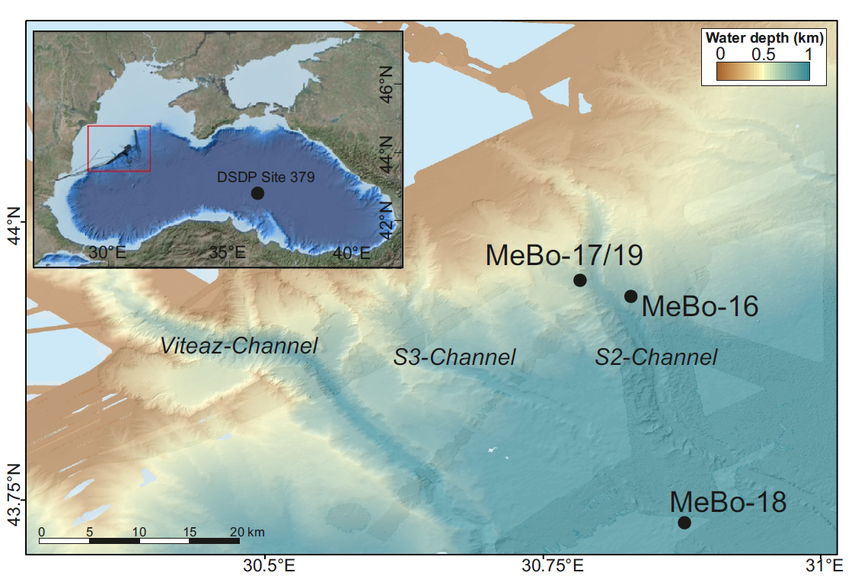
Figure 2. Seafloor bathymetric map near the S2 channel with the locations of drill sites. Position of multichannel seismic (MCS) sections shown in Figure 3 are indicated by red lines and PARASOUND high-resolution sub bottom profiler data shown in Figure 4 are indicated by blue lines. Outlines of head-scarps of slope failures and direction of sediment transport are overlain onto bathymetry.
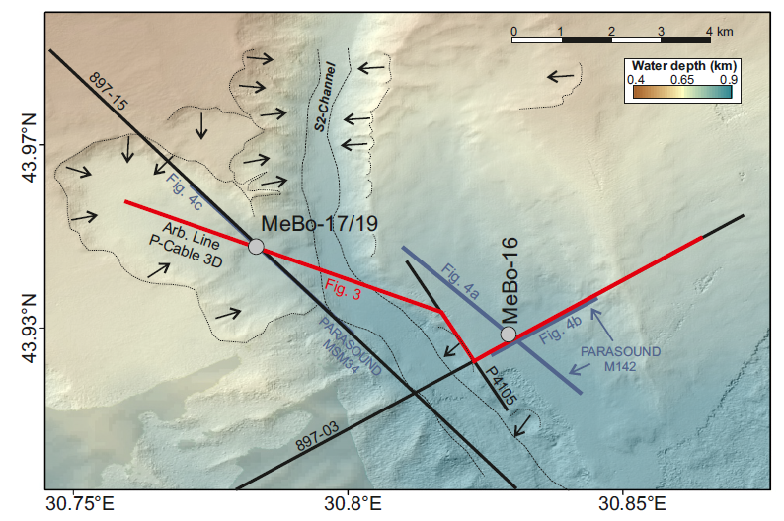
Figure 3. Seismic section composed of tie-lines through MeBo-16 and MeBo-17 (locations see Figure 2) from arbitrary line taken from the P-cable 3D data, multichannel seismic (MCS) line P4105 (with slightly reduced image quality due to proximity to channel-wall, and MCS line 897-03 (all from expedition MSM34).
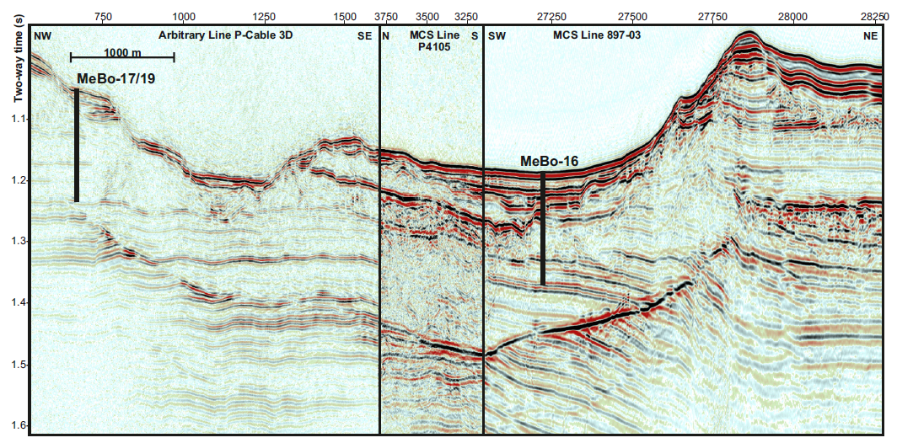

Figure 4. PARASOUND sub bottom profiler data across the drill sites: (a) section of N-S oriented line perpendicular to MCS lines 897-03 (Fig. 3), (b) section of E-W oriented line parallel to MCS line 897-03, both from expedition M142 across site MeBo-16, and (c) section of Line P3420 from expedition MSM34 across site MeBo-17/19.
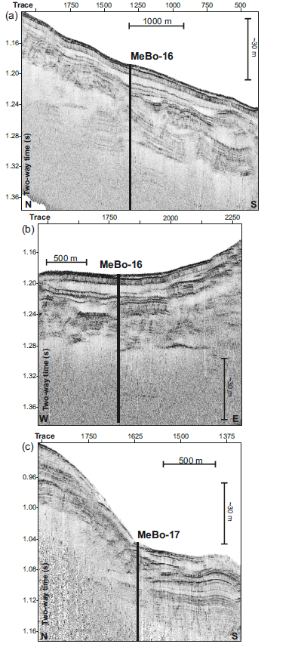

Figure 5. Cross plot of core-derived porosity and formation factor (FF) which is the logging-based medium-penetration formation resistivity divided by in situ pore-water resistivity (using the pore-water salinity values corrected for drilling water infiltration). The best least-square fit line for the Archie-relationship is shown as black dashed line as well as the most likely solution as yellow dashed line based on the bootstrap analysis (see Figure 6).
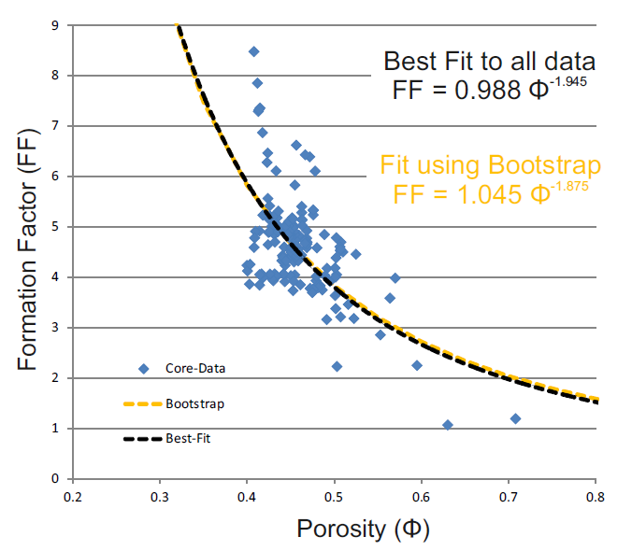

Figure 6. Results of the bootstrap analysis of the Archie parameters. (a) Histogram of parameter ‘m’, (b) histogram of parameter ‘a’, (c) R² value as measure of goodness of fit as function of parameter ‘m’ and (d) as function of parameter ‘a’. Cross-plot of both Archie parameters ‘m’ and ‘a’, with most likely values highlighted by black cross symbol.
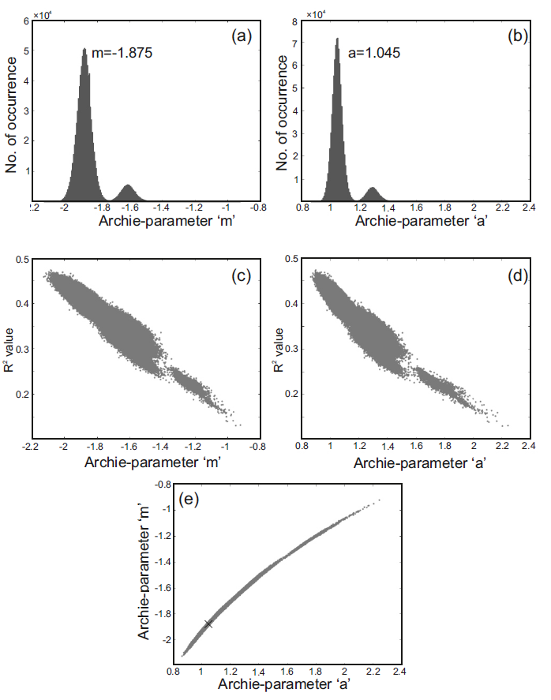

Figure 7. Core-based electrical resistivity from (a) Site MeBo-16 (GeoB22603-1), (b) MeBo-17 (GeoB22605-1), and MeBo-19 (GeoB22620-1) for raw measurements and corrections applied to reflect in situ conditions based on MeBo-19 log-properties. Note, two approaches in estimating the in situ pore fluid salinity were used using a best-fit polynomial and a piece-wise linear, point-by-point interpolation (details see Methods section).
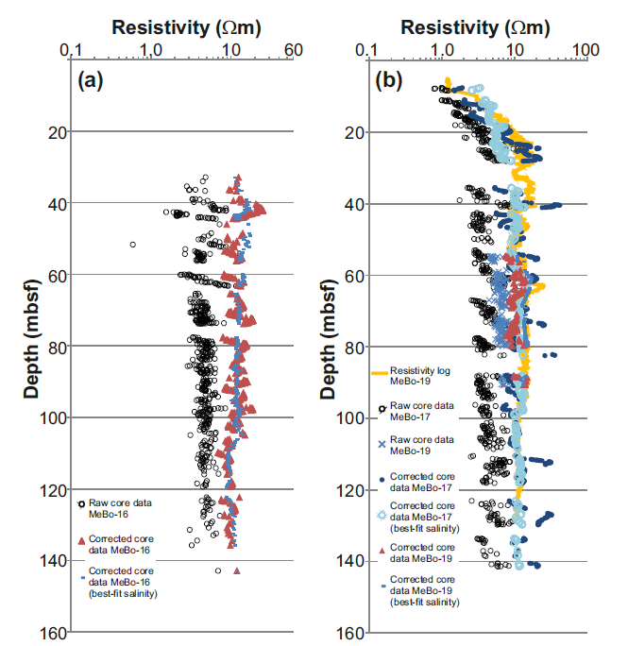

Figure 8. Diagram illustrating contamination of sediment pore fluid with drilling fluid (seawater with salinity of ~22). Shown are un-corrected pore-water salinity values (red circles) and estimates for contaminated pore-fluid based on electrical resistivity data (black symbols).
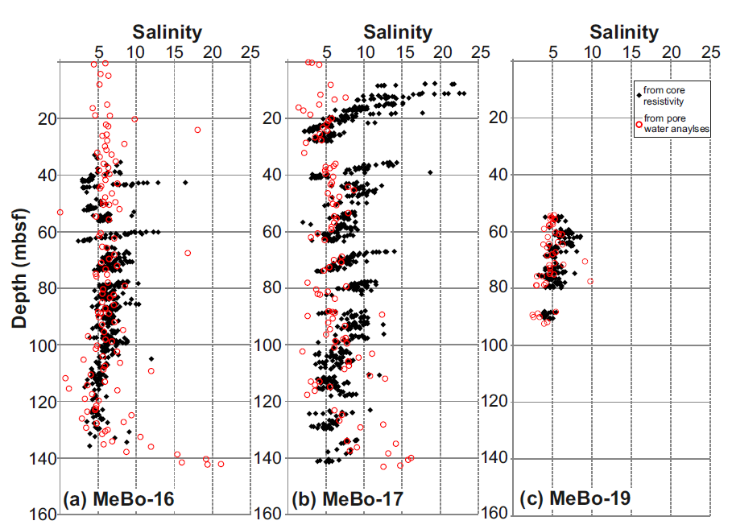

Figure 9. Physical properties for Site MeBo-16 (GeoB22603): Core-based bulk density, grain density, porosity, electrical resistivity (corrected for in situ conditions), and magnetic susceptibility. Lithologic units are shown as vertical column on the right-hand side.
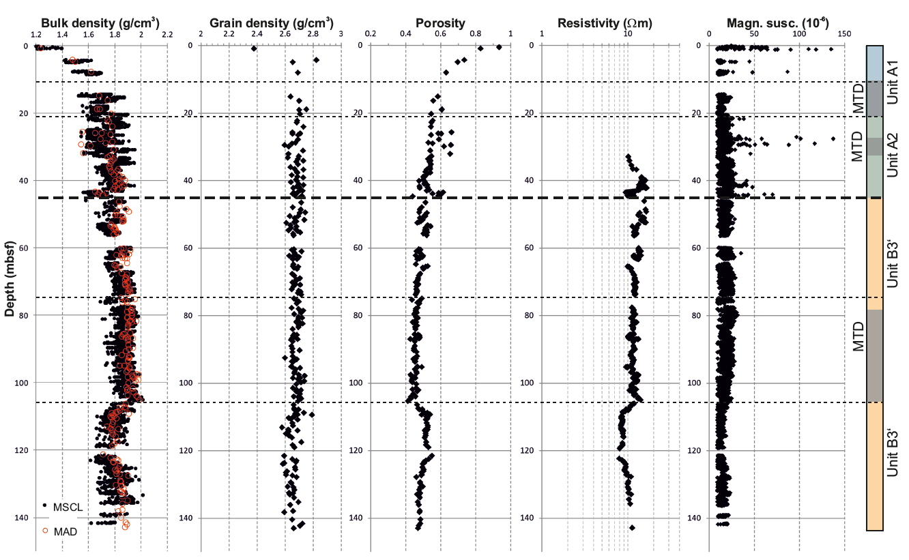

Figure 10. Physical properties for Site MeBo-17 (GeoB22605) and Site MeBo-19 (GeoB22620): Core-based bulk density, grain density, porosity, electrical resistivity (core-based values are corrected for in situ conditions), and magnetic susceptibility are shown. P-wave velocity and natural gamma radiation are for Site MeBo-17, electrical resistivity is from Site MeBo-19, ~40 south of Site MeBo-17. Lithologic units for Site MeBo-17 are shown as vertical column on the right-hand side.
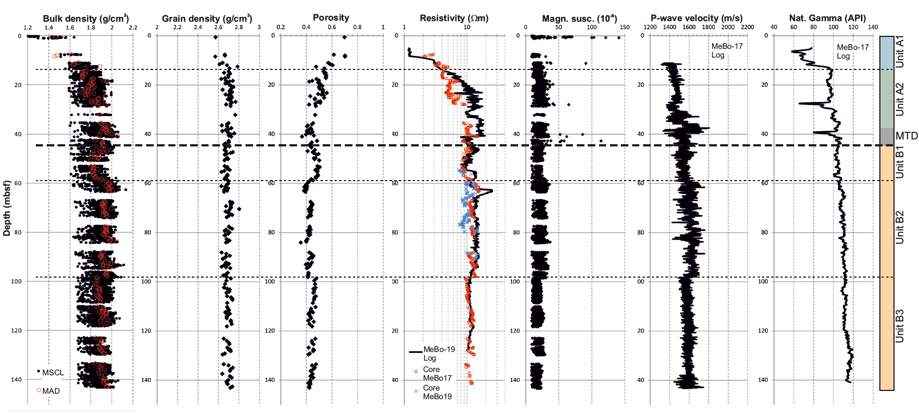
Figure 11. Integration of seismic data with log-data at Site MeBo-16: (a) initial correlation of seismic section from MCS Line 03 through the drill site (left-hand panel) to trace nearest to the drill site location (highlighted in green color, central panel) and synthetic traces (right-hand panel), (b) correlation of seismic data after stretch applied to match identified reflections with synthetic trace.
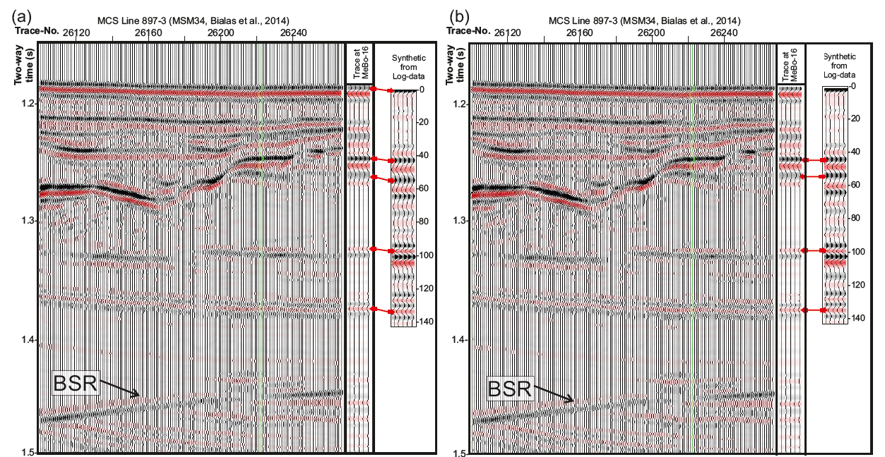

Figure 12. Integration of seismic data with log-data at Site MeBo-17: (a) initial correlation of seismic section from MCS Line 15 through the drill site (left-hand panel) to trace nearest to the drill site location (highlighted in green color, central panel) and synthetic traces (right-hand panel), (b) correlation of seismic data after stretch applied to match identified reflections with synthetic trace.
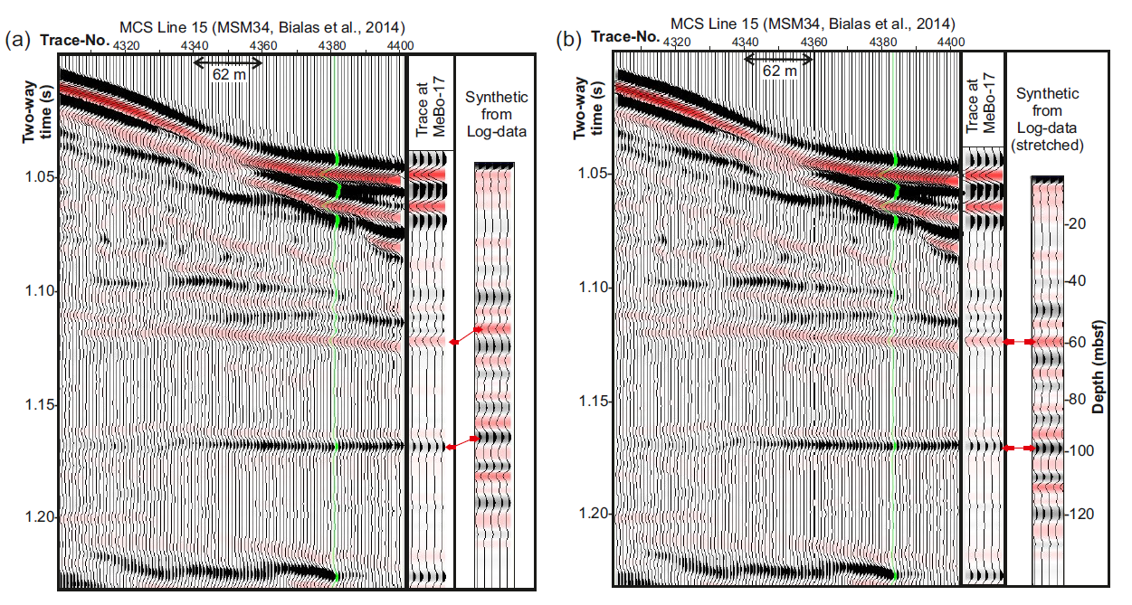

Figure 13. Integration of seismic data and core-based physical properties (bulk density, magnetic susceptibility) at Site MeBo-16 (GeoB22603): (a) Correlation with PARASOUND (N-S oriented) (b) airgun seismic data (E-W oriented), and (c) PARASOUND (E-W oriented). Location of data see Figure 2. Seismo-stratigraphic units and mass-transport deposits (MTD) in gray are included (details see text; compare to Figure 15). Blue dashed line marks polarity-reversed reflector within Unit B.
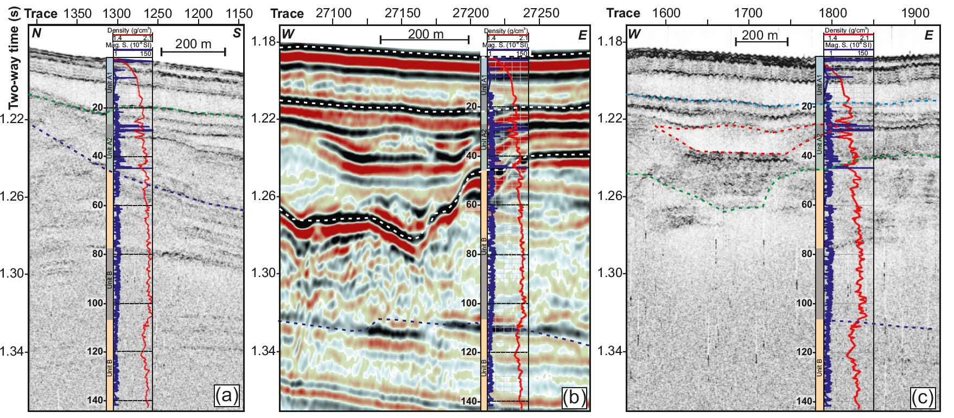

Figure 14. Integration of seismic data and core-based physical properties of magnetic susceptibility (blue) and bulk density (red) at Site MeBo-17 (GeoB22603): (a) Correlation between PARASOUND and (b) airgun seismic data. Location of data see Figure 2. Seismo-stratigraphic units are included (compare to Figure 15). Yellow dotted line marks base of upper high reflectivity in MCS data. Several spikes of high magnetic susceptibility occur in Unit A. Below this boundary, magnetic susceptibility is much lower and uniform in character. Blue dotted line marks the boundary to an underlying MTD of low seismic reflection amplitude.
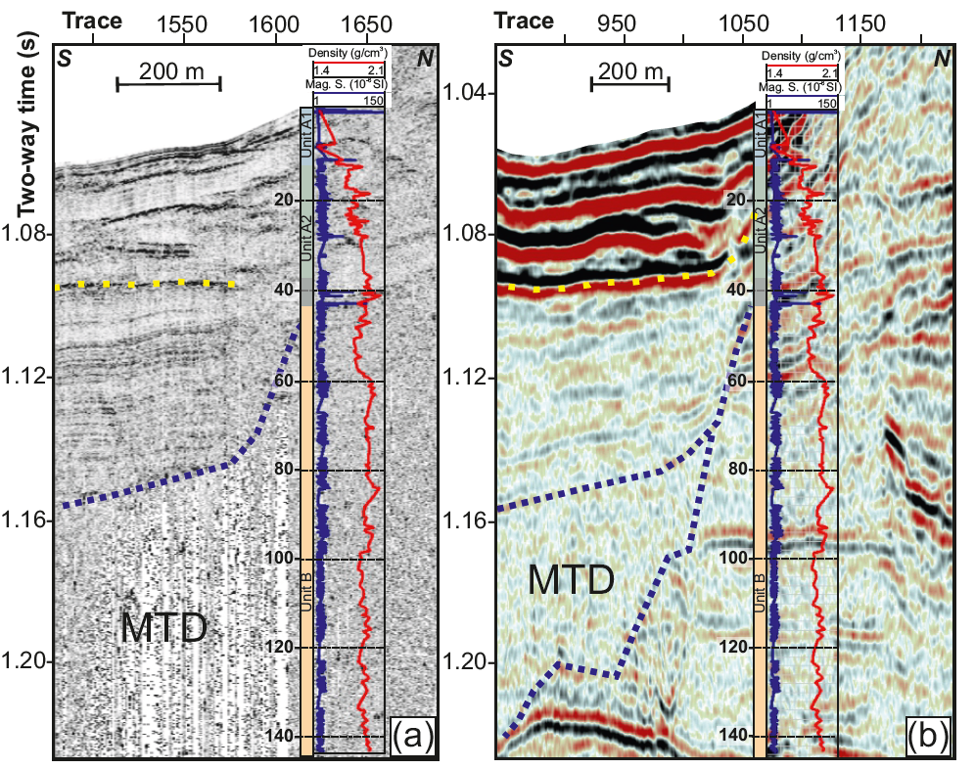

Figure 15. Regional stratigraphy and line-drawing from seismic display of Figure 3 around MeBo drill sites and the S2 channel. Drilling at Site MeBo-16 intersected an older sequence of stratigraphic Unit B (old levee complex) than at Site MeBo-17/19. Also, the upper sediments (stratigraphic Units A1 and A2) are intersected by several mass transport deposits (MTDs). The base of the (sI) methane gas hydrate stability zone (BGHSZ) is shown by the blue dashed line.
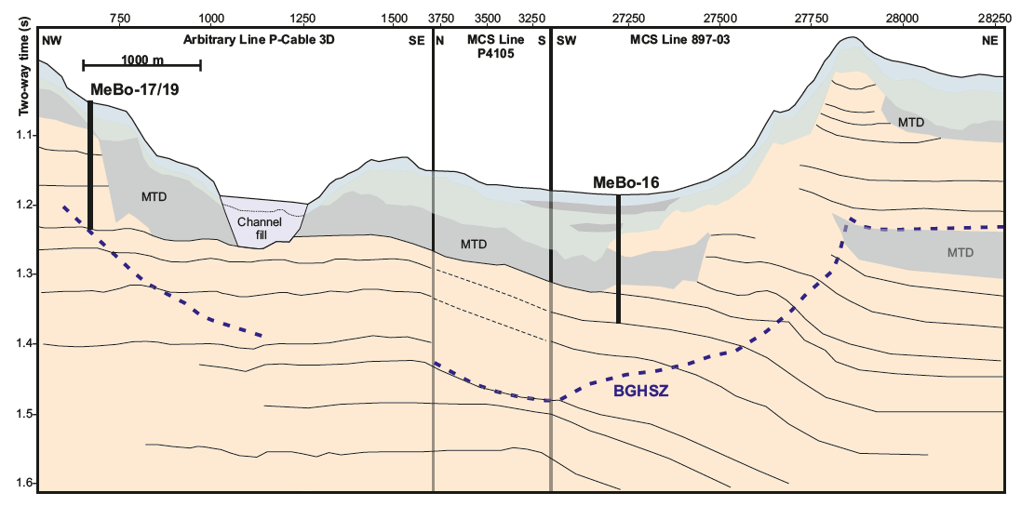

Appendix
Figure A.1 Calibration of the contact-resistivity tool and correlation function between measured resistance R (Ω) to sediment resistivity ρ (Ωm).
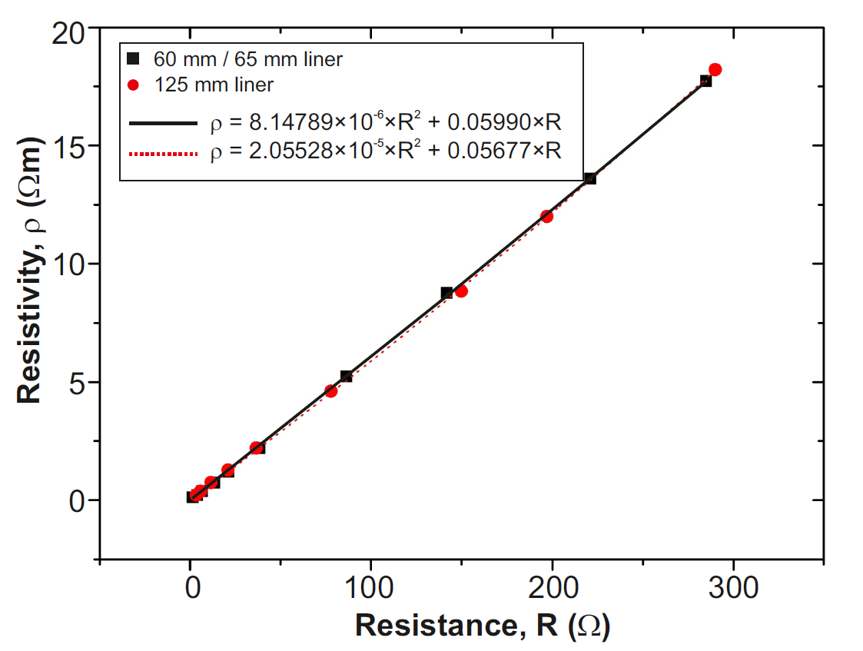

Figure A.2 Temperatures of the sediments while resistivity was measured on the surface in the laboratory onboard the vessel during expedition M142. Temperature was determined in the centre of the half-core once per section. Temperature fluctuations reflect length of time after core was taken in situ, extracted from the MeBo200 rig on deck, processed (including IR imaging, curation, splitting, and sub-sampling for pore-water) and/or stored prior to resistivity measurements.
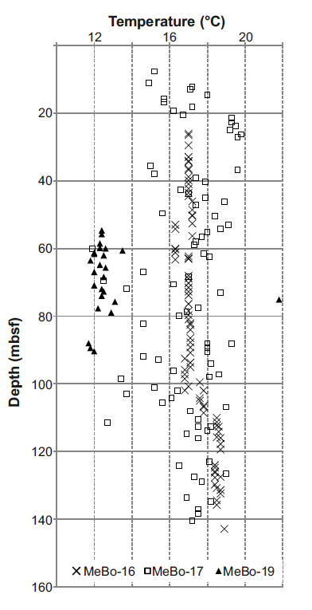
Table A.1. Correction values applied to bulk density values from MSCL gamma-density measurements for cores from Site MeBo-16 (GeoB22603-1)

core | section | value | depth interval affected (cm below seafloor) | reason for shift
1 | 1 | -0.2 | 0 – 130 | too dry
2 | 1 | -0.2 | 420 – 550 | too dry
3 | 1 | -0.1 | 756 - 886 | too dry
5 | 2-3 | -0.1 | 1441 - 1698 | too dry
6 - 16 | all | -0.1 | 1795 - 5636 | too dry
19 - 31 | all | -0.085 | 5995 – 10554 | too dry
32 - 42 | all | -0.1 | 10603 - 14184 | too dry

Table A.2. Correction values applied to bulk density values from MSCL gamma-density measurements for cores from Site MeBo-17 (GeoB22605-1)

core | section | value | depth interval affected (cm below seafloor) | reason for shift
1 – 8 | All | -0.18 | 0 – 2474 | too dry
20 | 1 | -0.043 | 5290-5640 | too dry
20 | 2 | -0.043 | 5290-5641 | too dry
20 | 3 | -0.043 | 5290-5642 | too dry
24 | 1 | -0.035 | 6690-7430 | too dry
23 | 1-3 | -0.05 | 6000-6350 | too dry
24 | 2 | -0.035 | 6690-7431 | too dry
24 | 3 | -0.035 | 6690-7432 | too dry
26 | 1 | -0.035 | 6690-7433 | too dry
26 | 2 | -0.035 | 6690-7434 | too dry
26 | 3 | -0.035 | 6690-7435 | too dry
27 | 1 | 0.08 | 7740-8011 | less core in liner relative to standard
27 | 2 | 0.08 | 7740-8011 | less core in liner relative to standard
27 | 3 | 0.05 | 8011-8405 | less core in liner relative to standard
29 | 1 | 0.05 | 8011-8405 | less core in liner relative to standard
29 | 2 | 0.05 | 8011-8405 | less core in liner relative to standard
29 | 3 | 0.05 | 8011-8405 | less core in liner relative to standard
30 | 1 | 0.068 | 8790-9135 | less core in liner relative to standard
30 | 2 | 0.053 | 8790-9135 | less core in liner relative to standard
30 | 3 | 0.053 | 8790-9135 | less core in liner relative to standard
32 | 1 | 0.1 | 9150-9400 | less core in liner relative to standard
32 | 2 | 0.1 | 9150-9400 | less core in liner relative to standard
34 | 1 | -0.08 | 9610-10190 | too dry
34 | 2 | -0.08 | 9610-10190 | too dry
34 | 3 | -0.08 | 9610-10190 | too dry
35 | 1 | -0.08 | 9610-10190 | too dry
35 | 2 | -0.08 | 9610-10190 | too dry
35 | 3 | -0.08 | 9610-10190 | too dry
39 | 3 | -0.125 | 11260-11831 | less core in liner relative to standard
40 | 1 | 0.075 | 11260-11831 | less core in liner relative to standard
40 | 2 | 0.075 | 11260-11831 | less core in liner relative to standard
40 | 3 | 0.075 | 11260-11831 | less core in liner relative to standard
42 | 1 | 0.075 | 11260-11831 | less core in liner relative to standard
42 | 2 | 0.075 | 11260-11831 | less core in liner relative to standard
42 | 3 | 0.075 | 11260-11831 | less core in liner relative to standard
46 | 1 | 0.076 | 13340-13820 | less core in liner relative to standard
46 | 2 | 0.076 | 13340-13820 | less core in liner relative to standard
46 | 3 | 0.076 | 13340-13820 | less core in liner relative to standard
47 | 1 | 0.076 | 13340-13820 | less core in liner relative to standard
48 | 1 | 0.04 | 14040-14287 | less core in liner relative to standard
48 | 2 | 0.004 | 14040-14287 | less core in liner relative to standard
48 | 3 | 0.04 | 14288-14349 | less core in liner relative to standard

