Fishery biomass trends of exploited fish populations in marine ecoregions, climatic zones and ocean basins

Palomares, M.L.D.^{1*}; Froese, R.²; Derrick, B.¹; Meeuwig, J.J.³; Nöel, S-L.¹; Tsui, G.¹; Woroniak, J.¹; Zeller, D.⁴ and Pauly, D.¹

¹ Sea Around Us, University of British Columbia, Vancouver, V6T 1Z4, Canada
² GEOMAR, Helmholtz Centre for Ocean Research, Düsternbrooker Weg 20, 24105, Kiel,
Germany
³ Marine Futures Lab, University of Western Australia, Crawley, 6009, Australia
⁴ Sea Around Us – Indian Ocean, University of Western Australia, Crawley, 6009, Australia

Supplementary materials
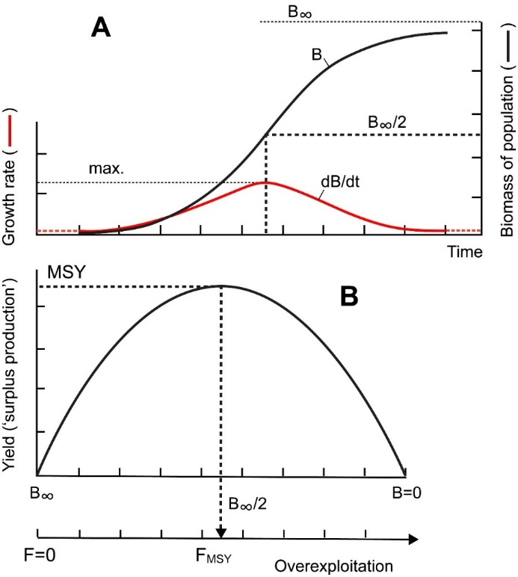
Figure S1. Basic principles behind (Schaefer-type) surplus-production models. A: the population size (i.e., biomass; B) of any living organisms (incl. fish) will, if released into a new ecosystem, increase slowly, then rapidly, then again slowly as the carrying capacity of the ecosystem (B∞) is approached. B: The growth of that population (dB/dt), when plotted against biomass, generates a parabola, with low values of dB/dt (i.e., ‘surplus production’) near carrying capacity (B∞) and near B=0. Surplus production has a maximum value at B∞/2, corresponding to Maximum Sustainable Yield. Surplus-yield predictions, and the CMSY method thus rest on a sound theoretical basis, as density-dependent limitation of carrying capacity is known to occur in all ecosystems (see also text and Figure 2).

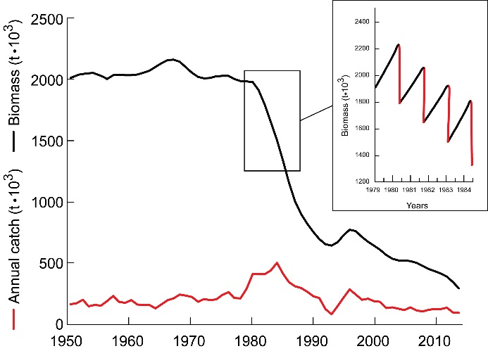
Figure S2. Illustrating the basic principle of the CMSY method: population biomass trajectories are projected from a start year (here 1950) where the biomass is assumed to be a (generally high) fraction of carrying capacity (k, or B∞) which increase via annual growth increments (as a function of population growth rate, r, and B/B∞, see Figure 1) and decrease due to catches (in red, see insert). The trajectories that are retained are those that do not crash the population and conform to various constraints (see text).

Table S1. Number of stocks per climate zone evaluated with either catch maximum sustainable yield (CMSY) method or Bayesian state-space implementation of the Schaefer model (BSM). The zonal B/B_{MSY} is averaged over the last five year period (2010-2014). Note that B/B_{MSY} should be equal to or greater than 1 for healthy populations.
Zone | CMSY | BSM | B/B_{MSY}
Polar, North | 23 | 18 | 0.643
Temperate, North | 75 | 93 | 0.719
Subtropical, North | 177 | 73 | 0.756
Tropical | 767 | 53 | 0.674
Subtropical, South | 33 | 6 | 0.713
Temperate, South | 56 | 1 | 0.669
Polar, South | 7 | 0 | 0.797

