Supporting Information for

A shallow seabed dynamic gas hydrate system off SW Taiwan: Results from 3D seismic, thermal, and fluid migration analyses

Pascal Kunath1, 2, Wu-Cheng Chi2, Christian Berndt3, Liwen Chen4, Char-Shine Liu5,Dirk Kläschen3,and Sina Muff3

1 Institute of Oceanography, National Taiwan University, Taiwan

2Institute of Earth Sciences, Academia Sinica, Taiwan

3Helmholtz Centre for Ocean Research Kiel, GEOMAR, Germany

4Marine Science and Information Research Center, National Academy of Marine Research

5Ocean Center, National Taiwan University, Taiwan

**Contents of this file**

Text S5

Figures S1 to S5

**Text for S5**

**Analysis of the Double BSRs: Sensitivity Tests of Higher-order Hydrocarbon Gas**

To test admixing of methane with higher-order hydrocarbon gases as a possible cause for the formation of a second BSR below BSR2, the observed BSR depth was compared to the predicted BGHSZ for different methane-ethane gas compositions (Fig. S5). The theoretical predictions were made using P-T phase boundary curves for hydrates for fractions of ethane gas up to 0.15. The pressure was assumed to be hydrostatic and the water temperatures and geothermal gradients from our calculations of the BSR temperature gradients were used. Ethane was assumed to be the only hydrate forming gas, as a significant contribution from thermogenic gas has been not reported in the study area (Chuang et al., 2010; Chen et al., 2017). Nonetheless, the calculations are qualitative due to a lack of information on gas composition in the study area. Further details are described in the figure caption for Fig. S5.

**References**

Chen, N. C., Yang, T. F., Hong, W. L., Chen, H. W., Chen, H. C., Hu, C. Y., et al., (2017). Production, consumption, and migration of methane in accretionary prism of southwestern Taiwan. *Geochemistry, Geophysics, Geosystems*, *18*(8), 2970-2989.

Chuang, P. C., Yang, T. F., Hong, W. L., Lin, S., Sun, C. H., Lin, A. T., Chen, J., Wang, Y. and Chung, S. H. (2010). Estimation of methane flux offshore SW Taiwan and the influence of tectonics on gas hydrate accumulation. *Geofluids*, *10*(4), 497-510. DOI: 10.1111/j.1468-8123.2010.00313.x.

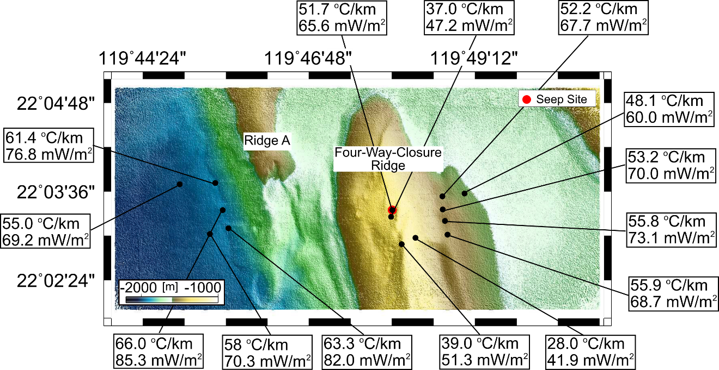

**S1:** Bathymetry map of 4WCR with locations of successful deployments of seafloor heat probe measurements. Geothermal gradients are in oC/km and heat flow values are in mW/m2.

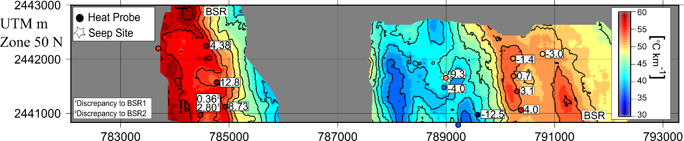

**S2:** BSR-derived geothermal gradient with geothermal gradients from seafloor heat probe measurements. Discrepancies between thermal gradients from the heat probe and BSR are annotated for all heat probes.

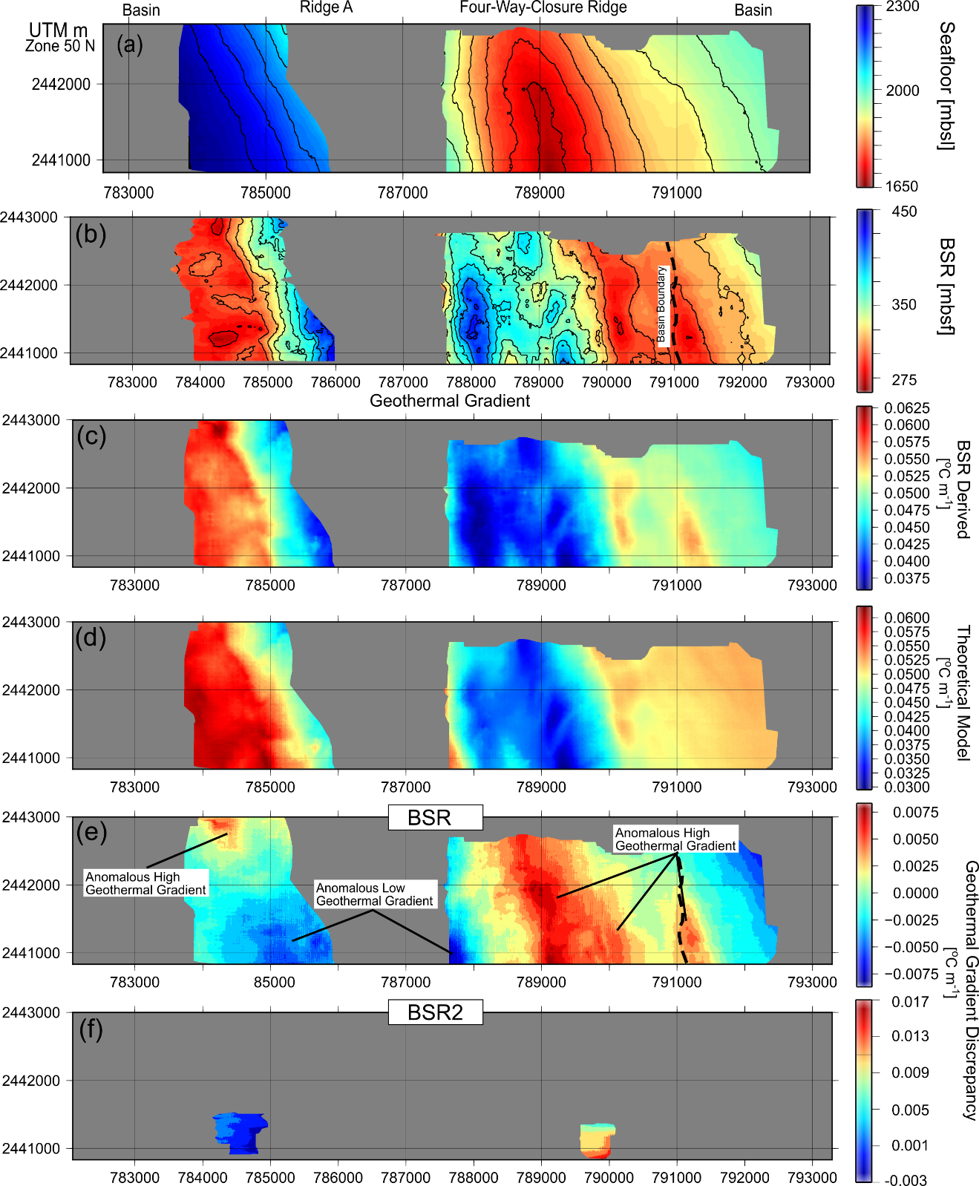

**S3:** **a.** BSR depth map. **b.** BSR sub-bottom depth. **c.** BSR-derived geothermal gradient. **d.** 3D steady-state conductive-only numerical modeling of the topographic effects. **e-f.** Geothermal gradient discrepancies between the numerical model and the BSR.

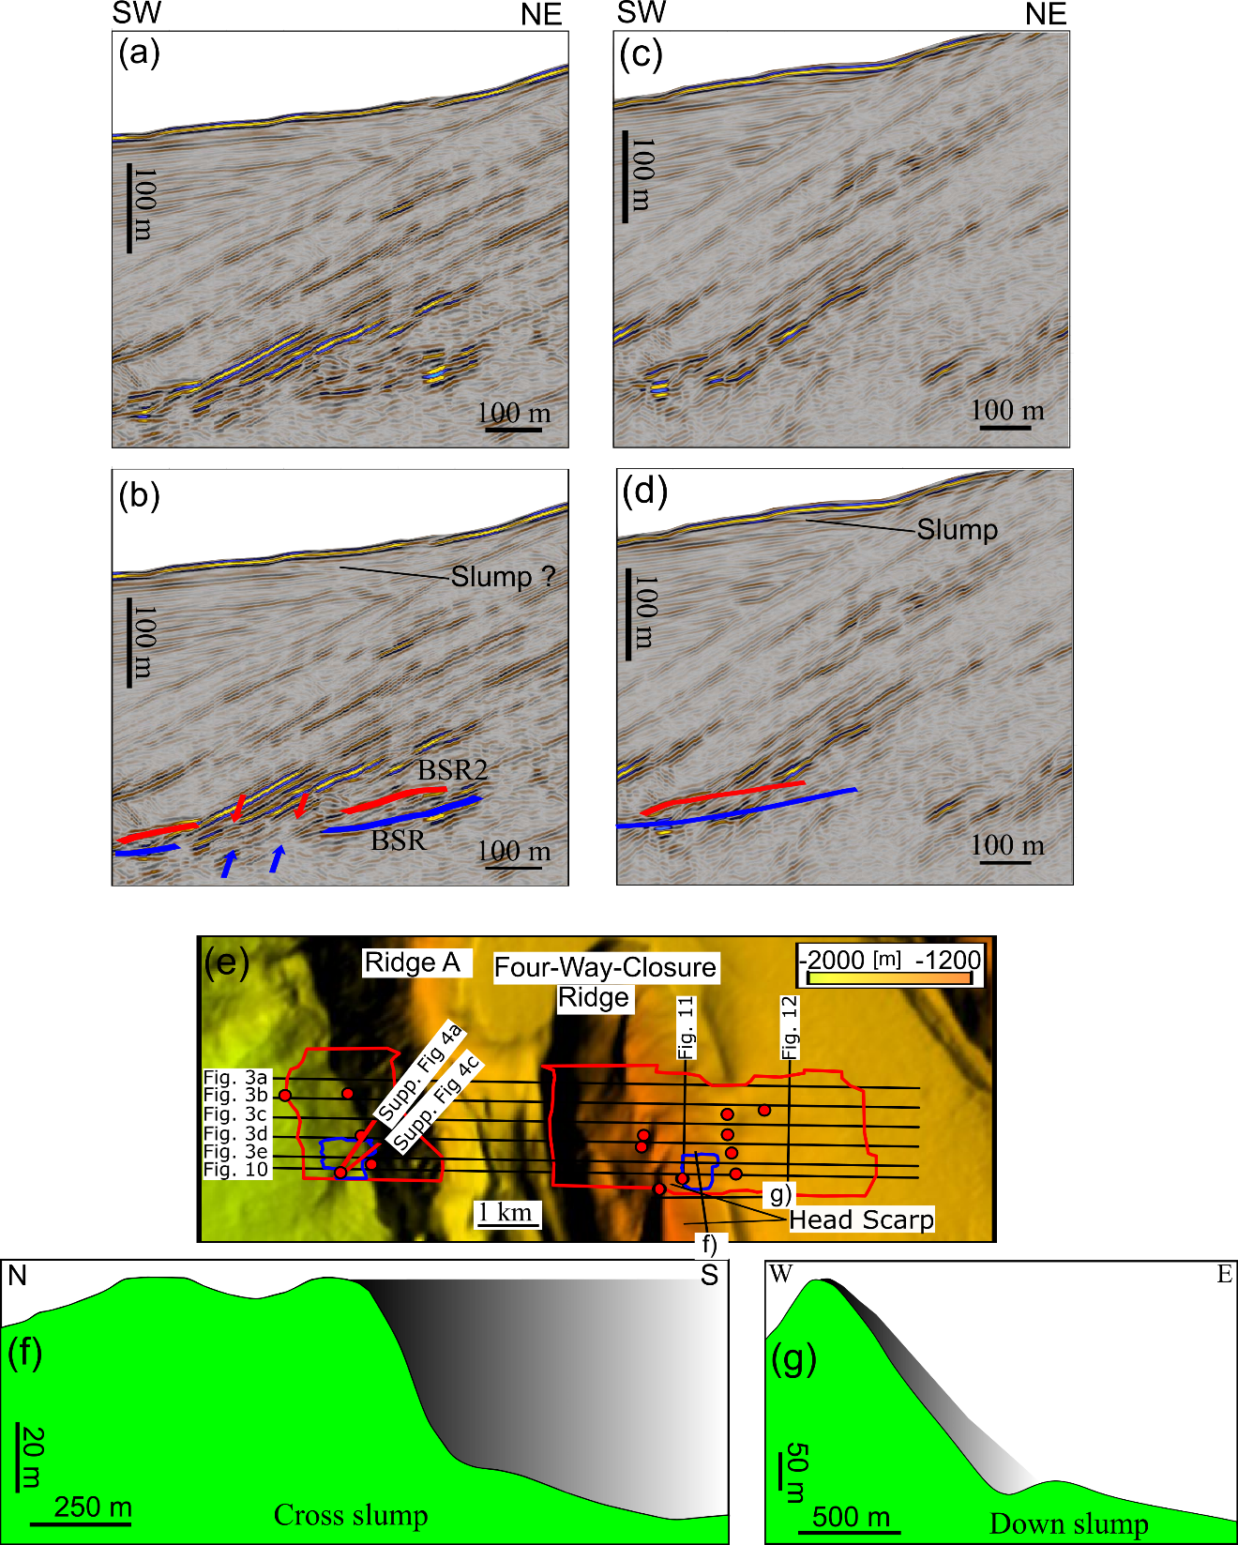

S4: a, c. Crossline section across the slope basin west of Ridge A. b, d. Interpreted crossline section showing BSR (blue) and BSR2 (red). e. 20-m resolution bathymetry map of the study area. Black lines overlain on the bathymetry show locations of seismic sections from the 3D seismic volume shown in the study. Red circles locate the SO-266 heat probe measurements. Red and blue polygons highlight the area where BSRs and double BSRs, respectively, were mapped. f. Bathymetric relief along the eastern limb of 4WCR. Pre-slump surface (grey shaded area) was estimated by interpolating across the slump. g. Bathymetric relief down the sliding surface on the eastern limb of 4WCR.

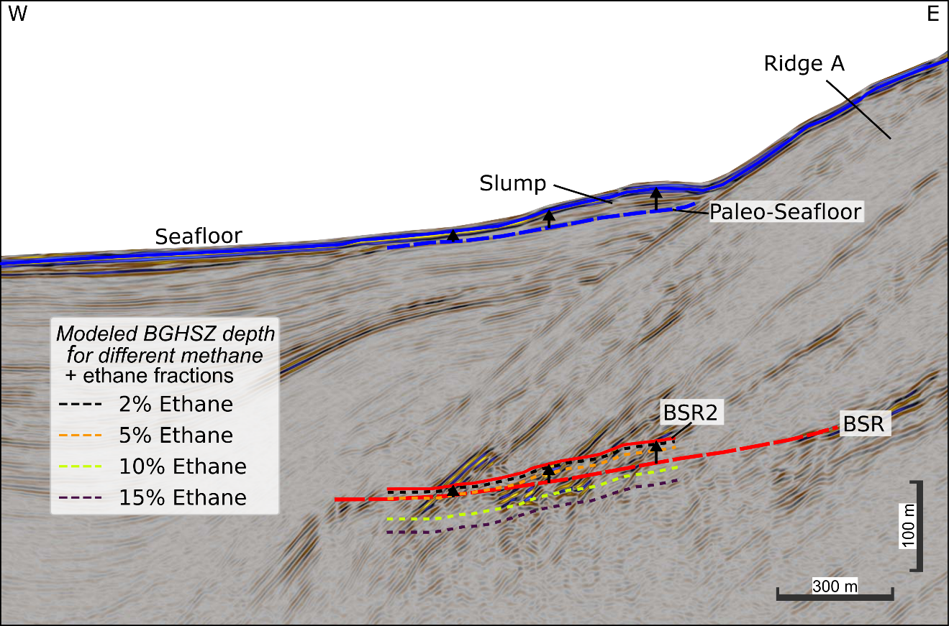

S5: Inline 1140 section across the slope basin west of Ridge A, with a comparison between observed (red dashed line) and modeled (colored dashed line) BSR depths for different fractions of ethane. The distinct mismatch between the BSR depth and predicted BGHSZ indicates that the admixing of methane with higher-order hydrocarbon gases is not likely to be the cause of the formation of a second BSR below BSR2. The blue dashed line is the pre-slump surface. Black arrows highlight that the vertical depth range between BSR and BSR2 is almost identical to the vertical depth range between the paleo-seafloor and seafloor before deposition occurred.