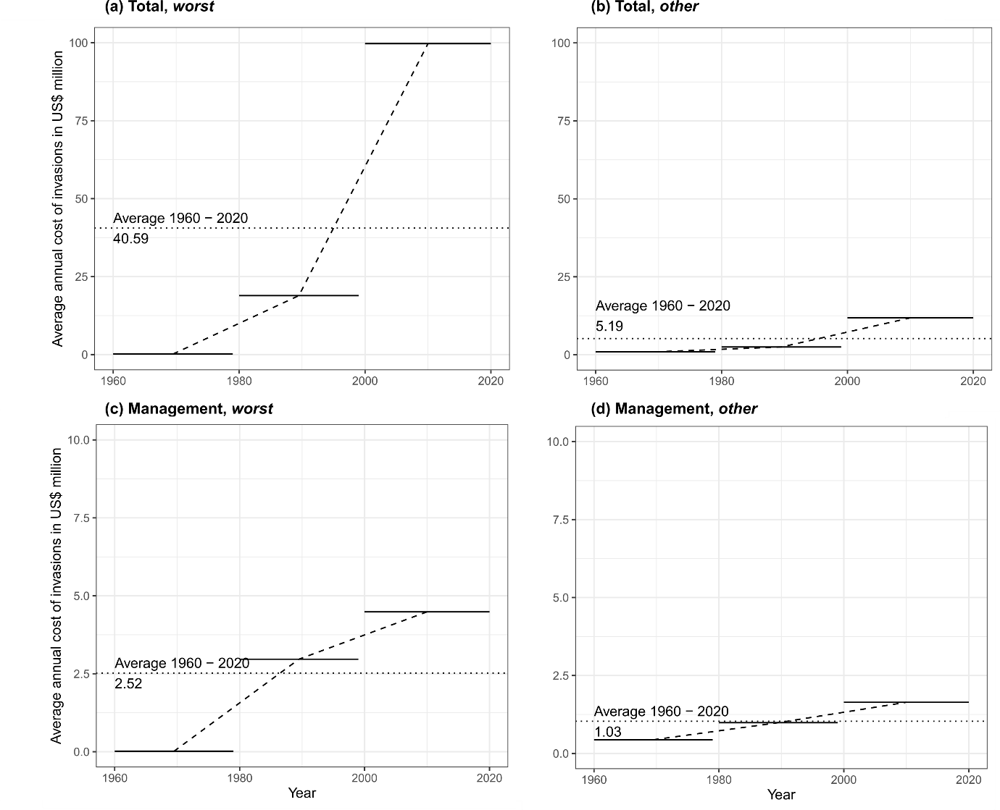

**Figure S1.** Increase in annual average costs per 20 years per species between 1960 to 2000 (i.e., before *worst* list), and 2000 to 2020 (i.e., after *worst* list) for *worst* (a, c) and *other* (b, d) invasive species, considering all costs (a, b) and management spending only (c, d). The dotted line represents the average over the entire period; the horizontal bars show the averages from before and after 2000. Note the *y*-axes are scaled differently among subplots.