Journal of Geophysical Research: Oceans
Supporting Information for
Changing spatial pattern of deep convection in the subpolar North Atlantic
Siren Rühs^{1,2}, Eric C. J. Oliver¹, Arne Biastoch^{2,3}, Claus W. Böning², Michael Dowd⁴, Klaus Getzlaff², Torge Martin², Paul G. Myers⁵
¹Department of Oceanography, Dalhousie University, Halifax, Canada
²GEOMAR Helmholtz Centre for Ocean Research Kiel, Kiel, Germany
³Christian-Albrechts-Universität zu Kiel, Kiel, Germany
⁴Department of Mathematics & Statistics, Dalhousie University, Halifax, Canada
⁵Department of Earth and Atmospheric Sciences, University of Alberta, Edmonton, Canada

Contents of this file

Figures S1 to S9

Additional Supporting Information (Files uploaded separately)

Captions for Movies S1 to S2

Introduction
This supporting information includes several additional Figures that do support the argumentation within the main manuscript (Figure S1-S9). In particular, supplementary Figures S7 and S8 illustrate the variability and associated source regions of upper ocean salinity in the north-western Labrador Sea, supporting the discussion in Section 4.2; the figures aim at providing modeled evidence that both enhanced input of Greenland meltwater into the boundary currents and the recent large-scale fresh anomaly in the eastern North Atlantic influence the current evolution of salinity—and thus mixed layer depth—in this region. In this respect we also show the evolution of the freshwater flux from Greenland as it is included in the forcing of SIM_{JRA} in Figure S9. Additionally, this supporting information provides the captions for two supplementary movies. These movies help assessing the robustness of the results between the two model simulations (movie S1), as well as between model simulation and observations (movie S2). The underlying data is the same as described and referenced in the main manuscript.

Figure S1. Comparison of simulated and observed spatial pattern of eddy kinetic energy (EKE) and center of deep convection (DCC). (a) Mean (1990-2019) simulated (SIM_{JRA}) EKE at 112 m depth calculated following Rieck et al. (2015) based on 5-day mean velocities referenced to the annual mean (color shading), and DCC defined as the area where the mean (1990-2019) March MLD exceed z_{crit} = 1000 m (light red contoured area) or 700 m (white contoured area); (b) Same as (a), but with mean EKE derived from geostrophic surface velocities obtained from satellite altimetry (1993-2017, global ocean gridded product L4, product identifier: SEALEVEL_GLO_PHY_L4_REP_OBSERVATIONS_008_047, made available by the E.U. Copernicus Marine Service) and DCC obtained from the updated ARGO MLD climatology (1990-2019) based on Holte et al. (2017).

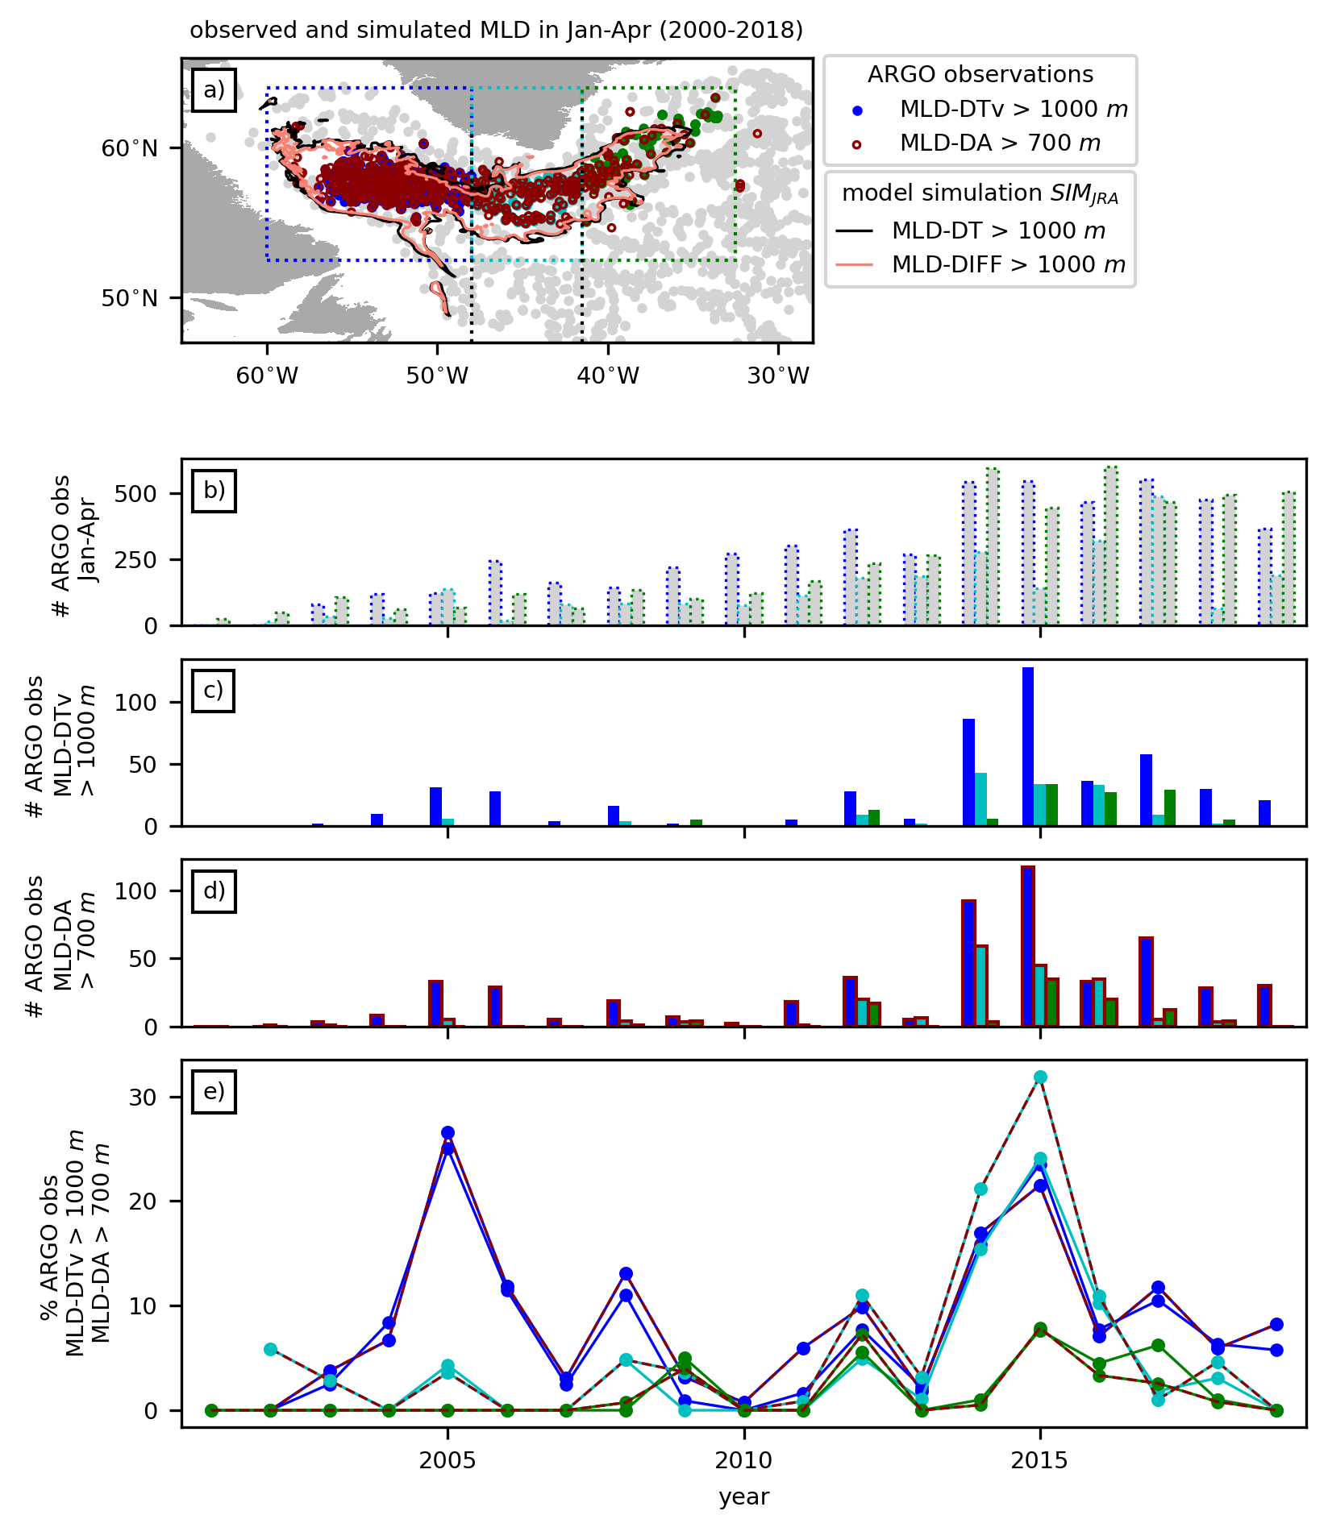Figure S2: Year-to-year variability (2000-2018) of the number of ARGO float observations in the three sub-regions WEST (blue), MID (light blue) and EAST (green) during the deep convection season (Jan-Apr). (a) locations of ARGO profiles with MLD > 1000 m diagnosed using the variable density threshold (MLD-DTv, colored dots), with MLD > 700 m diagnosed using the density algorithm (MLD-DA, red contoured dots), and with MLD-DTv < 1000 m and MLD-DA < 700 m (grey dots), as well as the simulated (SIM_{JRA}) potential deep convection region based on MLDs diagnosed using the fixed density threshold (MLD-DT, black contour) and a turbulent mixing coefficient criterion (MLD-diff, light red contour, representing the turbocline depth or actively mixing layer) ; (b) annual number of ARGO profiles in the sub-regions defined by the dotted frames in (a); number of ARGO profiles with (c) MLD-DTv > 1000 and (d) MLD-DA > 700 m in the three sub-domains; (e) fraction of annual ARGO profiles surpassing MLD-DTv > 1000 (single-colored lines) and MLD-DA > 700 m (red-colored dashed lines).
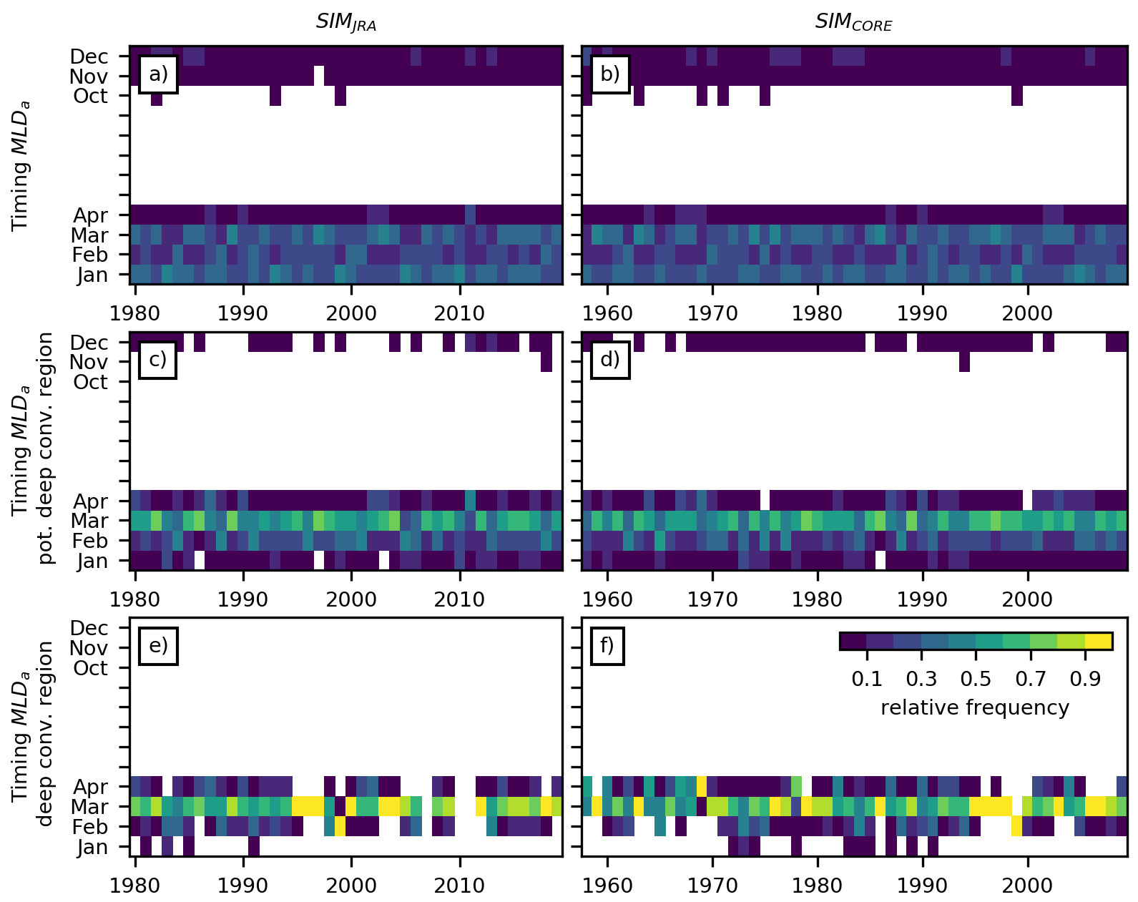
Figure S3: Timing of annual maximum mixed layer depths (MLD_{a}) in SIM_{JRA} (a,c,e) and SIM_{CORE} (b,d,f). Relative number of grid points that experience MLD_{a} in the respective month, considering (a,b) all ocean points between 47 to 66°N and 28 to 65°W (in total 435311), (c,d) all grid points in the potential deep convection region (in total 99429), and (e,f) only those grid points in the actual annual deep convection region (total number varies between the simulations and from year to year) with MLD_{a} > z_{crit}. Note that the relative frequency for each month varies in space and in time. On average, for the whole box only 29% (30%) of the grid points experience their MLD_{a} in March, while this ratio increases for the potential deep convection region to 54% (55%), and for the actual deep convection regions to 73% (69%) in SIM_{JRA} (SIM_{CORE}). However, on average, in the actual deep convection region all grid points, and in the potential deep convection region nearly all grid points (98% and 97% in SIMJRA and SIMCORE, respectively), experience their MLD_{a} in January to April.

Figure S4: Definition of moderate and major deep convection periods. Moderate (light shading, at least one grid point with MLD_{a} > z_{crit}) and major (dark shading, at least 25% of grid-points with MLD_{a} > z_{crit}) deep convection periods derived from (a) SIM_{JRA}, (b) SIM_{CORE}, (c) SIM_{JRA} + SIM_{CORE} (in the overlapping period 1980-2009 the respective criteria must be fulfilled by both simulations) for the potential deep convection region of the whole subpolar gyre (SPG, grey) and it’s sub-regions in the Labrador Sea (WEST, blue), south of Cape Farewell (MIDD, cyan), and in the Irminger Sea (EAST, green).

Figure S5: Simulated year-to-year variability of annual maximum deep convection area and mean deep convection depth. (a) annual maximum deep convection area, and (b) area-weighted spatial mean annual maximum deep convection depth for the Labrador Sea (blue), the region south of Cape Farewell (cyan), and the Irminger Sea (green) as simulated with SIM_{JRA} (solid lines with filled markers) and SIM_{CORE} (dotted lines with non-filled markers); grey shading highlights major deep convection periods as defined in Figure 2e (identical to Figure S4c) and red shading the years 2015-2018 with anomalous high (low) relative annual deep convection volume contribution of the EAST (WEST) deep convection sub-region.

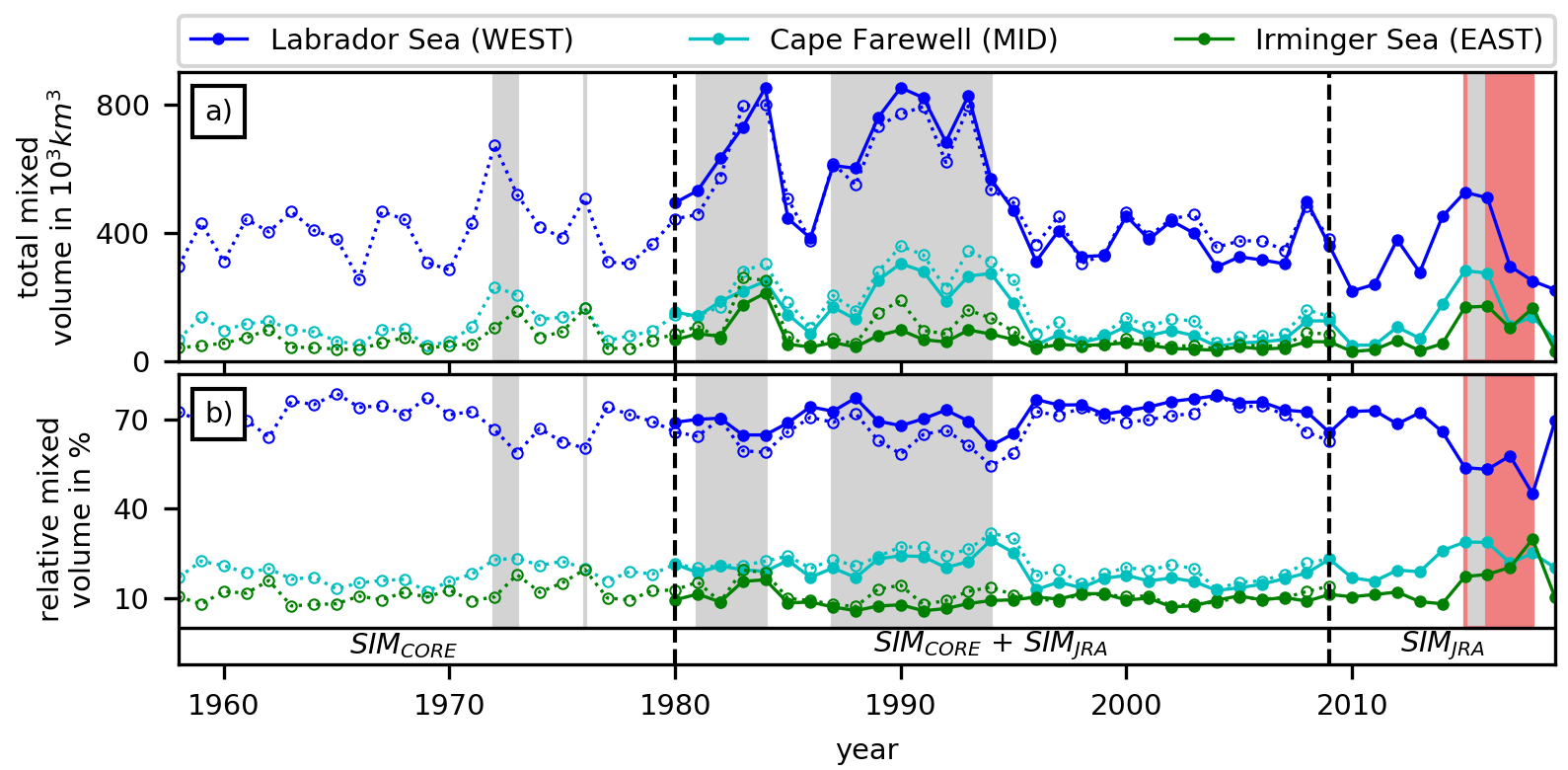
Figure S6: Simulated year-to-year variability of annual mixed layer depth volume. (a) absolute, and (b) relative contributions of the Labrador Sea (blue), the region south of Cape Farewell (cyan), and the Irminger Sea (green) to the mixed layer depth volume in the potential deep convection region as simulated with SIM_{JRA} (solid lines with filled markers) and SIM_{CORE} (dotted lines with non-filled markers); grey and red background shading as in Figures 4,5, and S5.

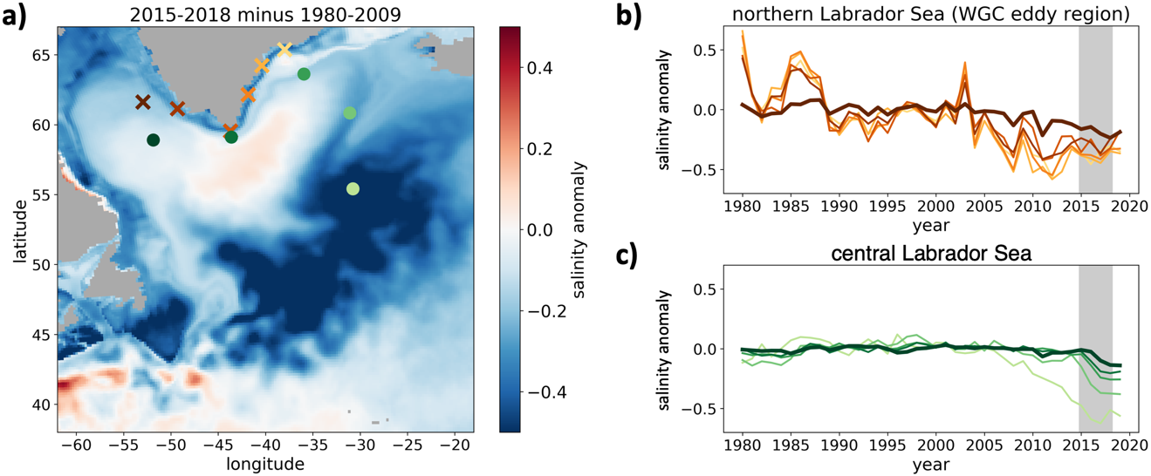
Figure S7: Simulated (SIM_{JRA}) upper ocean (0-200 m) salinity anomalies. (a) Salinity anomaly in the subpolar North Atlantic of the years 2015-2018. (b) Salinity anomalies at selected locations in the East Greenland Current (EGC, orange colors) and West Greenland Current (WGC, red) with a final point in the northern Labrador Sea (bold dark red), where Irminger Rings strongly influence salinity and MLDs; time series refer to crosses of same color in (a). (c) Salinity anomalies at selected locations from the eastern North Atlantic (pale green), passing Reykjanes Ridge and Cape Farewell (medium greens), entering the central Labrador Sea (bold dark green); time series refer to filled circles of same color in (a). All anomalies are computed based on annual mean values with respect to the reference period 1980-2009.

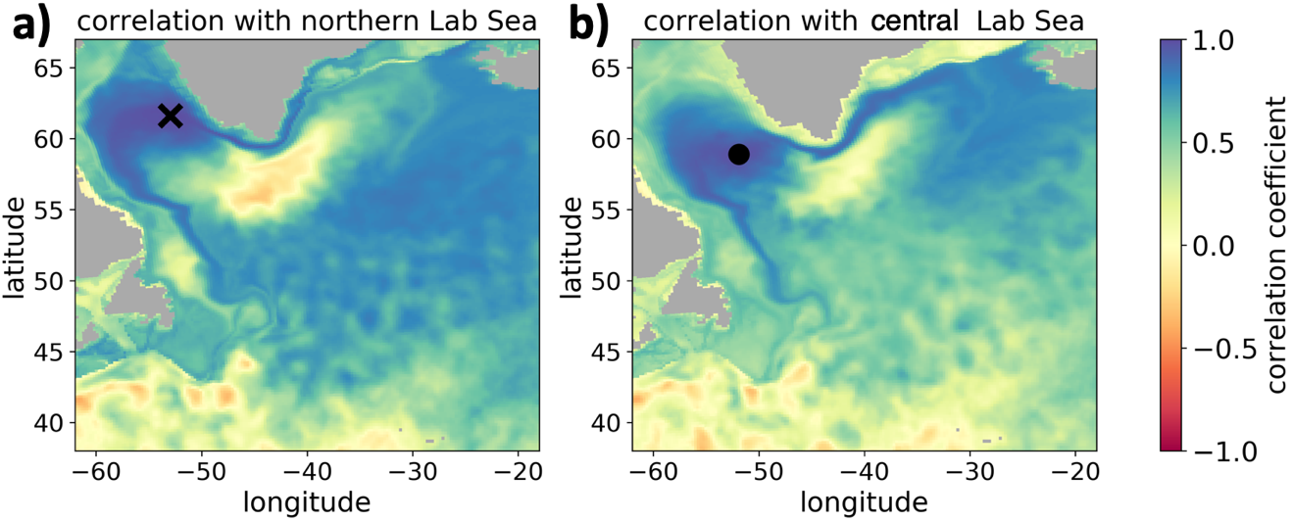
Figure S8: Covariability of simulated (SIM_{JRA}) salinity in the Labrador Sea and the larger subpolar North Atlantic. (a) Covariability of simulated local annual mean upper ocean (0-200 m) salinity with salinity at selected locations in (a) northern (black cross, equals dark red cross in Figure S7a) and (b) central (black dot, equals dark red dot in Figure S7a) Labrador Sea, illustrated by correlation coefficients (Pearson’s r).

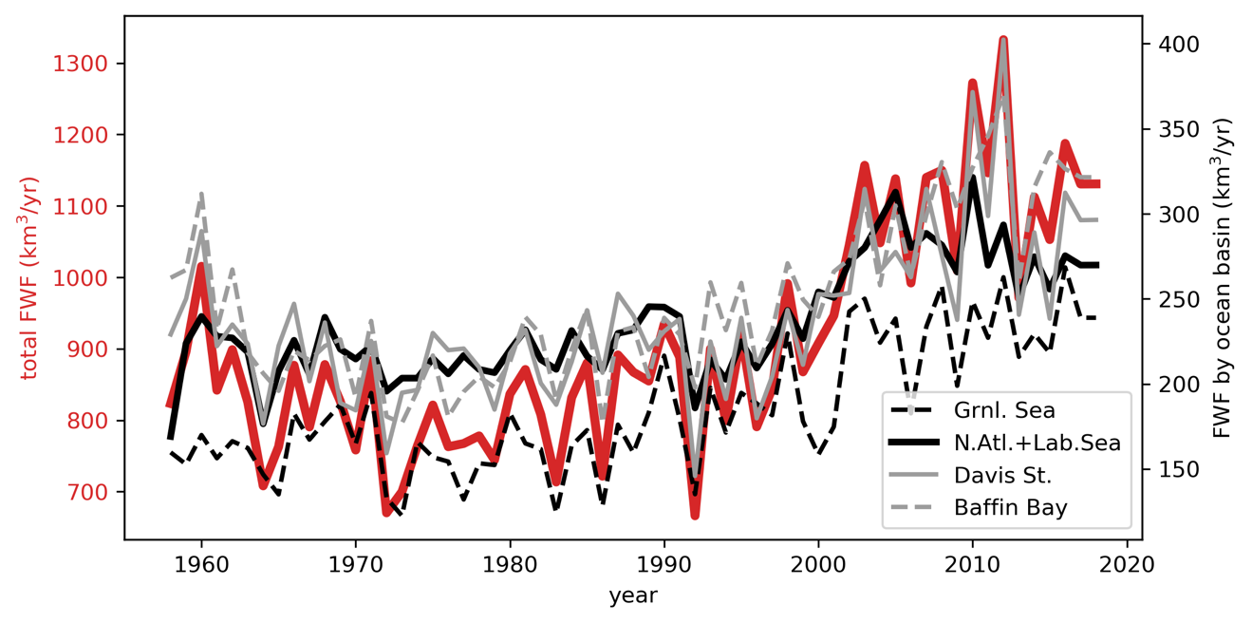
Figure S9: Annual mean freshwater flux (runoff and calving) from Greenland. The plot shows the runoff and calving rates (which we added as liquid flux to the runoff) as included in the JRA55-do forcing version 1.4 (Tsujino et al, 2018), which we applied to SIM_{JRA}. Note, these fluxes originate from Bamber et al. (2018). Ocean basins (black and gray lines) also refer to those defined in Bamber et al. (2018), their Figure 4.

Movie S1: Year-to-year variability in the spatial pattern of annual maximum MLD (anomalies) in SIM_{JRA} and SIM_{CORE}. Upper pannel: Year-to-year variability of spatial MLD_{a} aggregates for the whole potential deep convection region as simulated with SIM_{JRA} (solid lines, grey shading, colored maps) and SIM_{CORE} (dotted lines) and displayed in Figure 2a; Lower left: Long-term mean (1980-2009) MLD_{a}; Lower middle: time-evolving MLD_{a}; Lower right: time-evolving MLD_{a} anomaly referenced to the long-term (1980-2009) mean MLD_{a}. Potential (grey contour) and actual (light red contour) deep convection regions are highlighted.

Movie S2: Year-to-year variability in the spatial pattern of deep convection (Jan-Apr) as inferred from ARGO observations and simulated with SIM_{JRA}. Locations of individual ARGO profiles (i) with MLDs > 1000 m diagnosed using the variable density threshold (MLD-DTv, colored dots), (ii) with MLD > 700 m diagnosed using the density algorithm (MLD-DA, red contoured dots), and (iii) without MLD-DTv > 1000 m or MLD-DA > 700 m (grey dots); simulated annual deep convection area defined by all grid points that feature simulated MLD > 1000 m using the fixed density threshold method (MLD-DT, black contour) and a turbulent mixing coefficient criterion (MLD-diff, light red contour, representing the turbocline depth or actively mixing layer).

