## Short Report

**ALKOR Cruise No. 558**

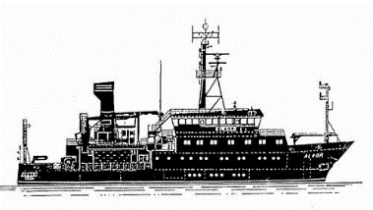

**Field Tests of the autonomous deep-sea crawler/lander system – MANSIO-VIATOR in the Eckernförder Bucht, western Baltic Sea**

**Kiel – Kiel: 28.06. - 30.06.2021**

**AL 558**

**Cruise Lead: Dr. Sascha Flögel**

**GEOMAR Helmholtz Centre for Ocean Research Kiel**

**Kiel, Germany**

## Objectives of the cruise

The expanding need for tools to investigate various parts of the world oceans such as the shelf seas and continental margins for scientific reasons is continually increasing while our ability to address questions concerning ocean change is fundamentally limited by the lack of key technologies for enabling in-situ experimentation and observation performing persistent sensor measurements in the ocean. The work carried out during this short ROBEX expedition will test the capability of the new GEOMAR MANSIO-VIATOR system.

During this cruise we will further test and improve the autonomous capabilities of the MANSIO-VIATOR (latin: harborage-traveller, Fig.1) system. New navigation functions that allow for an acoustic homing and docking will be investigated in extended field tests. The goal is to waive the optic docking completely. Additionally, we’ll test a new counter weight for the WLAN catamaran.

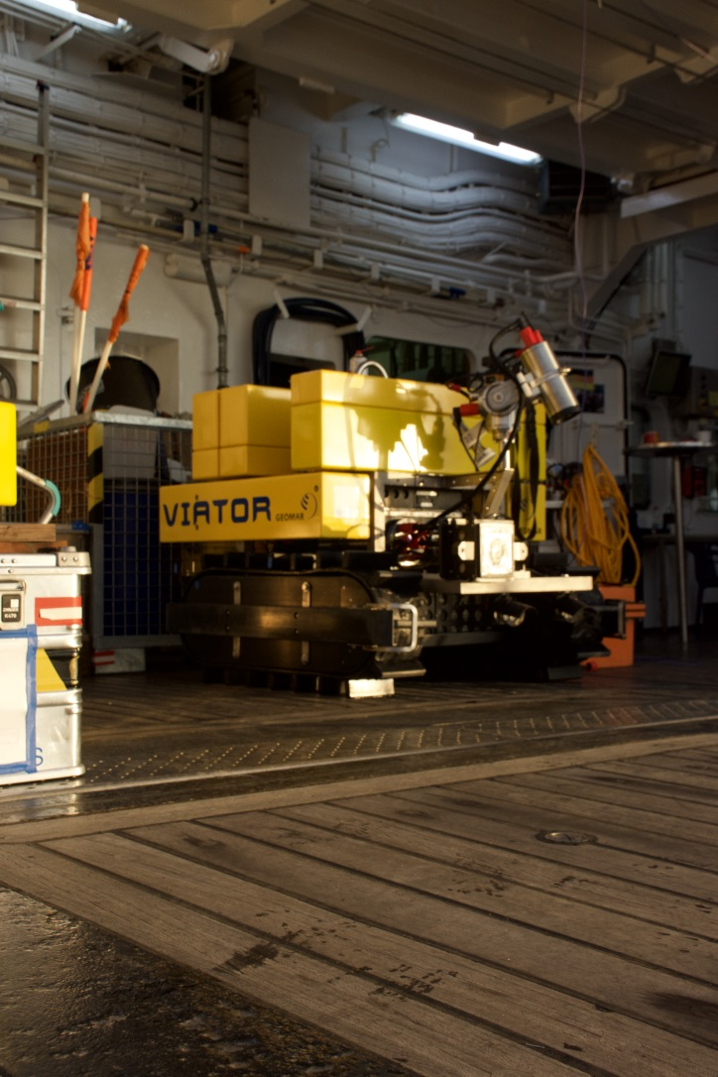

Fig. 1: VIATOR on board RV ALKOR (© S. Flögel).

During cruise 558 we will test new communication and homing functions that will enable VIATOR to locate the hangar MANSIO autonomously from any position. The communication is based on underwater acoustics with USBL modems from Evologics.

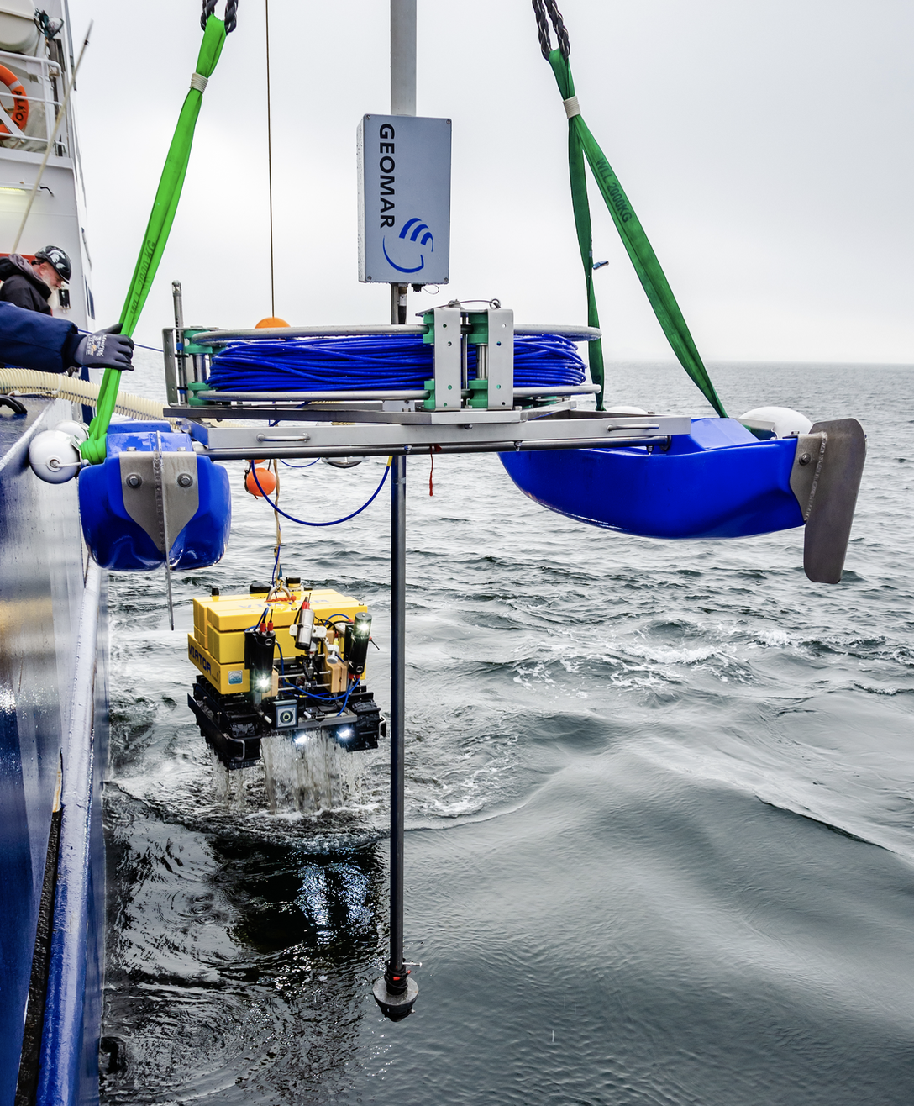

Fig. 2: VIATOR and the WLAN catamaran on-board RV ALKOR, incl. the new counter weight, cruise 558.

## Narrative of the cruise

Monday, 28-06-2021: We embarked the previous night at the Westshore building where we stayed overnight and started the setup of all the hardware incl. WLAN antennas and communication devices such as USBL (moonpool). R/V ALKOR left the GEOMAR easthshore pier in Kiel harbor at 07:57 and headed north towards the Eckernförder Bucht. We used the steaming time to calibrate our optodes and setup the systems. We arrived in our working area at 54°31.40' N and 010°05.130' E in the German EEZ at 10:00. Weather conditions were extremely fair with no wind and clear skies. At 10:30 the MANSIO system was successfully deployed at 18 m water depth (54°31,348’N and 010°05,135’E). Finally, we deployed the crawler VIATOR and the WLAN rig at 54°31,4’N and 010°05,2’E (18 m). All systems do work properly. Next, we lowered the ships USBL to establish a connection with the lander – works. First, we tested the new light control. The early afternoon is filled with a variety of test scenarios and setup of the further improved navigation frontend. During the late afternoon we have to recover the crawler and give it a power cycle due to a broken deep-sea light. Re-deployment just an hour later. We successfully performed multiple homing and docking tests until midnight. End of station work at 24:00.

Tuesday, 29-06-2021: At 08:00 we picked up the station work. Weather is fair, 20°C, light easterly winds. At 08:30 we picked up MANSIO to recharge some battery packs on the buoy. We redeployed MANSIO immediately. In the afternoon we had to recover MANSIO again. Unfortunately, we discovered a broken battery management system and couldn’t deploy it again. In the afternoon we get some rain. We continued our work with VIATOR and collected data for the new obstacle avoidance code. End of station work at 00:30.

Wednesday, 30-06-2021: At 08:00 we picked up the station work by performing additional odometry and logging runs. Weather is fair. Clear skies at 19°C, with some high clouds. We collected line laser until 10:55. Next, we started to recover the crawler. We left the working area at 11:30 and headed back to Kiel – eastshore pier where we arrived at 12:00. We continued with maintenance work on the crawler and started the charging process for the upcoming deployments. We disembarked at 14:00.

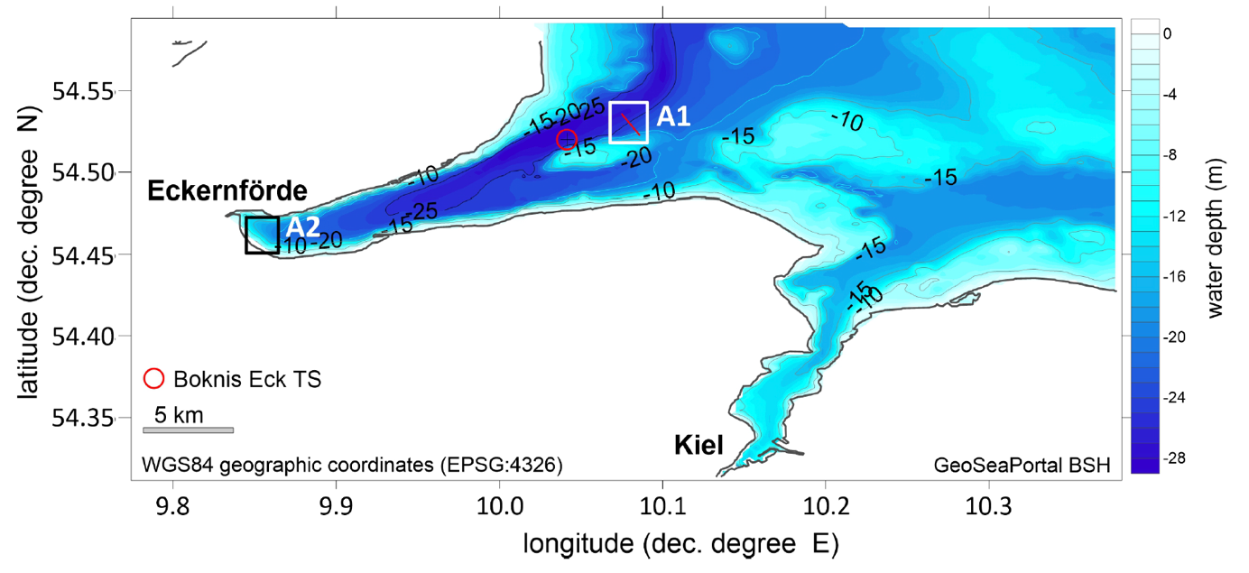

Fig. 3: Bathymetrical map of the Eckernförder Bay and the Kiel Fjord. The working area A1 at the entrance of the Eckernförde Bay at the northeastern slope of Mittelgrund.

## Participants and participating institutions

|  |  |  |
| --- | --- | --- |
| **Name** | **Profession** | **Institution / Company** |
| S. Flögel | Chief Scientist | GEOMAR |
| N. Pech | Engineer | GEOMAR |
| M. Busse | Engineer | GEOMAR |
| A. Barbie | Engineer | GEOMAR |
| R. Schwarz | Engineer | GEOMAR |

* GEOMAR Helmholtz Centre for Ocean Research Kiel, Wischhofstr. 1-3, 24148 Kiel, Germany

## Station list and gear abbreviations

|  |  |  |  |  |  |  |  |  |
| --- | --- | --- | --- | --- | --- | --- | --- | --- |
| **Station List ALKOR 558: 28.06. - 30.06. 2021** | | | | | |  |  |  |
|  |  | |  |  |  |  |  |  |
| **Station** | **Gear** | | **No.** | **Date** | **Time** | **Coordi** | **nates** | **Depth** |
| **AL558-No.** |  | |  | **2021** | **(UTC)** | **Lat. °N** | **Long. °E** | **(m)** |
| 1-1 | MANSIO deployment | | 1 | 28.6. | 08:31 | 54°31.389´ | 010°05.193´ | 17 |
| 2-1 | WLAN catamaran  deployment | | 2 | 28.6. | 08:42 | 54°31.413´ | 010°05.074´ | 18 |
| 3-1 | VIATOR deployment | | 3 | 28.6. | 08:46 | 54°31.428´ | 010°05.262´ | 18 |
| 4-1 | VIATOR recovery | | 4 | 29.6. | 06:38 | 54°31.404´ | 010°05.228´ | 18 |
| 4-1 | VIATOR redeployment | | 5 | 29.6. | 07:32 | 54°31.434´ | 010°05.216´ | 18 |
| 5-1 | MANSIO recovery | | 6 | 29.6. | 06:51 | 54°31.387´ | 010°05.202´ | 18 |
| 5-1 | MANSIO deployment | | 7 | 29.6. | 06:51 | 54°31.406´ | 010°05.194´ | 18 |
| 6-1 | MANSIO recovery | | 8 | 29.6. | 06:51 | 54°31.416´ | 010°05.173´ | 18 |
| 7-1 | WLAN recovery | | 9 | 30.6. | 08:55 | 54°31.423´ | 010°05.201´ | 18 |
| 8-1 | VIATOR recovery | | 10 | 30.6. | 10:05 | 54°31.425´ | 010°05.203´ | 18 |
|  |  | |  |  |  |  |  |  |
| **Gear Abbreviations**: | | |  |  |  |  |  |  |
| MANSIO/VIATOR | | Deep-sea lander and crawler |  |  |  |  |  |  |
| WLAN-buoy | |  |  |  |  |  |  |  |