**Supplementary Material**

Four supplementary figures (Figs. S1-S4) are provided for this article.

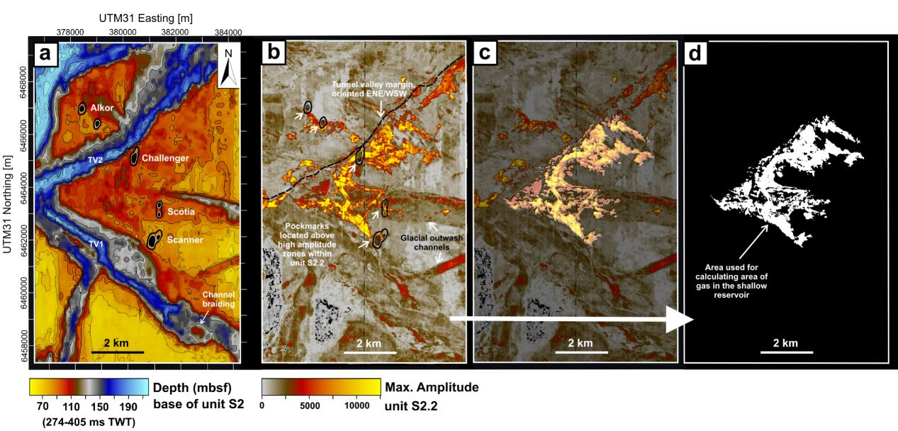

**Supplementary Fig. S1.** Glacial erosional features at base of the Ling Bank Fm. **(a)** Base of reflector S2 depth, **(b)** S2.2 maximum amplitude map from the 3D seismic reflection data. **(c-d)** The white zone highlights the area used for the gas volume calculations in the shallow reservoir. TV – Tunnel valley.

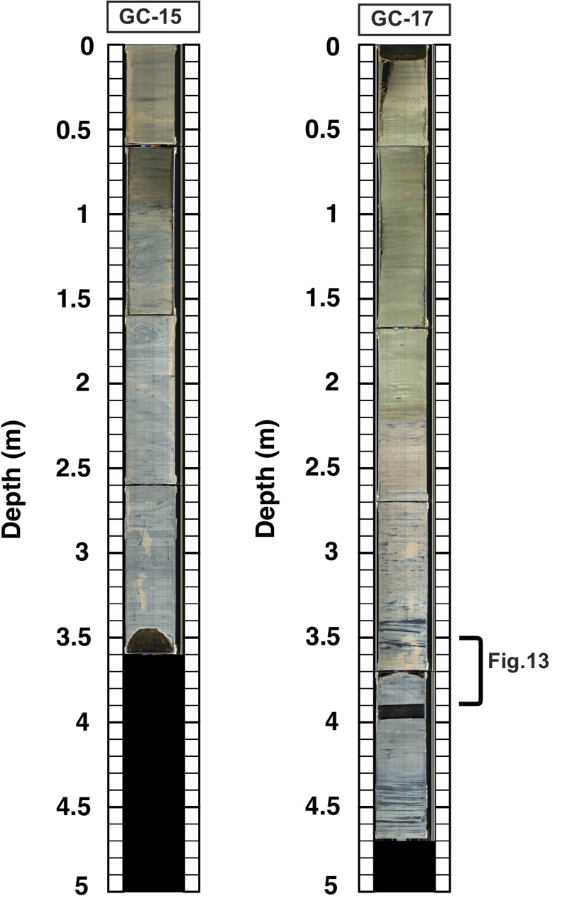

**Supplementary Fig. S2.** Photographs of gravity cores GC-15 and GC-17, extracted from below West (GC-15) and East (GC-17) Scanner pockmark (Figure 2b).

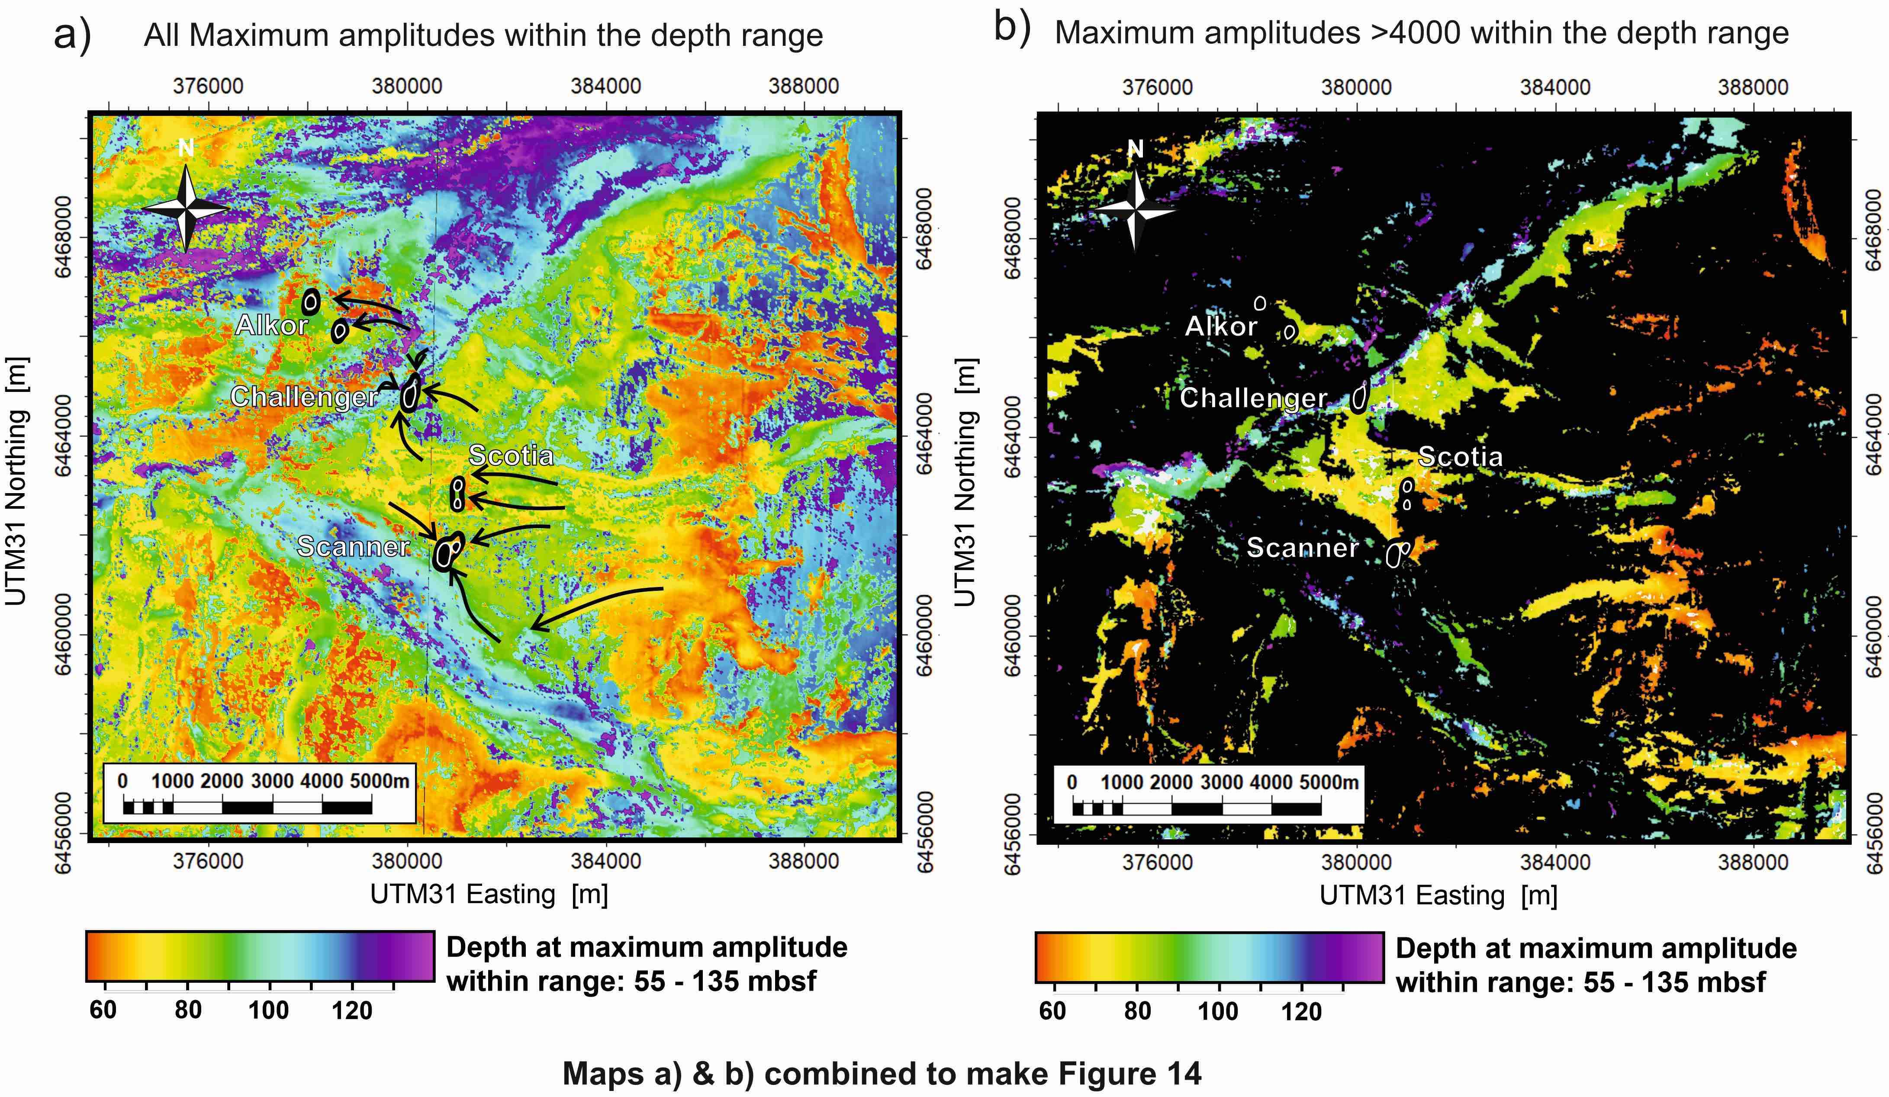

**Supplementary Fig. S3.** Distribution of gas-charged sediment across the Scanner pockmark complex from attribute analysis of 3D seismic reflection data. **(a)** The map shows the depth to the maximum amplitude in the depth range 55-135 metres below seafloor. Maximum amplitude is interpreted to correlate with the depth of gas charged sediment, as well as high impedance contrasts between clay-rich to sand-rich sediment. Black arrows indicate primary flow pathways towards the base of the large pockmarks. Locations of the large pockmarks are displayed using a black fill and dotted outlines. **(b)** brighter areas represent amplitude maxima corresponding to gas-saturated sediment (seismic amplitudes > 4000). Maps **a)** and **b)** are combined to make figure 14.

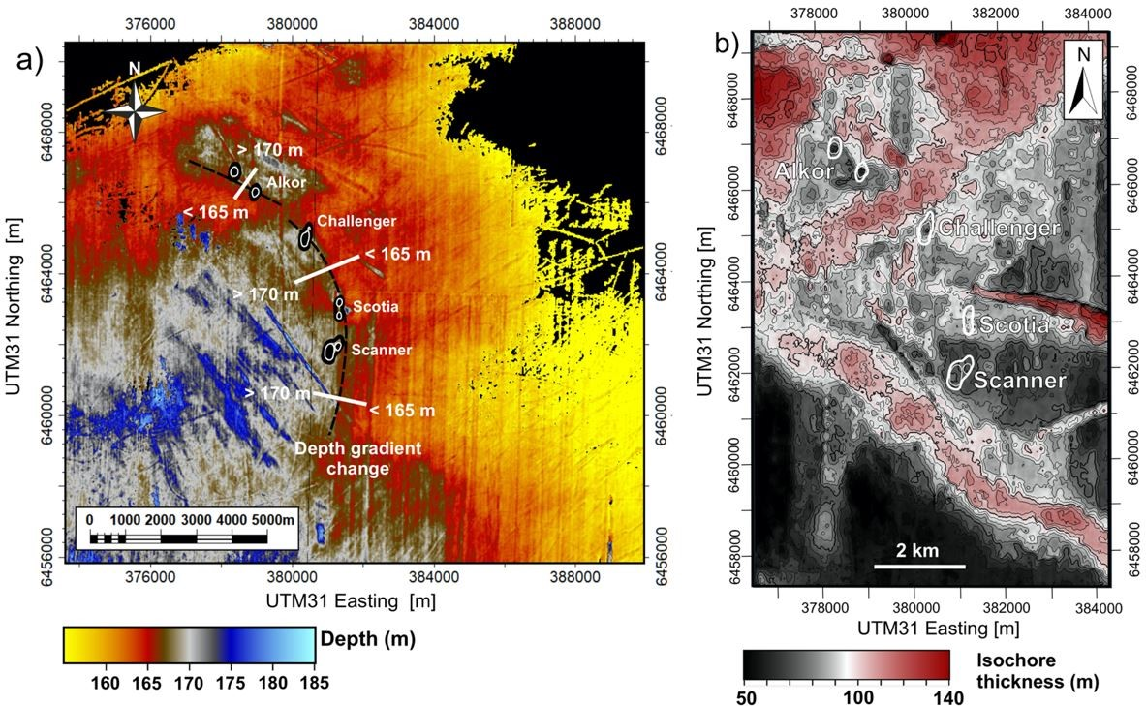

**Supplementary Fig. S4.** **(a)** Depth map of reflector base S5 (Witch Ground Fm) and **(b)** isochore thickness map from reflector base S5 to top S2.1 (basal unit of Ling Bank Fm). **a)** Near the large pockmarks, a 5 m depth increase is observed for reflector base S5. The comparatively sharp depth change (black dashed line) may cause localised focusing of fluid flow and subsequent overpressure generation in this stratigraphic interval. **b)** Areas of reduced isochore thickness correspond to the location of the large pockmarks. Therefore, it may be inferred that the pockmarks have formed in areas of reduced confining pressure/ overburden thickness.