

*Geophysical Research Letters*

Supporting Information for

**Mean-state dependence of CO2-forced tropical Atlantic sector climate change**

**Arielle Stela Imbol Nkwinkwa N.1, Mojib Latif1,2 and Wonsun Park1**

1 GEOMAR Helmholtz Centre for Ocean Research Kiel, Kiel, Germany

2 Faculty of Mathematics and Natural Sciences, University of Kiel, Kiel, Germany

**Contents of this file**

This material contains Methods, 1 section describing the ensemble-mean SST and precipitation responses, 6 Figures and 4 Tables.

**Methods**

*Data description*

We analyze SST and SLP observations for the period 1950-2019. SSTs from HadISST (Rayner et al. 2003) are used and available at a global resolution of 1° from the Met Office’s Hadley Centre. We also use the NOAA Extended reconstructed sea surface temperature version 5 (ERSSTv5, Huang et al. 2017) that is available at 2° global resolution. Additionally, we use the Centennial in situ Observation-Based Estimates SST version 2 (COBE-SST2, Hirahara et al. 2014) provided by NOAA at a global resolution of 1°. The SSTs from NCEP-NCAR (Kalnay et al. 1996) also are used and available at a global resolution of 1.8°. We use the SLPs from HadSLP2 (Allan and Ansell 2006), which is available at a global resolution of 5° from the Met Office’s Hadley Centre. The SLPs from the International Comprehensive Ocean-Atmosphere Data Set (ICOADS, Freeman et al. 2017) also is used that offers a global product at 2° resolution. The other atmospheric fields are from the European Centre for Medium-Range Weather Forecast reanalysis fifth generation (ECMWF ERA-5) available at 0.25° spatial resolution (Hersbach et al. 2019).

*Technical information*

We calculate the SST bias over the eastern equatorial Atlantic (4.5°N – 4.5°S, 10°E – 20°W) for each CMIP model by subtracting from the model SST averaged over the first 30 years, termed F30, the SST from HadISST averaged over the period 1950 – 2019. We note that the results are not sensitive to the exact choice of the box, and the results are similar when using the Atl3 box. The basin-averaged tropical Atlantic SST is removed prior to the calculation. This is done, because it is the relative rather than the absolute SST bias that is dynamically important. The correlation of the CO2-forced trends with the absolute (relative) SST bias amounts to 0.2 (0.6).

We apply the least-square method to compute linear trends over the 140-year period for the CMIP models and over the 70-year period 1950 – 2019 for the observational datasets. We avoid the pre-World War II data which are not considered trustworthy. The CO2-forced trends in the zonal SST and SLP gradient across the equatorial region are defined as the difference between the trends in the western (4.5°N – 4.5°S; 20°W – 50°W) and eastern equatorial Atlantic (4.5°N – 4.5°S; 10°E – 20°W). We note that the sign convention is different in the definition of the SST gradient and the SLP gradient (see the main part). Stippling indicates regions where the trend is not statistically significant at the 95 % confidence level (Figs. 3 and 4, Figs. S1-S3).

ETA models simulate a negative (reduced) SST gradient (eastward amplified SST warming) and exhibit a relatively small warm bias during F30 (smaller than the ensemble-mean warm bias). WTA models simulate a positive (enhanced) SST gradient (westward amplified SST warming) and exhibit a relatively large warm bias (larger than the ensemble-mean warm bias). There are 20 ETA models (8 from CMIP5, 12 from CMIP6) and 11 WTA models (5 from CMIP5, 6 from CMIP6). Details on the pressure adjustment mechanism is given in Nkwinkwa Njouodo et al. (2018).

The t-test is used to compare the CO2-forced trend in SST gradient with the warm SST bias, the mean state SST (F30), and the CO2-forced trend in SLP gradient. We estimate the linear trends and their statistical significance with the Spearman’s rho test (Spearman 1904; Lehmann and D’Abreara 1975). If the Mann-Kendall’s test (Kendall 1975) is applied for the same data, our conclusions do not change. Both tests are non-parametric methods, thus less affected by outliers sometimes contained in observations. The significance of the trends is tested by applying the Spearman’s test.

We calculate the transient climate response (TCR) from each model at the time of CO2-doubling and CO2-quadrupling (Table S4). The two TCRs are defined as the change in the globally averaged near-surface temperature (2m-temperature) in the 1% CO2-increase experiments averaged over years 60 – 79 and 121 – 140, respectively, relative to the preindustrial control experiment (Meehl et al. 2020). ETA models exhibit an averaged TCR of 2.2 °C (1.2 °C – 3.5 °C) at CO2-doubling and 4.9 °C (3.3 °C – 7.3 °C) at CO2-quadrupling, WTA models an averaged TCR of 1.7 °C (1.4 °C – 2.1 °C) at CO2-doubling and of 3.8 °C (2.9 °C – 4.7 °C) at CO2-quadrupling.

**Ensemble-mean SST and precipitation trends**

The ensemble-mean SST response (Fig. S1a) is characterized by a basin-wide warming with largest values in the cold tongue. In the eastern and central equatorial Atlantic and along the coast of southwestern Africa, the trends reach up to 4 °C per 140 years. We note that, when considering the departures from the basin-averaged warming, the pattern is reminiscent of the warming observed on interannual timescales during present-day Atlantic Niño events (e.g. Zebiak 1993, Lübbecke et al. 2018). There is a weak seasonal dependence, with largest warming in the cold tongue simulated in boreal winter and fall (Fig. S2).

The ensemble-mean precipitation response (Fig. S1b) depicts enhanced rainfall over the equatorial Atlantic with maxima over the western and central parts and the very eastern part. Increased rainfall also is observed over parts of western equatorial Africa. Drying is simulated over South America within ±10° latitude of the equator and over the subtropical northern TA. These changes suggest a zonal reorganization of the AWC, as in the ETA models (Fig. 5a). The Intertropical Convergence Zone (ITCZ), a major rain band that in the climatological mean is located north of the equator, has been shown to move in the meridional direction in association with climate variability on seasonal to decadal timescales (e.g. Nobre and Shukla 1996, Chiang et al. 2002). However, the ITCZ position, as defined by the zero 10 m meridional wind contour, hardly changes in response to the rising CO2-levels (Fig. S1b). Rainfall increases over the western equatorial Atlantic are largest in boreal winter and spring and the increases north of the equator in boreal summer and fall (Fig. S3). The differences are likely due to the seasonal march of the ITCZ and associated diabatic heating (Cabos et al. 2017, Nnamchi et al. 2020a).

The spread in the SST response, calculated as the standard deviation of the trends across the model ensemble, also is largest in the cold tongue (Fig. S1c). Nevertheless, the model spread is considerably smaller than the ensemble-mean response (Fig. S1a), indicating a high signal-to-noise ratio with respect to SST. In contrast, the spread in the precipitation response (Fig. S1d) is of similar magnitude and in some regions larger than the ensemble-mean, indicating a low signal-to-noise ratio. Largest standard deviations are observed over the equatorial region approximately between 10°N and 10°S, with maxima over the western TA off the equator, over equatorial South America near 60°W and the western Equatorial Africa region (Fig. S1d).

**References**

Allan, R. & Ansell, T. A new globally complete monthly historical gridded mean sea level pressure dataset (HadSLP2): 1850–2004. *Journal of Climate*, *19*(22), 5816-5842 (2006).

Cabos, W., Sein, D.V., Pinto, J.G., Fink, A.H., Koldunov, N.V., Alvarez, F., Izquierdo, A., Keenlyside, N. & Jacob, D. The South Atlantic Anticyclone as a key player for the representation of the tropical Atlantic climate in coupled climate models. *Climate Dynamics*, *48*(11-12), 4051-4069 (2017).

Chiang, J.C., Kushnir, Y. & Giannini, A. Deconstructing Atlantic Intertropical Convergence Zone variability: Influence of the local cross‐equatorial sea surface temperature gradient and remote forcing from the eastern equatorial Pacific. *Journal of Geophysical Research:* *Atmospheres*, *107*(D1), ACL-3 (2002).

Freeman, E., Woodruff, S.D., Worley, S.J., Lubker, S.J., Kent, E.C., Angel, W.E., Berry, D.I., Brohan, P., Eastman, R., Gates, L. & Gloeden, W. ICOADS Release 3.0: a major update to the historical marine climate record. *International Journal of Climatology*, *37*(5), 2211-2232 (2017).

Hersbach, H., Bell, B., Berrisford, P., Horányi, A., Sabater, J.M., Nicolas, J., Radu, R., Schepers, D., Simmons, A., Soci, C. & Dee, D. Global reanalysis: goodbye ERA-Interim, hello ERA5. *ECMWF newsletter, 159*, 17-24 (2019).

Hirahara, S., Ishii, M. & Fukuda, Y. Centennial-scale sea surface temperature analysis and its uncertainty. *Journal of Climate*, *27*(1), 57-75 (2014).

Huang, B., Thorne, P.W., Banzon, V.F., Boyer, T., Chepurin, G., Lawrimore, J.H., Menne, M.J., Smith, T.M., Vose, R.S.& Zhang, H.M. Extended reconstructed sea surface temperature, version 5 (ERSSTv5): upgrades, validations, and intercomparisons. *Journal of* *Climate*, *30*(20), 8179-8205 (2017).

Kalnay, E., Kanamitsu, M., 344 Kistler, R., Collins, W., Deaven, D., Gandin, L., Iredell, M., Saha, S., White, G., Woollen, J. & Zhu, Y. The NCEP/NCAR 40-year reanalysis project. *Bulletin of* *the American meteorological Society*, *77*(3), 437-472 (1996).

Kendall, M.G. Kendall rank correlation methods. *Griffin, London* (1975).

Lehmann, E.L., & D'Abrera, H.J. Nonparametrics: statistical methods based on ranks. Holden-day (1975). Lin, J.L. The double-ITCZ problem in IPCC AR4 coupled GCMs: Ocean–atmosphere feedback analysis. *Journal of Climate*, *20*(18), 4497-4525 (2007).

Lübbecke, J.F., Rodríguez‐Fonseca, B., Richter, I., Martín‐Rey, M., Losada, T., Polo, I. & Keenlyside, N.S. Equatorial Atlantic variability—Modes, mechanisms, and global teleconnections. *Wiley Interdisciplinary Reviews: Climate Change, 9*(4), e527 (2018).

Nnamchi, H.C., Latif, M., Keenlyside, N.S., Kjellsson, J. and Richter, I., 2021. Diabatic heating governs the seasonality of the Atlantic Niño. *Nature communications*, *12*(1), 1-10.

Nobre, P. & Shukla, J. Variations of sea surface temperature, wind stress, and rainfall over the tropical Atlantic and South America. *Journal of climate*, *9*(10), 2464-2479 (1996).

Rayner, N.A.A., Parker, D.E., Horton, E.B., Folland, C.K., Alexander, L.V., Rowell, D.P., Kent, E.C. & Kaplan, A Global analyses of sea surface temperature, sea ice, and night marine air temperature since the late nineteenth century. Journal of Geophysical Research: Atmospheres, 108(D14) (2003).

Spearman C. Measurement of association, Part II. Correction of ‘systematic deviations’, *American Journal of Psychology* 15(1):72–101 (1904).

Zebiak, S.E. Air–sea interaction in the equatorial 436 Atlantic region. *Journal of Climate*, *6*(8),156 7-1586 (1993).

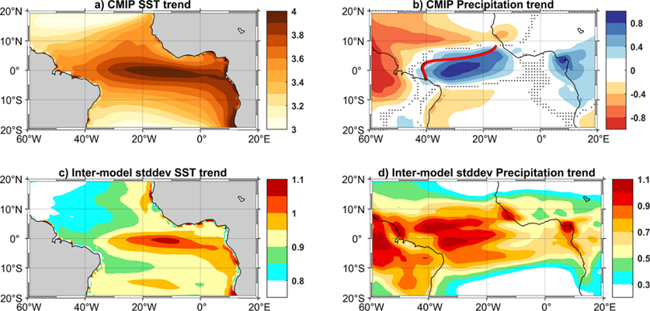

**Fig. S1: CO2-forced ensemble-mean SST and precipitation trends.**

Ensemble-mean trends calculated over all 140 years and all seasons: (a) SST and (b) precipitation, (c, d) the respective standard deviations. Dots indicate regions where the trend is not significant at the 95 % level according to the Spearman’s test. Units are °C/140yr and mm∙d-1/140yr, respectively. Bold solid lines in (b) indicate the position of the ITCZ: the black and red line depict the position during the first and last 30 years of the global warming (1 % CO2-increase per year) simulations, respectively. The two lines overlay each other, indicating that there is virtually no change in the position of the ITCZ.

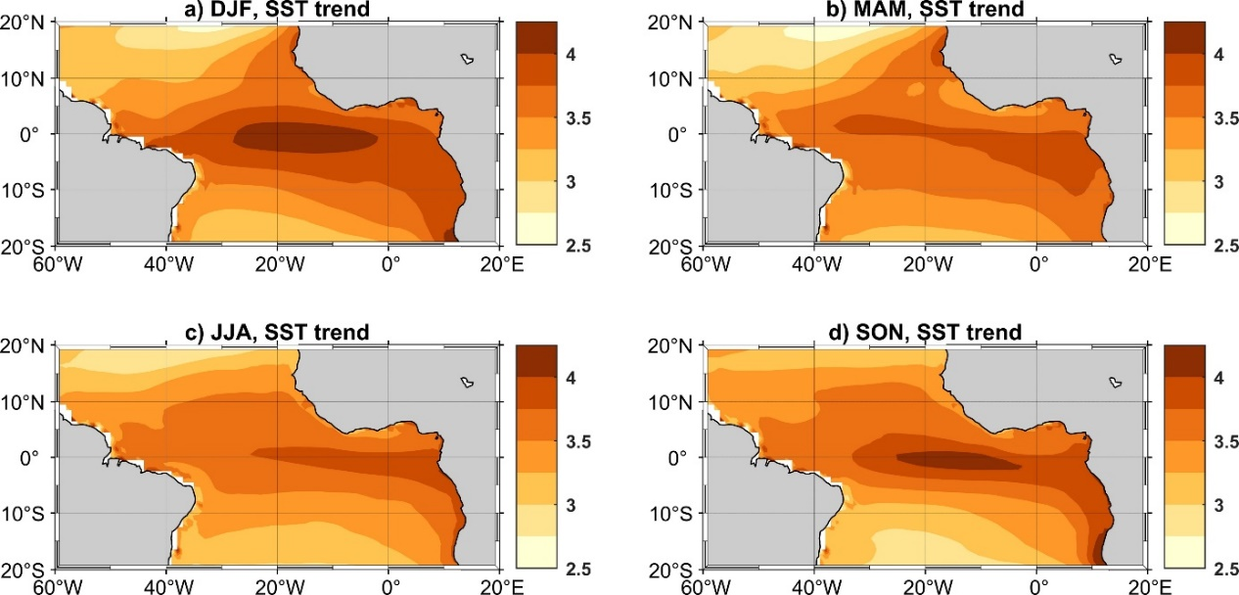

**Fig. S2: CO2-forced seasonal SST trends.**

CO2-forced ensemble-mean linear SST trends (°C/140yr) calculated over all 140 years and for each season: (a) December-January (DJF), (b) March-May (MAM), (c) June-August (JJA) and (d) September-November (SON). All trends are significant at the 95 % level according to the Spearman’s test.

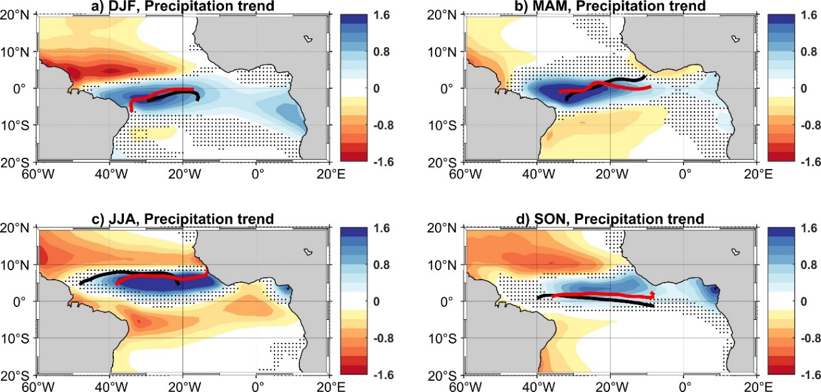

**Fig. S3: CO2-forced seasonal precipitation trends.**

CO2-forced ensemble-mean linear precipitation trends (mm∙day-1/140yr) calculated over all 140 years and for each season: (a) December-January (DJF), (b) March-May (MAM), (c) June-August (JJA) and (d) September-November (SON). Dots indicate regions where the trend is not significant at the 95 % level according to the Spearman’s test. Bold solid lines indicate the position of the ITCZ: the black and red line depict the position during the first and last 30 years of the global warming simulations (1 % CO2-increase per year), respectively.

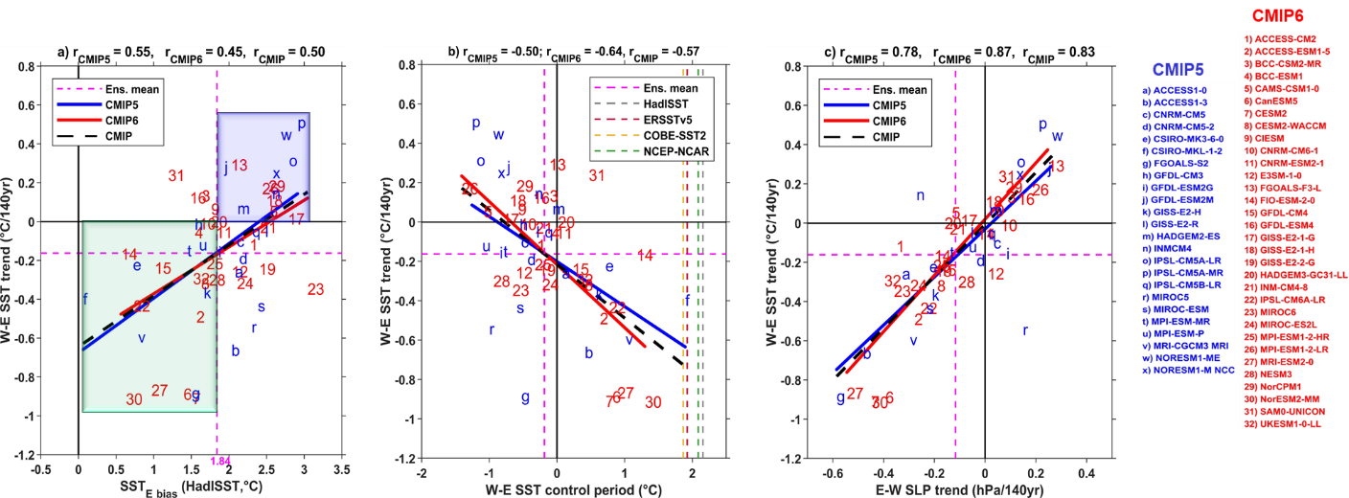

**Fig. S4: Seasonal dependence of the results shown in Fig. 1.**

Same as **Fig. 1** but for the cold tongue season (June-September, JJAS).

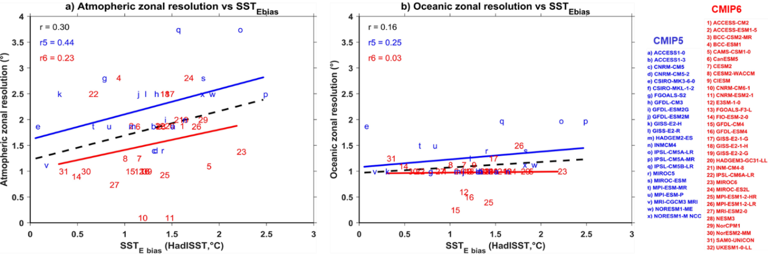

**Fig. S5: Dependence on zonal model resolution.**

Dependence of SST bias in the eastern equatorial Atlantic on zonal (a) atmospheric and (b) oceanic resolution. We note that model f has been excluded in this figure.

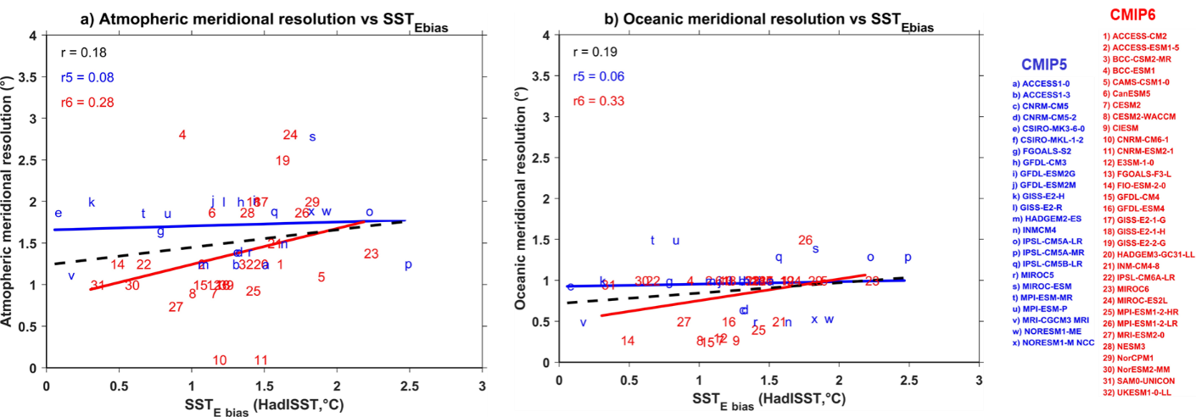

**Fig. S6: Dependence on meridional model resolution.**

Dependence of SST bias in the eastern equatorial Atlantic on meridional (a) atmospheric and (b) oceanic resolution. We note that model f has been excluded in this figure.

**Table S1:** Description of the CMIP5 models.

|  |  |  |  |  |  |  |  |  |
| --- | --- | --- | --- | --- | --- | --- | --- | --- |
| **CMIP5**  **Model name** | | **Ocean component**  **(OGCM)** | **Ocean resolution (°Lon x °Lat)** | **Ocean grid refinement in the Tropics (°Lon x °Lat)** | **Atmosphere component (AGCM)** | **Atmosphere resolution**  **(°Lon x °Lat)** | **Model top height (hPa)**  **(Vertical levels)** | **Modeling group** |
| a) | ACCESS1-0 | MOM4.1 | 1.0 x 1.0 | 0.3 x 0.3 | AGCM1.0 | 1.875 x 1.250 | / (38) | CSIRO-BoM, Australia |
| b) | ACCESS1-3 | MOM4.1 | 1.0 x 1.0 | 0.3 x 0.3 | AGCM1.0 | 1.875 x 1.250 | / (38) | CSIRO-BoM, Australia |
| c) | CNRM-CM5 | NEMO3.2 | 1.0 x 0.65 | 1.0 x 0.3 | ARPEGE5.2.3i | 1.406 x 1.400 | 10 (31) | CNRM-CERFACS, France |
| d) | CNRM-CM5-2 | NEMO3.2 | 1.0 x 0.65 | / | ARPEGE5.2.3i | 1.406 x 1.400 | 10 (91) | CNRM-CERFACS, France |
| e) | CSIRO-MK3-6-0 | MOM2.2 | 1.88 x 0.94 |  | AGCM7.3.5 | 1.875 x 1.875 | 4.5 (18) | CSIRO, Australia |
| f) | CSIRO-MK3L-1-2 |  | 2.8 x 1.6 |  |  | 5.625 x 3.180 | (18) | CSIRO, Australia |
| g) | FGOALS-S2 | LICOM2 | 1.0 x 1.0 |  | SAMIL2.4.7 | 2.812 x 1.659 |  | LASG, IAP, China |
| h) | GFDL-CM3 | MOM.4.1 | 1.0 x 1.0 |  | AM3.9 | 2.5 x 2.0 | 0.01 (48) | NOAA, USA |
| i) | GFDL-ESM2G | TOPAZ | 1.0 x 1.0 |  | AM2.14 | 2.00 x 2.02 | 3 (24) | NOAA, USA |
| j) | GFDL-ESM2M | MOM4.1 | 1.0 x 1.0 |  | AM2.14 | 2.50 x 2.02 | 3 (24) | NOAA, USA |
| k) | GISS-E2-H | HYCOM | 1.0 x 1.0 |  | GE2 | 2.5 x 2.0 | 0.1 (40) | NASA, USA |
| l) | GISS-E2-R | Russell Ocean | 1.25 x 1.0 |  | GE2 | 2.5 x 2.0 | 0.1 (40) | NASA, USA |
| m) | HADGEM2-ES | HadGOM2 | 1.0 x 1.0 |  | HadGAM2 | 1.875 x 1.250 | 40 km (38) | MOHC, UK |
| n) | INMCM4 |  | 1.0 x 0.5 | / |  | 2.0 x 1.5 | 10 (21) | INM, Russia |
| o) | IPSL-CM5A-LR | NEMO2.3 | 1.98 x 1.30 |  | LMDZ4.5 | 3.75 x1.89 | 0.04 (39) | IPSL, France |
| p) | IPSL-CM5A-MR | NEMO2.3 | 1.98 x 1.30 |  | LMDZ4.5 | 2.5 x 1.26 | 0.04 (39) | IPSL, France |
| q) | IPSL-CM5B-LR | NEMO2.3 | 1.98 x 1.30 |  | LMDZ5 | 3.75 x 1.89 |  | IPSL, France |
| r) | MIROC5 | COCO4.5 | 1.4 x 0.5 |  | AGCM6 | 1.406 x 1.400 | 3 (40) | MIROC, Japan |
| s) | MIROC-ESM | COCO3.4 | 1.4 x 1.4 |  | AGCM | 2.81 x 2.79 | 0.003 (80) | MIROC, Japan |
| t) | MPI-ESM-MR | MPIOM5234 | 1.5 x 1.5 |  | ECHAM6 | 1.875 x 1.865 |  | MPI-M, Germany |
| u) | MPI-ESM-P | MPIOM4571 | 1.5 x 1.5 |  | ECHAM6 | 1.875 x 1.865 | 0.01 (47) | MPI-M, Germany |
| v) | MRI-CGCM3 | MRICOM3.0 | 1.0 x 0.5 |  | GSMUV101124 | 1.125 x 1.121 | 0.01 (48) | MRI, Japan |
| w) | NORESM1-M | MICOM1 | 1.13 x 0.54 |  | CAM4 | 2.500 x 1.895 | 3.54 (26) | NCC, Norwegian |
| x) | NORESM1-ME | MICOM1 | 1.13 x 0.54 |  | CAM4 | 2.500 x 1.895 |  | NCC, Norwegian |

**Table S2:** Same as **Table S1** but for CMIP6 models.

|  |  |  |  |  |  |  |  |  |
| --- | --- | --- | --- | --- | --- | --- | --- | --- |
| **CMIP6**  **Model name** | | **Ocean component**  **(OGCM)** | **Ocean resolution (°Lon x °Lat)** | **Ocean grid refinement in the Tropics (°Lon x °Lat)** | **Atmosphere component**  **(AGCM)** | **Atmosphere resolution (°Lon x °Lat)** | **Model top height (hPa)**  **(Vertical levels)** | **Modeling group** |
| 1 | ACCESS-CM2 | MOM5 | 1.0 x 1.0 | / | HadGEM3.7.1 | 1.88 x 1.25 | 85 (85) | CSIRO and BoM, Australia |
| 2 | ACCESS-ESM1-5 | MOM5 | 1.0 x 1.0 | / | HadGAM2 | 1.88 x 1.25 | (38) | CSIRO and BoM, Australia |
| 3 | BCC-CSM2-MR | MOM4 | 1.0 x 1.0 | 1.0 x 0.3 | AGCM3MR | 1.0 x 1.0 | 1.46 (46) | BCC-CMA |
| 4 | BCC-ESM1 | MOM4 | 1.0 x 1.0 | 1.0 x 0.3 | AGCM3LR | 2.81 x 2.81 | 2.19 (26) | BCC-CMA |
| 5 | CAMS-CSM1-0 | MOM4 | 1.0 x 1.0 | 1.0 x 0.3 | ECHAM5 | 1.1 x 1.1 | 10 (31) | CAMS, China |
| 6 | CanESM5 | NEMO3.4.1 | 1.0 x 1.0 | 1.0 x 0.3 | CanAM5 | 1.87 x 1.87 | 1 (49) | CCCM, Canada |
| 7 | CESM2 | POP2 | 1.125 x 0.27 | / | CAM6 | 1.25 x 0.90 | 2.25 (32) | NCAR |
| 8 | CESM2-WACCM | POP2 | 1.125 x 0.27 | / | CAM6 | 1.25 x 0.90 | 4.5e-6 (70) | NCAR |
| 9 | CIESM | POP2 | 1.125 x 0.27 |  | CAM5 | 1.0 x 1.0 | 2.25 (30) | DESS, China |
| 10 | CNRM-CM6-1 | NEMO3.6 | 1.0 x 1.0 | / | Arpege6.3 | 0.1 x 0.1 | 78.4 (91) | CNRM-CERFACS, France |
| 11 | CNRM-ESM2-1 | NEMO3.6 | 1.0 x 1.0 | / | Arpege6.3 | 0.1 x 0.1 | 78.4 (91) | CNRM-CERFACS, France |
| 12 | E3SM-1-0 | MPAS6.0 | 0.6 x 0.3 | / | EAM1.0 | 1.0 x 1.0 | 0.1 (72) | LLNL, USA |
| 13 | FGOALS-F3-L | LICOM3.0 | 1.0 x 1.0 | / | FAMIL2.2 | 1.0 x 1.0 | 2.16 (32) | LASG, IAP, China |
| 14 | FIO-ESM-2-0 | POP2-W | 1.1 x 0.27 | / | CAM4 | 0.90 x 1.25 | 2 (26) | FIO, China |
| 15 | GFDL-CM4 | MOM6 | 0.25 x 0.25 | / | AM4.0.1 | 1.0 x 1.0 | 1 (33) | NOAA, USA |
| 16 | GFDL-ESM4 | MOM6 | 0.5 x 0.5 | / | AM4.1 | 1.0 x 1.0 | 0.001 (49) | NOAA, USA |
| 17 | GISS-E2-1-G | GO1 | 1.25 x 1.00 | / | GE2.1 | 2.5 x 2.0 | 0.1 (40) | NASA, USA |
| 18 | GISS-E2-1-H | HYCOM | 1.0 x 1.0 | / | GE2.1 | 2.5 x 2.0 | 0.1 (40) | NASA, USA |
| 19 | GISS-E2-2-G | GO1 | 1.0 x 1.0 | / | GE2.1 | 2.0 x 2.5 | 0.002 (102) | NASA, USA |
| 20 | HADGEM3-GC31-LL | eORCA1 | 1.0 x 1.0 | 1.0 x 0.3 | HadGEM3.7.1 | 1.88 x 1.25 | 85 (85) | MOHC, UK |
| 21 | INM-CM4-8 | INM-AM4-8 | 1.0 x 0.5 | / | INM-OM5 | 2.0 x 1.5 | 0.01 (21) | INM, Russia |
| 22 | IPSL-CM6A-LR | eORCA1.3 | 1.0 x 1.0 | / | LMDZ | 2.5 x 1.25 | 40 (79) | IPSL, France |
| 23 | MIROC6 | COCO4.9 | 1.0 x 1.0 | / | CCSR AGCM | 1.38 x 1.38 | 0.004 (81) | MIROC, Japan |
| 24 | MIROC-ES2L | COCO4.9 | 1.0 x 1.0 | / | CCSR AGCM | 2.81 x 2.81 | 3 (40) | MIROC, Japan |
| 25 | MPI-ESM1-2-HR | MPIOM1.63 | 0.4 x 0.4 | / | ECHAM6.3 | 0.93 x 0.93 | 0.01 (95) | MPI-M, Germany |
| 26 | MPI-ESM1-2-LR | MPIOM1.63 | 1.5 x 1.5 | / | ECHAM6.3 | 1.87 x 1.87 | 0.01 (47) | MPI-M, Germany |
| 27 | MRI-ESM2-0 | MRI.COM4.4 | 1.0 x 0.5 | 0.3 x 0.5 | AGCM3.5 | 0.74 x 0.74 | 0.01 (80) | MRI, Japan |
| 28 | NESM3 | NEMO3.4 | 1.0 x 1.0 | / | ECHAM6.3 | 1.87 x 1.87 | 0.01 (47) | NUIST, China |
| 29 | NorCPM1 | MICOM1.1 | 1.0 x 1.0 | / | CAM4.1 | 2.0 x 2.0 | 26 (2) | NCC, Norwegian |
| 30 | NorESM2-MM | MICOM | 1.0 x 1.0 | / | CAM | 1.0 x 1.0 | 3 (32) | NCC, Norwegian |
| 31 | SAM0-UNICON | POP2 | 1.25 x 0.95 | / | CAM5.3 | 1.0 x 1.0 | 2 (30) | SNU, Korea |
| 32 | UKESM1-0-LL | eORCA1 | 1.0 x 1.0 | 0.3 x 1.0 | HadGEM3.7.1 | 1.88 x 1.25 | 85 (85) | MOHC, UK |

**Table S3:** Missing variables for CMIP5 and CMIP6 models.

|  |  |  |
| --- | --- | --- |
| **Missing variables** | **CMIP5** | **CMIP6** |
| SLP | h) GFDL-CM3 (/)  w) NorESM1-M (WTA)  x) NorESM1-ME (WTA) | / |
| 10 m wind (u, v) | e) CSIRO-MK3-6-0 (ETA)  f) CSIRO-MK3L-1-2 (ETA) | 7) CESM2 (ETA)  8) CESM2-WACCM (ETA)  9) CIESM, E3SM-1-0 (/)  12) E3SM-1-0 (ETA)  14) FIO-ESM-2-0 (ETA)  30) NorESM2-MM (ETA)  31) SAM0-UNICON (ETA) |
| Vertical Velocity (wap) | f) CSIRO-MK3L-1-2 (ETA) | 13) FGOALS-F3-L (ETA) |

**Table S4:** Transient climate response (TCR) of the CMIP models. Not all information was available from every model.

|  |  |  |  |  |
| --- | --- | --- | --- | --- |
| **CMIP Model name** | | **TRC at CO2 doubling**  ***Meehl et al. 2020*** | **TCR at CO2 doubling**  ***this study*** | **TCR at CO2 quadrupling *this study*** |
| a) | ACCESS1-0 | 1.9 | 2.2 | 4.6 |
| b) | ACCESS1-3 | 1.6 | 1.7 | 4.2 |
| c) | CNRM-CM5 | 2.0 | 1.8 | 5.0 |
| d) | CNRM-CM5-2 | 1.8 | 2.5 | 5.2 |
| e) | CSIRO-MK3-6-0 | 1.7 | 1.4 | 3.5 |
| f) | CSIRO-MK3L-1-2 | - | - | - |
| g) | FGOALS-S2 | 2.4 | 2.9 | 5.2 |
| h) | GFDL-CM3 | 1.9 | 1.9 | 4.7 |
| i) | GFDL-ESM2G | 1.1 | 0.9 | 1.4 |
| j) | GFDL-ESM2M | 1.4 | 1.3 | 1.7 |
| k) | GISS-E2-H | 1.7 | 1.9 | 4.1 |
| l) | GISS-E2-R | 1.5 | 1.5 | 2.8 |
| m) | HADGEM2-ES | 2.5 | 2.9 | 5.8 |
| n) | INMCM4 | 1.3 | 1.4 | 2.9 |
| o) | IPSL-CM5A-LR | 2.0 | 1.9 | 4.5 |
| p) | IPSL-CM5A-MR | 2.0 | 2.0 | 4.5 |
| q) | IPSL-CM5B-LR | 1.5 | 1.5 | 3.5 |
| r) | MIROC5 | 2.2 | 2.6 | 5.4 |
| s) | MIROC-ESM | 1.4 | 1.6 | 4.0 |
| t) | MPI-ESM-MR | 2.0 | 2.0 | 4.4 |
| u) | MPI-ESM-P | 2.0 | 2.0 | 4.5 |
| v) | MRI-CGCM3 | 1.6 | 1.8 | 4.3 |
| w) | NORESM1-M | 1.4 | 1.7 | 3.8 |
| x) | NORESM1-ME | - | 1.4 | 3.6 |
| 1 | ACCESS-CM2 | 2.1 | 2.2 | 5.9 |
| 2 | ACCESS-ESM1-5 | 2.0 | 2.2 | 4.6 |
| 3 | BCC-CSM2-MR | 1.7 | 1.5 | 4.1 |
| 4 | BCC-ESM1 | 1.8 | 1.9 | 4.2 |
| 5 | CAMS-CSM1-0 | 1.7 | 1.5 | 3.1 |
| 6 | CanESM5 | 2.7 | 2.2 | 4.9 |
| 7 | CESM2 | 2.0 | 2.4 | 5.1 |
| 8 | CESM2-WACCM | 2.0 | 2.6 | 6.3 |
| 9 | CIESM | - | 2.4 | 5.8 |
| 10 | CNRM-CM6-1 | 2.1 | 2.0 | 5.8 |
| 11 | CNRM-ESM2-1 | 1.9 | 3.3 | 7.0 |
| 12 | E3SM-1-0 | 3.0 | 3.5 | 7.3 |
| 13 | FGOALS-F3-L | 2.1 | 2.1 | 4.7 |
| 14 | FIO-ESM-2-0 | - | 2.7 | 6.2 |
| 15 | GFDL-CM4 | 2.1 | - | - |
| 16 | GFDL-ESM4 | 1.6 | - | - |
| 17 | GISS-E2-1-G | 1.8 | 1.7 | 2.0 |
| 18 | GISS-E2-1-H | 1.9 | 2.0 | 4.3 |
| 19 | GISS-E2-2-G | 1.7 | 2.0 | 4.0 |
| 20 | HADGEM3-GC31-LL | 2.6 | 3.0 | 7.1 |
| 21 | INM-CM4-8 | 1.3 | 1.4 | 3.1 |
| 22 | IPSL-CM6A-LR | 2.3 | 1.8 | 4.3 |
| 23 | MIROC6 | 1.6 | 1.6 | 3.8 |
| 24 | MIROC-ES2L | 1.6 | 1.7 | 3.6 |
| 25 | MPI-ESM1-2-HR | 1.7 | 1.7 | 4.0 |
| 26 | MPI-ESM1-2-LR | 1.8 | 2.0 | 4.1 |
| 27 | MRI-ESM2-0 | 1.6 | 2.0 | 3.7 |
| 28 | NESM3 | 2.7 | 2.9 | 6.3 |
| 29 | NorCPM1 | 1.6 | 1.7 | 3.9 |
| 30 | NorESM2-MM | 1.5 | 1.2 | 3.3 |
| 31 | SAM0-UNICON | 2.3 | 2.3 | 4.8 |
| 32 | UKESM1-0-LL | 2.8 | 3.4 | 7.1 |
| Mean (min, max) | | 1.9 (1.1, 3.0) | 2.0 (0.9, 3.5) | 4.5 (1.4, 7.3) |
| Standard deviation | | 0.4 | 0.6 | 1.3 |
| ETA mean (min, max) | | - | 2.2 (1.2, 3.5) | 4.9 (3.3, 7.3) |
| WTA mean (min, max) | | - | 1.7 (1.4, 2.1) | 3.8 (2.9, 4.7) |