Supplementary Material

S1: Table of metadata on all known samples from APEI-6 (separate Microsoft Excel File)

S2: Table of individual sample data collected on JC120 not included in other publications (separate Microsoft Excel File). Including sediment biogeochemistry, sediment lipids. sediment grain size, nodule coverage and trawl faunal data.

S3: Average and 95% confidence intervals (CI), Standard Deviation (SD) or range (indicated by hyphen) for parameters measures across APEI-6 SW and UK1: UK Seabed Resources Limited eastern contract area as collected during cruise JC120. For nodule dimensions n: number of nodules measured, l = length, w = width, h = height.

|  |  |  |  |  |  |
| --- | --- | --- | --- | --- | --- |
| Parameter | APEI-6 SW Deep Plain | APEI-6 SW Flat | APEI-6 SW Ridge | APEI-6 SW Trough | UK1 |
| Nodule density, no m-2 | 632 (484 - 776) | 307 (200 - 388) | 246 (137 - 370) | 200 (14 - 455) | 16 |
| Nodule dimensions, mm | n= 474;  l: 21.4 (20.7 - 22.0)  w: 15.6 (14.9 - 16.3)  h: 8.4 (8.1 - 8.8) | n= 384;  l: 21.9 (21.2 - 22.6)  w: 18.5 (17.9 - 19.1)  h: 11.4 (11.1 - 11.7) | n= 307;  l: 18.0 (17.2 - 18.7)  w: 13.9 (13.3 - 14.5)  h: 8.9 (8.5 - 9.3) | n= 252;  l: 16.1 (14.9 - 17.11)  w: 12.5 (11.7 - 13.7)  h 7.8 (7.3 - 8.3) | n = 4;  l: 54.5 (30.5 - 88.5)  w: 47.5 (27.2 - 79.2)  h: 25.7 (16.2 - 42.0) |
| Nodule weight, kg m-2 | 2.56 (1.10 - 3.81) | 1.87 (1.15 - 2.40) | 0.84 (0.37 - 1.31) | 0.55 (0.05 - 1.08) | 1.67 |
| Seabed nodule coverage (%) |  | 8.2 (SD= 4.8)  range= 0 - 35 | 5.2 (SD= 4.2)  range= 0 - 48 | 3.32 (SD= 3.16)  range= 0 - 26 |  |
| TOC (%) ± SD | 0.42 ± 0.04 (n=3) | 0.44 ± 0.05 (n=6) | 0.41 ± 0.04 (n=5) | 0.44 ± 0.05 (n=5) | 0.71 (n=1) |
| TN (%) ± SD | 0.11 ± 0.01 (n=3) | 0.11 ± 0.01 (n=6) | 0.11 ± 0.01 (n=5) | 0.11 ± 0.01 (n=5) | 0.14 (n=1) |
| TOC:TN ± SD | 4.5 ± 0.2 (n=3) | 4.7 ± 0.3 (n=6) | 4.5 ± 0.2 (n=5) | 4.7 ± 0.5 (n=5) | 5.7 (n=1) |
| CaCO3 (%) ± SD | 0.3 ± 0.36 (n=3) | 0.4 ± 0.05 (n=6) | 0.5 ± 0.16 (n=5) | 0.4 ± 0.09 (n=5) | 0.1 (n=1) |
| Grain size, µm  (min - max) in 5 cm sediment depth horizons | 0-5 cm: 6.53 - 8.86  5-10 cm: 6.19 - 7.89  10-15 cm: 5.72 - 8.76  15-20 cm: 5.68 - 8.89 | 0-5 cm: 7.15 - 7.61  5-10 cm: 6.50 - 8.52  10-15 cm: 6.06 - 7.24  5-20 cm: 5.77 - 8.55 | 0-5 cm: 6.71 - 9.21  5-10 cm: 6.56 - 8.72  10-15 cm: 6.33 - 11.67  5-20 cm: 6.07 - 10.61 | 0-5 cm: 7.60 - 8.50  5-10 cm: 7.49 - 11.16  10-15 cm: 6.47 - 20.08  5-20 cm: 6.35 - 20.15 | 0-5 cm: 18.06  5-10 cm: 17.6  10-15 cm: 17.58  15-20 cm: 18.74 |
| Macrofaunal density (ind. m-2) ± SD | 69.2 ± 48.8 | 61.6 ± 40.8 | 88.7 ± 42.8 | 52.6 ± 24.9 |  |
| Megafaunal xenophyophore density, ind. m-2 |  | 2.21 (1.53- 2.98) | 4.10 (3.55 - 4.62) | 1.33 (0.48 - 2.59) |  |
| Megafaunal metazoan density, ind. m-2 |  | 0.48 (0.43 - 0.53) | 0.46 (0.41 - 0.52) | 0.32 (0.22 - 0.39) |  |
| Megafaunal metazoan taxon richness |  | 70.7 (67.2 - 74.5) | 69 (65.0 - 73.5) | 62.5 (53.5 72.5) |  |
| Megafaunal metazoan taxon richness, total |  | 105 (in 5907 m2 of seabed) | 105 (in 6311 m2 of seabed) | 97 (in 6364 m2 of seabed) |  |
| Fossils, no m-2 |  | 180 (156 - 210) | 336 (238 -420) | 395 (119 - 672) |  |

S4. Sediment grain size distribution (μm) at different depths obtained from Megacore samples collected during cruise JC120. Calculated applying geometric method of moments. Ranges shown in areas where more than 1 replicate core was obtained (Deep Plain: n=3; Flat, Trough, Ridge: n=5).

|  |  |  |  |  |  |  |  |
| --- | --- | --- | --- | --- | --- | --- | --- |
|  |  | **Deep Plain** | **Flat** | **Ridge** | **Trough** | **Seamount** | **UK1** |
| 0 to 5 cm | Mean | 6.53 - 8.86 | 7.15 - 7.61 | 6.71 - 9.21 | 7.60 - 8.50 | 27.62 | 18.06 |
| St dev | 2.57 - 3.95 | 2.82 - 3.03 | 2.54 - 4.77 | 2.99 - 4.04 | 4.84 | 3.96 |
| Skewness | 0.94 - 1.77 | 0.96 - 1.50 | 0.46 - 2.02 | 0.86 - 1.86 | -0.07 | 0.23 |
| Kurtosis | 5.33 - 7.09 | 4.50 - 7.35 | 3.22 - 8.29 | 3.79 - 7.50 | 2.15 | 2.2 |
| Mode | 7.19 | 7.19 | 7.19 | 7.19 | 57.74 | 7.19 |
| Median (D50) | 6.11 - 6.87 | 6.47 - 6.70 | 6.29 - 7.40 | 6.61 - 7.03 | 35.04 | 15.55 |
| 5 to 10 cm | Mean | 6.19 - 7.89 | 6.50 - 8.52 | 6.56 - 8.72 | 7.49 - 11.16 | 21.72 | 17.6 |
| St dev | 2.56 - 3.14 | 2.73 - 3.66 | 2.71 - 2.78 | 2.95 - 3.97 | 5 | 4.07 |
| Skewness | 1.08 - 1.13 | 0.89 - 1.56 | 0.46 - 1.15 | 0.67 - 1.07 | 0.1 | 0.2 |
| Kurtosis | 4.58 - 6.25 | 4.18 - 6.60 | 3.20 - 5.82 | 2.73 - 5.20 | 2.13 | 2.04 |
| Mode | 7.19 | 7.19 | 7.19 | 7.19 | 57.74 | 7.19 |
| Median (D50) | 5.80 - 6.71 | 5.97 - 6.89 | 5.98 - 7.95 | 6.63 - 8.17 | 22.92 | 14.92 |
| 10 to 15 cm | Mean | 5.72 - 8.76 | 6.06 - 7.24 | 6.33 - 11.67 | 6.47 - 20.08 | 15.97 | 17.58 |
| St dev | 2.43 - 3.49 | 2.10 - 3.00 | 2.43 - 6.73 | 2.48 - 4.72 | 4.36 | 4.21 |
| Skewness | 0.85 - 1.06 | 0.06 - 1.08 | 0.12 - 1.64 | 0.06 - 0.90 | 0.33 | 0.14 |
| Kurtosis | 3.23 - 6.94 | 2.75 - 5.02 | 2.34 - 6.26 | 1.79 - 6.14 | 2.43 | 1.99 |
| Mode | 7.19 | 7.19 | 7.19 | 7.19 | 7.19 | 7.19 |
| Median (D50) | 5.51 - 6.97 | 6.04 - 6.48 | 5.87 - 9.50 | 6.29 - 16.45 | 13.47 | 15.27 |
| 15 to 20 cm | Mean | 5.68 - 8.89 | 5.77 - 8.55 | 6.07 - 10.61 | 6.35 - 20.15 | 17.43 | 18.74 |
| St dev | 2.33 - 3.57 | 2.19 - 4.28 | 2.50 - 2.94 | 2.56 - 5.07 | 4.29 | 4.09 |
| Skewness | 0.50 - 0.92 | 0.01 - 1.93 | 0.13 - 1.18 | - 0.14 - 1.85 | 0.46 | 0.11 |
| Kurtosis | 3.40 - 6.01 | 2.59 - 7.50 | 2.35 - 6.17 | 1.77 - 8.79 | 2.63 | 1.95 |
| Mode | 7.19 | 7.19 | 7.19 | 7.19 - 115.00 | 7.19 | 7.19 |
| Median (D50) | 5.50 - 6.92 | 5.69 - 6.63 | 5.70 - 10.28 | 5.93 - 31.85 | 13.92 | 16.5 |

S5: Summary of biogeochemical results at APEI-6 SW. Average (95% confidence intervals) Total Organic Carbon (TOC as percentage), Total Nitrogen (TN as percentage), the molar Corg/TN ratio and CaCO3 (as percentage), total lipids (lipid), total fatty acids (FA), total saturated fatty acids (Sat-FA), (SC-SatFA), (Br-SatFA), total mono-unsaturated fatty acids (MUFA), total poly-unsaturated fatty acids (PUFA) and total unsaturated fatty acids (UnSatFA). All lipid data have units of ng g-1 dried sediment. n represents the number of cores analysed.

|  |  |  |  |  |  |  |
| --- | --- | --- | --- | --- | --- | --- |
| Area | Flat | Ridge | Trough | Deep-Plain | Seamount | UK1 |
| n | 6 | 5 | 5 | 3 | 1 | 1 |
| TOC (%) | 0.44 (0.02) | 0.41 (0.02) | 0.44 (0.02) | 0.42 (0.02) | 0.22 | 0.71 |
| TN (%) | 0.11 (0.01) | 0.11 (0) | 0.11 (0.01) | 0.11 (0) | 0.06 | 0.14 |
| Corg/N | 4.7 (0.01) | 4.49 (0.09) | 4.73 (0.21) | 4.52 (0.07) | 4.5 | 5.7 |
| CaCO3 (%) | 0.42 (0.04) | 0.48 (0.14) | 0.36 (0.08) | 0.3 (0.41) | 73.3 | 0.1 |
|  |  |  |  |  |  |  |
| Lipid | 4225 (1878) | 3953 (1579) | 4780 (2926) | 1995 (1377) | | 5225 |
| FA | 2437 (1315) | 2587 (1531) | 2885 (2002) | 1218 (1059) | | 3385 |
| Sat-FA | 1514 (715) | 1504 (744) | 1823 (1208) | 775 (734) |  | 1774 |
| SC-SatFA | 1133 (504) | 1232 (690) | 1383 (915) | 648 (619) |  | 1367 |
| Br-SatFA | 381 (223) | 272 (103) | 440 (298) | 126 (116) |  | 407 |
| MUFA | 765 (532) | 797 (684) | 845 (631) | 345 (276) |  | 1280 |
| PUFA | 158 (147) | 286 (213) | 217 (190) | 98 (92) |  | 331 |
| UnSatFA | 922 (626) | 1083 (793) | 1062 (805) | 444 (367) |  | 1611 |
| Sterols | 628 (319) | 528 (329) | 644 (573) | 231 (128) |  | 1115 |
| Alcohols | 248 (117) | 136 (73) | 140 (93) | 57 (111) |  | 169 |
| n-alkanes | 454 (122) | 373 (136) | 521 (225) | 245 (218) |  | 157 |
| hopanoids | 361 (148) | 261 (148) | 478 (338) | 172 (117) |  | 230 |
| alkenones | 68 (33) | 48 (21) | 70 (53) | 35 (24) |  | 113 |
| hydroxy-acids | 8 (10) | 3 (3) | 22 (26) | 32 (56) |  | 44 |

S6: Widespread species identified by combined molecular and morphological data from APEI-6 SW and UK Seabed Resources Exploration Contract Area 1 (UK1). x indicates presence, --- indicates not recorded. Only species present at APEI-6 and in at least one other site included. An additional 24 taxa were found at APEI-6 but not found at other sites. NHM # in species name refers to voucher specimen for the taxon, forming an informal name.

|  |  |  |  |
| --- | --- | --- | --- |
| Phylum | Species | APEI-6 | UK1 |
| Annelida | |  |  |
|  | Acrocirridae sp. (NHM_578) | x | x |
|  | Amphinomidae sp. (NHM_821) | x | x |
|  | *Aurospio dibranchiata* EU340087 Maciolek 1981 | x | x |
|  | *Aurospio* sp. (NHM_091) | x | x |
|  | *Bathyglycinde* cf. *profunda* (Hartman & Fauchald 1971) | x | x |
|  | Capitellidae sp. (NHM_1486) | x | x |
|  | *Ceratocephale* sp. (NHM_1928) | x | --- |
|  | Cirratulidae sp. (NHM_2163) | x | --- |
|  | Cirratulidae sp. (NHM_369) | x | x |
|  | Hesionidae sp. (NHM_773E) | x | x |
|  | *Laonice* sp. (NHM_048) | x | x |
|  | *Laonice* sp. (NHM_131) | x | x |
|  | *Lumbrinerides* sp. (NHM_020) | x | x |
|  | Nephtyidae sp. (NHM_487) | x | x |
|  | Nereididae sp. (NHM_171) | x | x |
|  | *Ophelina martinezarbizui* Wiklund et al. 2019 | x | x |
|  | Pholoidae sp. (NHM_366) | x | x |
|  | *Travisia* sp. (NHM_1244) | x | --- |
| Bryozoa |  |  |  |
|  | Bryozoa sp. (NHM_1213) | x | x |
| Echinodermata | |  |  |
|  | *Ophiosphalma* cf. *glabrum* (Lütken & Mortensen, 1899) | x | x |
| Mollusca | |  |  |
|  | *Myonera* sp. (NHM_186) | x | x |
|  | *Myonera* sp. (NHM_2103) | x | x |
| Porifera |  |  |  |
|  | *Plenaster craigi* Lim et al., 2017 | x | x |
|  | Porifera sp. (NHM_112) | x | x |
| Sipuncula | |  |  |
|  | Sipuncula sp. (NHM_126) | x | x |

S7: Amphipod species caught in traps in APEI-6 SW. This table includes total numbers and the percentage of the total.

|  |  |  |  |  |
| --- | --- | --- | --- | --- |
| Taxa | JC120-008 | % | JC120-039 | % |
|  |  |  |  |  |
| *Paralicella caperesca* Shulenberger & Barnard 1976 | 1846 | 52.74 | 3654 | 77.73 |
| *Paralicella tenuipes* Chevreux 1908 | 1023 | 29.23 | 285 | 6.06 |
| *Abyssorchomene gerulicorbis* (Shulenberger & Barnard 1976) | 210 | 6.00 | 97 | 2.06 |
| *Abyssorchomene distinctus* (Birstein & Vinogradov 1960) | 300 | 8.57 | 503 | 10.7 |
| *Abyssorchomene chevreuxi* (Stebbing 1906) | 6 | 0.17 | 5 | 0.11 |
| *Valettietta* cf. *anacantha* (Birstein & Vinogradov 1963) | 31 | 0.89 | 50 | 1.06 |
| *Parandania gigantea* (Stebbing 1883) | 0 | 0 | 2 | 0.04 |
| *Cyclocaris* sp. DISCOLL.CCZ.JC120.008.1 | 42 | 1.20 | 52 | 1.11 |
| *Paracallisoma* sp. DISCOLL.CCZ.JC120.008.2 | 31 | 0.89 | 26 | 0.55 |
| *Haptocallisoma* sp. DISCOLL.CCZ.JC120.008.3 | 2 | 0.06 | 0 | 0 |
| *Eurythenes* spp. | 8 | 0.23 | 27 | 0.57 |
| *Hirondellea* sp. indet. | 1 | 0.03 | 0 | 0 |

Supplementary Figures

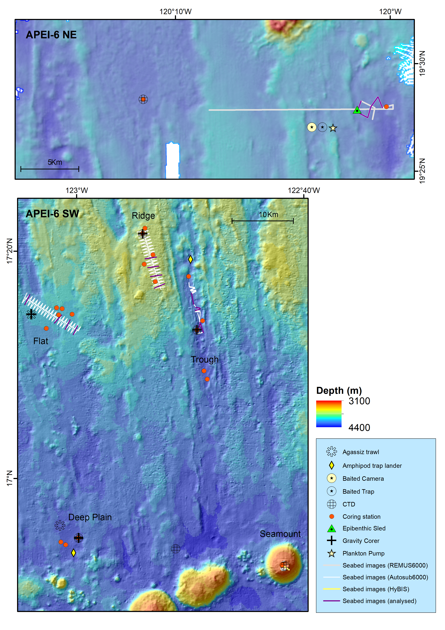

Supplementary Figure 1: Map of APEI-6 showing sampling stations overlaid onto multibeam bathymetry for northeastern area (top) and southwestern area (bottom).