**Multi-trophic marker analysis of a Marquesan food web highlights how reef ecosystems might respond to a warmer and nutrient-rich ocean future**

Pauline Fey1, Valeriano Parravicini2, Daniela Bănaru3, Jan Dierking4, René Galzin2, Benoit Lebreton5, Tarik Meziane6, Nicholas VC Polunin7, Mayalen Zubia8, Yves Letourneur1*

1 UMR ENTROPIE (UR-IRD-CNRS-IFREMER-UNC), LabEx « Corail », Université de la Nouvelle-Calédonie, BP R4, 98851 Nouméa Cedex, New Caledonia

2 CRIOBE, PSL Research University, USR 3278 EPHE-CNRS-UPVD, LabEx « Corail », Université de Perpignan, Avenue Paul Alduy, 66860 Perpignan Cedex, France (Orcid : 0000-0002-3408-1625)

3 Mediterranean Institute of Oceanography, UM 110 (AMU-UTV-CNRS-IRD), Campus de Luminy, Case 901, 13288 Marseille Cedex 9, France (Orcid : 0000-0002-8126-4328)

4 GEOMAR Helmholtz Centre for Ocean Research, Research Division Marine Ecology, Düsternbrooker Weg 20, 24105 Kiel, Germany (Orcid : 0000-0002-4660-6919)

5 UMR LIENSs 7266 (CNRS-ULR), Institut du littoral et de l’environnement, 2 rue Olympe de Gouges, 17000 La Rochelle, France (Orcid : 0000-0001-8802-2287)

6 Laboratoire BOREA, Muséum National d’Histoire Naturelle, CNRS 7208, IRD 207-SU-UCN-UA, Muséum National d’Histoire Naturelle, 61 rue Buffon, 5 CP 53, 75231 Paris Cedex, France (Orcid : 0000-0003-2142-6441)

7 Newcastle University, School of Natural and Environmental Sciences, Newcastle-upon-Tyne, NE1 7RU, United Kingdom

8 UMR EIO (UPF-IRD-ILM-IFREMER), Université de la Polynésie française, LabEx « Corail », BP 6570, 98702 Faa’a, Tahiti, French Polynesia (Orcid : [0000-0002-5043-3491](https://orcid.org/0000-0002-5043-3491))

* Corresponding author: yves.letourneur@unc.nc ; Orcid : 0000-0003-3157-1976

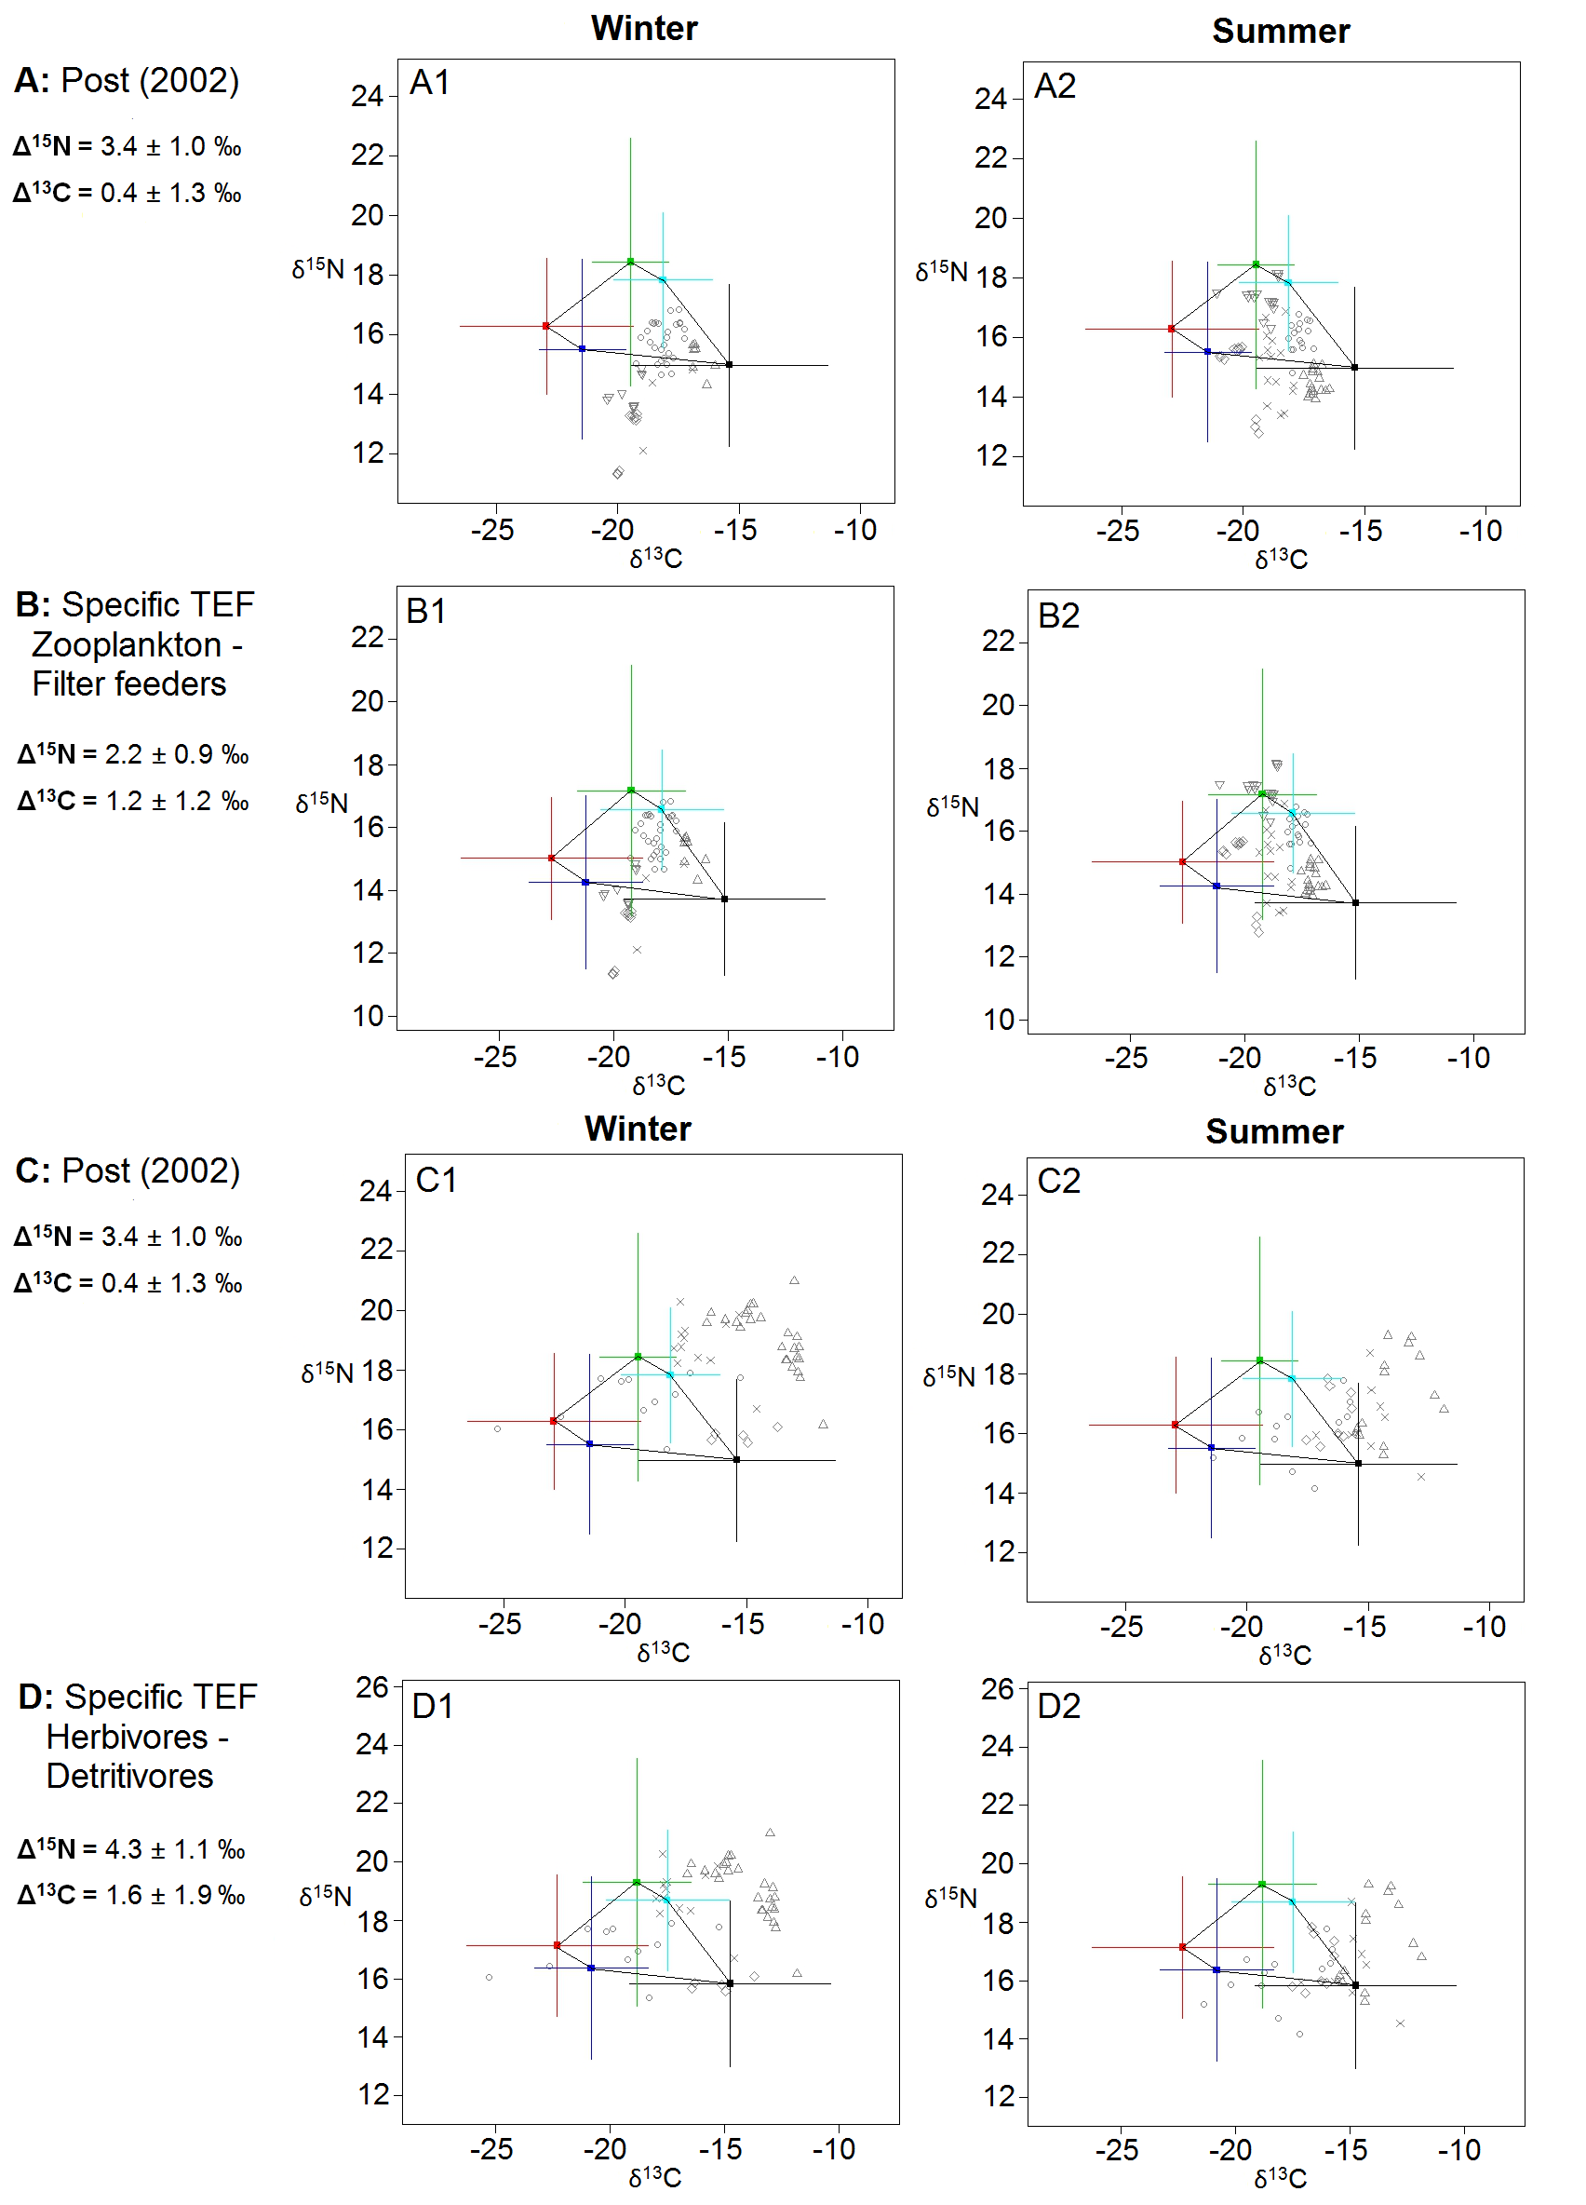

**Supplementary figure S1.** Comparison of the source polygons for the mixing models obtained with different trophic enrichment factors (TEF). For filter-feeders and zooplankton: fractionation factors of Post (2002) (A) and specific TEF (B). For herbivores and detritivores: fractionation factors of Post (2002) (C) and specific TEF (D). Cold season on the left, warm season on the right.

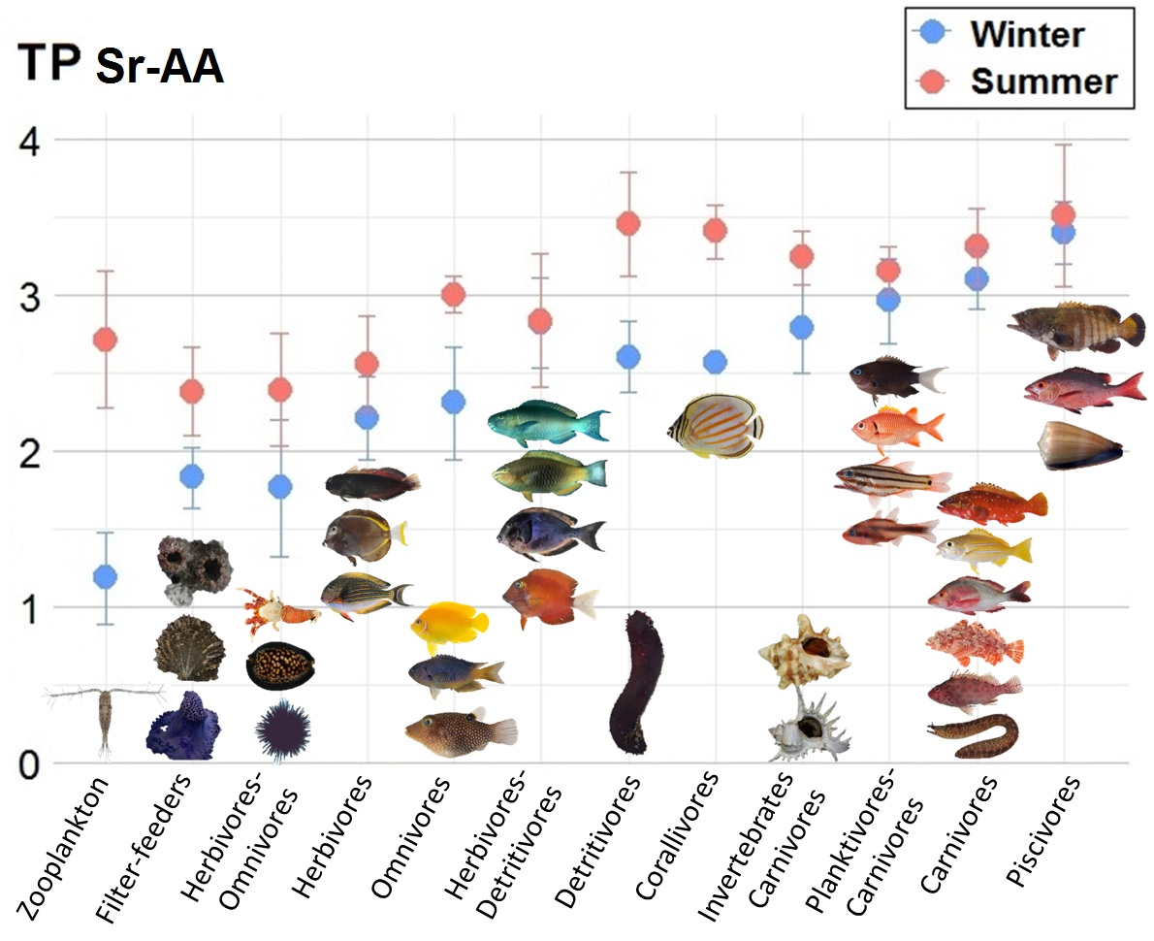

**Supplementary figure S2.** Trophic positions estimates for consumers by trophic group calculated with the Post equation (Post 2002) with the average δ15N of the source amino acids (glycine and phenylalanine) as baseline. Baseline value depending on the season: Winter δ15Nphe-gly = 12.8 ‰, Summer δ15Nphe-gly = 10.5 ‰.