Supplementary Material

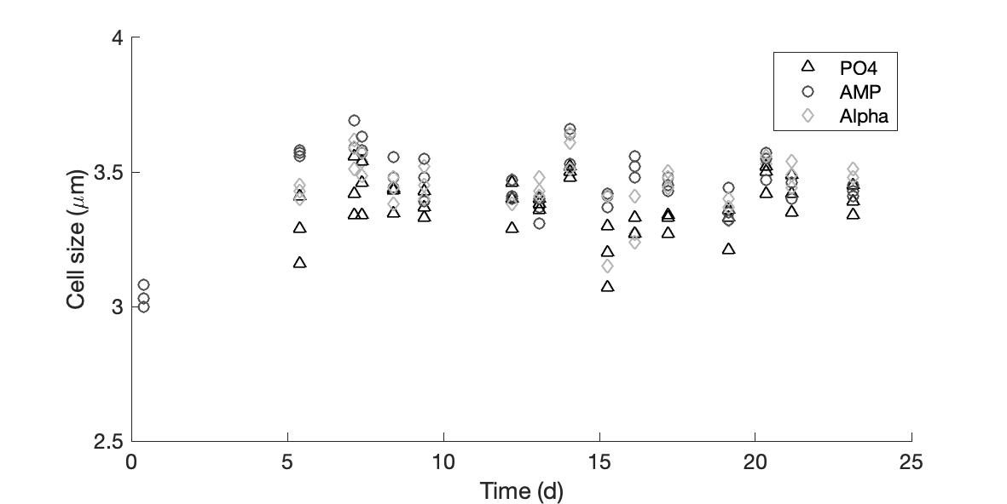

**Supplementary Figure 1.** Cell size (μm) measured in cultures provided with either an inorganic (PO4; triangles ) or organic (mono phosphate adenosin (AMP; circles) or DL-α-glycerophosphate (Alpha; diamonds)) source of phosphorus for growth. The period displayed here corresponds to the monitoring of cell abundances shown on Figure 1.

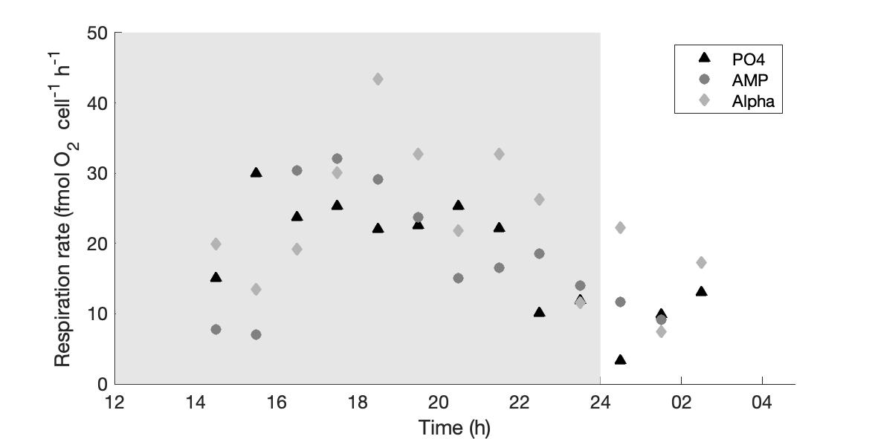

**Supplementary Figure 2.** Respiration rates (fmol O2 cell-1 h-1) measured over the dark phase in cultures provided with either an inorganic (PO4; triangles ) or organic (mono phosphate adenosin (AMP; circles) or DL-α-glycerophosphate (Alpha; diamonds)) source of phosphorus for growth. The grey, shaded area represents the dark phase.