On the consolidation state of sediments from the accretionary prism offshore Vancouver Island, North Cascadia Margin

Journal: Marine Geophysical Research

Michael Riedel1*, Awais Saeed2, Morelia Urlaub1, Achim Kopf2

1 GEOMAR Helmholtz Centre for Ocean Research Kiel, Wischhofstr. 1 – 3,

D-24148 Kiel, Germany

## 2 MARUM Cen­ter for Mar­ine En­vir­on­mental Sci­ences, Leo­bener Str. 8 D-28359 Bre­men, Ger­many

*Corresponding author: mriedel@geomar.de

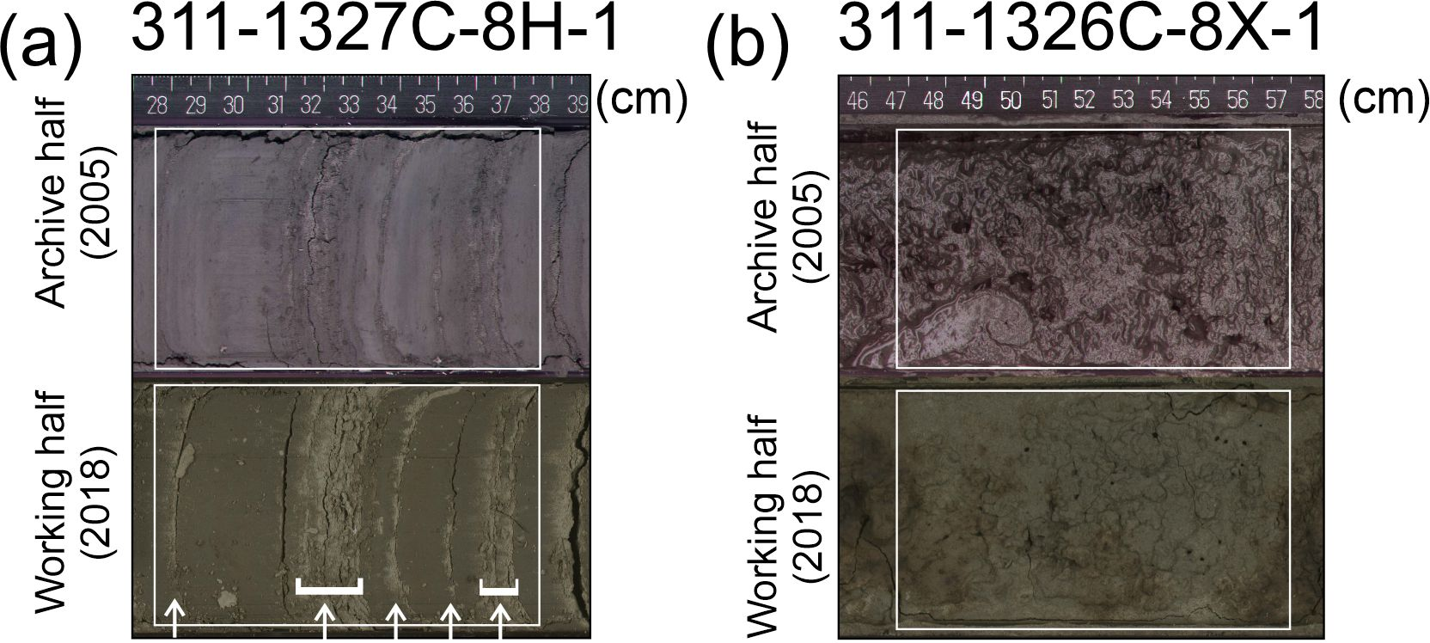

Figure A1 Images of recovered core yielding unusually high compression index values. (a) Sample consisting of finely layered silty turbidites (indicated by white arrows) and (b) sample from gas-hydrate bearing sediment. Images of the archive-half were made during X311 at sea whereas images of the working half were made later and show sample-drying (images of working halves were provided by Calie Payne, IODP Texas A&M University).