On the consolidation state of sediments from the accretionary prism offshore Vancouver Island, North Cascadia Margin

Journal: Marine Geophysical Research

Michael Riedel1*, Awais Saeed2, Morelia Urlaub1, Achim Kopf2

1 GEOMAR Helmholtz Centre for Ocean Research Kiel, Wischhofstr. 1 – 3,

D-24148 Kiel, Germany

## 2 MARUM Cen­ter for Mar­ine En­vir­on­mental Sci­ences, Leo­bener Str. 8 D-28359 Bre­men, Ger­many

*Corresponding author: mriedel@geomar.de

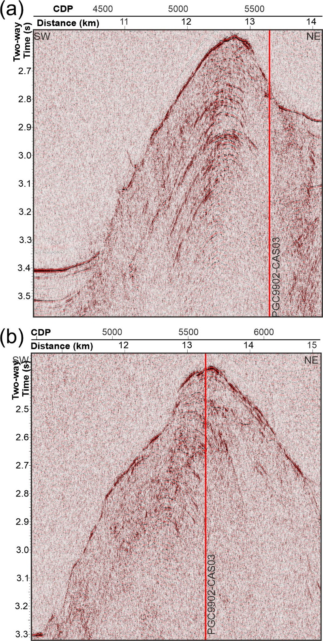

Figure A2 Seismic sections across the first accretionary ridge near Drill Site U1326. (a) Line PGC9902-ODP3 NW of the drill site showing some coherent reflectivity of the strongly folded sediments, (b) Line PGC9902-ODP7 SE of the drill site with little to no coherent reflectivity within the accretionary ridge.