

*Geochemistry, Geophysics, Geosystems*

Supporting Information for

**High carbon mineralization rates in subseafloor hadal sediments – Result of frequent mass wasting**

M. Zabel1, R. N. Glud2,3, H. Sanei4, M. Elvert1,5, T. Pape5, P.-C. Chuang6, E. Okuma5,  
P. Geprägs1, M. Kölling1

1 MARUM – Center for Marine Environmental Science, University of Bremen,  
Leobener Str. 8, 28359 Bremen, Germany

2 Hadal & Nordcee, Department of Biology, University of Southern Denmark,  
Campusvej 55, 5230 Odense, Denmark

3 Tokyo University of Marine Science and Technology, 4-5-7 Konan, Minato-ku, Tokyo, 108-8477, Japan

4 Lithospheric Organic Carbon (LOC) Group, Department of Geoscience, Aarhus University,  
Høegh-Guldbergs gade 2, 8000C, Aarhus, Denmark

5 Faculty of Geosciences, University of Bremen, Klagenfurter Str. 2-4, 28359 Bremen, Germany

6 GEOMAR Helmholtz Centre for Ocean Research, Wischhofstr. 1-3, 24148 Kiel, Germany

Corresponding author: Matthias Zabel (mzabel@uni-bremen.de)

**Calculation of flux rates**

Diffusive flux rates (*J*) were calculated using the following equation, assuming stationary conditions in a first approach:

$$J=-φ⋅D_{0}⋅{\left(1-lnφ^{2}\right)}^{-1}⋅\frac{∂C}{∂x}$$

The diffusive coefficients in free solution for seawater (*D*0) 177 cm2yr-1 and 274 cm2yr-1 For SO42- and CH4, respectively were calculated for 4°C in-situ temperature (Li & Gregory, 1974; Lerman, 1979; Iversen & Jørgensen, 1993). All values given base on the assumption of a constant porosity ($φ$) of 73% in the deeper core sections. This value represents the average in core GeoB22908-2(A10) as calculated by using gamma ray density measurements (cf. Fig. 4) and assuming a matrix density of 2.65 g cm-3 (Serra, 1984).

*References*

Iversen, N., & Jørgensen, B. B. (1993) Diffusion coefficients of sulfate and methane in marine sediments: Influence of porosity. *Geochimica et Cosmochimica Acta*, *57*, 571-578. doi: 10.1016/0016-7037(93)90368-7

Lerman, A. (1979) Geochemical Processes: Water and Sediment Environments. Wiley, 481 pp.

Li, Y.-H., & Gregory, S. (1979) Diffusion of ions in seawater and in deep-sea sediments. *Geochimica et Cosmochimica Acta*, *38*, 703-714. doi: 10.1016/0016-7037(74)90145-8

Serra, O. (Ed.) (1984) Formation Density Measurements (The Gamm-Gamma Log or Density Log). In Fundamentals of Well-Log Interpretation: 1. The Acquisition of Logging Data, Developments in Petroleum Science, *15*, 195-204. doi: 10.1016/S0376-7361(08)70425-4

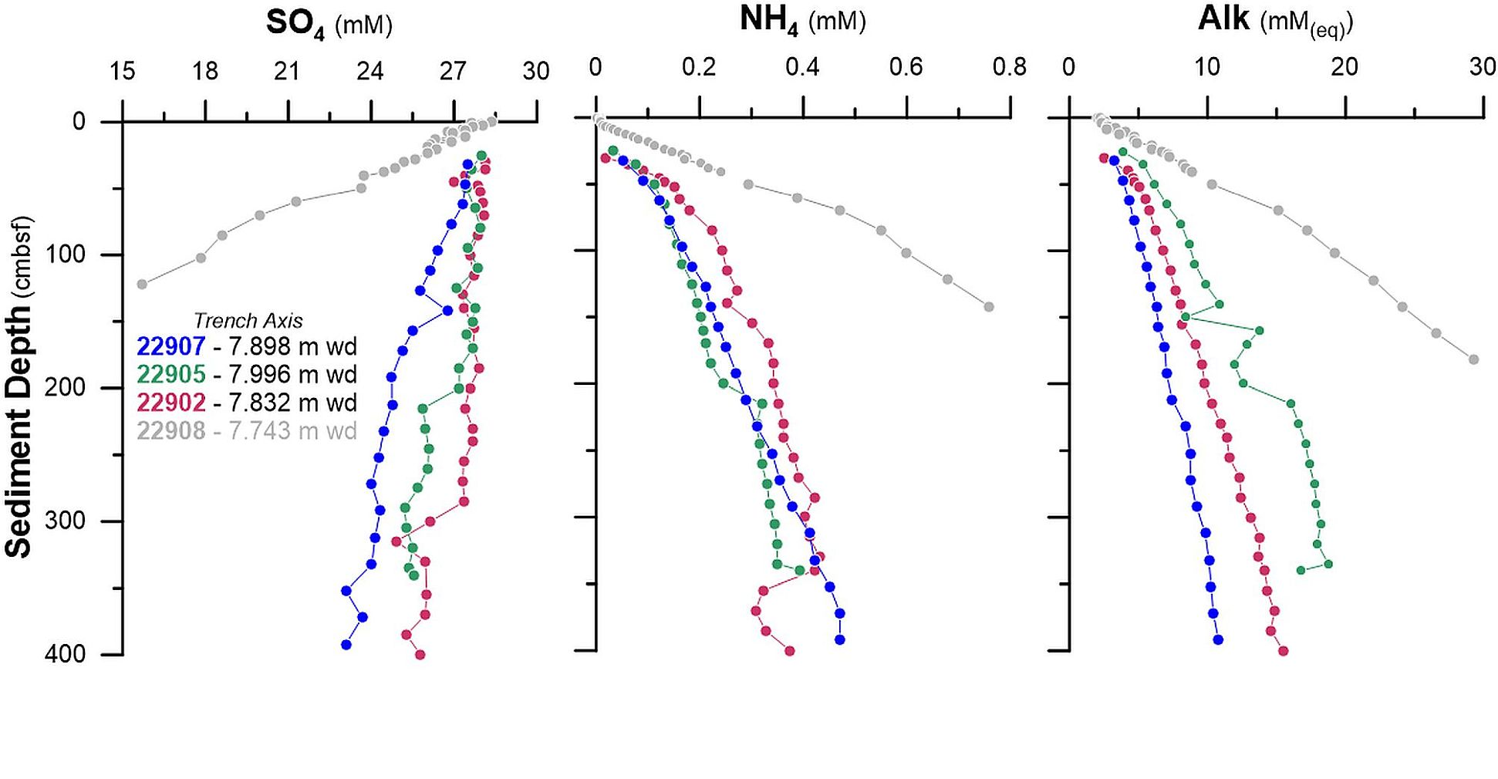 **Figure S1.** Pore water profiles of sulfate and ammonium concentrations an alkalinity from three sites along the Atacama Trench axis where the SMT was not reached. For comparison, profiles from core GeoB22908-2(A10) are shown in grey.

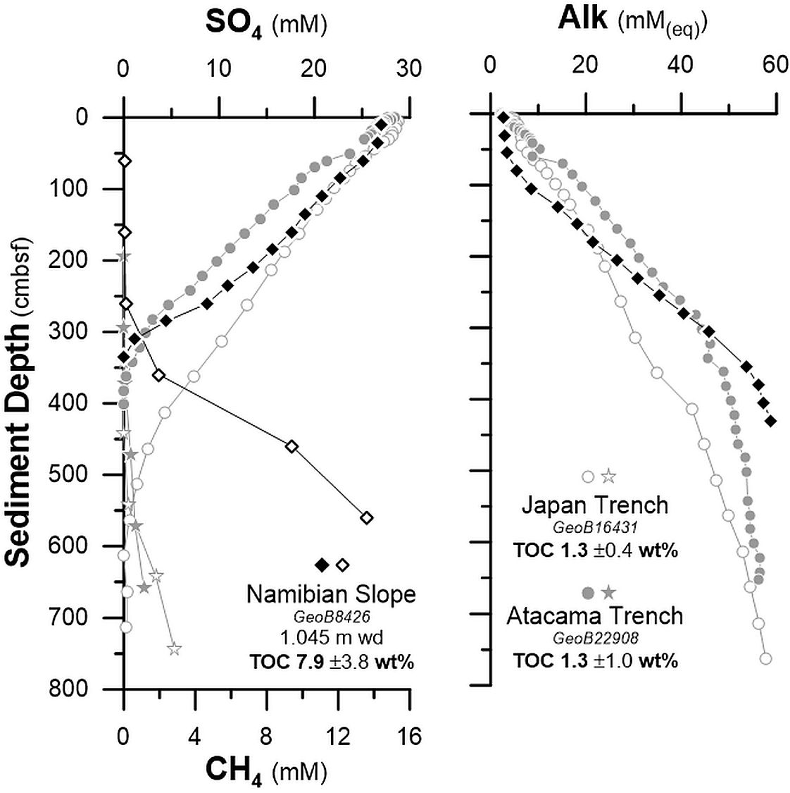

Figure S2. Comparison of the pore water profiles of SO42-, CH4 and alkalinity of two cores from one each of the two deep-sea trenches investigated and from a core recovered from the upper slope depot center of the high production area off Namibia (Riedinger et al., 2006). Although the total organic carbon content in the sediments from the both trenched investigated in this study is on average 6 times lower, comparable turnover rates are observed. The relatively low CH4 concentrations may be caused by outgassing during core retrieval.

|  |  |  |  |  |  |  |  |  |  |
| --- | --- | --- | --- | --- | --- | --- | --- | --- | --- |
| **AWI No.** | **sample depth** (cm) | **14C** (counts) | **12C** (µA) | **14C/12C** (10-12) | **13C/12C** (%) | **F14C** | **age** (y) | **+-** (yr) | **weight** (ugC) |
| 2942.1.1 | 122 | 282,970 | 17.7 | 0.6763 | 1.0870 | 0.5979 | 4,131 | 82 | 995 |
| 2943.1.1 | 180 | 132,710 | 19.3 | 0.2911 | 1.0906 | 0.2544 | 10,997 | 186 | 986 |
| 2944.1.1 | 263 | 814,96 | 15.4 | 0.2427 | 1.0803 | 0.2144 | 12,371 | 36 | 594 |
| 2945.1.1 | 290 | 271,795 | 18.8 | 0.6108 | 1.0891 | 0.5385 | 4,973 | 90 | 999 |
| 2946.1.1 | 533 | 185,311 | 16.6 | 0.4721 | 1.0872 | 0.4154 | 7,057 | 115 | 987 |
| 2947.1.1 | 600 | 150,619 | 17.0 | 0.3855 | 1.0833 | 0.3409 | 8,645 | 30 | 591 |
| 2948.1.1 | 615 | 175,846 | 17.8 | 0.4169 | 1.0863 | 0.3682 | 8,027 | 31 | 866 |

Table S1. AMS radio carbon dating.