**Supplementary Material**

**Figures**

Ein Bild, das Karte enthält.

Figure S1. Map showing the sampling location of herring used in this study. The main study area, the coastal spawning ground called Askøy, is marked with a triangular and a detailed map of the main study area is shown in the top left corner. Sampling location of the reference population samples of North Sea autumn spawning herring (NSASH) and Norwegian spring spawning herring (NSSH) are indicated with a circle and square, respectively. Genetic reference samples are marked in blue color and unfilled cube refers to Western Baltic Spring spawning herring (WBSS).

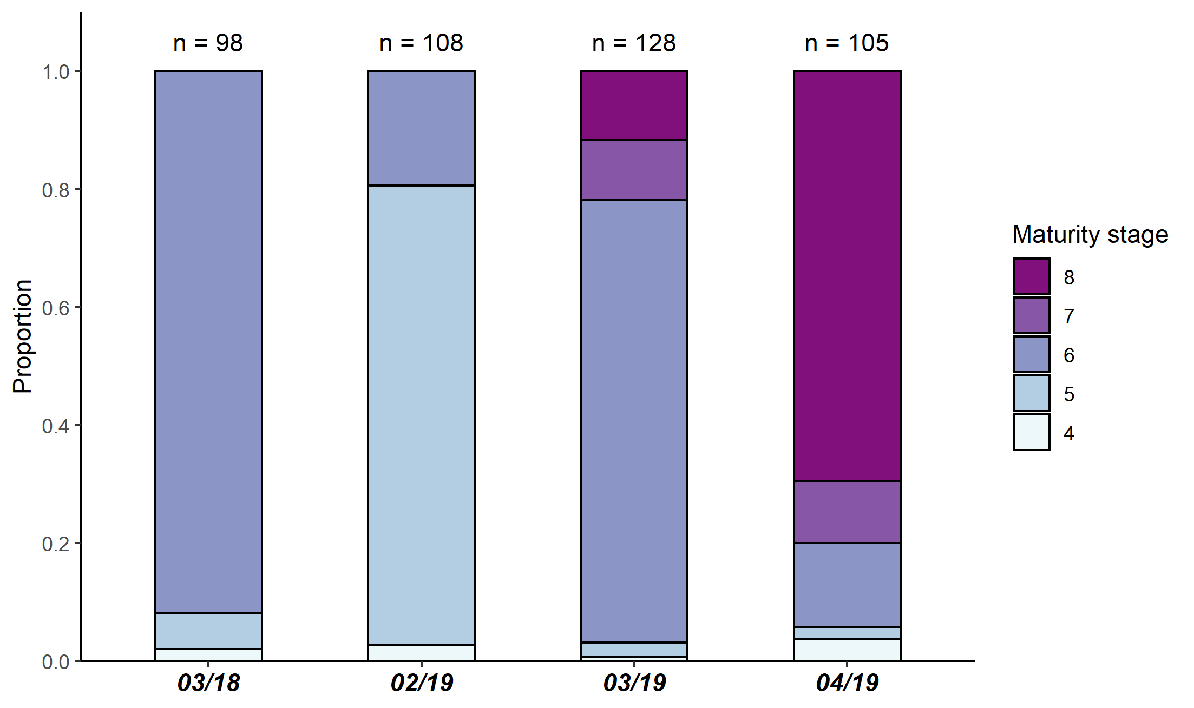

Figure S2. Maturity stage composition per sampling date. Number of fish per sampling date are given above each bar. Note that all fish were in stage 4 or above.

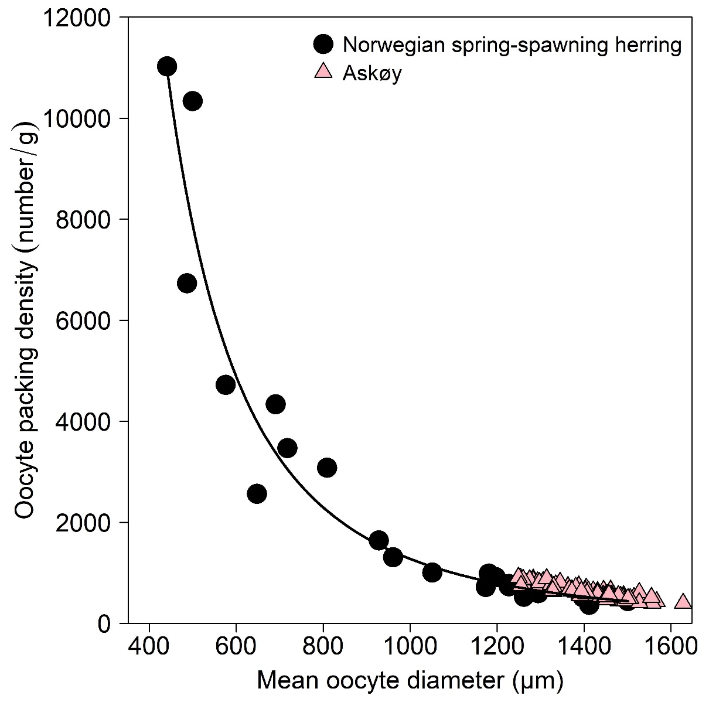

Figure S3. Mean oocyte diameter versus oocyte packing density (number /g). Data for Norwegian spring spawning herring (dos Santos Schmidt et al. 2017), Askøy samples and the underlying power function are shown.



Figure S4. Violin plot of the relative somatic fecundity (RFP,S) for Askøy herring compared among the different sampling dates. The size of the datapoints is proportional to the somatic gonadosomatic index (GSIS) of the sampled individual. Maximum RFP,S for NSSH is indicated by horizontal dashed line. Note that all herring (maturing & actively spawning herring) have been included here and actual fecundity estimates are higher due to egg losses before and during sampling.

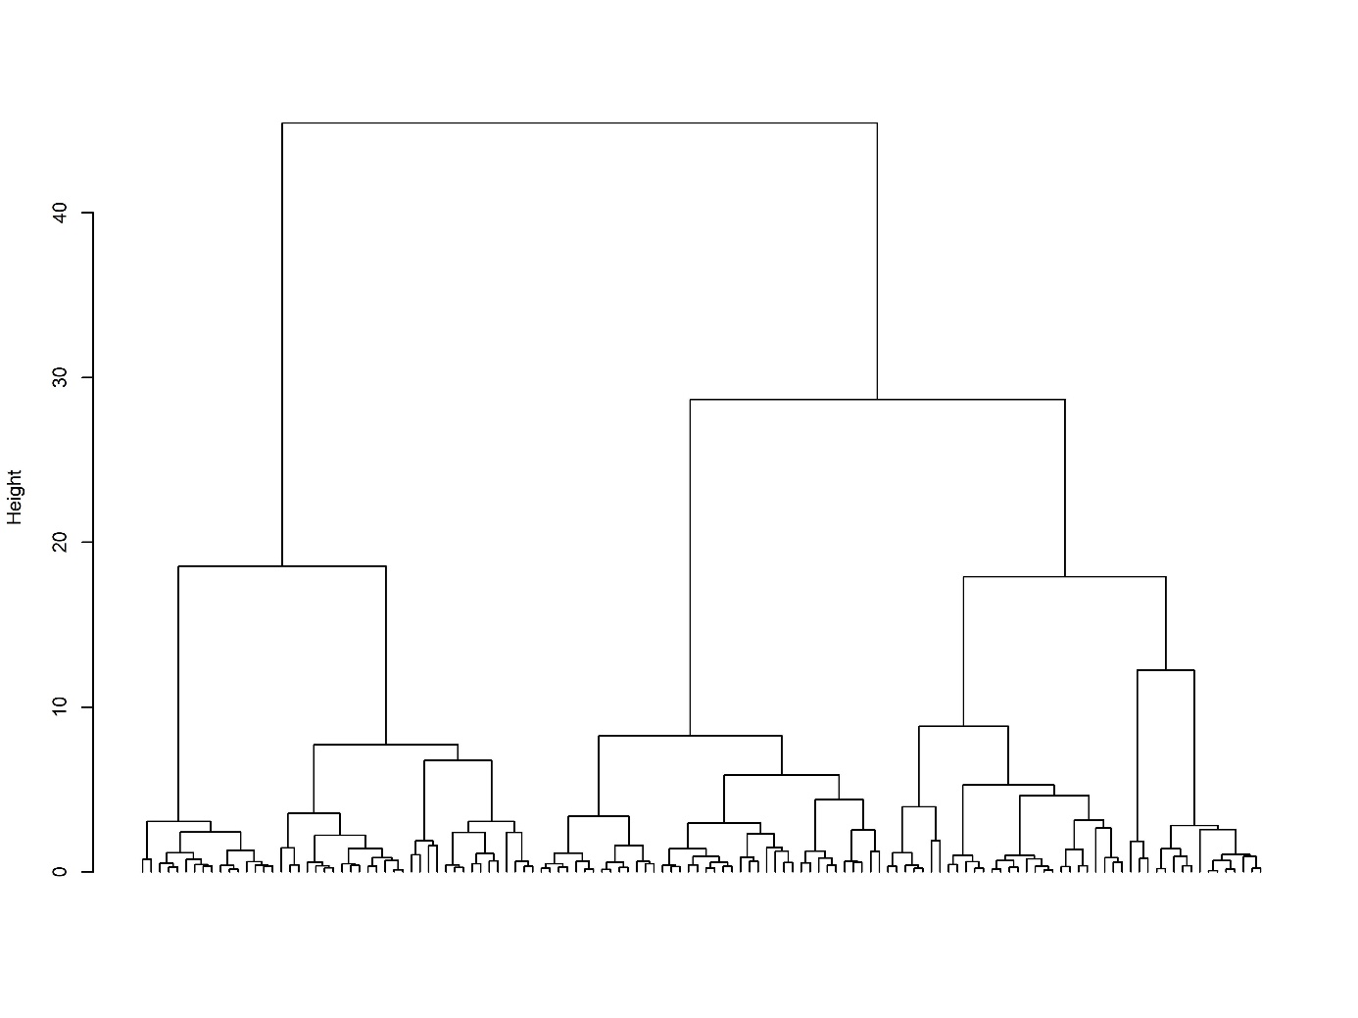

Figure S5. Cluster dendrogram showing the results from hierarchical agglomerative cluster analysis using total length (TL), oocyte diameter (OD) and somatic condition (KS)as input variables for Askøy genetic spring spawners.

Figure S6. Maturity stage composition per genetic assignment across all sampling dates. Number of fish per group are given above each bar.



Figure S7. Oocyte diameter (OD) as a function of fish total length (TL) for all sampling dates. No significant relationship exists between OD and TL for none of the sampling dates. Only hydrated oocytes of genetic spring spawners were included.



Figure S8. Standard deviation of oocyte diameter (OD) for different herring populations in the North-East Atlantic: Askøy (ASK, this study, 1 and 2 refer to clusters found in cluster analysis), Costal Skagerrak herring (CSH), Gloppenfjord herring (GLH), Lindåspollene herring (LPH), Landvik herring (LVH), Norwegian autumn spawning herring (NASH), North Sea autumn spawning herring (NSASH), Norwegian spring spawning herring (NSSH), Sognefjord herring (SGH) and Trondheimfjord herring (TRH). Note that that for all populations marked with an asterisk mixing with NSSH potentially occurs(Johannessen et al. 2009, Sørensen 2012, Eggers et al. 2014, Eggers et al. 2015). Data for other populations retrieved from dos Santos Schmidt et al. (2021).



Figure S9. Egg area from fertilization experiments compared among sampling dates (mean ± SD) per individual female. Data for egg area of 4 female fish (A and B) used in the fertilization experiment in 05/2013 was taken from Berg et al. (2019) and reflects egg area measure in seawater. Datapoints from 3 fish with exceptionally small oocytes which were sampled in this study in 03/2019 are indicated as C. Note that the unfilled points next to actual datapoints for 03/2019 and 04/2019 refers to measurements of unfertilized eggs in seawater from the same individual.

**Tables**

Table S1. Detailed description of SNPs identifying spawning time for Atlantic herring. Exaction position, chromosome, number of genotypes and flanking regions are provided.

|  |  |  |  |  |
| --- | --- | --- | --- | --- |
| Chromosome | Position (bp) | N genotypes | Internal name | Flanking region |
| chr10 | 25112283 | 3 | Uher_224 | TATTTACAATGTATTTACATGCATGCTGGCATGTTGAAGTTGAAC(T/C)TAACAATCAACGCAT(T/C)AATTGCACATCTTATGTATTCAAACACAAGCGCATGGA[A/G]AAATTCCTAGACGGGATTCTTGCATTCTTGCATGGAATTCCAGTGTGCATTTTTAGC(C/T)AC(G/A)GGCCCCAGCAGTGCTGCAGTAGAGAAGCCACAGTGTTCA |
| chr15 | 8813384 | 3 | Uher_294 | ATTTATCCTGGGTGCGGAAAAGGACACTGTATCTGC(G/A)TGACAGCGAATATTTCTTTTTTTAAAACACCAAGCTGCAGGAGACTCTGGTGTGATTGTATGC[T/C]GTTTAT(A/T)ATCCCTTTTACCACGATTTGA(T/A)TGATCTCATC(G/T)CTGTATGAAACAAAAG(C/A)AGCACATTTCTTGCCCAGGAATTAAAGAGAGGAGATTTAATCA |
| chr15 | 8920349 | 3 | Uher_325 | GGTTCCTAATGAGCAACAAAAGAACAACGATAGAACATTAACCACACTGAAATGAACAACGGCAGAACATTAACCATGCTGACAAGTCTCCCAAGTCCTT[A/C]AAGAACAACGATAGAACCTTAGCCATGCTGAAAAGTCTCCCAAGTCCTTAAACATATAGTCCGCTTTTCCCATTTACAGAGCCAGGACTGTGCATGAACA |
| chr15 | 10956917 | 3 | Uher_337 | ATTCACAGACCAGGTGTGCGT(A/G)TATTTCCCTTGCTCATACCTGATGGTCTGCCTTGGCCTGCACCAGTAGCCAGCGCAGGTGAAGAGCTCCGACCTGCTC[A/G]GCCAGGTGTGTCCGCTCCGCCCTGTCAGCCTC(G/T)TTTTTCACATGCCCCGCCTCCTCCACCAGCTGGCTCAGGTGG(T/C)CCATGCA(C/T)GCCTGGTGACTGGACA |
| chr15 | 10973697 | 3 | Uher_347 | AGAGAGAGAAAGAGAGAGAAAGTATGTGTGCGACAGAGAGAG(G/A)GAGAGAGAGATGAATGAAATGTAATTAAGATCAAGTGAATCAGAGACTAAGTGTGTT[C/T]GCAAGTTTTCCTACCTCCTGCAGTGGCTCTGGAGGTTCTGCAGCTCCTCGCAGATCTGGATGGGTTCCCCAGGGTCCCGTTGTGAGGGGGGGCCGAGGAG |
| chr19 | 20545960 | 3 | Uher_244 | ATAGAGCTCCACTCAGTATGTCTGACACT(A/G)TATGGTATGGTTGGAGGAGTCTATCCA(G/T)TTTCTCCAGGACATGGTTATAGTTACACAGACTGGGACTTGA[G/A]TTGTCTGTGTTGGTCTGGATGAACTCACAGAGACTGTGTCAGTCAGTATA(T/A)AT(C/A)TCACCTTCTGTGAGGATTTAGTCATCTAGGGAAATCAATTTTCATT |
| chr19 | 20571185 | 3 | Uher_259 | ATACTTCATGTACTGTAACATGCGGTACAGAATACTATAGAGCTAAGTGCTGAGTTATTCAGACTGAAGGGTCGGACTGTCCAGAAATATTCTGGCTCAT[G/A]AATACTAATTACTATTAAAGGTACTATTAAAAGTGCGACATGCACTTTTGTTGTTATGTGCTTGTTTTTAC(A/C)ATTTACCTTTTCATATACAACTTTTTTC |
| chr19 | 20577287 | 3 | Uher_256 | GGCCTAAATTACAA(T/G)TGGTGACATGAAATGAGGTCAGTAATCTGCAATGGGGTGCATCAGCTTGCAAGTAACCCCAAAT(G/T)AAGTGAATGCTCTTGCACAG[A/G]CACACATGCATCTGCACTCTGTCACTCA(C/A)TCTTTCGGGAATCCATGAAATGCATCACAATACTAAGGTGCAATTTGTGTGAATTAGATGATCATAATTTC |
| chr19 | 20608343 | 3 | Uher_246 | (G/T)(T/A)TCATGGTATATAGTCATGTGGAGGACAGACATTCCAA(C/G)TAGCCA(C/T)CTAGGCTGTGCAC(T/A)ATGCAGTGTGGTGGTCTGAGACGGACCACTCTGAGGAAA[C/T]GCAAAAAAGCTTTAACAGCACGGGATTGACAACTATATCGGCAAAAGACATGAGCTAGCAAGCCTTT(T/C)ACTCCTTAATACTGCTTTAGAGAAAGAAATTG |
| chr5 | 12867679 | 3 | UherIMR20 | CTGATGAATCTTTCACTGCACGTTAAACACGCATCTCCTTCCTGTGGGCTGTAAGTGTGACAGTNGCGTCTTAAATTAAACACTGACTTATAAAACACTT[G/A]GCGCTTCGTTTAGGCTGTGTGTGTGTGTGTGTGTGTGTGTGTGTGTGTGTGTGTGTGTGTGTGTGTGTGTGTGTGTGTGTGTGTGTGTGTTTTTGTGTGT |
| chr8 | 29857726 | 3 | Uher_29_014 | NAGACTGAAGTAGTGAATCTGGAGAAGGAGATTACAGAGAAACCCAAGGTGGCNTTCTCAGGAGGTCTGAGGCTTCNCCAAGGCTACATACAGGCTGGGG[C/G]CACTGATCTGGACCTGGTTTTCAATAANATCTNCACCAATGTTGGCGAGGCCTACANCAGCANGACCGGCTACTTCACAGCTCCAGTCAGGGGAGTCTAC |

Table S2. Sampling location and data of reference samples used for the genetic analysis to identify spawning season of herring collected on the coastal spawning ground Askøy.

|  |  |  |  |  |
| --- | --- | --- | --- | --- |
| *Population* | *Latitude* | *Longitude* | *Date of collection* | *Spawning season* |
| NSASH (Banks) | 54.20 | 03.30 | Aug. 2009, 2018 | Autumn |
| NSASH (Shetland) | 59.21 | -02.38 | Oct. 2016 | Autumn |
| NSSH | 62.70 | 5.47 | Feb. 2019 | Spring |
| WBSS-SK (East) | 57.60 | 11.40 | Apr. 2009 | Spring |
| WBSS-SK (West) | 58.15 | 08.27 | Feb. 2009 | Spring |

**References**

Berg F, Slotte A, Andersson L, Folkvord A (2019) Genetic origin and salinity history influence the reproductive success of Atlantic herring. Marine Ecology Progress Series 617-618:81-94

Eggers F, Olsen EM, Moland E, Slotte A (2015) Individual habitat transitions of Atlantic herring Clupea harengus in a human-modified coastal system. Marine Ecology Progress Series 520:245-256

Eggers F, Slotte A, Libungan LA, Johannessen A, Kvamme C, Moland E, Olsen EM, Nash RD (2014) Seasonal dynamics of Atlantic herring (*Clupea harengus* L.) populations spawning in the vicinity of marginal habitats. PLoS One 9:e111985

Johannessen A, Nøttestad L, Fernö A, Langård L, Skaret G (2009) Two components of Northeast Atlantic herring within the same school during spawning: support for the existence of a metapopulation? ICES Journal of Marine Science 66:1740-1748

Sørensen Ø (2012) Comparative biology and population dynamics between Trondheimsfjord herring and Norwegian spring spawning herring, implications for management. Master's thesis, University of Bergen, Norway