**Journal of Geophysical Research: Solid Earth**

**Supplementary Material**

The Mid-Lithospheric Discontinuity caused by channel flow of proto-cratonic mantle

Haibin Yang *a, b, Irina M. Artemieva c, d, e, Hans Thybo c, e, f

a. School of Earth Sciences, Zhejiang University, Hangzhou, China

b. Research School of Earth Sciences, Australian National University, Canberra, Australia

c. SinoProbe Laboratory, Chinese Academy of Geological Sciences, Beijing,China

d. Section of Marine Geodynamics, GEOMAR Helmholtz Center for Ocean Research, Kiel , Germany

e. State Key Laboratory of Geological Processes and Mineral Resources, School of Earth Sciences, China University of Geosciences, Wuhan, China

f. Eurasia Institute of Earth Science, Istanbul Technical University, Maslak, 34469 Istanbul, Turkey

Corresponding author: Haibin Yang

Email: [haibin.yang@anu.edu.au](mailto:haibin.yang@anu.edu.au)

**This file includes:**

1. Methods description

2. Table S1: Parameters of the reference model

3. References to Methods and Table S1

4. Table S2: Model codes and model parameters

5. References to Figure 1

6. Supplementary Figures S1-S3

# 1. Methods

We model the long-term evolution of the Archean cratonic mantle by the particle-in-cell, finite-element, geodynamics code Underworld2 (Moresi et al., 2007), which solves the thermo-mechanically coupled conservation equations of mass and momentum:

|  |  |
| --- | --- |
| $∇∙u=0$ | (1) |
| $∇∙σ^{'}−∇P+ρg=0$ | (2) |

where $u$ is velocity, $σ^{'}$ is deviatoric stress, $P$ is pressure, $ρ$ is density and $g$ is gravitational acceleration. For the equation of conservation of mass (1), we assume incompressibility condition. Lateral and secular changes in temperature are incorporated through the heat conservation equation:

|  |  |  |
| --- | --- | --- |
| $ρc_{p}\left(\frac{∂T}{∂t}+u∙∇T\right)−∇∙k∇T−H=0$ | (3) |  |

where $ρ$ is density, $c_{p}$ is heat capacity, $k$ is thermal conductivity and $H$ is heat production (only radioactive heat sources are considered). The model domain is a rectangular box with a dimension of 4000 km x 660 km (Fig. 2a), which is resolved on 540 x 240 bilinear elements. We adopt edge-parallel free slip and edge-normal zero slip at all four boundaries. The model parameters for the three model layers (crust, lithospheric mantle, and sublithospheric mantle) are specified in Table S1; and we assume that density and thermal conductivity are temperature dependent.

Non-Newtonian viscous deformation in the mantle is specified by:

|  |  |  |
| --- | --- | --- |
|  | (4) |  |

where $\overset{´}{ε}$ is strain rate, $A$ a material constant, $n$ the stress exponent, $E$ the activation energy, $V$ the activation volume, and $R$ the gas constant. Mantle dehydration due to melt extraction during craton formation may increase the viscosity of the cratonic root (Hirth and Kohlstedt, 2003). Therefore, we assume that at the same strain rate and temperature, the intrinsic viscous strength in the sub-lithospheric mantle is 1/5 of that in the lithospheric mantle. The effective viscosity is given by

|  |  |
| --- | --- |
| $η_{eff}=\frac{σ_{II}}{2{\overset{´}{ε}}_{II}}$ = $\frac{{σ_{II}}^{1−n}}{2A}exp\left(\frac{E+VP}{RT}\right)$ | (5) |

where $σ_{II}$ and ${\overset{´}{ε}}_{II}$ are the square roots of the second invariants of stress and strain rate, respectively. The effective viscosity is restricted to the range between 1018 Pas and 1024 Pas.

# 2. Table S1. Parameters of the end-member model (Figure 2)

Density depends on temperature *T* as ${ρ=ρ}_{o}\left[1−α\left(T−T_{0}\right)\right],$ where $ρ_{\text{0}}$ is standard (SPT) density at $P_{O}=0$.1MPaand K; = 1.0×10-5 K-1 is thermal expansion; $k$ is temperature-dependent thermal conductivity, and $Cp=1200J/K$ is heat capacity.

The results for reference model evolution are shown in Figures 3-4. Models with other parameters are tested as well (Table S2, Figures 5-8, S2-S3).

|  |  |  |  |
| --- | --- | --- | --- |
|  | Crust | Lithospheric Mantle | Sub-lithospheric Mantle |
| Wet quartzite[1] | Dry olivine[2] | Dry olivine[2] |
| (MPa-n S-1) | 3.2×10-4 | 1.585×103.5 | 1.585×103.5 |
|  | 2.3 | 3.5 | 3.5 |
| $E$ kJ/mol | 154 | 510 | 510 |
| (cm3/mol) | 0 | 11 | 11 |
| (kg/m3) | 2700 | 3300 | 3330 |
| $k$ (W/mK)[3] | 0.64+807/(T+77) | 0.73+1293/(T+77) | 0.73+1293/(T+77) |
| (μW/m3) | 1 | 0.2 | 0.02 |
| *Thickness* (km) | 40 | 55 and 195 | 565 and 425 |
| *Depth to bottom* (km) | 40 | 95 and 235 | 660 |

[1] Ranalli (1995); [2] Hirth and Kohlstedt (2003); [3] Clauser and Huenges (1995).

# 3. References to Methods and Table S1

Clauser, C. and Huenges, E., 1995. Thermal conductivity of rocks and minerals. Rock physics & phase relations: A handbook of physical constants: 105-126.

Hirth, G. and Kohlstedt, D., 2003. Rheology of the Upper Mantle and the Mantle Wedge: A View from the Experimentalists, Inside the Subduction Factory. American Geophysical Union, pp. 83-105.

Moresi, L., Quenette, S., Lemiale, V., Meriaux, C., Appelbe, B. and Mühlhaus, H.-B., 2007. Computational approaches to studying non-linear dynamics of the crust and mantle. Physics of the Earth and Planetary Interiors, 163(1): 69-82.

Ranalli, G., 1995. Rheology of the Earth. Springer Science & Business Media.

# 4. Table S2: Model codes and model parameters

Parameters of the reference model are listed in Table S1 and are illustrated in Figure 2. The results for end-member model evolution are shown in Figures 3-4.

|  |  |  |
| --- | --- | --- |
| Model code | Difference with the reference model | Figure with model evolution |
| N/A | 1. CLAB in thin proto-CBL domain is initially 95-210 km thick (95 km in the end-member model). 2. Thermal expansion coefficient 3×10-5 K-1 (1×10-5 K-1 in the reference model). | Fig. 5 |
| N/A | 1. CLAB in thin proto-CBL domain is initially 210 km thick (95 km in the reference model).  2. Thermal expansion coefficient 3×10-5 K-1 (1×10-5 K-1 in the reference model).  3. Viscosity in sublithospheric mantle is reduced by a factor of 5 of the end-member model | Fig. 6 |
| N/A | A broad thick-thin proto-CBL domain transition at  x = 800-2600 km (the reference model has a narrow transition at x = 2400-2600 km). | Fig. 7 |
| M_den15_exp2 | 1. Density contrast across the CLAB is 15 kg/m3 (30 kg/m3 in the reference model). 2. Thermal expansion coefficient 2×10-5 K-1 (1×10-5 K-1 in the reference model). | Fig. 8, 9c |
| M_den05_exp3 | 1. Density contrast across the CLAB is 5 kg/m3 (30 kg/m3 in the reference model). 2. Thermal expansion coefficient 3×10-5 K-1 (1×10-5 K-1 in the reference model). | Fig. 9b |
| N/A | Temperature profile in the lithospheric mantle is limited by solidus temperature. | Fig. S2a, wet solidus;  Fig. S2b, dry solidus |
| N/A | Thermal expansion coefficient 3×10-5 K-1 (1×10-5 K-1 in the endmember model). | Fig. S3a |
| N/A | 1. The model accounts for the effect of latent heat. 2. Thermal expansion coefficient 3×10-5 K-1 | Fig. S3b |
| N/A | 1.TLAB is initially at depth of 150 km (90 km in the endmember model).  2. Thermal expansion coefficient 3×10-5 K-1 | Fig. S3c |

# 5. References to Figure 1

Abramovitz, T., Thybo, H., Perchuc, E., 2002. Tomographic inversion of seismic P- and S-wave velocities from the Baltic Shield based on FENNOLORA data. Tectonophysics 358, 151-174.

Abt, D. L., K. M. Fischer, S. W. French, H. A. Ford, H. Yuan, B. Romanowicz, 2010. North American lithospheric discontinuity structure imaged by Ps and Sp receiver functions, J. Geophys. Res., 115, B09301, doi:10.1029/2009JB006914.

Bruneton, M., Pedersen, H. A., Vacher, P., et al. and the SVEKALAPKO Seismic Tomography Working Group (2004). Layered lithospheric mantle in the central Baltic Shield from surface waves and xenolith analysis. Earth Planet. Sci. Lett., 226, 41–52.

Debayle, E., Kennett, B., Priestley, K., 2005. Global azimuthal seismic anisotropy and the unique plate-motion deformation of Australia. Nature 433, 509-512.

Egorkin, A.V., Zuganov, S.K., Pavlenkova, N.A., Chernyshev, N.M., 1987. Results of Lithospheric Studies from Long-Range Profiles in Siberia. Tectonophysics 140, 29-47.

Fuchs, K. and Vinnik, L.P., 1982. Investigation of the subcrustal lithosphere and astenosphere by controlled source seismic experiments on long range profiles. In: G. Palmason et al. (Editors), Continental and Oceanic Riffs. AGU Geodyn. Ser., 8: 81-89.

Griffin, W.L., Doyle, B.J., Ryan, C.G., Pearson, N.J., O'Reilly, S.Y., Davies, R., Kivi, K., Van Achterbergh, E., Natapov, L.M., 1999. Layered mantle lithosphere in the Lac de Gras area, Slave Craton: Composition, structure and origin. Journal of Petrology 40, 705-727.

Griffin, W.L., O'Reilly, S.Y., Doyle, B.J., Pearson, N.J., Coopersmith, H., Kivi, K., Malkovets, V., Pokhilenko, N., 2004. Lithosphere mapping beneath the north American plate. Lithos 77, 873-922.

Griffin, W.L., O'Reilly, S.Y., Natapov, L.M., Ryan, C.G., 2003. The evolution of lithospheric mantle beneath the Kalahari Craton and its margins. Lithos 71, 215-241.

Griffin, W.L., Ryan, C.G., Kaminsky, F.V., O'Reilly, S.Y., Natapov, L.M., Win, T.T., Kinny, P.D., Ilupin, I.P., 1999. The Siberian lithosphere traverse: mantle terranes and the assembly of the Siberian Craton. Tectonophysics 310, 1-35.

Hansen, S.E., Nyblade, A.A., Julià, J., Dirks, P.H.G.M., Durrheim, R.J., 2009. Upper-mantle low-velocity zone structure beneath the Kaapvaal craton fromS-wave receiver functions. Geophysical Journal International 178, 1021-1027.

Jones, A.G., Lezaeta, P., Ferguson, I.J., Chave, A.D., Evans, R.L., Garcia, X., Spratt, J., 2003. The electrical structure of the Slave craton. Lithos 71, 505-527.

Kopylova, M. G. and Russell, J. K. (2000). Chemical stratification of cratonic lithosphere: Constraints from the northern Slave craton, Canada. Earth Planet. Sci. Lett., 181: 71–87.

Lehtonen, M.L., O'Brien, H.E., Peltonen, P., Johanson, B.S., Pakkanen, L.K., 2004. Layered mantle at the Karelian Craton margin: P–T of mantle xenocrysts and xenoliths from the Kaavi–Kuopio kimberlites, Finland. Lithos 77, 593-608.

Mareschal, M., Kellett, R. L., Kurtz, R. D., et al. (1995). Archaean cratonic roots, mantle shear zones and deep electrical anisotropy. Nature, 375: 134–137.

Olsson, S., Roberts, R. G. & Böðvarsson, R. 2007. Analysis of waves converted from S to P in the upper mantle beneath the Baltic Shield. Earth Planet. Sci. Lett. 257, 37–46

Perchuc, E., Thybo, H., 1996. A new model of upper mantle P-wave velocity below the Baltic Shield: Indication of partial melt in the 95 to 160 km depth range. Tectonophysics 253, 227-245.

Rychert, C.A., Shearer, P.M., 2009. A global view of the lithosphere-asthenosphere boundary. Science 324, 495-498.

Savage, B. and Silver, P. G. (2008). Evidence for a compositional boundary within the lithospheric mantle beneath the Kalahari craton from S receiver functions. Earth Planet. Sci. Lett., 272, 600–609.

Silvennoinen, H., E. Kozlovskaya, and E. Kissling (2016), POLENET/LAPNET teleseismic P wave travel time tomography model of the upper mantle beneath northern Fennoscandia, Solid Earth, 7(2), 425-439, doi:10.5194/se-7-425-2016.

Skirrow, R. G., van der Wielen, S. E.,Champion, D. C., Czarnota, K., & Thiel, S.(2018). Lithospheric architecture and mantle metasomatism linked to ironoxide Cu-Au ore formation:Multidisciplinary evidence from the Olympic Dam region, South Australia. Geochemistry, Geophysics, Geosystems, 19. https://doi.org/10.1029/ 2018GC007561.

Snyder, D. B. (2008), Stacked uppermost mantle layers within the Slave craton of NW Canada as defined by anisotropic seismic discontinuities, Tectonics, 27, TC4006, doi:10.1029/2007TC002132.

Sodoudi, F. , Yuan X., Kind R., et al., 2013. Seismic evidence for stratification in composition and anisotropic fabric within the thick lithosphere of Kalahari Craton. Geochem. Geophys. Geosyst. 14, 5393–5412.

Sun, W., Fu, L.Y., Saygin, E., Zhao, L., 2018. Insights Into Layering in the Cratonic Lithosphere Beneath Western Australia. Journal of Geophysical Research: Solid Earth, 123 (2),1405-1418.

Thybo, H., Perchuć, E., 1997. The Seismic 8° Discontinuity and Partial Melting in Continental Mantle. Science 275, 1626-1629.

Vinnik, L., et al. (2014), Anisotropic lithosphere under the Fennoscandian shield from P receiver functions and SKS waveforms of the POLENET/LAPNET array, Tectonophysics, 628, 45-54, doi:10.1016/j.tecto.2014.04.024.

Wittlinger, G., V. Farra, 2007. Converted waves reveal a thick and layered tectosphere beneath the Kalahari supercraton, Earth Planet. Sci. Lett., 254, 404–415.

Yuan, H., Romanowicz, B., 2010. Lithospheric layering in the North American craton. Nature 466, 1063-1068.

Yuan, H., Romanowicz, B., Fischer, K. M., Abt, D. 2011. 3-D shear wave radially and azimuthally anisotropic velocity model of the North American upper mantle. Geophys. J. Int. 184, 1237–1260.

# 6. Supplementary Figures S1-S3

**Figure S1**. Relative heat production in the Earth for the past 4.5 Gy. The assumed present abundances for K, Th, and U are 200 ppm, 74 ppb, and 20 ppb, respectively. The weight percentage of 40K/K, 232Th/Th, 235U/U and 238U/U is 0.0119, 100.0, 0.71 and 99.28, respectively (Van Schmus, 1995). 40K and 235U provide the major contribution to heat production in the early Earth.

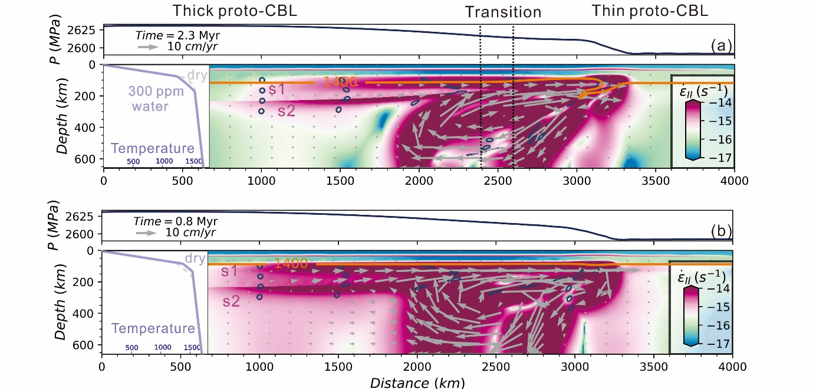

**Figure S2.** Snapshots of the model evolution for different temperature fields at time zero. Snapshots show the square root of the second invariant strain rate. Model settings are the same as in the end-member model, except that the temperature (white panel inserts) in the lithospheric mantle is lowered to the corresponding solidus temperature (Katz et al., 2003) when it reaches (**a**) wet solidus with 300 ppm water or (**b**) dry solidus. Even in the case of wet solidus (**a**), the model evolution produces a large-scale channel flow (> 1000 km) in the thick continental root.

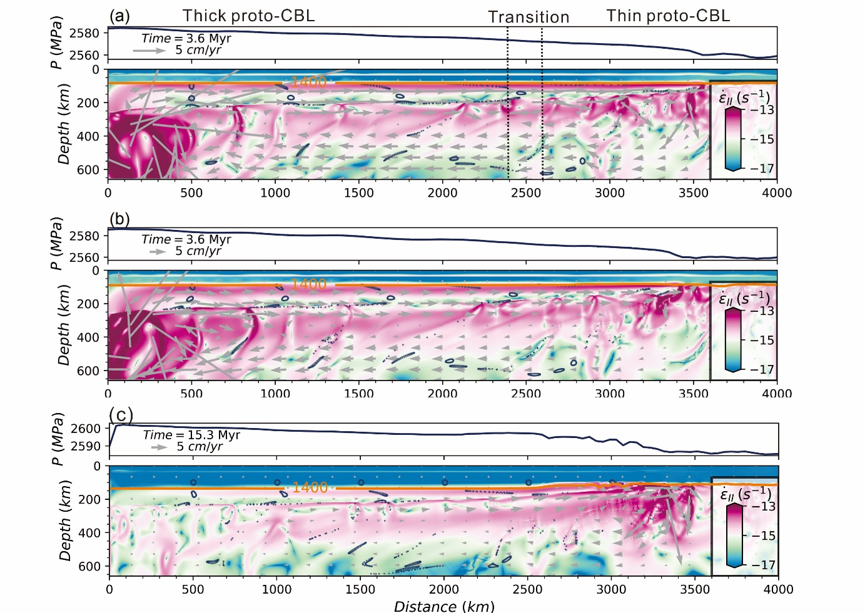

**Figure S3**. Snapshots of the model evolution with the square root of the second invariant strain rate.

(**a**) Model parameters are the same as in the end-member model, except for higher value of the thermal expansion coefficient of 3×10-5 K-1.

(**b**) The same parameters as in (a) except the initial temperature at time zero is the same as in Fig. S2b (insert), so that the model accounts for the effect of latent heat. After the same time of model evolution as in Figure 2b (the endmember model), the channel flow forms in the lower lithospheric mantle in the entire model domain with a pressure difference of more than 20 MPa.

(**c**) The same parameter as in (a) except that the TLAB is initially at depth of 150 km, instead of 90 km as in the endmember model. The channel flow is observed as well, but the top of shear zone s1 is at a depth of ~150 km, which is deeper than that in the endmember model.