

*Geophysical Research Letters*

Supporting Information for

**Rapid cycling of bacterial particulate organic matter in the upper layer of the Western Pacific Warm Pool**

Jinqiang Guo1,2,4, Bu Zhou1,3,4,5, Eric P. Achterberg2, Huamao Yuan1,3,4,5*, Jinming Song1,3,4,5*, Liqin Duan1,3,4,5, Xuegang Li1,3,4,5

1 Key Laboratory of Marine Ecology and Environmental Sciences, Institute of Oceanology, Chinese Academy of Sciences, Qingdao, China

2 Marine Biogeochemistry Division, GEOMAR Helmholtz Centre for Ocean Research Kiel, Kiel, Germany

3 Laboratory for Marine Ecology and Environmental Sciences, Laoshan Laboratory, Qingdao, China

4 University of Chinese Academy of Sciences, Beijing, China

5 Center for Ocean Mega-Science, Chinese Academy of Sciences, Qingdao, China

* Corresponding authors at Key Laboratory of Marine Ecology and Environmental Sciences, Institute of Oceanology, Chinese Academy of Sciences, Qingdao 266071, PR China.

E-mail addresses: yuanhuamao@qdio.ac.cn (H. Yuan), jmsong@qdio.ac.cn (J. Song)

**Contents of this file**

Text S1

Figures S1

**Introduction**

This file mainly contains the methodology for the determination of enantiomeric amino acids and the figure. Text S1 introduces the detailed measurement of the amino acids. Figure S1 presents the typical chromatograms of amino acids at different depths.

Text S1. Determination of D- and L-amino acids.

In this study, suspended particulate matter samples were obtained from discrete depths (P1: 3, 30, 50, 75, 106, 150, 200, 300, 500, 1000, 2000, 2200 m; P2: 3, 30, 50, 75, 110, 150, 200, 300, 500, 1000, 2000, 3000, 5000 m). Particles were collected by filtration of 10 L of seawater onto Whatman GF/F filters (0.7 μm nominal pore size; 25 mm diameter, pre-combusted at 450°C for 5 h) in upper 500 m, while 30 L of seawater were filtered below 500. Pre-treatment of amino acid samples was conducted in a laminar flow hood. GF/F filters for D- and L-amino acids analysis were hydrolyzed using 6 M hydrochloric acid (HCl) at 110°C for 24 h after being freeze-dried. Then, HCl was removed by repeated drying, and the residue was derivatized by *o*-phthaldialdehyde and *N*-isobutyryl-L-cysteine. Separation and detection of amino acids were performed using a Thermo Fisher Scientific U3000 ultrahigh performance liquid chromatography (UPLC)/fluorescence detection (excitation: 330 nm; emission: 445 nm) system equipped with a Poroshell 120 EC-C18 column (4.6×100 mm, 2.7 μm particles) (Kaiser & Benner, 2005; Shen et al., 2017). The column temperature was 30°C and the flow rate was 1 mL min−1. A linear binary gradient was used starting with 100% potassium di-hydrogen phosphate (KH2PO4; 48 mmol L−1, pH = 6.25) to 61% KH2PO4 and 39% methanol: acetonitrile (13:1, v/v) at 22 min, 46% KH2PO4 at 30 min, 40% KH2PO4 at 37 min, and 20% KH2PO4 at 39 min. Amino acids included in the analysis were as follows: asparagine acid (Asp), glutamine acid (Glu), serine (Ser), histidine (His), glycine (Gly), threonine (Thr), β-alanine (β-Ala), arginine (Arg), alanine (Ala), γ-aminobutyric acid (γ-Aba), tyrosine (Tyr), valine (Val), phenylalanine (Phe), isoleucine (Ile), leucine (Leu), and lysine (Lys). Reference standards were injected every 3 samples to calibrate the instrument drift. Hydrolysis-induced racemization was corrected according to Kaiser and Benner (2005). This method has a detection limit (S/N = 3) of ~30 fmol and the blank is < 0.5 nmol L−1. The relative standard deviation among six runs of a given sample was < 5% for individual amino acids. The typical chromatograms are shown below.

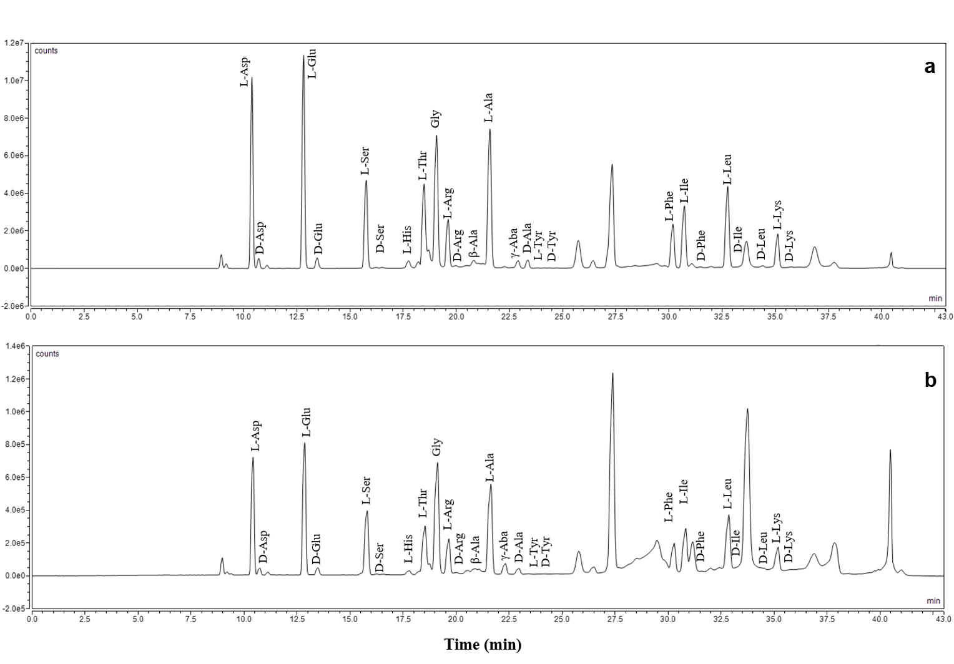

Figure S1. Chromatograms of amino acids at 106 m (a) and 2200 m (b).