

*Global Biogeochemical Cycles*

Supporting Information for

**Magnitude, trends, and variability of the global ocean carbon sink from 1985-2018**

Tim DeVries (1,2), Kana Yamamoto (2,3), Rik Wanninkhof (4), Nicolas Gruber (5), Judith Hauck (6), Jens Daniel Müller (5), Laurent Bopp (7), Dustin Carroll (8,9), Brendan Carter (10,11), Thi-Tuyet-Trang Chau (12), Scott Doney (13), Marion Gehlen (14), Lucas Gloege (15,16), Luke Gregor (5), Stephanie Henson (17), Ji Hyun Kim (2,3), Yosuke Iida (18), Tatiana Ilyina (19), Peter Landschützer (19,20), Corinne Le Quéré (21), David Munro (22,23), Cara Nissen (6,24), Lavinia Patara (25), Fiz F. Perez (26,27), Laure Resplandy (28), Keith Rodgers (29,30), Jörg Schwinger (31), Roland Séférian (32), Valentina Sicardi (33), Jens Terhaar (34,35,36), Joaquin Trinanes (4,37), Hiroyuki Tsujino (38), Andrew Watson (39), Sayaka Yasunaka (40,41), Jiye Zeng (42)

(1) Department of Geography, University of California, Santa Barbara (2) Earth Research Institute, University of California, Santa Barbara (3) Interdepartmental Graduate Program in Marine Science, University of California, Santa Barbara (4) Atlantic Oceanographic and Meteorological Laboratory, National Oceanic and Atmospheric Administration, Miami, Florida, USA (5) Environmental Physics, Institute of Biogeochemistry and Pollutant Dynamics, ETH Zurich, Zürich, Switzerland (6) Alfred-Wegener-Institut, Helmholtz-Zentrum für Polar- und Meeresforschung, Bremerhaven, Germany (7) LMD/IPSL, Ecole normale supérieure, Université PSL, CNRS, Sorbonne Université, Ecole Polytechnique, Paris, France (8) Moss Landing Marine Laboratories, San José State University, Moss Landing, CA, USA (9) Jet Propulsion Laboratory, California Institute of Technology, Pasadena, CA, USA (10) Cooperative Institute for Climate, Ocean, and Ecosystem Studies, Seattle, WA, USA (11) Pacific Marine Environmental Laboratory, National Oceanic and Atmospheric Administration, Seattle, WA, USA (12) Laboratoire des Sciences du Climat et de l’Environnement, LSCE/IPSL, CEA-CNRS-UVSQ, Université Paris-Saclay, F-91191 Gif-sur-Yvette, France (13) Department of Environmental Sciences, University of Virginia, Charlottesville, VA, USA (14) LSCE-IPSL, CEA, CNRS, Université Paris-Saclay, Gif-sur-Yvette, France. (15) Lamont-Doherty Earth Observatory and Department of Earth and Environmental Sciences, Columbia University, New York, NY 10027, USA (16) Open Earth Foundation, Marina del Rey, CA 90292, USA (17) National Oceanography Centre, European Way, Southampton, UK (18) Global Environment and Marine Department, Japan Meteorological Agency, 1-3-4 Otemachi Chiyoda-ku, Tokyo 100-8122, Japan (19) Max Planck Institute for Meteorology, Hamburg, Germany (20) Flanders Marine Institute (VLIZ), Ostened, Belgium (21) School of Environmental Sciences, University of East Anglia (22) Cooperative Institute for Research in Environmental Sciences, University of Colorado, Boulder, CO 80305, USA (23) National Oceanic & Atmospheric Administration/Global Monitoring Laboratory (NOAA/GML), Boulder, CO 80305, USA (24) Department of Atmospheric and Oceanic Sciences and Institute of Arctic and Alpine Research, University of Colorado, Boulder, Colorado, USA (25) GEOMAR Helmholtz-Zentrum für Ozeanforschung Kiel, Düsternbrooker Weg 20, 24105 Kiel, Germany (26) Instituto de Investigaciones Marinas (IIM), CSIC, Vigo, Spain. (27) Oceans Department, Stanford University, Stanford, CA 94305, USA (28) Geosciences and High Meadows Environmental Institute, Princeton University, Princeton, NJ. USA. (29) Center for Climate Physics, Institute for Basic Science, Busan, South Korea (30) Pusan National University, Busan, South Korea (31) NORCE Climate & Environment, Bjerknes Centre for Climate Research, Bergen, Norway (32) CNRM, Université de Toulouse, Météo-France, CNRS, Toulouse, France (33) Barcelona Supercomputing Center, Climate Variability and Change Group. Barcelona, Spain (34) Department of Marine Chemistry and Geochemistry, Woods Hole Oceanographic Institution, Woods Hole, 02543, Massachusetts, USA (35) Climate and Environmental Physics, Physics Institute, University of Bern, Switzerland (36) Oeschger Centre for Climate Change Research, University of Bern, Switzerland (37) Dpt. Electronics and Computer Sciences, Universidad de Santiago de Compostela, Santiago de Compostela, Spain (38) JMA Meteorological Research Institute, Tsukuba, Ibaraki, Japan (39) Global Systems Institute, University of Exeter, UK (40) Research Institute for Global Change, Japan Agency for Marine-Earth Science and Technology, Yokosuka, Japan (41) Graduate School of Science, Tohoku University, Sendai, Japan (42) Earth Systems Division, National Institute for Environmental Studies, Tsukuba, Ibaraki, Japan

**Contents of this file**

Tables S1 to S3

Figures S1 to S6

**Introduction**

This Supplementary Information includes Supplementary Tables S1-S3, listing details of the Global Ocean Biogeochemical Models (GOBMs, Table S1) and the pCO2-observation based products (Table S2), and comparing sea-air CO2 fluxes and trends . It also includes Supplementary Figures S1-S6, cited in the main text.

**Table S1: Details of RECCAP2 model simulations. N/A indicates information is not available.**

|  |  |  |  |  |  |  |  |  |  |  |  |  |  |  |
| --- | --- | --- | --- | --- | --- | --- | --- | --- | --- | --- | --- | --- | --- | --- |
| **Model name** | OCIM | ECCO-Darwin | CCSM | CESM-ETHZ | CNRM-ESM2-1 | EC-Earth3 | FESOM_REcoM_LR | MOM6-COBALT-PRINCETON | MPIOM-HAMOCC | MRI-ESM2-1 | NorESM-OC1.2 | IPSL-NEMO-PISCES | PlankTOM12 | ORCA025-  GEOMAR |
| **version** | v20210511  v2014 | v20210712 | CCSM-WHOI (CCSM 3.1) | v20211122 | v20211208 | v20220323 | v20221119 | v20210312 | v20210501 | v20220502 | v20211125 | v20211215 | v20220404 | v20210804 |
| **reference** | DeVries (2014, 2022) | Carroll et al. (2020,2022) | Doney et al. (2009) | Lindsay et al. (2014);  Yang and Gruber (2016) | Séférian et al. (2019)  Berthet et al. (2019) Séférian et al. (2020) | Doscher et al. (2021) | Hauck et al. (2020);  Sein et al. (2018) | Liao et al. (2020); Stock et al. (2020) | Ilyina et al. (2013); Mauritsen et al. (2019) | Urakawa et al. (2020); Tsujino et al. (2017) | Schwinger et al. (2016) | Aumont et al. (2015); Friedlingstein et al. (2022) | Le Quéré et al. (2016); Wright et al. (2021) | Kriest and Oschlies (2015); Chien et al., (2022) |
| **original horizontal resolution** | lon: 2°  lat: 2° | ⅓ degree at equator and ~18 km at high latitudes | lon: 3.6°  lat: 0.8° - 1.8° | lon: 1.125°  lat: 0.27° - 0.53° | eORCA1L75  lon: 1°  lat: 0.3° - 1° | ORCA1L75  lon: 1°  lat: 0.3 - 1° | 1°; refined in equatorial, coastal, and polar regions | lon: 0.5°  lat: 0.25° - 0.5° | GR15L40  bipolar grid with 1.5° resolution near equator | tripolar grid  lon: 1°  lat: 0.3° - 0.5° | tripolar grid  lon: 1°  lat: 0.17° - 0.86° | eORCA1L75  lon: 1°  lat: 0.3° - 1° | ORCA2  lon: 2°  lat: 0.3° - 2° | ORCA025  lon: 0.25°  lat: 0.25° |
| **vertical layers** | 48 (v2021)  24 (v2014) | 50 | 25 | 60 | 75 | 75 | 46 | 75 | 40 | 60 | 53 | 75 | 31 | 46 |
| **Native surface area (m2)** | 3.56x1014 | 3.59x1014 | 3.60x1014 | 3.59x1014 | 3.63x1014 | 3.65x1014 | 3.64x1014 | 3.61x1014 | 3.62x1014 | 3.61x1014 | 3.60x1014 | 3.66x1014 | 3.61x1014 | 3.61x1014 |
| **Native volume (m3)** | 1.32x1018 | 1.33x1018 | 1.32x1018 | 1.32x1018 | 1.35x1018 | 1.35x1018 | 1.31x1018 | 1.33x1018 | 1.34x1018 | 1.33x1018 | 1.33x1018 | 1.35x1018 | 1.38x1018 | 1.33x1018 |
| **spin up procedure** | spun up to a seasonally cyclostationary equilibrium using Newton’s method | Initial conditions are optimized using a suite of physical and biogeochemical observations, , model biogeochemistry was spun up from 1992-1994 | Spun-up for 751 years using repeating annual cycle forcing (CORE v1 “normal year” forcing) followed by 45 years using NCEP variable forcing | 180 years with CORE forcing and 1850 pCO2,switch to JRA forcing for 14 years  Sim A: 3x cycling through JRA with historical forcing  Sim B: 3x cycling through JRA with normal year forcing and constant CO2 | spun up to preindustrial SS from GLODAPv1 + WOA databases, cycling over 1948 for atm forcing (JRA55 v1.5). | Spin up for 1403 years forced with fixed atm CO2.  Sim A/D: 183 years with interannually variable JRA55 v1.4.  Sim B/C: 183 years with climatological forcing (JRA55 v1.4) | Spun up from 1850-1957 with JRA55-do-v1.3.1, repeating year 1961. Seperate spin-ups using increasing atm CO2 (A,C) and constant atm CO2 (B,D) | Sim A: 1959 JRA-v1.3 forcing and 1959 CO2, repeat 81 years  Sim B:  1959 JRA forcing and 1850 atm CO2 (278 ppm), repeat 81 years | Spun up to preindustrial SS using previous spin-up of HAMOCC standalone version.  Sim A: spun up wit ERA20C, 1905 + 25 years | Repeat forcing (Mar1990-Apr1991) of JRA55-do for 1464 years, followed by repeat 61-year JRA55-do forcing (1958-2018) 6 times, with CO2 increasing at 198th model year (equivalent to 1850) | Spun up for 1000 years with constant CO2 using CORE I (normal year) forcing, followed by evolving CO2 and CORE I forcing from 1762-1947. | Initialized with observations in year 1836, looping full JRA55 reanalysis for 1836-1958 | Spun up from 1750-1947 with looped 1990 NCEP forcing data | initial spin-up with ½ model (ORCA05): 3 cycles under JRA-55-do from 1958 to 2018. Second spin-up with ORCA025-GEOMAR (JRA-55-do from 1958 to 2018) |
| **intial conditions** | Preindustrial CO2 based on average ice-core CO2 concentrations from 1700-1780; constant DIC, fixed alkalinity at GLODAPv2 | -- | POP2 model using Levitus data and a state of rest, carbonate chemistry from GLODAPv1 pre-industrial | POP2 model using Levitus data and a state of rest, carbonate chemistry from GLODAPv2 pre-industrial | Initialized from a previous ocean-forced simulation of NEMO3.6-PISCESv2. (simulated for over 2000 years using 1948 for atm forcing JRA55 v1.5 and preindustrial atm CO2 level) | O2, NO3, DIP, DISi (WOA13); DIC and TA (GLODAPv2) | DIC and TA (GLODAPv2); N, Si, and O2 (WOA13); Fe (PISCES) | T, S, NO3, PO4, Si, O2 (WOA13); DIC and TA (GLODAPv2); intial DIC is corrected for accumulation of Cant to match level expected in 1959 (Sim A) and 1850 (SimB) (Khatiwala et al 2013) | initialized from previously spun-up HAMOCC standalone version (standalone spin up time of 10,0000s years) | DIC and TA (GLODAPv2); temp, sal, NO3, PO4, O2 (WOA13v2, Jan) | PO4, NO3, Si, O2 (WOA09); DIC and TA (GLODAPv1) | DIC and TA (GLODAPv2) ; N, Si, and O2 (WOA13); Fe (PISCES) | Observations for T, S, NO3, PO4, Si and O2 (WOA05), TA and DIC adjusted to pre-industrial conditions (GLODAPv1), previous model results for other fields. | Levitus (1998) for T and S,  WOAv2 for PO4, O2, and NO3, GLODAPv2.2016b for preindustrial DIC and alkalinity, pre- spin-up of sea ice from a different experiment |
| **length of spin up** | Infinite | -- | 751 years (CORE) + 45 years NCEP | 180 years (CORE) + 14 years (JRA) | several hundred years | 1403 years | 1850-1957 | 81 years | several thousand years | 1661 years | 1000 years | 1836-1957 | 1750-1947 | 1714-1957 |
| **initial xCO2 (ppm)** | 277 (v21)  280 (v14) | -- | 278 | 287 | 286 | 284.32 | 278 | 278 | 296 | 284.32 | 278 | 286 | 278 | 284 |
| **Average Fsea-air from Sim B** | -0.01 (v21)  -0.00 (v14) | -- | -0.17 | 0.01 | -0.14 | 0.20 | -0.35 | -0.22 | -0.08 | 0.18 | -0.00 | -0.25 | -0.09 | -0.36 |
| **physical forcing** | SST: ERRSTv4, COBE SST, HadSST Winds: NCEP | adjusted ERA-interim through ECCO optimization, 6 hourly | NCEP (CDC) & CORE | JRA-55 v1.3 | NCEP-2, COREII | JRA55 v1.4, 55km horizontal, 3 hourly | JRA55-do v1.3.1, 55km hortizontal, 3-hourly (repeat 1961 for B and C) | JRA55-do v1.4, 55km horizontal, 3 hourly | 1901-1947: ERA20C 6-hourly  1948-onward: NCEP 6-hourly  (repeat 1957 for Sim B) | Sim A: JRA55-do v1.5.0, 3 hourly  Sim C: repeat year forcing from May 1990 to Apr 1991 of JRA55-do v1.5.0 | NCEP1 reanalysis with CORE forcing corrections (Schwinger et al. 2016) | JRA55 v1.4 | NCEP daily reanalysis data | Sim A,D: JRA55-do v1.4, 3 hourly  Sim B,C: repeat year forcing from May 1990 to Apr 1991 of JRA55-do v1.4 |
| **atm CO2** | 1958-present: monthly  xCO2 from South Pole, American Samoa, Mauna Loa, Alaska  1780-1958: Law Dome ice core xCO2 | zonally-averaged, monthly (varying grid spacing by lat)  NOAA MBL | spatially uniform atmospheric CO2, pre-1958 Law Dome ice core; post-1958 Mauna Loa CO2 record | pre-1958: ice core xCO2 (Joos and Spahni, 2008)  1958-1979:monthly  xCO2 from Mauna Loa and South Pole 1979–:  Monthly xCO2 from multiple stations (Ballantyne et al 2012) | annual, global mean  xCO2  (Friedlingstein et al. 2022) | annual, global mean  input4MIP | monthly, global mean  xCO2 (Friedlingstein et al. 2022) | monthly, global mean  xCO2 (Friedlingstein et al. 2022) | N/A | annual, global mean  CMIP6 protocol, annual mean values linearly interpolated in time | monthly, global mean  xCO2  (Friedlingstein et al. 2022) | annual, global mean  xCO2  (Friedlingstein et al. 2022) | global monthly mean  xCO2  (Friedlingstein et al. 2022) | annual, global mean  xCO2 (Meinshausen et al., 2017). Values after 2015 are extrapolated based on the difference between 2014 and 2015. |
| **Kw parameters** | a = 0.262, 1-fice | a = 0.31 (Wanninkhof 1992), 1-fice | a = 0.31 (Wanninkhof 1992), 1-fice | a = 0.31 (Wanninkhof 1992), 1-fice | a = 0.251 (Wanninkhof 2014), 1-fice | a = 0.31 (Wanninkhof 1992), 1-fice | a = 0.251 (Wanninkhof 2014), 1-fice | a = 0.31 (Wanninkhof 2014), 1-fice | a = 0.251 (Wanninkhof 2014), 1-fice | a = 0.251 (Wanninkhof 2014), 1-fice | a = 0.337 (OCMIP2 protocol), 1-fice | a = 0.251 (Wanninkhof 2014), 1-fice | a = 0.31 (Wanninkhof 1992), 1-fice | a = 0.251 (Wanninkhof 2014), 1-fice |
| **Fland-sea (PgC yr-1)** | 0 | -1.29 | 0 | 0.08 | -0.13 | 0.14 | 0 | -0.02 | N/A | 0 | -0.54 | 0.02 | 0 | -0.34 |
| **Riverine source** | 0 | 0 | 0 | 0.33 | 0.61 | 0.61 | 0 | 0.18 | N/A | 0 | 0 | 0.61 | 0.72 | 0 |
| **Carbon burial** | 0 | 1.29 | 0 | 0.25 | 0.74 | 0.47 | 0 | 0.20 | N/A | 0 | 0.54 | 0.59 | 0.72 | 0.34 |
| **Simulations** | A, B, C (2) | A | A, B, C, D | A, B, C, D | A, B, C, D | A, B, C, D | A, B, C, D | A, B | A, B(1), C(1), D(1) | A, B, C, D | A, B, C, D | A, B, C, D | A, B, C, D | A, B, C, D |
| **Time period covered** | 1980-2018(2) | 1995-2018 | 1980-2017 | 1980-2018 | 1980-2018 | 1980-2018 | 1980-2018 | 1980-2018 | 1980-2019 | 1980-2018 | 1980-2018 | 1980-2018 | 1980-2018 | 1980-2018 |
| **AMOC (Sv)** | 19 | 12-14 | 22 | 3.04 | 17.03 | 15-18 | 8-12 | 17 +/- 3 | 16.75 | 13-14 | 23-24 | 16 +/- 1.3 | N/A | 13.3 |

(1)B-D have different forcing from A, so A is not combined with B-D in any analysis

(2) v2014 only goes to 2017, and simulations A and C are equivalent in this model

**Table S2: Details of pCO2 products**

|  |  |  |  |  |  |  |  |  |  |  |  |
| --- | --- | --- | --- | --- | --- | --- | --- | --- | --- | --- | --- |
| **Product name** | AOML_EXTRAT | CMEMS-LSCE-FFNN | CSIR-ML6 | JenaMLS | JMAMLR | LDEO-HPD | MPI-SOMFFN | OceanSODAETHZ | UOEX_Wat20 | Takahashi update (2010) | NIES-MLR3 |
| **version** | v20211018 | v20210709 | v2020b | v2021 | v20211208 | v20211210 | v20211121 | v20211207 | v20211204 | v2021 | v202011 |
| **references** | main paper in prep (Wanninkhof et al., 2023) | Chau et al. (2022) | Gregor et al. (2019) | Rödenbeck et al. (2013); Rödenbeck et al. (2022) | Iida et al. (2021) | Gloege et al. (2022) | Landschützer et al. (2016) | Gregor and Gruber (2021) | Watson et al. (2020) | Takahashi et al. (2009), DSRII; updated publication in prep (Fay et al., 2023) | Zeng et al. (2022) |
| **Interpolation method** | Extra Trees regressors | An ensemble of 100 feed-forward neural network models | Ensemble of clustering-regression approaches | Hybrid approach combining ocean biogeochemical mixed-layer model with linear regression and optimal interpolation | Multiple linear regression | Hybrid approach combining GOBMs and EXtreme Gradient Boosting (XGB) algorithm | Clustering-regression approach with self-organizing map (SOM) and feed-forward neural network (FFN) | Ensemble of clustering-regression approaches | SOM-FFN (Landschutzer et al., 2016) with adjustments for clustering variables and datasets | Time normalization to a reference year, spatiotemporal binning, advection-diffusion scheme to gap fill | Ensemble of Random Forest, Gradient Boost Machine, and Feedforward Neural Network |
| **sea surface pCO2 data** | SOCATv2020; monthly, 1°x1° | SOCATv2020; monthly, 1°x1° | SOCATv5; monthly, 1°x1° | SOCATv2021 | SOCATv2019 | SOCATv2019; monthly, 1°x1° | SOCATv2020 | SOCATv2019 | SOCATv2019 temperature-corrected to subskin temperature (Goddijn-Murphy et al., 2015) | SOCATv2020 | SOCATv2021 |
| **Kw formulation** | Wanninkhof (2014) with a = 0.251; scaled by 1-fice | Wanninkhof (2014); a adjusted for global mean piston velocity = 16.5 cm/h; scaled by 1-fice | Wanninkhof (1992) with a = 0.276; scaled by 1-fice | Wanninkhof (1992); a adjusted for global mean piston velocity = 16.5 cm/h; scaled by 0.9(1-fice)+0.1 | Wanninkhof (2014) with a = 0.259; global mean piston velocity = 15.8 cm/h, only in ice-free ocean | Wanninkhof (1992) with Schmidt number from Wanninkhof (2014); scaled to bomb 14C (Fay et al., 2021); scaled by 1-fice | Wanninkhof (1992); a adjusted for global mean piston velocity = 16cm/h; scaled by 1-fice | Wanninkhof (1992); scaled by 1-fice | Nightingale et al. (2000); global mean piston velocity = 14.73 cm/h; scaled by 1-fice | Wanninkhof (1992); a varies from 0.261 to 0.276 following Wanninkhof (2014) | Wanninkhof (2014) with a = 0.271 |
| **SST** | OISST | CMEMS | OISST | Hadley EN.4.2.1 (g10) | MGDSST | OISST | NOAA OISST | OSTIA | NOAA OISST v2, reduced by 0.17°C to calculate Schmidt number | NOAA OISST | COBE-SST |
| **SSS** | HYCOM | CMEMS | EN4 | WOA 2001 | MOVE/MRI.COM-G2 | EN4 | EN4 | SODA | 1992-2018: ECCO2 increased by 0.1 psu for skin effect;  1985-1991: ECCO2 monthly climatology for 1992-1995 | EN4 | WOA18 |
| **wind-speed** | ERA5 | ERA5 | ERA5 | JRA55-do v1.5.0 | JRA55 | CCMP2, ERA5, JRA55 | ERA5 | average of ERA5, JRA55, and NCEP1 | CCMP (1988-); for years 1985-1987, monthly mean wind climatology calculated for 1988-1991 was used | average of products using CCMPv2, ECMWF 5th generation, and JRA55 | ERA5 Monthly mean |
| **sea-ice fraction** | NOAA OISST | OSTIA/CMEMS product | NOAA OISST | HADISST.2.2.0.0 | -- | NOAA OISST | HadISST | OSTIA | NOAA OISST | NOAA OISST |  |
| **pCO2atm** | xCO2 from NOAA MBL; water vapor correction from Pierrot et al. (2009) | xCO2 from CAMS inversion; sea level pressure from ERA5; water vapor correction from Weiss and Price (1980) | xCO2 from NOAA MBL; sea level pressure from ERA5; water vapor correction from Dickson et al. (2007) | xCO2 from Jena CarboScope version sEXTALL_v2021; sea level pressure from JRA55-do v1.5.0; water vapor correction from Weiss and Price (1980) | xCO2 from JMA-GSAM; sea level pressure from JRA55; assumed 100% humidity | xCO2 from NOAA MBL; sea level pressure from ERA5; water vapor correction from Dickson et al. (2007) | xCO2 from NOAA MBL; sea level pressure from NCEP; water vapor correction from Dickson et al. (2007) | xCO2 from NOAA MBL; sea level pressure from ERA5; water vapor correction from Dickson et al. (2007) | xCO2 from NOAA MBL; sea level pressure from NCEP/NCAR; water vapor correction from Cooper et al. (1998) | xCO2 from NOAA MBL; sea level pressure from ERA5; water vapor correction from Dickson et al. (2007) | xCO2 from NOAA MBL; sea level pressure from ERA5; water vapor correction from Weiss & Price (1980) |
| **Native surface area(a)** | 3.67x108 km2 | 3.48x108 km2 | 3.64x108 km2 | 3.91x108 km2 | 3.32x108 km2 | N/A | 3.48x108 km2 | N/A | 3.48x108 km2 | 3.20x108 km2 | N/A |
| **Time period** | 1997-2020 | 1985-2018 | 1985-2018 | 1985-2018 | 1985-2019 | 1985-2018 | 1982-2019 | 1985-2018 | 1985-2019 | Reference year of 2010 | 1980-2020 |

(a) Areas from Fay et al. (2021). May vary slightly from one month to another based on input data availability.

**Table S3: Comparison of global and regional fluxes from this study (“Global chapter”) and the regional RECCAP2 analyses**

|  |  |  |  |  |  |
| --- | --- | --- | --- | --- | --- |
|  |  | **Mean sea-to-air flux [PgC yr-1]** | | | |
|  |  | **GOBMs / ROBMs1 (Sim A - Trend Sim B)2** | | **pCO2 products** | |
| **Region3** | **Period4** | **Regional chapter estimate** | **Global chapter estimate** | **Regional chapter estimate** | **Global chapter estimate** |
| **Global Ocean (this study)** | **1985-2018** | NA | -2.11 ± 0.25 | NA | -1.64 ± 0.21 |
| **1985-2000** | NA | -1.89 ± 0.24 | NA | -1.30 ± 0.39 |
| **2001-2018** | NA | -2.31 ± 0.26 | NA | -1.88 ± 0.17 |
| **2000-2009** | NA | -2.12 ± 0.26 | NA | -1.57 ± 0.20 |
| **2010-2018** | NA | -2.47 ± 0.27 | NA | -2.14 ± 0.18 |
| **1990-2009** | NA | -2.05 ± 0.25 | NA | -1.48 ± 0.25 |
| **Atlantic Ocean** | **1985-2018** | -0.47 ± 0.15 | -0.47 ± 0.15 | -0.37 ± 0.06 | -0.36 ± 0.06 |
| **1985-2000** | -0.43 ± 0.15 | -0.44 ± 0.15 | -0.30 ± 0.09 | -0.28 ± 0.11 |
| **2001-2018** | -0.50 ± 0.15 | -0.51 ± 0.15 | -0.43 ± 0.05 | -0.42 ± 0.05 |
| **2000-2009** | -0.48 ± 0.15 | -0.48 ± 0.15 | -0.37 ± 0.05 | -0.36 ±0.05 |
| **2010-2018** | -0.53 ± 0.15 | -0.53 ± 0.15 | -0.48 ± 0.05 | -0.47 ± 0.05 |
| **1990-2009** | -0.46 ± 0.15 | -0.46 ± 0.15 | -0.33 ± 0.07 | -0.33 ± 0.07 |
| **Pacific Ocean** | **1985-2018** | -0.47 ± 0.15 | -0.50 ± 0.15 | -0.36 ± 0.12 | -0.35 ± 0.11 |
| **1985-2000** | -0.42 ± 0.15 | -0.45 ± 0.14 | -0.28 ± 0.17 | -0.26 ± 0.17 |
| **2001-2018** | -0.52 ± 0.16 | -0.54 ± 0.16 | -0.42 ± 0.10 | -0.42 ± 0.10 |
| **2000-2009** | -0.42 ± 0.15 | -0.44 ± 0.16 | -0.32 ± 0.11 | -0.33 ± 0.10 |
| **2010-2018** | -0.60 ± 0.16 | -0.63 ± 0.16 | -0.47 ± 0.10 | -0.48 ± 0.10 |
| **1990-2009** | -0.45 ± 0.15 | -0.48 ± 0.15 | -0.30 ± 0.13 | -0.32 ± 0.12 |
| **Indian Ocean (Sarma et al., 2023)** | **1985-2018** | -0.21 ± 0.102 | -0.25 ± 0.08 | -0.13 ± 0.04 | -0.10 ± 0.04 |
| **1985-2000** | -0.19 ± 0.103 | -0.23 ± 0.08 | -0.11 ± 0.05 | -0.08 ± 0.07 |
| **2001-2018** | -0.23 ± 0.102 | -0.26 ± 0.08 | -0.15 ± 0.05 | -0.12 ± 0.04 |
| **2000-2009** | -0.22 ± 0.104 | -0.26 ± 0.08 | -0.13 ± 0.04 | -0.10 ± 0.05 |
| **2010-2018** | -0.23 ± 0.102 | -0.27 ± 0.08 | -0.17 ± 0.05 | -0.14 ± 0.04 |
| **1990-2009** | -0.21 ± 0.102 | -0.24 ± 0.08 | -0.12 ± 0.04 | -0.09 ± 0.06 |
| **Southern Ocean (Hauck et al., 2023b)** | **1985-2018** | -0.75 ± 0.28 | -0.75 ± 0.31 | -0.73 ± 0.07 | -0.75 ± 0.07 |
| **1985-2000** | -0.63 ± 0.28 | -0.64 ± 0.31 | -0.62 ± 0.08 | -0.61 ± 0.09 |
| **2001-2018** | -0.85 ± 0.29 | -0.84 ± 0.31 | -0.82 ± 0.08 | -0.83 ± 0.09 |
| **2000-2009** | -0.79 ± 0.28 | -0.79 ± 0.31 | -0.71 ± 0.07 | -0.70 ± 0.08 |
| **2010-2018** | -0.90 ± 0.29 | -0.88 ± 0.31 | -0.95 ± 0.10 | -0.96 ± 0.11 |
| **1990-2009** | -0.72 ± 0.28 | -0.72 ± 0.30 | -0.68 ± 0.06 | -0.67 ± 0.06 |
| **Arctic Ocean (Yasunaka et al., 2023)** | **1985-2018** | -0.09 ± 0.03 | -0.10 ± 0.03 | -0.12 ± 0.00 | -0.11 ± 0.05 |
| **1985-2000** | -0.08 ± 0.03 | -0.09 ± 0.03 | -0.09 ± 0.02 | -0.09 ± 0.05 |
| **2001-2018** | -0.10 ± 0.03 | -0.10 ± 0.03 | -0.14 ± 0.01 | -0.12 ± 0.06 |
| **2000-2009** | -0.10 ± 0.03 | -0.10 ± 0.03 | -0.13 ± 0.01 | -0.11 ± 0.05 |
| **2010-2018** | -0.10 ± 0.03 | -0.11 ± 0.04 | -0.16 ± 0.01 | -0.13 ± 0.06 |
| **1990-2009** | -0.09 ± 0.03 | -0.10 ± 0.03 | -0.11 ± 0.01 | -0.10 ± 0.05 |

1 ROBMs = Regional Ocean Biogeochemical Models (used in some RECCAP2 regional chapters, but not this study)

2 Only the linear trend in Sim B is subtracted, rather than the entire flux in Sim B as done throughout the rest of this study (e.g. Table 2 and 3 in main text). This is to facilitate comparison with the regional estimates, which only subtract the trend in Sim B. At the regional scale, subtracting the entire Sim B would remove the steady-state flux component (Fsea-air,ss) which is not desired. Fsea-air,ss integrates to zero at the global scale. However, the mean global flux of Sim B in the GOBMs is -0.11 PgC/yr due to model drifts.

3 The surface area of each ocean basin is defined by v20221025 of the RECCAP2-ocean basin mask: <https://reccap2-ocean.github.io/regions/>

4 All time periods start in January, 1 of the first and end in December, 31 of the second year.

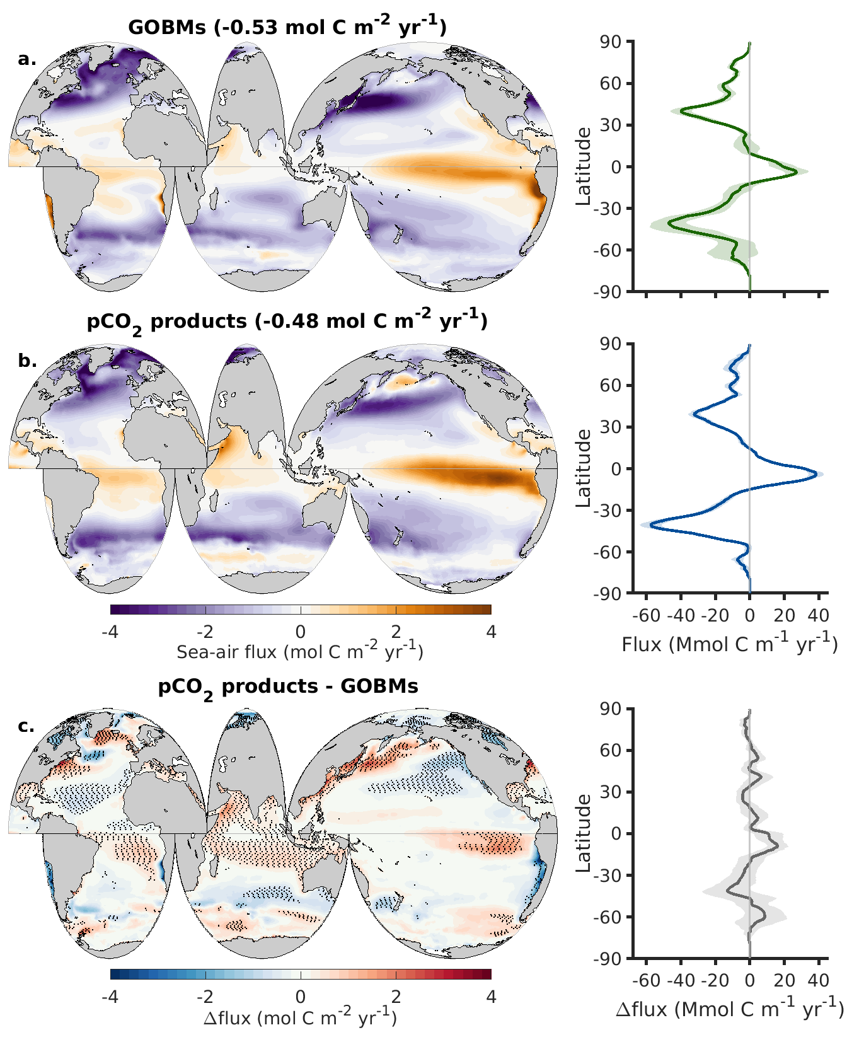

**Figure S1:** Like Figure 1 but for the period 2005-2015.

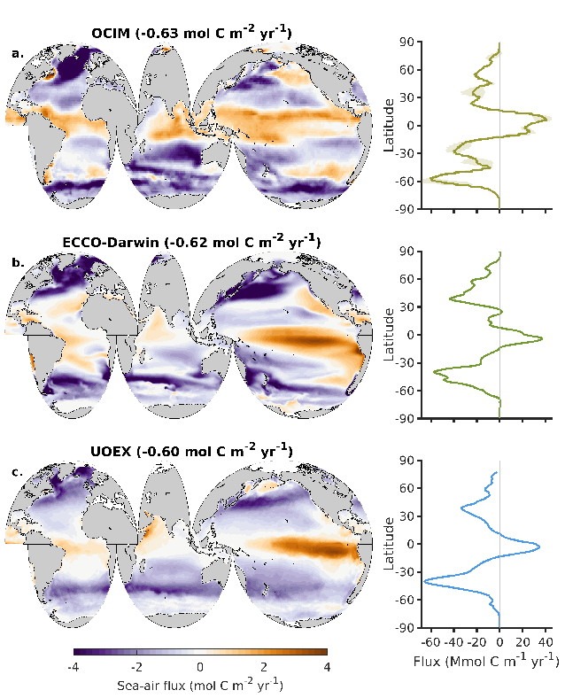

**Figure S2:** Like Figure S1a-b but for the (a) OCIM, (b) ECCO-Darwin, and (c) UOEX products sea-air CO2 flux for the 2005-2015 period.

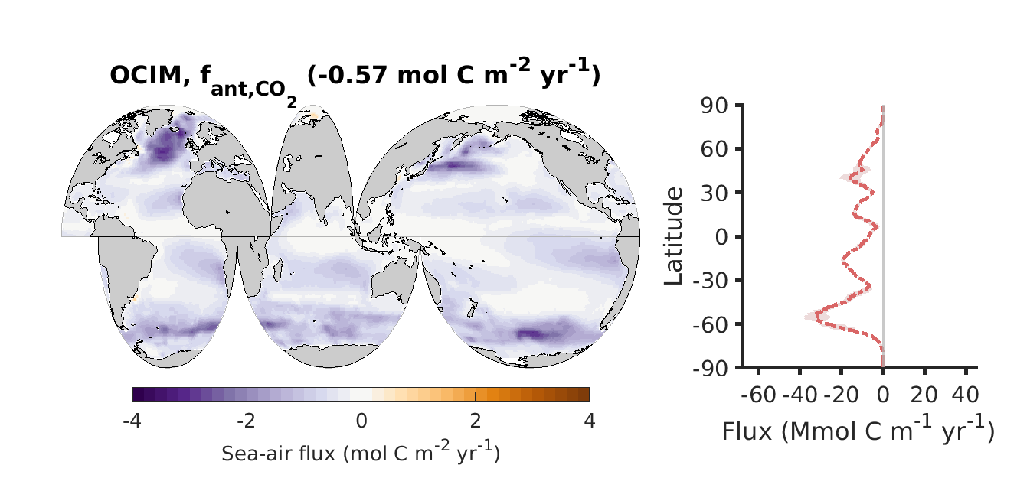

**Figure S3:** Sea-air anthropogenic CO2 fluxes from the OCIM averaged over 1985-2018. Compare with GOBMs in Figure 3b.

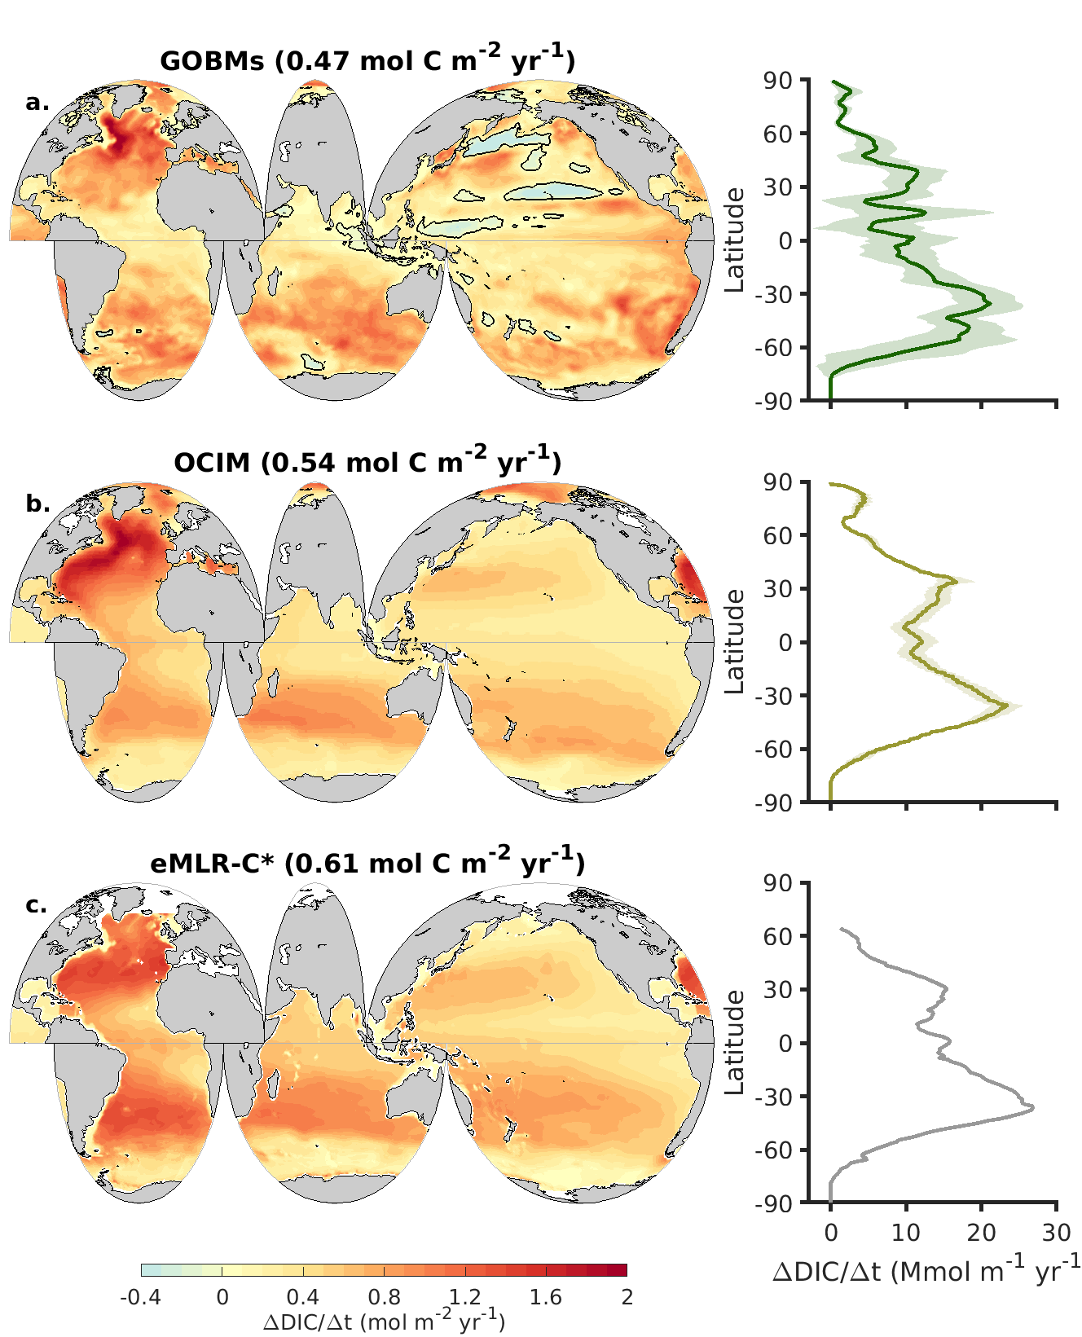

**Figure S4:** Like Figure 5 but for the period 1994-2007.

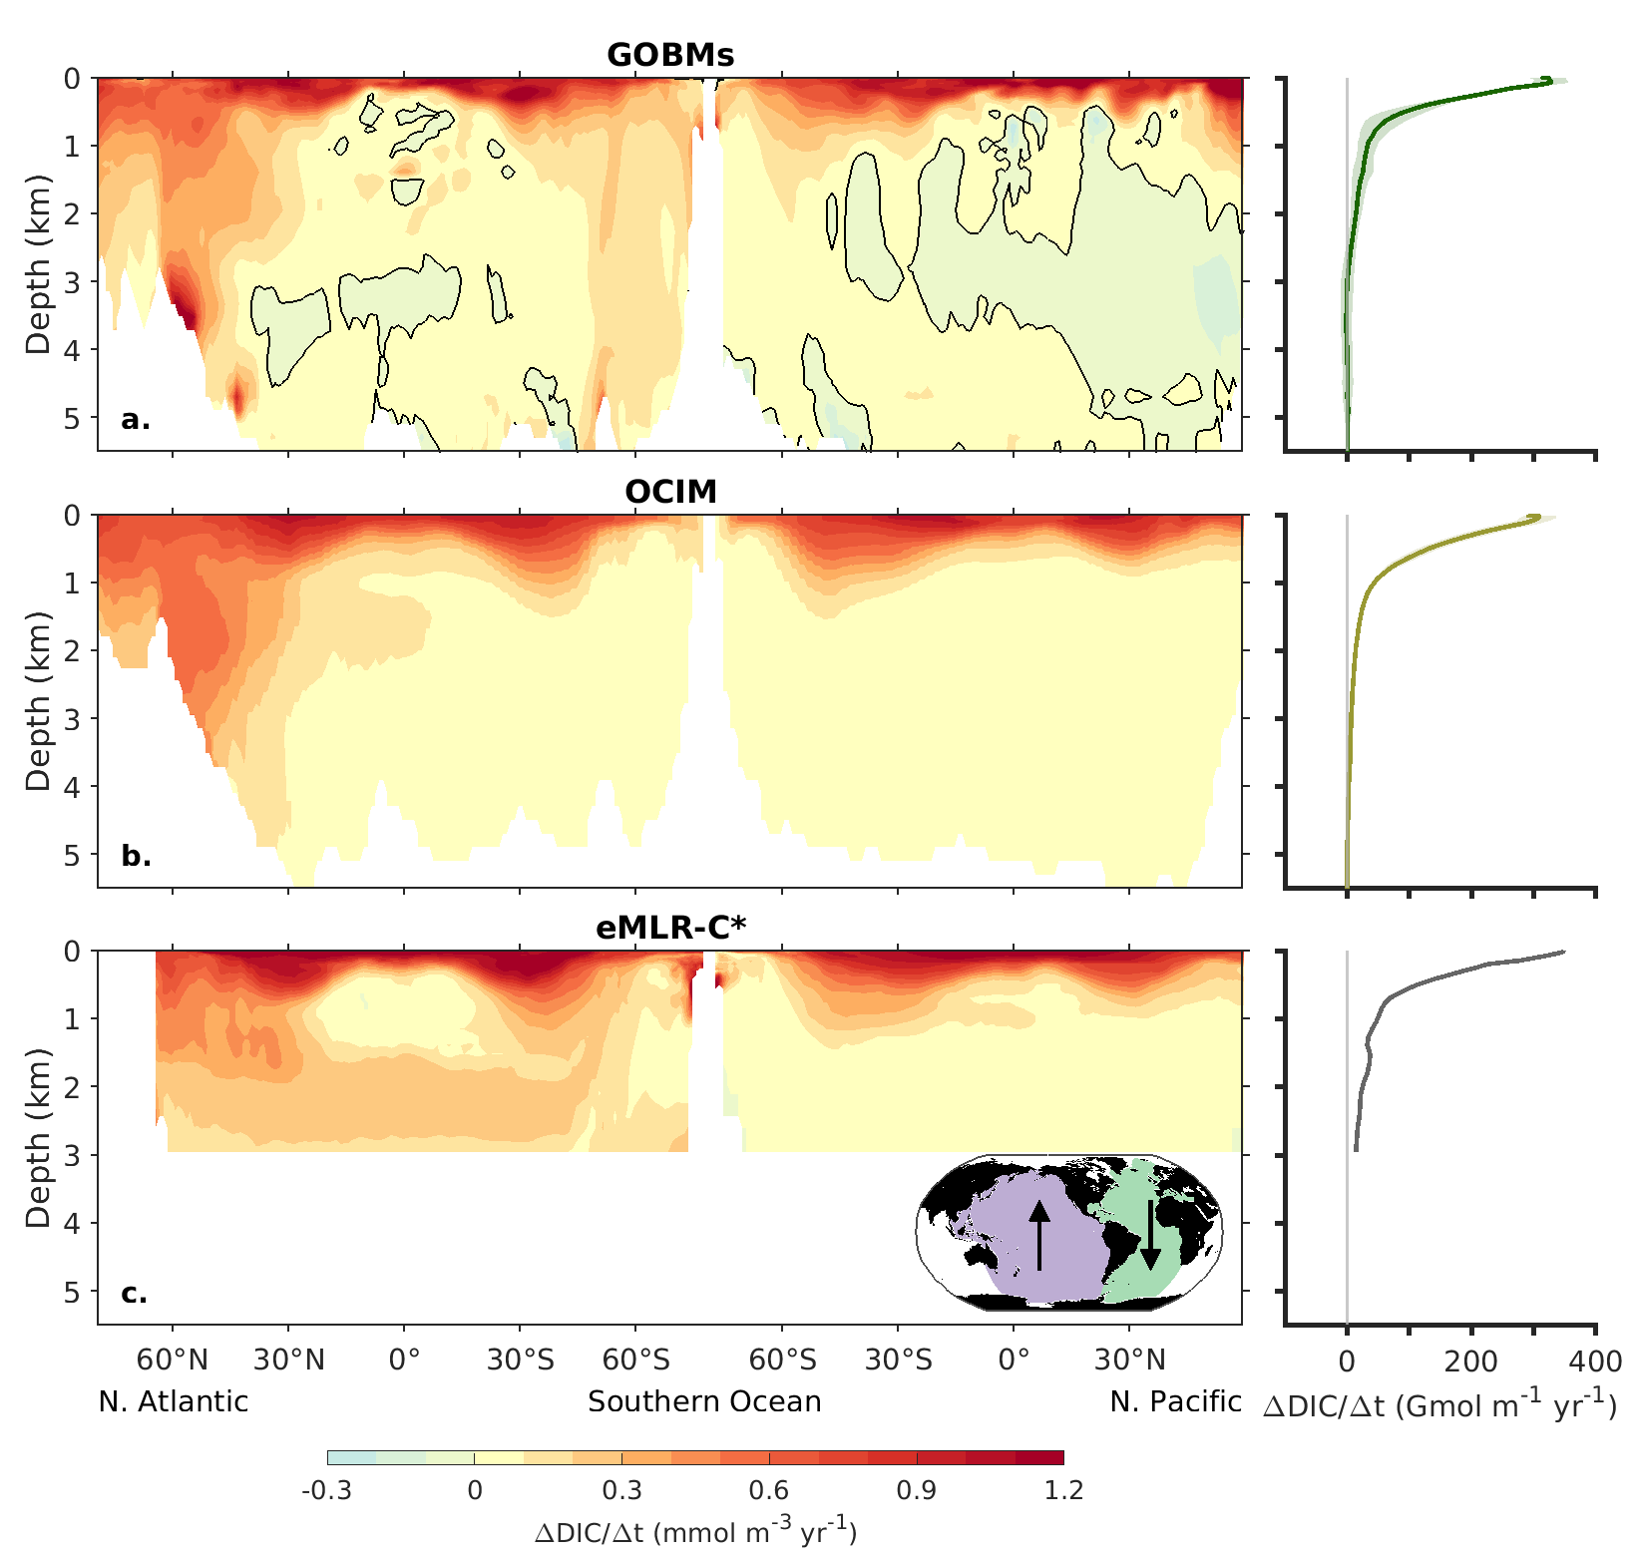

**Figure S5:** Like Figure 6 but for the period 1994-2007.

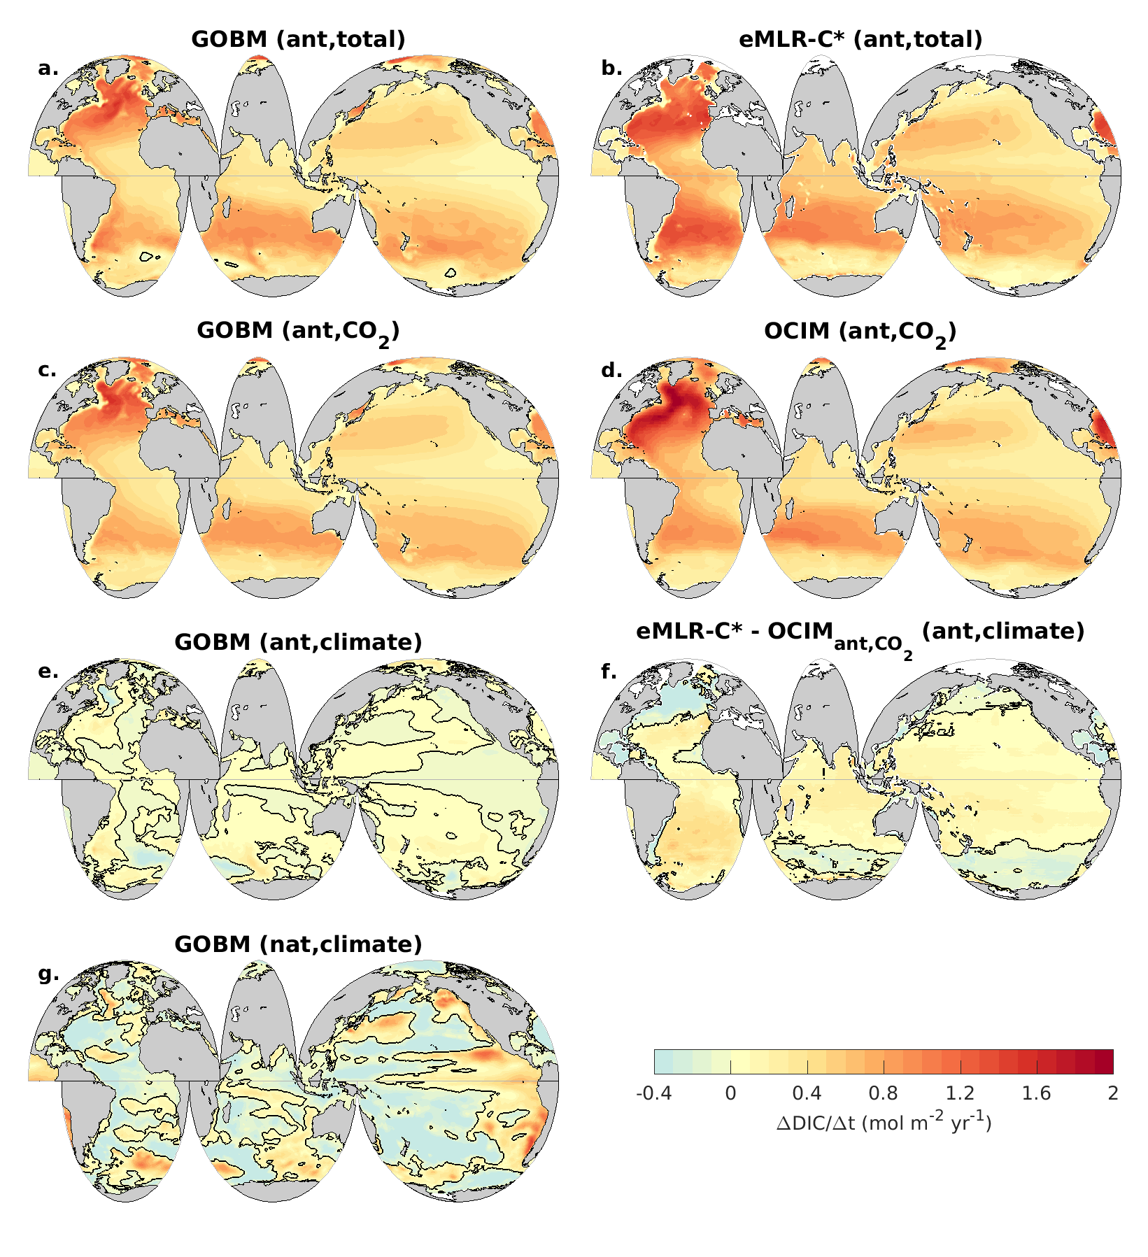

**Figure S6:** Like Figure 7 but for the period 1994-2007.