## Supplementary Material

### Supplementary Figures

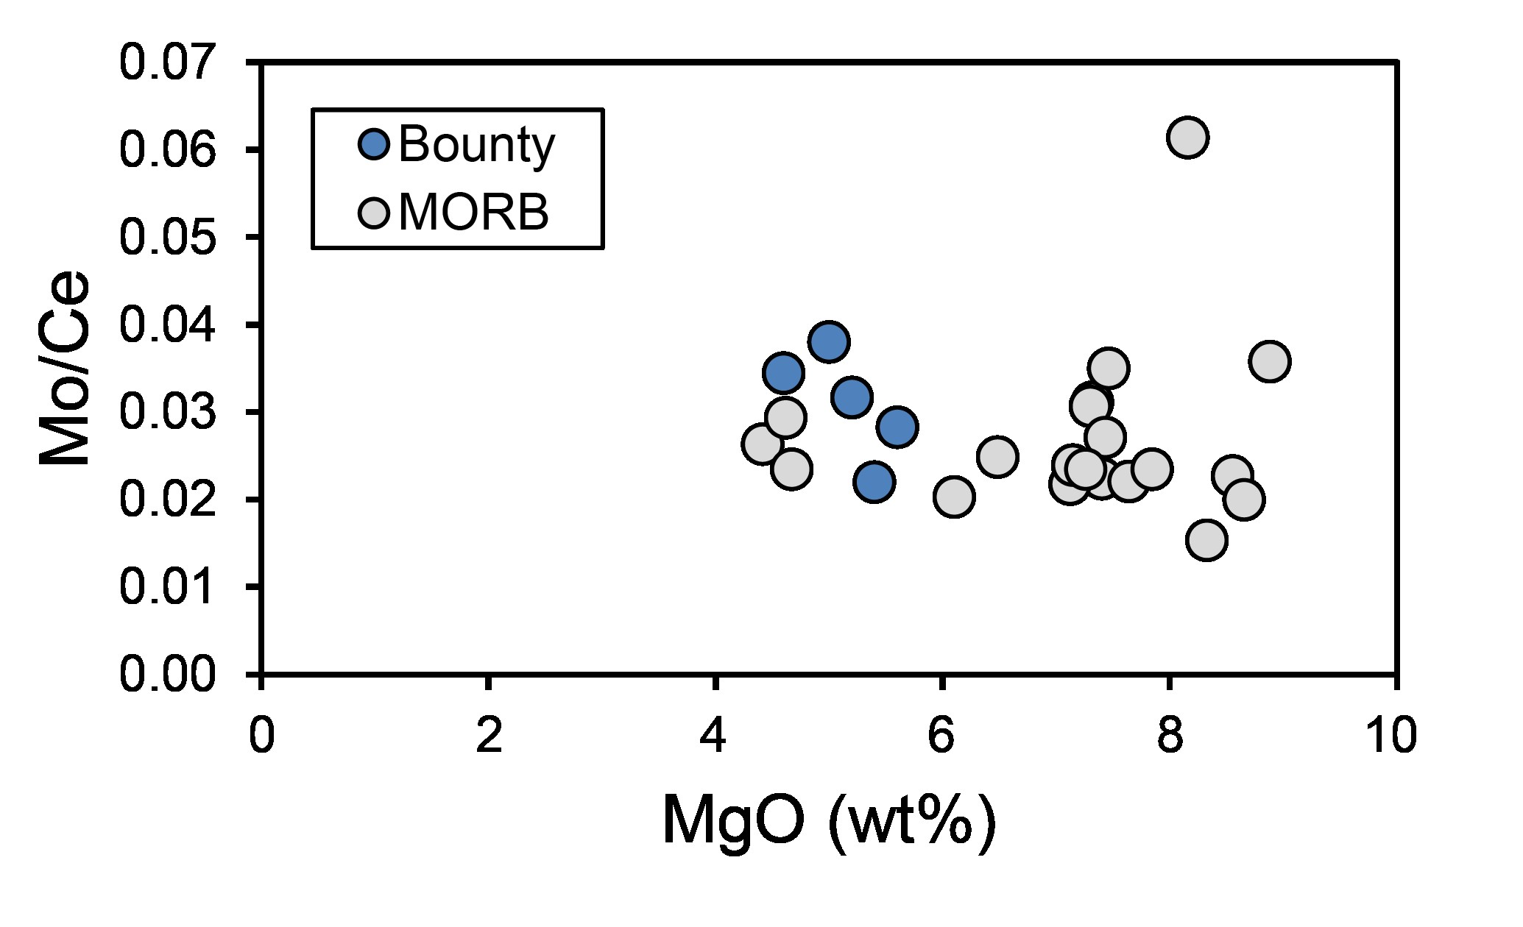

**Figure S-1.** Plot of Mo/Ce vs. MgO. As Mo and Ce are similarly compatible during mantle melting (Wang and Becker, 2018), the vague trend with MgO might (oceanic) crustal assimilation. However, low Cl/K and overall homogeneous δ98/95Mo argue against a control on the Mo isotope composition. MORB data is from Bezard et al. (2016).

### Individual data

**Table S-1.** Average and individual Mo isotope data of analyzed Pitcairn Island lavas. Individual measurements are from the same chromatographic aliquot. *Internal precision on a sample run (over 80 cycles) is reported as 2 standard error (2 SE).

|  |  |  |  |  |  |
| --- | --- | --- | --- | --- | --- |
|  | Individual measurements | | Mean values | |  |
| **Sample** | **δ98/95Mo (‰)** | **2 SE* (‰)** | **δ98/95Mo (‰)** | **2 SD (‰)** | **Mo (µg/g)** |
| ***Pitcairn island basalts*** |  |  |  |  |  |
| pn03-08 | −0.133 | 0.013 | −0.119 | 0.039 | 2.93 |
| −0.097 | 0.016 |
| −0.127 | 0.014 |
| pn03-10 | −0.125 | 0.015 | −0.115 | 0.030 | 1.38 |
| −0.104 | 0.014 |
| pn03-01 | −0.082 | 0.014 | −0.121 | 0.067 | 2.47 |
| −0.133 | 0.015 |
| −0.146 | 0.016 |
| pn03-02 | −0.119 | 0.016 | −0.121 | 0.006 | 1.26 |
| −0.123 | 0.013 |
| pn03-03 | −0.117 | 0.016 | −0.112 | 0.009 | 2.45 |
| −0.108 | 0.015 |
| −0.111 | 0.016 |
| pn03-05 | −0.120 | 0.012 | −0.113 | 0.026 | 2.23 |
| −0.098 | 0.017 |
| −0.120 | 0.012 |
| pn03-07 | −0.113 | 0.014 | −0.111 | 0.007 | 1.53 |
| −0.108 | 0.017 |
| pn03-11 | −0.115 | 0.016 | −0.111 | 0.022 | 2.41 |
| −0.119 | 0.014 |
| −0.098 | 0.014 |
| pn14-14 | −0.090 | 0.018 | −0.093 | 0.013 | 4.22 |
| −0.101 | 0.016 |
| −0.090 | 0.019 |
| pn08-07 | −0.077 | 0.017 | −0.097 | 0.039 | 4.40 |
| −0.117 | 0.015 |
| −0.098 | 0.018 |
| ***Rock reference materials*** |  |  |  |  |  |
| BHVO-2 | −0.090 | 0.015 | −0.077 | 0.025 | 3.59 |
| −0.066 | 0.014 |
| −0.076 | 0.017 |
| AGV-2 | −0.187 | 0.015 | −0.175 | 0.037 | 2.00 |
| −0.154 | 0.016 |
| −0.185 | 0.016 |

### Misfit model

Due to the enriched radiogenic isotope composition of the model 1.5 Ga recycled sediment (Table S-2), different combinations of [Mo] and δ98/95Mo in the model sediment can lead to a best fit (i.e. different mixing lines/hyperbolas). Therefore, we applied a misfit algorithm to model potential sediment end members similar to Ahmad et al. (2022). In the misfit plot (Fig. 4), the best agreement between potential sediment end members and measured samples is given by the least squares error (blue field) of the misfit function. The white dashed line indicates the sample amount multiplied by the external 2 SD reproducibility to obtain a conservative upper limit for model compositions. The white solid line indicates the contour line of the least squares error (see minimum Δ98/95Mo in Fig. 4a, b) with added Δ98/95Mo ≈ 0.1 ‰. Because many hypothetical sediment end members in the blue field can potentially cause the heavy Mo enrichment in the mantle plume, the compositions of OM-rich sediments sorted by age intervals (Ye et al., 2021; Table S-2), UCC (Voegelin et al., 2014; Greber et al., 2014; Rudnick and Gao, 2014; Freymuth et al., 2015; Willbold and Elliott, 2017; Yang et al., 2017; Greaney et al., 2020), MORB (Gale et al., 2013; Bezard et al., 2016; Chen et al., 2022), pelagic Mn-rich and clastic metasediments (Ahmad et al., 2021), and blueschists and MORB-type eclogites (Chen et al., 2019; Ahmad et al., 2021) are plotted for comparison, (Fig. 4). This allows a simpler visualization and differentiation of potential contaminants in the mantle source.

**Table S-2.** Parameters from the two-component mixing model (Fig. 4) and compositions of marine sediments. The misfit calculation is conducted based on Mo-Sr systematics and a model 1.5 Ga old recycled pelagic sediment.

|  |  |  |  |  |  |  |
| --- | --- | --- | --- | --- | --- | --- |
|  | δ98/95Mo (‰) | [Mo] (µg/g) | 87Sr/86Sr | Sr (µg/g) | 143Nd/144Nd | Nd (µg/g) |
| ***End members*** |  |  |  |  |  |  |
| Ambient depleted mantleA | −0.204 ± 0.008 | 0.025 ± 0.007 | 0.702819 | 11.32 | 0.51312 | 1.118 |
| 1.5 Ga old recycled pelagic sedimentB |  |  | 0.7203 | 300 ± 17 | 0.5117 | 85 ± 5.2 |
| Upper continental crustC | 0.05 to 0.15 | 1.1 ± 0.2 |  |  |  |  |
|  |  |  |  |  |  |  |
| ***Marine sediments*D** |  |  |  |  |  |  |
| Archean | 0.218 ± 0.150 | $${4.70}_{-3.75}^{+18.4}$$ |  |  |  |  |
| (*M* = 19, *N* = 417) | (*M* = 19, *N* = 744) |  |  |  |  |
| Proterozoic | 0.244 ± 0.114 | $${4.10}_{-3.30}^{+17.0}$$ |  |  |  |  |
| (*M* = 51, *N* = 696) | (*M* = 53, *N* = 1262) |  |  |  |  |
| Phanerozoic | 0.528 ± 0.132 | $${22.9}_{-15.7}^{+49.7}$$ |  |  |  |  |
| (*M* = 48, *N* = 882) | (*M* = 48, *N* = 1154) |  |  |  |  |

A Ambient depleted mantle values from Salters and Stracke (2004), Delavault et al. (2016), and McCoy-West et al. (2019)

B 1.5 Ga recycled pelagic sediment values from Ahmad et al. (2022) and references therein.

C Upper continental crust values are from Voegelin et al. (2014), Greber et al. (2014), Rudnick and Gao (2014), Freymuth et al. (2015), Willbold and Elliott (2017), Yang et al. (2017) and Greaney et al. (2020).

D Marine sediment values of different eons are averages of log-normal means of individual sediments sorted by age intervals (>1 Myr) from the literature (see compilation of Ye et al., 2021). M = number of individual sediment formations from one age interval within an eon; N = number of individual sediment samples.

### Supplementary Information References

Ahmad, Q., Wille, M., König, S., Rosca, C., Hensel, A., Pettke, T., and Hermann, J., 2021, The molybdenum isotope subduction recycling conundrum: A case study from the Tongan subduction zone, Western Alps and Alpine Corsica: Chemical Geology, v. 576, p. 120231, https://doi.org/10.1016/J.CHEMGEO.2021.120231.

Ahmad, Q., Wille, M., Rosca, C., Labidi, J., Schmid, T., Mezger, K., and König, S., 2022, Molybdenum isotopes in plume-influenced MORBs reveal recycling of ancient anoxic sediments: Geochemical Perspectives Letters, v. 23, p. 43–48, https://doi.org/10.7185/GEOCHEMLET.2236.

Bezard, R., Fischer-Gödde, M., Hamelin, C., Brennecka, G.A., and Kleine, T., 2016, The effects of magmatic processes and crustal recycling on the molybdenum stable isotopic composition of Mid-Ocean Ridge Basalts: Earth and Planetary Science Letters, v. 453, p. 171–181, https://doi.org/10.1016/j.epsl.2016.07.056.

Burkhardt, C., Hin, R.C., Kleine, T., and Bourdon, B., 2014, Evidence for Mo isotope fractionation in the solar nebula and during planetary differentiation: Earth and Planetary Science Letters, v. 391, p. 201–211, https://doi.org/10.1016/j.epsl.2014.01.037.

Chen, S., Hin, R.C., John, T., Brooker, R., Bryan, B., Niu, Y., and Elliott, T., 2019, Molybdenum systematics of subducted crust record reactive fluid flow from underlying slab serpentine dehydration: Nature Communications, v. 10, https://doi.org/10.1038/s41467-019-12696-3.

Chen, S., Sun, P., Niu, Y., Guo, P., Elliott, T., and Hin, R.C., 2022, Molybdenum isotope systematics of lavas from the East Pacific Rise: Constraints on the source of enriched mid-ocean ridge basalt: Earth and Planetary Science Letters, v. 578, p. 117283, https://doi.org/10.1016/J.EPSL.2021.117283.

Delavault, H., Chauvel, C., Thomassot, E., Devey, C.W., and Dazas, B., 2016, Sulfur and lead isotopic evidence of relic Archean sediments in the Pitcairn mantle plume: Proceedings of the National Academy of Sciences of the United States of America, v. 113, p. 12952–12956, https://doi.org/10.1073/pnas.1523805113.

Freymuth, H., Vils, F., Willbold, M., Taylor, R.N., and Elliott, T., 2015, Molybdenum mobility and isotopic fractionation during subduction at the Mariana arc: Earth and Planetary Science Letters, v. 432, p. 176–186, https://doi.org/10.1016/j.epsl.2015.10.006.

Gale, A., Dalton, C.A., Langmuir, C.H., Su, Y., and Schilling, J.G., 2013, The mean composition of ocean ridge basalts: Geochemistry, Geophysics, Geosystems, v. 14, p. 489–518, https://doi.org/10.1029/2012GC004334.

Greaney, A.T., Rudnick, R.L., Romaniello, S.J., Johnson, A.C., Gaschnig, R.M., and Anbar, A.D., 2020, Molybdenum isotope fractionation in glacial diamictites tracks the onset of oxidative weathering of the continental crust: Earth and Planetary Science Letters, v. 534, p. 116083, https://doi.org/10.1016/J.EPSL.2020.116083.

Greber, N.D., Pettke, T., and Nägler, T.F., 2014, Magmatic–hydrothermal molybdenum isotope fractionation and its relevance to the igneous crustal signature: Lithos, v. 190–191, p. 104–110, https://doi.org/10.1016/J.LITHOS.2013.11.006.

McCoy-West, A.J., Chowdhury, P., Burton, K.W., Sossi, P., Nowell, G.M., Fitton, J.G., Kerr, A.C., Cawood, P.A., and Williams, H.M., 2019, Extensive crustal extraction in Earth’s early history inferred from molybdenum isotopes: Nature Geoscience, v. 12, p. 946–951, https://doi.org/10.1038/s41561-019-0451-2.

Rudnick, R.L., and Gao, S., 2014, Composition of the Continental Crust, in Treatise on Geochemistry: Second Edition, Elsevier Inc., v. 4, p. 1–51, https://doi.org/10.1016/B978-0-08-095975-7.00301-6.

Salters, V.J.M., and Stracke, A., 2004, Composition of the depleted mantle: Geochemistry, Geophysics, Geosystems, v. 5, Q05B07, https://doi.org/10.1029/2003GC000597.

Voegelin, A.R., Pettke, T., Greber, N.D., von Niederhäusern, B., and Nägler, T.F., 2014, Magma differentiation fractionates Mo isotope ratios: Evidence from the Kos Plateau Tuff (Aegean Arc): Lithos, v. 190–191, p. 440–448, https://doi.org/10.1016/j.lithos.2013.12.016.

Wang, Z., Becker, H., 2018. Molybdenum partitioning behavior and content in the depleted mantle: Insights from Balmuccia and Baldissero mantle tectonites (Ivrea Zone, Italian Alps). Chemical Geology v. 499, p. 138–150. https://doi.org/10.1016/j.chemgeo.2018.09.023.

Willbold, M., and Elliott, T., 2017, Molybdenum isotope variations in magmatic rocks: Chemical Geology, v. 449, p. 253–268, https://doi.org/10.1016/j.chemgeo.2016.12.011.

Yang, J., Barling, J., Siebert, C., Fietzke, J., Stephens, E., and Halliday, A.N., 2017, The molybdenum isotopic compositions of I-, S- and A-type granitic suites: Geochimica et Cosmochimica Acta, v. 205, p. 168–186, https://doi.org/10.1016/j.gca.2017.01.027.

Ye, Y., Zhang, S., Wang, H., Wang, X., Tan, C., Li, M., Wu, C., and Canfield, D.E., 2021, Black shale Mo isotope record reveals dynamic ocean redox during the Mesoproterozoic Era: Geochemical Perspectives Letters, v. 18, p. 16–21, https://doi.org/10.7185/GEOCHEMLET.2118.

Yierpan, A., König, S., Labidi, J., and Schoenberg, R., 2020, Recycled selenium in hot spot–influenced lavas records ocean-atmosphere oxygenation: Science Advances, v. 6, p. eabb6179, https://doi.org/10.1126/SCIADV.ABB6179.