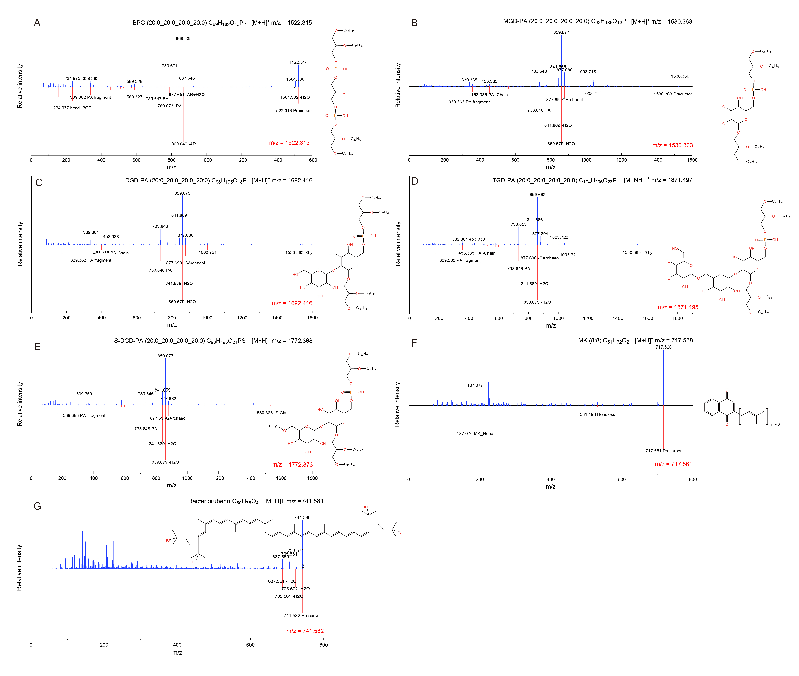Figure S1 Mass spectra of annotated non-diether lipids and the corresponding spectra in the library. In each figure (A to H), the upper spectrum presents the MS² detected from samples analyzed in this study and the lower one refers to the corresponding MS² in the library. Precursor mass and adduct type are shown in the upper right corner of the figure. The m/z value in red color is the precursor mass in the library.

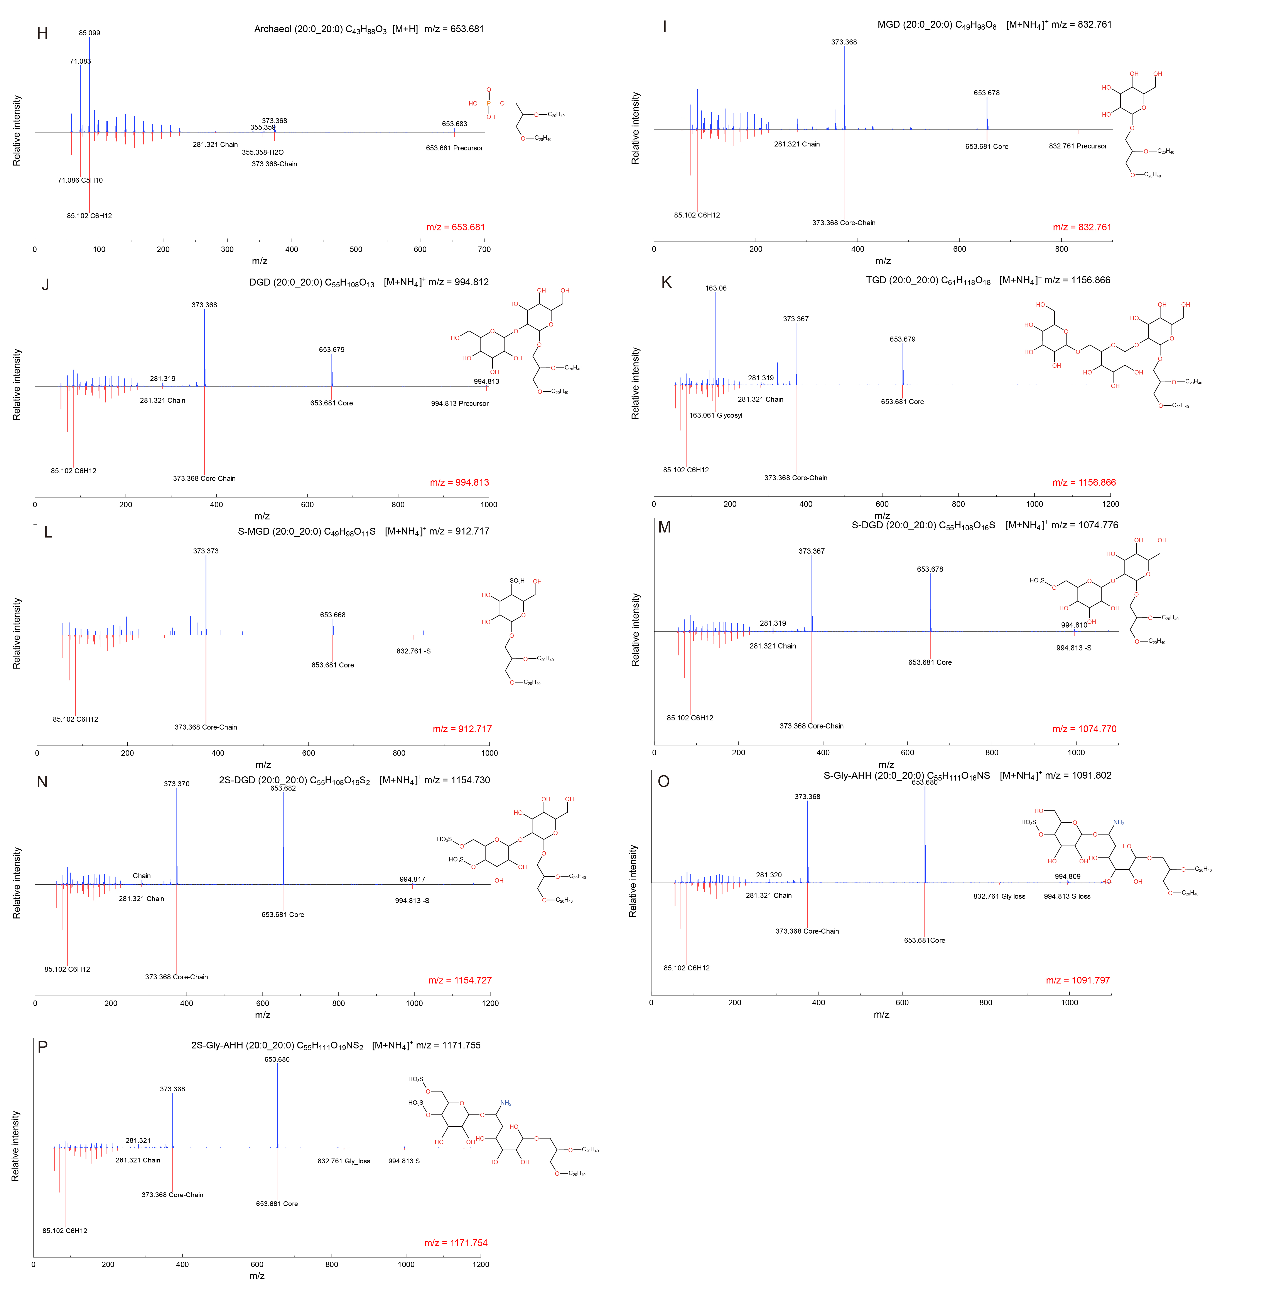Figure S2 Mass spectra of annotated archaeol and glycolipids, and the corresponding spectra in the library. In each figure (I-Q), the upper spectrum presents the MS² detected from samples analyzed in this study and the lower one refers to the corresponding MS² in the library. Precursor mass and adduct type are shown in the upper right corner of the figure. The m/z value in red color is the precursor mass in the library.

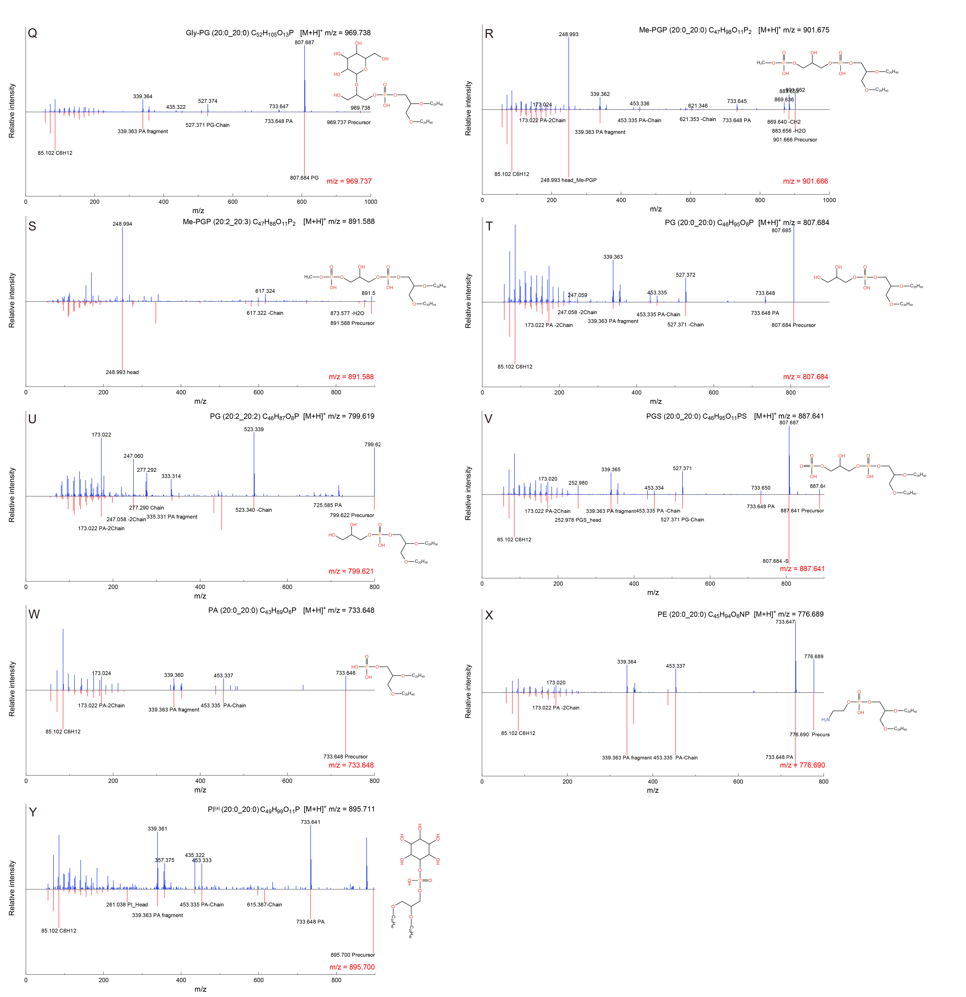
Figure S3 Mass spectrum of annotated phospholipids and the corresponding spectrum in the library. In each figure (R-Z), the upper spectrum presents the MS² detected from samples analyzed in this study and the lower one refers to the corresponding MS² in the library. Precursor mass and adduct type are shown in the upper right corner of the figure. The m/z value in red color is the precursor mass in the library.

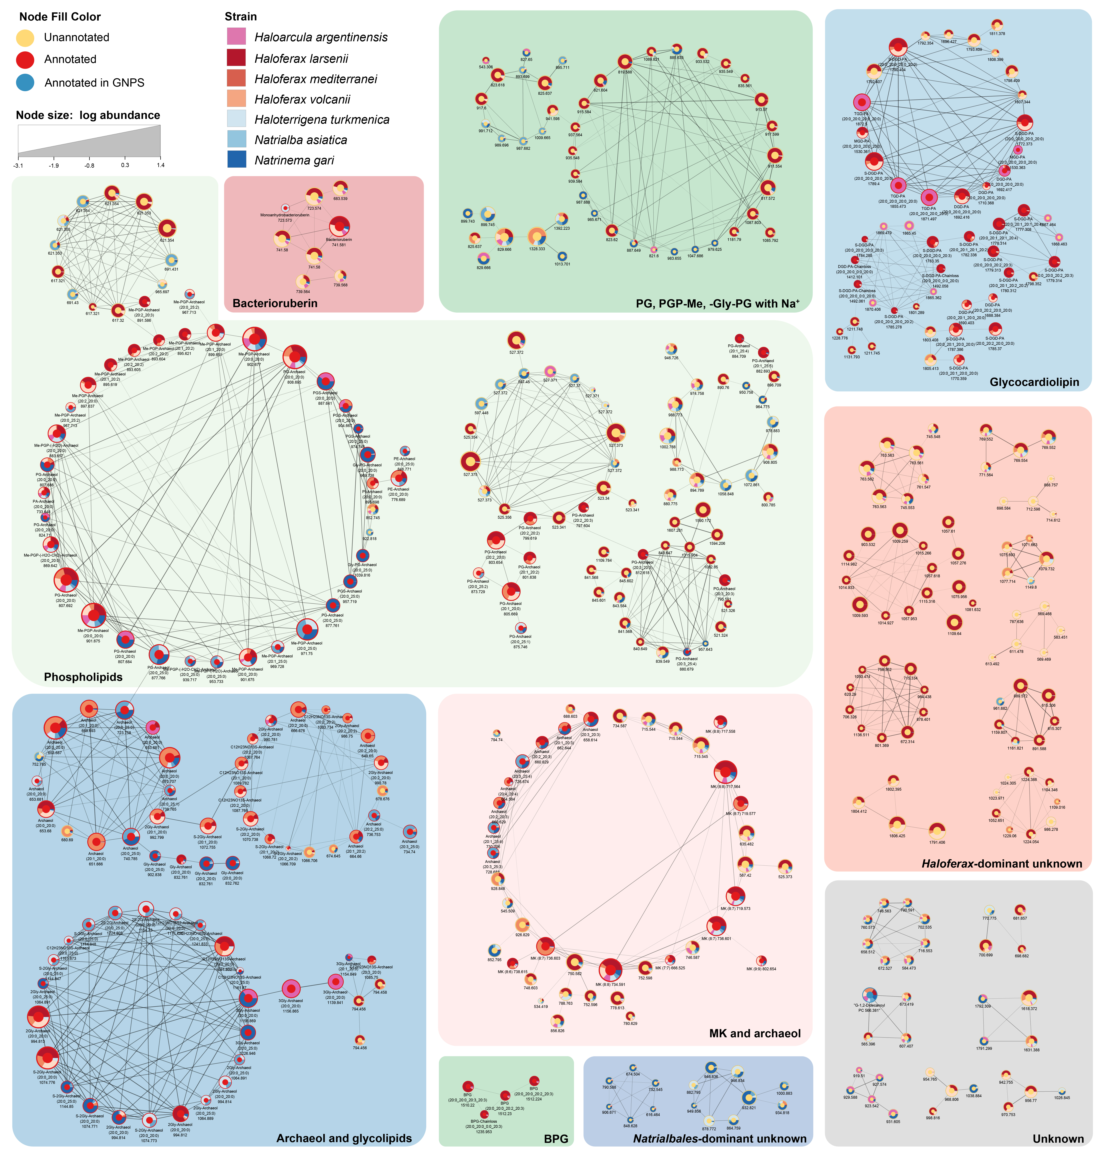Figure S4 Feature-based molecular network of Halobacteria. The sub-networks are annotated based on the composition of the nodes and their occurrence in different strains. Edge thickness and opacity in the network represent the cosine score. Features with m/z < 500 and networks containing less than 4 nodes are filtered. In total, 444 features are involved in the networks. The annotated features are marked with a red core, while the unidentified lipids are with a yellow core.

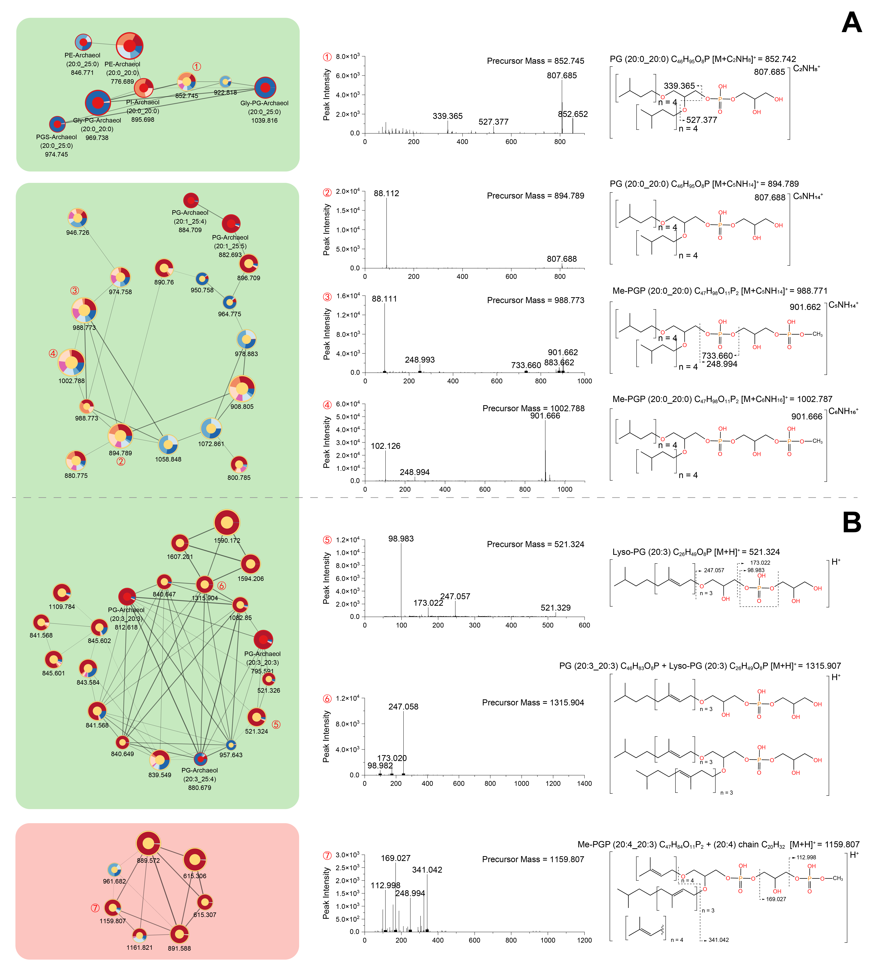Figure S5 Network of the special form of PG and Me-PGP. A: Adduct forms of (CH₂)_{n}NH³⁺; B: Loss or addition of an unsaturated chain.

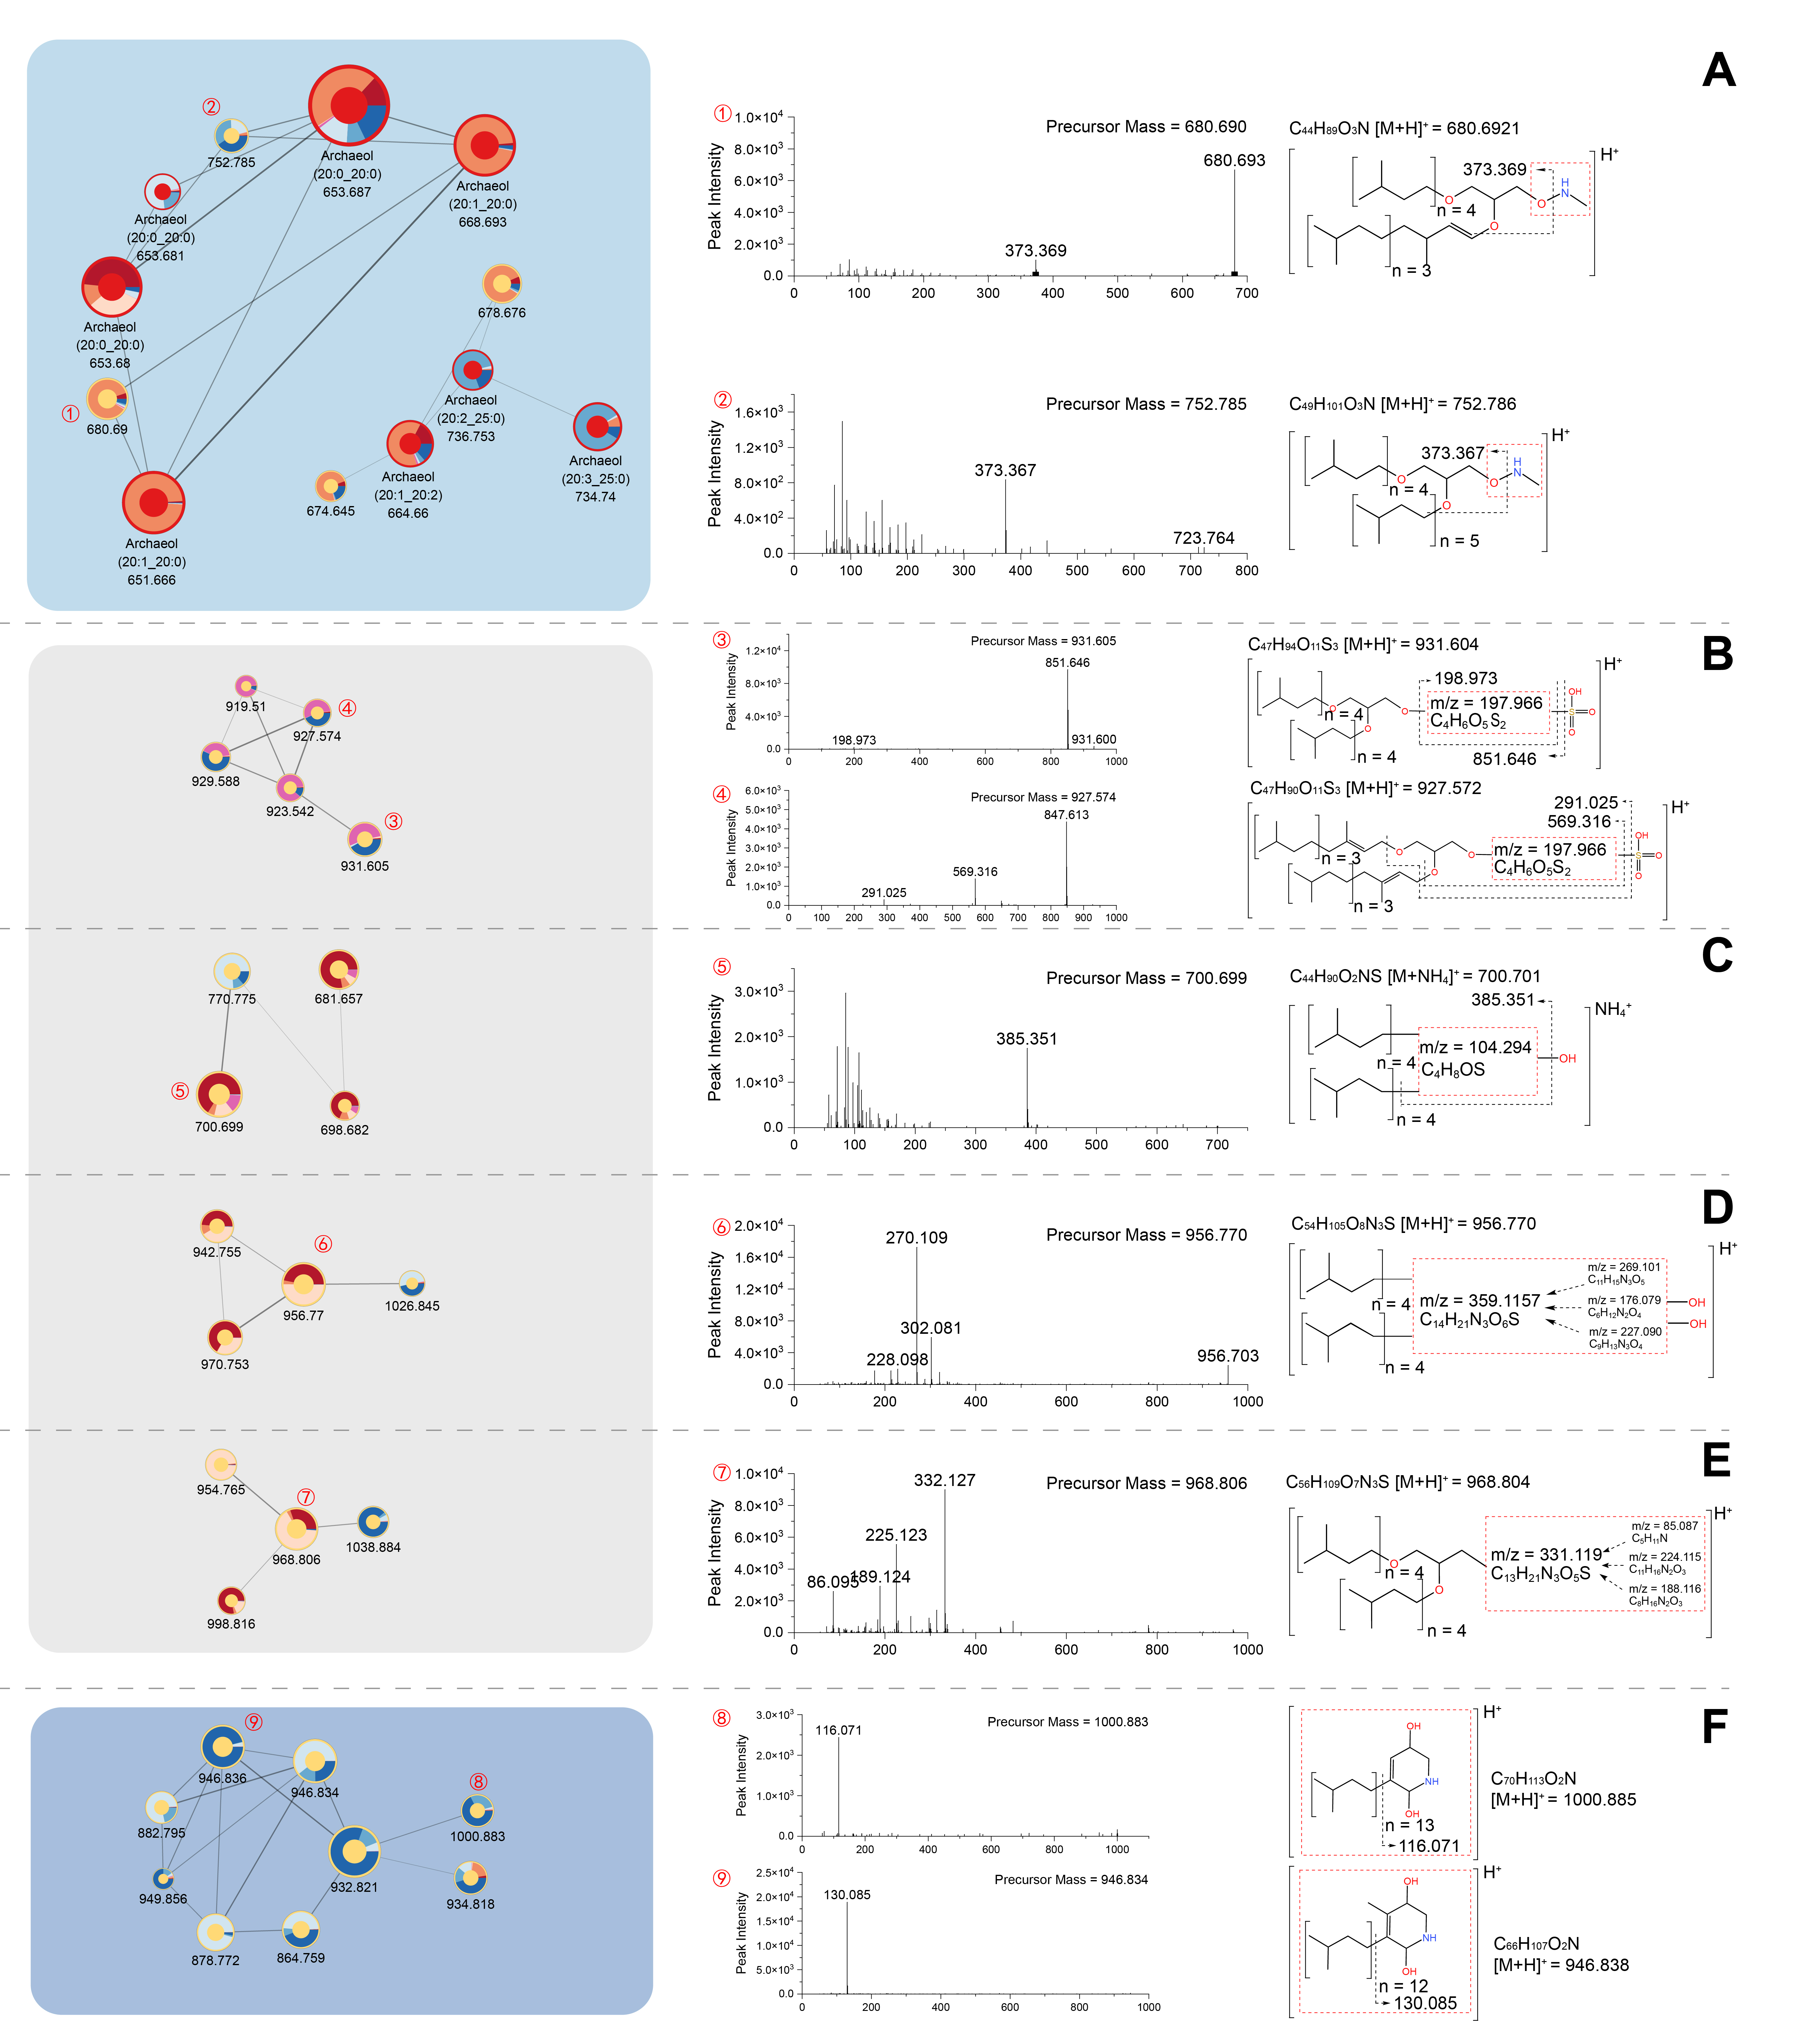Figure S6 Network of the unknown structure containing valuable features. The molecular formula of the unknown structure is predicted in SIRUS. A ‒ E: diether-like network; F: quinone-like network.

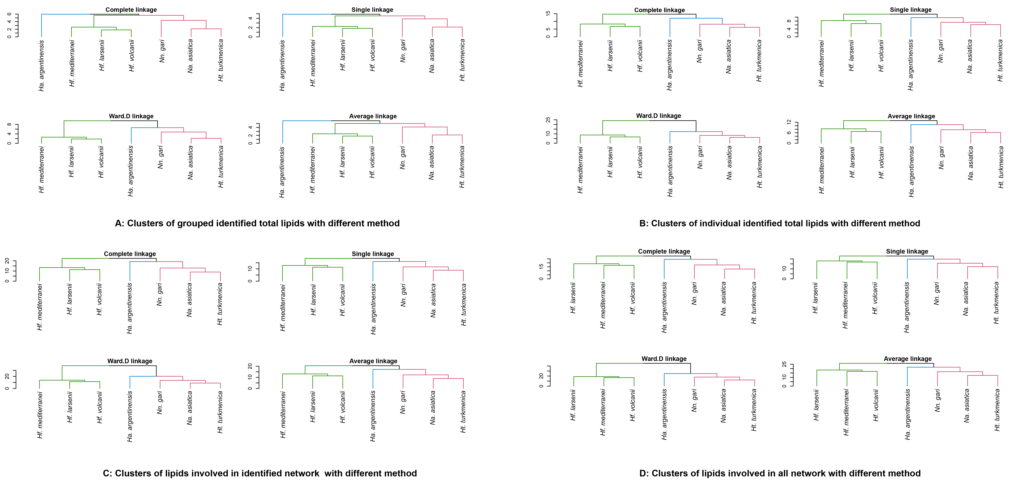Figure S7 Cluster analysis with 4 different methods including complete linkage; single linkage; Ward. D linkage; average linkage. A: Clusters of grouped identified total lipids; B: Clusters of identical identified total lipids; C: Clusters of lipids in identified network; D: Clusters of lipids involved in all networks.

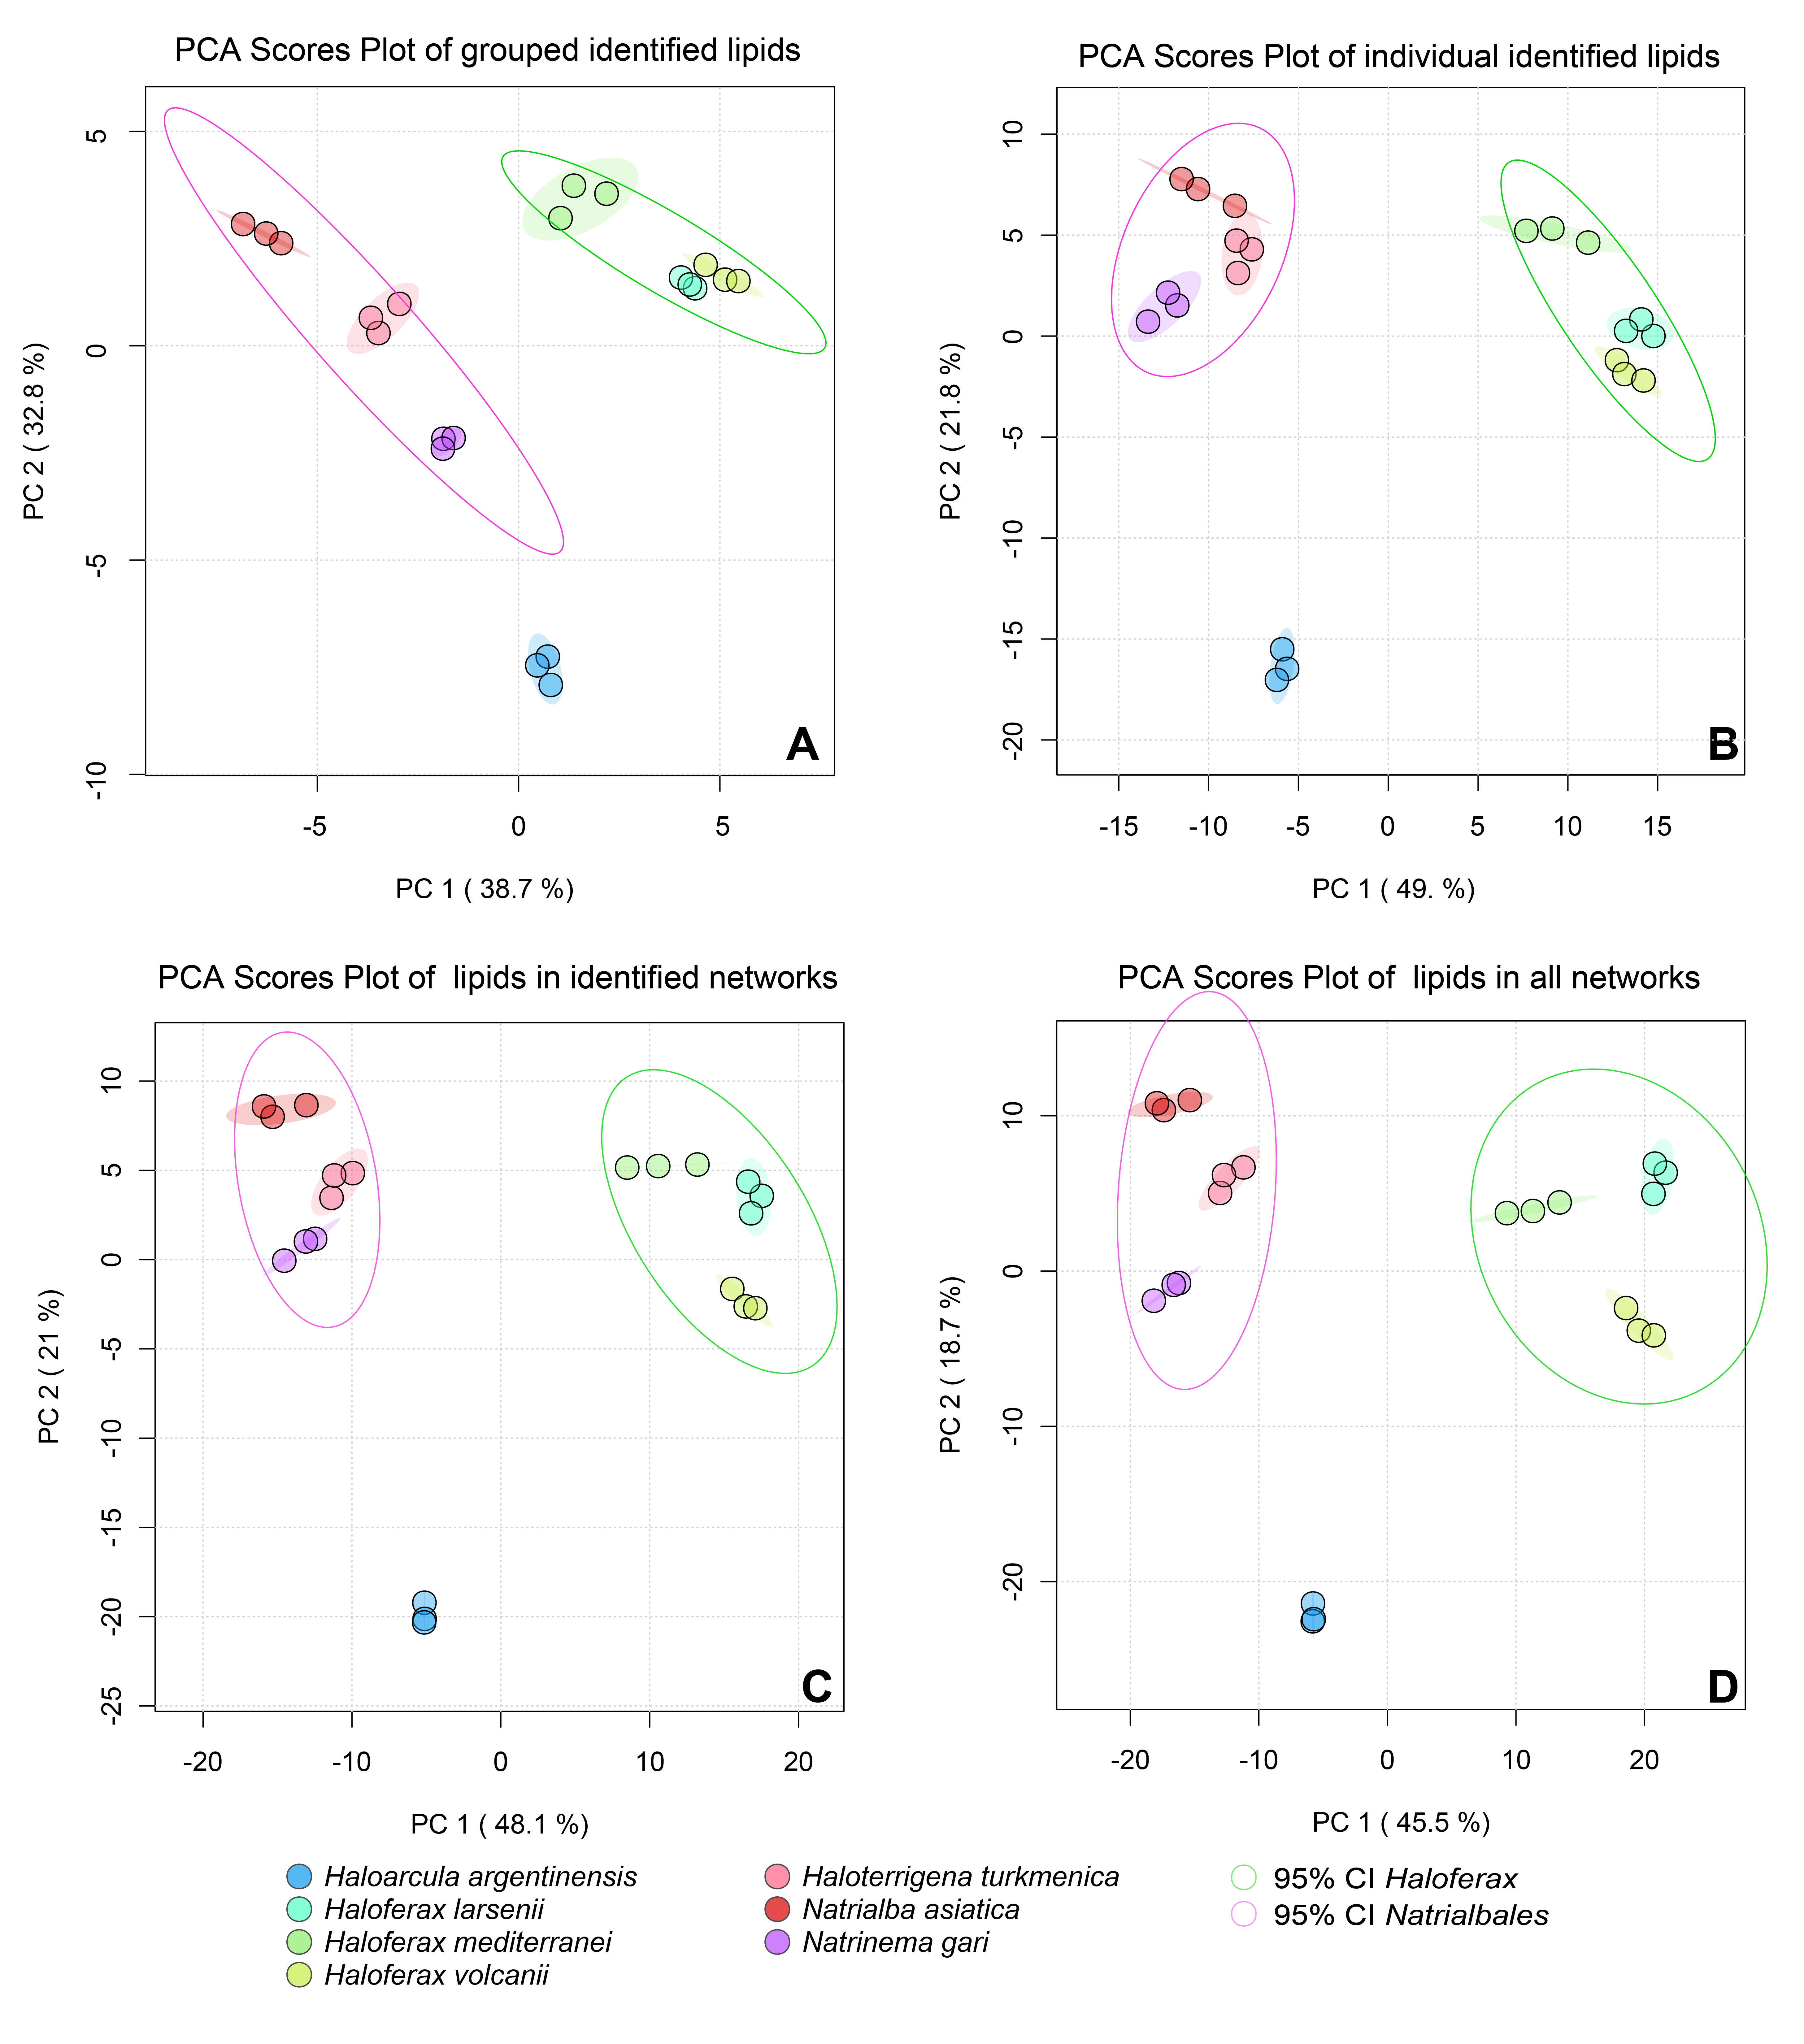Figure S8 PCA score plot of strains using A) grouped annotated lipids, B) individual annotated lipids, C) lipids involved in identical networks, and D) lipids in all networks. Areas indicating 95% confidence interval (CI) for each strain or strain group are shown in solid sphere and empty sphere respectively.

Figure S9 PLS-DA plot of strains using A) grouped annotated lipids, C) individual annotated lipids, E) features involved in identified networks, and F) features in all networks. Areas indicating 95% confidence interval (CI) for strain group are shown in solid sphere. The corresponding VIP scores plot with top 15 features is shown in B, D, E and F. The dash line in B indicates VIP >1. Feature name shown in red indicate newly involved features in the analysis.

