Noble gases in groundwater reflect wet-season temperature in an arid, monsoonal and mountainous environment

Thomas Müller^{1,2}, Gerrit de Rooij³, Nico Trauth⁴, Mark Schmidt¹, Humaid Al Badi⁵ and Werner Aeschbach⁶
¹GEOMAR Helmholtz Centre for Ocean Research Kiel, RD2/Marine Geosystems.
²Helmholtz Centre for Environmental Research GmbH - UFZ, Department Hydrogeology.
³ Helmholtz Centre for Environmental Research GmbH - UFZ, Department of Soil System Science.
⁴ Björnsen Beratende Ingenieure GmbH.
⁵ Directorate General of Meteorology, Sultanate of Oman. Civial Aviation Authority.
⁶ Heidelberg University, Institute of Environmental Physics.

Corresponding author: Thomas Müller (thmueller@geomar.de)

The Supplementary Information contains the following topics:

SI-1 Groundwater level data for well 25 3
SI-2 Air temperatures 4
SI-3 Sea Surface Temperatures (SST) 6
SI-4 Soil temperature measurements 7
SI-5 Spring and Groundwater sampling 15
SI-6 Stable Isotopes northern Oman 21
SI-7 Air temperatures northern Oman 21
References 22

SI-1 Groundwater level data for well 25
Groundwater well 25 is an observation well at the foot of the Dhofar Mountains (see Table S5-1). The groundwater level was measured using HT Datalogger Type 575. The water level increases during the monsoon season (Fig. S1-1).
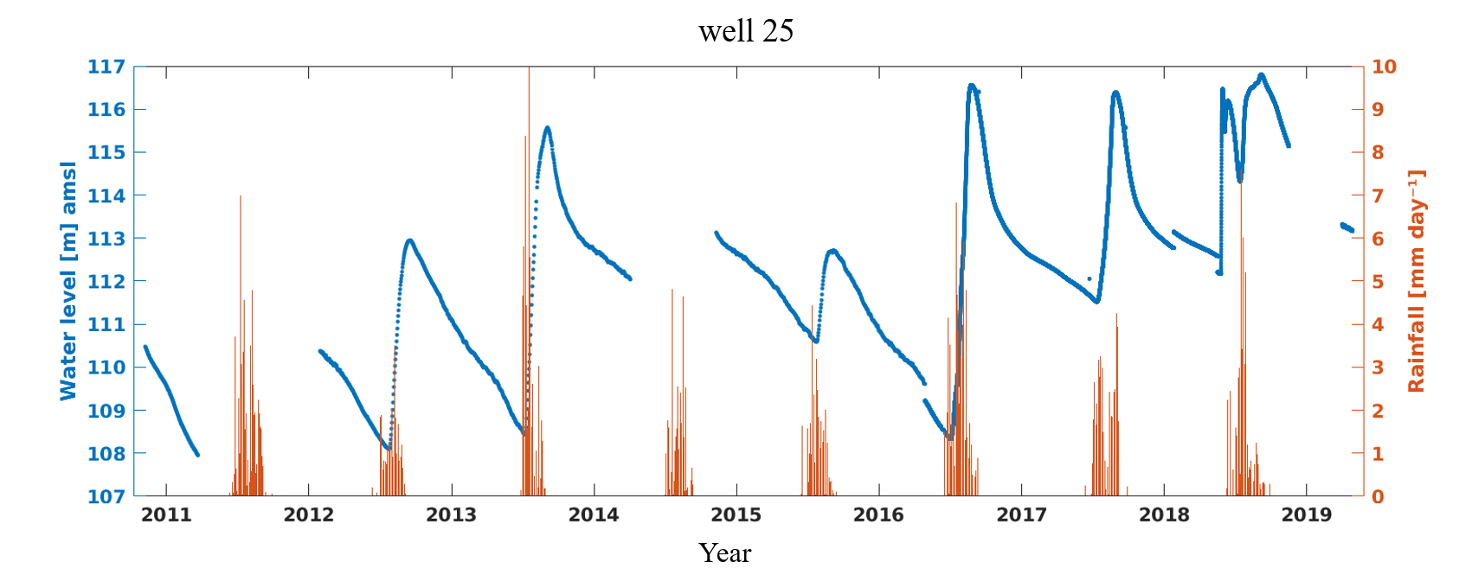
Fig. S1-1. Groundwater level data well 25

SI-2 Air temperatures
Air temperature measurements (daily) from Salalah Airport (coastal plain) and at Qaroon Hairiti
(mountain peak, same location like soil measurement site A) were provided by the Civil Aviation Authority, Directorate General of Meteorology, Sultanate of Oman. The period from 01/01/1996 to 12/31/2021 was considered since for this period data is available for both stations. At station Q. Hairiti, the MAAT for this period is 21.2°C (year 1998 and most of 2009 is missing), while for the coastal plain the MAAT is 26.5°C (missing Oct-Dec 2015). At both stations, the maximum temperature is reached in the weeks before the monsoon. The temperature minimum, on the other hand, is in winter, in the months of December to February (Fig. S2-1). Except for 2018, the MAAT in the period 2016 to 2021 (duration of soil temperature measurements) at both stations are slightly above the long-term means. For Salalah MAAT vary from 26.3°C (2018) to 27.3°C (2019), for Q. Hairiti from 21.2°C (2018) to 22.7°C (2021). During the period 01/01/1996 to 12/31/2021 the annual mean values vary between 20.5 and 22.7°C (Qaroon Hairiti) and 25.7 and 27.3 (Salalah).

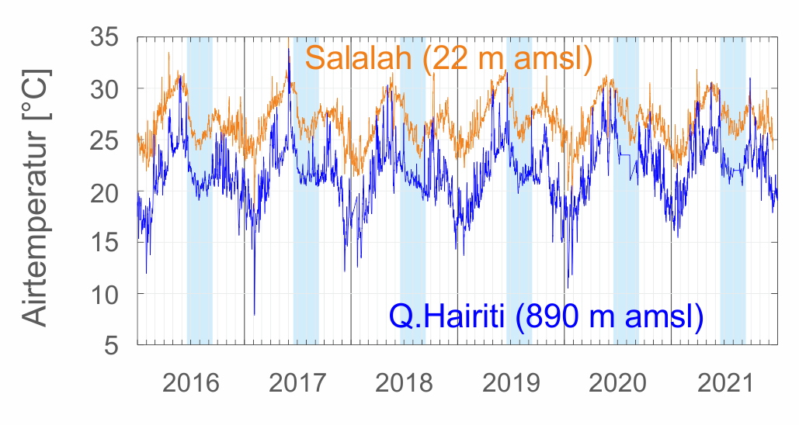
Figure S2-1. Air temperatures at station Q. Hairiti at the top of the mountain is on average 4 to 5 degrees colder than the temperatures in the coastal plain (Salalah). Maximum values at both stations are reached in the weeks before the Monsoon season, minimum values in December and January.

Calculating MAAT at different elevations in the Dhofar Mountains from the long-term observations at Salalah (22 m amsl) and Q. Hairiti (890 m amsl) results in 21.2°C (890 m), 23.6°C (500 m amsl) and 24.8°C (300m amsl), with a slope of -0.61°C per 100 m elevation.
Own air temperature measurements at the soil measurement stations were done by using the TidbiT® probes. However, some of them failed after some time or disappeared causing data gaps of air temperatures. MAAT could therefore not be determined for the soil measurement stations B to D, IPAT could only be determined for a few monsoon periods.
For all temperature data sets (air and soil measurements) the daily mean temperatures were calculated in order to obtain similar time intervals. Furthermore, the mean, median and the lower and upper quartiles are calculated on a multi-annual (depending on the data availability 2 to 6 years) monthly basis. For air temperature stations Salalah and Q. Hairiti this data can be found in Tables S2-1 and S2-2, the yearly means for the period 1996 to 2021 are given in Table S2-3.
Table S2-1. monthly air temperatures Salalah Airport (30 m amsl) for the period 2016 to 2021
Month | 1 | 2 | 3 | 4 | 5 | 6 | 7 | 8 | 9 | 10 | 11 | 12
n | 6 | 6 | 6 | 6 | 6 | 6 | 6 | 6 | 6 | 6 | 6 | 6
Mean | 23,8 | 24,3 | 26,5 | 28,8 | 30,0 | 29,6 | 26,7 | 25,7 | 27,1 | 27,2 | 26,9 | 25,4
Median | 24,0 | 24,0 | 26,0 | 29,0 | 30,0 | 29,0 | 27,0 | 26,0 | 27,0 | 27,0 | 27,0 | 26,0
Quantil 25 | 22,0 | 23,0 | 25,0 | 28,0 | 29,0 | 28,0 | 26,0 | 25,0 | 26,0 | 26,0 | 25,0 | 23,0
Quantil 75 | 26,0 | 26,0 | 28,0 | 30,0 | 31,0 | 31,0 | 28,0 | 26,0 | 28,0 | 29,0 | 29,0 | 27,0
Table S2-2. monthly air temperatures Qaroon Hairiti (870 m amsl) for the period 2016 to 2021
Month | 1 | 2 | 3 | 4 | 5 | 6 | 7 | 8 | 9 | 10 | 11 | 12
n | 6 | 6 | 6 | 6 | 6 | 6 | 6 | 6 | 6 | 6 | 6 | 6
Mean | 17,5 | 18,3 | 21,5 | 24,0 | 25,2 | 24,9 | 21,8 | 21,5 | 22,0 | 23,3 | 21,5 | 18,8
Median | 17,2 | 17,9 | 21,1 | 23,5 | 24,3 | 23,8 | 21,6 | 21,2 | 21,4 | 22,9 | 21,1 | 18,6
Quantil 25 | 15,4 | 16,0 | 18,8 | 21,2 | 22,4 | 22,5 | 21,0 | 20,5 | 20,2 | 20,3 | 19,0 | 16,5
Quantil 75 | 19,8 | 20,6 | 23,8 | 26,2 | 27,5 | 26,5 | 22,5 | 22,0 | 23,3 | 25,8 | 23,9 | 21,0
Table S2-3. Yearly mean air temperatures Qaroon Hairiti (QH) and Salalah (SLL) for the period 1996 to 2021
Year | 1996 | 1997 | 1998 | 1999 | 2000 | 2001 | 2002 | 2003 | 2004 | 2005
QH | 20,5 | 21,0 | - | 21,2 | 22,0 | 21,4 | 20,7 | 20,8 | 20,8 | 20,5
SLL | 26,1 | 26,5 | 27,2 | 26,1 | 26,2 | 26,3 | 26,3 | 26,7 | 26,2 | 26,3
Year | 2006 | 2007 | 2008 | 2009 | 2010 | 2011 | 2012 | 2013 | 2014 | 2015
QH | 20,7 | 21,4 | 20,6 | - | 21,6 | 21,0 | 21,4 | 21,2 | 21,2 | 21,5
SLL | 26,5 | 26,8 | 25,7 | 26,6 | 26,8 | 26,3 | 26,4 | 26,4 | 26,5 | 26,9
Year | 2016 | 2017 | 2018 | 2019 | 2020 | 2021
QH | 21,4 | 21,4 | 21,2 | 21,4 | 22,1 | 22,7
SLL | 26,6 | 26,9 | 26,3 | 27,3 | 26,9 | 27,0

SI-3 Sea Surface Temperatures (SST)
Sea Surface Temperatures (Fig. S3-1) were derived for two locations offshore Salalah and offshore Muscat, with the locations shown in Figure S3-2. Data source was the NOAA Coral Reef Watch database (NOAA Coral Reef Watch, 2019).

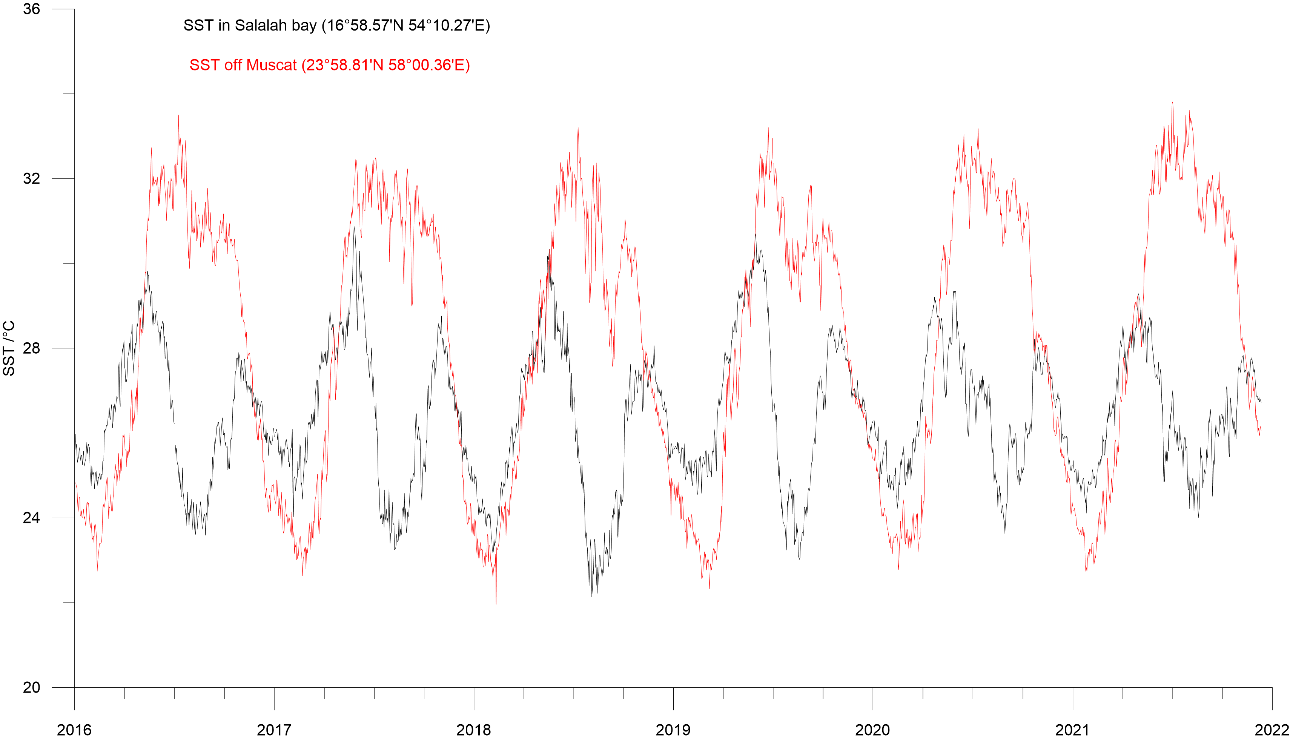

Figure S3-1. SST offshore Salalah and Muscat for the period 01/2016 to 12/2021. SST offshore Salalah show a bimodal temperature distribution.
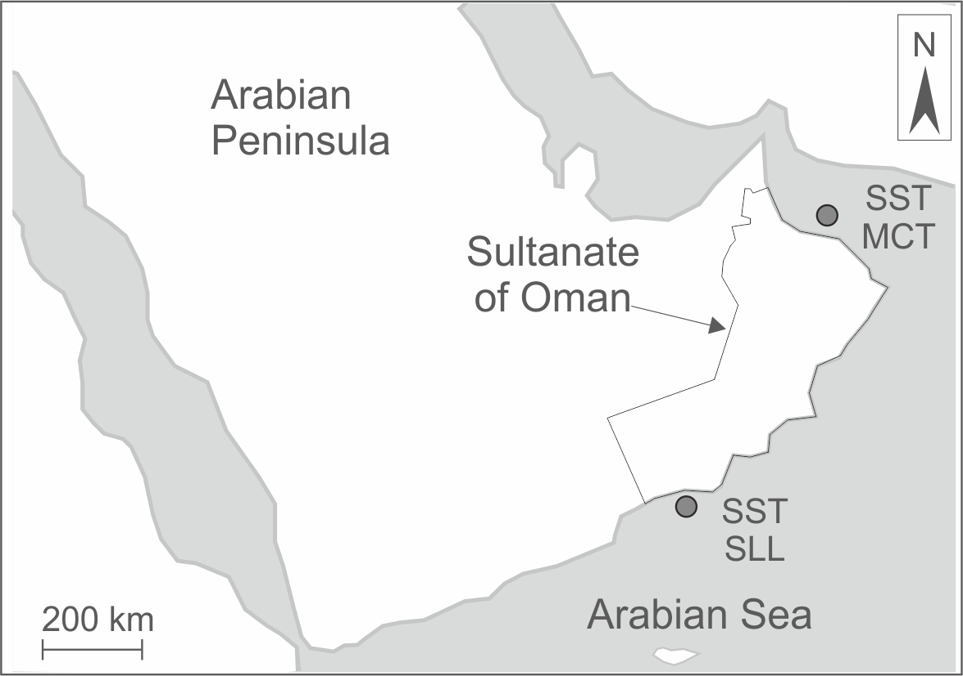
Figure S3-2. Locations of SST-data offshore Salalah (SLL) and Muscat (MCT).

SI-4 Soil temperature measurements
Table S4-1. Overview of soil temperature monitoring stations, including measurement periods (full months).
Location ID | Elevation  [m a.s.l.] | Coordinates | Data availability
A | 880 | 17°15'9.9"N, 54°5'20.8"E | 10/2016; 05/2017 - 08/2019
B | 700 | 17°12'27.28"N,  54°6'37.34 "E | 07/2017 – 11/2021
C1  C2 | 620 | 17°6'48.88"N, 54°31'14.98"E | 02/2016 – 10/2016; 05/2017 – 10/2018; 07/2019 – 11/2021
D | 510 | 17°11'2.73"N, 54°7'3.97"E | 10/2016; 04/2017 – 06/2019
E | 169 | 17°9'31.15"N, 54°10'14.76"E | 06/2018 – 09/2020

Site description
Lush vegetation develops in the mountains during the monsoon season. The soil is densely covered with grass, shrubs and flowering plants, some of which grow taller than 50 cm, and the trees have dense foliage (see pictures S4-1 to S4-5). With the end of the monsoon and the absence of precipitation, the vegetation changes. Due to the drought, but above all due to the grazing, the vegetation decreases sharply in a short time, baring parts of the soil within 2 to 3 months.

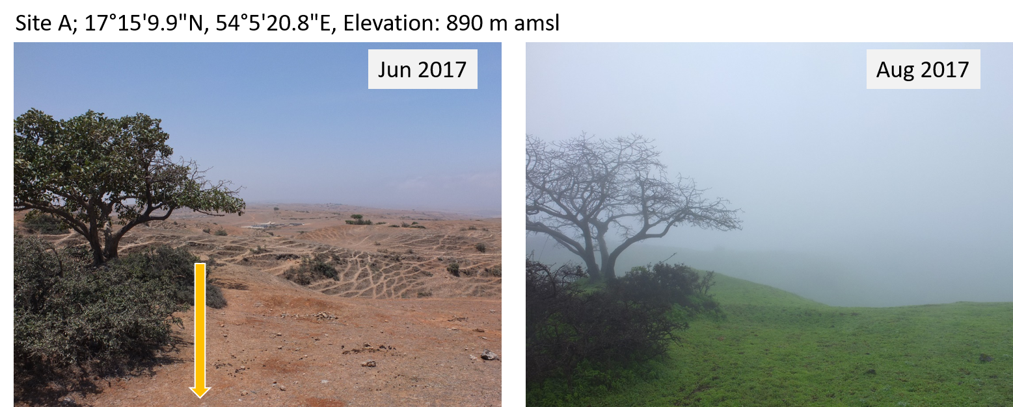
Figure S4-1. Site A is located on the top of the mountains. The arrow indicates the location of the temperature probe.

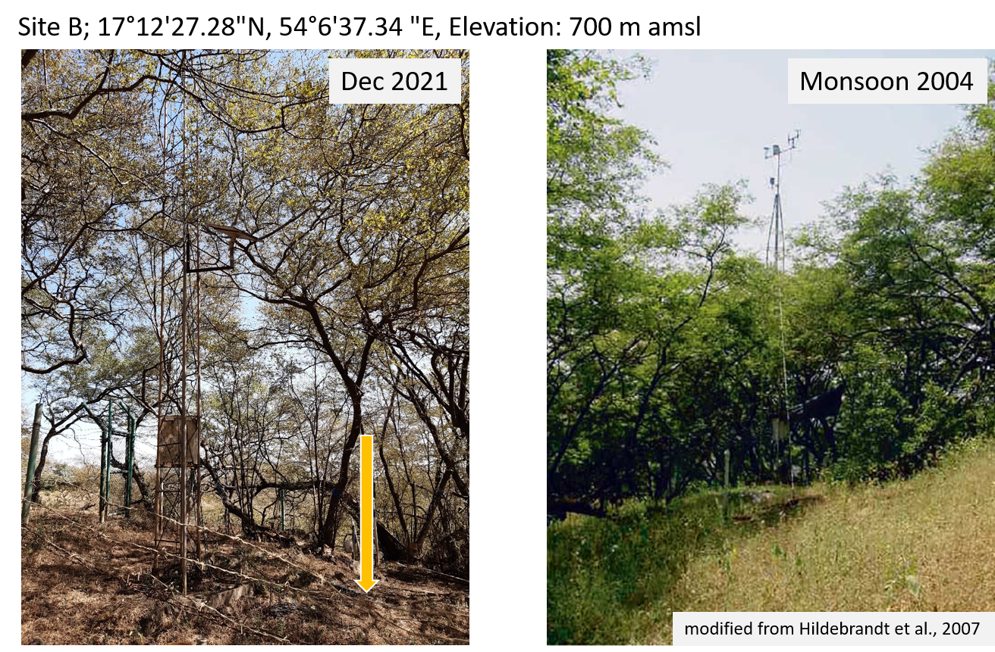
Figure S4-2. Site B is located on a hillside and is under trees that are about 8m high. The trees form a dens canopy of vegetation during the monsoon and provide shadow for the rest of the year. Grazing occurs to a low degree at this station, which may be due to the slope of the terrain or obstacles the remains of a fence were still in place when measurements began 2016). Site B was used in a previous study on the Dhofar cloud forest, which presents more detailed information on the location (Hildebrandt et al., 2007).

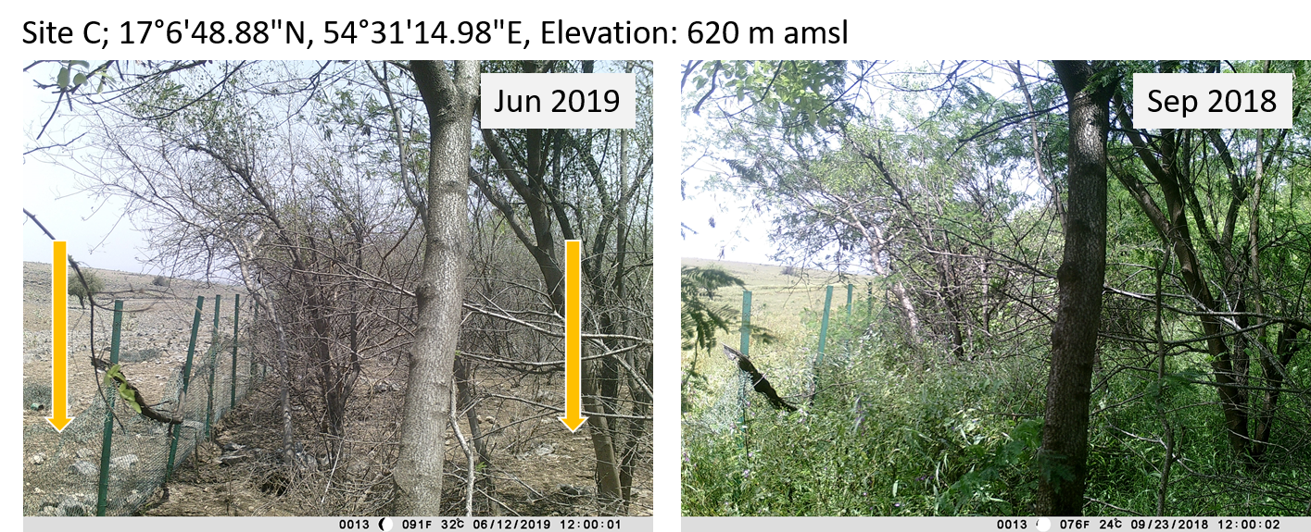
Figure S4-3. Site C is on a flat surface. Soil temperatures were measured inside and outside the fenced area. The locations are about 10 m apart. In the monsoon period, a high and dense shrub and grass layer is formed, sometimes with grass lengths > 80 cm. Site C was used in a previous study on the Dhofar cloud forest, which presents more detailed information on the location (Bawain, 2010).

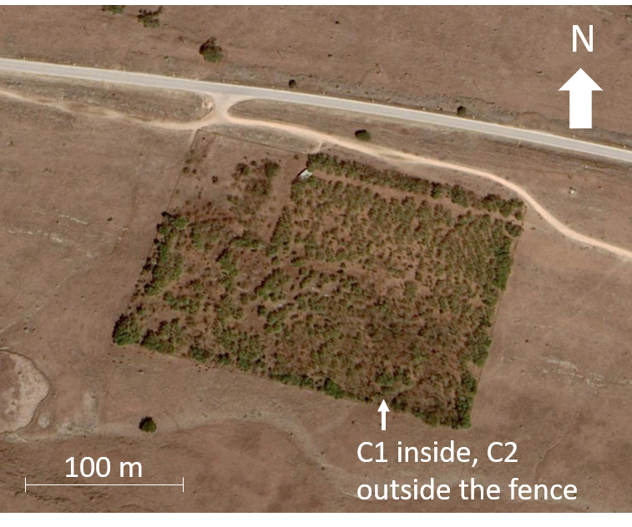
Figure S4-4. Aerial view of Site C for January 2020. Outside the fenced area almost no vegetation can be found. satellite image: Google Earth pro

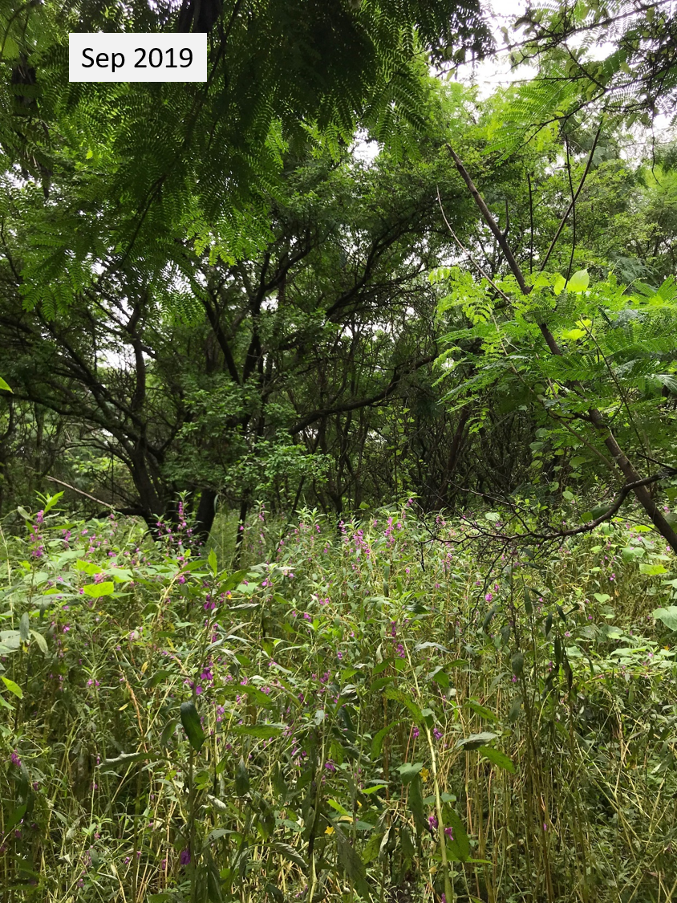
Figure S4-5. Lush vegetation at the end of the monsoon at Site C1.

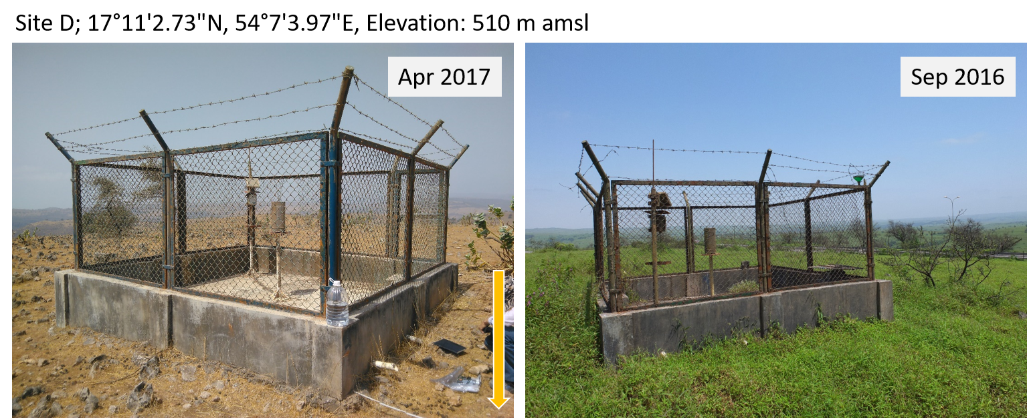Figure S4-6. Site D is about halfway up the mountain.

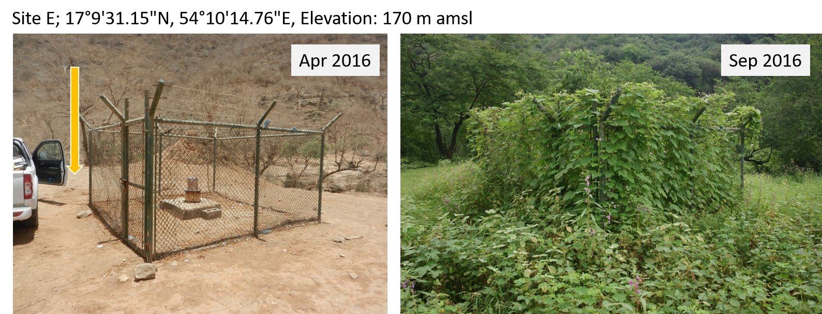
Figure S4-7. Site E at the foot of the mountain.

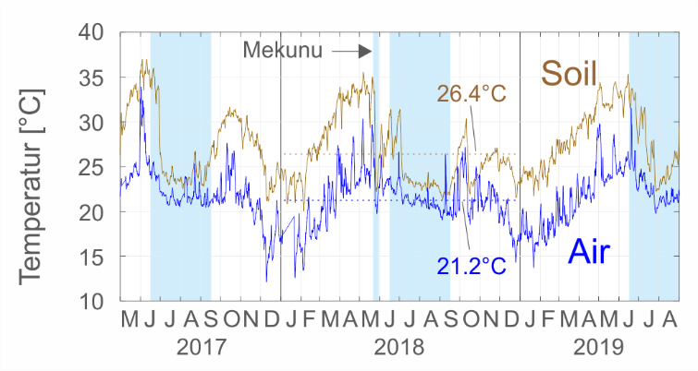
Figure S4-8. Soil and air temperatures (windowed means) for station A at the mountain top. Temperature differences during and shortly after the monsoon are smaller than in the other months of the year. Dashed lines represent the annual means for the year 2018. The temperature drop end of May 2018 was caused by Cyclone Mekunu, an extreme event that brought large amounts of rain to the area.

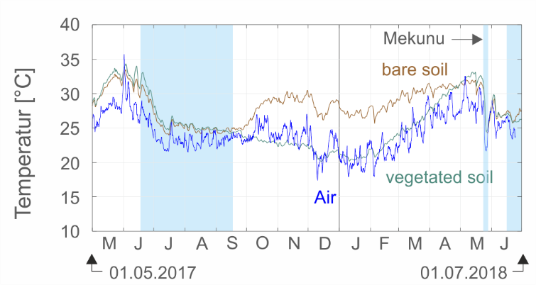
Figure S4-9. Soil and air temperatures (windowed means) for Site C. Outside the monsoon season, the temperatures of the none vegetated site are significantly higher (up to 7°C) than the air temperatures. For the vegetated site, on the other hand, the air and soil temperatures are almost the same until April 2018. The temperature drop end of May 2018 was caused by Cyclone Mekunu, an extreme event that brought large amounts of rain to the area.

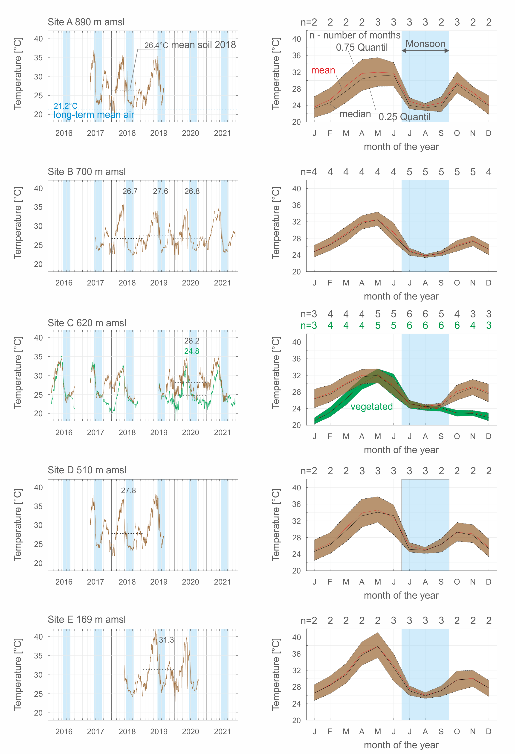
Figure S4-10. Left: Soil temperature (windowed means) vs time with strong seasonal variations. Dashed lines represent yearly means. Right: Monthly soil temperatures as median with lower and upper quartile. Annual means are presented when data record is available for a full year. “n” shows the fully available monthly data record.
Table S4-2. Monthly soil temperatures (mean) for all stations. The number in brackets indicates the number of analyzed months. The monsoon months July and August are marked.
Month | Jan | Feb | Mar | Apr | May | Jun | Jul | Aug | Sep | Oct | Nov | Dec
A (880 m amsl) | 23,6 (2) | 25.4 (2) | 28.7 (2) | 31.7 (2) | 32,0 (3) | 31,8 (3) | 25,0 (3) | 23,8 (3) | 24.6 (2) | 29,4 (2) | 27.1 (2) | 24,1 (2)
B (700 m amsl) | 24,8 (4) | 26,6 (4) | 29.1 (4) | 31,9 (4) | 32,5 (4) | 29.4 (4) | 25.0 (5) | 23,8 (5) | 24,3 (5) | 26,3 (5) | 27,5 (5) | 25,3 (5)
C1 (610 m amsl) | 21,2 (3) | 23,8 (4) | 27,4 (4) | 30,6 (4) | 32.8 (5) | 31,1 (5) | 25,4 (6) | 24,4 (6) | 24,2 (6) | 22,8 (6) | 23.1 (4) | 22.2 (3)
C2 (610 m amsl) | 26,4 (3) | 27,5 (4) | 30,1 (4) | 32.0 (4) | 32.7 (5) | 30,3 (5) | 25,0 (6) | 24,4 (6) | 24,9 (5) | 27.0 (4) | 29,3 (3) | 27,9 (3)
D ((500 m amsl) | 24,9 (2) | 26,6 (2) | 30.3 (2) | 33,9 (2) | 34,6 (3) | 32.8 (3) | 25,9 (3) | 25.0 (3) | 26,3 (2) | 29,3 (2) | 28,9 (2) | 25,6 (2)
E (170 m amsl) | 26,6 (2) | 28,6 (2) | 31.3 (2) | 36.1 (2) | 37,7 (3) | 33.2 (3) | 27,7 (3) | 26.0 (3) | 27,1 (3) | 29,7 (2) | 30.1 (2) | 27,8 (2)

Table S4-3. Mean annual air temperature (MAAT), mean annual soil temperature (MAST), infiltration period air temperature (IPAT) and infiltration period soil temperature (IPST) for locations A to E (cf. Figure 1).
Station | Elevation (m amsl) | T (°C) | 2016 | 2017 | 2018 | 2019 | 2020 | 2021 | 1996-2021
A | 890 | MAAT  MAST  IPAT  IPST | 21.4  -  20.6  - | 21.4ª  -  21.7ª  24.0 | 21.2  26.4  21.2  23.5 | 21.5  -  21.9  25.7 | -  -  -  - | 22.7^{b}  -  22.0^{b}  - | 21.2  -  21.1  -
B | 700 | MAAT  MAST  IPAT  IPST | -  -  -  - | -  -  23.0  24.6 | -  26.7  -  23.6 | -  27.6  -  24.9 | -  26.8  -  24.8 | -  27,7  -  24.1 | (22.4)^{f}  -  (22.1)^{g}
C1 | 620 | MAAT  MAST  IPAT  IPST | -  -  -  25.1 | 24.1^{c}  25.4^{c}  23.1  25.5 | -  -  -  23.7 | -  -  -  25.3 | -  24.8  -  24.3 | -  -  -  24.1 | (22.8)^{f}  -  (22.6)^{g}  -
C2 | 620 | MAAT  MAST  IPAT  IPST | -  -  -  24.5 | 24.1^{c}  28.2^{c}  23.1  25.1 | -  -  -  24.3 | -  -  -  25.4 | -  28.2  -  25.3 | -  -  -  24.6 | (22.8)^{f}  -  (22.6)^{g}  -
D | 510 | MAAT  MAST  IPAT  IPST | -  -  -  - | -  -  23.0  25.3 | 23.5  27.8  22.4  24.4 | -  -  23.5  - | -  -  -  - | -  -  -  - | (23.6)^{f}  -  (23.2)^{g}
E | 169 | MAAT^{d.e}  MAST  IPAT^{d,e}  IPST | 26.6  -  25.3  - | 27.0  -  26.2  - | 26.3  -  25.5  25.6 | 27.3  31.3  26.7  27.9 | 26.9  -  27.0  27.0 | 27.0  -  26.5  - | 26.5  -  25.8  -
ª 02.08.-05.08. no data; ^{b} 23.07., 26.07., 28.07., 30.07., 31.07., 01.08., 04.08. no data;
^{c} time period 01.05.2017 - 30.04.2018; ^{d} air temperatures are from Airport Salalah at 22m amsl; ^{e} air temperratures are given as integer values; ^{f} calculated with -0.61°C per 100m; ^{g} calculated with -0.54°C per 100m

SI-5 Spring and Groundwater sampling
SI-5.1 Groundwater temperatures
Groundwater temperatures in wells 25 and 33 are always above 28.5°C and 29.5°C, respectively. They stay almost constant also during the monsoon season when the soil temperature is lowered and the groundwater level increases as shown in (Figure S5-1) for well 25 at location E.

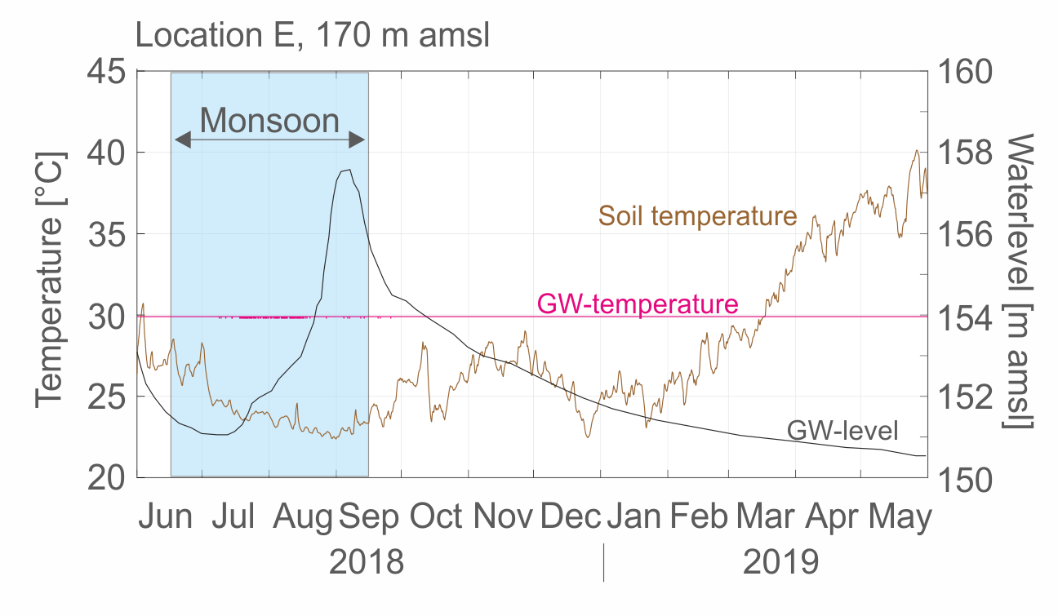
Figure S5-1. Observations at location E. Groundwater levels and soil temperatures change as a result of monsoon precipitation, but the groundwater temperature remains constant.

Groundwater temperatures from wells in the mountains are not available because the wells are equipped with pumps to supply water, which means that measuring the temperature on the water surface is not possible. Information on undisturbed groundwater temperature in the Dhofar Mountains comes from a drilling log. In this borehole (DWS-10, elevation 710 m amsl) drilled in 2007, WTT in a similar range were observed with 27.3°C (water level 91 m below ground surface) in the shallow aquifer and 31.2°C (water level 113 m below ground surface) in the deeper aquifer (unpublished data). The same borehole was used for a heatflow study by (Rolandone et al., 2013). The authors describe that the well is perturbed by circulations and give a groundwater temperature of about 27.5°C down to 500m. Another indication of groundwater temperatures well above 25°C are the temperatures during sampling which are all above 27.5°C (Table S5-1).

SI-5.2 Water sampling
The sampling locations were selected to sample recently recharged water from different infiltration elevations. While the water of the high-elevation springs 76 and 74 must come from high areas, the low-lying springs 5, 77, and 8 may also have lower recharge elevations.The two groundwater wells are located in wadi courses. Groundwater hydrographs starting in the 1980s show a strong seasonal course of the Groundwater level in these wells with maximum differences between pre- and post-monsoon of up to 6 (33) and 8 m (25) respectively. While long groundwater residence times for the high-lying springs could not be reasonably explained, it is possible that the springs at the foot of the mountain and the two groundwater wells carry mixed water which was recharged at very different heights but also contains parts of water that is several decades or even centuries old. However, the source of precipitation has not changed in these periods either. There have been monsoon rains in both the last 800 years and the millennia before that (Burns et al., 2002; Dominik Fleitmann et al., 2003).
Samples from the springs were taken by a copper pipe which was driven into the spring openings. The surrounding space was sealed off so that the water had to drain off through the sampling pipe. A hose was then tightly connected to the pipe from which the water sample was taken. Groundwater samples were collected with a submersible pump (MP1 by Grundfos, Bjerringbro, Denmark) from groundwater wells. The wells were purged before sampling to remove stagnant water until onsite parameters were stable. On-site analyses included the measurement of pH, temperature, electrical conductivity (EC), and dissolved oxygen (Multi 3430 by WTW, Weilheim, Germany) and are shown in Table S5-1.
Well 1 is located on the watershed, while well 2 is 10 and well 3 16 km away from it (Fig. 1b, 1c). More information on these wells can be found in Müller et al. (2016).

Table S5-1. Sampling locations and field parameters during sampling.
Site | Elevation  [m a.s.l.] | Sampling data | Coordinates | Well/ spring | pH | EC  [µS cm-1] | T  [°C]
76 | 795 | 22.09.2017 | 17°13'36.68"N, 54°19'37.59"E | spring | 7.14 | 1.467 | 30.0
74 | 635 | 18.08.2017 | 17°13'58.88"N, 54°6'38.62 "E | spring | 6.82 | 500 | 27.9
5 | 273 | 17.08.2017 | 17°6'2.85"N, 54°19'35.75"E | spring | 6.76 | 607 | 28.2
77 | 193 | 24.09.2017 | 17°1'2.36"N, 53°51'41.16"E | spring | 6.99 | 831 | 27.9
8 | 116 | 17.08.2017 | 17°5'48.94"N, 54°16'45.19"E | spring | 6.70 | 656 | 27.6
33 | 135 | 27.06.2017 | 17°9'0.54"N, 54°10'35.76"E | observation well | 716 | 6.96 | 29.8
25 | 125 | 22.06.2017 | 17°6'20.92"N, 54°4'27.66"E | observation well | 7.02 | 737 | 29.6
1 | 810 | 17.11.2009 | 17°15'49.45"N, 54°7'54.27"E | water supply well | 7.10 | 1.451 | 30.1
2 | 655 | 17.11.2009 | 17°20'14.37"N, 54°4'22.52"E | water supply well | - | 1.882 | 31.1
3 | 624 | 17.11.2009 | 17°21'27.51"N, 53°56'46.85"E | water supply well | 7.2 | 2.310 | 33.7

SI-5-3 NGT evaluation and infiltration height
Noble gas concentrations are shown in Table S5-2. The noble gas temperatures were determined using the software PANGA (Jung & Aeschbach, 2018). The standard closed-system equilibration (CE) excess air model (Aeschbach-Hertig et al., 2000) was applied and the model parameters T, A, and F were treated as free fit parameters. The application of an average infiltration elevation for all locations is not possible due to the different altitudes of the sampling locations. Four plausible recharge elevation levels (300, 500, 700, and 900 m amsl) were prescribed for each sample and the fitting procedure was evaluated for all levels higher than the spring or well elevation. All samples yielded good CE model fit results for all possible recharge elevations (Table S5-3). The modeled NGTs depend systematically and nearly linearly on the assumed recharge elevations, with a slope of (-0.36 ± 0.01) °C per 100 m elevation for all samples within the range of possible elevations. A slight deviation occurs only for the spring at site 76 and the water supply well 3, where the CE model fit runs into the limiting case of the unfractionated excess air (UA) model with F = 0. The NGT – elevation relationship for theses samples is somewhat steeper and more curved.
However, the choice of the infiltration height for location 76 is unambiguous; at an infiltration height of 900 m, the resulting temperature range within 1Ϭ NGT uncertainty is between 22.61 and 23.89°C. For site 74, infiltration heights of 700 and 900 m are possible. Assuming a maximum infiltration height of 700 m for the other locations results in a minimum NGT of 23.06 °C. Infiltration heights of 300 m are theoretically also possible for all other stations in the south, which results in the maximum temperature of 26.17°C (location 33). The northern wells may have received recharge from both the southern and northern sides of the mountains in the past. Considering the heights of the wells (624 to 810 m amsl) recharge elevations of 700 and 900 m were chosen. As long as the recharge elevation is above the maximum groundwater level in the mountains (500 to 600 m amsl), recharge towards the north is still possible today, even if the monsoon is limited to the south side.

Table S5-2 Noble Gas Concentrations
Sample | T | He | err He | Ne | err Ne | Ar | err Ar | Kr | err Kr | Xe | err Xe | 3He | err 3He | 3He/4He | err 3/4
Name | [°C] | [ccSTP/g] | [ccSTP/g] | [ccSTP/g] | [ccSTP/g] | [ccSTP/g] | [ccSTP/g] | [ccSTP/g] | [ccSTP/g] | [ccSTP/g] | [ccSTP/g] | [ccSTP/g] | [ccSTP/g] | [-] | [-]
3 | 33.7 | 1.7907E-07 | 1.7907E-09 | 2.0137E-07 | 1.0068E-09 | 0.00028942 | 2.3153E-06 | 6.1399E-08 | 1.3254E-09 | 8.6226E-09 | 1.3821E-10 | 5.8431E-14 | 2.9116E-15 | 3.2629E-07 | 1.5928E-08
2 | 31.1 | 1.2898E-07 | 1.2898E-09 | 2.1683E-07 | 1.0842E-09 | 0.0002934 | 2.3472E-06 | 6.2086E-08 | 1.3956E-09 | 7.9339E-09 | 1.2311E-10 | 7.4272E-14 | 3.7286E-15 | 5.7582E-07 | 2.8328E-08
1 | 30.1 | 1.2167E-07 | 1.2167E-09 | 2.7652E-07 | 1.3826E-09 | 0.00032443 | 2.5954E-06 | 6.4949E-08 | 1.3594E-09 | 8.1458E-09 | 1.2625E-10 | 9.7744E-14 | 4.9901E-15 | 8.0338E-07 | 4.022E-08
76 | 30.0 | 4.2336E-08 | 1.7736E-10 | 1.717E-07 | 2.0475E-09 | 0.00026745 | 1.0552E-06 | 5.8519E-08 | 8.0861E-10 | 7.8888E-09 | 1.1858E-10 | 5.657E-14 | 1.0225E-15 | 1.3362E-06 | 2.3494E-08
5 | 28.2 | 4.6891E-08 | 1.9655E-10 | 1.8702E-07 | 2.2304E-09 | 0.00028131 | 1.1123E-06 | 6.0314E-08 | 8.3595E-10 | 8.0096E-09 | 1.1747E-10 | 6.4279E-14 | 1.1754E-15 | 1.3708E-06 | 2.44E-08
33 | 30.2 | 1.0921E-07 | 4.5618E-10 | 3.9977E-07 | 4.8534E-09 | 0.00041509 | 1.6284E-06 | 7.8456E-08 | 1.0563E-09 | 9.2671E-09 | 1.398E-10 | 1.5064E-13 | 2.5084E-15 | 1.3793E-06 | 2.2233E-08
25 | 29.7 | 6.3439E-08 | 2.6405E-10 | 2.4565E-07 | 2.9392E-09 | 0.00031437 | 1.236E-06 | 6.4538E-08 | 8.9539E-10 | 8.368E-09 | 1.2315E-10 | 8.6302E-14 | 1.5225E-15 | 1.3604E-06 | 2.3321E-08
77 | 27.9 | 4.6959E-08 | 1.9739E-10 | 1.8727E-07 | 2.2334E-09 | 0.0002832 | 1.123E-06 | 6.0005E-08 | 8.2854E-10 | 8.1309E-09 | 1.2262E-10 | 6.5211E-14 | 1.1434E-15 | 1.3887E-06 | 2.3638E-08
74 | 27.9 | 1.8686E-07 | 7.8519E-10 | 6.4355E-07 | 7.6765E-09 | 0.00052298 | 2.0339E-06 | 9.0287E-08 | 1.2087E-09 | 1.0092E-08 | 1.5006E-10 | 2.5873E-13 | 4.1504E-15 | 1.3846E-06 | 2.1435E-08
8 | 27.6 | 5.4596E-08 | 2.2857E-10 | 2.0716E-07 | 2.474E-09 | 0.0002953 | 1.1652E-06 | 6.2458E-08 | 8.7262E-10 | 8.1945E-09 | 1.245E-10 | 7.4568E-14 | 1.3314E-15 | 1.3658E-06 | 2.3707E-08

Table S5-3 NGT evaluation considering different recharge elevations. Results of CE model fits with PANGA are shown, including the sum of weighted squared model – data deviations (χ²), the corresponding probability from the chi-square distribution, as well as the model parameters A, F, and T with their estimated 1-sigma uncertainties. For each well or spring, the evaluations for all possible (higher than local elevation) recharge elevations are shown.

Location | Recharge elevation [m amsl] | Chi square  [-] | Probability[%] | A [ccSTP/g] | A error [ccSTP/g] | F  [-] | F error  [-] | T  [°C] | T error  [°C]
76 | 900 | 0.008 | 92.67 | 0.00041 | 0.06120 | 0.000 | 5.60 | 23.25 | 0.64
74 | 900 | 0.554 | 45.67 | 0.03036 | 0.00130 | 0.033 | 0.01 | 24.30 | 0.92
74 | 700 | 0.500 | 47.97 | 0.02997 | 0.00132 | 0.032 | 0.01 | 25.03 | 0.94
5 | 900 | 0.006 | 94.08 | 0.01356 | 0.01048 | 0.793 | 0.07 | 23.49 | 0.82
5 | 700 | 0.013 | 90.92 | 0.01253 | 0.01162 | 0.814 | 0.08 | 24.19 | 0.82
5 | 500 | 0.024 | 87.70 | 0.01124 | 0.01302 | 0.834 | 0.09 | 24.89 | 0.81
5 | 300 | 0.039 | 84.39 | 0.00956 | 0.01476 | 0.854 | 0.12 | 25.60 | 0.80
77 | 900 | 1.190 | 27.53 | 0.01435 | 0.01117 | 0.798 | 0.06 | 23.22 | 0.85
77 | 700 | 1.278 | 25.82 | 0.01345 | 0.01252 | 0.819 | 0.07 | 23.91 | 0.85
77 | 500 | 1.371 | 24.16 | 0.01235 | 0.01422 | 0.841 | 0.08 | 24.62 | 0.85
77 | 300 | 1.469 | 22.54 | 0.01094 | 0.01646 | 0.863 | 0.10 | 25.33 | 0.84
8 | 900 | 0.011 | 91.59 | 0.01106 | 0.00495 | 0.623 | 0.08 | 23.16 | 0.78
8 | 700 | 0.004 | 94.91 | 0.01021 | 0.00518 | 0.634 | 0.09 | 23.85 | 0.79
8 | 500 | 0.0004 | 98.32 | 0.00926 | 0.00543 | 0.644 | 0.11 | 24.56 | 0.78
8 | 300 | 0.001 | 98.18 | 0.00820 | 0.00570 | 0.651 | 0.13 | 25.28 | 0.78
33 | 900 | 1.153 | 28.29 | 0.02285 | 0.00185 | 0.177 | 0.02 | 23.59 | 0.88
33 | 700 | 1.069 | 30.12 | 0.02247 | 0.00189 | 0.180 | 0.02 | 24.31 | 0.89
33 | 500 | 0.986 | 32.06 | 0.02207 | 0.00192 | 0.182 | 0.02 | 25.03 | 0.90
33 | 300 | 0.906 | 34.11 | 0.02166 | 0.00196 | 0.184 | 0.03 | 25.76 | 0.91
25 | 900 | 0.006 | 93.69 | 0.00894 | 0.00232 | 0.334 | 0.09 | 23.17 | 0.72
25 | 700 | 0.016 | 90.02 | 0.00827 | 0.00237 | 0.326 | 0.11 | 23.88 | 0.72
25 | 500 | 0.030 | 86.29 | 0.00756 | 0.00242 | 0.314 | 0.13 | 24.60 | 0.73
25 | 300 | 0.049 | 82.52 | 0.00682 | 0.00247 | 0.296 | 0.15 | 25.33 | 0.73
1 | 900 | 0.082 | 77.41 | 0.01070 | 0.00239 | 0.242 | 0.07 | 24.98 | 0.88
1 | 700 | 0.065 | 79.84 | 0.01014 | 0.00244 | 0.237 | 0.08 | 25.70 | 0.89
2 | 900 | 0.485 | 48.60 | 0.00878 | 0.00418 | 0.496 | 0.12 | 24.39 | 0.86
2 | 700 | 0.445 | 50.45 | 0.00794 | 0.00431 | 0.495 | 0.14 | 25.10 | 0.87
3 | 900 | 3.423 | 6.43 | 0.00192 | 0.00088 | 0.000 | 0.12 | 21.43 | 0.74
3 | 700 | 4.247 | 3.93 | 0.00176 | 0.00079 | 0.000 | 0.10 | 22.30 | 0.76

SI-6 Stable Isotopes northern Oman

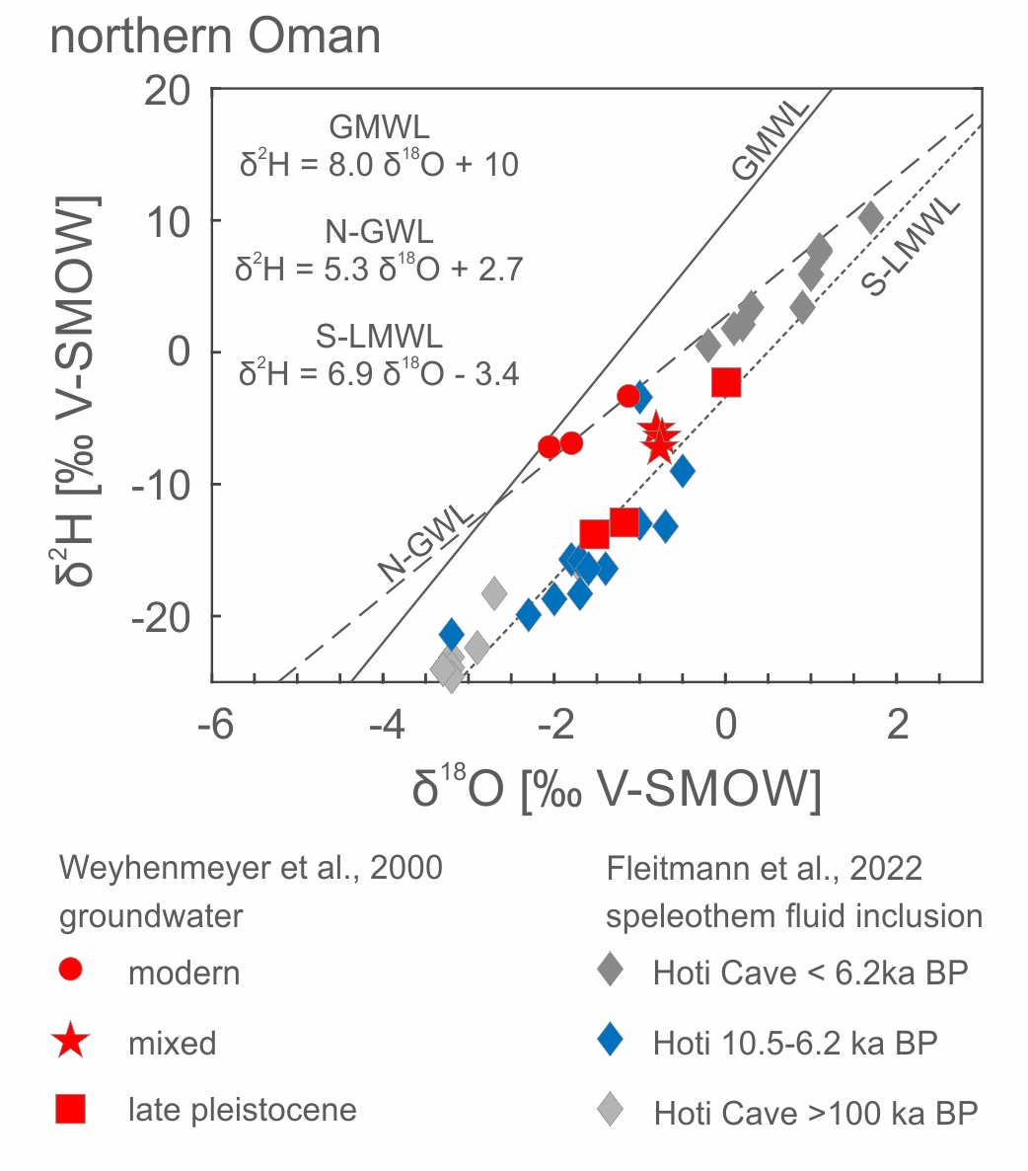
Figure S6-1. Stable isotope values of the three wells classified as mixed plot along the Southern Local Meteoric Waterline (S-LMWL δ²H=6.9 δ¹⁸O-3.4, Weyhenmeyer et al., 2000) and close to early holocene monsoon precipitation derived from stalagmites (Fleitmann et al., 2022).

SI-7 Air temperatures northern Oman
If the mean of the years 2010 to 2020 is calculated for the weather station Nizwa (462 m amsl) which is nearest station with long-term data availabe, 28.8°C is obtained (Directorate General of Meteorology, 2022). Since the recharge areas for both northern studies are higher (620 and 1000 m, respectively), data for a higher station are needed to estimate corresponding air temperatures. Only data for the station Saiq at 1752 m amsl are available, where the long term mean (2010-2020) is 18.5°C (Directorate General of Meteorology, 2022). Calculating MAAT from the long-term observations at Nizwa and Saiq results in 27.4°C for 620 m amsl and 24.5°C for 1000 m amsl, with a lapse rate of -0.79°C per 100 m elevation.

References
Aeschbach-Hertig, W., Peeters, F., Beyerle, U., & Kipfer, R. (2000). Palaeotemperature reconstruction from noble gases in ground water taking into account equilibration with entrapped air. Nature, 405(6790), 1040–1044. https://doi.org/10.1038/35016542
Aeschbach-Hertig, Werner, & Solomon, D. K. (2013). Noble gas thermometry in groundwater hydrology. The Noble Gases as Geochemical Tracers, 81–122.
Bawain, A. (2010). Heterogeneity of net precipitation due to tree species and edge effect in a semi-arid cloud forest in Dhofar, Oman. In EGU General Assembly Conference Abstracts.
Burns, S. J., Fleitmann, D., Mudelsee, M., Neff, U., Matter, A., & Mangini, A. (2002). A 780‐year annually resolved record of Indian Ocean monsoon precipitation from a speleothem from south Oman. Journal of Geophysical Research: Atmospheres, 107(D20), ACL 9-1-ACL 9-9.
Directorate General of Meteorology. (n.d.). Retrieved December 20, 2022, from https://met.gov.om/opencms/export/sites/default/dgman/en/weather-chart/historical-data/
Fleitmann, D., Burns, S. J., Matter, A., Cheng, H., & Affolter, S. (2022). Moisture and Seasonality Shifts Recorded in Holocene and Pleistocene Speleothems From Southeastern Arabia. Geophysical Research Letters, 49(16), e2021GL097255.
Fleitmann, Dominik, Burns, S. J., Mudelsee, M., Neff, U., Kramers, J., Mangini, A., & Matter, A. (2003). Holocene Forcing of the Indian Monsoon Recorded in a Stalagmite from Southern Oman. Science, 300(5626), 1737–1739. https://doi.org/10.1126/science.1083130
Hildebrandt, A., Al Aufi, M., Amerjeed, M., Shammas, M., & Eltahir, E. A. B. (2007). Ecohydrology of a seasonal cloud forest in Dhofar: 1. Field experiment. Water Resources Research, 43(10). https://doi.org/10.1029/2006WR005261
Jung, M., & Aeschbach, W. (2018). A new software tool for the analysis of noble gas data sets from (ground)water. Environmental Modelling & Software, 103, 120–130. https://doi.org/10.1016/j.envsoft.2018.02.004
Müller, Th., Osenbrück, K., Strauch, G., Pavetich, S., Al-Mashaikhi, K.-S., Herb, C., et al. (2016). Use of multiple age tracers to estimate groundwater residence times and long-term recharge rates in arid southern Oman. Applied Geochemistry, 74, 67–83. https://doi.org/10.1016/j.apgeochem.2016.08.012
NOAA Coral Reef Watch. (2019). Daily 5km Satellite Regional Virtual Station Time Series Data for South of Salalah, Oman and Muscat, Oman, 2016-2021. College Park, Maryland, USA: NOAA Coral Reef Watch. Retrieved from https://www.pacioos.hawaii.edu/voyager/.
Rolandone, F., Lucazeau, F., Leroy, S., Mareschal, J.-C., Jorand, R., Goutorbe, B., & Bouquerel, H. (2013). New heat flow measurements in Oman and the thermal state of the Arabian Shield and Platform. Tectonophysics, 589, 77–89. https://doi.org/10.1016/j.tecto.2012.12.034
Weyhenmeyer, C. E., Burns, S. J., Waber, H. N., Aeschbach-Hertig, W., Kipfer, R., Loosli, H. H., & Matter, A. (2000). Cool Glacial Temperatures and Changes in Moisture Source Recorded in Oman Groundwaters. Science, 287(5454), 842–845. https://doi.org/10.1126/science.287.5454.842

