Journal of Geophysical Research: Biogeosciences

Supporting Information for

Assessing phytoplankton primary productivity variability in the Changjiang estuary, East China Sea from coupled Fast Repetition Rate (FRR) fluorometry and Chlorophyll-a measurements

**Yuanli Zhu1,2, David J. Hughes3, Yuanyuan Feng4, Thomas J. Browning5, Ping Du1,2,7, Qicheng Meng6,7, Shengqiang Wang8, Bing Wang1,2,7, Dewang Li1,2,7, Zhibing Jiang1,2,7, Jiangning Zeng1,2,7**

1Key Laboratory of Marine Ecosystem Dynamics, Ministry of Natural Resources, Second Institute of Oceanography, Hangzhou, 310012, PR China

2Key Laboratory of Nearshore Engineering Environment and Ecological Security of Zhejiang Province, Hangzhou 310012, PR China

3Australian Institute of Marine Science, Townsville, QLD, Australia

4School of Oceanography, Shanghai Jiao Tong University, Shanghai, PR China

5Marine Biogeochemistry Division, GEOMAR Helmholtz Centre for Ocean Research, Kiel, Germany

6State Key Laboratory of Satellite Ocean Environment Dynamics, Second Institute of Oceanography, Ministry of Natural Resources, Hangzhou 310012, PR China

7Observation and Research Station of Marine Ecosystem in the Yangtze River Delta, Ministry of Natural Resources, Hangzhou 310012, PR China

8School of Marine Sciences, Nanjing University of Information Science and Technology, Nanjing, 210044, Jiangsu, PR China

**Contents of this file**

Supplementary Table S1, Supplementary Figures S1 to S4, the text section describes in detail how to calculate the electrons requirements for carbon fixation, *Kc.*

**Introduction**

One table and four figures have been added to support our main text. Table S1 describes the geographical locations and sampling times of all stations during two summer cruises in 2019 and 2021. The text delineates the detailed method for calculating *Kc* in this study, intended for discussion.

Figure S1 is a plot of Spearman rank correlation between photophysiological variables and environmental parameters*.* Figure S2 is a scatter plot of Repetition Rate (FRR) fluorometry, FRRf-derived $F_{o }$ and Chl-a, providing the regression function between these two parameters. This correlation demonstrated that the Chl-a can be directly estimated by FRRf. Figure S3 is a temperature-salinity diagram colored by values of $F_{v}{/F}_{m}$, $σ_{PSII}^{447}$, Chl-a or Primary Productivity. Figure S4 shows plots of light intensity (PAR) and NPQNSV with electron requirement for carbon fixation *(Kc)*

Table S1. Geographical locations and sampling time of all stations during two summer cruises in 2019 and 2021.

|  |  |  |  |  |
| --- | --- | --- | --- | --- |
| Station | mon/day/yr | hh:mm | Longitude [degrees_east] | Latitude [degrees_north] |
| N1 | 08/16/2019 | 9:19 | 122.02222 | 32.42417 |
| N2 | 08/16/2019 | 12:00 | 122.31556 | 32.50444 |
| N3 | 08/16/2019 | 13:56 | 122.65111 | 32.54972 |
| N6 | 08/16/2019 | 17:58 | 123.64472 | 32.77917 |
| J6 | 08/17/2019 | 7:24 | 123.58889 | 32.16028 |
| J5 | 08/17/2019 | 9:23 | 123.20639 | 32.10472 |
| J4 | 08/17/2019 | 11:50 | 122.79889 | 32.065 |
| J3 | 08/17/2019 | 13:56 | 122.49944 | 32.02472 |
| A1 | 08/17/2019 | 17:52 | 122.24917 | 31.51361 |
| A3 | 08/18/2019 | 7:14 | 122.59861 | 31.50083 |
| A4 | 08/18/2019 | 8:42 | 122.80556 | 31.49833 |
| A5 | 08/18/2019 | 9:57 | 122.99361 | 31.49806 |
| A6 | 08/18/2019 | 11:42 | 123.19917 | 31.49694 |
| A7 | 08/18/2019 | 13:02 | 123.40389 | 31.49889 |
| A8 | 08/18/2019 | 14:47 | 123.73611 | 31.50472 |
| A9 | 08/18/2019 | 17:09 | 124.24111 | 31.49167 |
| B12 | 08/19/2019 | 7:25 | 124.23389 | 31.00556 |
| B11 | 08/19/2019 | 9:31 | 123.75 | 30.99972 |
| B10 | 08/19/2019 | 11:16 | 123.40028 | 31 |
| B8 | 08/19/2019 | 13:30 | 123.00056 | 30.99 |
| B6 | 08/19/2019 | 16:22 | 122.67528 | 30.99278 |
| C2 | 08/20/2019 | 7:38 | 122.49917 | 30.49917 |
| C3 | 08/20/2019 | 8:43 | 122.65833 | 30.50194 |
| C5 | 08/20/2019 | 11:17 | 123.00167 | 30.50028 |
| C6 | 08/20/2019 | 13:16 | 123.19889 | 30.49972 |
| C7 | 08/20/2019 | 14:42 | 123.39778 | 30.49639 |
| C8 | 08/20/2019 | 16:51 | 123.74694 | 30.49972 |
| D6 | 08/21/2019 | 7:51 | 123.3875 | 30.0075 |
| D4 | 08/21/2019 | 10:56 | 123.00556 | 30.00028 |
| D3 | 08/21/2019 | 12:33 | 122.81806 | 30.00444 |
| D2 | 08/21/2019 | 13:30 | 122.65083 | 29.99556 |
| D1 | 08/21/2019 | 14:21 | 122.51139 | 30.0025 |
| F2 | 08/17/2021 | 14:50 | 122.22905 | 29.07171667 |
| F1 | 08/17/2021 | 15:27 | 122.1119 | 29.06904167 |
| F3 | 08/17/2021 | 17:40 | 122.33593 | 29.001315 |
| F6 | 08/18/2021 | 9:35 | 122.68275 | 28.898595 |
| E6 | 08/18/2021 | 12:31 | 123.04626 | 29.41501 |
| E5 | 08/18/2021 | 14:02 | 122.91329 | 29.46295833 |
| E3 | 08/18/2021 | 16:30 | 122.5464 | 29.52136167 |
| E1 | 08/18/2021 | 18:17 | 122.36265 | 29.57640333 |
| D1 | 08/19/2021 | 7:54 | 122.49986 | 29.99931667 |
| D2 | 08/19/2021 | 9:04 | 122.63235 | 29.99897833 |
| D3 | 08/19/2021 | 10:17 | 122.79718 | 29.99701667 |
| D4 | 08/19/2021 | 12:02 | 123.0004 | 29.996 |
| D5 | 08/19/2021 | 13:25 | 123.19301 | 29.99696333 |
| D6 | 08/19/2021 | 14:53 | 123.39434 | 30.00055333 |
| C7 | 08/20/2021 | 7:30 | 123.41508 | 30.49918333 |
| C6 | 08/20/2021 | 9:52 | 123.21208 | 30.49855667 |
| C5 | 08/20/2021 | 11:45 | 123.02816 | 30.50117833 |
| C4 | 08/20/2021 | 13:32 | 122.81682 | 30.49676833 |
| C3 | 08/20/2021 | 15:49 | 122.67279 | 30.49710667 |
| C2 | 08/20/2021 | 17:40 | 122.5168 | 30.49982833 |
| B12 | 08/28/2021 | 8:15 | 123.89005 | 30.99278167 |
| B11 | 08/28/2021 | 10:18 | 123.64728 | 31.000795 |
| B10 | 08/28/2021 | 11:54 | 123.40165 | 31.00041667 |
| B9 | 08/28/2021 | 13:58 | 123.19821 | 30.99972167 |
| B8 | 08/28/2021 | 15:28 | 123.00375 | 30.98979167 |
| B7 | 08/28/2021 | 16:52 | 122.8527 | 30.9957 |
| B6 | 08/28/2021 | 18:02 | 122.65387 | 30.91678833 |
| B5 | 08/29/2021 | 7:30 | 122.41753 | 30.93813 |
| B3 | 08/29/2021 | 10:00 | 122.07549 | 31.05087167 |
| B1 | 08/29/2021 | 13:06 | 121.73254 | 31.297525 |
| A1 | 08/30/2021 | 7:22 | 122.2564 | 31.49066167 |
| A2 | 08/30/2021 | 8:26 | 122.4105 | 31.5002 |
| A3 | 08/30/2021 | 9:50 | 122.60832 | 31.49853 |
| A5 | 08/30/2021 | 13:12 | 122.98804 | 31.50058333 |
| A6 | 08/30/2021 | 16:24 | 123.19672 | 31.49745833 |
| J2 | 09/02/2021 | 7:34 | 122.40998 | 32.030475 |
| J3 | 09/02/2021 | 9:18 | 122.67355 | 32.05505167 |
| J4 | 09/02/2021 | 11:20 | 122.9891 | 32.07804833 |
| J5 | 09/02/2021 | 13:30 | 123.27399 | 32.09654833 |
| J6 | 09/02/2021 | 15:45 | 123.59207 | 32.15802833 |
| J7 | 09/02/2021 | 17:56 | 123.94564 | 32.20945333 |
| N6 | 09/03/2021 | 7:50 | 123.66193 | 32.77738667 |
| N5 | 09/03/2021 | 9:58 | 123.33815 | 32.70117 |
| N4 | 09/03/2021 | 12:00 | 123.01091 | 32.646 |
| N3 | 09/03/2021 | 14:12 | 122.66719 | 32.5495 |
| N2 | 09/03/2021 | 16:51 | 122.33942 | 32.501005 |

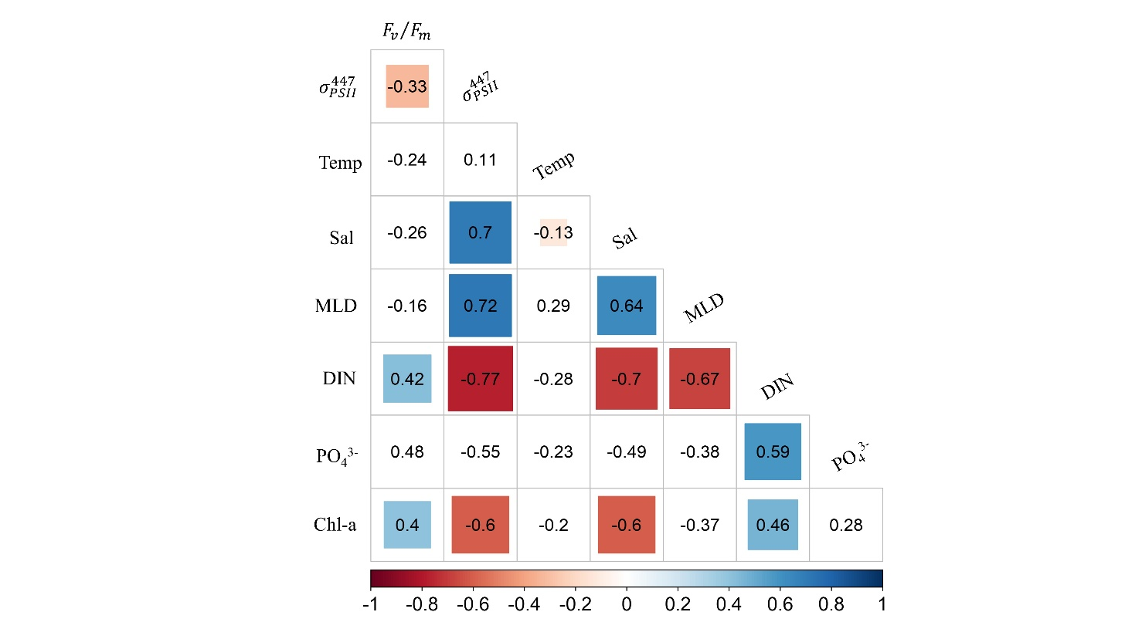

Figure S1. Plot of Spearman rank correlation betweenphotophysiological variables and environmental parameters. Temp: temperature (℃), Sal: salinity, MLD: mixing layer depth (m), photophsyiological parameters (Photosystem II (PSII) maximum quantum yield [*F*v/*F*m], the functional absorption cross-section of PSII [, nm2 PSII-1]) and Chlorophyll-a concentration (Chl-a, µg L-1)

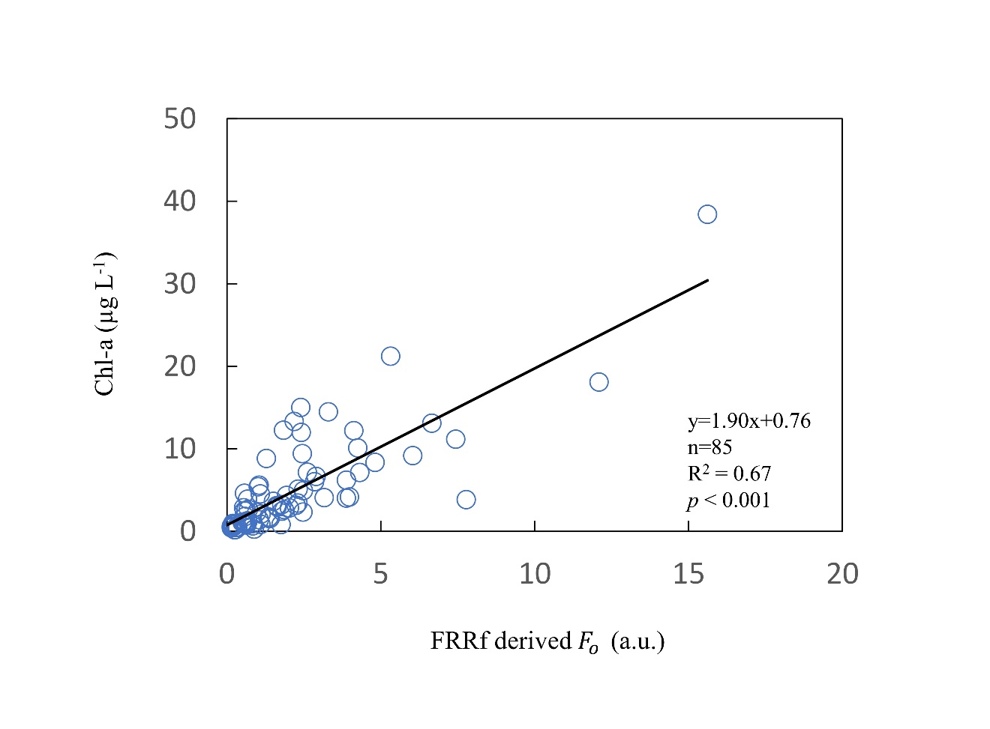

**Figure S2.** Scatter plot of FRRf-derived $F_{o }$ and Chl-a (mg m-3) collected during two cruises in the summertime Changjiang estuary, ECS). The equation is derived from a linear regression.

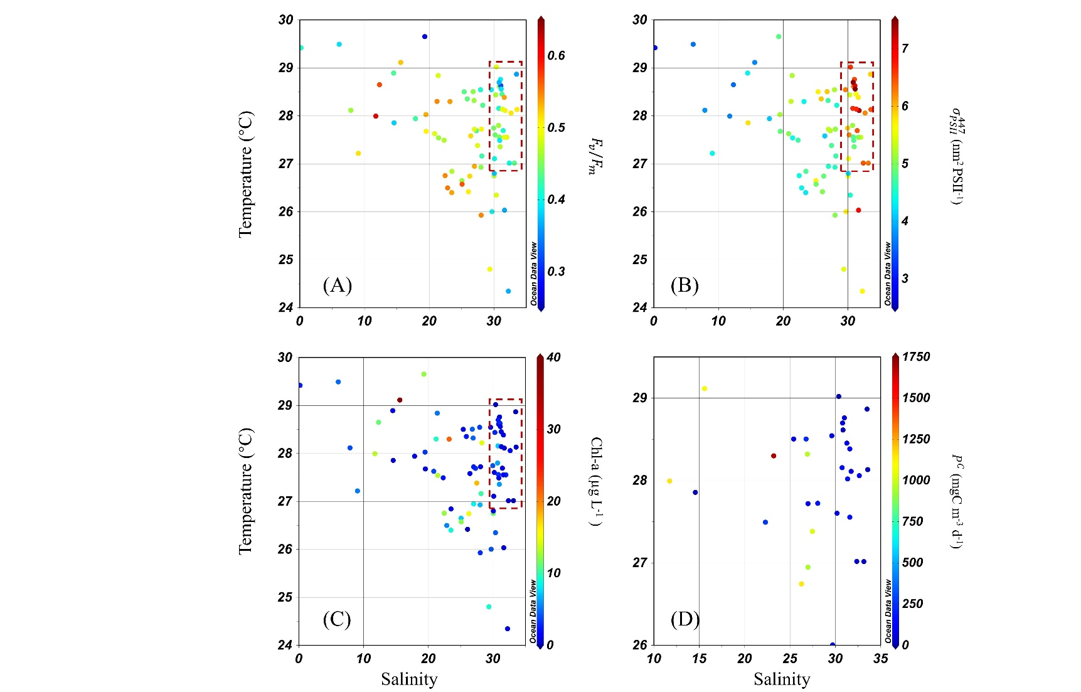

Figure S3. Temperature-salinity diagrams colored by (a) $F_{v}{/F}_{m}$ (b) $σ_{PSII}^{447}$,(c) Chl-a and (d) PP. The red dashed box indicates the relatively lower $F_{v}{/F}_{m}$ and higher values of $σ_{PSII}^{447}$ were typically observed at higher salinity and temperature offshore waters with lower nutrient and Chl-a

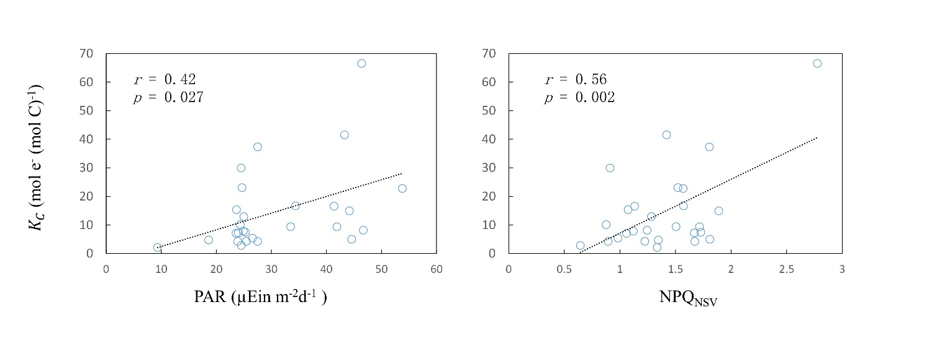

Figure S4. Plots of light intensity (PAR) and NPQNSV with electron requirement for carbon fixation *(Kc)*

Calculation ofelectron requirement for carbon fixation, *Kc.*

FRRf measurements were made continuously during a protocol of ambient light levels following an initial dark step. The sample was sequentially exposed to 12 white photosynthetically available radiation (PAR) levels (0, 32, 73, 124, 189, 272, 376, 509, 677, 889, 1159, 1500 µmol quanta m-2 s-1, white LEDs) within the FastAct2, to retrieve a active fluorescence-PAR response curve

The instantaneous PSII reaction centre normalised electron transport rate (${ETR}_{PSII}$, mol e- [mol PSII]-1 s-1) for each light level was calculated as per Kolber and Falkowski (1993),

${ETR}_{PSII}=PAR×σ_{PSII}^{450 }× q_{p}×Φ_{RC}×6.022× {10}^{-3}$ (1)

where PAR is in units of μmol quanta m-2 s-1 and (PSII-1) is the spectrally uncorrected effective absorption cross section of PSII. $Φ_{RC}$ accounts for the assumption that one electron is produced from each RCII charge separation (see Kolber and Falkowski 1993), and the constant value $6.022× {10}^{-3}$ converts μmol quanta to quanta, PSII to mol PSII and to m2. The term $q_{p}$ (dimensionless) is the PSII operating efficiency and accounts for the extent of photochemical energy conversion by PSIIs, determined as ($F_{m}^{'}-F'$*)/($F_{m}^{'}-F_{o}^{'}$*). To account for a lack of phytoplankton absorption and in situ light spectral measurements, an empirical relationship between “correction factor” (*f*, dimensionless) and optical depth was applied to spectrally correct values of $σ_{PSII}$ (see Suggett et al., 2006a for detail). Specifically, for our surface data, an f value of 1.6 was used as optical depth was effectively 0. The spectrally corrected ${ETR}_{PSII}$ is equal to ${ETR}_{PSII}$/*f*.

Spectrally corrected ETRPSII and PAR data from the FRRf-light response curves were then fit to the photosynthesis-light dependency model of Platt et al. (1980), Eq. 2.

${ETR}_{PSII}= {ETR}_{PSII}^{max}×(1-e^{-αE/{ETR}_{PSII}^{max}}),$ (2)

Using knowledge of $α$ and ${ETR}_{PSII}^{max}$, we were then able to retrieve the surface ${ETR}_{PSII}$ for any given value of surface PAR (in Eq. 2 denoted by E, continuously measured by full-spectrum quantum sensor) at any given time. As such, the daily integrated ${ETR}_{PSII}$ (mol e- [mol PSII]-1 d-1) at the surface was finally determined as:

$daily {ETR}_{PSII}$ = $\int_{t1}^{t2}{{ETR}_{PSII}dt}$ (3)

where the period between $t1$ and $t2$ is daylength (h).

In order to convert ETR normalised to PSII content (${ETR}_{PSII}$) to that normalised to Chl-a content, and hence ETRs that could be directly compared with parallel measures of carbon uptake to retrieve *Kc* (Lawrenz et al., 2013), knowledge of the RCII per Chl-a (i.e. $n_{PSII }$, mol RCII [mol Chl-a]-1) is required. Since diatoms and dinoflagellates are known to dominate phytoplankton assemblages in the study area (Jiang et al., 2014, 2015; Yang et al., 2014), here we assumed a ‘standard’ $n_{PSII}$ value of 0.002 mol RCII [mol chl]-1 for eukaryotes (Kolber and Falkowski, 1993) in our ETR calculation.

Thus, a daily Chl-a specific ETR (mmol e- mg Chl-a-1 d-1) was calculated as follows:

$daily ETR= daily {ETR}_{PSII} ×0.002 × {893}^{-1}$ (4)

the constant factor 893 converts mol Chl-a to mg Chl-a and mol e- to mmol e-.

Finally, *Kc* (mol e- (mol C)-1) was defined to be the ratio of the two independently determined variables, $ETR$ and $P_{B}^{C}$ as per Zhu et al. (2016, 2017):

*Kc $={daily ETR}/{P_{B}^{C}}×12$* (5)

where $P_{B}^{C}$ is the daily-integrated carbon assimilation per unit Chl-a (mgC mg Chl-a-1 d-1), and the factor 12 converts g C to mol C.

References

Jiang, Z., Liu, J., Chen, J., Chen, Q., Yan, X., Xuan, J., & Zeng, J. (2014), Responses of summer phytoplankton community to drastic environmental changes in the Changjiang (Yangtze River) estuary during the past 50 years. *Water Research*, *54*, 1-11. https://doi.org/10.1016/j.watres.2014.01.032.

Kolber, Z., and Falkowski, P. G. (1993), Use of active fluorescence to estimate phytoplankton photosynthesis in situ. *Limnology and Oceanography,* 38, 1646–1665. doi: 10.4319/lo.1993.38.8.1646.

Lawrenz, E., Silsbe, G., Capuzzo, E., Ylöstalo, P., Forster, R. M., Simis, S. G., et al. (2013), Predicting the electron requirement for carbon fixation in seas and oceans. *PLoS One* 8:e58137. doi: 10.1371/journal.pone.0058137

Platt, T., Gallegos, C. L., Harrison, W. G.(1980), Photoinhibition of photosynthesis in natural assemblages of marine phytoplankton. *Journal of Marine Research*, 38, 687–701.

Suggett, D. J., Moore, C. M., Marañón, E., Omachi, C., Varela, R. A., Aiken, J., et al. (2006), Photosynthetic electron turnover in the tropical and subtropical Atlantic Ocean. *Deep Sea Research Part II: Topical Studies in Oceanography*, 53, 1573–1592. doi: 10.1016/j.dsr2.2006.05.014

Yang, S., Han, X., Zhang, C., Sun, B., Wang, X., Shi, X. (2014), Seasonal changes in phytoplankton biomass and dominant species in the Changjiang River Estuary and adjacent seas: General trends based on field survey data 1959–2009. *Journal of* Ocean University *of China*, *13*, 926–934.

Zhu, Y., Ishizaka, J., Tripathy, S. C., Wang, S., Mino, Y., Matsuno, T., et al. (2016), Variation of the photosynthetic electron transfer rate and electron requirement for daily net carbon fixation in Ariake Bay, Japan. *Journal of Oceanography*, 72,761–777 doi: 10.1007/s10872-016-0370-4.

Zhu, Y., Ishizaka, J., Tripathy, S. C., Wang, S., Sukigara, C., Goes, J., et al. (2017), Relationship between light, community composition and the electron requirement for carbon fixation in natural phytoplankton. *Marine Ecology Progress Series*, *580*, 83–100 doi: 10.3354/meps12310.