

*Journal of Geophysical Research-Oceans*

Supporting Information for

**Influence of hydrodynamics on the composition and reactivity of particulate organic matter in a large river influenced ocean margin**

Jinqiang Guo1,2,3, Bu Zhou1,3,4,5, Eric P. Achterberg2, Jinming Song1,3,4,5*, Liqin Duan1,3,4,5, Xuegang Li1,3,4,5, Huamao Yuan1,3,4,5*

1 Key Laboratory of Marine Ecology and Environmental Sciences, Institute of Oceanology, Chinese Academy of Sciences, Qingdao, China

2 Marine Biogeochemistry Division, GEOMAR Helmholtz Centre for Ocean Research Kiel, Kiel, Germany

3 University of Chinese Academy of Sciences, Beijing, China

4 Laboratory for Marine Ecology and Environmental Sciences, Laoshan Laboratory, Qingdao, China

5 Center for Ocean Mega-Science, Chinese Academy of Sciences, Qingdao, China

* Corresponding authors at Key Laboratory of Marine Ecology and Environmental Sciences, Institute of Oceanology, Chinese Academy of Sciences, Qingdao 266071, PR China.

E-mail addresses: yuanhuamao@qdio.ac.cn (H. Yuan), jmsong@qdio.ac.cn (J. Song)

**Contents of this file**

Text S1 to S2

Figures S1 to S4

**Introduction**

This file mainly contains the analytical methods of Leucine aminopeptidases and bacterial community, and figures, which support understanding the current study. Text S1 and S2 introduce the detailed procedures of Leucine aminopeptidases and bacterial community. Figure S1 presents the bacterial community. Figure S2 presents the vertical distributions of total suspended matter (TSM) along the transect 3300, CJ and DH in the Changjiang Estuary and adjacent sea (CEAS) during spring and autumn. Figure S3 presents correlations between amino acid yields (PAA-C%) and heterotrophic bacterial abundance. Figure S4 shows correlations between PAA-C% and bacterial contributions to particulate organic carbon (POC).

Text S1. Leucine aminopeptidases analysis

Potential rates of extracellular enzyme activity (EEA) for leucine aminopeptidases on the particles were measured using fluorescently tagged substrate analog (L-Leucine-7-amido-4-methlcoumarin hydrochloride, Leu-MCA) (Hoppe 1993, Kellogg and Deming 2014). Filters were extracted by Tris-HCl (40 mL, pH = 8.0), and then divided into test and control groups after centrifuged. Substrate analog was added into the extracts at the half-saturation concentration (25 μmol L−1) determined by substrate saturation experiments, in which the controls were inactivated before adding the substrate analogs. All samples were incubated at the in situ temperature in the dark for 3 hours and then measured by F-4600 fluorescence spectrophotometer (λex = 330 nm, λem = 445). Fluorescence signals were converted to the concentration using calibration curves of fluorophore (MCA) solutions generated shipboard. Finally, the hydrolysis rates of the extracellular enzyme were calculated with dilution multiples and reaction time.

Text S2. Bacterial community

The bacterial 16S rRNA gene was analyzed by NovoGene Technology Co. Ltd (Beijing, China). The V3V4 hypervariable regions of the 16S rRNA gene were amplified with primers 341F (5’-CCTAYGGGRBGCASCAG-3’) and 806R (5’-GGACTACNNGGGTATCTAAT-3’). The bacterial community was observed from the analysis of bacterial 16S rRNA gene clone libraries.

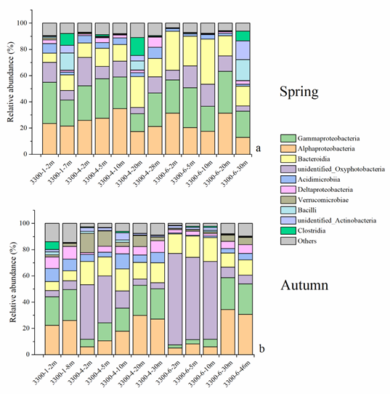

Figure S1. Bacterial community in section 3300 in spring (a) and autumn (b).

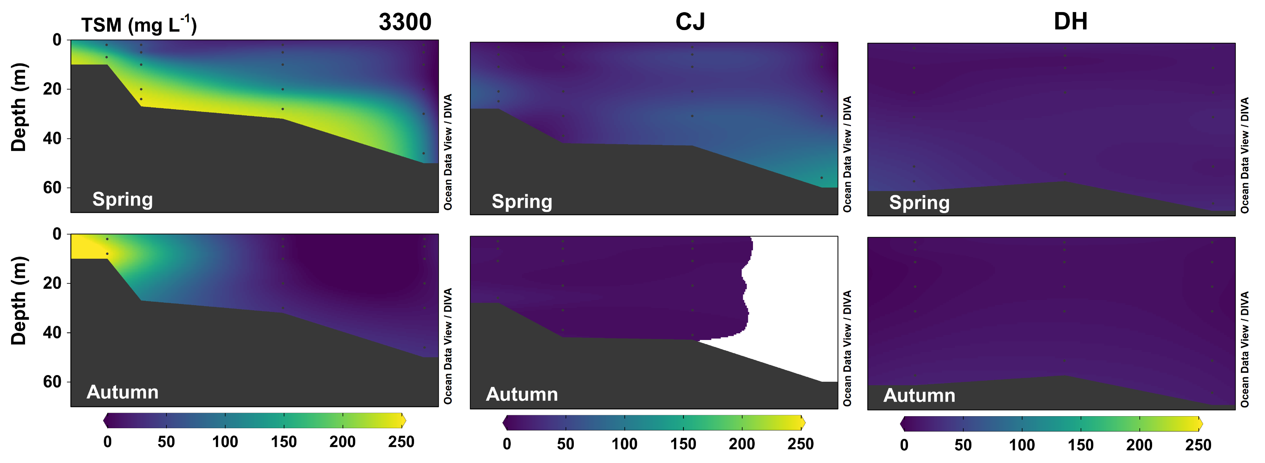

Figure S2. Sections of total suspended matter (TSM) in the Changjiang Estuary and adjacent sea (CEAS) in spring and autumn.



Figure S3. Correlations between amino acid yields (PAA-C%) and heterotrophic bacterial abundance (HBA) during spring and summer.



Figure S4. Correlations between amino acid yields (PAA-C%) and bacterial contributions to particulate organic carbon (POC) during spring and summer.