Appendix/Supplementary material

Table 1: Multicorer (MUC) samples collected for environmental and meiofaunal analyses. Samples are reported for each sampling campaign (2019: SO268 and 2021: IP21) per sampling category (Pre-impact, Collector Impact, Plume Impact), MUC deployment core labels (CL) per analysis type: Metabarcoding (Meta), Morphological (Morpho) and Environmental (Enviro).

|  |  |  |  |  |  |
| --- | --- | --- | --- | --- | --- |
| **Sampling campaign** | **Sampling category** | **MUC deployment** | **Meta (CL)** | **Morpho (CL)** | **Enviro**  **(CL)** |
| SO268 (2019) | Pre-impact | 50MUC | 6/8/9 | 10/12 | 4/12/18 |
| SO268 (2019) | Pre-impact | 56MUC | 4/6/11 | 8/10 | 7/13 |
| SO268 (2019) | Pre-impact | 65MUC | 5/8/9 | 4/8/14 | 6/12 |
| SO268 (2019) | Pre-impact | 75MUC | 8/10/11 | 4/5/6 | 9/14 |
| IP21 (2021) | Pre-impact | 05MUC | 14/15 | 6/7 | 9/18/20 |
| IP21 (2021) | Pre-impact | 40MUC | 14/16/17 | 6/7 | 8/18/19 |
| IP21 (2021) | Pre-impact | 41MUC | 14/16/18 | 7/19 | 8/13/20 |
| IP21 (2021) | Collector Impact | 19MUC | 17/19 | 6/7 | 9/13/18 |
| IP21 (2021) | Collector Impact | 20MUC | 14/16/17 | 6/7 | 8/13/18 |
| IP21 (2021) | Collector Impact | 24MUC | 14/16/17 | 6/7 | 8/13/18 |
| IP21 (2021) | Plume Impact | 25MUC | 14/16/17 | 6/7 | 8/13/18* |
| IP21 (2021) | Plume Impact | 30MUC | 14/16 | 6/7 | 9/13/18 |
| IP21 (2021) | Plume Impact | 31MUC | 14/16/17 | 6/7 | 8/13/18 |
| *\*grain size and TOC-TN measurements were not available for these cores* | | | | | |

Text Box 1: Detailed description of the applied methodology for library preparation during the metabarcoding analysis.

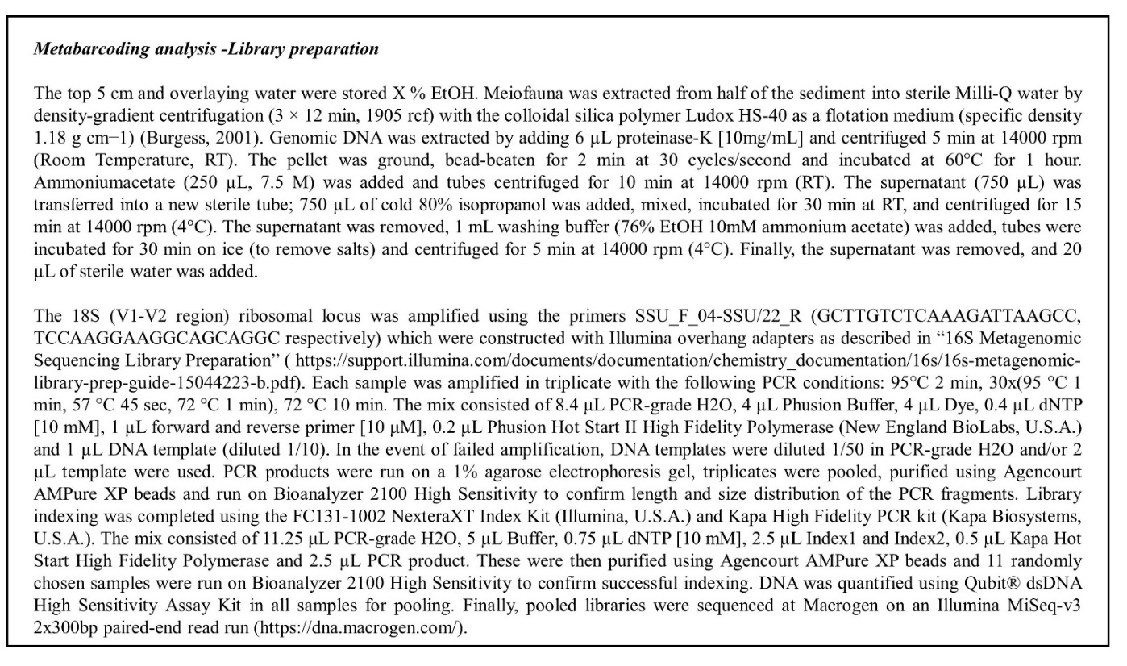

Table 2: Minimum (Min), maximum (Max), average and standard deviation (Av ± SD) of the environmental and biological univariate variables in the 0-5cm sediment depth layer for Pre-impact samples obtained during both campaigns (SO268 and IP21). Granulometry: Median grain size (MGS, µm) and percent Silt/Clay (%). Nutrients: Total nitrogen (TN, %), Total organic carbon (TOC, %) and Total organic carbon to Nitrogen ration (C/N ratio). Biotic indices: Total Nematoda Abundance (TNAb, ind. /10 cm2), Number of Nematoda Amplicon Sequence Variants (ASVs) corresponding to the ASV Richness and ASV Shannon diversity.

|  |  |  |  |  |  |  |
| --- | --- | --- | --- | --- | --- | --- |
| Environmental variables | Pre-impact (SO268) | | | Pre-impact (IP21) | | |
| Min | Max | Av ± SD | Min | Max | Av ± SD |
| *MGS (µm)* | 15 | 19 | 17 ± 1 | 17 | 24 | 20 ± 2 |
| *Sand (%)* | 11 | 14 | 12 ± 1 | 11 | 20 | 14 ± 3 |
| *Silt (%)* | 71 | 73 | 72 ± 1 | 68 | 75 | 72 ± 2 |
| *Clay (%)* | 14 | 17 | 16 ± 1 | 12 | 14 | 13 ± 1 |
| *TN (%)* | 0.12 | 0.21 | 0.16 ± 0.03 | 0.10 | 0.20 | 0.12 ± 0.03 |
| *TOC (%)* | 0.40 | 0.44 | 0.42 ± 0.01 | 0.44 | 0.67 | 0.55 ± 0.08 |
| *C/N ratio* | 2.09 | 3.42 | 2.73 ± 0.46 | 4.48 | 5.02 | 4.80 ± 0.23 |
| Biological variables | Pre-impact (SO268) | | | Pre-impact (IP21) | | |
| Min | Max | Av ± SD | Min | Max | Av ± SD |
| *TNAb (ind. /10 cm2)* | 68 | 260 | 136 ± 60 | 7 | 145 | 71 ± 57 |
| *ASV Richness* | 96 | 243 | 243 ± 120 | 35 | 297 | 145 ± 97 |
| *ASV Shannon diversity* | 2.75 | 4.75 | 3.66 ± 0.56 | 3.18 | 4.05 | 3.54 ± 0.37 |



*Figure 1: Biological variables: (a) Total Nematoda Abundance (TNAb, ind. /10 cm2), (b) Number of Nematoda Amplicon Sequence Variants (ASVs) corresponding to the ASV Richness and (c) ASV Shannon diversity for the Pre-impact samples collected within the Trial site during the SO268 (2019) and IP21 (2021) campaigns. The crossbar and extent of the box represent the mean and standard deviation, respectively.*

*Figure 2: Heat map with the relative read abundance (%) of genus-assigned Nematoda Amplicon Sequence Variants (ASVs) for the Pre-impact samples collected within the Trial site during the SO268 (2019) and IP21 (2021) campaigns.*

*Figure* *3: Metric dimensional scaling (MDS) plot of Nematoda Amplicon Sequence Variant (ASV) community composition for the Pre-impact samples collected within the Trial site during the SO268 (2019, triangles) and IP21 (2021, squares) campaigns based on Bray-Curtis dissimilarity.*

*Appendix Figure 4: Total meiofaunal abundance (TMAb, ind. /10cm2) for each sample within the different impact categories (Pre-impact, Collector Impact and Plume Impact) sampled during the IP21 campaign. Colour codes represent higher taxa and nauplii (i.e., Crustacea larvae).*

*Figure 5: Total Nematoda Abundance (TNAb, ind. /10cm2) of the Pre-impact samples collected during the IP21 campaign. For each sample, nodule characteristics are added such as the approximate nodule diameter (ø) and sediment depth position (i.e., surface/sediment interface or subsurface).*

*Figure 6: Example high-resolution images of cores taken for meiofaunal morphological analysis from the post-impact category: Collector Impact. Visual inspection was performed to qualitatively estimate the lower limit of the dark, manganese-oxide rich layer (solid grey lines) and the level of sediment resuspension (dashed grey lines).*

Table 3: Samples collected within the Collector Impact site during the IP21 campaign, with corresponding Total Nematoda Abundance (ind. /10 cm2). Based on the high-resolution images, the estimated sediment removal, description of the sediment surface topography and proposed subcategory are added.

|  |  |  |  |  |
| --- | --- | --- | --- | --- |
| **Sample** | **TNAb (ind. /10 cm2)** | **Estimated sediment removal** | **Sediment surface topography** | **Proposed subcategory** |
| 19MUC06 | 46 | 6 cm | Regular, homogenous | Sediment strip between imprints (caterpillar profile) |
| 19MUC07 | 15 | 5 cm | Regular, homogenous | Sediment strip between imprints (caterpillar profile) |
| 20MUC06 | 16 | 4.5-7.5 cm | Irregular | Interface? (caterpillar profile) |
| 20MUC07 | 20 | 4-6 cm | Irregular | Interface? (caterpillar profile) |
| 24MUC06* | 12 | 0-0.5 cm | Irregular | Depression (caterpillar profile) |
| 24MUC07* | 98 | 5 cm | Irregular with sediment clump | Ripple (caterpillar profile) |
| *\*TV-guided MUC deployment* | | | | |