

*Geochemistry, Geophysics, Geosystems*

Supporting Information for

**Incorporation of dissolved heavy metals into the skeleton of the scleractinian corals *Porites lobata* and *Porites lichen* based on multi-element culturing experiments**

Sarina Schmidt1, Ed C. Hathorne1, Joachim Schönfeld1, Kathleen J. Gosnell1 and Dieter Garbe-Schönberg2

1GEOMAR Helmholtz Centre for Ocean Research Kiel, Wischhofstraße 1-3, 24148 Kiel, Germany

2Institute of Geosciences, Kiel University, Ludewig-Meyn-Straße 10, 24118 Kiel, Germany

**Contents of this file**

Figures S1 to S5

Tables S4 to S6

**Additional Supporting Information (Files uploaded separately)**

**Table S1:** TE/Ca values in the culturing medium of the control and the metal system. The mean values are given for both systems at the bottom of the table. Note that no Hg values are available for phase 0 of both systems. CL=Metal system, CR=Control system, W=week, D=Day, SE=Standard Error, Ph=Phase.

**Table S2:** Growth rates of the different coral colonies A, B, C and D in mm/ year. Calculations are based on the staining lines and the outer surface of the colonies after the experimental period. Staining took place before phase 0 (control phase) and before phase 1 (first metal phase). The system, the elemental scan line number and the growth rate in phase 0 and during phases 1 through 4 are indicated. (1) = polluted sites.

**Table S3:** Comparison of DTE values of the present study to other studies and other coral species. DTE values are derived from the composite line of all coral colonies. Sample preparation: 1 = NaClO + pre-ablation, 2 = H2O2 + HNO3, 3 = acid leaching/ oxidative/ reductive cleaning procedure after Shen and Boyle (1988), 4 = procedure Boyle et al., (1988) deionized water rinse, 5 = distilled water, HNO3, H2O2 + NaOH, H2NNH2 + NH4OH + C₆H₈O₇, coprecipitation with APDC + HNO3, 6 = dilution HCl, AgNO3 carrier for precipitating AgCl, HNO3, NH4OH, scavenging with ferric chloride, re-precipitation of silver with nitric acid, drying, dissolving in NH4OH.

**Introduction**

This supplement provides additional figures showing all individual laser ablation ICP-MS lines while composite lines are used in the main manuscript.



***Figure S1.*** Seawater Sn/Ca ratio measured in the metal and control systems over the experiment.

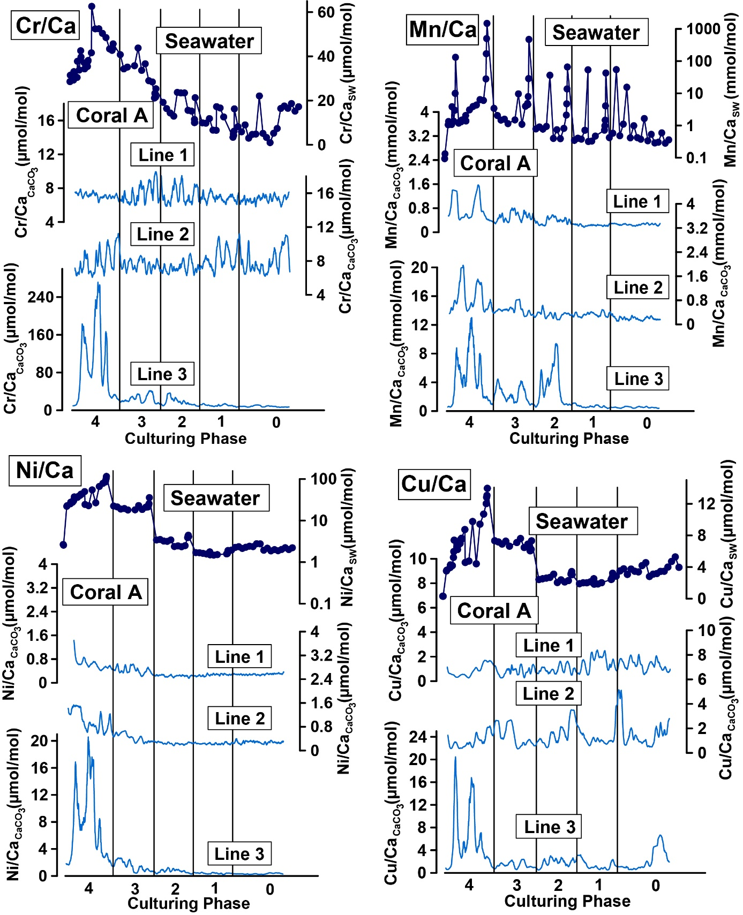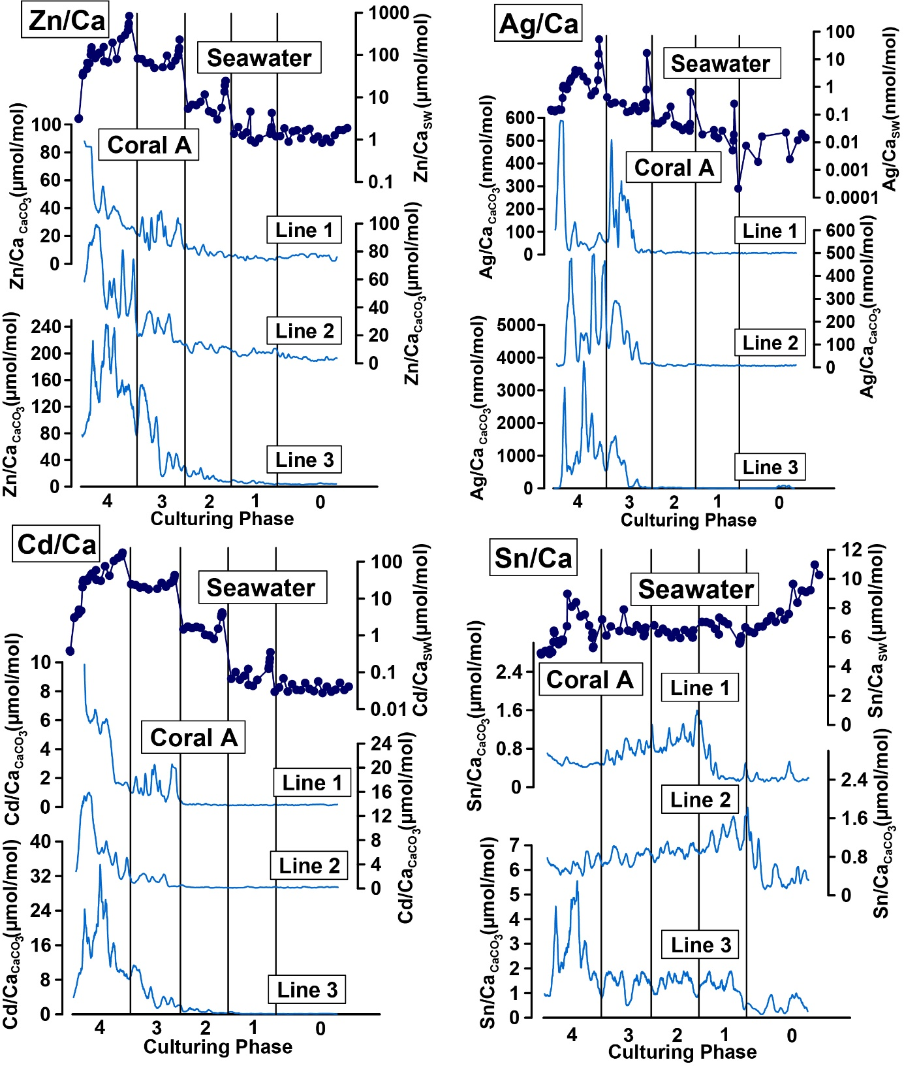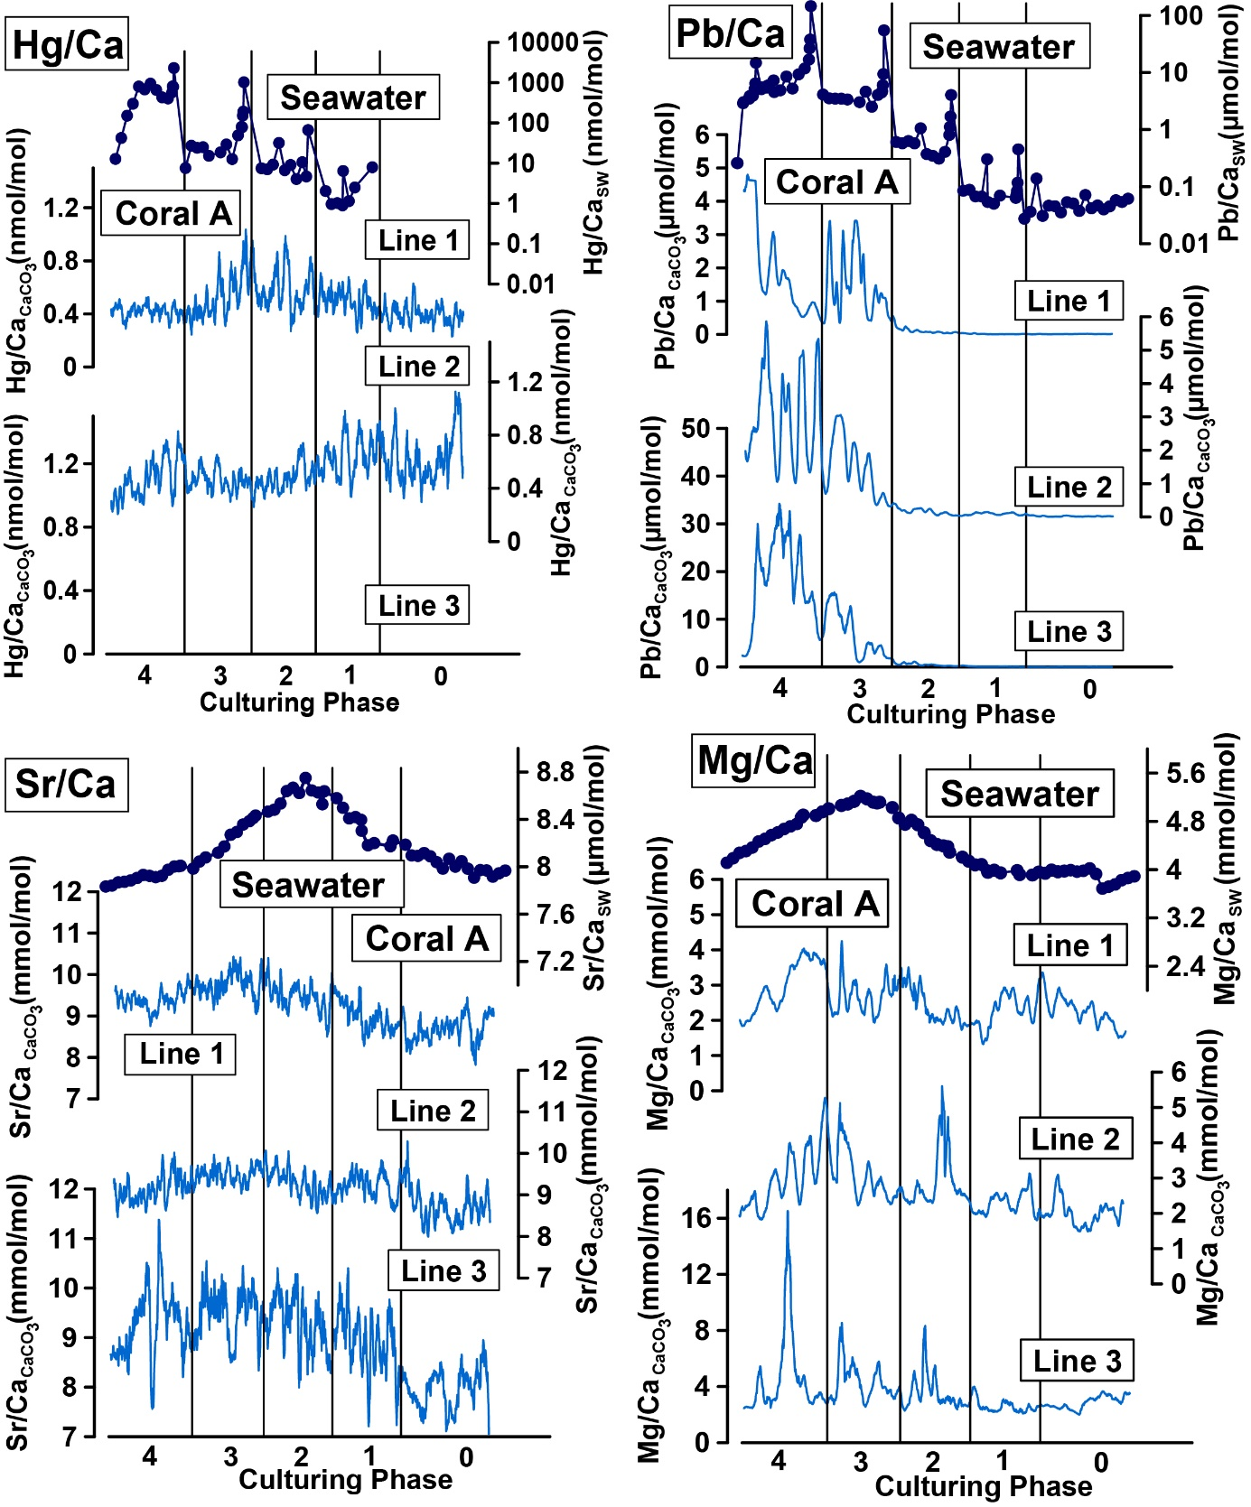

***Figure S2:*** *TE/Ca values of single lines on coral A cultured in the metal system measured by laser ablation ICP-MS and corresponding TE/Ca values in the culturing. To facilitate a comparison, all coral and water lines were transformed to the same Y-scale and therefore, differences in growth rates cannot be seen in this figure (see Table S2 for growth rates). Hg were not detectable in line 3. All elements but Cr, Cu, Sn, Sr and Mg are displayed with a logarithmic scale for the water measurements.*

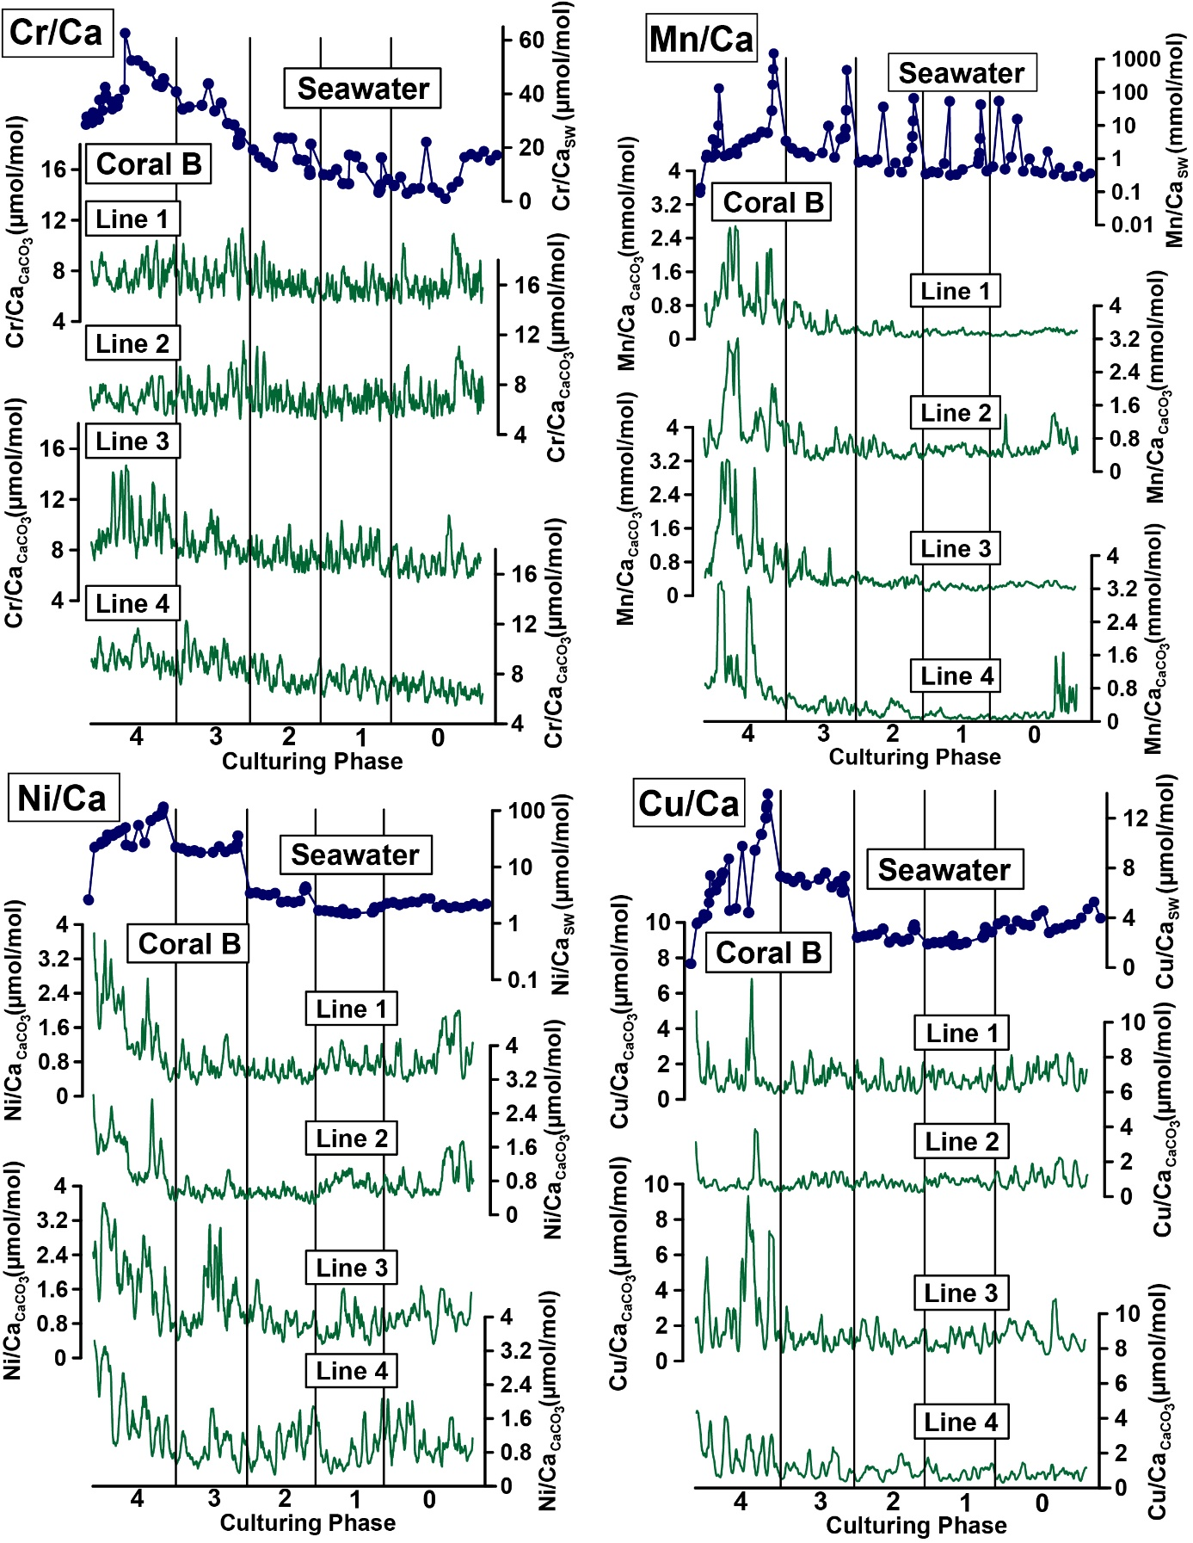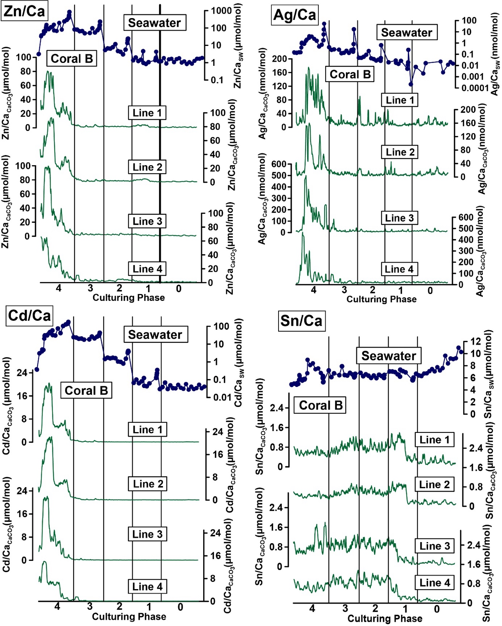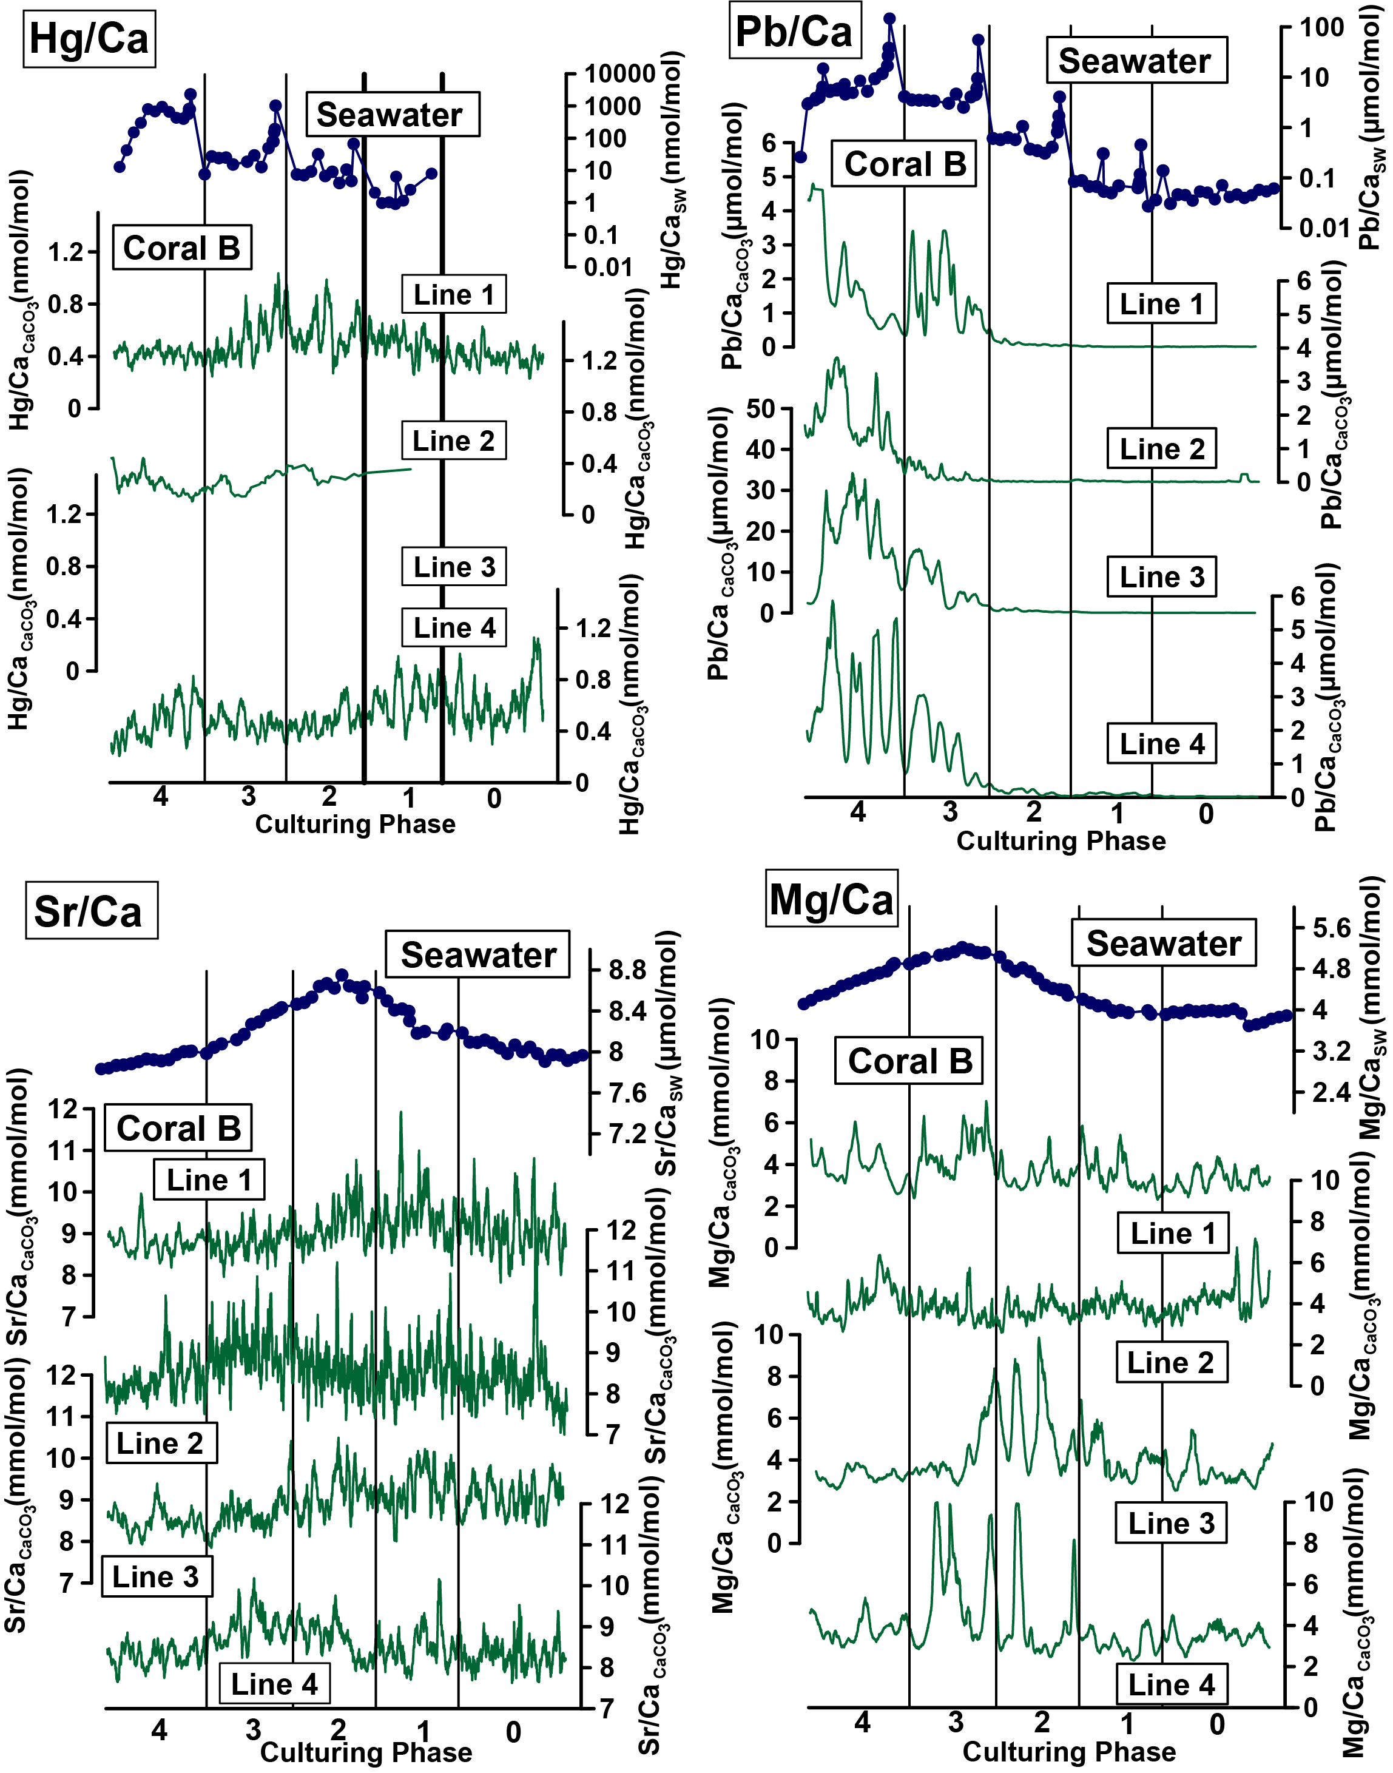

***Figure S3:*** *TE/Ca values of single lines on coral B cultured in the metal system measured by laser ablation ICP-MS and corresponding TE/Ca values in the culturing medium. To facilitate a comparison, all coral and water lines were transformed to the same Y-scale and therefore, differences in growth rates cannot be seen in this figure (see Table S2 for growth rates). Hg were not detectable in line 3. All elements but Cr, Cu, Sn, Sr and Mg are displayed with a logarithmic scale for the water measurements.*

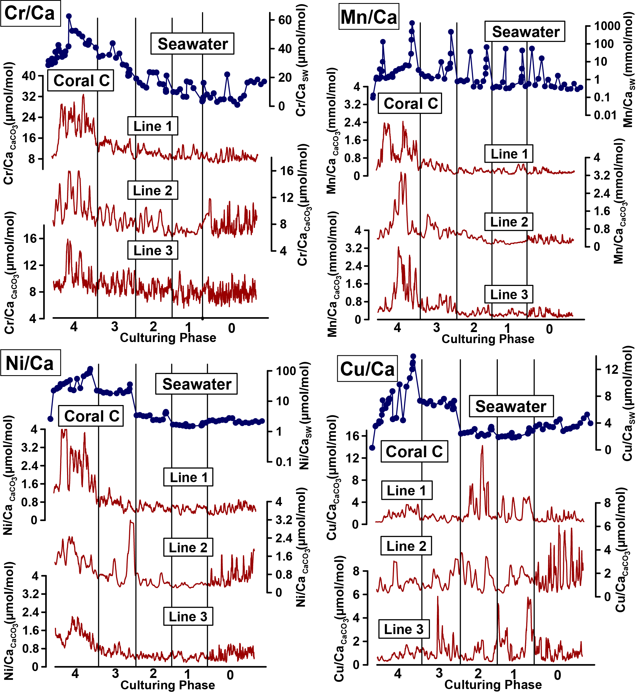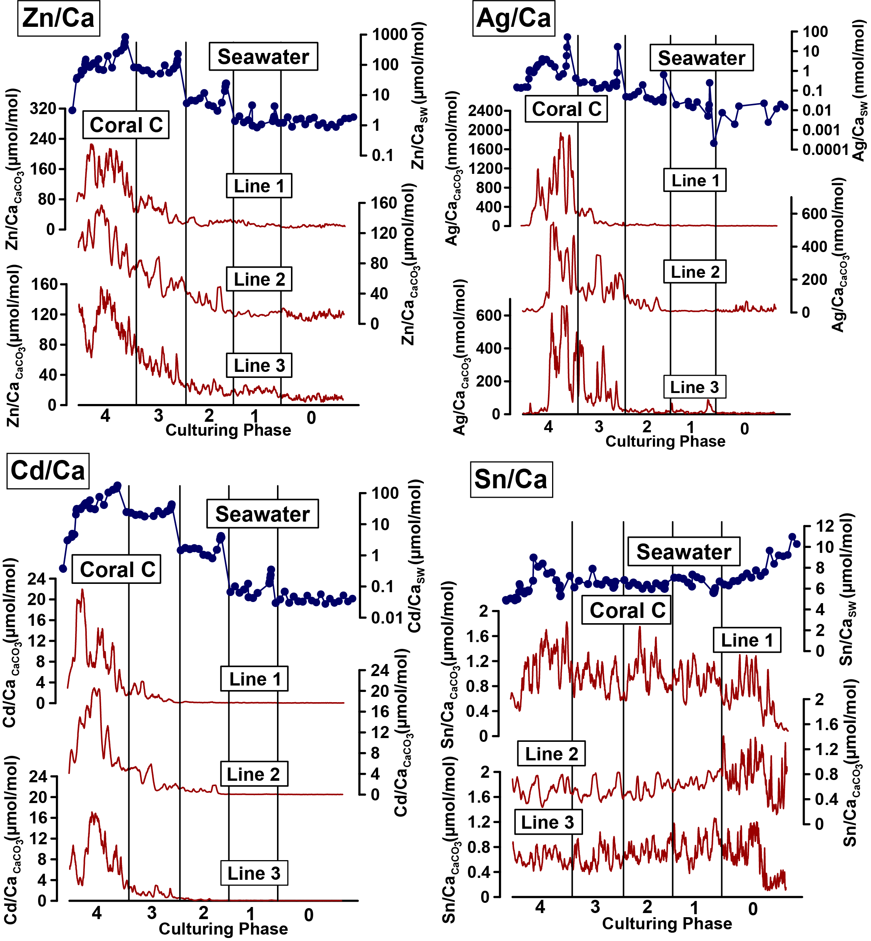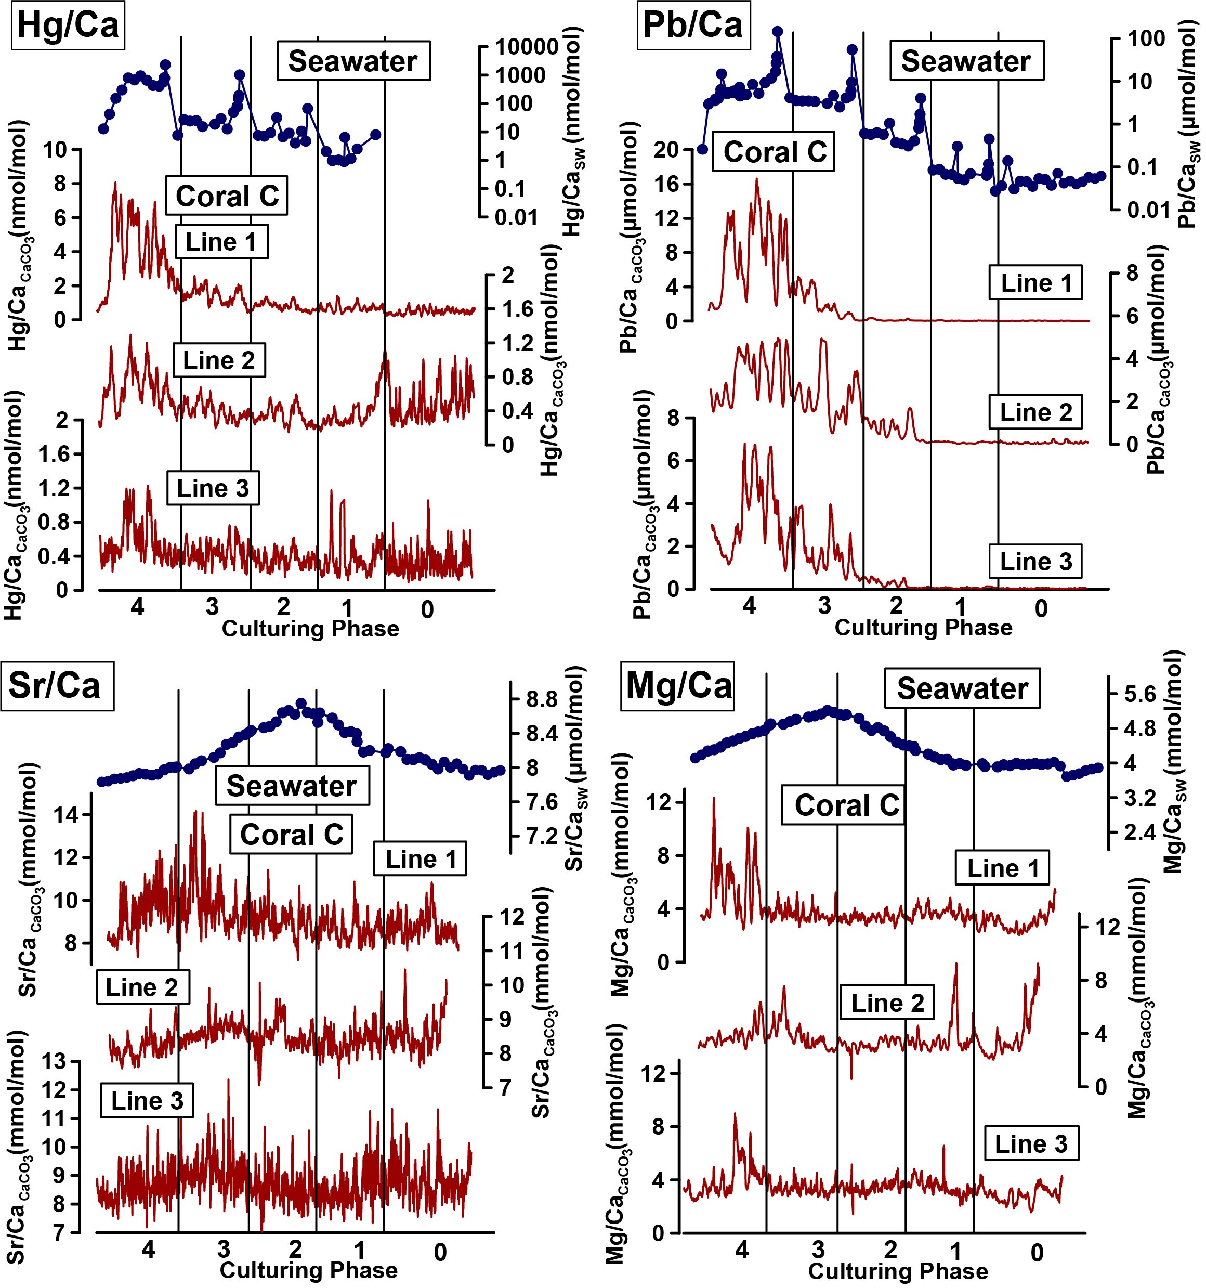

***Figure. S4:*** *TE/Ca values of single lines on coral C cultured in the metal system measured by laser ablation ICP-MS and corresponding TE/Ca values in the culturing medium. To facilitate a comparison, all coral and water lines were transformed to the same Y-scale and therefore, differences in growth rates cannot be seen in this figure (see Table 3 for growth rates). All elements but Cr, Cu, Sn, Sr and Mg are displayed with a logarithmic scale for the water measurements.*

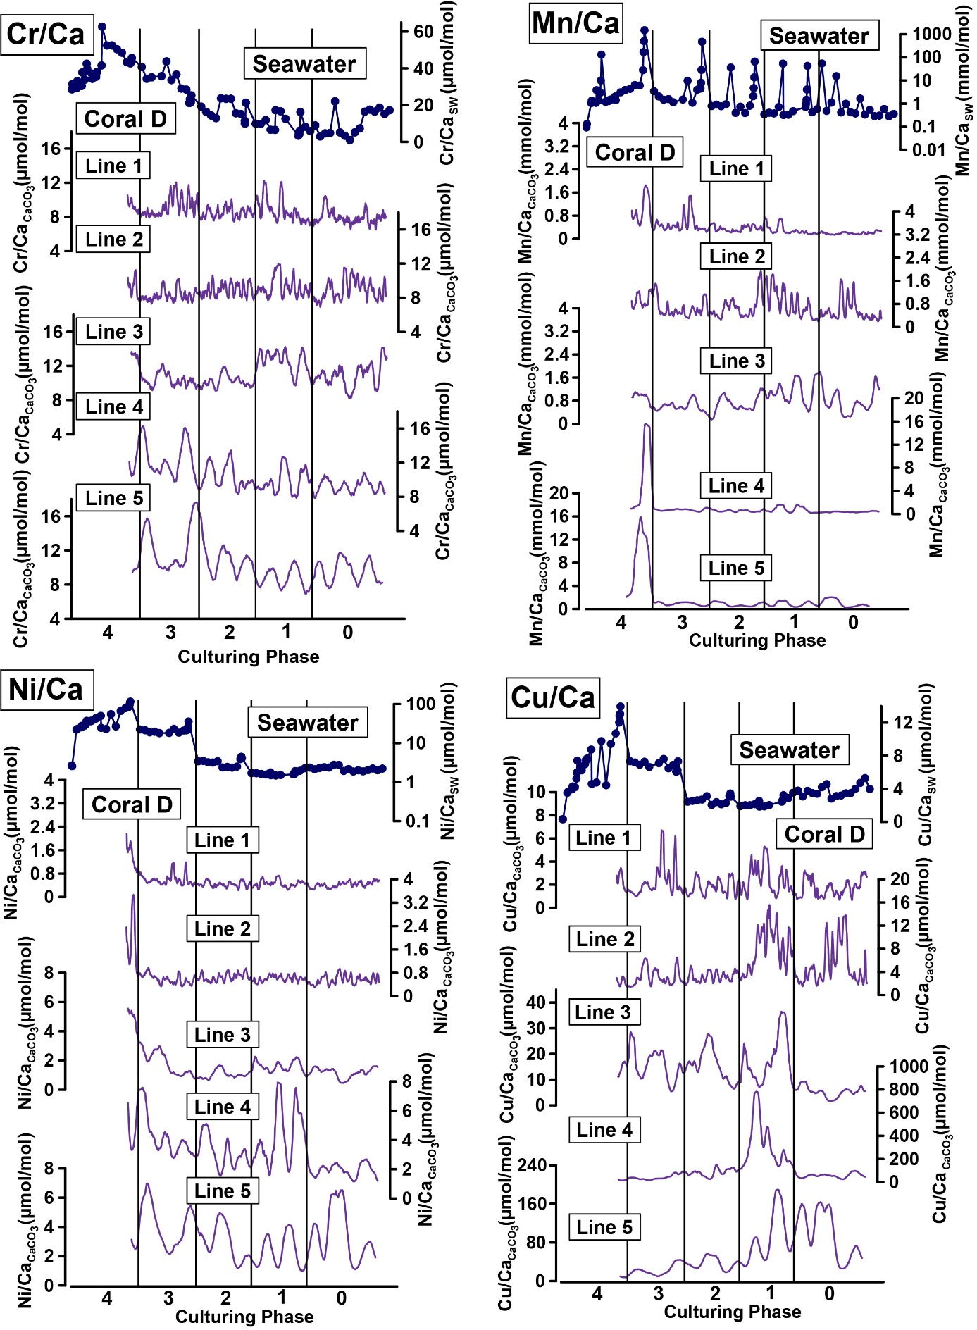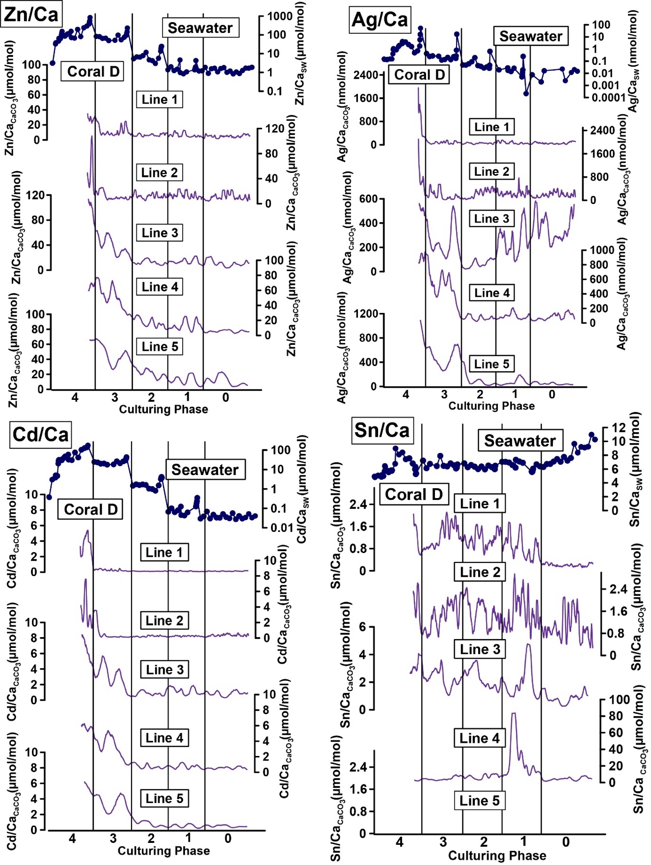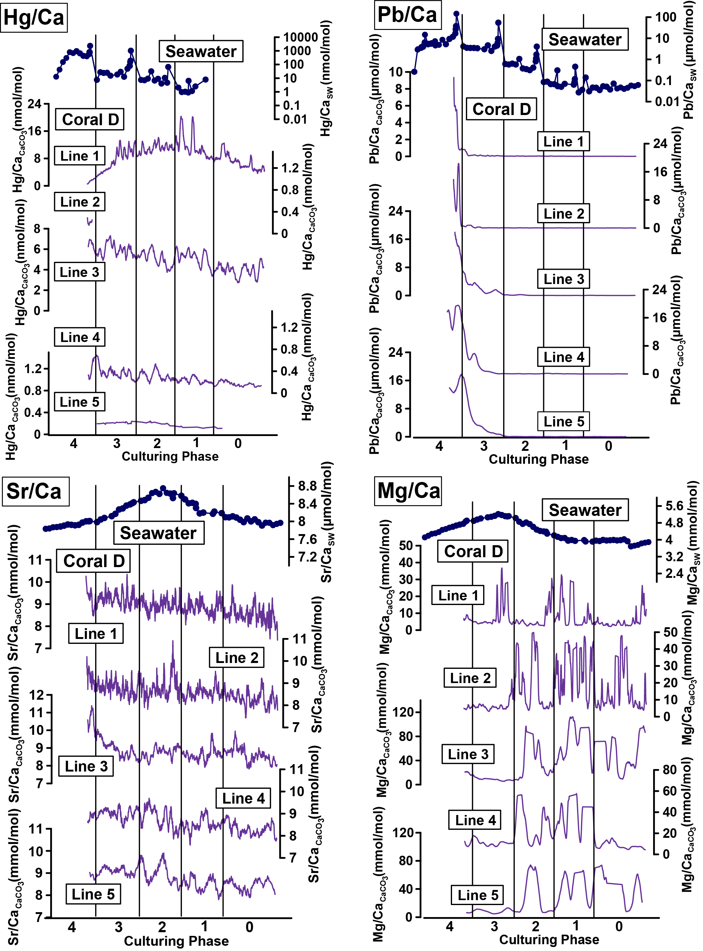

***Figure S5:*** *TE/Ca values of single lines on coral D cultured in the metal system measured by laser ablation ICP-MS and corresponding TE/Ca values in the culturing medium. To facilitate a comparison, all coral and water lines were transformed to the same Y-scale and therefore, differences in growth rates cannot be seen in this figure (see Table 3 for growth rates). Note that coral D died at the beginning of phase 4 after approximately 2.5 weeks. In some cases, Sn (line 5) and Hg (line 2, Phase 0 to 3) were not detectable. All elements but Cr, Cu, Sn, Sr and Mg are displayed with a logarithmic scale for the water measurements.*

***Table S4:*** *Mg/Ca and Sr/Ca values in the culturing medium of the metal system. CL=Metal system, W=week, D=Day, Ph=Phase.*

|  |  |  |  |  |
| --- | --- | --- | --- | --- |
| *Sample ID* | *Phase* | *Sampling  Date* | *Mg/Ca* | *Sr/Ca* |
| *Metal System* |  |  | *mmol/mol* | *µmol/mol* |
| *CL0 W2* | *0* | *16.8.19* | *3.89* | *7.97* |
| *CL0 W3* | *0* | *25.8.19* | *3.86* | *7.94* |
| *CL0 W4* | *0* | *29.8.19* | *3.83* | *7.92* |
| *CL0 W5* | *0* | *4.9.19* | *3.76* | *7.97* |
| *CL0 W6* | *0* | *9.9.19* | *3.72* | *7.97* |
| *CL0 W7* | *0* | *16.9.19* | *3.69* | *7.91* |
| *CL0 W8* | *0* | *23.9.19* | *3.93* | *7.98* |
| *CL0 W9* | *0* | *2.10.19* | *4.02* | *8.05* |
| *CL0 W10* | *0* | *7.10.19* | *3.98* | *8.00* |
| *CL0 W11* | *0* | *15.10.19* | *3.97* | *8.07* |
| *CL0 W12* | *0* | *21.10.19* | *3.99* | *7.98* |
| *CL0 W13* | *0* | *28.10.19* | *3.98* | *8.04* |
| *CL0 W14* | *0* | *4.11.19* | *3.96* | *8.09* |
| *CL0 W15* | *0* | *11.11.19* | *3.99* | *8.12* |
| *CL0 W16* | *0* | *21.11.19* | *3.94* | *8.09* |
| *CL0 W17* | *0* | *28.11.19* | *3.96* | *8.10* |
| *CL0 W18* | *0* | *5.12.19* | *3.91* | *8.19* |
| *CL0 W19* | *0* | *10.12.19* | *3.92* | *8.22* |
| *CL1 W1 D1* | *1* | *16.12.19* | *3.98* | *8.17* |
| *CL1 W1 D5* | *1* | *20.12.19* | *3.95* | *8.20* |
| *CL1 W4* | *1* | *6.1.20* | *3.99* | *8.18* |
| *CL1 W5* | *1* | *16.1.20* | *3.96* | *8.30* |
| *CL1 W6* | *1* | *23.1.20* | *3.98* | *8.40* |
| *CL1 W6 D2* | *1* | *24.1.20* | *4.08* | *8.42* |
| *CL1 W7* | *1* | *28.1.20* | *4.08* | *8.41* |
| *CL1 W8* | *1* | *6.2.20* | *4.14* | *8.50* |
| *CL1 W9* | *1* | *10.2.20* | *4.21* | *8.58* |
| *CL1 W10* | *1* | *18.2.20* | *4.29* | *8.64* |
| *CL2 W1 D1* | *2* | *24.2.20* | *4.38* | *8.53* |
| *CL2 W1 D4* | *2* | *27.2.20* | *4.39* | *8.63* |
| *CL2 W2* | *2* | *2.3.20* | *4.42* | *8.64* |
| *CL2 W3* | *2* | *9.3.20* | *4.48* | *8.75* |
| *CL2 W4* | *2* | *16.3.20* | *4.61* | *8.62* |
| *CL2 W5* | *2* | *26.3.20* | *4.74* | *8.67* |
| *CL2 W6* | *2* | *31.3.20* | *4.82* | *8.64* |
| *CL2 W7* | *2* | *7.4.20* | *4.75* | *8.53* |
| *CL2 W8* | *2* | *14.4.20* | *4.86* | *8.48* |
| *CL2 W9* | *2* | *23.4.20* | *5.03* | *8.47* |
| *CL2 W10* | *2* | *30.4.20* | *5.12* | *8.43* |
| *CL3 W1 D1* | *3* | *4.5.20* | *5.11* | *8.41* |
| *CL3 W1 D5* | *3* | *8.5.20* | *5.12* | *8.38* |
| *CL3 W2* | *3* | *12.5.20* | *5.17* | *8.36* |
| *CL3 W3* | *3* | *19.5.20* | *5.21* | *8.29* |
| *CL3 W4* | *3* | *26.5.20* | *5.13* | *8.27* |
| *CL3 W5* | *3* | *4.6.20* | *5.09* | *8.17* |
| *CL3 W6* | *3* | *11.6.20* | *5.06* | *8.12* |
| *CL3 W7* | *3* | *18.6.20* | *5.01* | *8.08* |
| *CL3 W8* | *3* | *25.6.20* | *4.96* | *8.04* |
| *CL3 W9* | *3* | *2.7.20* | *4.90* | *7.98* |
| *CL3 W10* | *3* | *9.7.20* | *4.90* | *8.01* |
| *CL4 W1 D1* | *4* | *15.7.20* | *4.87* | *8.00* |
| *CL4 W1 D4* | *4* | *17.7.20* | *4.76* | *8.00* |
| *CL4 W2* | *4* | *22.7.20* | *4.72* | *7.97* |
| *CL4 W3* | *4* | *27.7.20* | *4.67* | *7.92* |
| *CL4 W4* | *4* | *6.8.20* | *4.62* | *7.91* |
| *CL4 W5* | *4* | *13.8.20* | *4.57* | *7.92* |
| *CL4 W6* | *4* | *20.8.20* | *4.51* | *7.93* |
| *CL4 W7* | *4* | *25.8.20* | *4.47* | *7.90* |
| *CL4 W8* | *4* | *31.8.20* | *4.37* | *7.88* |
| *CL4 W9* | *4* | *7.9.20* | *4.31* | *7.87* |
| *CL4 W10* | *4* | *14.9.20* | *4.28* | *7.87* |
| *CL4 W11 D1* | *4* | *22.9.20* | *4.19* | *7.84* |
| *CL4 W12* | *4* | *28.9.20* | *4.11* | *7.83* |
| *CL4 W13 D1* | *4* | *5.10.20* | *4.00* | *7.82* |

***Table S5:*** *Average concentration, RSD (1σ in %), literature values, accuracy in comparison to literature values and number of measurements of the reference materials SLRS-6, SLEW-3, in-house reference materials (South Atlantic surface water and South Atlantic Gyre water) and NASS-6 measured with ICP-MS. Average concentration, RSD and accuracy values displayed here are averaged from single measuring days. Cr values are analysed after dilution of the samples and all other elements were analyses after preconcentration with a SeaFAST system. NRCC-National Research Council Canada. *Values originated from 1:10 dilution of SLRS-6. See also Schmidt et al.,* *2022.*

|  |  |  |  |  |  |  |  |
| --- | --- | --- | --- | --- | --- | --- | --- |
| *Reference  Materials* | *Cr* | *Mn* | *Ni* | *Cu* | *Zn* | *Cd* | *Pb* |
| ***SLRS-6*** | *nmol kg-1* | *nmol kg-1* | *nmol kg-1* | *nmol kg-1* | *nmol kg-1* | *nmol kg-1* | *nmol kg-1* |
| *Average conc.* | *4732* | *52956* | *9811* | *338014\** | *31391\** | *62* | *786* |
| *RSD%* | *3.5* | *3.9* | *6.0* | *1.7\** | *7.2\** | *12.8* | *0.8* |
| *Yeghicheyan  et al.,* *2019* | *4509* | *38616* | *10496* | *376378\** | *26920\** | *56* | *820* |
| *Accuracy* | *0.96* | *0.74* | *1.08* | *1.11\** | *0.86\** | *0.90* | *1.04* |
| *Number* | *4* | *11* | *11* | *13\** | *13\** | *7* | *7* |
| ***SLEW-3*** |  |  |  |  |  |  |  |
| *Average conc.* |  | *40007* | *17508* | *22907* | *4442* | *343* |  |
| *RSD%* |  | *4.3* | *3.5* | *4.2* | *9.1* | *4.8* |  |
| *Leonhard et al.,* *2019* |  | *29326* | *20958* | *24409* | *3074* | *427* |  |
| *Accuracy* |  | *0.74* | *1.21* | *1.07* | *0.78* | *1.28* |  |
| *Number* |  | *12* | *12* | *12* | *12* | *12* |  |
| *South Atlantic Gyre water* | | |  |  |  |  |  |
| *Average conc.* |  | *1615* | *2189* | *2649* | *5614* |  |  |
| *RSD%* |  | *6.2* | *3.7* | *5.3* | *13.2* |  |  |
| *Number* |  | *10* | *10* | *10* | *10* |  |  |
| *South Atlantic surface water* | | |  |  |  |  |  |
| *Average conc.* |  | *1959* | *2417* | *2646* | *39718* |  |  |
| *RSD%* |  | *6.8* | *2.8* | *5.8* | *2.2* |  |  |
| *Number* |  | *6* | *6* | *6* | *6* |  |  |
| ***NASS-6*** |  |  |  |  |  |  |  |
| *Average conc.* | *6747* | *11162* | *3557* | *5206* | *5158* | *169* |  |
| *RSD%* | *15.9* | *5.2* | *3.2* | *3.0* | *25.3* | *7.0* |  |
| *NRCC* | *2293* | *9654* | *5129* | *3528* | *3931* | *165* |  |
| *Accuracy* | *0.34* | *0.87* | *0.76* | *0.35* | *0.81* | *0.98* |  |
| *Number* | *9* | *11* | *11* | *11* | *11* | *2* |  |

***Table S6:*** *Average concentration, RSD (1σ in %), literature values, accuracy in comparison to literature values and number of measurements of the reference materials NIST SRM 614, JCt-1, JCp-1, MACS-3 and ECRM752-1 measured with LA-ICP-MS. For the ECRM752-1 no reported values for the elements of interest are available, which is also the case for some elements in other reference materials. The Hg/Ca values in the NIST glasses are not reliable as Hg is volatile and most likely volatilized during the glass formation. Average concentration, RSD and accuracy values displayed here are averaged from single measuring days.*

|  |  |  |  |  |  |  |  |  |  |  |
| --- | --- | --- | --- | --- | --- | --- | --- | --- | --- | --- |
| *Reference materials* | *Cr/Ca* | *Mn/Ca* | *Ni/Ca* | *Cu/Ca* | *Zn/Ca* | *Ag/Ca* | *Cd/Ca* | *Sn/Ca* | *Hg/Ca* | *Pb/Ca* |
| *NIST SRM 614* | *µmol mol-1* | *µmol mol-1* | *µmol mol-1* | *µmol mol-1* | *µmol mol-1* | *µmol mol-1* | *µmol mol-1* | *µmol mol-1* | *µmol mol-1* | *µmol mol-1* |
| *Mean value* | *14.30* | *10.93* | *9.74* | *10.22* | *85.88* | *1.82* | *3.13* | *6.05* | *0.28* | *5.70* |
| *RSD%* | *6.89* | *6.04* | *10.77* | *2.31* | *1.80* | *2.88* | *4.95* | *2.96* | *45.43* | *3.29* |
| *Jochum et al.,* *2011* | *10.78* | *12.18* | *8.83* | *10.16* | *20.11* | *1.83* | *2.35* | *6.67* |  | *5.28* |
| *Accuracy* | *0.79* | *1.12* | *0.93* | *0.99* | *0.23* | *1.01* | *0.79* | *1.11* |  | *0.93* |
| *Number of spots* | *24* | *24* | *24* | *24* | *24* | *24* | *24* | *24* | *12* | *24* |
| *MACS-3* | *mmol mol-1* | *mmol mol-1* | *mmol mol-1* | *mmol mol-1* | *mmol mol-1* | *mmol mol-1* | *mmol mol-1* | *mmol mol-1* | *µmol mol-1* | *mmol mol-1* |
| *Mean value* | *0.21* | *0.96* | *0.09* | *0.18* | *0.15* | *0.06* | *0.05* | *0.04* | *5.41* | *0.03* |
| *RSD%* | *1.08* | *1.39* | *1.28* | *1.27* | *1.96* | *4.51* | *2.53* | *2.05* | *11.41* | *2.51* |
| *Jochum et al.,* *2019* | *0.23* | *0.99* | *0.10* | *0.19* | *0.20* | *0.05* | *0.05* | *0.05* | *5.41* | *0.03* |
| *Accuracy* | *1.10* | *1.04* | *1.10* | *1.10* | *1.39* | *0.87* | *1.11* | *1.16* | *1.00* | *1.20* |
| *Number of spots* | *22* | *22* | *22* | *22* | *22* | *22* | *22* | *22* | *22* | *22* |
| *JCt-1NP* | *µmol mol-1* | *µmol mol-1* | *µmol mol-1* | *µmol mol-1* | *µmol mol-1* | *µmol mol-1* | *µmol mol-1* | *µmol mol-1* | *µmol mol-1* | *µmol mol-1* |
| *Mean value* | *8.70* | *0.78* | *0.61* | *1.19* | *1.95* | *0.003* | *0.08* | *0.01* | *0.20* | *0.07* |
| *RSD%* | *2.40* | *3.31* | *3.52* | *3.71* | *6.30* | *26.03* | *24.17* | *10.77* | *20.54* | *2.65* |
| *Jochum et al., 2019* | *0.93* | *1.01* | *1.03* | *1.48* |  |  |  |  |  | *0.06* |
| *Accuracy* | *0.03* | *0.55* | *0.33* | *1.20* |  |  |  |  |  | *0.71* |
| *Number of spots* | *38* | *38* | *38* | *38* | *38* | *36* | *38* | *38* | *29* | *38* |
| *JCp-1NP* | *µmol mol-1* | *µmol mol-1* | *µmol mol-1* | *µmol mol-1* | *µmol mol-1* | *µmol mol-1* | *µmol mol-1* | *µmol mol-1* | *µmol mol-1* | *µmol mol-1* |
| *Mean value* | *11.93* | *1.63* | *1.77* | *0.92* | *1.59* | *0.01* | *0.07* | *0.07* | *0.02* | *0.14* |
| *RSD%* | *6.30* | *5.22* | *6.39* | *4.42* | *5.21* | *12.29* | *12.56* | *10.49* | *14.81* | *4.85* |
| *Jochum et al., 2019* | *1.27* | *2.16* | *1.05* | *1.29* | *3.53* |  |  |  |  | *0.15* |
| *Accuracy* | *5.78* | *0.61* | *4.72* | *1.26* | *0.51* |  |  |  |  | *0.67* |
| *Number of spots* | *34* | *34* | *34* | *34* | *34* | *34* | *34* | *34* | *20* | *34* |
| *ECRM752-1* | *µmol mol-1* | *µmol mol-1* | *µmol mol-1* | *µmol mol-1* | *µmol mol-1* | *µmol mol-1* | *µmol mol-1* | *µmol mol-1* | *µmol mol-1* | *µmol mol-1* |
| *Mean value* | *162.31* | *4.77* | *2.75* | *10.60* | *0.005* | *0.59* | *0.06* | *0.05* | *0.92* | *0.92* |
| *RSD%* | *2.25* | *5.41* | *5.76* | *3.51* | *16.41* | *2.29* | *5.79* | *18.44* | *5.56* | *5.56* |
| *Number of spots* | *22* | *22* | *22* | *22* | *22* | *22* | *22* | *19* | *22* | *22* |

***References***

*Al-Rousan S.A., Al-Shloul R.N., Al-Horani F.A., Abu-Hilal A.H. (2007) Heavy metal contents in growth bands of Porites corals: Record of anthropogenic and human developments from the Jordanian Gulf of Aqaba. Marine Pollution Bulletin,* ***54****, 1912–1922.*

*Carriquiry J.D., Villaescusa J.A. (2010) Coral Cd/Ca and Mn/Ca records of ENSO variability in the Gulf of California. Climate of the Past,* ***6****, 401–410.*

*Cooper T.F., De'Ath G., Fabricius K.E., Lough J.M. (2008) Declining coral calcification in massive Porites in two nearshore regions of the northern Great Barrier Reef. Global Change Biology,* ***14****, 529–538.*

*Edinger E.N., Risk M.J. (2000) Effect of land-based pollution on central Java coral reefs. Journal of Coastal Development, 3, 593–613.*

*Fallon S.J., McCulloch M.T., van Woesik R., Sinclair D.J. (1999) Corals at their latitudinal limits: Laser ablation trace element systematics in Porites from Shirigai Bay, Japan. Earth and Planetary Science Letters,* ***172****, 221–238.*

*Grottoli, A. G., Matthews, K. A., Palardy, J. E., & McDonough, W. F. (2013). High resolution coral Cd measurements using LA-ICP-MS and ID-ICP-MS: Calibration and interpretation. Chemical Geology, 356, 151–159. <https://doi.org/10.1016/j.chemgeo.2013.08.024>*

*Guzmán H.M., Cortes J. (1989) Growth rates of eight species of scleractinian corals in the eastern Pacific (Costa Rica). Bulletin of Marine Science,* ***44****, 1186–1194.*

*Jiang W., Yu K., Wang N., Yang H., Yang H., Xu S., Wei C., Wang S., Wang Y. (2020) Distribution coefficients of trace metals between modern coral-lattices and seawater in the northern South China Sea: Species and SST dependencies. Journal of Asian Earth Sciences,* ***187****, 104082.*

*Jochum K.P., Garbe‐Schönberg D., Veter M., Stoll B., Weis U., Weber M., Lugli F., Jentzen A., Schiebel R., Wassenburg J.A. (2019) Nano‐powdered calcium carbonate reference materials: Significant progress for microanalysis? Geostandards and Geoanalytical Research,* ***43****, 595–609.*

*Jochum K.P., Weis U., Stoll B., Kuzmin D., Yang Q., Raczek I., Jacob D.E., Stracke A., Birbaum K., Frick D.A. (2011) Determination of reference values for NIST SRM 610–617 glasses following ISO guidelines. Geostandards and Geoanalytical Research,* ***35****, 397–429.*

*Klein R., Loya Y. (1991) Skeletal growth and density patterns of two Porites corals from the Gulf of Eilat, Red Sea. Marine Ecology Progress Series,* ***77****, 253–259.*

*Leonard N.D., Welsh K.J., Nguyen A.D., Sadler J., Pandolfi J.M., Clark T.R., Zhao J.X., Feng Y.X., Webb G.E. (2019) High resolution geochemical analysis of massive Porites spp. corals from the Wet Tropics, Great Barrier Reef: Rare earth elements, yttrium and barium as indicators of terrigenous input. Marine Pollution Bulletin, 149, 110634.*

*Linn L.J., Delaney M.L., Druffel E.R.M. (1990) Trace metals in contemporary and seventeenth-century Galapagos coral: Records of seasonal and annual variations. Geochimica et Cosmochimica Acta,* ***54****, 387–394.*

*Livingston H.D., Thompson G. (1971) Trace Element concentration in some modern corals. Limnology and Oceanography,* ***16****, 786–796.*

*Lough J.M., Barnes D.J., Devereux M.J., Tobin B.J., Tobin S. (1999) Variability in growth characteristics of massive Porites on the Great Barrier Reef. CRC Reef Research Technical Report No.28 Australian Institute of Marine Science, Townsville.*

*Mokhtar M.B., Praveena S.M., Aris A.Z., Yong O.C., Lim A.P. (2012) Trace metal (Cd, Cu, Fe, Mn, Ni and Zn) accumulation in Scleractinian corals: A record for Sabah, Borneo. Marine Pollution Bulletin,* ***64****, 2556–2563.*

*Prouty N.G., Hughen K.A., Carilli J. (2008) Geochemical signature of land-based activities in Caribbean coral surface samples. Coral Reefs,* ***27****, 727–742.*

*Schmidt S., Hathorne E.C., Schönfeld J., Garbe-Schönberg D. (2022) Heavy metal uptake of nearshore benthic foraminifera during multi-metal culturing experiments. Biogeosciences,* ***19****(3), 629–664.*

*Shen G.T. (1986) Lead and cadmium geochemistry of corals: Reconstruction of historic perturbations in the upper ocean.*

*Shen G.T. (1996) Rapid changes in the tropical ocean and the use of corals as monitoring systems. Berger A (ed) Geoindicator: assessing rapid environmental changes in earth systems. Brokfield, Rotterdam, pp 125–169.*

*Shen G.T., Boyle E.A. (1988) Determination of lead, cadmium and other trace metals in annually-banded corals. Chemical Geology,* ***67****, 47–62.*

*Shen G.T., Campbell T.M., Dunbar R.B., Wellington G.M., Colgan M.W., Glynn P.W. (1991) Paleochemistry of manganese in corals from the Galapagos Islands. Coral Reefs,* ***10****, 91–100.*

*Shen G.T., Sanford C.L. (1990) Trace element indicators of climate variability in reef-building corals. In Elsevier oceanography series, pp. 255–283: Elsevier.*

*Smith L.W., Barshis D., Birkeland C. (2007) Phenotypic plasticity for skeletal growth, density and calcification of Porites lobata in response to habitat type. Coral Reefs,* ***26****, 559–567*

*Tortolero-Langarica J.J.A., Rodríguez-Troncoso A.P., Carricart-Ganivet J.P., Cupul-Magaña A.L. (2016) Skeletal extension, density and calcification rates of massive free-living coral Porites lobata Dana, 1846. Journal of Experimental Marine Biology and Ecology,* ***478****, 68–76.*

*Veeh H.H., Turekian K.K. (1968) Cobalt, silver, and uranium concentrations of reef-building corals in the pacific ocean. Limnology and Oceanography,* ***13****, 304–308.*

*Yeghicheyan D., Aubert D., Bouhnik‐le Coz M., Chmeleff J., Delpoux S., Djouraev I., Granier G., Lacan F., Piro J.‐l., Rousseau T. (2019) A new interlaboratory characterisation of silicon, rare earth elements and twenty‐two other trace element concentrations in the natural river water certified reference material SLRS‐6 (NRC‐CNRC). Geostandards and Geoanalytical Research,* ***43****, 475–496.*