## Supplementary material

## Section A: Study area & sampling

Ein Bild, das Karte, Text, Diagramm, Atlas enthält.

Figure S1. Salinity and temperature maps of the lagoons around Rügen island, Germany, interpolated for the time between January 2005 and December 2022. A: Annual mean salinity in PSU; B: Annual variability (monthly standard deviation) of salinity in PSU; C: Annual mean temperature in °C; D: Mean annual temperature range over the period 2005-2022 in °C. White points indicate measuring buoys of salinity and temperature (data source: Landesamt für Umwelt, Naturschutz und Geologie in Mecklenburg-Vorpommern, MV).

Table S1. Overview of sampling of 113 northern pike from the lagoons around Rügen island, Germany between July 2019 and April 2022, indicating date and place of capture along with employed gear.

|  |  |  |  |
| --- | --- | --- | --- |
| **Capture area** | **Sampling date** | **N** | **Gear** |
| WRBC | 01.11.2019 – 31.12.2019 | 13 | Fyke |
| WRBC | 01.01.2020 – 18.02.2020 | 10 | Gillnet |
| WRBC | 01.05.2020 – 31.05.2020 | 2 | Fyke |
| NRBC | 01.01.2020 – 28.02.2020 | 25 | Gillnet/Fyke |
| NRBC | 01.05.2020 – 31.05.2020 | 2 | Angling |
| GB | 01.11.2019 – 30.11.2019 | 2 | Angling |
| GB | 01.11.2020 – 31.01.2021 | 16 | Angling/Gillnet |
| Barthe | 01.07.2019 – 31.07.2019 | 6 | Electrofishing |
| Barthe | 01.03.2022 – 31.04.2022 | 17 | Electrofishing |
| Peene | 01.07.2019 – 31.07.2019 | 5 | Electrofishing |
| Sehrowbach | 01.04.2021 – 31.04.2021 | 5 | Electrofishing |
| Sehrowbach | 01.03.2022 – 31.04.2022 | 17 | Electrofishing |
| Ziese | 01.04.2021 – 31.04.2021 | 5 | Electrofishing |
| NHG | 01.04.2021 – 31.04.2021 | 3 | Electrofishing |
| Badendycksgraben | 01.03.2021 – 31.03.2021 | 2 | Electrofishing |

Ein Bild, das Text, Screenshot, Diagramm, Reihe enthält.

Figure S2. Age and sex distribution of 113 northern pike captured in brackish lagoons and tributaries around Rügen island in Northern Germany between July 2019 and April 2022.

Ein Bild, das Text, Diagramm, Screenshot, Reihe enthält.

Figure S3. Size (total length, mm) and sex distribution of 113 northern pike captured in brackish lagoons and tributaries around Rügen island in Northern Germany between July 2019 and April 2022.

## Section B: EPMA maps of key trace elements and of the major element Ca

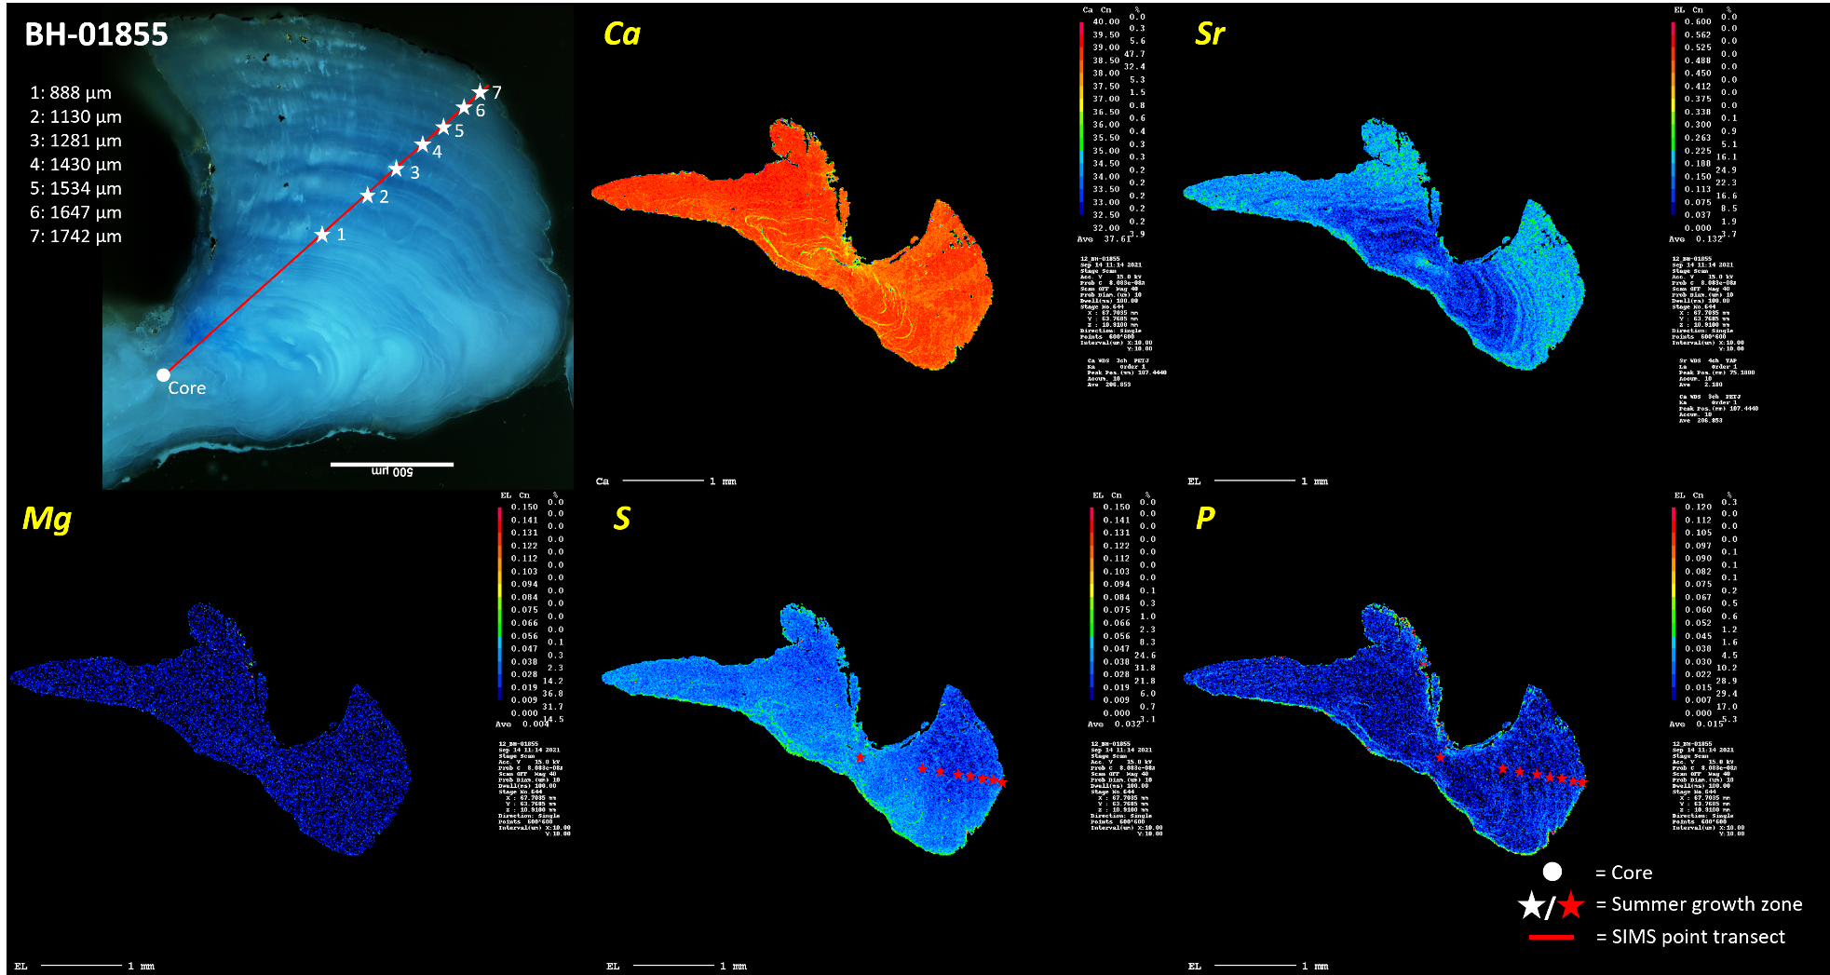

Figure S4. Dark field optical microscope image (upper left panel) and EPMA maps of the elements calcium, strontium, magnesium, sulfur and phosphorus (in order from left-right and top-bottom) of pike otolith specimen BH-01855, a seven-year-old male pike sampled from WRBC in May 2020 at 72.2 cm total length. Symbols mark positions of summer growth zones in the dark field image and the EPMA scans of organic proxies sulfur and phosphorus.

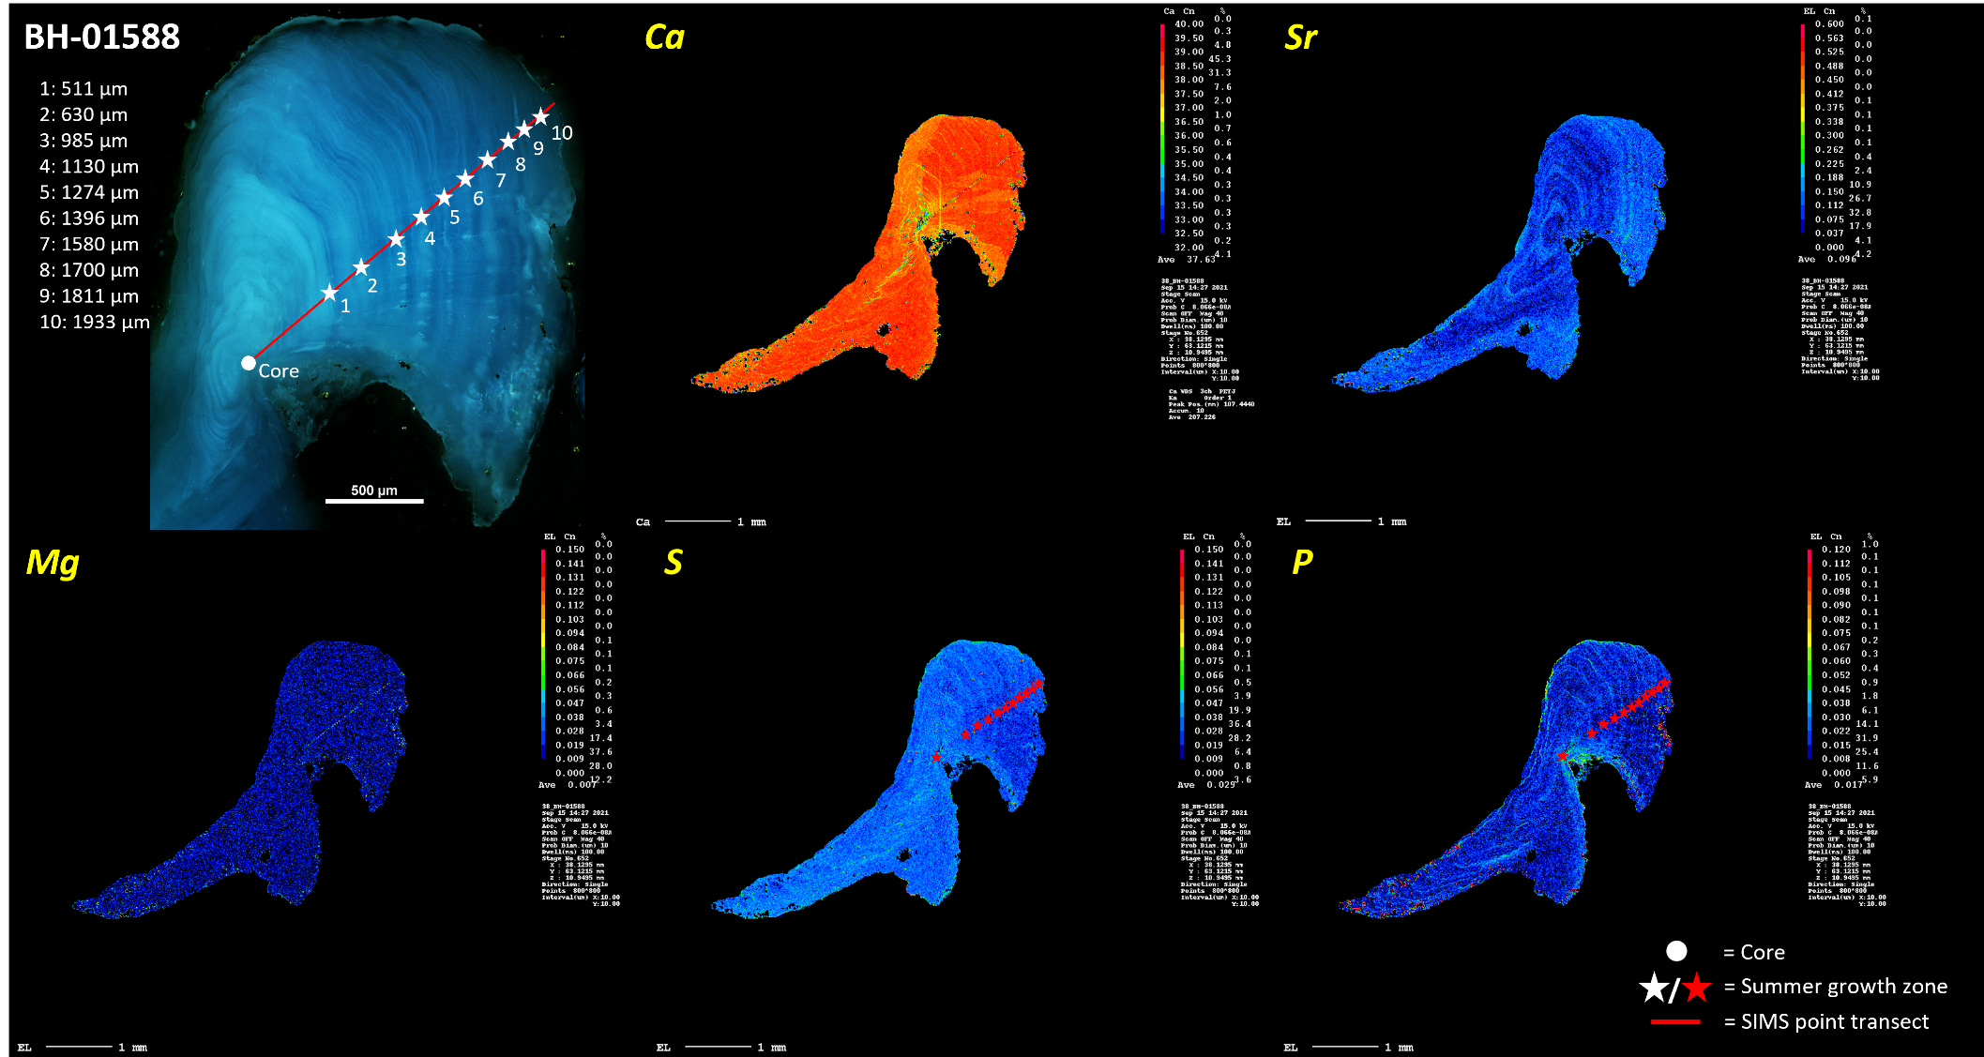

Figure S5. Dark field optical microscope image (upper left panel) and EPMA maps of the elements calcium, strontium, magnesium, sulfur and phosphorus (in order from left-right and top-bottom) of pike otolith specimen BH-1588, a 10-year-old female pike sampled from NRBC in February 2020 at 105 cm total length. Symbols mark positions of summer growth zones in the dark field image and the EPMA scans of organic proxies sulfur and phosphorus.

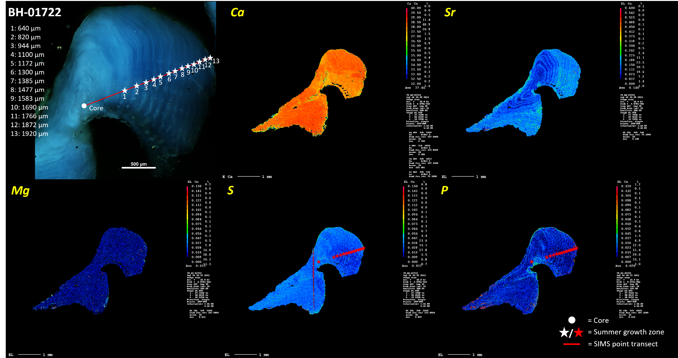

Figure S6. Dark field optical microscope image (upper left panel) and EPMA maps of the elements calcium, strontium, magnesium, sulfur and phosphorus (in order from left-right and top-bottom) of pike otolith specimen BH-01722, a 13-year-old female pike sampled from NRBC in February 2020 at 95.0 cm total length. Symbols mark positions of summer growth zones in the dark field image and the EPMA scans of organic proxies sulfur and phosphorus.

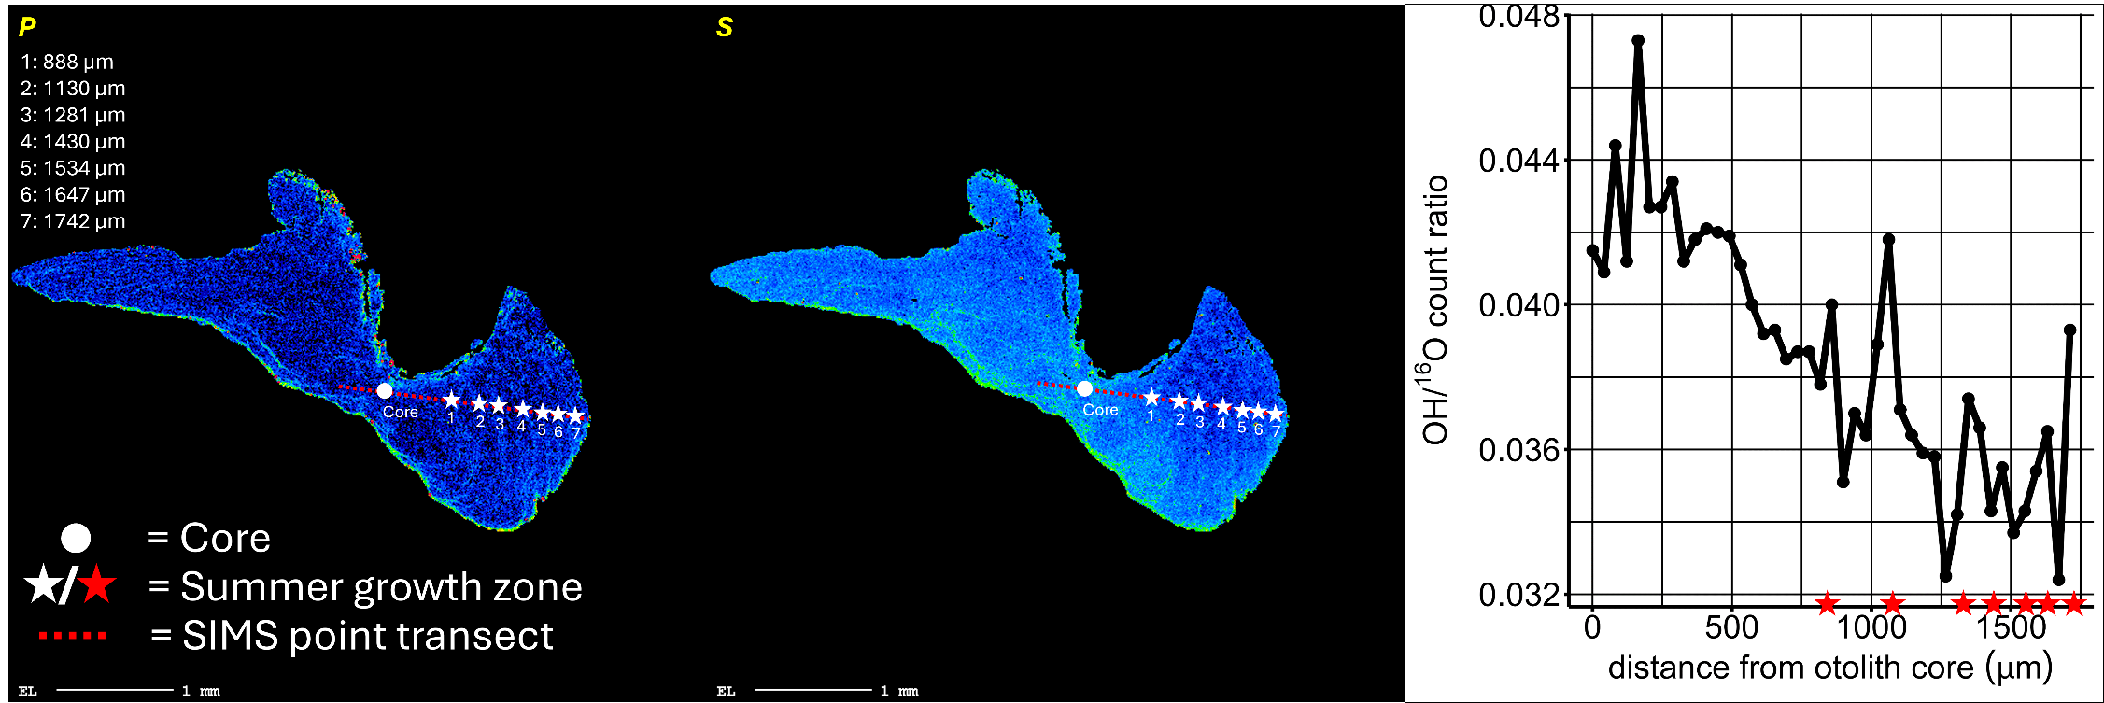

Figure S7. EPMA element map of P (left) and S (middle), and OH/16O plot (right), for otolith specimen BH-01855, a seven-year-old male pike sampled from WRBC in May 2020 at 72.2 cm total length. Symbols mark positions of summer growth zones in the EPMA scans of organic proxies sulfur and phosphorus, and the SIMS point transect.

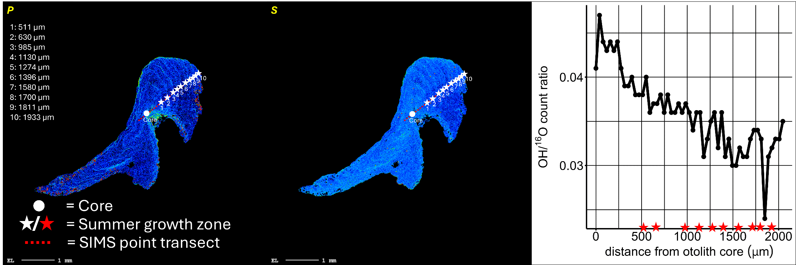

Figure S8. EPMA element map of P (left) and S (middle), and OH/16O plot (right), for otolith specimen BH-1588, a 10-year-old female pike sampled from NRBC in February 2020 at 105 cm total length. Symbols mark positions of summer growth zones in the EPMA scans of organic proxies sulfur and phosphorus, and the SIMS point transect.

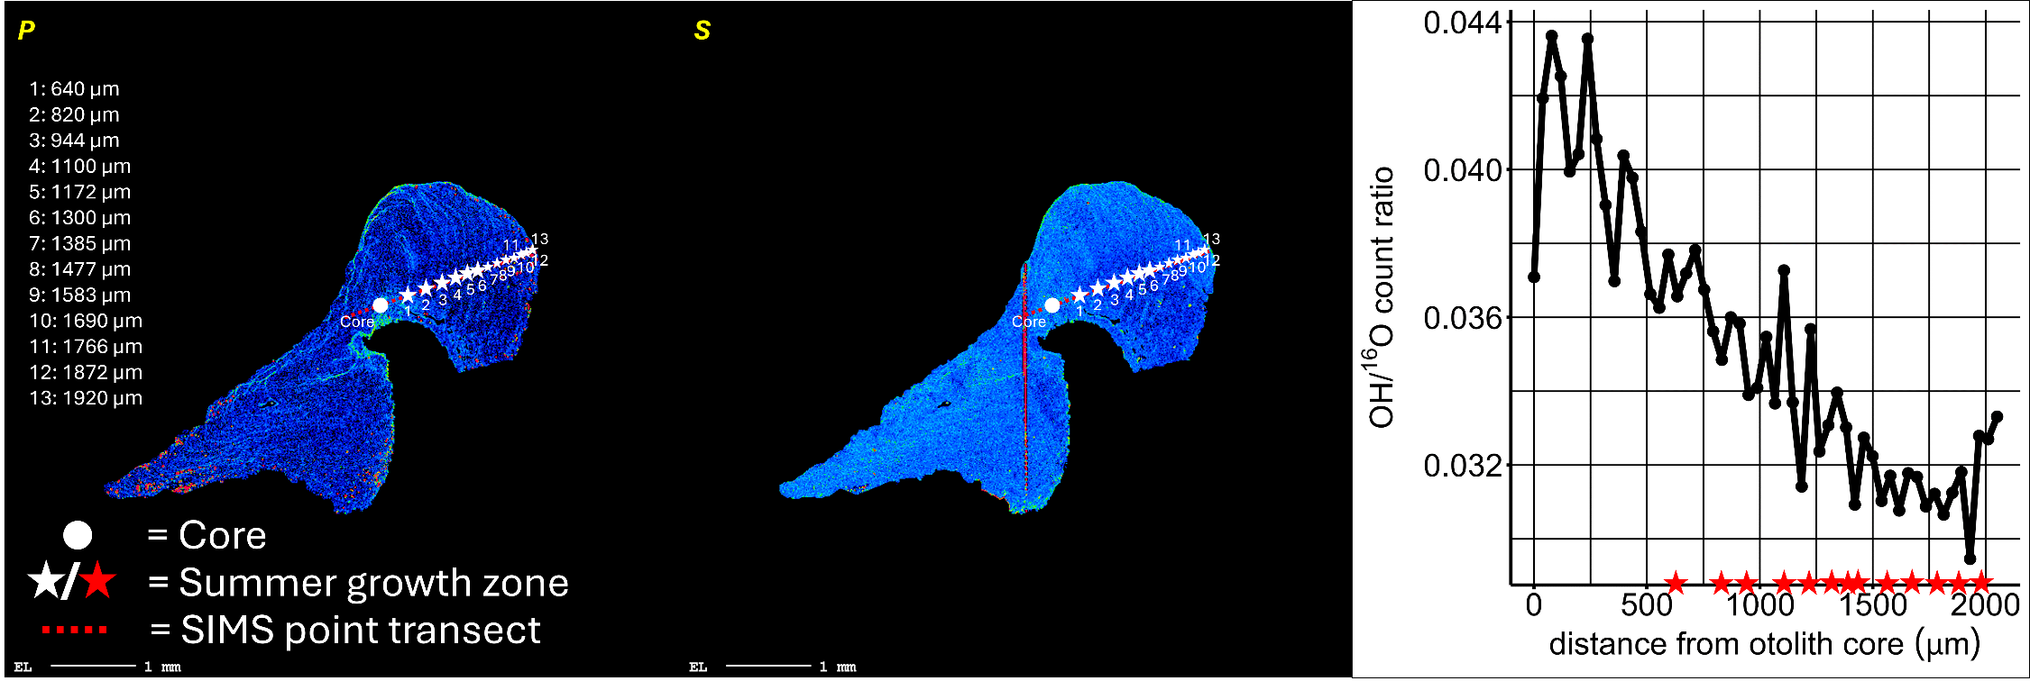

Figure S9. EPMA element map of P (left) and S (middle), and OH/16O plot (right), for otolith specimen BH-01722, a 13-year-old female pike sampled from NRBC in February 2020 at 95.0 cm total length. Symbols mark positions of summer growth zones in the EPMA scans of organic proxies sulfur and phosphorus, and the SIMS point transect.

## Section C: Linear mixed modelling of intra-otolith δ18O

## 

Figure S10. Fitted vs. residuals assessing the heterogeneity of residuals of the linear mixed effect model predicting intra-otolith δ18O values from OH/16O, Sr/Ca, distance from otolith core (µm), yearly otolith increment, capture location and sex, with individual ID as a random predictor on data of 113 northern pike captured between July 2019 and April 2022 in the lagoons and several tributaries around Rügen island in German and a control lake. Patterns or skew would indicate a violation of the variance heterogeneity assumptions of the model.

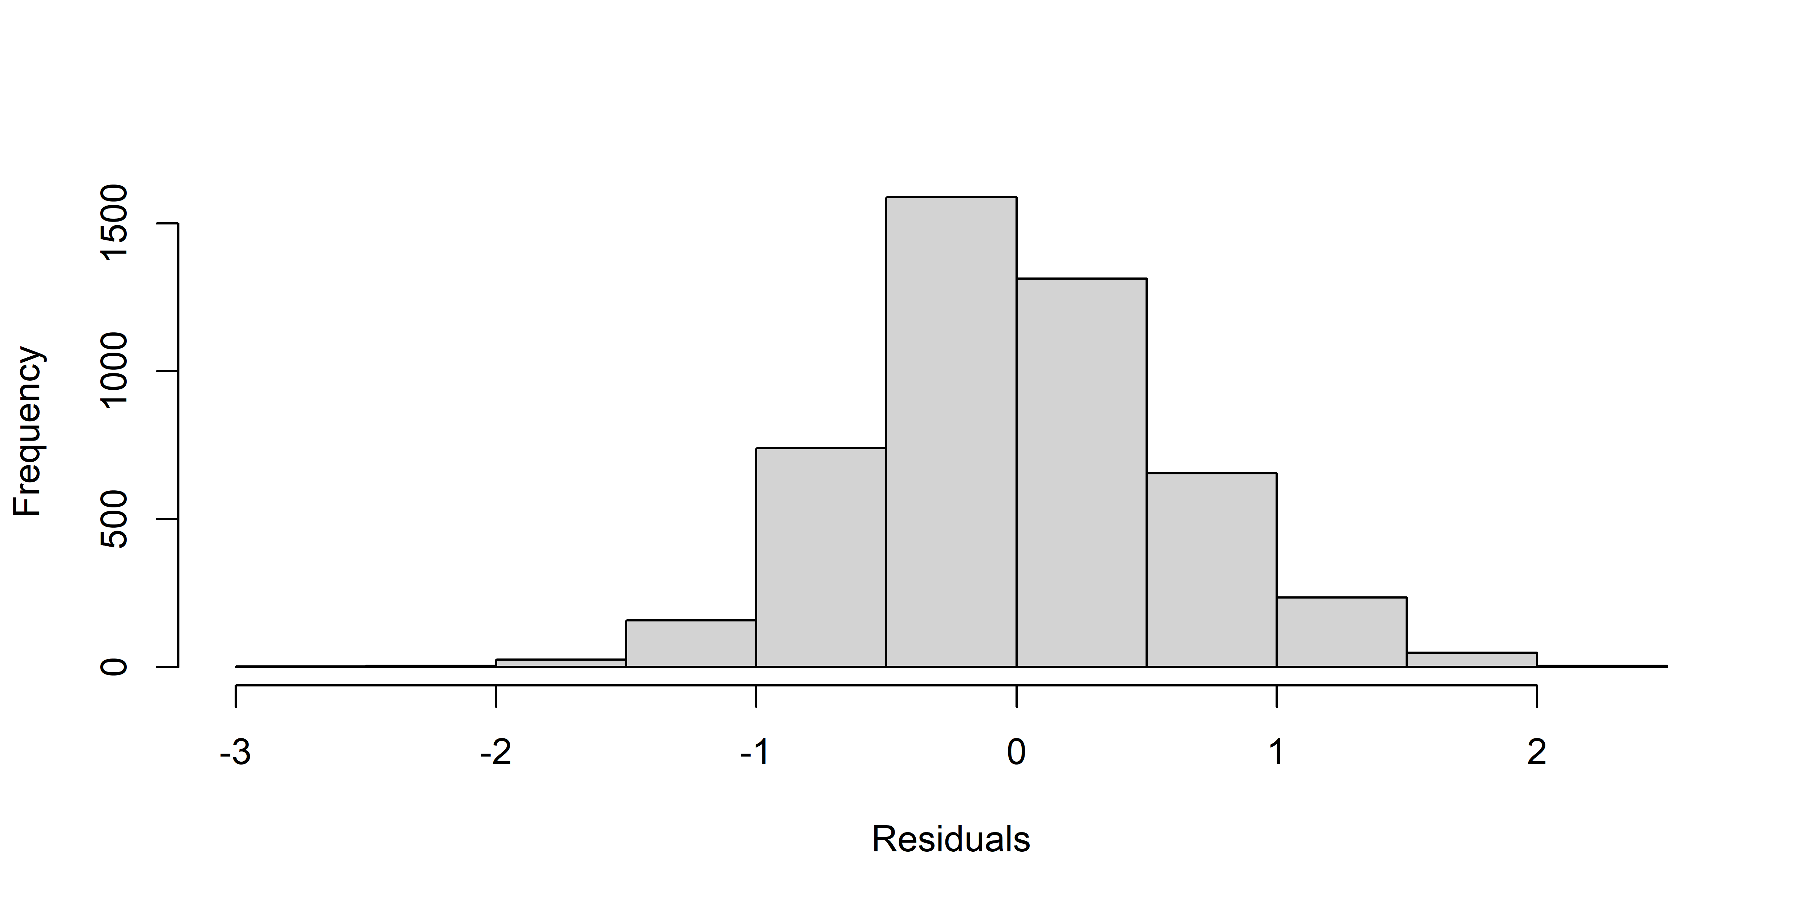

Figure S11. Histogram of residuals for assessing normality of residuals for the linear mixed effect model predicting intra-otolith δ18O values from OH/16O, Sr/Ca, distance from otolith core (µm), yearly otolith increment, capture location and sex, with individual ID as a random predictor on data of 113 northern pike captured between July 2019 and April 2022 in the lagoons and several tributaries around Rügen island in German and a control lake. Deviations from a normal distribution for this plot would indicate a violation of the normality of residual distribution assumption of the model.

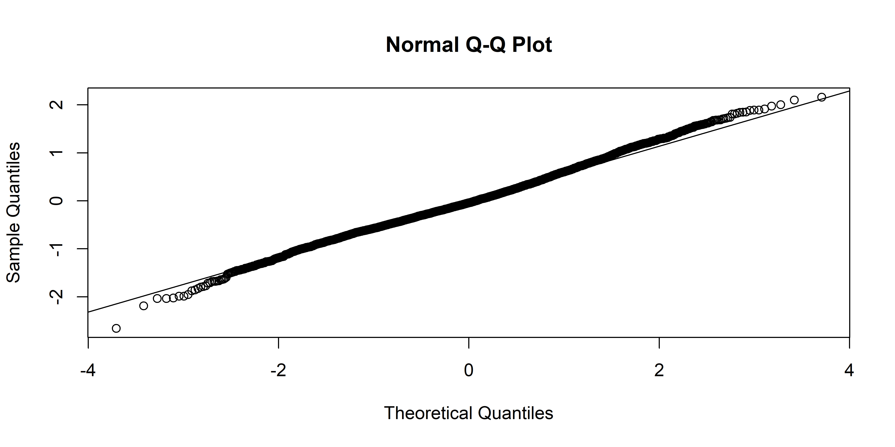

Figure S12. Residual qqplot for assessing normality of residuals of the linear mixed effect model predicting intra-otolith δ18O values from OH/16O, Sr:Ca, distance from otolith core (µm), yearly otolith increment, capture location and sex, with individual ID as a random predictor on data of 113 northern pike captured between July 2019 and April 2022 in the lagoons and several tributaries around Rügen island in German and a control lake. Deviations from the diagonal line would be indicative of deviations from normality of the residuals.

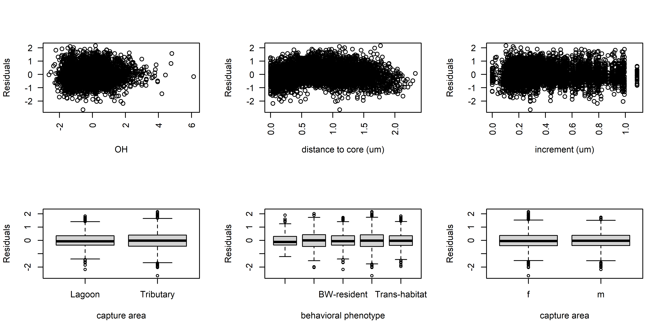

Figure S13. Residuals vs. fitted for the fixed predictors to assess heterogeneity of residuals dependent on used predictors used in the linear mixed effect model predicting intra-otolith δ18O values from OH/16O, Sr/Ca, distance from otolith core (µm), yearly otolith increment, capture location and sex, with individual ID as a random predictor on data of 113 northern pike captured between July 2019 and April 2022 in the lagoons and several tributaries around Rügen island in German and a control lake. Patterns, skew or strong differences between groups – which are not seen here – would indicate deviations from the assumption of heterogeneity of variances of the model.

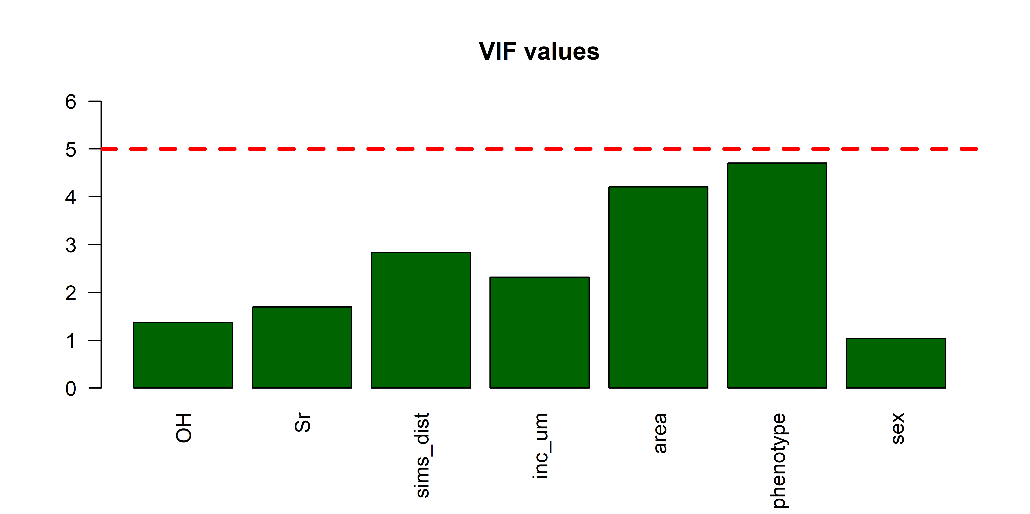

Figure S14. Variance inflation factors (VIF) for each of the fixed effects used in the linear mixed effect model predicting intra-otolith δ18O values from OH/16O, Sr/Ca, distance from otolith core (µm), yearly otolith increment, capture location and sex, with individual ID as a random predictor for data from 113 northern pike captured between July 2019 and April 2022 in the lagoons and several tributaries around Rügen island in German and a control lake. High values crossing the red dotted line, i.e., values higher than five, would indicate multicollinearity problems and a violation of the assumption of independency of predictors.