Supporting Information to:

**Widespread environmental contamination from relic munitions in the southwestern Baltic Sea**

Aaron J. Beck, Martha Gledhill, Ulf Gräwe, Mareike Kampmeier, Anja Eggert, Christian Schlosser, Beate Stamer, Jens Greinert, Eric P. Achterberg

Contents:

1. Detailed methods description
2. 8 figures
3. References

**1 Detailed Methods**

**1.1 Dissolved and particulate munition compounds**

Water column samples were collected with a CTD-mounted Niskin-rosette. Munition compounds were extracted at sea using a method adapted from Gledhill et al. (2019) to allow simultaneous processing of many samples. One-liter samples were filled into infusion bags and spiked with stable isotope-labeled TNT and DNB. The sample was then passed by gravity through a glass fiber filter (GF/F; MF300, Fisher) in a Swinnex filter holder and then through a solid-phase extraction column (SPE; Chromabond EASY, Machery-Nagel). After extraction, the GF/F filters and SPE columns were rinsed with a few mL of ultrapure water (MilliQ, Millipore) and stored frozen until further processing. Tests showed that this method gives recoveries similar to those in the original method and precision on triplicate samples of 5-8%. In the land-based laboratory, SPE columns were eluted with 1 mL of Optima-grade acetonitrile (ACN; Fisher), evaporated to near dryness, and taken up in 200 µl of 50:50 v:v Optima-grade methanol and water. Particles collected on the filters were extracted with 1 mL Optima-grade ACN under sonication for 15 minutes. The extract was then transferred to a second vial, and re-concentrated by evaporation as for SPE samples.

**1.2 Sediment munition compounds**

Sediment samples were collected with a Van Veen grab, multi-corer, or by hand by divers. Sediments were collected in plastic bags (Whirl-Pak) and frozen at -20°C until analysis. Sediment cores were sliced at 2 cm intervals to approximately 20 cm depth, the edges of the slices removed to avoid cross-contamination by smearing along the core barrel, and transferred to Whirl-Pak bags and frozen. In the land-based laboratory, sediments were thawed under cool and dark conditions and homogenized by stirring. Aliquots of 5 g were transferred to polypropylene centrifuge tubes, and extracted by sonication for 15 min with 20 mL of Optima-grade ACN. The ACN was spiked with stable isotope-labeled TNT and DNB to monitor analyte recoveries. The extracts were then centrifuged and the supernatant decanted into a glass beaker. The ACN extracts were diluted 10-fold with ultrapure water and the explosive compounds extracted by SPE. SPE columns were then processed as for water samples.

Some of these sediment samples were previously used by Janssen and colleagues (2021) to examine potential effects of sediment MC on microbial communities, and data published in the supplementary information. The environmental distribution of these data has not previously been reported.

**1.3 Degradation experiment**

Unfiltered Baltic seawater was collected from Kiel Bay in September 2017 and returned to the land-based laboratory for the experiment. The seawater was divided into three portions. The first was filtered with a 0.2 µm cellulose acetate filter and microwave-sterilized according to Sunda et al. (2005). The second was left unfiltered, but microwave-sterilized to retain particles but eliminate microbial effects. The third portion was untreated. The solutions were divided among duplicate 1 L amber glass bottles and spiked with a TNT analytical standard (M-8330-11; AccuStandard, Inc.) to achieve a final concentration of 400 nM. This concentration was sufficiently high to allow analysis by 10-fold dilution with 50% methanol and direct injection (see below). Bottles were incubated in the dark at 2, 8, and 22°C, and subsamples collected at seven intervals over a 55 day period.

**1.4 Munition compound analysis**

Munition compounds were measured in the SPE extracts or diluted samples by ultra-high-performance liquid chromatography-electrospray ionization mass spectrometry (uHPLC-ESI-MS) on a Q-Exactive Orbitrap mass spectrometer (Gledhill et al., 2019). Method detection limits, precision, and accuracy are given in Gledhill et al. (2019). Briefly, detection limits were approximately 0.15, 0.5, 0.0.2 and 0.15 pmol for TNT, ADNT, RDX, and DNB, respectively. Blanks were tested by extracting ultrapure water with SPE columns and processing as for samples. No signal for the target MCs was detected in the blanks. The high mass resolution detection method gives zero background signal for the target MCs, except DNB, which has some baseline noise. Nonetheless, no DNB was detected in the blanks. Detection limits are therefore set by the lowest measurable signals, not the variability of the blanks. Additional quality control measures followed the description in Gledhill et al. (2019), and included stable isotope-labeled internal standards (only available for TNT and DNB), sample replicates, and samples spiked with the target analytes for external calculation of recoveries (60-90%) and reproducibility (concentration-dependent, but generally ±15%). The original method targets a suite of 17 explosives related compounds, but initial surveys in the study region showed that only three parent explosive compounds were abundant, TNT, RDX, and DNB. The TNT transformation product, ADNT, was also frequently detected. The current discussion will focus on these compounds. The original method did not include the ADNT transformation product, DANT, and the method was improved to include this compound only late in the current study. Therefore, DANT data are only available for sediments, but are included here as important for understanding the fate of TNT in the study region.

**1.5 MC inventories**

To estimate the total inventory of dissolved MCs in the study region, the surface area from the German coastline to the territorial marine boundary was divided into Voronoi polygons around sampling stations (Fig. S8). These polygons separate the sampling region into sub-areas around each sampling station in which all points are closest to the sampling station. Water sample profiles at each station were then divided into cells with boundaries equidistant between sampling depths, and the volume of each cell calculated according to the water depth at the CTD sampling location and the corresponding surface area polygon. This method may over-estimate the volume in the near-shore polygons, as the depth decreases shoreward. This is likely to be compensated by a deepening slope in the polygon seaward from the sampling location, but the inventories conservatively represent maximum estimates. Chemical inventories for each cell were computed as the product of volume and concentration, and summed over the sampling region (Table 3 in the manuscript).

**1.6 GETM Model and updated TNT module**

Dissolved MC concentrations were modelled as TNT, as an active tracer, attached to a 3-dimensional numerical ocean model. The ocean model (General Estuarine Transport Model – GETM; Klingbeil et al., 2018) has a spatial resolution of approximately 600 × 600 m and 42 vertical adaptive terrain-following coordinate levels (Gräwe et al., 2015; Vedenin et al., 2024). The TNT is modelled in the form of open explosives surfaces on the seafloor and dissolved TNT in the water column. Its dynamics depend on temperature- and salinity-modulated dissolution rates, and temperature-dependent degradation rate in the water column. The parametrization is based on lab and field experiments previously published and described in the current study (Beck et al., 2019). The TNT model is coupled via FABM (Framework for Aquatic Biogeochemical Models; Bruggeman and Bolding, 2014) to the GETM model.

The source regions of TNT in the model are based on the munitions dumping grounds described in the

database of BLANO-Expertenkreis “Munition im Meer” and the naval command of the German armed

forces (Marinekommando der Bundeswehr – Abteilung Einsatz, Unterabteilung Geoinformation) (Böttcher et al., 2011). The amount of dumped munitions and the size of their exposed TNT surfaces is estimated based on hydroacoustic measurements and underwater video recordings at the Kolberger Heide dumpsite. About 100 corroded munition objects were found on an area of 1260 ha with an open TNT surface of about 50 × 50 cm (ca. 2 cm2/ha). Due to the lack of complete mapping in the entire western Baltic Sea, this estimate has been applied to all dumpsites in the western Baltic Sea. To account for different levels of munitions prevalence in other areas, we assumed that munitions cover only 10 % of the dumpsite estimate in known munitions-contaminated regions, and only 1 % of the dumpsite estimate in regions that are only suspected to be contaminated with munitions.

**2 Additional figures**

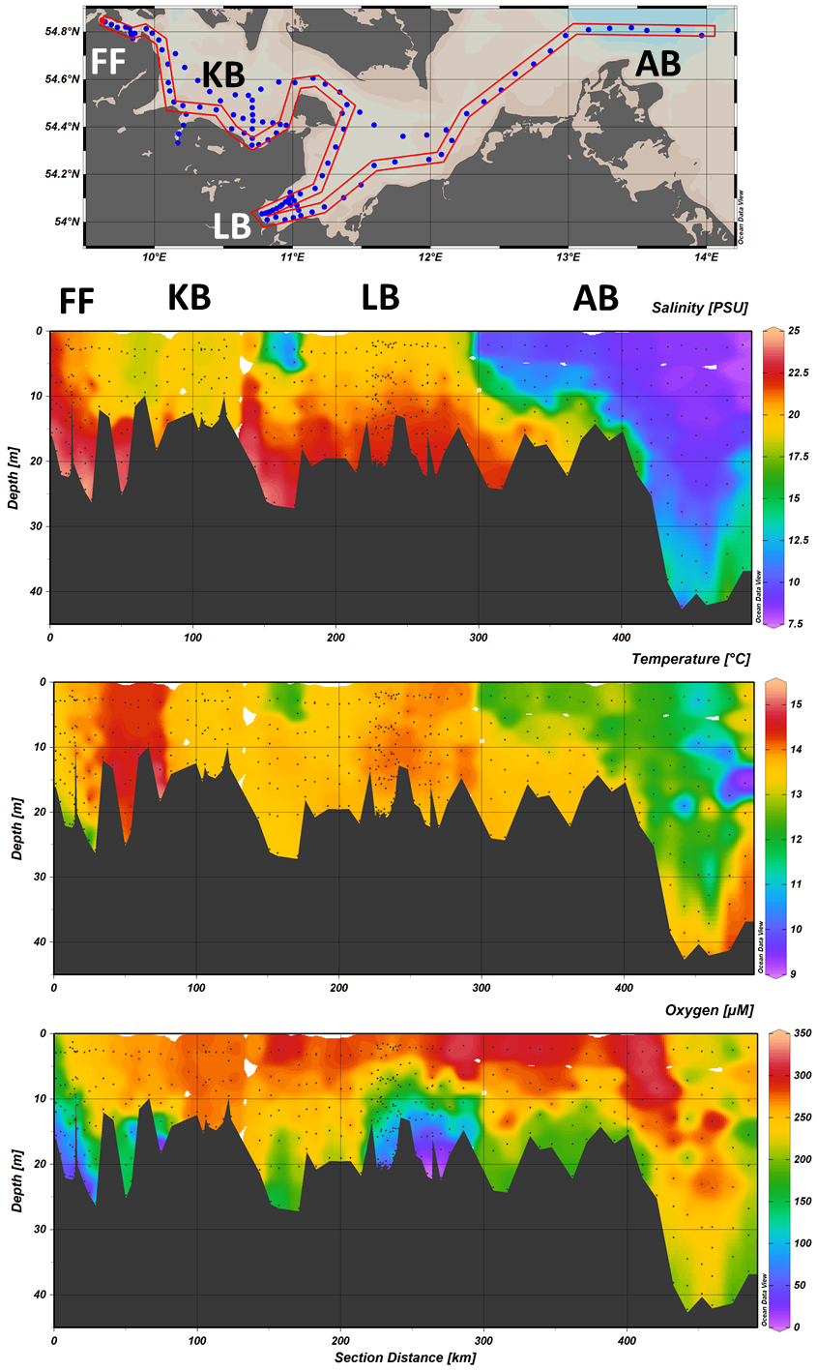

Figure S1. Water quality parameter distribution (salinity, temperature, dissolved oxygen) along a 2-D section from the western margin of the study region (Flensburg Fjord) to the Arkona Basin in the east. The map at the top shows the stations included in the section, and black points on the parameter panels indicate individual water samples. The seafloor is shown in dark grey. Selected sub-regions are indicated on the map and above the sections, and correspond to those shown in Fig. 1 and Table 1. Figure drawn in Ocean Data View v.5.7.0 (Schlitzer, 2023).

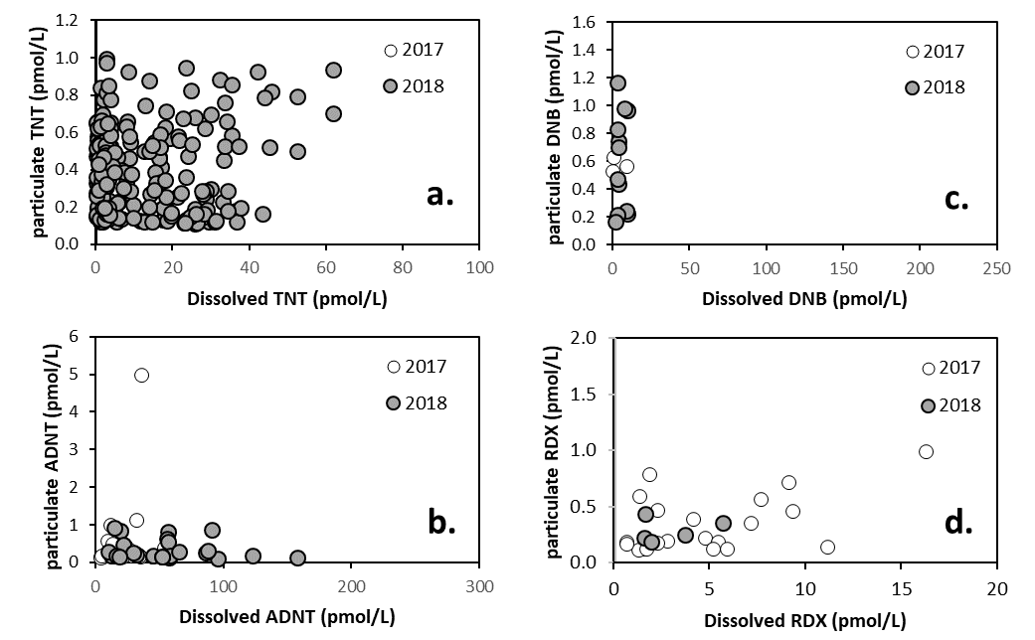

Figure S2. Covariation of particulate and dissolved MC: a) TNT, b) ADNT, c) DNB, d) RDX. A few outliers have been removed for clarity.

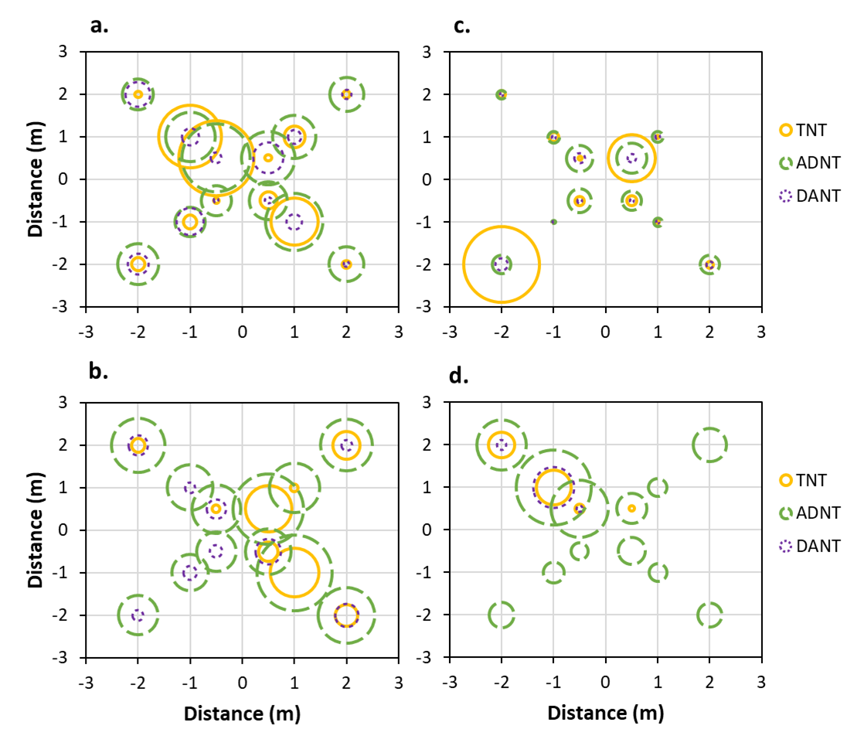

Figure S3. Sediment MC content in close proximity to munition objects (located at the origin in each figure). Circle areas indicate MC content scaled to the maximum value for each mine. All three MC are shown on the same scale in each panel, with maximum values of a) 22 pmol/g, b) 9 pmol/g, c) 465 pmol/g, and d) 20 pmol/g. Symbols for different MC are solid orange line for TNT, dashed green line for ADNT, and dotted purple line for DANT.

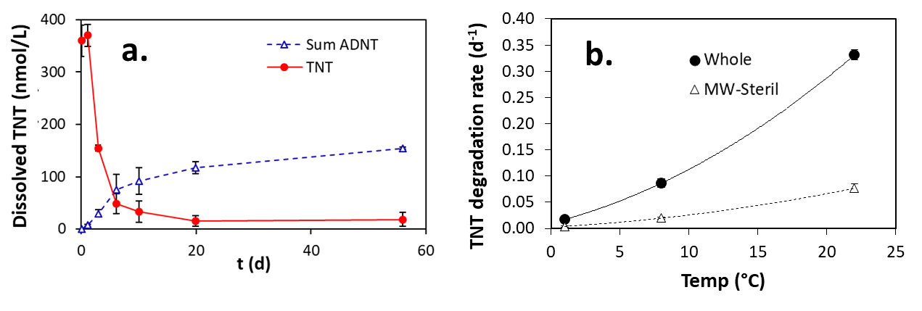

Figure S4. (a) Dissolved TNT and ADNT concentrations during the 55 day incubation period for the 22°C treatment. Error bars show the range of duplicate incubation bottles. (b)TNT removal rates as a function of temperature in whole and microwave-sterilized Baltic Sea water (solid circles and hollow triangles, respectively). Rate uncertainties were calculated from the data fits, and error bars are shown here but are often smaller than the symbol size.

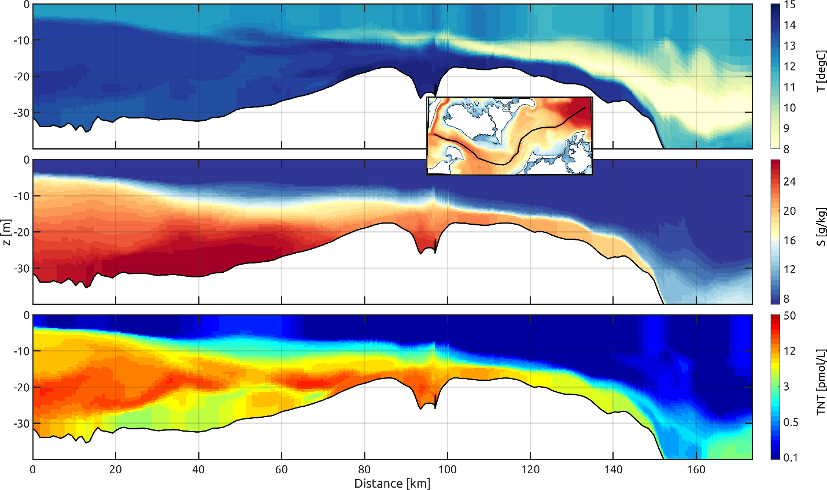

S5. Transect through the Fehmarn Belt (0-40 km), Kadetrinne (40-70 km), and Darss Sill (70-100 km) during October 2018 showing temperature (upper panel), salinity (middle panel) and TNT (lower panel). The insert shows a map with the route of the transect.

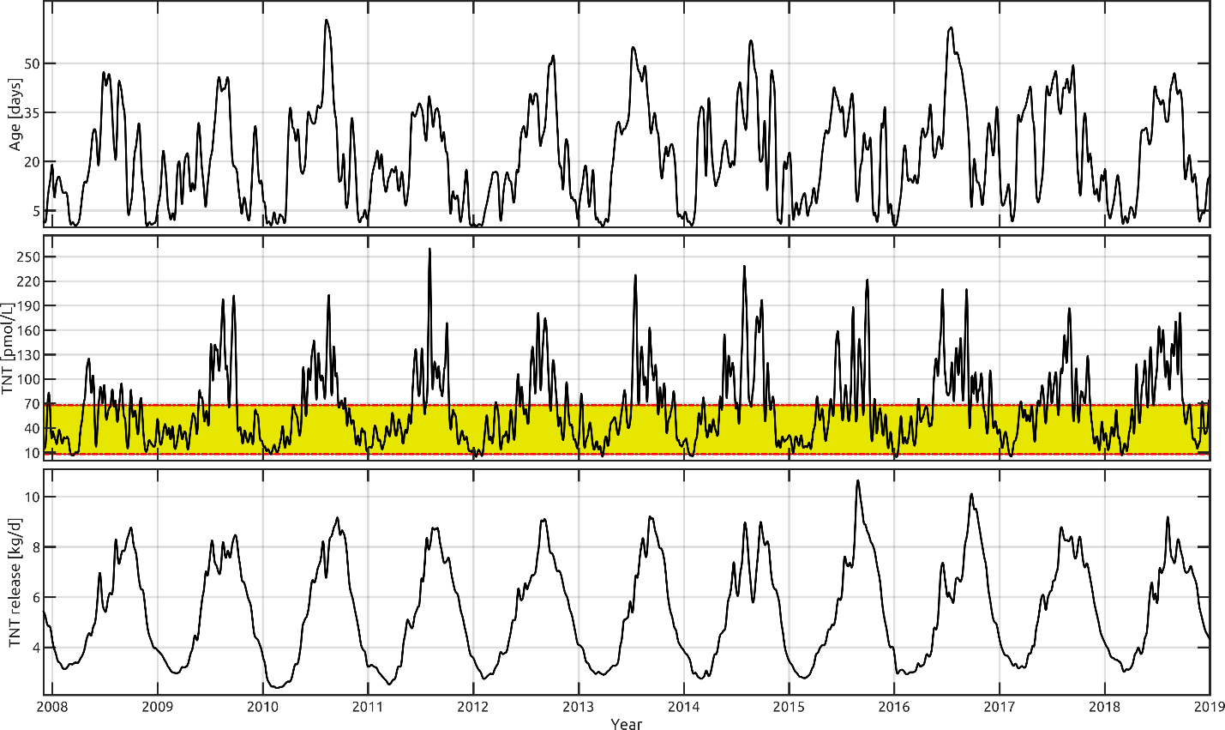

Figure S6. a) Time series of the modelled water age at Kolberger Heide, b) TNT concentration in the bottom layer at Kolberger Heide, and c) release of TNT into the water column for the entire western Baltic Sea, for the period 2008-2018. The yellow area in the middle panel indicates the core of the field measurements.

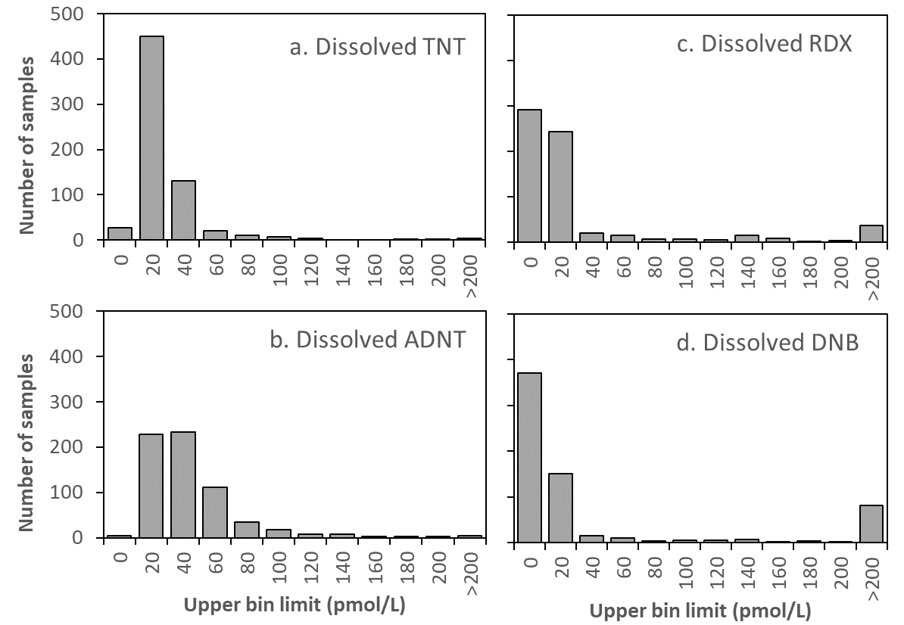

Figure S7. Histograms of dissolved MC concentrations observed in the southwest Baltic Sea.

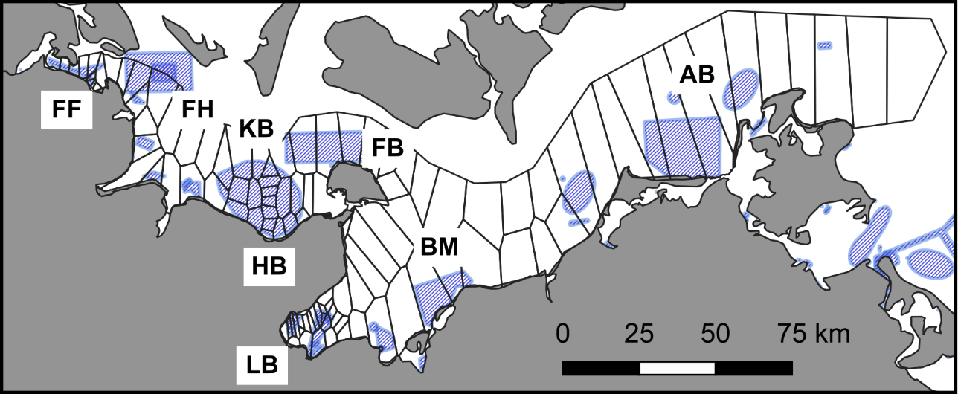

Figure S8. Voronoi polygons used to divide the study area around sampling stations. Sub-region abbreviations as in Table 1 in the manuscript.

**3 References**

Beck, A. J., van der Lee, E. M., Eggert, A., Stamer, B., Gledhill, M., Schlosser, C., & Achterberg, E. P. (2019). In situ measurements of explosive compound dissolution fluxes from exposed munition material in the Baltic Sea. Environmental science & technology, 53(10), 5652-5660.

Böttcher, C. et al. (2011). Munitions contamination of German marine waters - inventory and recommendations (status 2011). (<https://www.blmp-online.de/PDF/Indikatorberichte/2011_03_sd.pdf>) (accessed 18 July 2024, in German).

Bruggeman, J. & Bolding, K. (2014) A general framework for aquatic biogeochemical models. Environ. Model. Softw. 61, 249–265.

Gledhill, M., Beck, A. J., Stamer, B., Schlosser, C., & Achterberg, E. P. (2019). Quantification of munition compounds in the marine environment by solid phase extraction–ultra high performance liquid chromatography with detection by electrospray ionisation–mass spectrometry. Talanta, 200, 366-372.

Gräwe, U., Holtermann, P., Klingbeil, K. & Burchard, H. (2015) Advantages of vertically adaptive coordinates in numerical models of stratified shelf seas. Ocean Model. 92, 56–68.

Janssen, R., Beck, A. J., Werner, J., Dellwig, O., Alneberg, J., Kreikemeyer, B., ... & Labrenz, M. (2021). Machine learning predicts the presence of 2, 4, 6-trinitrotoluene in sediments of a baltic sea munitions dumpsite using microbial community compositions. Frontiers in Microbiology, 12, 626048.

Klingbeil, K., Lemarié, F., Debreu, L. & Burchard, H. The numerics of hydrostatic structured-grid coastal ocean models: State of the art and future perspectives. Ocean Model. 125, 80–105 (2018).

Schlitzer, R., (2023) Ocean Data View, [odv.awi.de](https://odv.awi.de/) (Accessed 24.07.2024).

Sunda, W. G., Price, N. M., & Morel, F. M. (2005). Trace metal ion buffers and their use in culture studies. Algal culturing techniques, 4, 35-63.

Vedenin, A. A., Kröncke, I., Beck, A. J., Bodenbinder, A., Chrysagi, E., Gräwe, U., ... & Greinert, J. (2024). Spatial structure and biodiversity of macrofauna around marine munition dumpsites–A case study from the Baltic Sea. Marine Pollution Bulletin, 198, 115865.